Supplementary Tables and Figures

Supplementary Table S1a: Benchmarking steps developed by van Lent and application in this study
13 steps by van Lent | Application of the steps in this study
1 Determine what to benchmark | Haemovigilance Function (Blood Regulatory Systems)
2 Form a benchmarking team | Scientific Officers from the Paul Ehrlich Institut with background in Blood Regulation
3 Choose benchmarking partners | National Regulatory Authorities in Ethiopia, Kenya, Liberia, Malawi, Nigeria, Uganda, Rwanda, South Africa, Tanzania, and Zimbabwe.
4 Define and verify the main characteristics of the partners | A mapping exercise of the national blood supply systems and relevant laws in which the NRAs are located was performed.
5 Identify stakeholders | WHO and group of international experts from members of the WHO Blood Regulators Network
6 Construct a framework to structure the indicators | The framework was based on that identified in the WHO Global Benchmarking Tool (medicines and vaccines), the WHO Criteria for Assessment of Blood Regulatory Systems and ISO 9004:2018 Quality management — Quality of an organization — Guidance to achieve sustained success
7 Develop relevant and comparable indicators | Indicators and sub-indicators were drawn from the WHO GBT (medicines and vaccines) and the WHO BRN Assessment Criteria for Blood Regulatory Systems
8 Stakeholders select indicators | Stakeholders met at WHO, in Geneva in August 2017 and selected indicators from BRN Assessment Criteria to integrate into GBT
9 Measure the set of performance indicators | Data collection phase was seven months, from February 2018 to August 2018. The same team performed a visit to each NRA to grasp the context and clarify any questions.
10 Analyse performance indicators | The performance of the haemovigilance systems in 10 countries was compared against the sub-indicators. Reports of this comparison were checked by the other members of the country visit team.
11 Take action: results are presented in a report and recommendations are given | For each participating NRA, a report was made containing the outcomes of the benchmark for all NRAs. Data was anonymized. Improvement recommendations for each participating NRA were sent in a separate report.
12 Develop relevant plans | Institutional Development Plans (IDPs) were developed jointly and agreed with each participating NRA.
13 Implement the improvement plans | Outside the scope of this study.

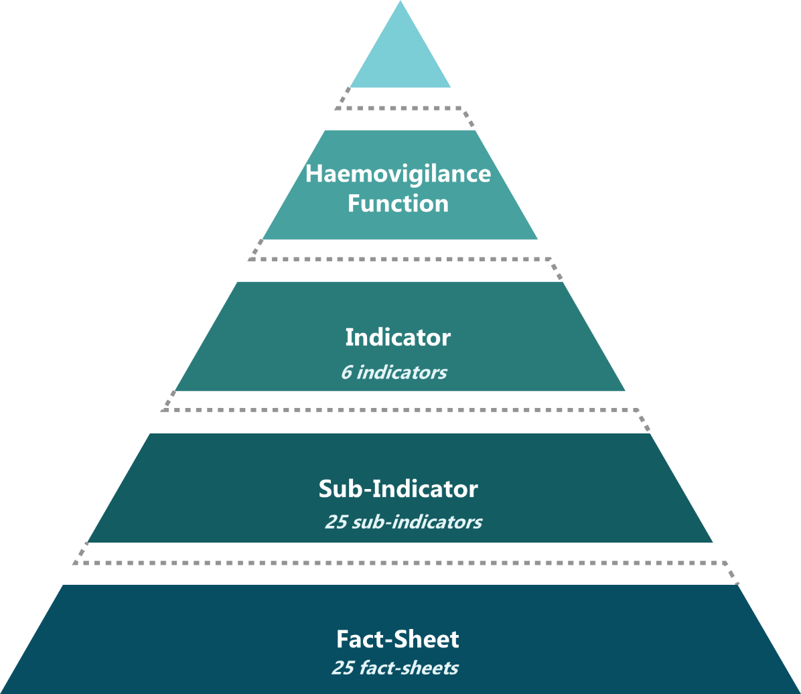
Supplementary Figure S1b: Structure of the Haemovigilance Function in the GBT+ Blood (adapted from the WHO Regulatory Systems Strengthening)

Supplementary Table 1c: Haemovigilance function indicators and sub-indicators in the WHO GBT+ Blood
Indicator | Sub-indicator | Maturity Level
VL01 Legal provisions, regulations and guidelines required to define regulatory framework of vigilance. | VL01 Legal provisions, regulations and guidelines required to define regulatory framework of vigilance. | 1
VL01 Legal provisions, regulations and guidelines required to define regulatory framework of vigilance. | VL01.02: Legal provisions, and/or regulations require the manufacturers and/or MAH to set up a vigilance system of their medical products and periodically report vigilance data, including zero events, to the NRA. | 1
VL01 Legal provisions, regulations and guidelines required to define regulatory framework of vigilance. | VL01.03: Regulations encourage distributors, importers, exporters, health- care institutions, other stakeholders and consumers to report the vigilance events to the MAH and/or NRA. | 1
VL01 Legal provisions, regulations and guidelines required to define regulatory framework of vigilance. | VL01.04: The legal provisions and/or regulations allow NRA to require manufacturers and/or MAH to conduct specific studies on safety and efficacy under specific conditions. | 2
VL01 Legal provisions, regulations and guidelines required to define regulatory framework of vigilance. | VL01.05: Legal provisions, regulations and/or guidelines require manufacturers and/or marketing authorization holders to designate a Qualified Person responsible for vigilance. | 3
VL01 Legal provisions, regulations and guidelines required to define regulatory framework of vigilance. | VL01.06: There are guidelines for planning, conducting (including monitoring) and reporting of vigilance activities. | 3
VL01 Legal provisions, regulations and guidelines required to define regulatory framework of vigilance. | VL01.07: Legal provisions and/or regulations allow recognition and/or reliance on vigilance-relevant decisions, reports or information from other countries, regional and/or international bodies. | 1
VL02 Arrangement for effective organization and good governance. | VL02.01: There is a defined structure with clear responsibilities to conduct vigilance activities. | 2
VL02 Arrangement for effective organization and good governance. | VL02.02: Collaboration between all stakeholders relevant to medical products vigilance is in place. | 3
VL03 Human resources to perform vigilance activities. | VL03.01: Enough competent staff (education, training, skills and experience) are assigned to perform vigilance activities. | 3
VL03 Human resources to perform vigilance activities. | VL03.02: Respective job descriptions are established and regularly updated with inclusion of duties, functions, responsibilities and necessary competencies. | 3
VL03 Human resources to perform vigilance activities. | VL03.03: Training plan developed, implemented and updated at least once a year. | 3
VL03 Human resources to perform vigilance activities. | VL03.04: The NRA performs and maintains records of staff training activities and training effectiveness verification. | 3
VL04 Procedures established and implemented to perform vigilance activities. | VL04.01: Risk approach is considered throughout different vigilance activities, including timely response to safety signals. | 3
VL04 Procedures established and implemented to perform vigilance activities. | VL04.02: Vigilance procedures and tools are in place for collection, assessment, investigation and interpretation of safety issues. | 3
VL04 Procedures established and implemented to perform vigilance activities. | VL04.03: Staff access to information resources relevant to vigilance processes (e.g. safety information sources and reference materials) is ensured. | 3
VL04 Procedures established and implemented to perform vigilance activities. | VL04.04: Expert committee(s) exists to review serious vigilance events. | 3
VL04 Procedures established and implemented to perform vigilance activities. | VL04.05: Assessment of the risk/benefit balance of medical products is regularly conducted considering vigilance data. | 3
VL04 Procedures established and implemented to perform vigilance activities. | VL04.06: The development and implementation of a proactive monitoring programme to promote adherence to vigilance by the NRA. | 4
VL04 Procedures established and implemented to perform vigilance activities. | VL04.07: Standard procedures exist and are implemented for enforcement of the national vigilance programme. | 4
VL05 Mechanism exists to promote transparency, accountability and communication | VL05.01: Mechanism for regular feedback to all stakeholders on vigilance events exists and is complemented with a risk communication plan. | 4
VL05 Mechanism exists to promote transparency, accountability and communication | VL05.02: Vigilance activities and feedbacks are appropriately communicated to the public community. | 4
VL05 Mechanism exists to promote transparency, accountability and communication | VL05.03: Vigilance data and findings are shared with relevant regional and international partners. | 3
VL06 Mechanism in place to monitor regulatory performance and output. | VL06.01: Vigilance information is used to amend or issue regulatory decisions and consequent actions in timely manner. | 3
VL06 Mechanism in place to monitor regulatory performance and output. | VL06.02: Performance indicators for vigilance activities are established. | 4

Supplementary Figure 1d: WHO GBT Performance Maturity Levels, adapted with permission from WHO Regulatory Systems Strengthening [6]
