Supplementary Materials for: Target Fidelity, but not Inducer Fidelity, Modulates Repulsive Serial Dependence of Visual Working Memory Representations

Pilot Experiment
The current experiment was designed to test a novel paradigm where three target Gabor patches were presented in rapid serial visual presentation. Our goal was to test how attention allocation to the inducer and to the target influence the serial bias. In doing so, we varied the Lag between the first (T1) and the second target (T2) in the stream to be Lag 1, Lag 3, and Lag 7 to manipulate attention allocation to T2. We included a Lag 1 condition where we expected the impairment in T2 representation to be low as both T1 and T2 could be processed in the same attentional episode (1). This aimed at providing a test of the temporal distance between T1, T2, and T3 where T2 is spared from the attentional blink, for comparison with the Lag 7 condition. On the other hand, T3 was presented at a fixed lag, in the 6th position following the onset of T2. We manipulated the relative orientation differences between T1 and T2 as well as T2 and T3 from -60° to +60° in steps of 15°.
Analyzing the bias in T2 estimates contingent upon the relative orientation of T1, T2 served as the target and T1 served as the inducer. Turning to the bias in T3 estimates contingent upon the relative orientation of T2, T2 became the bias inducer and T3 the target. We investigated the serial bias in T2 and T3 estimates when T1-T2 Lag was 3 and 7. The pilot experiment was preregistered (https://aspredicted.org/nzdn-fthj.pdf).

Results
The pilot experiment followed the same analytical procedure described in the present study. The only exception was that we did not conduct the linear mixed-effects model analysis here. For repeated-measures ANOVA tests and pairwise t-tests, we used the afex package (2). We applied the Greenhouse-Geisser correction wherever the sphericity assumption of ANOVA was not met. For pairwise tests we used the Bonferroni-Holm adjustments.

Attentional Blink
T2. A one-way repeated measures ANOVA on absolute T2|T1 error (given T1 correct) revealed a significant effect of Lag, F(1.65, 37.96) = 4.13, p = .03, η_{p}² ​= .15. Pairwise t-tests revealed significantly lower absolute T2|T1 error in the Lag 7 (M = 11.89, SD = 1.85) condition compared to Lag 1 (M = 13.14, SD = 2.69) and Lag 3 (M = 12.92, SD = 2.41) conditions, ps < .05. The difference between Lag 1 and Lag 3 was not significant, p > .05. Additionally, we conducted Bayesian tests to confirm these findings. The Bayes factor for the effect of Lag on absolute T2|T1 error was BF₁₀ = 2.42. Bayesian t-tests further confirmed the difference between the Lag 7 condition and the Lag 1 (BF₁₀ = 3.17) as well as the Lag 3 (BF₁₀ = 6.23) conditions. Moreover, Bayesian analysis, with BF₀₁ = 4.29, indicated no difference between Lag 1 and Lag 3 conditions in terms of absolute T2|T1 error. Overall, this suggested that while the typical attentional blink effect was observed for T2s, the lag-1 sparing effect was not.
T3. We conducted a repeated measures ANOVA on absolute T3|T1 error (given T1 correct). The effect of Lag on absolute T3|T1 error was significant, F(1.76, 40.59) = 15.68, p < .001, η_{p}² ​= .41. Pairwise t-tests revealed that absolute T3|T1 error in both Lag 7 (M = 13.98, SD = 3.32) and Lag 3 (M = 14.36, SD = 2.82) conditions were significantly lower compared to the Lag 1 (M = 17.11, SD = 3.70), ps < .001. The difference between Lag 7 and Lag 3 was not significant, p = .45. The Bayes factor for the effect of Lag on absolute T3|T1 error was BF₁₀ = 2797.69. Bayesian t-tests also confirmed significant differences between Lag 1 and Lag 7 (BF₁₀ = 181.79) and Lag 1 and Lag 3 (BF₁₀ = 144.06) conditions. Bayes factor analysis, with BF₀₁ = 3.58, suggested no difference between Lag 7 and Lag 3 conditions in terms of absolute T3|T1 error. This suggested that T3|T1 absolute estimation error was significantly high in the Lag 1 condition, contrary to our expectations, while it was comparable across Lag 3 and Lag 7 conditions.

Serial Dependence
T2 – Effect of Target Fidelity. We conducted a one-way repeated-measures ANOVA on α values quantifying the bias in T2 estimates away from T1, estimated based on individual data (Figure S1). The effect of Lag was significant, F(1.26, 22.67) = 7.55, p = .008, η_{p}² ​= .30. Mean α values in all conditions turned out to be negative, suggesting that the serial dependence bias is repulsive. Pairwise comparisons revealed that mean α in the Lag 3 condition (M = -9.59, SD = 2.60) was significantly lower than that in the Lag 1 condition (M = -1.59, SD = 10.8), p = .006, and in the Lag 7 (M = -6.96, SD = 3.92) condition, p = .045. The mean α in the Lag 7 condition did not significantly differ from the mean α in the Lag 1 condition, p = .058. The data was 49.77 times more likely under the alternative model with Lag as a factor compared to the null model. The results of Bayesian t-tests showed strong evidence for the α difference between Lag 1 and Lag 3 conditions (BF₁₀ = 19.97). There was anecdotal evidence for the α difference between Lag 1 and Lag 7 (BF₁₀ = 1.26), and Lag 3 and Lag 7 (BF₁₀ = 2.11) conditions in terms of serial dependence bias.

Figure S1
Individual estimates of serial dependence magnitude in T2 representations by Lag conditions
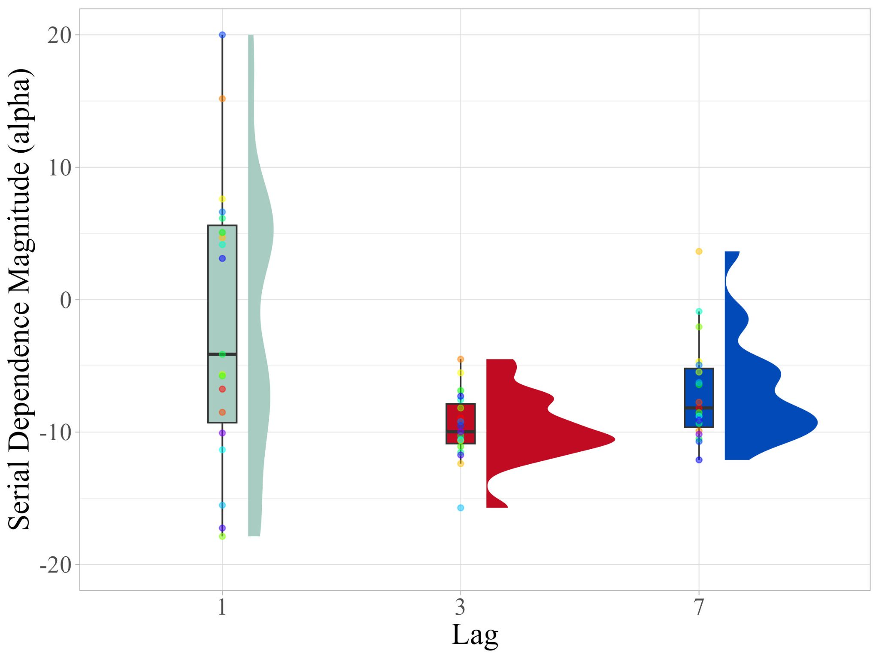
Note. Negative values of α indicate repulsion. Each individual is represented by a distinct color.
We then performed the permutation test by fitting the DoG function to the aggregated data. The estimated values for the parameter α based on the observed data were -5.56, -7.08, and -5.55, respectively in the Lag 1, Lag 3, and Lag 7 conditions. The results suggested that the parameter α was lowest in the Lag 3 condition in comparison to α values in Lag 7, α_{Lag7-Lag3} = 1.53 , 95% CI [-1.44, 1.44], p_{perm} = .037, and Lag 1 conditions, α_{Lag1-Lag3} = 1.52 , 95% CI [-1.48, 1.49], p_{perm} = .046. The parameter α did not differ significantly across Lag 1 and Lag 7 conditions, α_{Lag7-Lag1} = .01 , 95% CI [-1.53, 1.49], p_{perm} = .99. DoG function fits to the observed data can be seen in Figure S2. Overall, the permutation test results were aligned with those of the parametric frequentist and Bayesian tests conducted on the individually estimated parameters. This suggested that repulsive serial dependence was highest when the target fidelity was low due to the attentional blink (Lag 3). The bias was significantly lower in the Lag 1 and Lag 7 conditions. However, the high individual variance in the Lag 1 condition is noteworthy (Figure S1).
Figure S2
T2|T1 estimation error by relative orientation of T1 by Lag
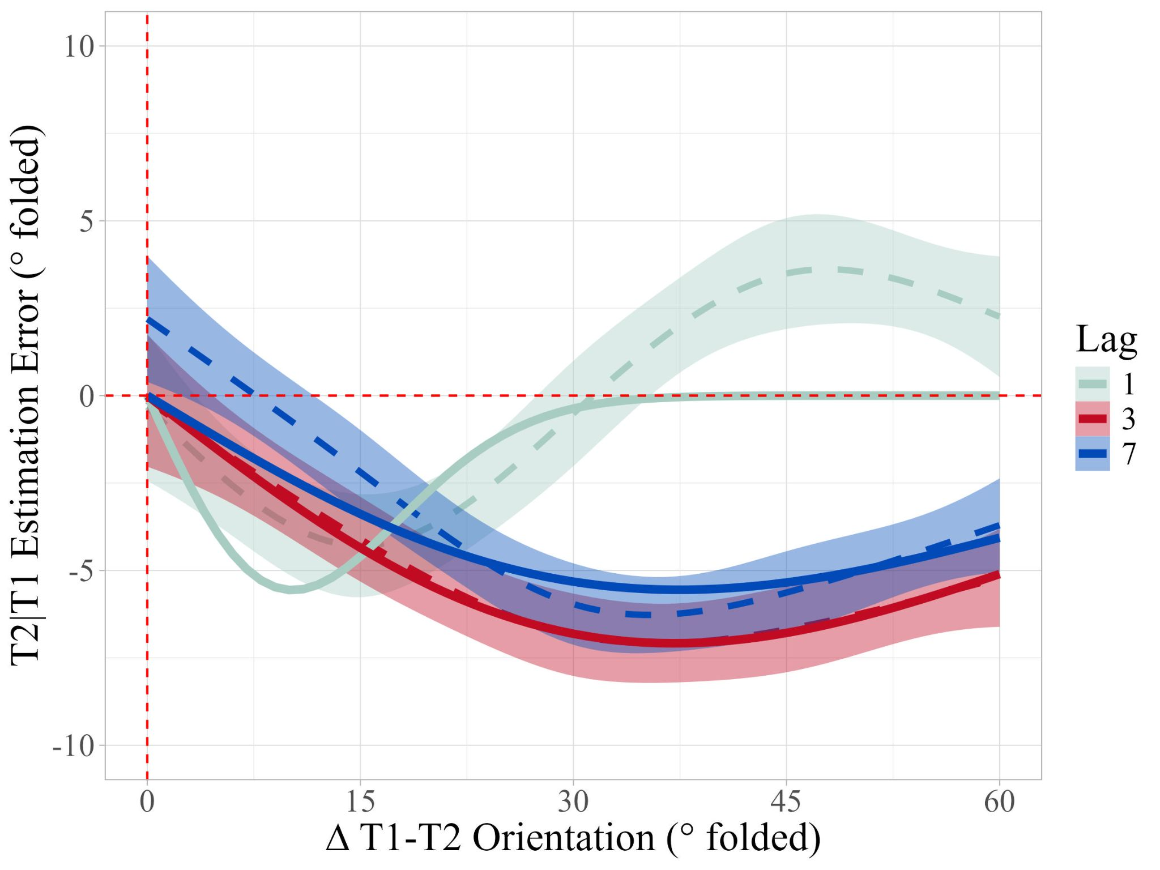
Note. Solid lines show DoG fits whereas dashed lines indicate the smoothed mean error observed in the data. Shaded areas show standard error of the mean. Negative folded estimation error in the positive Δ range indicates repulsion.
T3 – Effect of Inducer Fidelity. A one-way repeated-measures ANOVA on individual α values revealed that Lag did not influence the bias in T3 estimates away from T2 orientations, F(1.74, 33.01) = 1.30, p = .28, η_{p}² ​= .06. This is despite numeric differences across Lag 1 (M = -9.51, SD = 6.58), Lag 3 (M = -7.57, SD = 5.23), and Lag 7 (M = -8.96, SD = 3.39) conditions. Bayes Factor analysis provided anecdotal evidence suggesting that the data was 2.84 times more likely under the null hypothesis compared to the alternative hypothesis.
Next, we performed the permutation analysis on the aggregated data. The parameter α values estimated from the observed data were as follows respectively in the Lag 1, Lag 3, and Lag 7 conditions; -7.56, -6.40, -6.01. The results suggested that the α difference between Lag 7 and Lag 1 conditions was significant, α_{Lag7-Lag1} = 1.55 , 95% CI [-1.46, 1.51], p_{perm} = .040, while the difference between Lag 7 and Lag 3, α_{Lag7-Lag3} = .39 , 95% CI [-1.44, 1.47], p_{perm} = .60, as well as Lag 3 and Lag 1, α_{Lag3-Lag1} = 1.16 , 95% CI [-1.51, 1.52], p_{perm} = .13, were not statistically significant. The DoG fits and the observed data can be seen in Figure S3. The results suggested that the magnitude of the repulsive serial dependence bias did not change depending on the fidelity of the inducer.

Figure S3
T3|T1 estimation error by relative orientation of T2 by Lag
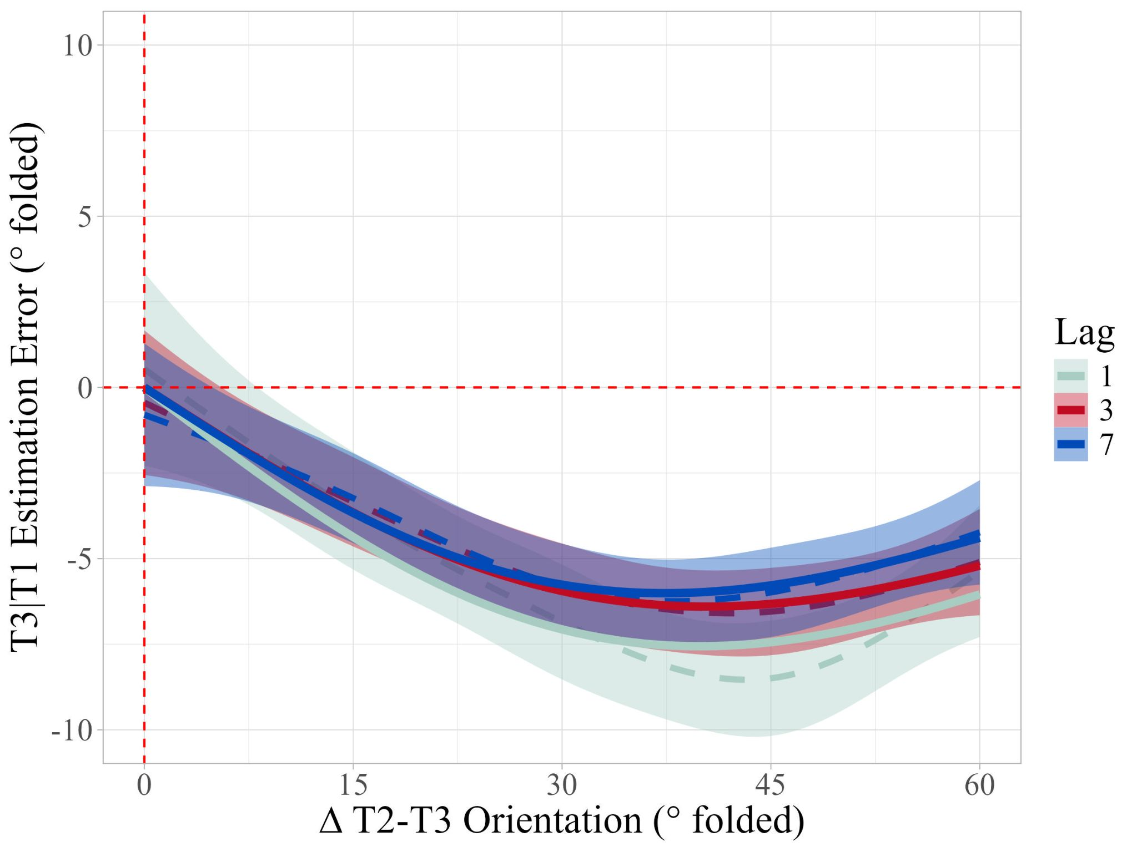
Note. Solid lines show DoG fits whereas dashed lines indicate the smoothed mean error observed in the data. Shaded areas show standard error of the mean. Negative folded estimation error in the positive Δ range indicates repulsion.

Discussion
The findings of the pilot experiment suggested that the magnitude of the repulsive serial bias increases when the target fidelity is low. Moreover, the results demonstrated that the fidelity of the inducer does not influence the magnitude of serial dependence. On the other hand, we did not observe the lag-1 sparing effect. Focusing on the absolute mean T2|T1 error difference between Lag 3 and Lag 7 conditions, the attentional blink effect magnitude in the pilot experiment was lower (Cohen’s d = .48) than that of the present study (Cohen’s d = .75). Regardless, we observed a higher repulsive bias in T2 representations in the Lag 3 condition compared to the other Lag conditions. The aggregated DoG fit spuriously suggested that there is a systematic bias in the Lag 1 condition in T2 estimates. It appears as if there is a repulsive bias for relative orientation differences smaller than 30° which then turns to an attractive bias (Figure S2). However, when the data is plotted to show bias for individual participants (Figure S2), it is apparent that almost half of the participants had a strong bias toward T1 while the rest had a strong bias away from T1. Therefore, we considered the bias in T2 estimates the Lag 1 condition to be uninterpretable. We suspected that Lag 1 condition might have increased the subjective difficulty of the task, decreasing the precision in target estimates in other Lag conditions too. This might have underlied the relatively lower attentional blink effect in the Lag 3 condition compared to the Lag 7 condition where the attentional blink effect should no longer exist. Given these and the fact that the lag-1 sparing was not observed here we decided to drop the Lag 1 condition to test our hypotheses using Lag 3 and Lag 7 conditions only in the present study.

Method

Participants
24 Koç University undergraduate students (22 females and 2 males) participated in the current experiment. The sample size was determined following an a priori power analysis aiming for a large effect (Cohen’s F of .4) with alpha of .05, beta of .80 (Faul et al., 2009). Participants were adults (M_{age} = 21.21, SD_{age} = 1.19) who were not diagnosed with a neurological disorder and had normal or corrected-to-normal vision. Five participants were removed from the T2 serial dependence analysis we ran based on individual estimates as they were outliers (1.5 times below or above the lowest and highest interquartile range). Four participants (two also removed from T2 analysis) were removed from T3 serial dependence analysis based on individual data. However, these participants were included in the serial dependence analysis we ran based on aggregate data for both T2 and T3.

Apparatus & Stimuli
All apparatus and stimuli were the same as the present study except that mask stimuli in the pilot experiment were created by dividing a black and white Gabor patch into 5x5 pixel-squares and randomly shuffling the squares.

Design and Procedure
The pilot experiment employed a within-subjects design with the Lag between the first (T1) and the second target (T2) as the only factor with three levels (Lag: 1, 3, 7). In addition to Lag, we manipulated the relative orientation difference between successive targets (Δ_{T1-T2} and Δ_{T2-T3}) from -60° to + 60° with increments of 15°. In doing so, we ensured each level of Δ_{T1-T2} paired with every level of Δ_{T2-T3}, forming a fully factorial design.
We used RSVP technique to present three target stimuli (T1, T2, and T3) on each trial as in the present study. The RSVP stream consisted of 22 displays in total, in which all stimuli (3 targets and 19 distractors) were presented at the center of the screen alone for 100 ms, with ~17 ms blank interval in between each display. Therefore, Lags of 1, 3, and 7 corresponded to stimulus onset asynchronies (SOAs) of ~117, 350, and ~817 ms. There were either 0, 2, or 6 distractors between T1 and T2 respectively in Lag 1, 3, and 7 conditions. There were always 5 distractors between T2 and T3. The experiment consisted of 10 practice and 320 experimental trials completed in a single experimental session which took 55 minutes on average. The rest of the details were the same as in the present study.

References
1. Hommel B, Akyürek EG. Lag-1 sparing in the attentional blink: Benefits and costs of integrating two events into a single episode. The Quarterly Journal of Experimental Psychology Section A. 2005 Nov;58(8):1415–33.
2. Singmann H, Bolker B, Westfall J, Aust F, Ben-Shachar MS. afex: Analysis of Factorial Experiments [Internet]. 2023. Available from: https://CRAN.R-project.org/package=afex

