Table 1
Summary of the linear regression and validation findings in pure form of the investigated drugs simultaneously
Parameters | CTN | TSN
RF | 0.57 | 0.84
Linearity range (µg/bandl)ª | 0.005-1.25 | 0.12-2.5
Slope ± SD | 0.0004±1.9 | 0.0081±0.000037
Intercept ± SD | 0.003 ±0.00034 | 0.01642±0.0174
Determination coefficient (r) | 0.9999 | 0.9999
Limit of quantitation (LOQs), | 0.043 | 0.107
Limit of detection (LODs), | 0.014 | 0.035
Robustness
PH=4 ± 0.2 | 99.76±0.88
Saturation time of the mobile phase
20 min ± 3min | 100.44±0.67
Composition of mobile phase
Phosphate buffer 70ml±1% | 98.88±1.01
Methanol 30ml±1% | 100.31±0.59
SD standard deviation, R_{F} retardation factor
(ª) volume of injection equal to 5 µl

Table 6
Comparison of the developed TLC method with some reported Chromatographic methods
Variable | TLC-UV | TLC [3] | HPTLC [12]
Technique used | TLC-UV | TLC [3] | HPTLC [12]
Mobile phase | phosphate buffer and methanol in a 70:30 (v/v). | Ammonia: ethyle acetate:triethyle amine  [6:3.5:0.5,v/v] | Acetonitril:ethyle acetate:Briton-ribonson buffer  [50:20:20,v/v v]
Linearity range | (0.,05-1.25µg/band)for CTN and (0.12-2.5 µg/band)for TSN | (60-220 µg/mL)of CTN | (10-100 µg/mL) of TSN
Analytes | CTN and TSN | CTN | TSN and tryptophan
Application | Dosage form and spiked human plasma and urine | Dosage form | Serum sample
GAPI assessment | 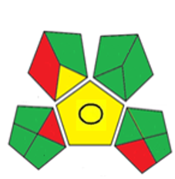 | 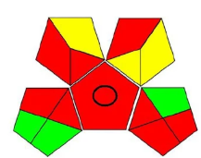 | 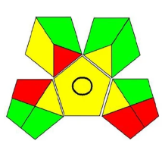
AGREE assessment | 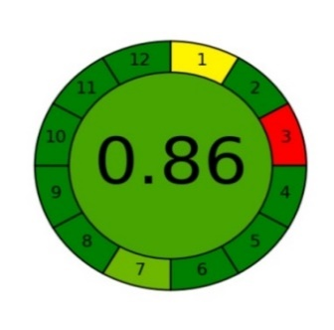 | 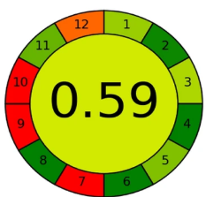 | 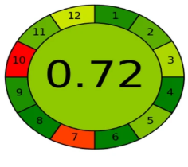
BAGI assessment | 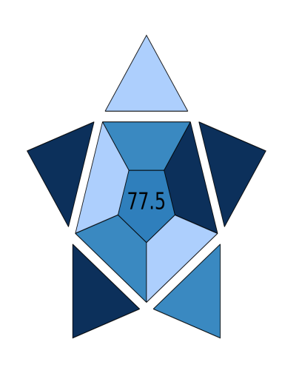 | 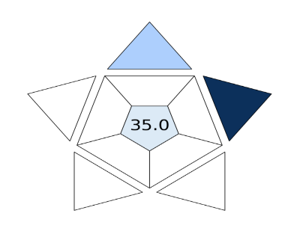 | 