Quantitative Magnetic Deflection Enables Continuous‐Flow Separation of Cell Subtypes
Zhenwei Liang ¹, Xiaolei Guo ^{1,2}, Xuanhe Zhang ¹, Yiqing Chen ¹, Chuan Du ³, Yuan Ma ¹*and Jiadao Wang ¹*
¹ Department of Mechanical Engineering, Tsinghua University, Beijing 100084, PR China.
² Center for Medical Device Evaluation, National Medical Products Administration, Beijing 100081, PR China.
³ LenCyte Biotechnology (Xuzhou City) Co., Ltd. Xuzhou, Jiangsu 221000, PR China.

* Correspondence:
Yuan Ma
yuanma@tsinghua.edu.cn
Jiadao Wang
jdwang@mail.tsinghua.edu.cn

Group | Distance (μm) | Width (μm) | Thickness (μm)
1 | 50 | 800 | 100
2 | 50 | 1000 | 100
3 | 50 | 1200 | 100
4 | 60 | 800 | 100
5 | 60 | 1000 | 100
6 | 60 | 1200 | 100
7 | 70 | 800 | 100
8 | 70 | 1000 | 100
9 | 70 | 1200 | 100
Table. S1 Orthogonal experimental design for regulating magnetic field parameters.
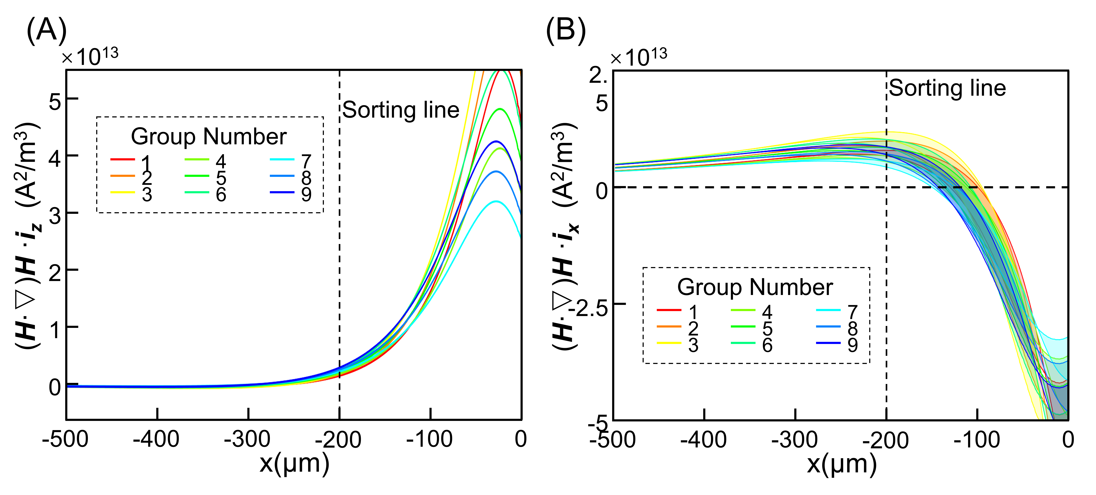
Fig. S1 The magnetic field parameters in the flow channel corresponding to the orthogonal experiment. (A) The z-axis component of the (H∙∇)H parameter within the flow channel for the nine design models. (B) The x-axis component of the (H∙∇)H parameter within the flow channel for the nine design models.
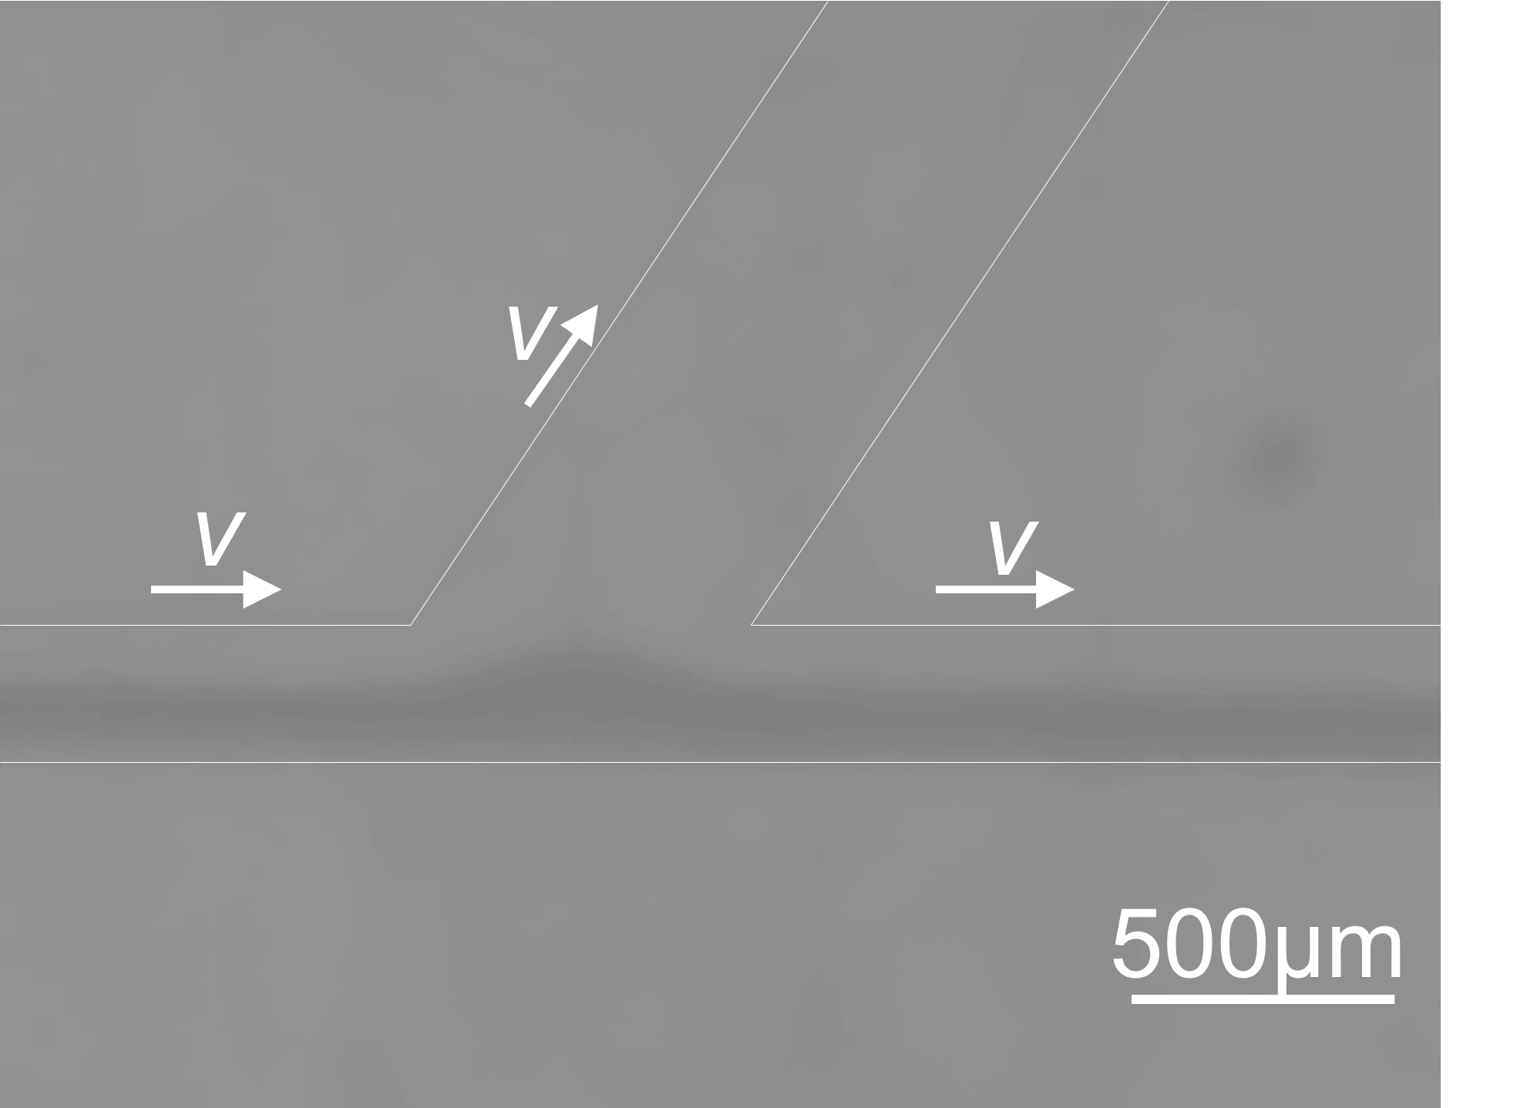
Fig. S2 Phase field distribution in continuous flow sorting chips. Whole blood and PBS solution were used as the sample and buffer phases, respectively. The darker region in the figure corresponds to the whole-blood phase.

