Supplemental materials 1: Food questionnaire
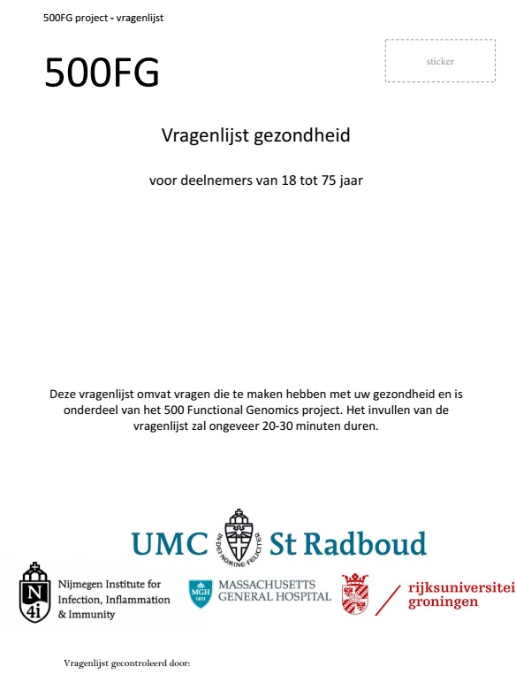
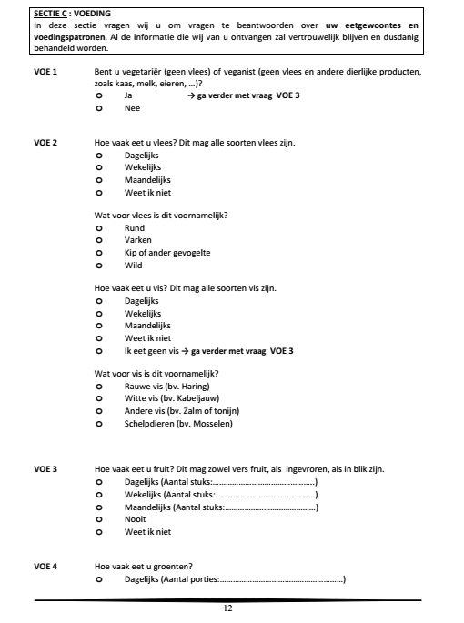
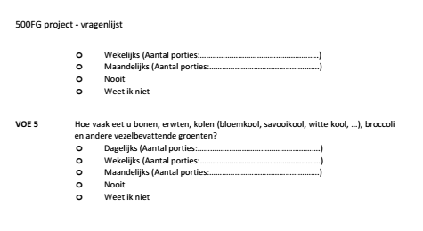
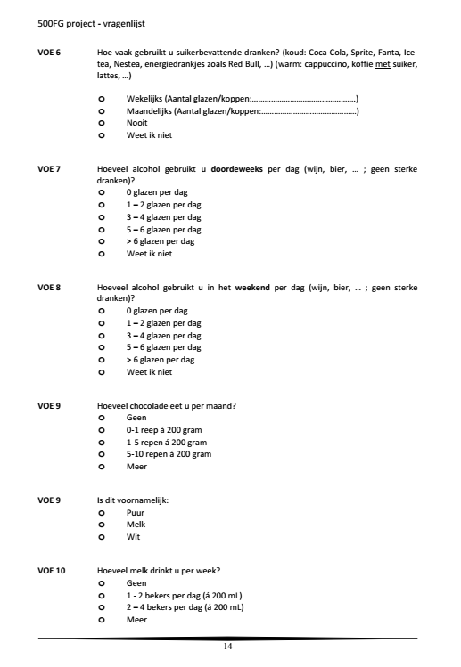
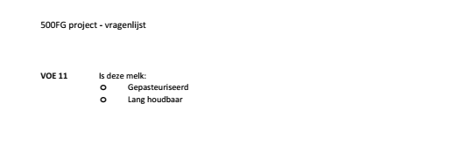
English translation

VOE 1 Are you vegetarian (no meat) or vegan (no meat and other animal products,
such as cheese, milk, eggs, …)?
o Yes → continue with question VOE 3
o No

VOE 2 How often do you eat meat? This can be any type of meat.
o Daily
o Weekly
o Monthly
o I don't know

What kind of meat is this mainly?
o beef
o Pig
o Chicken or other poultry
o Wild

How often do you eat fish? This can be any kind of fish.
o Daily
o Weekly
o Monthly
o I don't know
o I do not eat fish → continue with question VOE 3

What kind of fish is this mainly?
o Raw fish (e.g. herring)
o White fish (e.g. cod)
o Other fish (e.g. salmon or tuna)
o Shellfish (e.g. mussels)

VOE 3 How often do you eat fruit? This can be fresh fruit, frozen or canned.
o Daily (Number of pieces:……………………………………..)
o Weekly (Number of pieces:……………………………………….)
o Monthly (Number of pieces:……………………………………)
o Never
o I don't know

VOE 4 How often do you eat vegetables?
o Daily (Number of servings:…………………………………………………)
o Weekly (Number of servings:…………..)
o Monthly (Number of servings:…………………………………………….)
o Never
o I don't know

VOE 5 How often do you eat beans, peas, cabbages (cauliflower, Savoy cabbage, white cabbage, …), broccoli
and other fiber-containing vegetables?
o Daily (Number of servings:……………….)
o Weekly (Number of servings:………………)
o Monthly (Number of servings:…………………………………………….)
o Never
o I don't know

VOE 6 How often do you consume sugary drinks? (cold: Coca Cola, Sprite, Fanta, Ice‐
tea, Nestea, energy drinks such as Red Bull, …) (hot: cappuccino, coffee with sugar,
lattes,...)
o Weekly (Number of glasses/cups:………………………………………….)
o Monthly (Number of glasses/cups:………………………………………)
o Never
o I don't know

VOE 7 How much alcohol do you consume per day during the week (wine, beer, … ; not strong
drinks)?
o 0 glasses per day
o 1 – 2 glasses per day
o 3 – 4 glasses a day
o 5 – 6 glasses a day
o > 6 glasses a day
o I don't know
VOE 8 How much alcohol do you consume per day at the weekend (wine, beer, … ; not strong
drinks)?
o 0 glasses per day
o 1 – 2 glasses per day
o 3 – 4 glasses a day
o 5 – 6 glasses a day
o > 6 glasses a day
o I don't know

VOE 9 How much chocolate do you eat per month?
o None
o 0‐1 bar of 200 grams
o 1‐5 bars of 200 grams
o 5‐10 bars of 200 grams
o More

VOE 9A Is this mainly:
o Pure
o Milk
o White

VOE 10 How much milk do you drink per week?
o None
o 1 ‐ 2 cups per day (á 200 mL)
o 2 – 4 cups per day (á 200 mL)
o More

VOE 11 Is deze melk:
o Gepasteuriseerd
o Lang houdbaar

Supplement table 1. Characteristics by quintile (Q) of dietary pattern scores by gender.
 |  |  | Age | BMI | Smoking | No Physical activity | College  education
 |  |  | y |  | % | % | %
Men
 | High-meat
 |  | Q1 | 28.1 ± 12.5 | 22.6 ± 2.7 | 16.0 | 44.0 | 88.0
 |  | Q3 | 30.0 ± 15.5 | 23.4 ± 3.1 | 16.2 | 23.2 | 81.3
 |  | Q5 | 27.1 ± 10.5 | 23.6 ± 2.9 | 15.6 | 23.5 | 88.4
 |  | P valueª | 0.82 | 0.042 | 0.912 | 0.118 | 0.818
 | Prudent diet
 |  | Q1 | 25.4 ± 9.8 | 23.4 ± 3.0 | 20.0 | 40.0 | 85.4
 |  | Q3 | 33.8 ± 16.8 | 23.3 ± 2.8 | 23.9 | 41.3 | 80.4
 |  | Q5 | 30.9 ± 15.5 | 23.6 ± 2.8 | 22.2 | 22.2 | 81.0
 |  | P valueª | 0.001 | 0.865 | 0.072 | 0.022 | 0.428
 | High-alcohol
 |  | Q1 | 34.9 ± 17.0 | 23.4 ± 3.6 | 10.3 | 20.6 | 65.5
 |  | Q3 | 32.5 ± 15.8 | 23.1 ± 3.2 | 8.82 | 23.5 | 91.1
 |  | Q5 | 25.5 ± 10.5 | 23.3 ± 2.0 | 27.9 | 32.3 | 89.8
 |  | P valueª | 0.005 | 0.982 | 0.001 | 0.064 | 0.011
Women
 | High-meat
 |  | Q1 | 27.4 ± 13.1 | 22.2 ± 2.7 | 5.71 | 36.1 | 84.7
 |  | Q3 | 25.4 ± 10.3 | 21.9 ± 2.0 | 13.2 | 33.9 | 90.5
 |  | Q5 | 28.0 ± 11.8 | 22.9 ± 2.5 | 11.1 | 42.2 | 86.6
 |  | P valueª | 0.543 | 0.203 | 0.794 | 0.794 | 0.165
 | Prudent diet
 |  | Q1 | 25.6 ±11.2 | 22.4 ± 3.0 | 19.0 | 35.7 | 80.9
 |  | Q3 | 24.7 ±10.2 | 21.9 ± 2.2 | 6.12 | 42.0 | 92.0
 |  | Q5 | 29.8 ±14.2 | 22.5 ± 2.5 | 6.66 | 21.6 | 91.6
 |  | P valueª | 0.073 | 0.534 | 0.097 | 0.015 | 0.311
 | High-alcohol
 |  | Q1 | 27.4 ± 11.9 | 23.4 ± 3.6 | 8.82 | 39.7 | 89.7
 |  | Q3 | 27.5 ±12.5 | 23.1 ± 3.2 | 13.1 | 24.1 | 85.4
 |  | Q5 | 22.0 ±3.3 | 23.3 ± 2.0 | 14.2 | 46.4 | 92.8
 |  | P valueª | 0.123 | 0.925 | 0.061 | 0.061 | 0.412
ª P values are based on ANOVA for continuous variables and chi-square tests for categorical variables.

