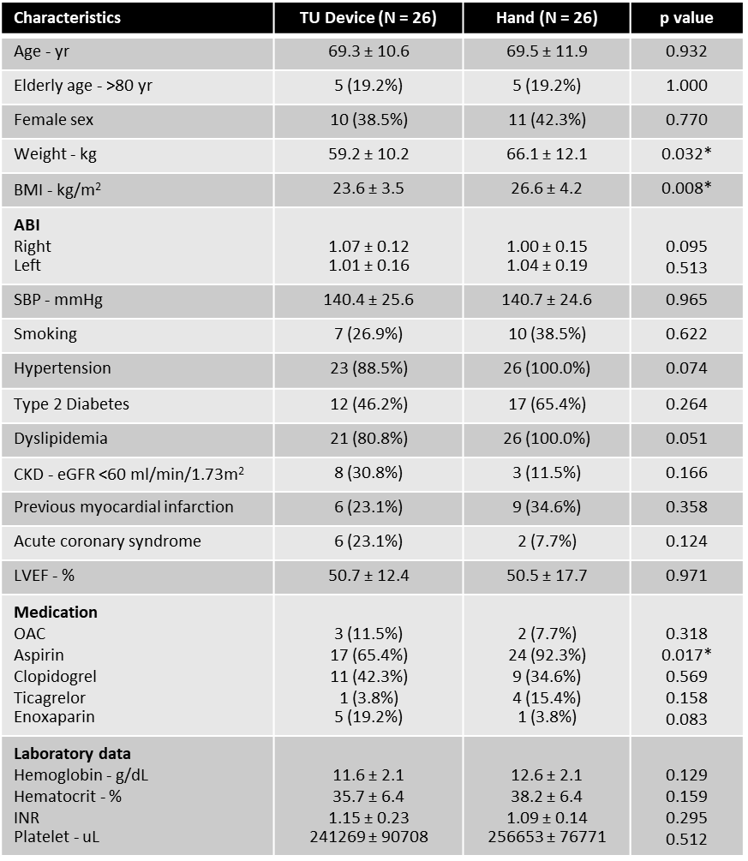
BMI: body mass index, ABI: Ankle-brachial index, SBP: Systolic blood pressure, CKD: Chronic kidney disease, OAC: oral anticoagulant *Statistical significance
Table 1: Baseline clinical characteristics.

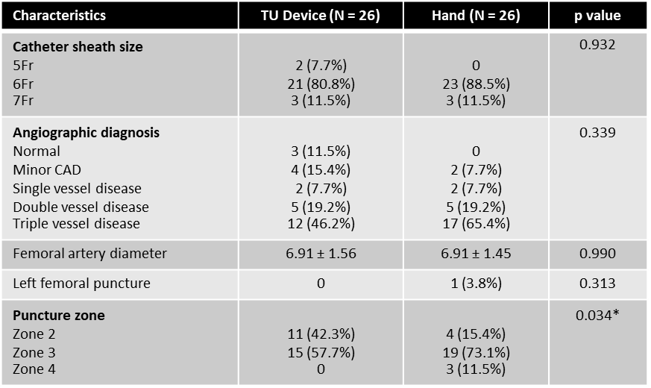
*Statistical significance
Table 2: Baseline angiographic characteristics.

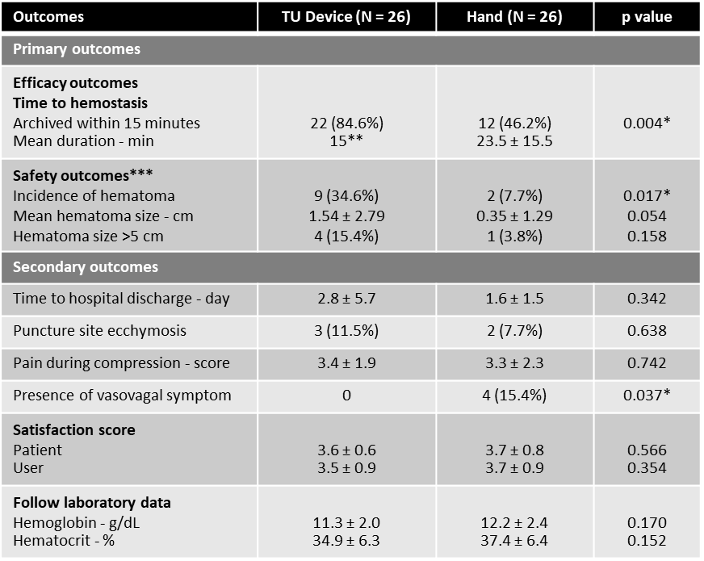
*Statistical significance, **Excluded patient with device failure (n = 22), ***Absence of other complications such as AV fistula, pseudoaneurysm, or overt bleeding in this study.
Table 3: Study outcomes.
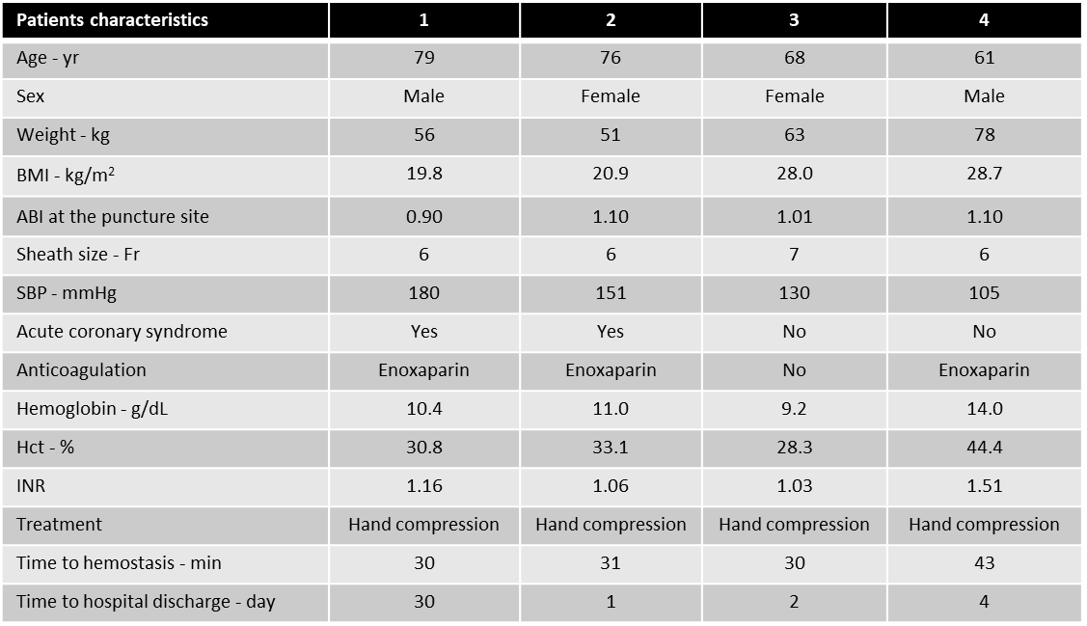
For patient 1, there was a prolonged time to hospital discharge due to his comorbidity (surgical condition). In these four patients, there were no major vascular complications, and complete hemostasis was achieved with hand compression.
Table 4: Characteristics of patients with device failure.

