Supplementary Information

Three-Dimensional Continuous Multi-Walled Carbon Nanotubes Network-Toughened Diamond Composite
Jiawei Zhang^{1,2}, Keliang Qiu³, Tengfei Xu⁴, Xi Shen¹, Junkai Li⁵, Fengjiao Li¹, Richeng Yu¹, Huiyang Gou⁵, Duanwei He⁶, Liping Wang⁷, Zhongzhou Wang³, Guodong Li⁸, Yusheng Zhao², Ke Chen^{3,8,}*, Fang Hong^{1,}*, Ruifeng Zhang^{4,}*, Xiaohui Yu^{1,}*
- Beijing National Laboratory for Condensed Matter Physics, Institute of Physics, Chinese Academy of Sciences, Beijing 100190, P. R. China.
- Eastern Institute for Advanced Study, Eastern Institute of Technology; Ningbo 315201, P. R. China.
- School of Chemistry, Beihang University; Beijing 100191, P. R. China.
- School of Materials Science and Engineering, Beihang University; Beijing 100191, P. R. China.
- Center for High Pressure Science and Technology Advanced Research; Beijing 100193, P. R. China.
- Institute of Atomic and Molecular Physics, Sichuan University; Chengdu 610065, P. R. China.
- Academy for Advanced Interdisciplinary Studies, and Department of Physics, Southern University of Science and Technology; Shenzhen 518055, P. R. China.
- State Key Lab of Tropic Ocean Engineering Materials and Materials Evaluation, Hainan University, Haikou 570228, P. R. China.
- These authors contributed equally: Jiawei Zhang, Keliang Qiu, Tengfei Xu, Xi Shen,

Email: yuxh@iphy.ac.cn; chenke0119@buaa.edu.cn; hongfang@iphy.ac.cn; zrf@buaa.edu.cn

The file includes:

Supplementary Figs. 1-12
Supplementary Table 1

Other Supplementary Materials for this manuscript include the following:

Supplementary Movies 1 and 2

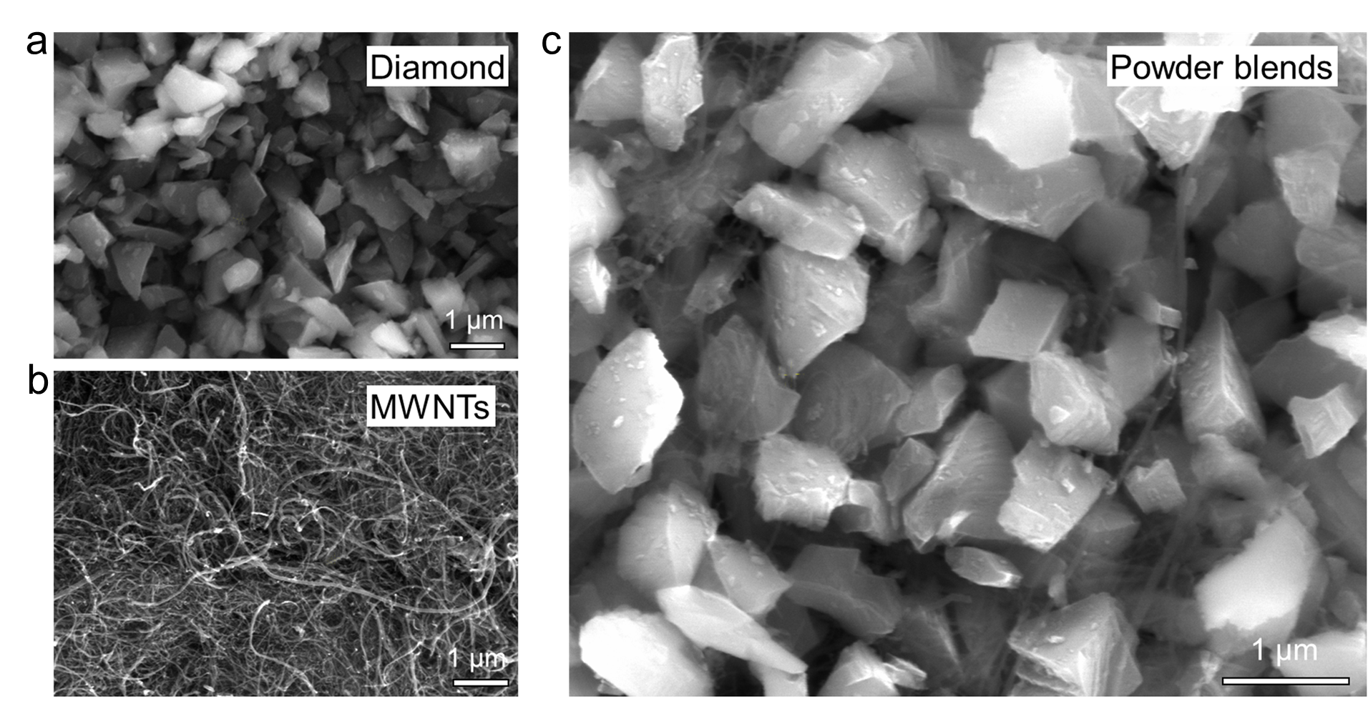
Supplementary Fig. 1 | Characterization of the starting materials. a, SEM image of the diamond powder with grain size of 0.8–1.3 μm. b, SEM image of MWCNTs with large aspect ratio. c, SEM image of diamond powders blended with MWCNTs.

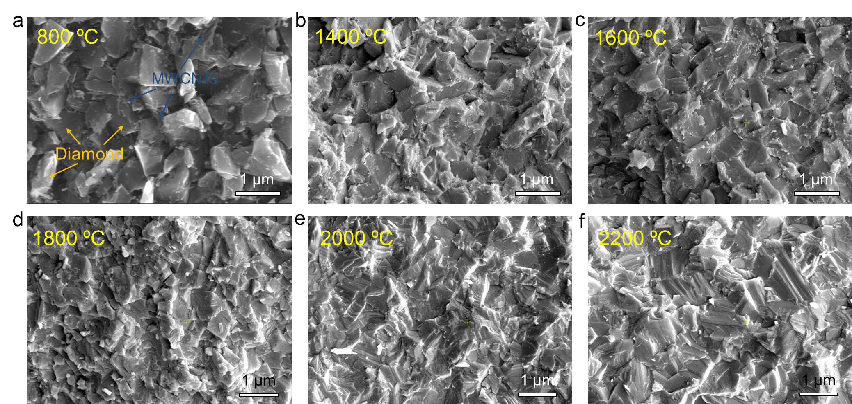
Supplementary Fig. 2 | Characterization for fractured surfaces of 3D-MWCNTs-diamond composites sintered at different temperatures (from 800 °C to 2200 °C) under 15 GPa. a-d, SEM images for the fracture morphologies of the composites sintered at 800 °C (a), 1400 °C (b), 1600 °C (c), and 1800 °C (d), respectively. The composites are gradually densified as the sintering temperature increases from 1400 °C to 1800 °C, but there are still a large number of pores, in which MWCNTs are protected from the pressure compression. Fine diamond grains are produced by the fracture of large diamond grains, which is also the main densification behavior at lower sintering temperature. e,f, SEM images for the fracture morphologies of the composites sintered at 2000 °C (e) and 2200 °C (f). The diamond grains undergo obvious plastic deformation and achieve good bonding when the temperature is equal to (higher than) 2000 °C. The pores are greatly reduced or even eliminated, and plastic deformation becomes the main densification behavior at higher sintering temperature (≥2000 °C).
Supplementary Fig. 3 | XRD patterns of 3D-MWCNTs-diamond composites sintered at different temperatures under 15 GPa. The graphite peak gradually weakens and disappears as the sintering temperature increases from 1400 °C to 2200 °C. MWCNTs are gradually transformed into diamond with smaller pores and greater actual pressure due to fracture and plastic deformation of diamond particles. A small amount of graphite phase may also exist at 1800 °C and 2000 °C, but it cannot be detected by the low intensity X-ray source.

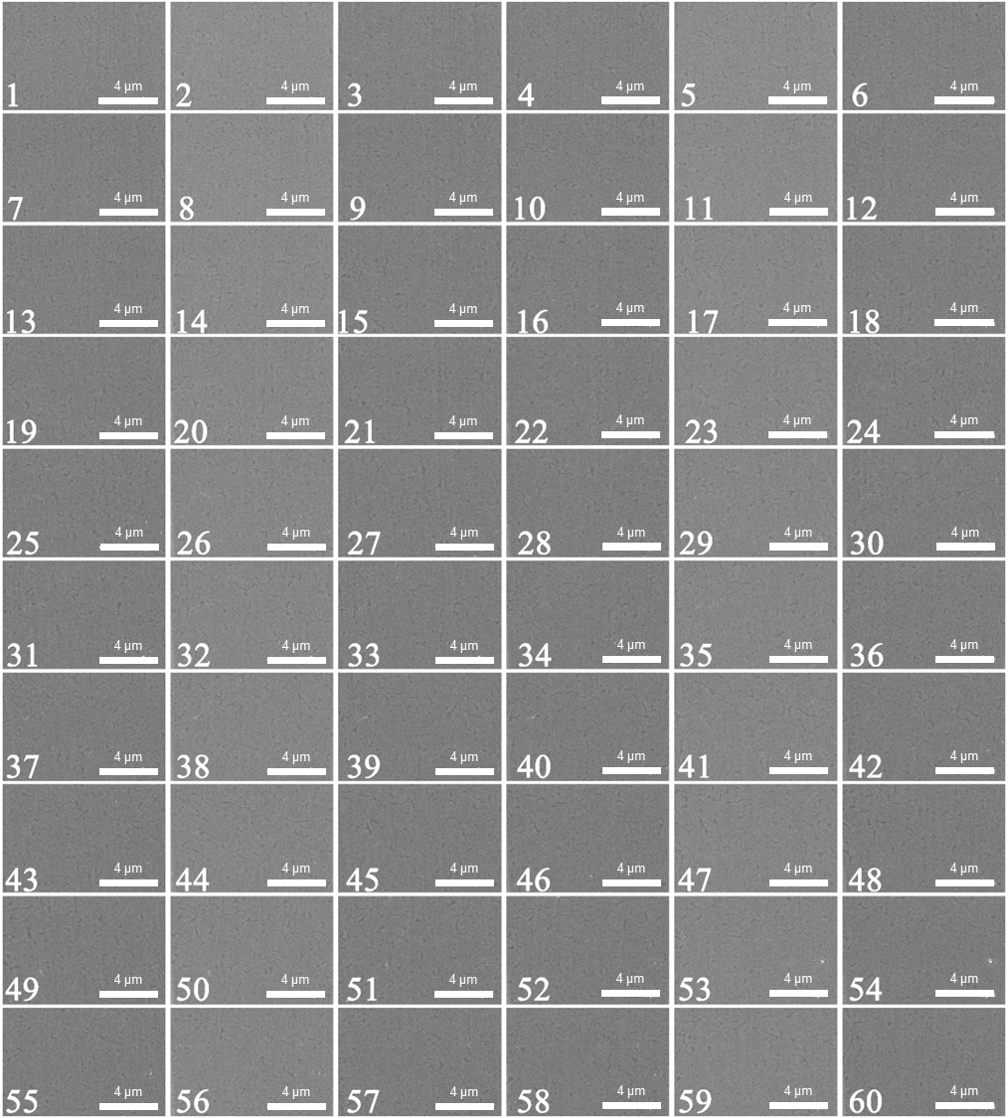
Supplementary Fig. 4 | The SEM image of continuous sixty composite slices (size: 10 µm × 6 µm × 20 nm), obtained by focused ion beam (FIB) technology. The SEM images show uniform defect network structure (dark regions) around diamond grains on the 2D planes, preliminarily demonstrating the formation of 3D MWCNTs network structure around diamond grains.

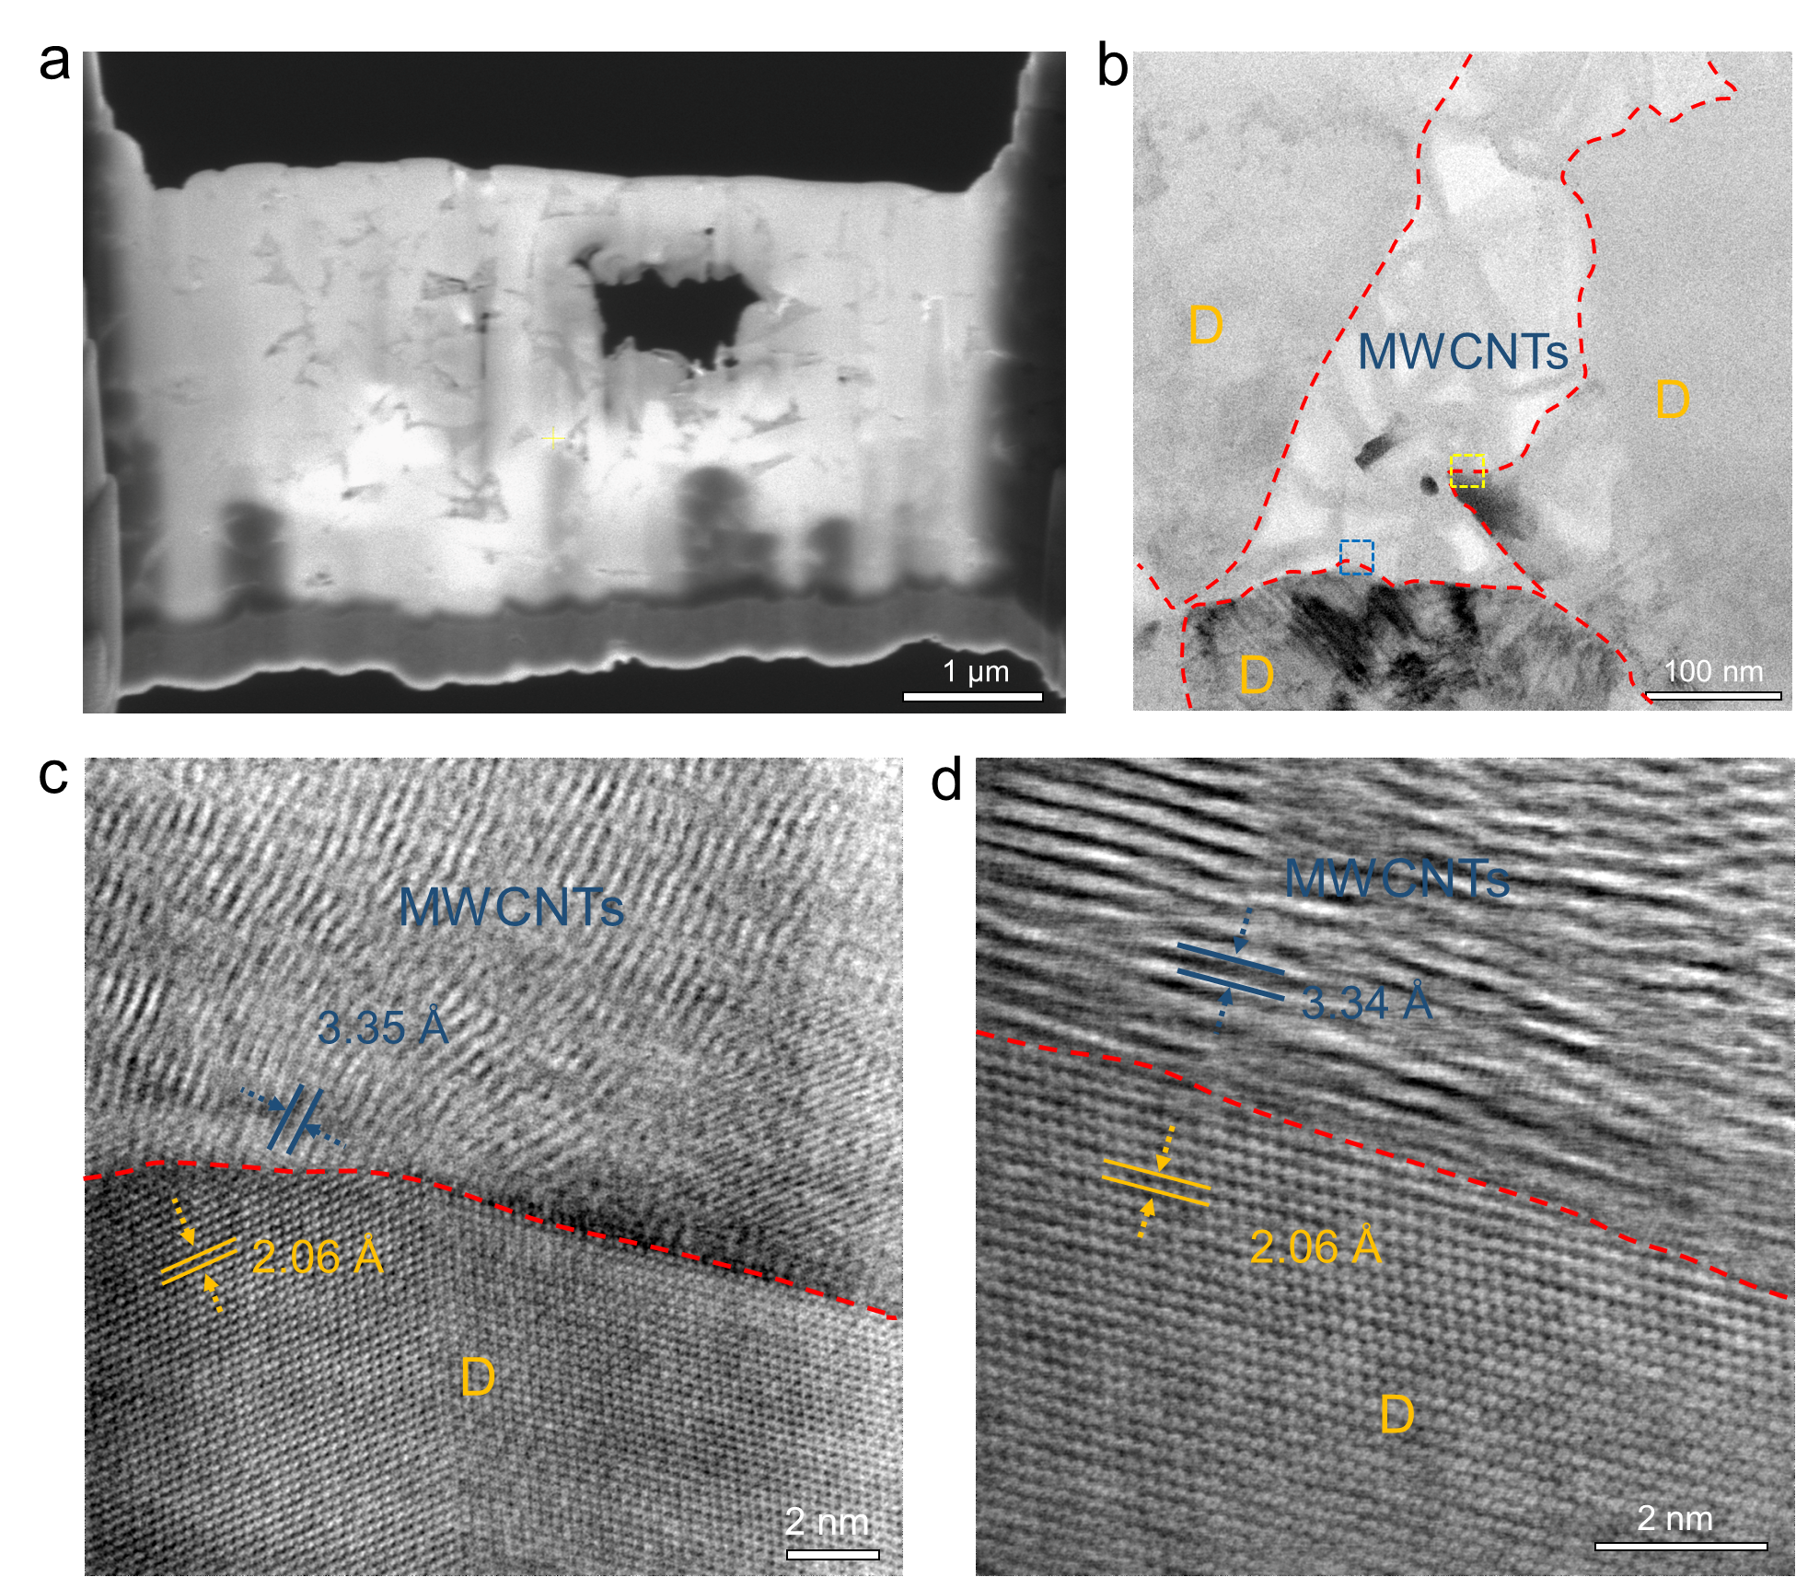
Supplementary Fig. 5 | Microstructure characterization of 3D-MWCNTs-diamond composite prepared at 15 GPa and 2000 °C, revealed by STEM. a, A low-magnified STEM image of a thin foil taken out to prepare STEM sample. The foil is translucent and the gap of diamond grains can be vaguely observed. b, A low-magnified ABF-STEM image of the thin foil, showing that MWCNTs are filled in the gaps between diamond grains, forming a 3D continuous MWCNTs network in the polycrystal diamond matrix. c,d, High-magnified ABF-STEM images of heterogenous MWCNTs/diamond interfaces, corresponding to the yellow box (c) and blue box (d) in (b), respectively.

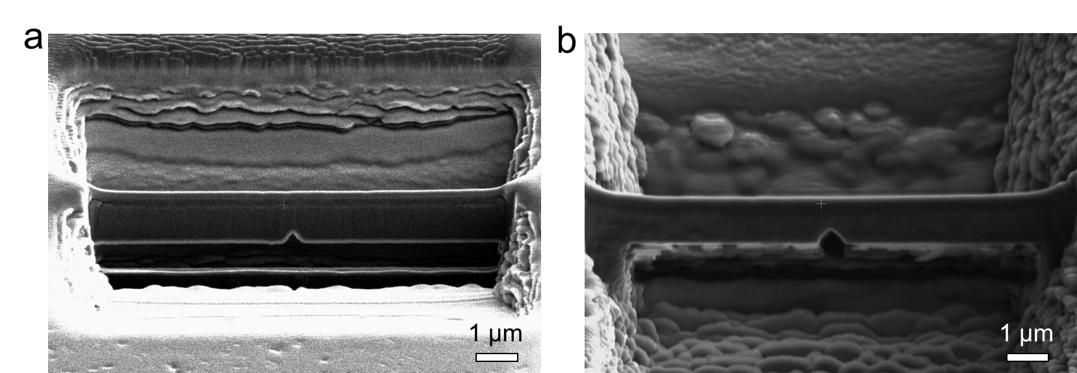
Supplementary Fig. 6 | SEM images of the micrometre-sized beams with different pre-existing cracks in 3D-MWCNTs-diamond for SENB testing.

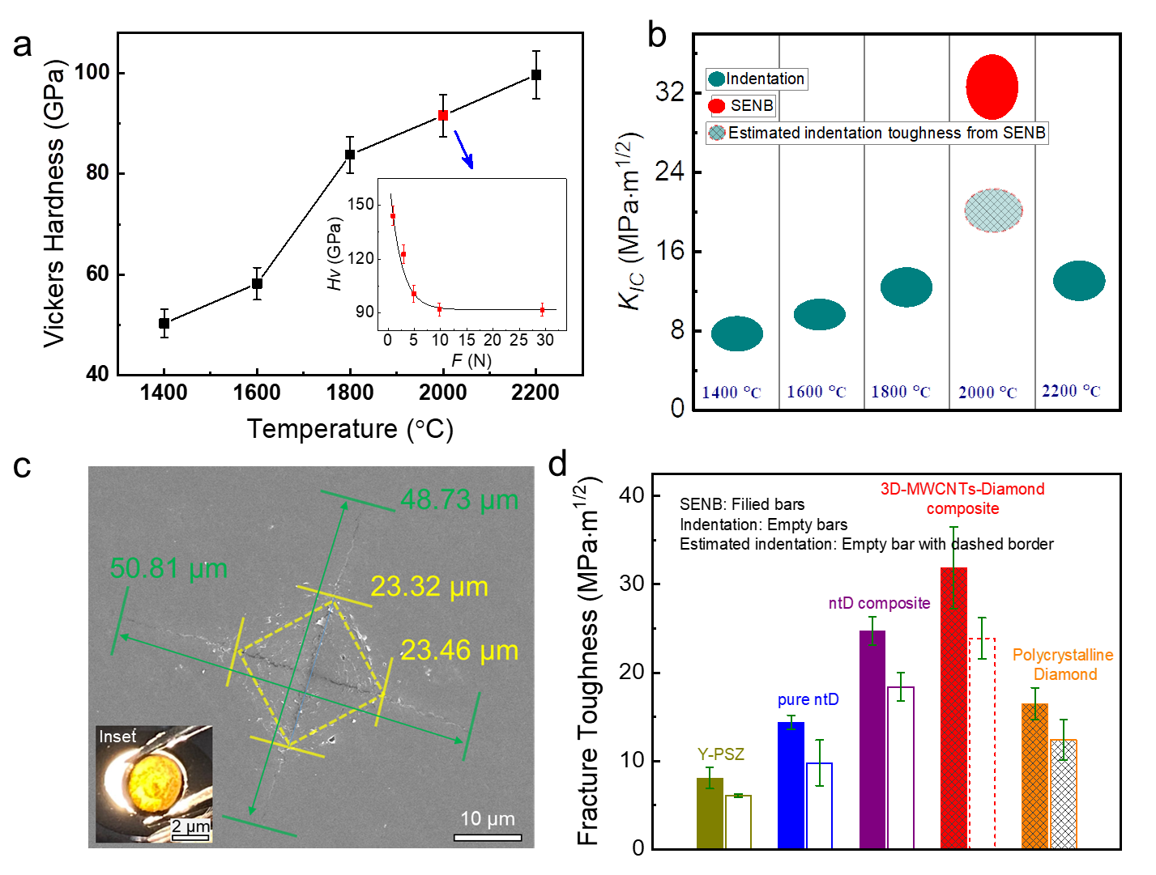
Supplementary Fig. 7 | Vickers hardness and fracture toughness of 3D-MWCNTs-diamond composites, in comparison with other materials. a, Vickers hardness of the composites sintered at different temperatures (1400 °C~2200 °C) under 15 GPa. Inset in a: Vickers hardness of the composites (15 GPa, 2000 °C) as a function of the applied load. Beyond 9.8 N, Vickers hardness decreases to the asymptotic values of ~90 GPa. b, Fracture toughness of the composites sintered at different temperatures under 15 GPa. The fracture toughness in b is cyan from the indentation test and red from the SENB test. c, The typical post-indentation SEM micrograph of the composite surface prepared at 15 GPa and 2200 °C, subjected to a 29.4 N load by a Vicker indentation test, showing visible indentation cracks. Inset: photograph of the composite, transparent under the bottom light source. d, Comparison of fracture toughness values from SENB and indentation measurements for commercial yttria partially stabilized zirconia (Y-PSZ, Beilong Electronics, China), pure nanotwinning diamond (pure ntD), ntD composite, polycrystalline diamond, and 3D-MWCNTs-diamond composite. SENB, filled bars; indentation: empty bars; Estimated indentation: empty bars with dashed border. The loads for indentation fracture toughness measurement were 49 N for Y-PSZ, and 19.6 N for pure nt-diamond and nt-diamond composite (References). Error bars indicate 1 s.d. (n = 5 for Y-PSZ and nt-diamond composite, n = 3 and 5 for indentation and SENB measurements of pure nt-diamond, respectively). ntD, nt-diamond, polycrystalline diamond, and 3D-MWCNTs-diamond composite.
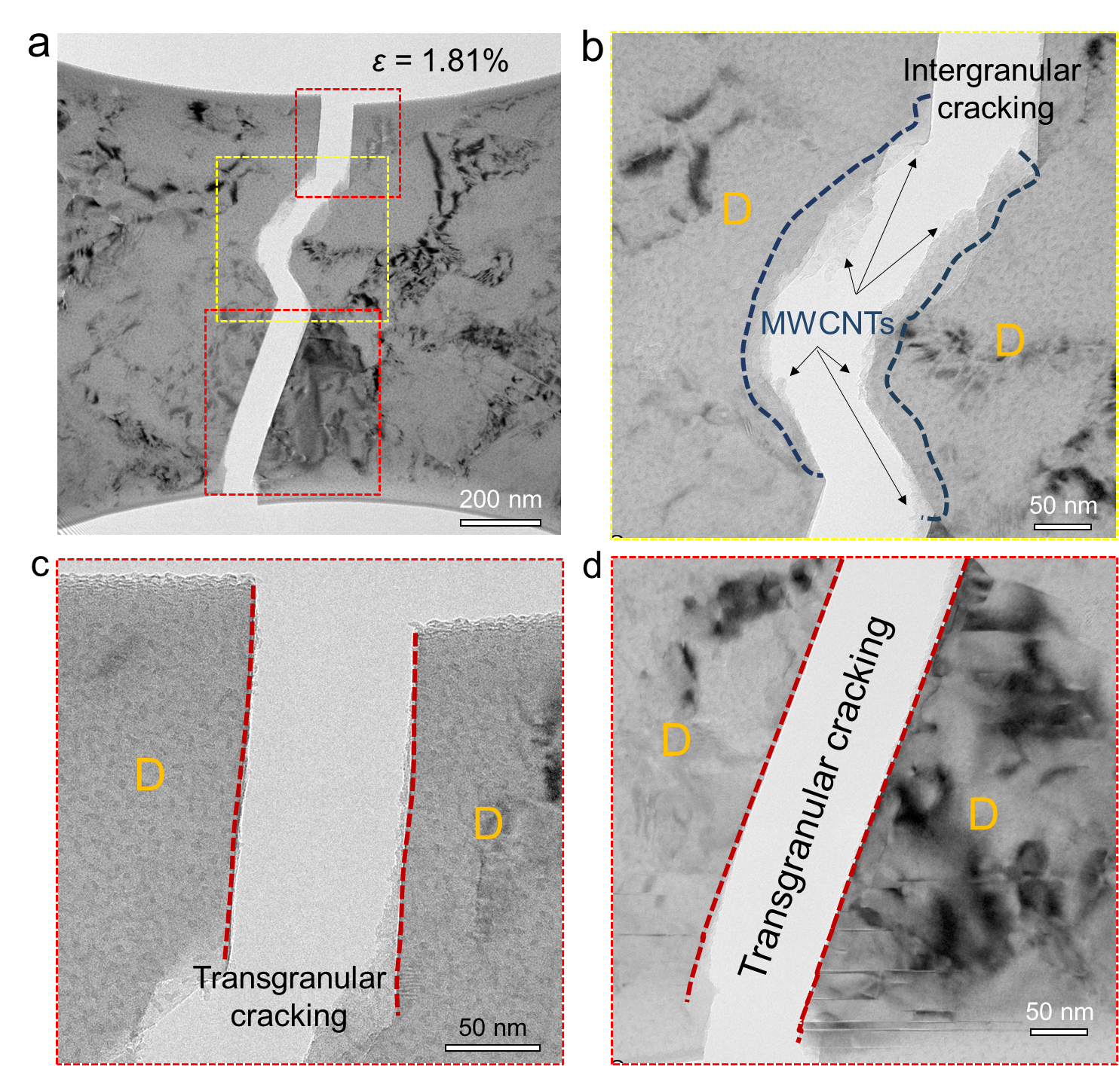
Supplementary Fig. 8 | The fracture behavior of a specially designed (bone-like) 3D-MWCNTs-diamond composite sample, by an in situ tensile test in the TEM. a, TEM image of fractured 3D-MWCNTs-diamond composite slice, corresponding to the TEM image of Fig. 4a (ε = 1.81%) in the main manuscript. b, Enlarged TEM image of fractured 3D-MWCNTs-diamond composite in intergranular cracking region, taken from the yellow dashed frame in a. c,d, Enlarged TEM images of fractured 3D-MWCNTs-diamond composite in transgranular cracking region, taken from the red dashed frames in a.

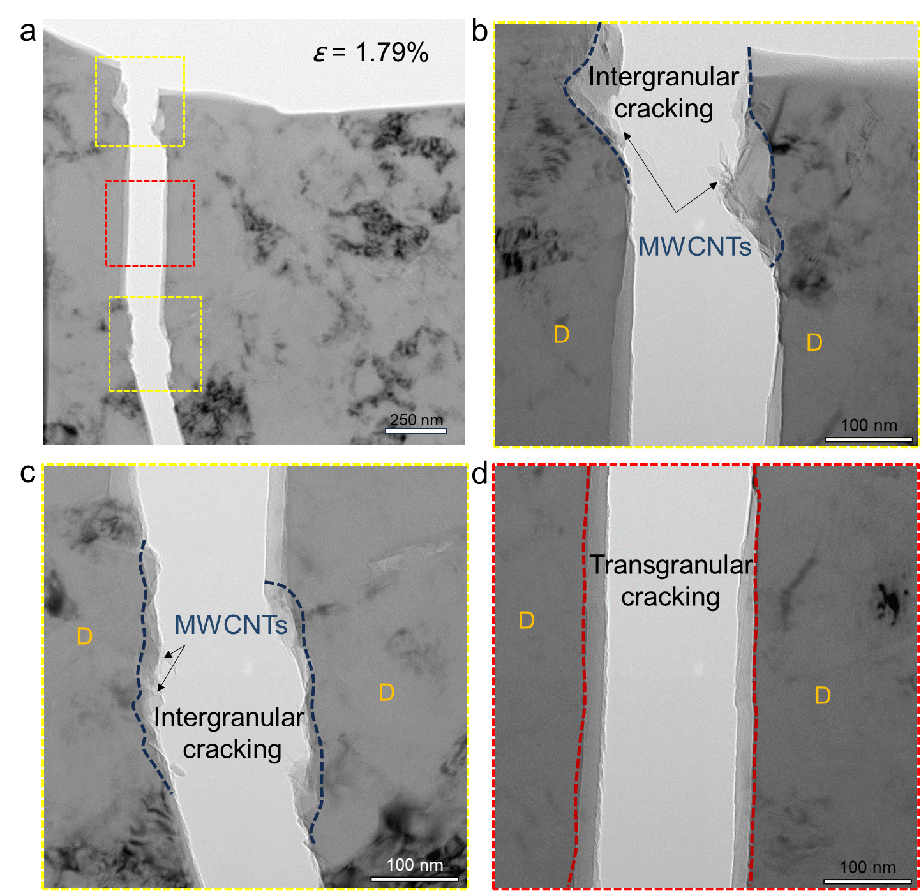
Supplementary Fig. 9 | The fracture behavior of a specially designed (I-shaped) 3D-MWCNTs-diamond composite sample, by an in situ tensile test in the TEM. a, TEM image of fractured 3D-MWCNTs-diamond composite slice, at the strain of ε = 1.79%. b,c, Enlarged TEM images of fractured 3D-MWCNTs-diamond composite in intergranular cracking region, taken from the yellow dashed frames in a. d, Enlarged TEM image of fractured 3D-MWCNTs-diamond composite in transgranular cracking region, taken from the red dashed frame in a.

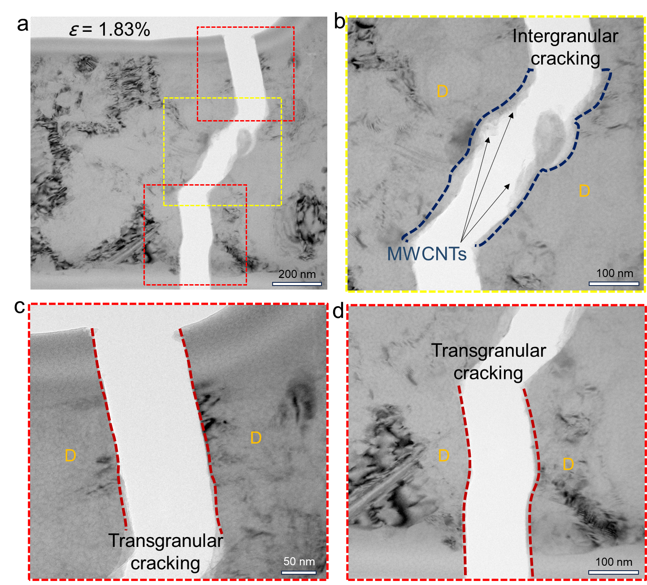
Supplementary Fig. 10 | The fracture behavior of a specially designed (I-shaped) 3D-MWCNTs-diamond composite sample, by an in situ tensile test in the TEM. a, TEM image of fractured 3D-MWCNTs-diamond composite slice, at the strain of ε = 1.83%. b, Enlarged TEM image of fractured 3D-MWCNTs-diamond composite in intergranular cracking region, taken from the yellow dashed frame in a. c,d, Enlarged TEM images of fractured 3D-MWCNTs-diamond composite in transgranular cracking region, taken from the red dashed frames in a.

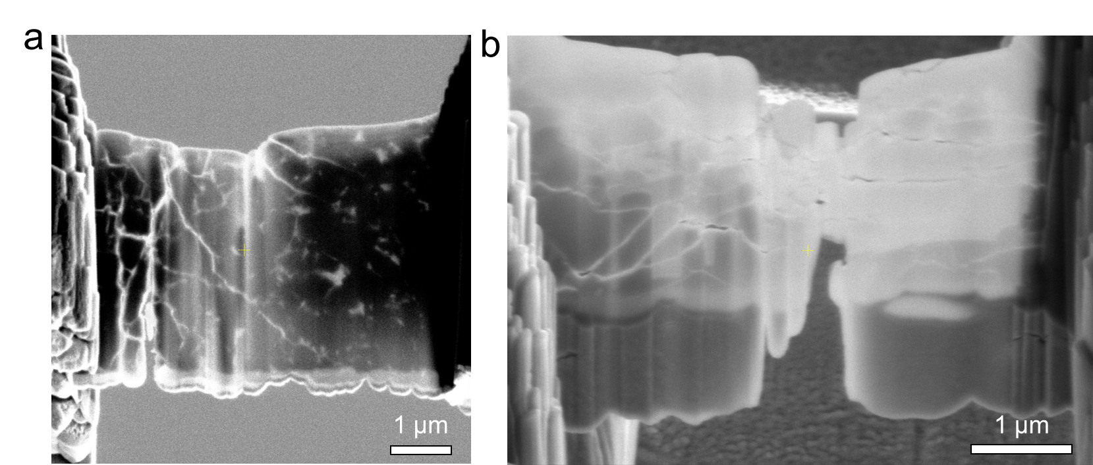
Supplementary Fig. 11 | Morphology characterization of 3D-MWCNTs-diamond samples for micromechanical tests, obtained by a focused ion beam (FIB) technology. a,b SEM images of thin composite slices with cracks under different forces, measured by Vickers indentation.

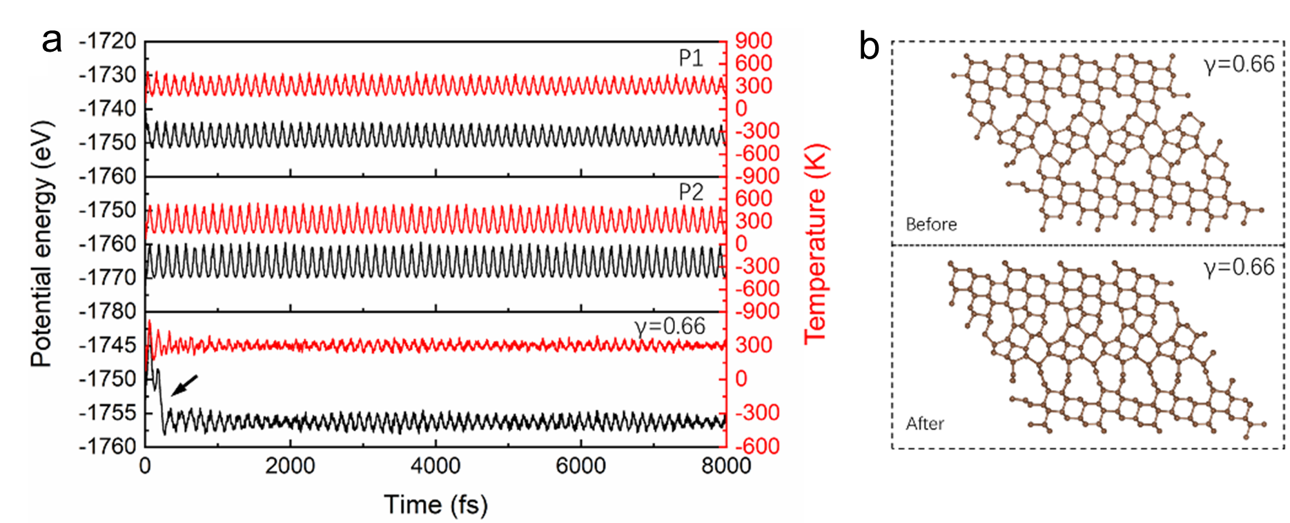
Supplementary Fig. 12 | The Ab initio molecular dynamics (AIMD) simulation results of several carbon polymorphs. a, The variation of total potential energy and temperature fluctuation for the supercells of different polymorphs during AIMD simulation of the Canonical ensemble (NVT) at 300 K. b, The deformed structures at the strain of 0.66 before and after the AIMD simulation. Different from the structural stability of P1 and P2 phases, for structure at strain of 0.66, there is a noticeable drop in energy (see black arrow) and a significant structural change before and after the relaxation, suggesting the instability of this phase-transitioned structure and thus the final failure of the composite during the deformation.

Supplementary Table 1. Fracture toughness of 3D-MWCNTs-diamond composite samples (synthesized at 15 GPa and 2000 °C) from SENB tests.
Sample No. | Fracture toughness (MPa•m^{1/2})
Sample No. | measured value | average value | median value
1 | 27.3 | 31.9 ± 4.6 | 33.8
2 | 26.7 | 31.9 ± 4.6 | 33.8
3 | 36.4 | 31.9 ± 4.6 | 33.8
4 | 35.5 | 31.9 ± 4.6 | 33.8
5 | 33.8 | 31.9 ± 4.6 | 33.8

Supplementary Movie 1.
Multi-cycle bending test on 3D-MWCNTs-diamond (shown in Fig. 2b-f). Video speed at 8 times the speed of experiment.

Supplementary Movie 2.
in-situ tensile fracture test on 3D-MWCNTs-diamond. Video speed at 100 times the speed of experiment.

