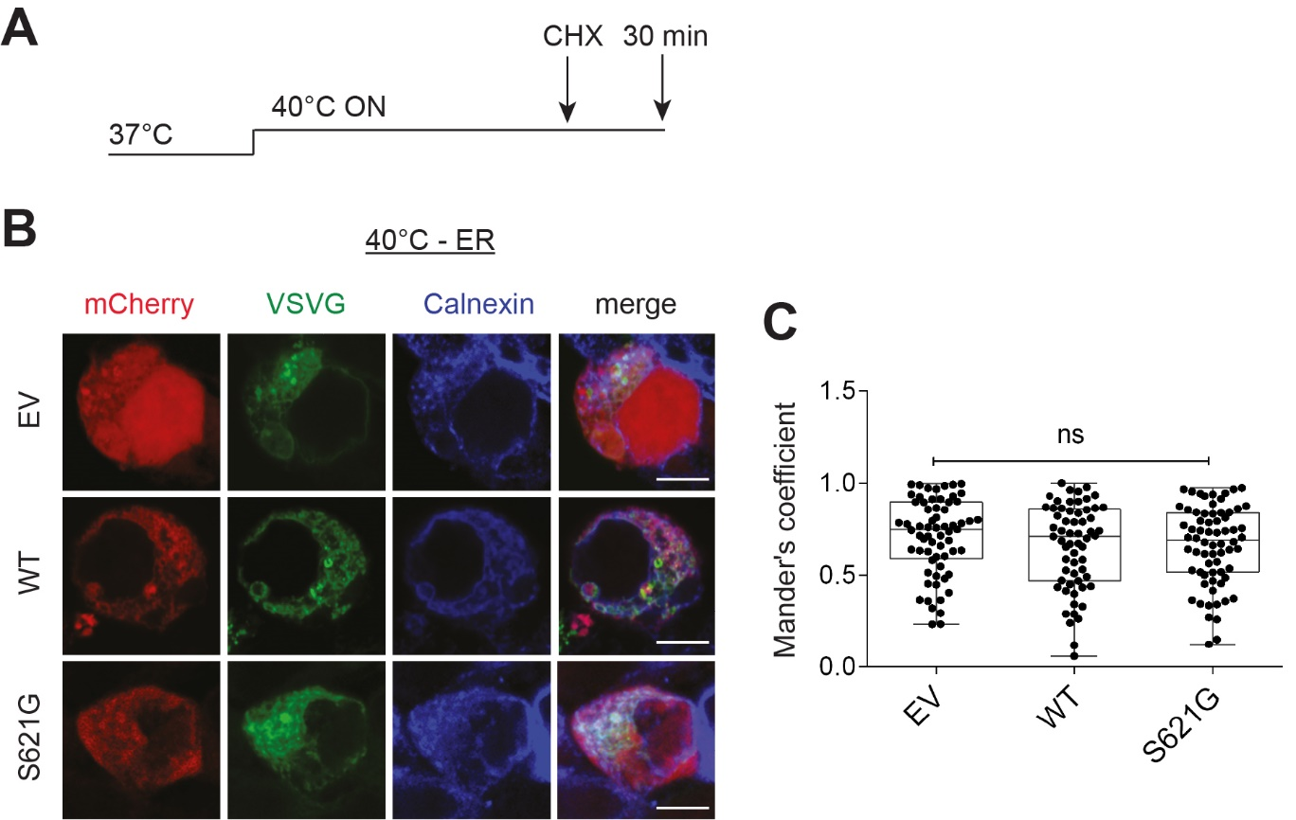
Supplementary Figure 1 Control experiments illustrating that VSVG^{ts045} is retained in the ER at 40°C
(A) Experimental designed for control cells: cells expressing VSVG^{ts045} for 24h were incubated at 40°C overnight to misfold VSVG^{ts045}. Cells are then fixed without incubating the cells at the permissive temperature (32°C) to refold VSVG^{ts045}.
(B) Immunocytochemistry of Calnexin in undifferentiated SH-SY5Y cells co-expressing GFP-tagged VSVG^{ts045} (VSVG) and mCherry-tagged empty vector (EV), wild-type (WT) or cyclin F^{S621G}, after incubation at 40°C. Scale bar = 10 µm.
(C) The degree of co-localisation of VSVG^{ts045} with Calnexin was quantified using Mander’s coefficient.
The graph represents median (centre lines) and plot whiskers down to the minimum and up to the maximum value. Circles represent for EV: n=65, WT: n=61, cyclin F^{S621G}: n=68 cells; ns, non-significant, one-way ANOVA.

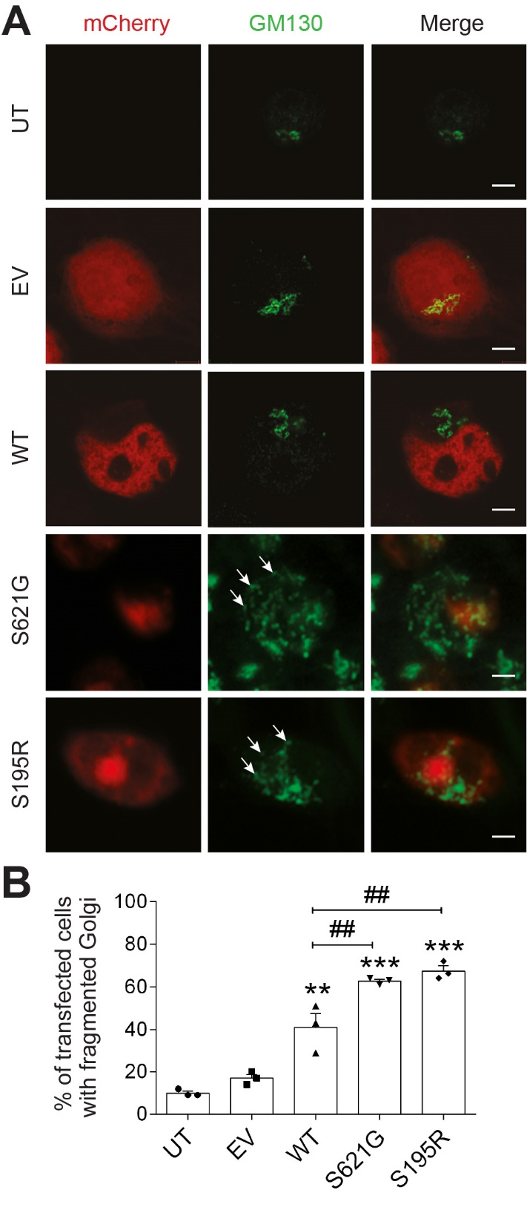
Supplementary Figure 2 ALS/FTD mutant cyclin F induces Golgi fragmentation in HEK293T cells
(A) Fluorescent confocal microscopy images of EV or cyclin F, following immunocytochemistry for GM130 and Hoechst staining, of HEK293T cells expressing EV or cyclin F. Arrows: Golgi fragments. Scale bar = 10 µm
(B) The proportion of cells with fragmented Golgi in A was quantified.
The graph represents mean ± SEM, n = 50+ cells per group were analysed from 3 independent experiments, one-way ANOVA followed by a post-hoc Tukey test for multiple comparisons, **p<0.01 and ***p<0.001 vs UT and EV; ##p<0.01 vs cells expressing WT.

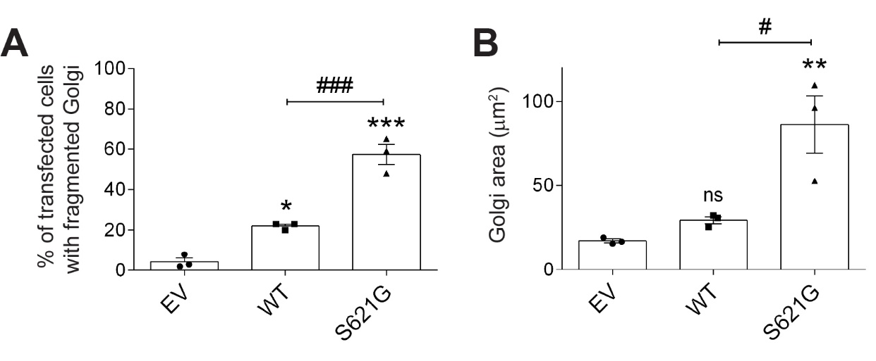
Supplementary Figure 3 ALS/FTD mutant cyclin F induces Golgi fragmentation in HEK293T cells co-expressing cyclin F and VSVG and incubated at 40ºC overnight (see Figure 1)
(A) The proportion of cells with fragmented Golgi in Figure 1 was quantified.
(B) The area covered by Golgi fragments was measured in each cell.
The graph represents mean ± SEM, n = 30+ cells per group were analysed from 3 independent experiments, one-way ANOVA followed by a post-hoc Tukey test for multiple comparisons, ns, non-significant, **p<0.01 and ***p<0.001 vs UT and EV; #p<0.05, ###p<0.001 vs cells expressing WT.

