Supporting Information for
Taming crystallization to achieve superior soft magnetic performance via ultrafine nanocrystallines

R.C. Sun^{1,#}, X.S. Li^{1,#}, J. Zhou^{1,*}, Y.Q. Yan¹, S.Y. Di², J.H. Luan², H.L. Peng^{3,*}, B.A. Sun^{1,4}, H.B. Ke^{1,*}, W.H. Wang^{1,4}, H.Y. Bai^{1,4,*}
¹Songshan Lake Materials Laboratory, Dongguan 523808, China
²Department of Materials Science Engineering, College of Science and Engineering, City University of Hong Kong, Hong Kong 999077, China
³School of Materials Science and Engineering, State Key Laboratory of Powder Metallurgy, Central South University, Changsha 410083, China
⁴Institute of Physics, Chinese Academy of Sciences, Beijing 100190, China

#These authors contributed equally to this work.

*Corresponding authors: Haiyang Bai (hybai@iphy.ac.cn); Jing Zhou (zhoujing@sslab.org.cn); Hailong Peng (hailong.peng@csu.edu.cn); Haibo Ke (kehaibo@sslab.org.cn)

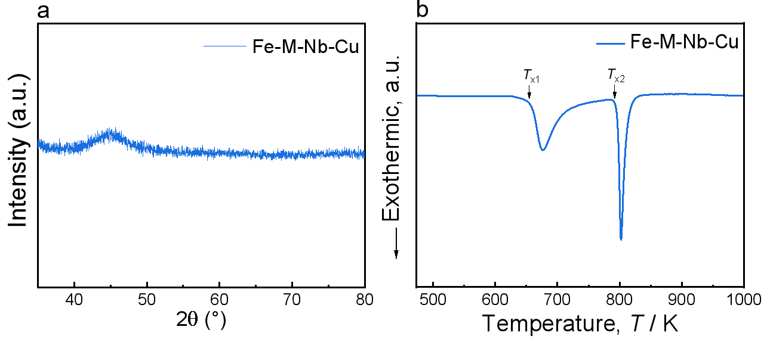
Fig. S1 (a) XRD pattern of as-quenched Fe_{78.65}Co₄Si₂B₁₃Cu_{1.35}Nb₁ amorphous alloy ribbon. (b) DSC curve of as-quenched Fe_{78.65}Co₄Si₂B₁₃Cu_{1.35}Nb₁ amorphous alloy ribbon under a heating rate of 20 K min⁻¹

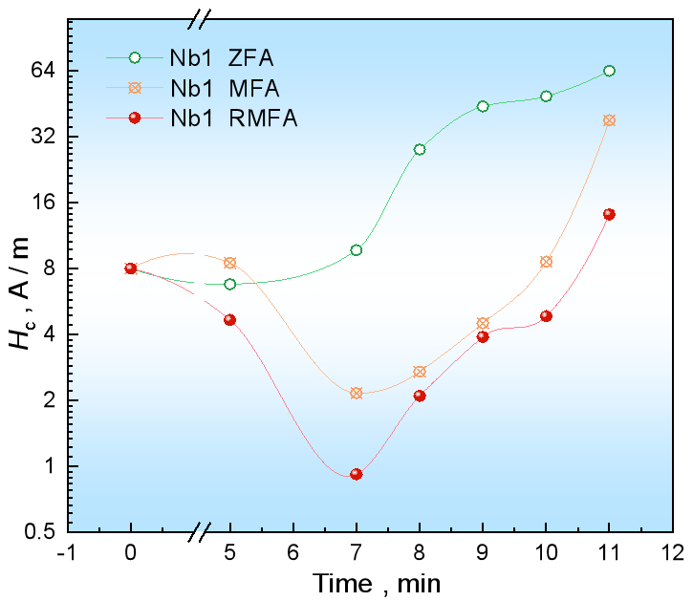
Fig. S2 The trend of H_{c} variation with annealing time under ZFA, MFA, and RFA processes of Fe_{78.65}Co₄Si₂B₁₃Cu_{1.35}Nb₁ nanocrystalline alloy.

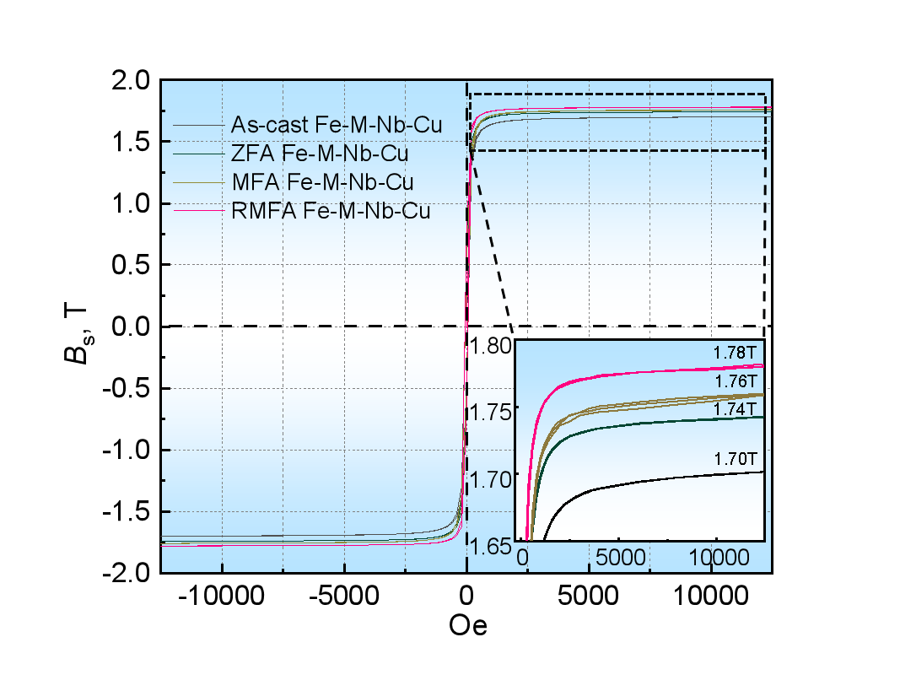
Fig. S3 The hysteresis loops of Fe_{78.65}Co₄Si₂B₁₃Cu_{1.35}Nb₁ nanocrystalline alloy of the as-cast state and after optimal ZFA, MFA, and RFA processes, respectively. The lower-right illustration is an enlarged view of the area of the rectangular box of the hysteresis loops.

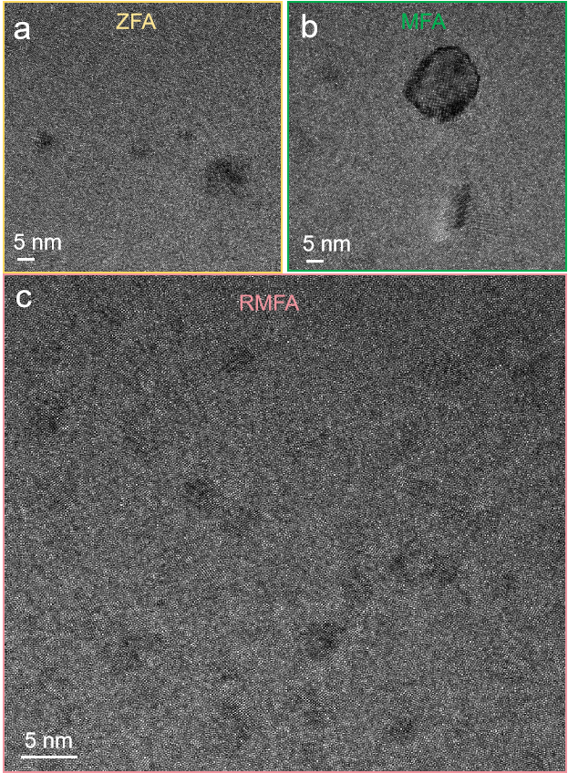
Fig. S4 Bright-field TEM images with high magnification of Fe_{78.65}Co₄Si₂B₁₃Cu_{1.35}Nb₁ nanocrystalline alloy after optimal ZFA (a), MFA (b), and RMFA (c) processes, respectively. These images are derived from the rectangular area in Figs. 2b, 2c and 2d, respectively.
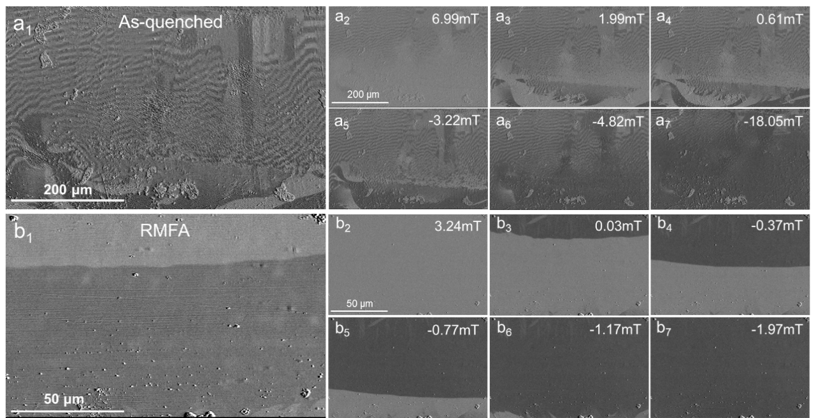
Fig. S5 Magnetic domains in the demagnetized state for the as-quenched (a1) and RMFA (b1) samples. Evolution of domain structure with different magnitudes of external magnetic fields of the as-quenched (a2-a7) and RMFA (b2-b7) samples.

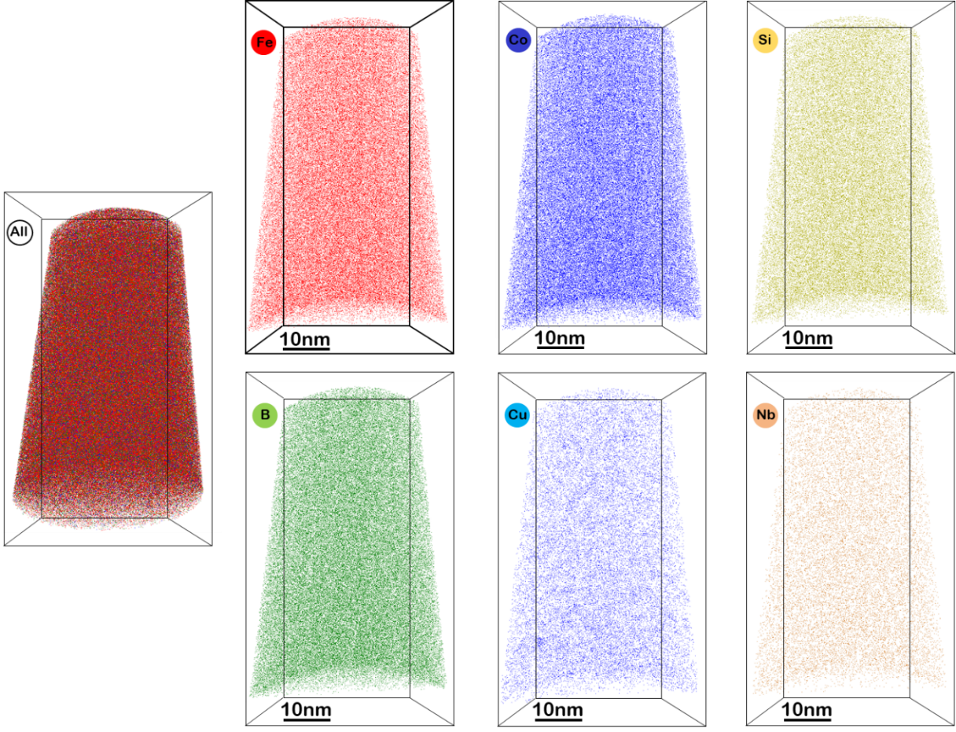
Fig. S6 The atom map for corresponding Fe, Co, Si, B, Cu, Nb element distributions of the RMFA Fe_{78.65}Co₄Si₂B₁₃Cu_{1.35}Nb₁ sample.

