Graphical abstract
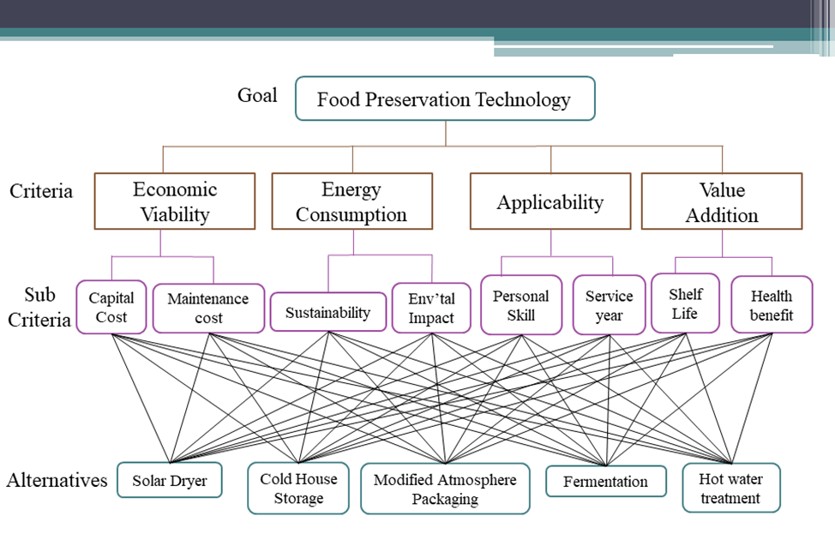
Figure 1 Hierarchical model of decision making process for selecting food preservation technique for tomato

