Extended tables and Figures
Source | Records
Web of Science | 411,194
Scopus | 476,778
Total unique records | 610,098
Extended Table 1: Records retrieved from Web of Science and Scopus

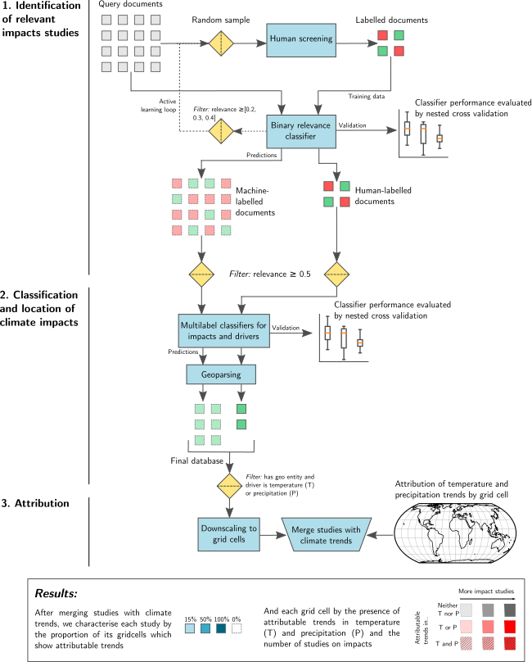
Extended Fig 1| A visual representation of the workflow of our machine learning assisted attribution map.

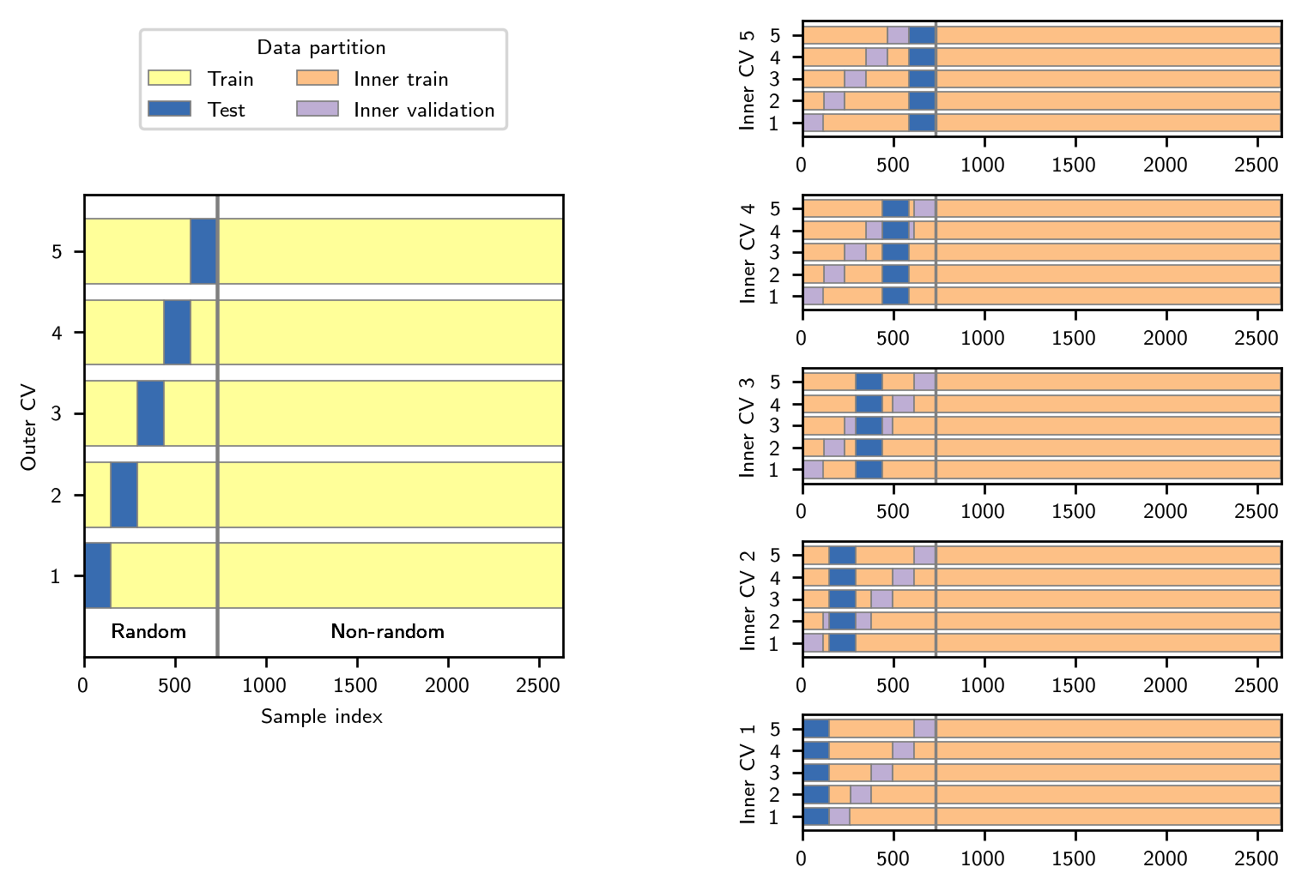
Extended Fig 2| Nested cross validation (CV) procedure for the binary relevance classifier. Models are fit using training documents and evaluated on validation/test documents. The inner CV loop is used to search for optimal hyperparameter settings, which are then evaluated on the outer test sets.
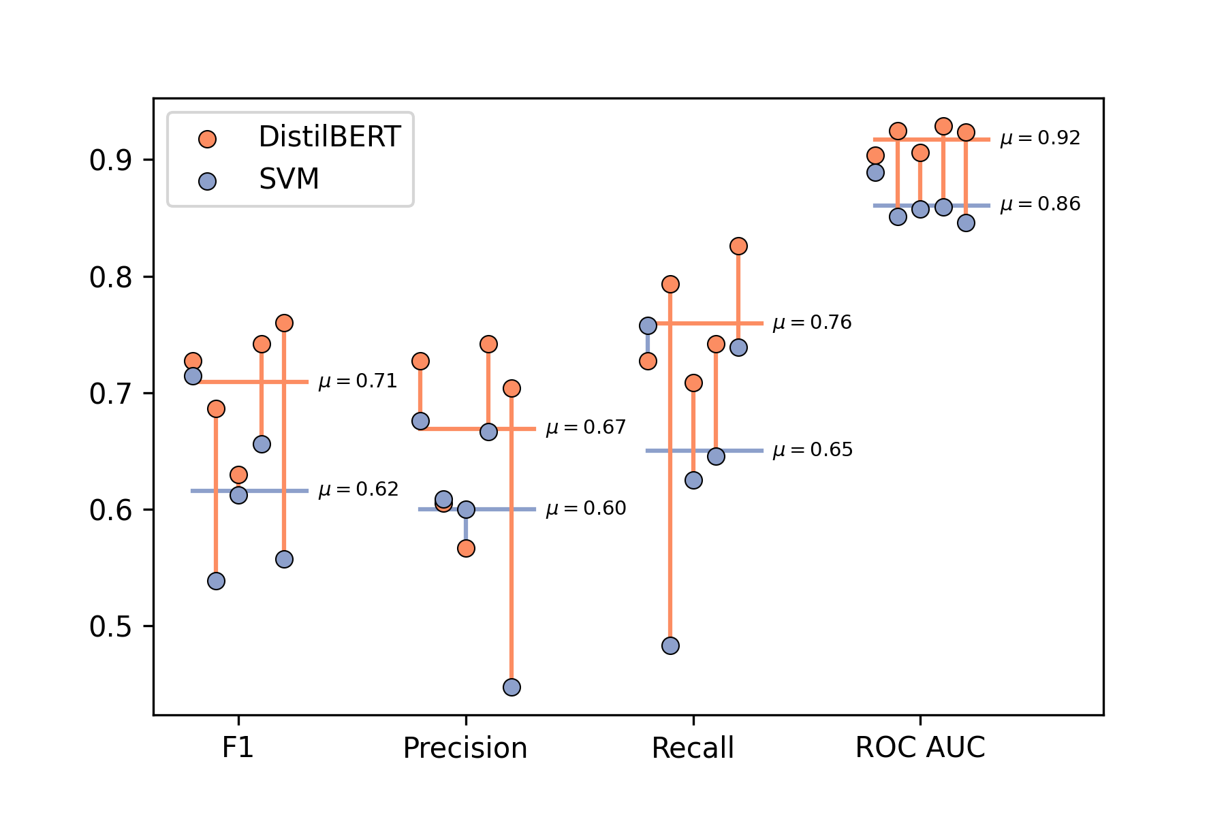
Extended Fig. 3| Performance metrics for the binary inclusion/exclusion classifier. Each pair of dots represents the scores for a distinct cross-validation fold. Horizontal lines show the mean score across folds.

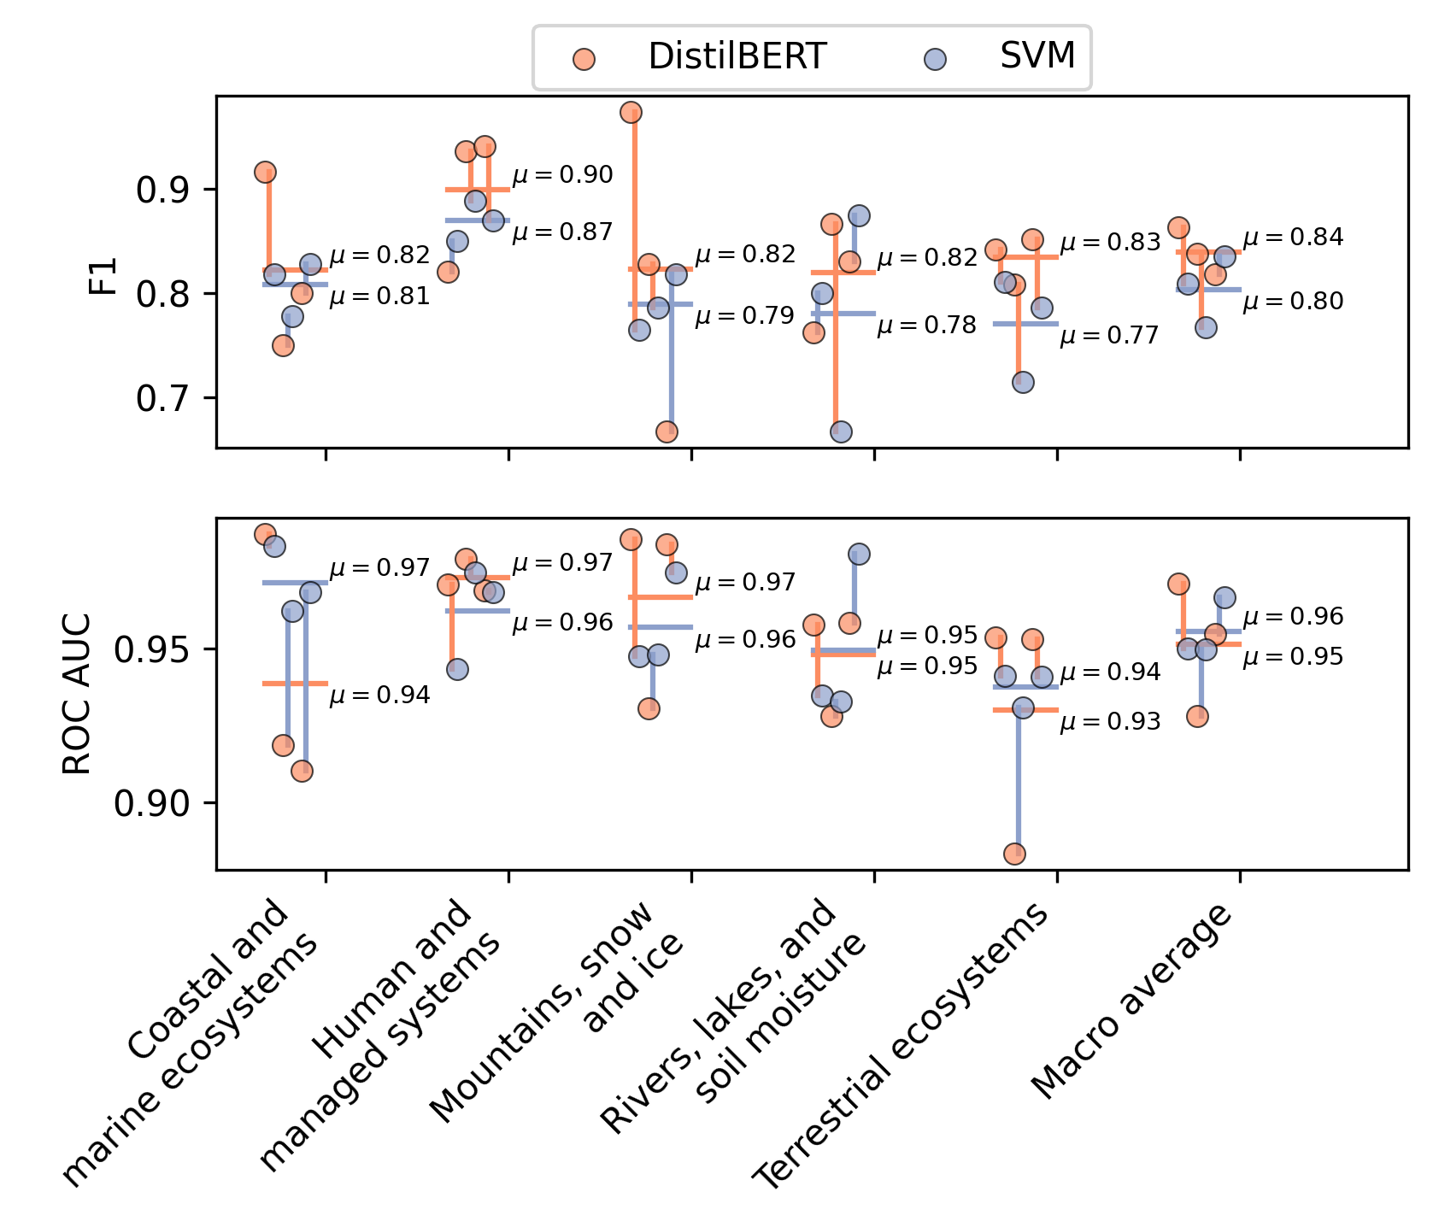
Extended Figure 4| Receiver operating curve area under the curve scores (ROC AUC) and F1 scores for the classification of impact categories. Each pair of dots represents the scores for a distinct cross-validation fold. Horizontal lines show the mean score across folds.

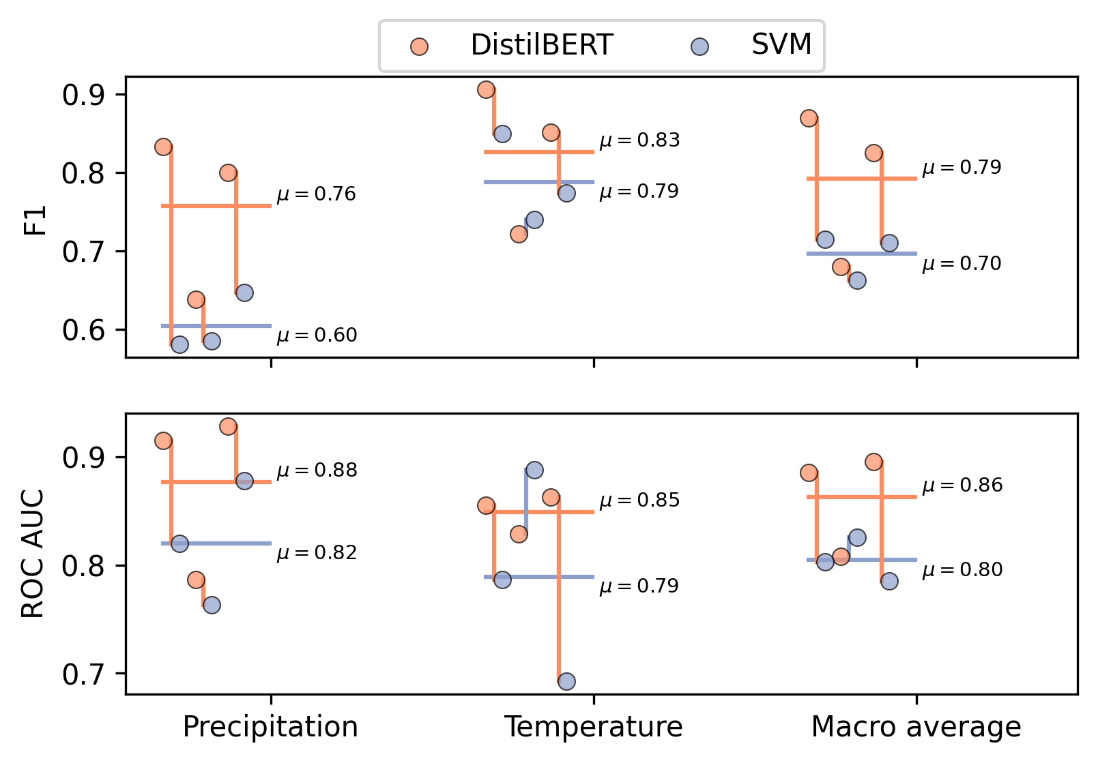

Extended Fig. 5| Receiver operating curves area under the curve scores (ROC AUC)(ROC) and F1 scores for the classification of drivers. Each pair of dots represents the scores for a distinct cross-validation fold. Horizontal lines show the mean score across folds.
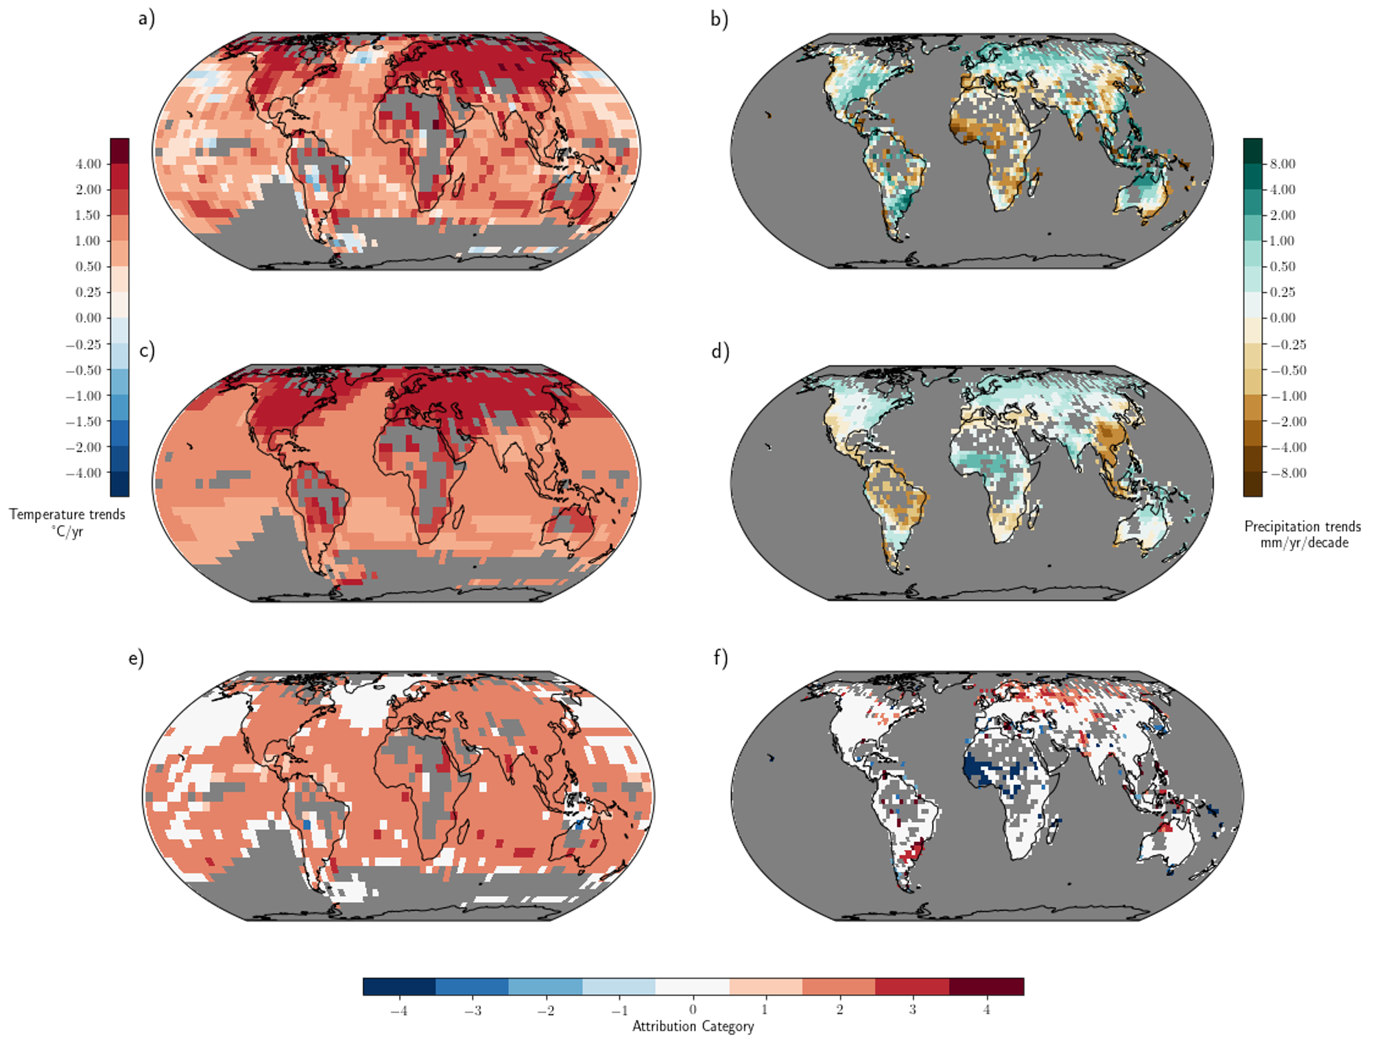

Extended Fig. 6: Geographical distribution of surface trends. Temperature from 1951 to 2018 (left) and precipitation trends from 1951 to 2016 (right) in (a),(b) observations and (c),(d) CMIP6 10-model ensemble mean all-forcing runs. Bottom panels (e),(f) show observations categorised into attribution categories, following ref. 8 and 7, respectively. Observed cooling/warming or drying/wetting trends that--after accounting for internal climate variability-- are inconsistent with the simulated response to natural forcings but consistent with the simulated response to both natural and anthropogenic forcings are indicated by categories -/+2. This is clearest case of changes that are at least partially attributable to anthropogenic forcing, according to the CMIP6 ensemble. Categories -/+1 have detectable observed changes, but are not assessed as attributable to anthropogenic forcing because the observed changes are significantly less than those simulated in the average all-forcing runs. Categories -/+3 have detectable changes and are assessed as at least partly attributable anthropogenic forcing, although the observed changes are inconsistent with the all-forcing runs. That is, they are in the same direction as, but are significantly stronger than, the mean of the all-forcing runs. . Categories -/+4 represents cooling/warming or drying/wetting trends that are inconsistent with the simulated response to natural forcings but whose sign is opposite to that of the average simulated all-forcing response; category 0 represents trends that are not distinguishable from natural variability alone. Categories -/+4 and 0 are considered to be examples of non-detectable trends).

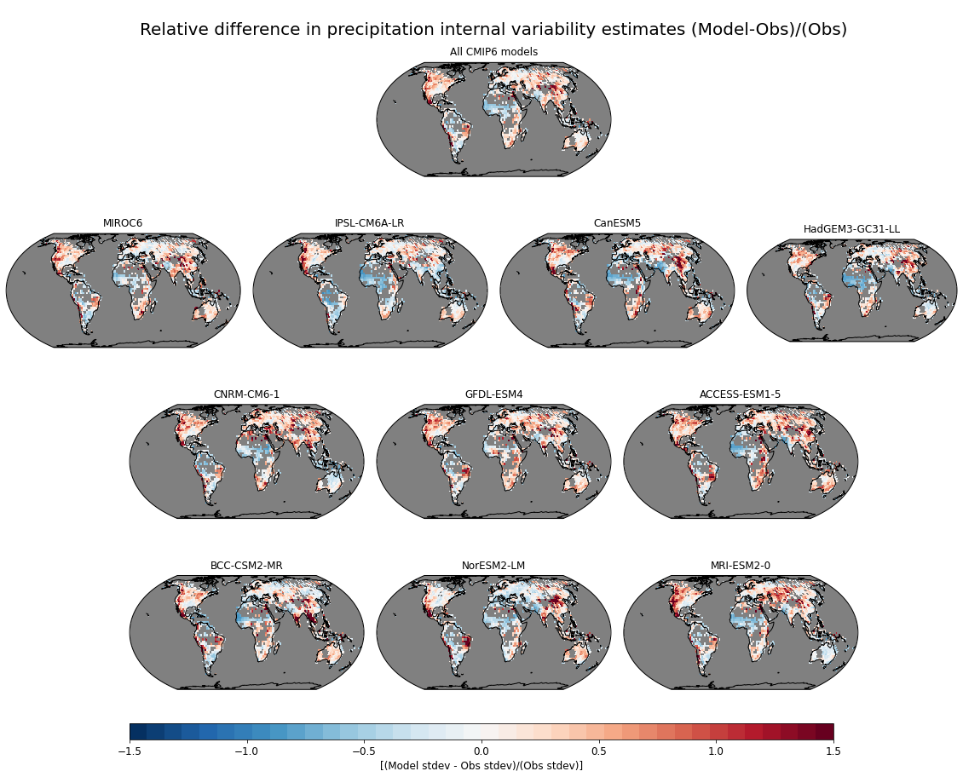
Extended Fig. 7: Fractional difference between average CMIP6 modeled low-frequency standard deviation of annual mean precipitation vs observed precipitation. To estimate the internal low-frequency variability for both models and observations, the observed timeseries were detrended and low-pass filtered with a 7-year running mean filter prior to computing the standard deviations while for the models we used the full available control runs (7-yr running mean filtered) to estimate the internal low-frequency variability for each model. The top panel shows the multi-model ensemble standard deviation comparison while the ten individual panels below it show the comparison for each individual CMIP6 model used in the study. The fraction difference was computed as: [(Model st. dev. - Observed st. dev.) / (Observed st. dev.)].

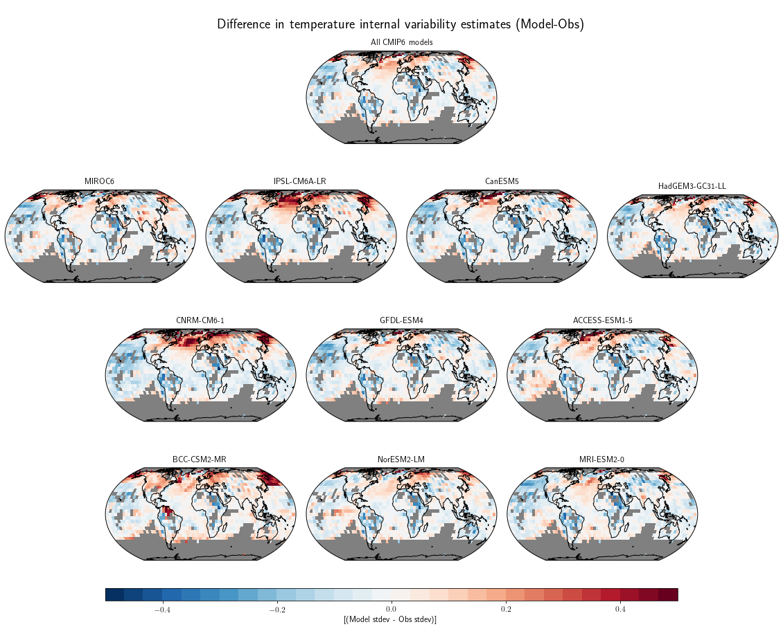
Extended Fig. 8| Difference between average CMIP6 modeled low-frequency standard deviation (ºC) of annual mean surface air temperature vs observed surface temperature. To estimate the internal low-frequency variability for both models and observations, the observed timeseries were detrended and low-pass filtered with a 7-year running mean filter prior to computing the standard deviations while for the models we used the full available control runs (7-year running mean filtered) to estimate the internal low-frequency variability for each model. The top panel shows the multi-model ensemble standard deviation comparison while the ten individual panels below it show the comparison for each individual CMIP6 model used in the study.

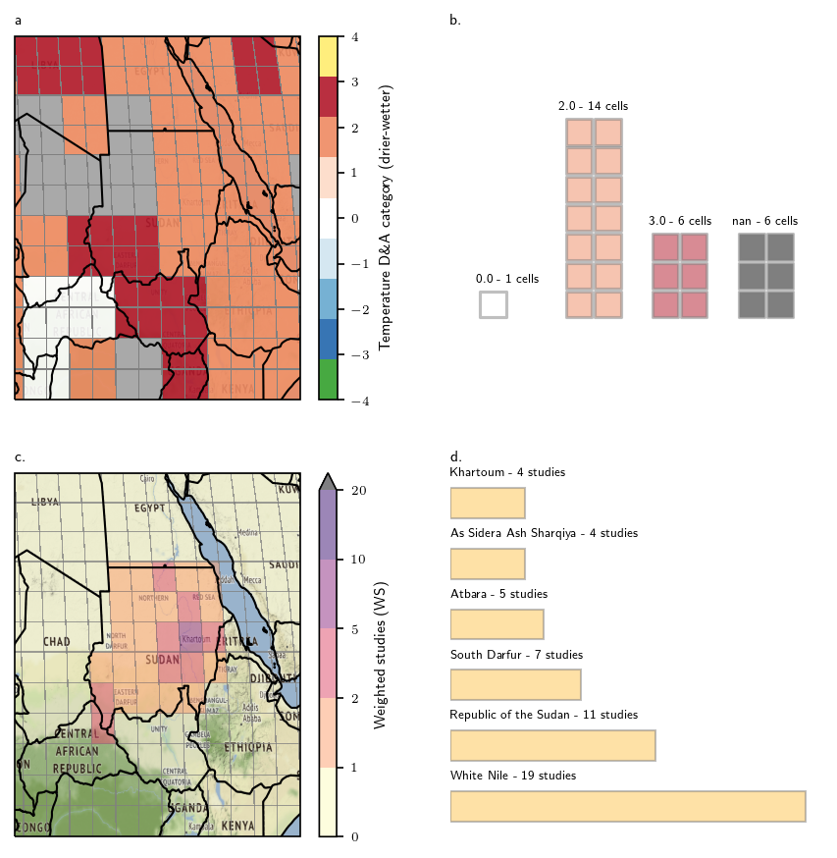
Extended Fig. 9| An illustration of the spatial resolution and weighting methodology. a. Detection and attribution categories for temperature in East Africa; b. the number of grid cells of each type in Sudan; c. weighted studies for each grid cell in Sudan; d. The number of studies referring to each extracted geographical location in Sudan.

