Extended tables and Figures
Source | Records
Web of Science | 411,194
Scopus | 476,778
Total unique records | 610,098
Extended Table 1: Records retrieved from Web of Science and Scopus

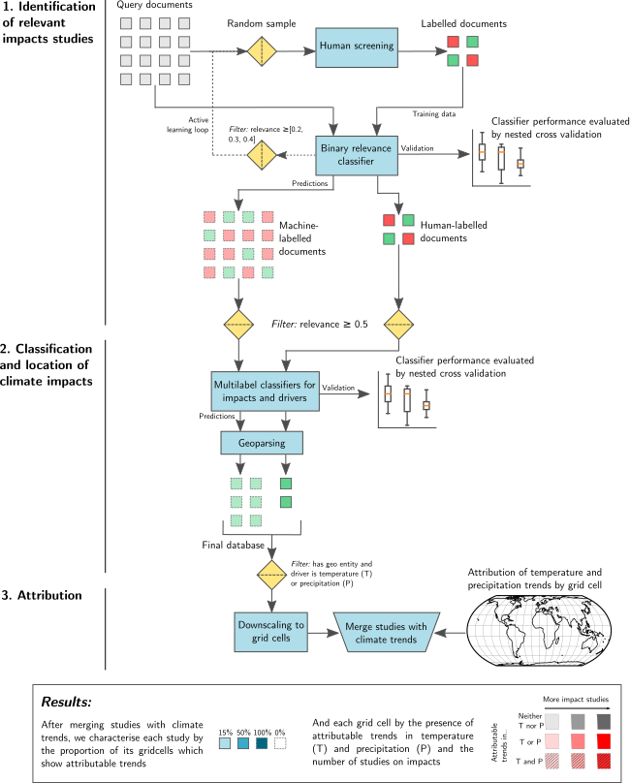
Extended Fig 1| A visual representation of the workflow of our machine learning assisted attribution map.

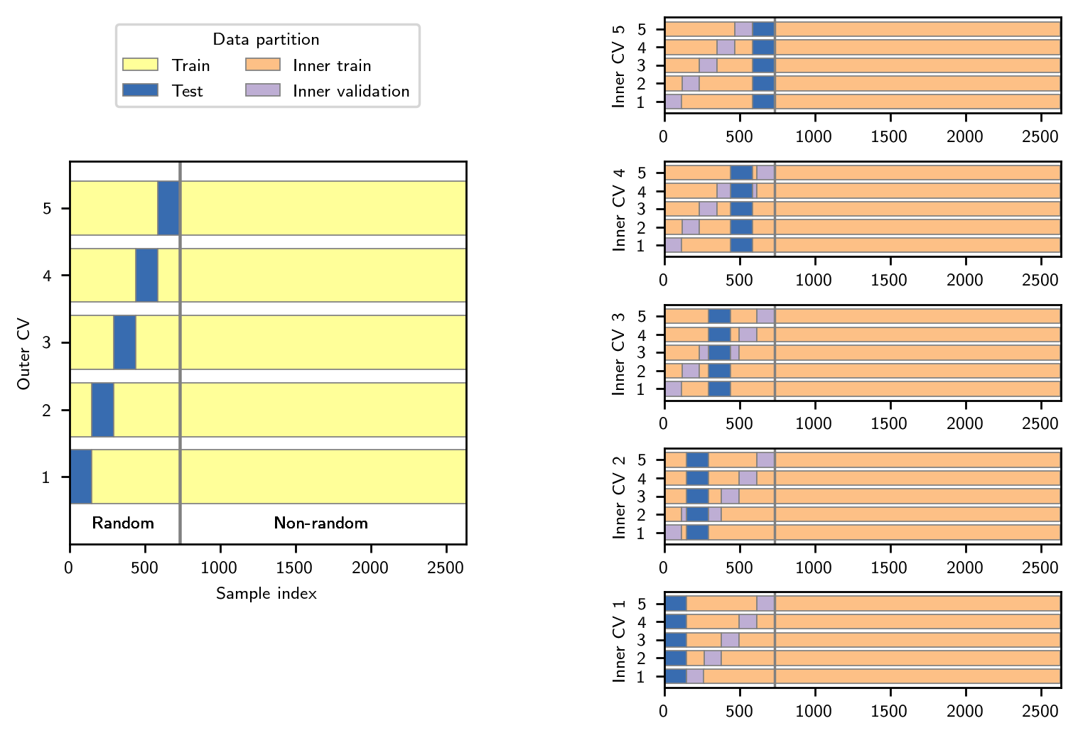
Extended Fig 2| Nested cross validation (CV) procedure for the binary relevance classifier. Models are fit using training documents and evaluated on validation/test documents. The inner CV loop is used to search for optimal hyperparameter settings, which are then evaluated on the outer test sets.
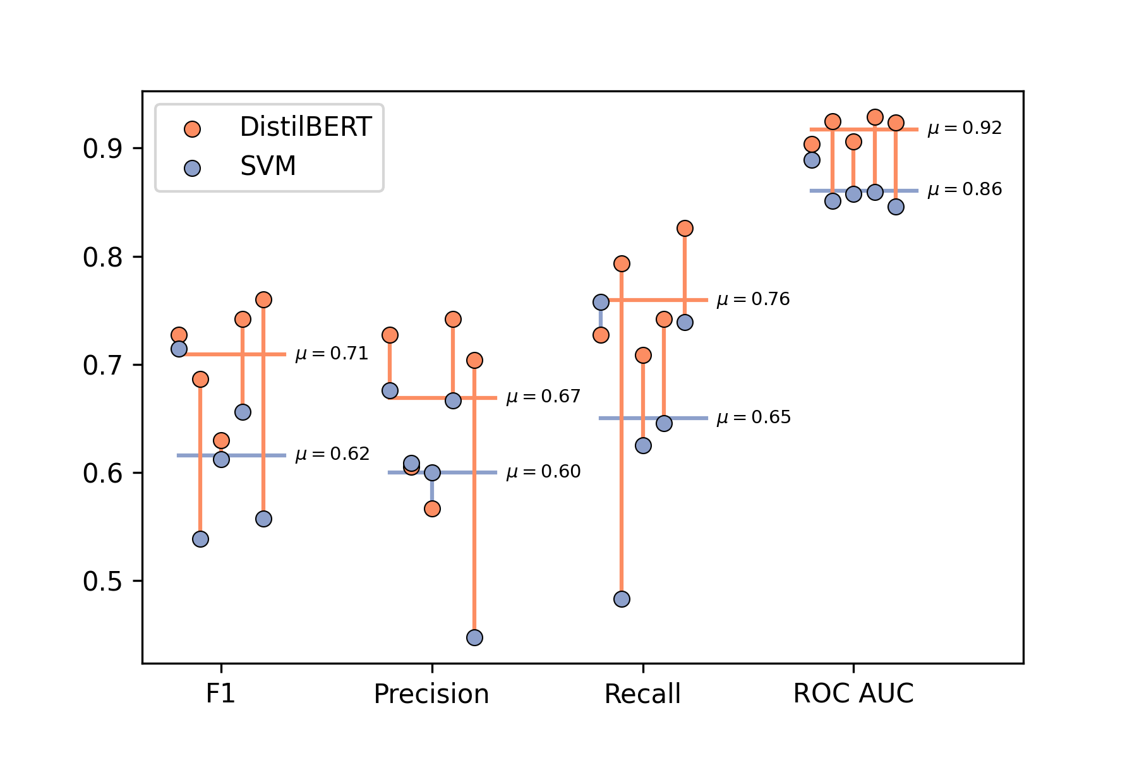
Extended Fig. 3| Performance metrics for the binary inclusion/exclusion classifier. Each pair of dots represents the scores for a distinct cross-validation fold. Horizontal lines show the mean score across folds.

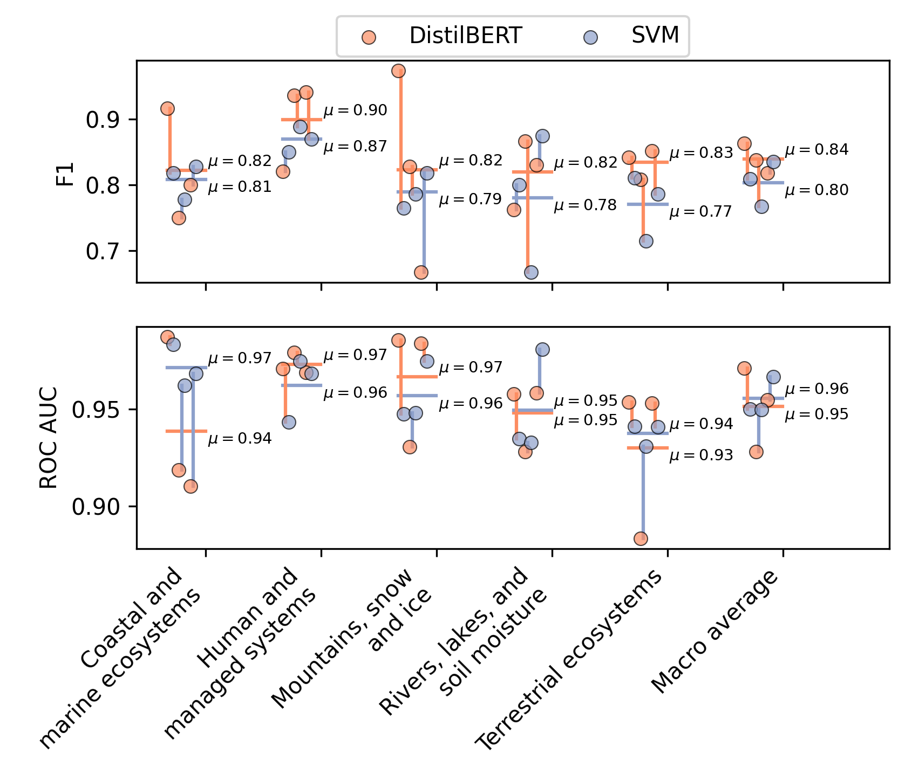
Extended Figure 4| Receiver operating curve area under the curve scores (ROC AUC) and F1 scores for the classification of impact categories. Each pair of dots represents the scores for a distinct cross-validation fold. Horizontal lines show the mean score across folds.

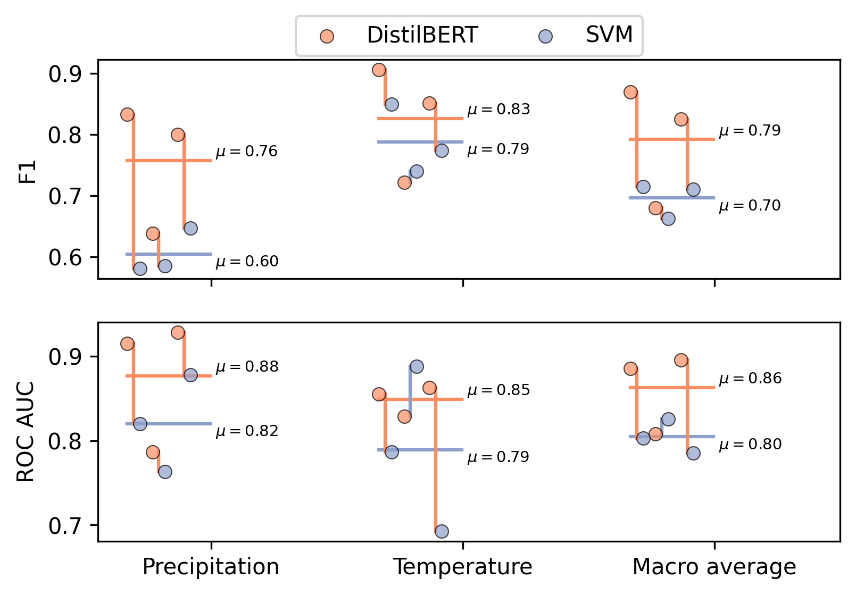

Extended Fig. 5| Receiver operating curves area under the curve scores (ROC AUC)(ROC) and F1 scores for the classification of drivers. Each pair of dots represents the scores for a distinct cross-validation fold. Horizontal lines show the mean score across folds.
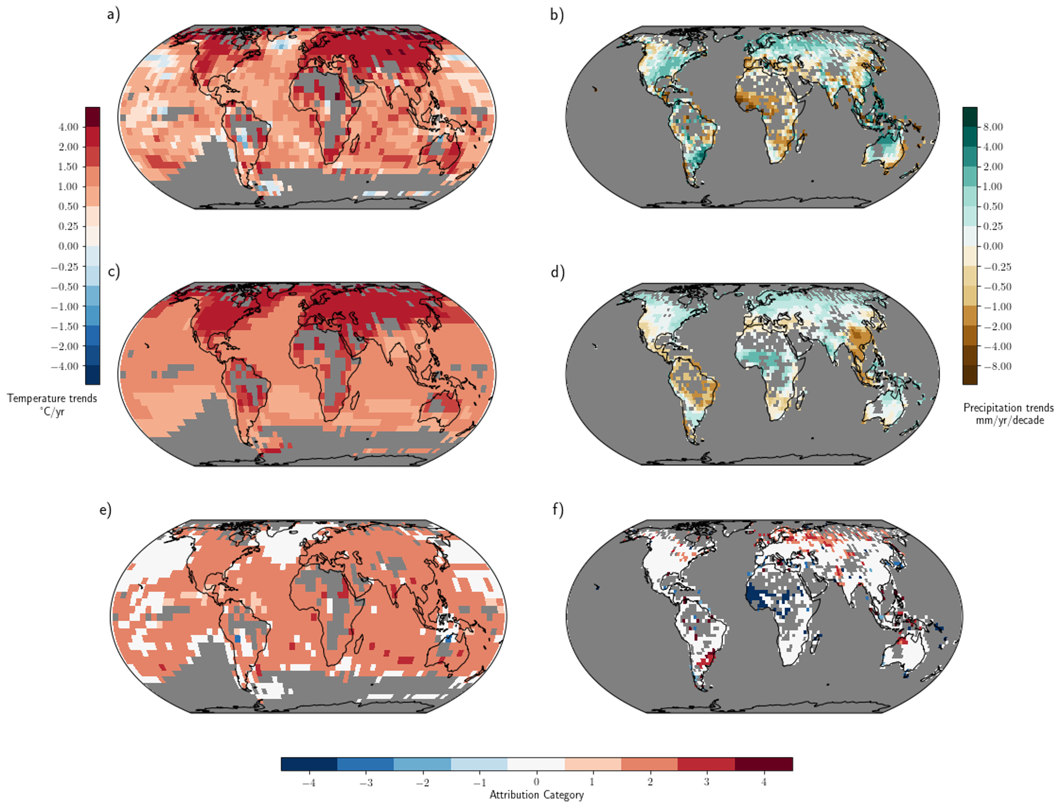

Extended Fig. 6: Geographical distribution of surface trends. Temperature from 1951 to 2018 (left) and precipitation trends from 1951 to 2016 (right) in (a),(b) observations and (c),(d) CMIP6 10-model ensemble mean all-forcing runs. Bottom panels (e),(f) show observations categorised into attribution categories, following ref. 8 and 7, respectively. Observed cooling/warming or drying/wetting trends that--after accounting for internal climate variability-- are inconsistent with the simulated response to natural forcings but consistent with the simulated response to both natural and anthropogenic forcings are indicated by categories -/+2. This is clearest case of changes that are at least partially attributable to anthropogenic forcing, according to the CMIP6 ensemble. Categories -/+1 have detectable observed changes, but are not assessed as attributable to anthropogenic forcing because the observed changes are significantly less than those simulated in the average all-forcing runs. Categories -/+3 have detectable changes and are assessed as at least partly attributable anthropogenic forcing, although the observed changes are inconsistent with the all-forcing runs. That is, they are in the same direction as, but are significantly stronger than, the mean of the all-forcing runs. . Categories -/+4 represents cooling/warming or drying/wetting trends that are inconsistent with the simulated response to natural forcings but whose sign is opposite to that of the average simulated all-forcing response; category 0 represents trends that are not distinguishable from natural variability alone. Categories -/+4 and 0 are considered to be examples of non-detectable trends).

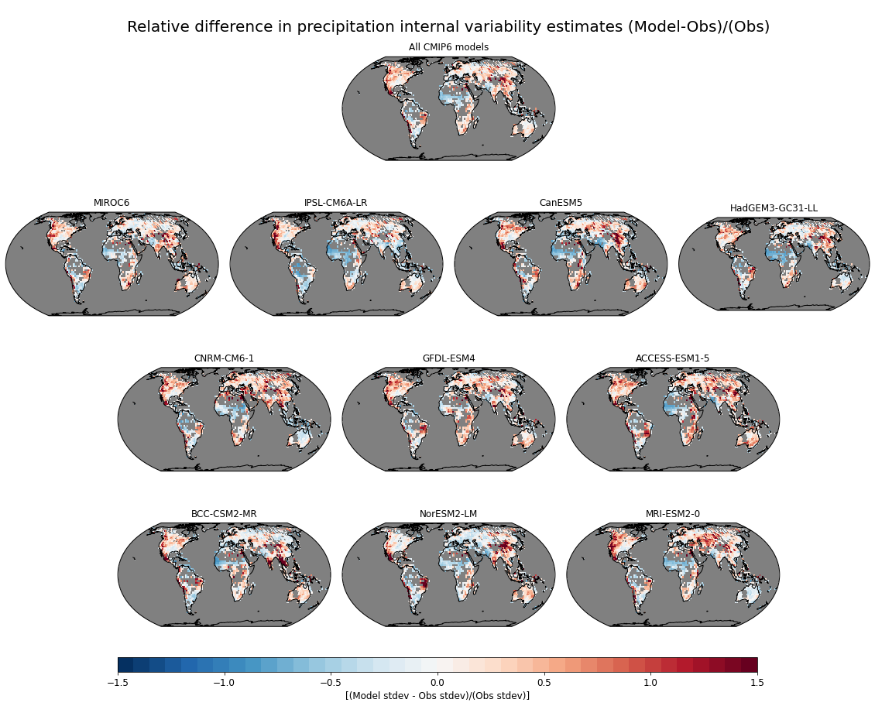
Extended Fig. 7: Fractional difference between average CMIP6 modeled low-frequency standard deviation of annual mean precipitation vs observed precipitation. To estimate the internal low-frequency variability for both models and observations, the observed timeseries were detrended and low-pass filtered with a 7-year running mean filter prior to computing the standard deviations while for the models we used the full available control runs (7-yr running mean filtered) to estimate the internal low-frequency variability for each model. The top panel shows the multi-model ensemble standard deviation comparison while the ten individual panels below it show the comparison for each individual CMIP6 model used in the study. The fraction difference was computed as: [(Model st. dev. - Observed st. dev.) / (Observed st. dev.)].

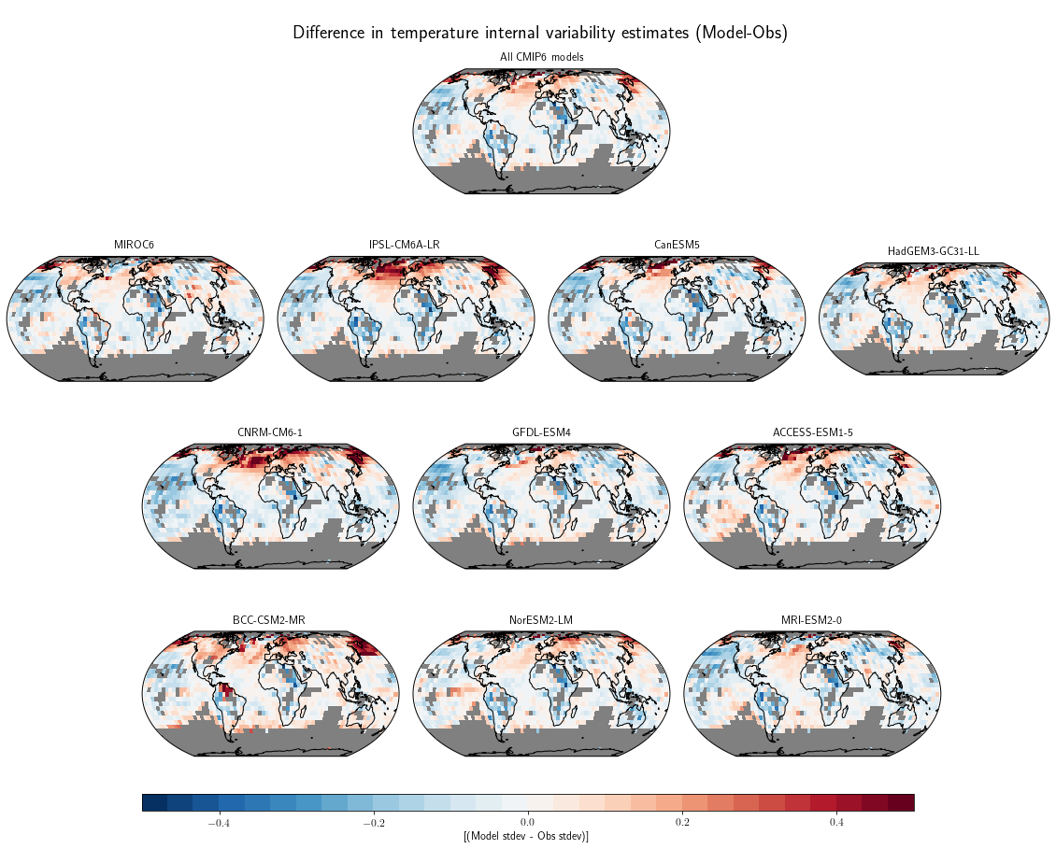
Extended Fig. 8| Difference between average CMIP6 modeled low-frequency standard deviation (ºC) of annual mean surface air temperature vs observed surface temperature. To estimate the internal low-frequency variability for both models and observations, the observed timeseries were detrended and low-pass filtered with a 7-year running mean filter prior to computing the standard deviations while for the models we used the full available control runs (7-year running mean filtered) to estimate the internal low-frequency variability for each model. The top panel shows the multi-model ensemble standard deviation comparison while the ten individual panels below it show the comparison for each individual CMIP6 model used in the study.

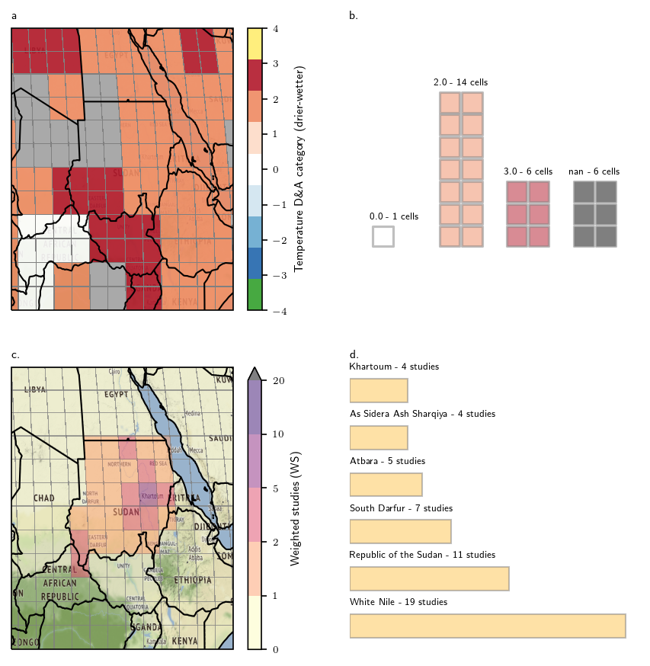
Extended Fig. 9| An illustration of the spatial resolution and weighting methodology. a. Detection and attribution categories for temperature in East Africa; b. the number of grid cells of each type in Sudan; c. weighted studies for each grid cell in Sudan; d. The number of studies referring to each extracted geographical location in Sudan.

Author contribution statement
M.W.C. and J.C.M., and C-F.S. designed the research. M.W.C developed the coding platform and machine learning pipeline to identify studies, with advice from M.R., M.W.C, C-F.S., G.H., Q.L., E.T. developed the codebook and coordinated screening and coding. M.W.C., Q.L., S.N., C-F.S.. conceptualised the link to detection and attribution data. S.N. performed the reanalysis of temperature and precipitation trends with T.R.K. M.W.C and S.N. designed and implemented the matching of studies with detection and attribution data. All other authors contributed to screening and coding studies. M.W.C., C-F.S., J.C.M., Q.L., and S.N. wrote the manuscript with contributions from all authors.

