Supplementary materials Djibouti

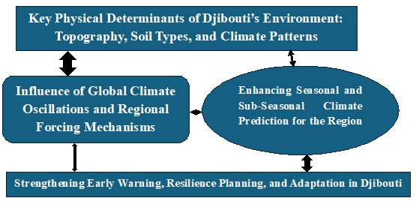
Graphical Abstract Description: Djibouti’s rainfall exhibits strong seasonal and spatial variability, driven by ocean-atmosphere interactions and topography. The main rainy season occurs July–September (JAS), contributing ~46% of annual rainfall, with secondary peaks in March–May (MAM). REOF and RPC analyses reveal dominant variability zones: the western sector for JAS, northeastern for MAM, and the eastern tip for the October–November (ON) short rains. Sea Surface Temperature anomalies in the western Indian Ocean, Red Sea, and Gulf of Aden, along with IOD and ENSO phases, critically modulate moisture transport and rainfall intensity. These insights emphasize the interplay of climate drivers and geography, informing seasonal forecasting, early warning, and climate-resilient planning in Djibouti and the broader Horn of Africa.

