Supplementary information for
Interpretable physics-based models compared with symbolic regression for hopping transport in organic field-effect transistors
Madhavkrishnan Lakshminarayanan^{1,2#}, Rajdeep Dutta^{3#}, D V Maheswar Repaka², Senthilnath Jayavelu^{3*}, Wei Lin Leong^{1*}, Kedar Hippalgaonkar^{2,4*}

- School of Electrical Electronic Engineering, Nanyang Technological University, 50 Nanyang Avenue, Singapore 639798

- Institute of Materials Research & Engineering, Agency for Science, Technology and Research (A*STAR), Singapore 138632

- Institute for Infocomm Research, Agency for Science, Technology and Research (A*STAR), Singapore 138632

- School of Materials Science and Engineering, Nanyang Technological University, 50 Nanyang Avenue, Singapore 639798

*correspondence to j_senthilnath@i2r.a-star.edu.sg, wlleong@ntu.edu.sg, kedar@ntu.edu.sg

Figure S1: Temperature-dependent mobility data for (a) P3HT and (b) C₆₀ OFETs
[reproduced data from ref ^{1,2}]
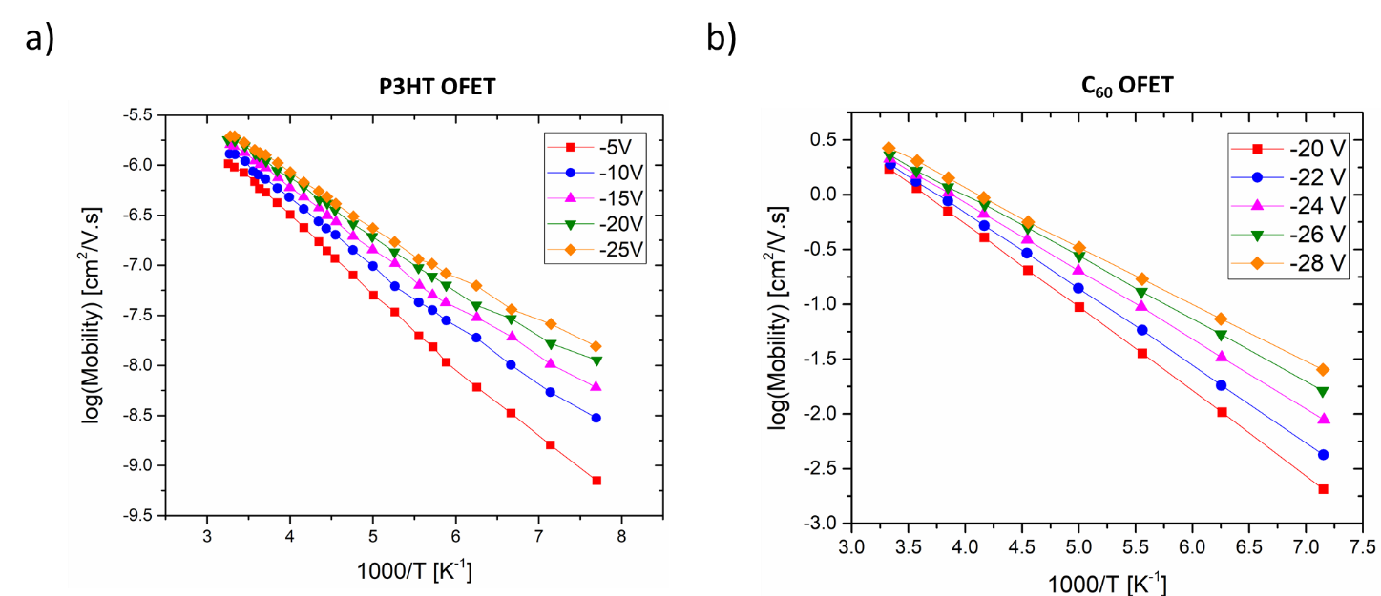

The logarithmic mobility of P3HT and C₆₀ OFETs is plotted against the reciprocal temperature (in K⁻¹) for different values of gate voltage (V_{g}). The activation energy of each curve can be extracted from its slope as $E_{a}=\left|slope\right|*k_{B}*2303$, where k_{B} is the Boltzmann constant.

Figure S2: SR mutation and crossover operations

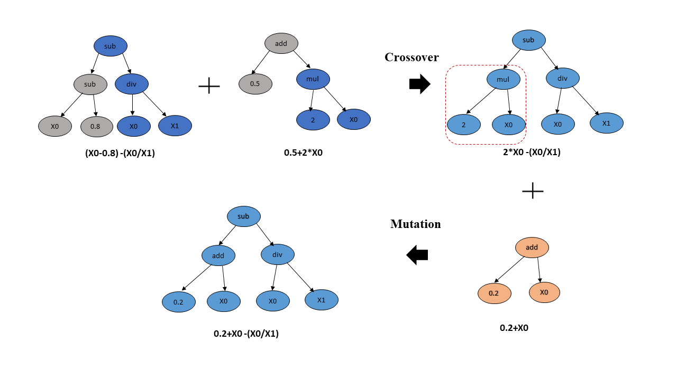
We provide here a precise mathematical overview of a generic Symbolic Regression (SR) problem. Consider a dataset (X,y) of n input variables and one output variable, where $X ϵ R^{n}, y ϵ R$. SR seeks to find a function $f\left(X\right) : R^{n}⟶R$that minimizes an error metric $E_{m}(y, f(X))$ between actual and predicted values. The optimal function can be represented as: $f^{*}=\arg{\min_{f}{E_{m}(y, f(X))} }$. Genetic Programming (GP) is an evolutionary algorithm used in functional optimization³, where candidate solutions are represented by computer-generated programs or trees made up of numbers, symbols, and functions⁴. GP candidates get updated at every generation (iteration) using Tournament Selection followed by crossover and mutation³ operations. GP applies crossover and mutation operators within the tree structures corresponding to candidate programs, as shown in Figure S2. The exploitation and exploration phases of the evolutionary search are considered by crossover and mutation operations, respectively, which we describe briefly in the following.
In the Tournament selection procedure, random individuals from a population are chosen to construct a pool to play a tournament amongst themselves. The tournament winner, i.e., the individual (tree) with the highest fitness, is carried forward to the next operation. The pool size needs to be carefully selected as a large pool size discourages weak individuals to participate in the tournament. Crossover propagates information from parents to offspring to improve the fitness of the next generation. A crossover operation in GP needs at least two tournaments to find out a parent and a donor. A crossover takes the winner of a tournament and selects a random subtree from it to be replaced by a donor determined by another tournament. Also, the donor has a randomly selected subtree that is inserted into the parent to form an offspring. Mutation enhances the exploration capability of the evolution process and maintains the diversity of a population by random replacement(s) of subtrees or nodes.
Some important tuning parameters associated with GP are population size, tournament size, crossover rate, mutation rate, tree depth bounds, and parsimony coefficient. The compactness of SR outcome expressions is determined by the related parsimony coefficient³.
Tables T1-T3: Activation energy E_{a} calculated from the slope of log(Mobility) versus 1/T plots compared with the E_{a} extracted from the T_{r} value of each V_{g} curve as $E_{a}=k_{B}\ln\left(2\right)\frac{T_{r}T_{p}}{T_{p}-T_{r}}$
The following tables compare the values of the activation energies as obtained from the slope of the temperature-dependent mobility curves (as shown in Figure S1) and those obtained from the T_{r} value of each V_{g} curve that was used for performing the renormalization.

T1: C₆₀ OFET
V_{g} (V) | E_{a} from slope (eV) | E_{a} from T_{r} (eV)
-20 | 0.15144 | 0.1483
-22 | 0.13795 | 0.1288
-24 | 0.12342 | 0.1207
-26 | 0.11166 | 0.1134
-28 | 0.10556 | 0.1063

T2: P3HT OFET
V_{g} (V) | E_{a} from slope (eV) | E_{a} from T_{r} (eV)
-5 | 0.14626 | 0.1328
-10 | 0.12158 | 0.1299
-15 | 0.1135 | 0.1191
-20 | 0.10503 | 0.1159
-25 | 0.09904 | 0.1008

T3: Pentacene OFET
V_{g} (V) | E_{a} from slope (eV) | E_{a} from T_{r} (eV)
-5 | 0.21058 | 0.1891
-10 | 0.15358 | 0.1345
-15 | 0.12192 | 0.1172
-20 | 0.10292 | 0.1014
-25 | 0.09025 | 0.0882

References:
1. Meijer, E. Ph.D. thesis: Charge transport in disordered organic field-effect transistors. (Technical University of Delft, 2003).
2. Ullah, M. et al. Dependence of Meyer-Neldel energy on energetic disorder in organic field effect transistors. Appl. Phys. Lett. 96, 1–4 (2010).
3. GitHub - trevorstephens/gplearn at ad57cb18caafdb02cca861aea712f1bf3ed5016e. Available at: https://github.com/trevorstephens/gplearn/tree/ad57cb18caafdb02cca861aea712f1bf3ed5016e. (Accessed: 7th February 2021)
4. Sun, S., Ouyang, R., Zhang, B. & Zhang, T. Y. Data-driven discovery of formulas by symbolic regression. MRS Bull. 44, 559–564 (2019).

