 | Class | Number of Teachers(n) | Number of Students (n) | Age range (years) | Floor
Total |  | 30 | 318 | 3.8~7.3
Junior | 1A | 3 | 30 | 3.8~4.8 | Second
Junior | 1B | 3 | 30 | 3.9~4.8 | Second
Junior | 1C | 3 | 29 | 3.8~4.8 | Second
Middle | 2A | 3 | 34 | 4.8~5.8 | First
Middle | 2B | 3 | 35 | 4.8~5.8 | First
Middle | 2C | 3 | 34 | 4.8~5.8 | First
Senior | 3A | 4 | 42 | 5.8~7.3 | Third
Senior | 3B | 4 | 42 | 5.8~6.8 | Third
Senior | 3C | 4 | 42 | 5.8~6.9 | Third
Supplementary Table 1The school is organized into three parallel classes per grade level. Each class is assigned a standard complement of three teachers. This staffing model is enhanced in the senior classes with the addition of a dedicated childcare attendant. Furthermore, all teaching staff assigned to the same grade level are co-located on the same floor to facilitate collaboration and grade-specific management.
Variable |  | Include(282) | Exclude(36) | z/Χ² | p
Age | (year) | 5.54(4.75,6.25) | 5.25(4.5,5.63) | 1.826 | 0.068
Sex | Girl | 133 | 13 | 1.570 | 0.21
Sex | Boy | 149 | 23 | 1.570 | 0.21
Grade | Junior | 77 | 12 | 0.128 | 0.072
Grade | Middle | 57 | 12 | 0.128 | 0.072
Grade | Senior | 148 | 12 | 0.128 | 0.072
Supplementary Table 2Comparison of information between excluded and included students,there is no statistical difference between the two groups.

 | ALL |  | Outdoor |  | Indoor
 | Cumulative  time(min) | Cumulative events | Cumulative time(min) | Cumulative events | Cumulative time(min) | Cumulative events
Summary | 1006993.78 | 389616 | 263045.27 | 170081 | 743948.52 | 219535
Low risk | 358737.65  (35.62%) | 345917(88.78%) | 150319.8 (57.15%) | 158864 (93.40%) | 208417.85 (28.02%) | 187053 (85.20%)
Medium-  low risk | 231171.03  (22.96%) | 25878(6.64%) | 61763.43 (23.48%) | 8222 (4.83%) | 169407.60 (22.77%) | 17656 (8.04%)
Medium-  high risk | 342171.15  (33.98%) | 15529  (3.99%) | 42365.80 (16.11%) | 2608 (1.53%) | 299805.35 (40.30%) | 12921 (5.89%)
High risk | 74913.95  (7.44%) | 2292(0.59%) | 8596.23 (3.27%) | 387 (0.23%) | 66317.72 (8.91%) | 1905 (0.87%)
Supplementary Table 3 Supplementary results for Figure 2:Cumulative time (total duration of all contact events),Cumulative events (total count of all contact events

Period | Activity | Location | Edge Count | Contact Events | Total Contact Time（min)
7:40-8:10 AM | Morning Exercises | Outdoors | 2992 | 5391 | 6517.967
8:10-9:00 AM | Breakfast | Indoors | 9504 | 37313 | 108868.467
9:00-11:00 AM | Outdoor activates | Outdoors | 16138 | 144042 | 301302.583
11:00 AM-12:00 PM | Lunch | Indoors | 11143 | 63287 | 163715.350
12:00-12:30 PM | Walk | Outdoors | 10421 | 30313 | 49661.433
12:30-2:00 PM | Nap | Indoors | 4046 | 18235 | 152586.833
2:00-4:00 PM | Indoor class | Indoors | 10901 | 91035 | 224341.150
Supplementary Table 4 Kindergarten Daily Schedule(Location: Indicates whether the activity is conducted indoors or outdoors.Contact Events: Refers to the total number of contact events occurring during the activity.Total Contact Time: Represents the cumulative duration of all contact events in the activity)Barring special holidays or events, the school’s schedule typically remains unchanged. However, during outdoor activities, the assigned activity areas for each class are rotated on a regular basis.

Class | Medium-low risk |  |  |  | low risk
Class | Node Count | Edge Count | Avg. Degree | Density | Node Count | Edge Count | Avg. Degree | Density
1A | 25 | 391 | 23.280 | 0.970 | 25 | 300 | 24.000 | 1.000
1B | 28 | 342 | 24.429 | 0.905 | 28 | 378 | 27.000 | 1.000
1C | 24 | 258 | 21.500 | 0.935 | 24 | 276 | 23.000 | 1.000
2A | 27 | 310 | 22.963 | 0.883 | 27 | 351 | 26.000 | 1.000
2B | 30 | 393 | 26.200 | 0.903 | 30 | 435 | 29.000 | 1.000
2C | 28 | 299 | 21.357 | 0.791 | 28 | 378 | 27.000 | 1.000
3A | 38 | 633 | 31.316 | 0.900 | 38 | 703 | 37.000 | 1.000
3B | 42 | 721 | 35.171 | 0.879 | 41 | 820 | 40.000 | 1.000
3C | 41 | 625 | 34.488 | 0.762 | 41 | 820 | 40.000 | 1.000
ALL | 312 | 4738 | 30.372 | 0.098 | 312 | 9017 | 57.800 | 0.186
Supplementary Table 5 The network characteristics of contact networks for classes at different exposure risk levels ,For medium-low risk , the Spearman correlation coefficient between network density and infectious disease-related absence rates is 0.250 (p= 0.516).

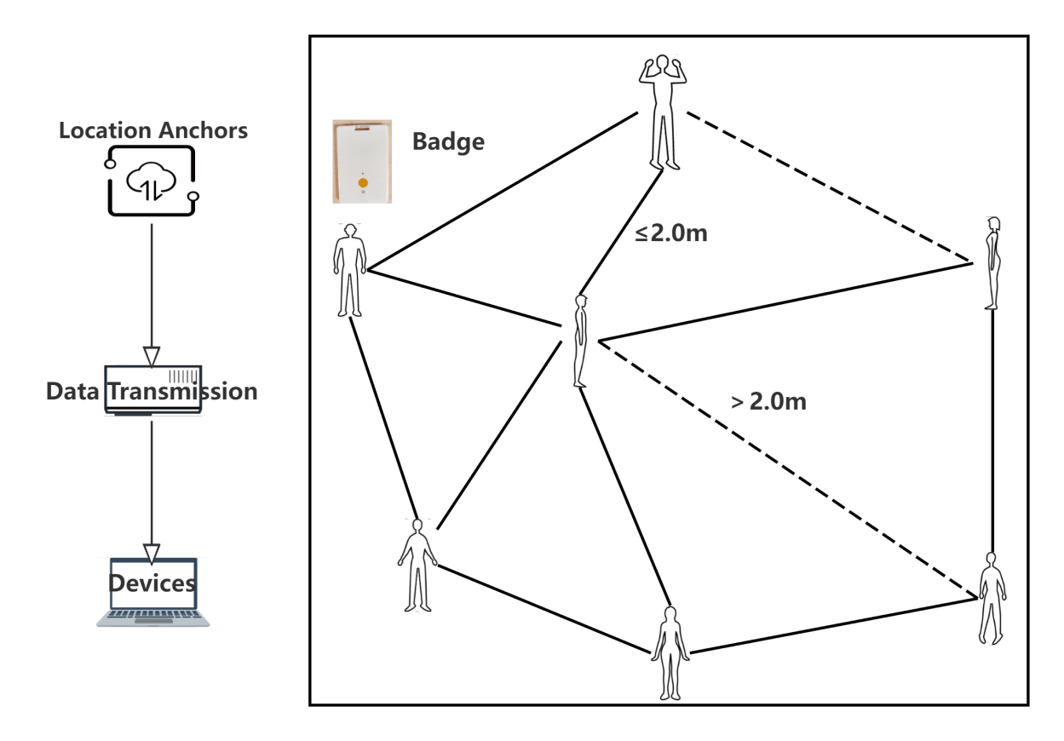
Supplementary Figure 1 Participants wear Badges. When two individuals come within <2 meters proximity, the interaction is recorded until separation exceeds 2 meters, logged as a single contact event. Data from Badges are transmitted via Location Anchors to central computing terminals.
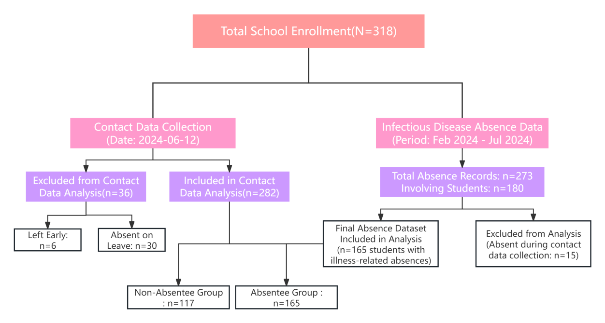
Supplementary Figure 2 Student Inclusion and Data Collection Process This structural diagram summarizes the available datasets and exclusion steps. Contact data were collected on a single day (2024-06-12), with 36 students excluded due to absence or early departure. Infectious disease absenteeism was tracked over a six-month period (Feb–Jul 2024). For integrated analysis, 33 students with absence records were excluded as they were not present during contact data collection. The final analytical dataset includes 282 students with contact data, of whom 147 had illness-related absences and 165 did not.

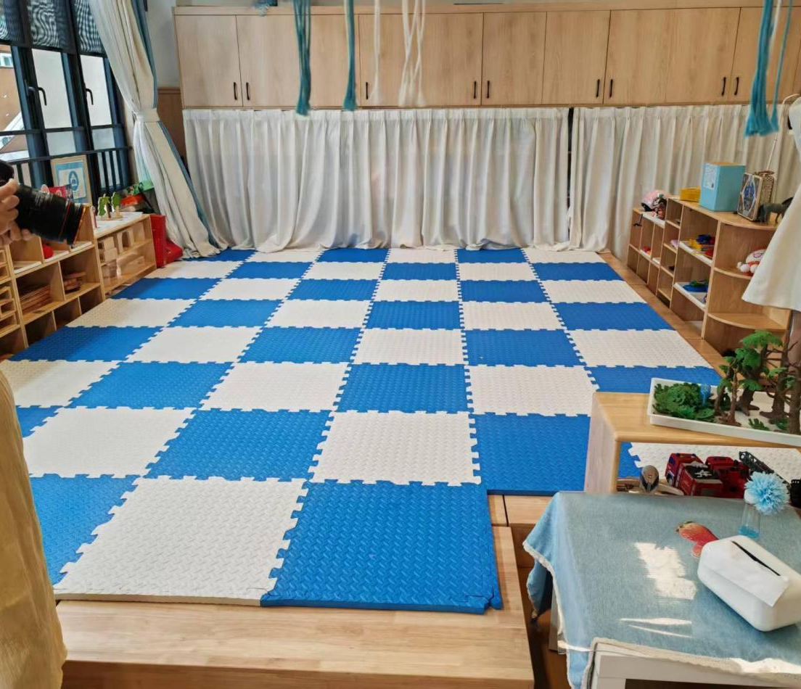
Supplementary Figure 3 Students take naps in this area

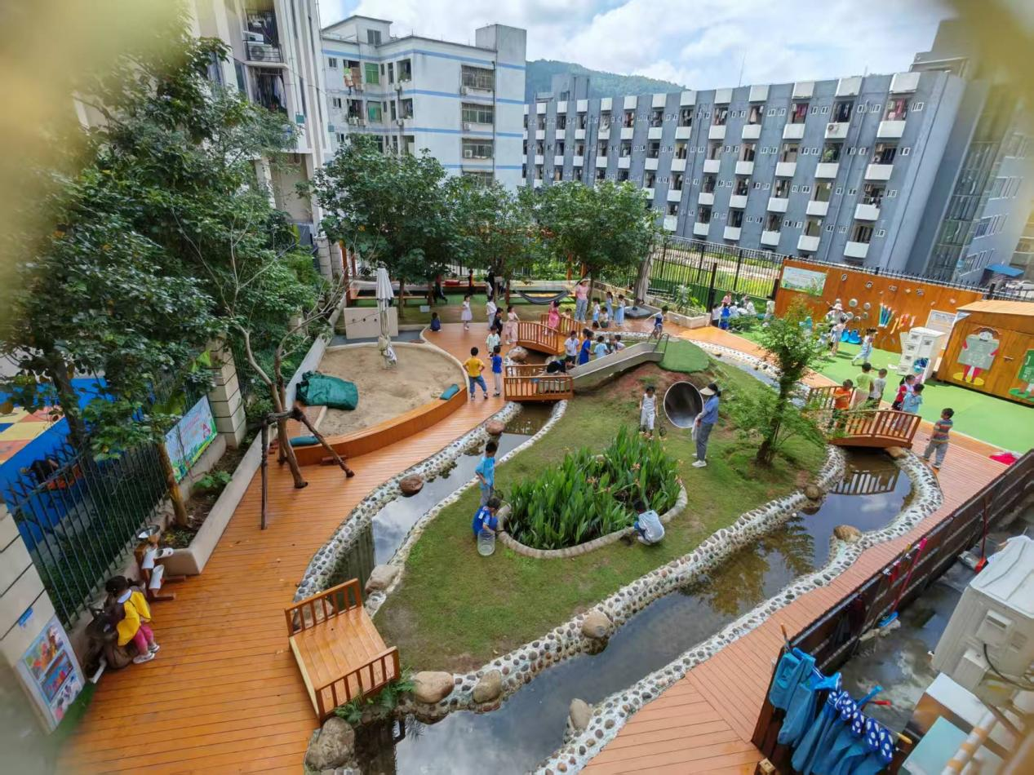
Supplementary Figure 4 Students playing outdoors
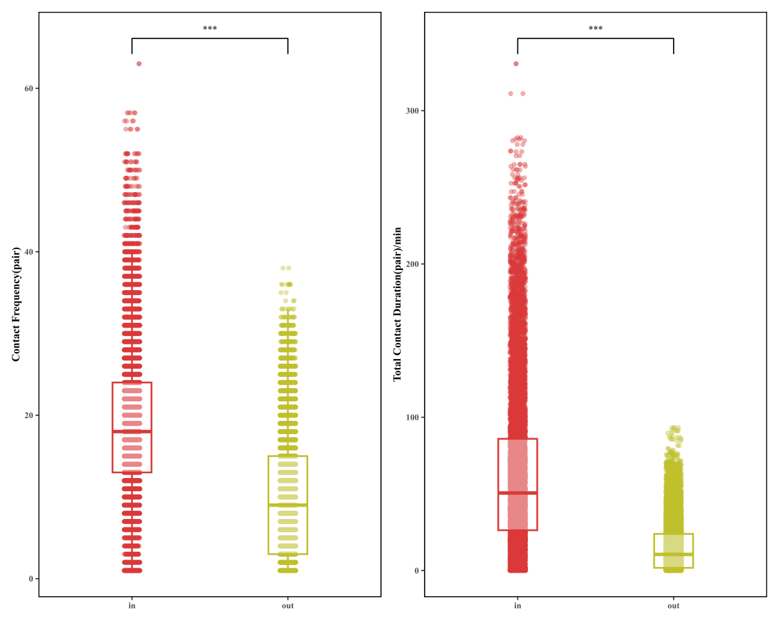
Supplementary Figure 5
The Distribution of Contact Time and Frequency for Indoor vs. Outdoor Activities

