Supplementary Materials
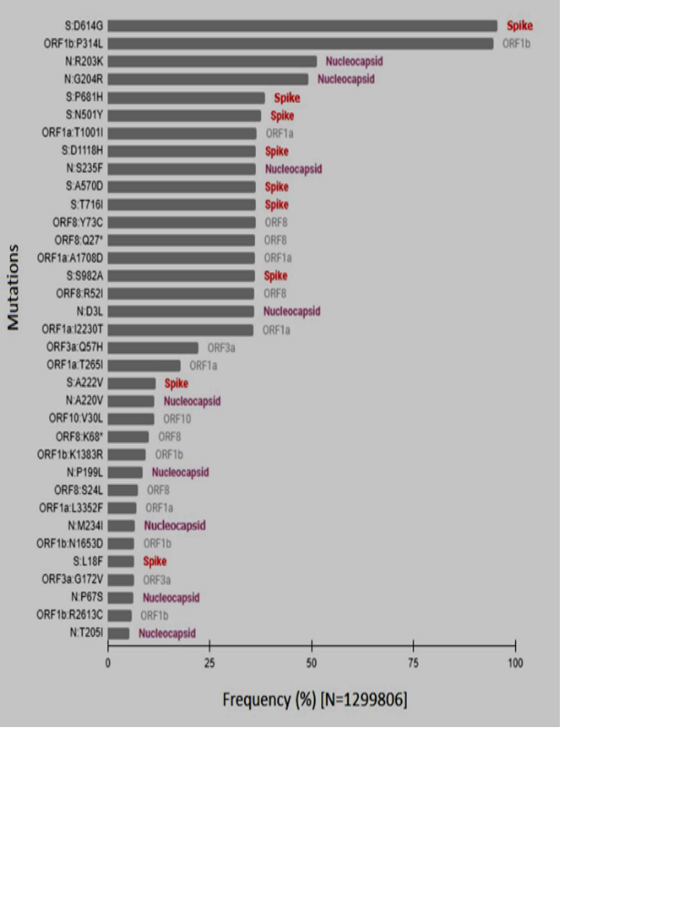

Figure S1: Phylogenetic analysis of the SARS-CoV-2 target proteins: A. RNA dependent RNA Polymerase, B: Spike Protein, C. 3-CL-pro, and D: Helicase

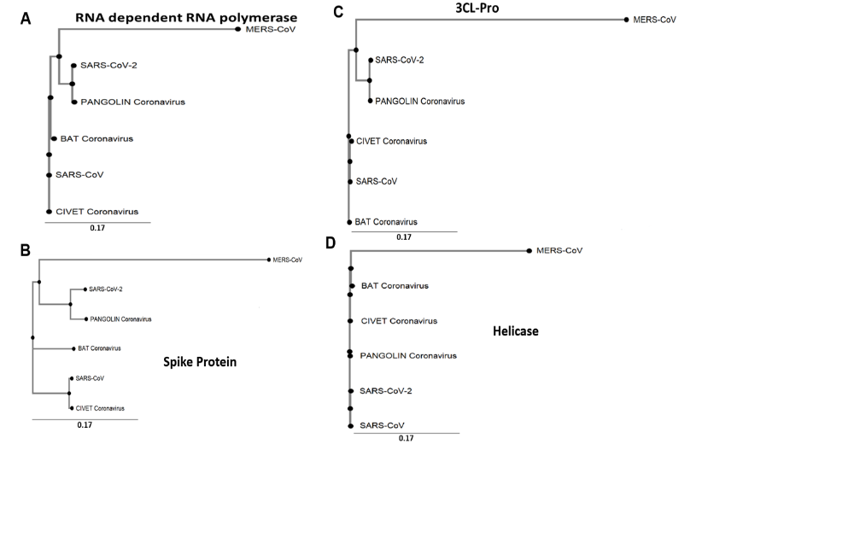

Figure S2: Mutational landscape of the SARS-CoV-2 genome

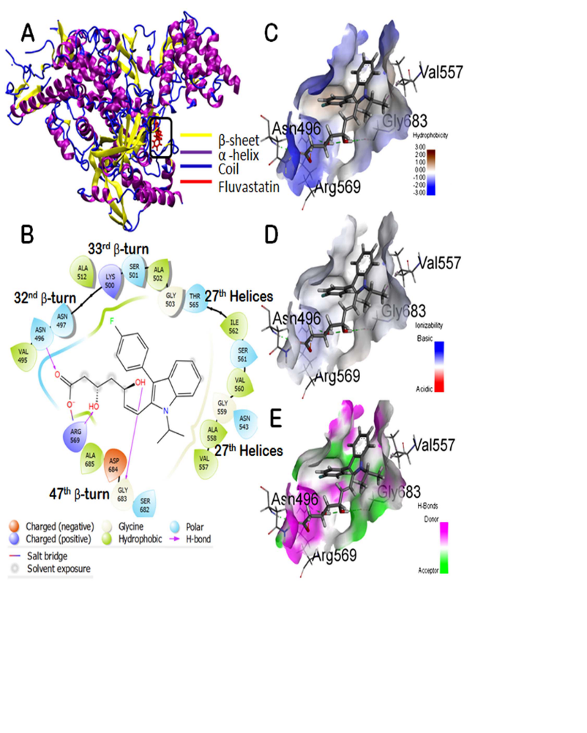

Figure S3. Molecular docking study of fluvastatin to RdRp. A: 3D diagram of the ligand-protein complex. B: 2D diagram for representation of interactions of the ligand with the amino acid residues at the binding site. C-E: Mapping of binding site cavity according to hydrophobicity, ionizability, and presence of H-bond donor-acceptor residue, respectively.
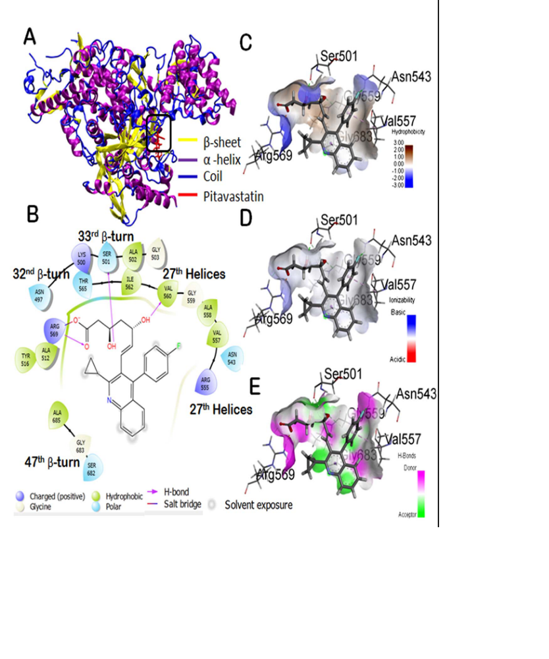

Figure S4. Molecular docking study of pitavastatin to RdRp. A: 3D diagram of the ligand-protein complex. B: 2D diagram for representation of interactions of the ligand with the amino acid residues at the binding site. C-E: Mapping of binding site cavity according to hydrophobicity, ionizability, and presence of H-bond donor-acceptor residue, respectively.

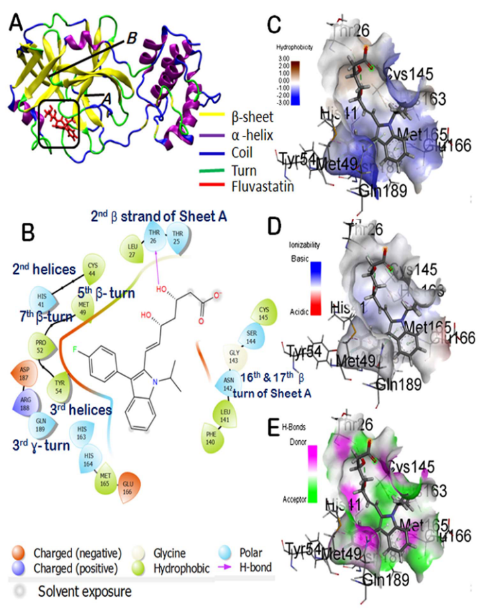

Figure S5. Molecular docking study of fluvastatin to 3-Cl-Pro. A: 3D diagram of the ligand-protein complex. B: 2D diagram for representation of interactions of the ligand with the amino acid residues at the binding site. C-E: Mapping of binding site cavity according to hydrophobicity, ionizability, and presence of H-bond donor-acceptor residue, respectively.
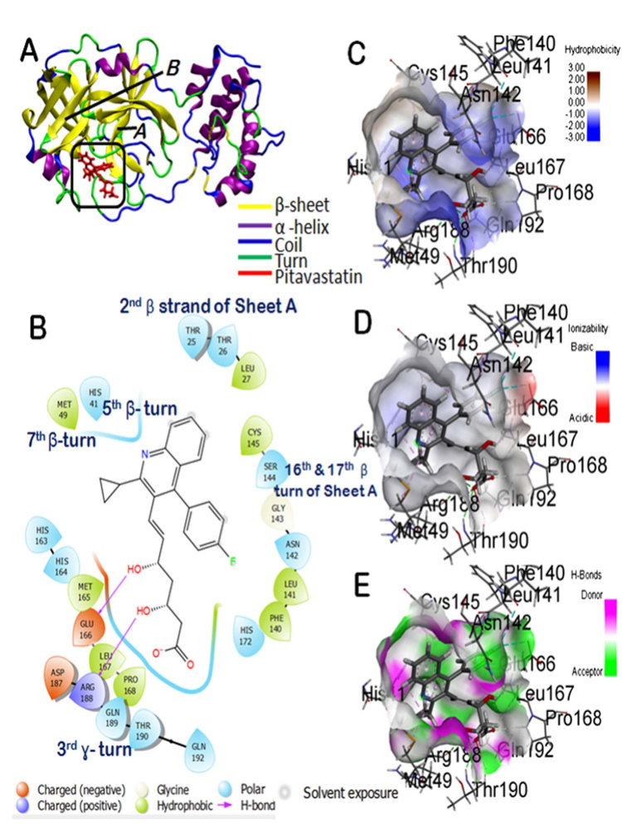

Figure S6. Molecular docking study of pitavastatin to 3-Cl-Pro. A: 3D diagram of the ligand-protein complex. B: 2D diagram for representation of interactions of the ligand with the amino acid residues at the binding site. C-E: Mapping of binding site cavity according to hydrophobicity, ionizability, and presence of H-bond donor-acceptor residue, respectively.
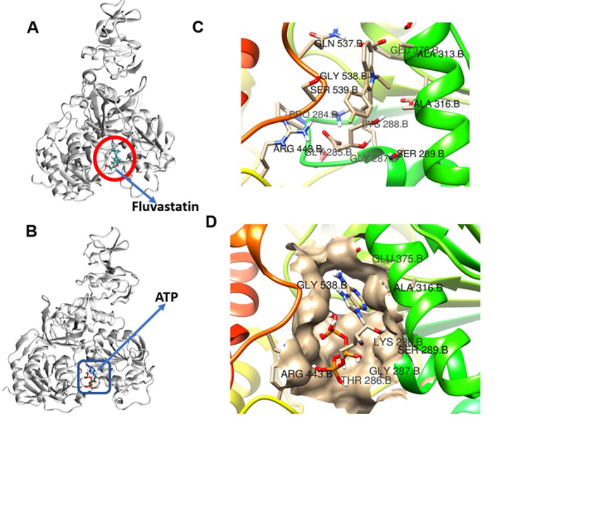

Figure S7. The binding site of fluvastatin (A and C) and ATP (B and D) on helicase

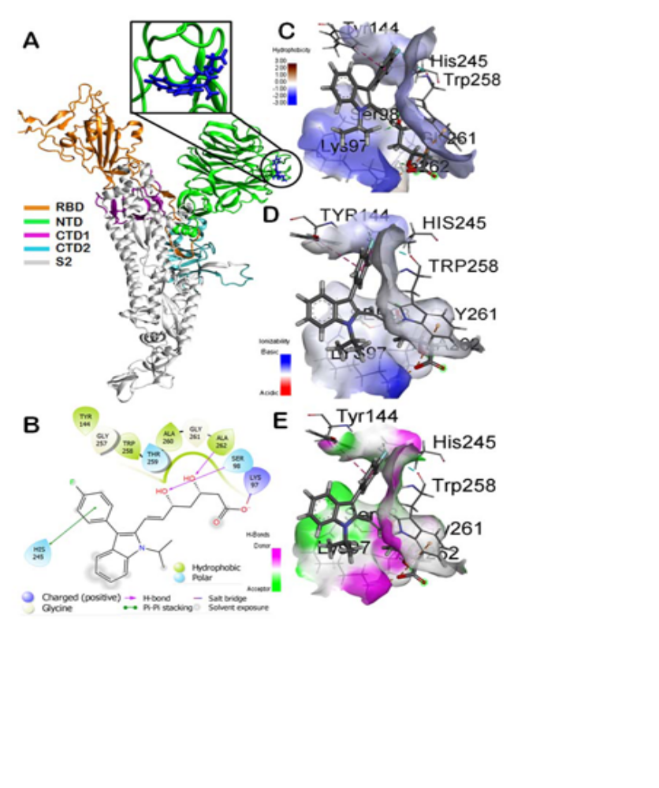

Figure S8. Molecular docking study of fluvastatin to Spike_{WT}. A: 3D diagram of the ligand-protein complex. B: 2D diagram for representation of interactions of the ligand with the amino acid residues at the binding site. C-E: Mapping of binding site cavity according to hydrophobicity, ionizability, and presence of H-bond donor-acceptor residue, respectively.

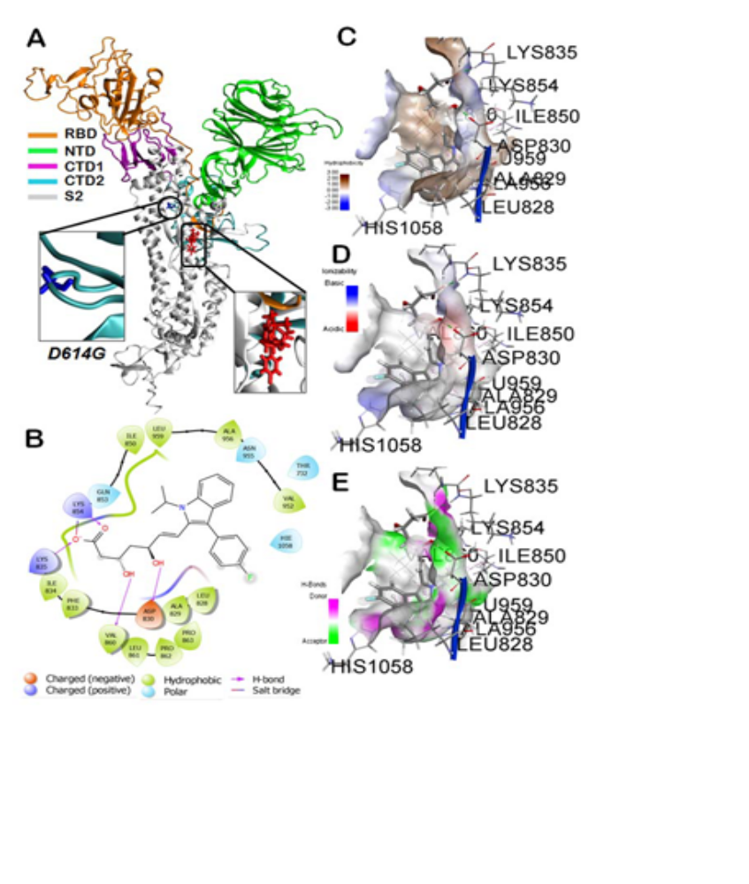

Figure S9. Molecular docking study of fluvastatin to S_{D614G}. A: 3D diagram of the ligand-protein complex. B: 2D diagram for representation of interactions of the ligand with the amino acid residues at the binding site. C-E: Mapping of binding site cavity according to hydrophobicity, ionizability, and presence of H-bond donor-acceptor residue, respectively.
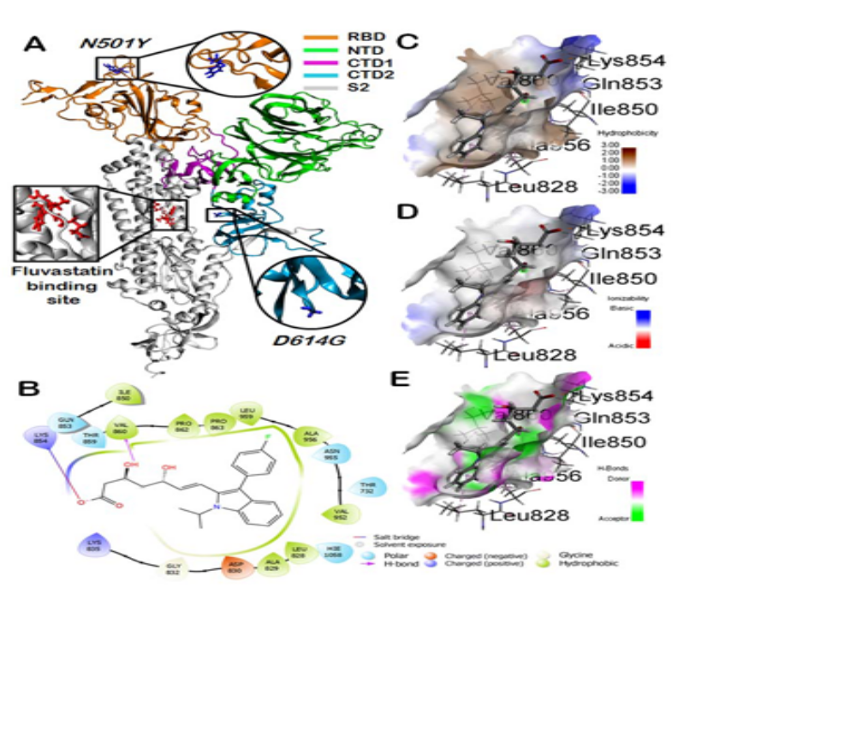

Figure S10. Molecular docking study of fluvastatin to S_{D614G/N501Y}. A: 3D diagram of the ligand-protein complex. B: 2D diagram for representation of interactions of the ligand with the amino acid residues at the binding site. C-E: Mapping of binding site cavity according to hydrophobicity, ionizability, and presence of H-bond donor-acceptor residue, respectively.
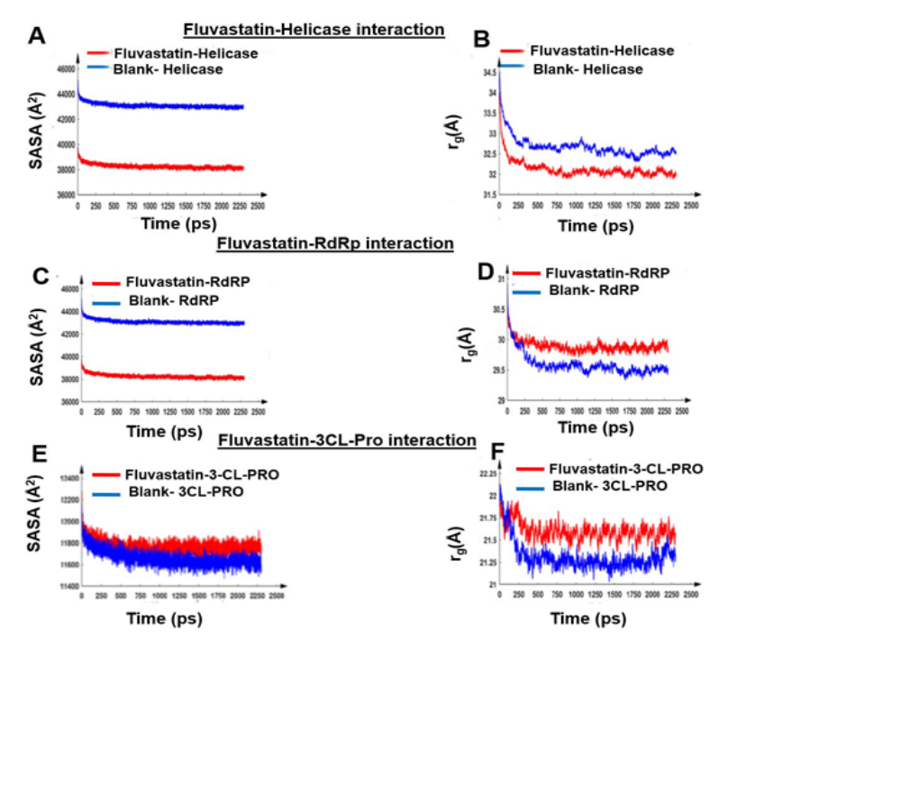

Figure S11. Molecular dynamics simulation study of the fluvastatin-target protein complex. The comparative plot of Solvent Accessible Surface Area (SASA) and gyration radius against time. A,B: Fluvastatin-Helicase complex; C,D: Fluvastatin-RdRp complex; E,F: Fluvastatin-3Cl-Pro complex.
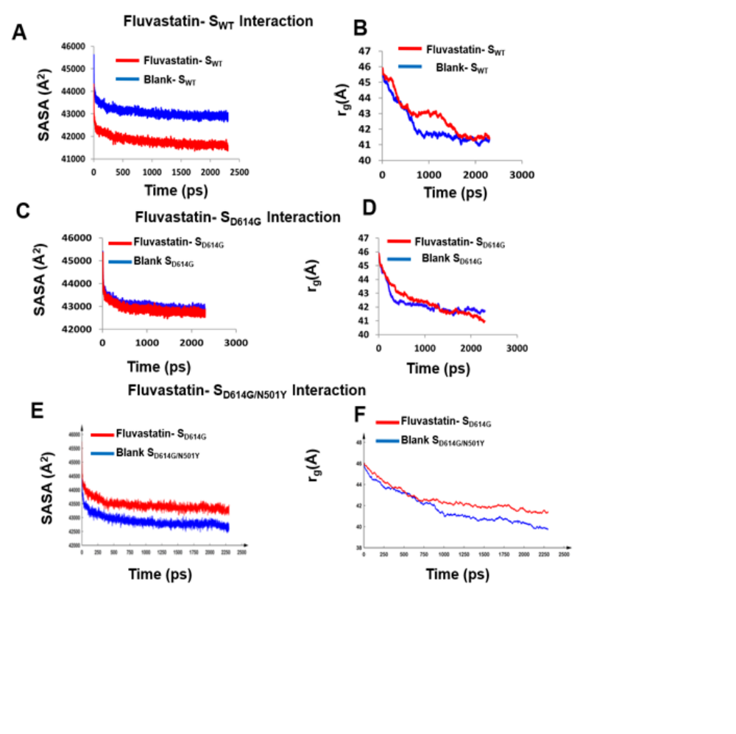
Figure S12. Molecular dynamics simulation study of the fluvastatin-target protein complex. The comparative plot of Solvent Accessible Surface Area (SASA) and gyration radius against time. A,B: Fluvastatin-Spike_{WT} complex; C,D: Fluvastatin- Spike_{D614G} complex; E,F: Fluvastatin- Spike_{D614G/N501Y} complex.

Table S1: Physicochemical properties of all statin molecules
Statins | Pub Chem CID | Molecular weight | Solubility  (μg/mL) | TPSA (Topological Polar Surface Area) (Å²) | Hydrogen Bond Donor Count | Hydrogen Bond Acceptor Count | logP | pKa
Atorvastatin | 60823 | 558.6 | 1.12 | 111.79 | 4 | 6 | 6.36 | 4.46
Cerivastatin | 446156 | 459.5 | 240 | 99.88 | 3 | 7 | 3.4 | pKa1 = 3.9  pKa2 = 5.4
Fluvastatin | 446155 | 411.5 | 460 | 82.69 | 3 | 5 | 4.85 | 4.5
Lovastatin | 53232 | 404.5 | 0.4 | 72.83 | 1 | 5 | 4.68 | 13.49
Mevastatin | 64715 | 390.5 | 1.4 | 72.83 | 1 | 5 | 3.95
Pitavastatin | 5282452 | 421.5 | 0.426 | 90.65 | 3 | 6 | 4.8 | 4.3
Pravastatin | 54687 | 424.5 | 6 | 124.29 | 4 | 7 | 2.18 | 4.2
Simvastatin | 54454 | 418.6 | 0.03 | 72.83 | 1 | 5 | 4.68 | 14.91
Rosuvastatin | 446157 | 481.5 | 17.96 | 149.3 | 3 | 10 | 0.13 | 4

Table S2: Similarity of amino acids comprising the binding sites of fluvastatin at different target proteins.
Target Protein | Amino acids at the binding site | Interactions | Bond distance (Å) | Part of fluvastatin molecule involved in the interaction
3CL-Pro | ASN142 | H-bond Donor | 1.69432 | O4
3CL-Pro | ASN142 | H-bond Donor | 2.80973 | O4
3CL-Pro | ASN142 | H-bond Donor | 2.58498 | O1
3CL-Pro | SER144 | H-bond Donor | 2.37891 | O3
3CL-Pro | THR25 | H-bond Donor | 3.0612 | O2
3CL-Pro | ASP187 | Halogen acceptor | 3.63138 | F1
Helicase | LYS283 | H-Donor | 1.81859 | O4
Helicase | LYS283 | H-Donor | 1.78696 | O4
Helicase | LYS283 | H-Donor | 2.33093 | O3
Helicase | SER284 | H-Donor | 2.71129 | O1
Helicase | SER284 | H-Donor | 1.66841 | O2
Helicase | PRO279 | H-Donor | 2.8378 | O3
Helicase | SER284 | H-Donor | 2.35577 | O1
Helicase | SER284 | H-Donor | 2.8405 | O2
RdRp | ARG489 | Electrostatic (Attractive Charge) | 2.9811 | O4
RdRp | ASN417 | Conventional Hydrogen Bond | 1.92779 | O4
RdRp | ARG489 | Conventional Hydrogen Bond | 1.82987 | O3
RdRp | ARG489 | Conventional Hydrogen Bond | 2.85354 | O2
RdRp | ASP604 | Carbon Hydrogen Bond | 2.64315 | H10
RdRp | THR485 | π -σ | 2.81061 | π-Orbitals
RdRp | LYS420 | Alkyl | 4.28062 | C3
RdRp | LYS420 | π -Alkyl | 4.43519 | π -Orbitals
RdRp | LYS420 | π-interaction | 5.2991 | π -Orbitals
RdRp | LYS420 | Salt Bridge; Attractive Charge | 2.09659 | O4
RdRp | LYS420 | Conventional Hydrogen Bond | 1.89781 | O2
S_{WT} | SER98 | Conventional Hydrogen Bond | 2.14073 | O1
S_{WT} | ALA262 | Conventional Hydrogen Bond | 2.04942 | O2
S_{WT} | TRP258 | Halogen bond | 3.46297 | F
S_{WT} | TRP258 | π-anion interaction | 4.80289 | O3
S_{WT} | TYR114 | π-π T-shaped | 5.56202 | π -Orbitals
S_{WT} | HIS245 | π-π T-shaped | 5.48378 | π -Orbitals
S_{WT} | HIS245 | Carbon Hydrogen Bond | 2.68551 | F
S_{WT} | LYS97 | Salt-bridge type electrostatic interactions | 1.79721 | O3
S_{D614G} | LYS854 | Salt-bridge type electrostatic interactions | 1.70087 | O1
S_{D614G} | LYS854 | Electrostatic  Interactions | 3.58228 | O2
S_{D614G} | LYS835 | Conventional Hydrogen Bond | 1.82959 | O2
S_{D614G} | VAL860 | Conventional Hydrogen Bond | 2.05887 | H20
S_{D614G} | ASP830 | Conventional Hydrogen Bond | 1.62172 | H21
S_{D614G} | VAL860 | Pi-Alkyl  Hydrophobic interactions | 4.42385 | π -Orbitals
S_{D614G} | ALA829 | Pi-Alkyl  Hydrophobic interactions | 4.2279 | π -Orbitals
S_{D614G} | ALA956 | Pi-Alkyl  Hydrophobic interactions | 5.03872 | π -Orbitals
S_{D614G} | LEU828 | Pi-Alkyl  Hydrophobic interactions | 5.33841 | π -Orbitals
S_{D614G/N501Y} | ALA829 | Pi-Alkyl  Hydrophobic | 4.97986 | π -Orbitals
S_{D614G/N501Y} | ALA956 | Pi-Alkyl  Hydrophobic | 5.07077 | π -Orbitals
S_{D614G/N501Y} | VAL860 | Pi-Alkyl  Hydrophobic | 5.22452 | π -Orbitals
S_{D614G/N501Y} | VAL860 | Conventional H-bond | 1.90493 | O2
S_{D614G/N501Y} | LYS854 | Conventional H-bond | 1.86965 | O4
S_{D614G/N501Y} | LYS854 | Electrostatic attractive charges | 4.88705 | O3
S_{D614G/N501Y} | ASP830 | Conventional H-bond | 2.08256 | H11
S_{D614G/N501Y} | ASP830 | Carbon Hydrogen Bond | 2.64201 | H4

