Supplementary Material
Genome-wide analysis of BAHD gene family and in vivo characterization of HQT-like genes involved in chlorogenic acid synthesis in tobacco (Nicotiana tabacum L.)

Lin Xia^{1, 3}, Weiwu Song², Zhengtai Liu⁴, Yangwei Mu¹, Jie Li⁴, Mengru Liu¹, Junping Gao², Zefeng Li¹, Pingping Liu¹, Zhong Wang¹, Jun Yang¹, Shixiao Xu^{3, *}, Sheng Xu^{4 *}, Mingzhu Wu ^{1, *}
a China Tobacco Gene Research Center, Zhengzhou Tobacco Research Institute of China National Tobacco Corporation, Zhengzhou 450001, China
b China Tobacco Hunan Industrial Co., Ltd., Changsha 410007, China
c College of Tobacco Science, Henan Agricultural University, Zhengzhou 450002, China
d Institute of Botany, Jiangsu Province and Chinese Academy of Sciences, Nanjing, 210014, P.R. China
Corresponding author: Mingzhu Wu, wumz@ztri.com.cn

Supplementary Table 1.
The PCR primer sequences for PCR and qRT-PCR.
Accession number | Primer name | Sequences (5’→3’)
Nta11g31320.1 | NtHQT1-clone-F | ATGAAGATCGACATTAAGGA
Nta11g31320.1 | NtHQT1-clone-R | AGTCATACAGGTACTTCTCA
Nta21g17010.1 | NtHQT2-clone-F | ATGAGGATCAATATTAAGGA
Nta21g17010.1 | NtHQT2-clone-R | ATTCATACAAGTACTTCTCA
Nta13g21800.1 | NtHQT3-clone-F | ATGGGAAGTGAAAAGGTGATG
Nta13g21800.1 | NtHQT3-clone-R | ATCATACAAATACTTCTCAA
Nta14g20290.1 | NtHQT4-clone-F | ATGAAAGAAGCATTAAGTAAT
Nta14g20290.1 | NtHQT4-clone-R | GTTAGGATCCTCATTAGCTTC
Nta11g31320.1 | NtHQT1-q-F | ATCAACACATGGTCGGAAG
Nta11g31320.1 | NtHQT1-q-R | TGAACGTATTCTGACGATGA
Nta21g17010.1 | NtHQT2-q-F | ACCACCAGGCTACTTAGG
Nta21g17010.1 | NtHQT2-q-R | GTATTCGTCGTCCATTCTTG
Nta13g21800.1 | NtHQT3-q-F | AGTATCATCCTCCTCCATCT
Nta13g21800.1 | NtHQT3-q-R | TTCGTAAGTGCTACCATCAT
Nta14g20290.1 | NtHQT4-q-F | TATCATCCTCCTCCATCTCTA
Nta14g20290.1 | NtHQT4-q-R | TTCGTATGTGCTACCTTCAT
L25 | L25-F | CCCCTCACCACAGAGTCTGC
L25 | L25-R | AAGGGTGTTGTTGTCCTCAATCTT
NtHQT1 | NtHQT1-vigs-F  NtHQT2-BJ-R | TCGACGACAAGACCCTGCAGACTTCTGGTGACATCTCTTC
NtHQT1 | NtHQT1-vigs-F  NtHQT2-BJ-R | TGAGGAGAAGAGCCCTGCAGTGAACGTATTCTGACGATGA
NtHQT2 | NtHQT2-vigs-F | TCGACGACAAGACCCTGCAGGTGTGGTGGAATCTCCTTAG
NtHQT2 | NtHQT2-vigs-R | TGAGGAGAAGAGCCCTGCAGAGTTGGTCACTTGTGATCTT
NtHQT3 | NtHQT3-vigs-F  NtHQT2-BJ-R | TCGACGACAAGACCCTGCAGATCATCCTCCTCCATCTCTT
NtHQT3 | NtHQT3-vigs-R  NtHQT2-BJ-R | TGAGGAGAAGAGCCCTGCAGAGCCTAGACCTACCATCAG
NtHQT4 | NtHQT4-vigs-F | TCGACGACAAGACCCTGCAGAGTATCATCCTCCTCCATCT
NtHQT4 | NtHQT4-vigs-R | TGAGGAGAAGAGCCCTGCAGAAGCCTAGACCTACCATCA

Supplementary Table 2.
Different modes of gene duplication in tobacco BAHD families.
Different modes of gene duplication in tobacco BAHD families. Model ID | Gene Name | DupType
Nta01g11340.1 | NtBAHD1 | Tandem duplication
Nta01g11350.1 | NtBAHD2 | Tandem duplication
Nta01g19580.1 | NtBAHD3 | Proximal duplication
Nta03g13700.1 | NtBAHD4 | WGD or Segmental duplication
Nta03g21320.1 | NtBAHD5 | WGD or Segmental duplication
Nta03g23080.1 | NtBAHD6 | WGD or Segmental duplication
Nta04g11920.1 | NtBAHD7 | Proximal duplication
Nta04g11970.1 | NtBAHD8 | Tandem duplication
Nta04g13300.1 | NtBAHD9 | WGD or Segmental duplication
Nta04g21960.1 | NtBAHD10 | WGD or Segmental duplication
Nta04g27440.1 | NtBAHD11 | Tandem duplication
Nta04g27460.1 | NtBAHD12 | Tandem duplication
Nta04g27470.1 | NtBAHD13 | Tandem duplication
Nta04g27470.2 | NtBAHD14 | Tandem duplication
Nta05g07210.1 | NtBAHD15 | WGD or Segmental duplication
Nta05g07220.1 | NtBAHD16 | Tandem duplication
Nta05g14400.1 | NtBAHD17 | WGD or Segmental duplication
Nta05g18130.1 | NtBAHD18 | WGD or Segmental duplication
Nta05g29800.1 | NtBAHD19 | WGD or Segmental duplication
Nta06g07710.1 | NtBAHD20 | WGD or Segmental duplication
Nta06g12830.1 | NtBAHD21 | WGD or Segmental duplication
Nta06g16320.1 | NtBAHD22 | WGD or Segmental duplication
Nta06g24980.1 | NtBAHD23 | WGD or Segmental duplication
Nta09g16890.1 | NtBAHD24 | WGD or Segmental duplication
Nta09g24910.1 | NtBAHD25 | WGD or Segmental duplication
Nta09g24920.1 | NtBAHD26 | Tandem duplication
Nta10g14010.1 | NtBAHD27 | WGD or Segmental duplication
Nta10g21160.1 | NtBAHD28 | Tandem duplication
Nta11g09700.1 | NtBAHD29 | WGD or Segmental duplication
Nta11g22420.1 | NtBAHD30 | WGD or Segmental duplication
Nta11g31320.1 | NtBAHD31 | WGD or Segmental duplication
Nta12g08060.1 | NtBAHD32 | Dispersed duplication
Nta13g17110.1 | NtBAHD33 | WGD or Segmental duplication
Nta13g21800.1 | NtBAHD34 | WGD or Segmental duplication
Nta14g00680.1 | NtBAHD35 | WGD or Segmental duplication
Nta14g16260.1 | NtBAHD36 | WGD or Segmental duplication
Nta14g20290.1 | NtBAHD37 | WGD or Segmental duplication
Nta15g22690.1 | NtBAHD38 | WGD or Segmental duplication
Nta15g24850.1 | NtBAHD39 | WGD or Segmental duplication
Nta15g24890.1 | NtBAHD40 | WGD or Segmental duplication
Nta16g14530.1 | NtBAHD41 | WGD or Segmental duplication
Nta16g19590.1 | NtBAHD42 | WGD or Segmental duplication
Nta16g21140.1 | NtBAHD43 | WGD or Segmental duplication
Nta16g21160.1 | NtBAHD44 | Proximal duplication
Nta16g21190.1 | NtBAHD45 | WGD or Segmental duplication
Nta16g21210.1 | NtBAHD46 | WGD or Segmental duplication
Nta16g23840.1 | NtBAHD47 | WGD or Segmental duplication
Nta17g05610.1 | NtBAHD48 | WGD or Segmental duplication
Nta17g21590.1 | NtBAHD49 | WGD or Segmental duplication
Nta17g21630.1 | NtBAHD50 | Proximal duplication
Nta17g21630.3 | NtBAHD51 | Proximal duplication
Nta18g18450.1 | NtBAHD52 | WGD or Segmental duplication
Nta18g20140.1 | NtBAHD53 | WGD or Segmental duplication
Nta19g02780.1 | NtBAHD54 | WGD or Segmental duplication
Nta19g02790.1 | NtBAHD55 | WGD or Segmental duplication
Nta19g04310.1 | NtBAHD56 | WGD or Segmental duplication
Nta19g11930.1 | NtBAHD57 | WGD or Segmental duplication
Nta19g11940.1 | NtBAHD58 | Tandem duplication
Nta20g00930.1 | NtBAHD59 | Dispersed duplication
Nta20g08560.1 | NtBAHD60 | WGD or Segmental duplication
Nta20g10500.1 | NtBAHD61 | WGD or Segmental duplication
Nta20g10570.1 | NtBAHD62 | Tandem duplication
Nta20g10580.1 | NtBAHD63 | WGD or Segmental duplication
Nta20g10610.1 | NtBAHD64 | WGD or Segmental duplication
Nta20g10700.1 | NtBAHD65 | Proximal duplication
Nta20g12010.1 | NtBAHD66 | WGD or Segmental duplication
Nta21g02690.1 | NtBAHD67 | Dispersed duplication
Nta21g02810.1 | NtBAHD68 | WGD or Segmental duplication
Nta21g07980.1 | NtBAHD69 | WGD or Segmental duplication
Nta21g08930.1 | NtBAHD70 | WGD or Segmental duplication
Nta21g17010.1 | NtBAHD71 | WGD or Segmental duplication
Nta22g02260.1 | NtBAHD72 | Dispersed duplication
Nta22g02700.1 | NtBAHD73 | WGD or Segmental duplication
Nta23g03470.1 | NtBAHD74 | WGD or Segmental duplication
Nta23g08220.1 | NtBAHD75 | WGD or Segmental duplication
Nta23g21510.1 | NtBAHD76 | WGD or Segmental duplication
Nta23g23480.1 | NtBAHD77 | Proximal duplication
Nta23g23520.1 | NtBAHD78 | Proximal duplication
Nta23g23630.1 | NtBAHD79 | WGD or Segmental duplication
Nta23g23650.1 | NtBAHD80 | Proximal duplication
Nta23g23670.1 | NtBAHD81 | Proximal duplication
Nta23g23680.1 | NtBAHD82 | WGD or Segmental duplication
Nta24g03630.1 | NtBAHD83 | WGD or Segmental duplication
Nta24g08160.1 | NtBAHD84 | WGD or Segmental duplication
Nta24g09860.1 | NtBAHD85 | Dispersed duplication
Nta24g12220.1 | NtBAHD86 | WGD or Segmental duplication
Nta24g18450.1 | NtBAHD87 | WGD or Segmental duplication
Nta24g18450.2 | NtBAHD88 | WGD or Segmental duplication
Nta24g19800.1 | NtBAHD89 | Proximal duplication
Nta24g19840.1 | NtBAHD90 | Proximal duplication
Nta24g19920.1 | NtBAHD91 | WGD or Segmental duplication
Nta24g19930.1 | NtBAHD92 | Dispersed duplication
Nta24g19940.1 | NtBAHD93 | WGD or Segmental duplication
Nta00g00540.1 | NtBAHD94 | WGD or Segmental duplication

Supplementary Figure 1. Alignment of putative BAHD-related proteins. Red boxes indicate the two functional domains HXXXD and DFGWG.
Supplementary Figure 2. Different modes of gene duplication in tobacco BAHD families.

Supplementary Figure 3. Alignment of the CGA related proteins. The purple boxes indicate two functional domains HXXXD and DFGWG.

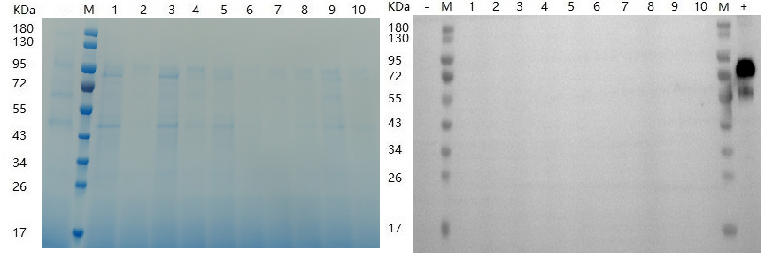
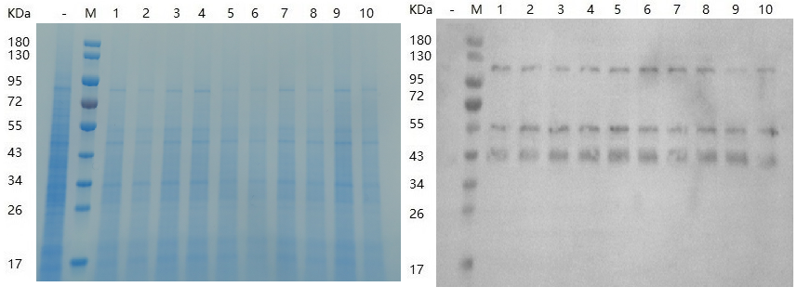
A
B
C
D
Supplementary Figure 4. Analysis of secreted (A, B) and intracellular (C, D) protein expression was carried out by SDS-PAGE and Western blot using an anti-His antibody. M: Protein marker; Lanes 1-10: Colonies positive by PCR detection; -: Negative control (uninduced); +: Positive control

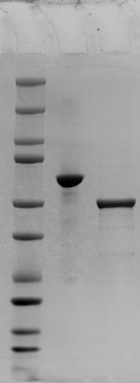
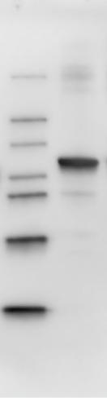
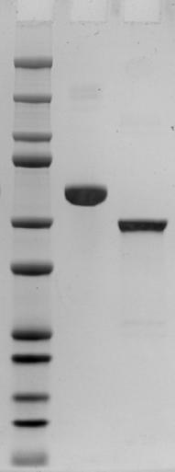
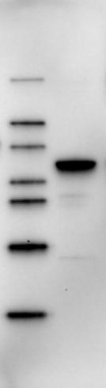
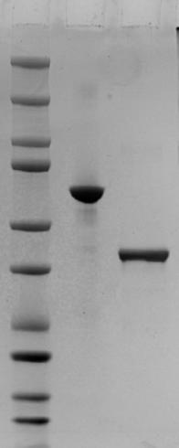
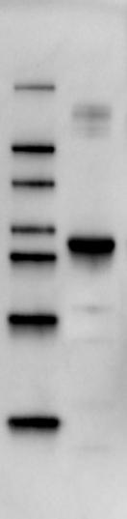
Western Blot
M1 HQT3
10
15
20
25
37
50
75
100
150
250
A
kDa
SDS
M1 BSA HQT2
18
32
42
50
60
80
120
Western Blot
M1 HQT2
B
10
15
20
25
37
50
75
100
1500
2500
SDS
M1 BSA HQT3
kDa
C
18
32
42
50
60
80
120
D
50
SDS
M1 BSA HQT4
10
15
20
25
37
75
100
150
200
E
kDa
32
18
42
50
60
80
120
Western Blot
M1 HQT4
kDa
F

Supplementary Figure 5. Analysis of intracellular protein expression of NtHQT2, NtHQT3, and NtHQT4 by SDS-PAGE and anti-His Western blot. M1: Protein marker; BSA: positive control.

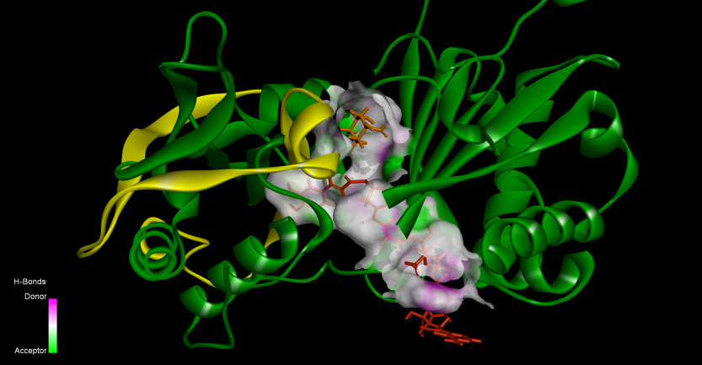
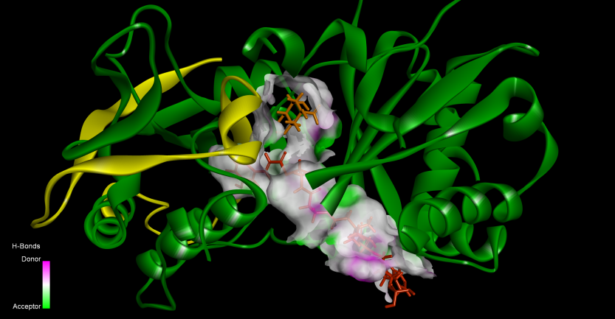
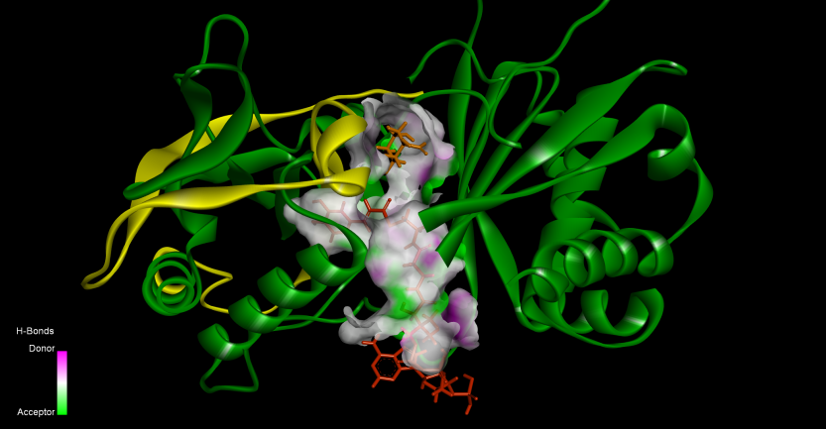
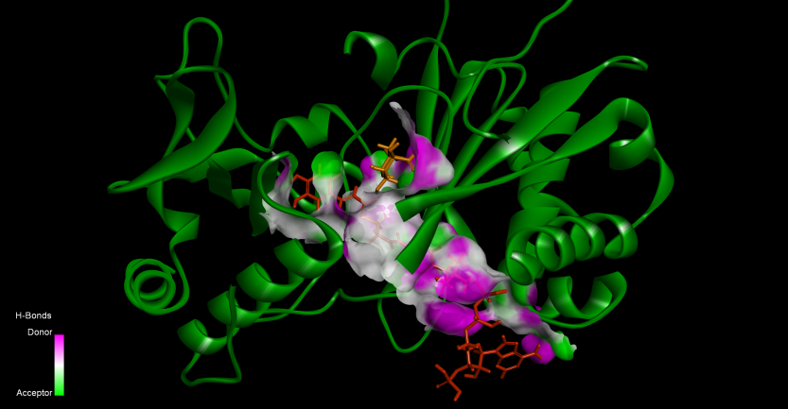
A
B
C
D

Supplementary Figure 6. A stereoview depicting the distribution of structural elements of NtHQT1 (A), NtNtHQT2 (B), NtHQT3 (C), and NtHQT4(D). Quinic acid is depicted in orange, Caffeoyl-CoA is represented in red.

Supplementary Figure 7. Downregulation of NtHQT1, NtHQT2, NtHQT3, and NtHQT4 gene expression in Nicotiana benthamiana leaves following VIGS-mediated silencing. Bars denoted by different letters indicate significant differences at P < 0.05, as determined by Duncan’s multiple test.

