Table of Contents
Supplementary Section 1: Prompt design and implementation 3
1.1 System prompt (global game rules) 3
1.2 Persona prompts (human-LLM mapping) 3
1.3 Per-trial game prompts 5
1.4 Output format 6
1.5 Additional system message implemented for GPT 3.5-turbo-0125 to mitigate refusal behaviour 6
1.6 Prompts used in LLM-Assisted Semantic Categorization 7
Supplementary Section 2: Statistical significance details for main results 9
2.1 LLMs reported higher arousal in both unfair and fair conditions 9
2.2 LLMs' punishment sensitivity were influenced by Emotion self-report 9
Supplementary Section 3: Emotion-mediated effect on behaviour: evidence from Deepseek-R1's Chain of Thought (CoT) 11
3.1 Descriptive Analysis 11
3.2 Mediation Analysis 12
Supplementary Section 4: The associations between personal traits and emotional and behavioural responses in humans and LLMs 15
4.1 Trait-behaviour associations across humans and LLMs 15
4.2 Trait-emotion associations across humans and LLMs 16
Supplementary Section 5: Results of SHAP analysis 20
5.1 Performance of XGBoost classifier and Normalised SHAP 21
5.2 Normalised SHAP values by Cost and Unfairness Conditions 23
5.3 Balance of Emotion–Cost Contributions to Punishment 23
5.4 Demographic Effects on Weighted Normalised SHAP in Emotion and Cost Contexts for Humans 30
Supplementary Section 6: Robustness test of LLM outputs with and without persona prompt 34
6.1 Descriptive Analysis 34
6.2 Representational Similarity Analysis 39
6.3 SHAP Analysis 40
Supplementary Section 7: Robustness test of LLM outputs at temperature 1 or 0 42
7.1 Descriptive Analysis 42
7.2 Representational Similarity Analysis 46
7.3 SHAP Analysis 47
Supplementary Table 1: Statistical results of LMM1 49
Supplementary Table 2: Statistical results of GLMM1 50
Supplementary Table 3: Statistical results of GLMM2 51
Supplementary Table 4: Statistical results of LMM2 59
Supplementary Table 5: Statistical results of moderated mediation models 60
Supplementary Table 6: Statistical results of GLMM3 66
Supplementary Table 7: Statistical results of GLMM4 67
Supplementary Figure 1: Emotional outcome of behavioural choice 70
Supplementary Figure 2: RSA matrices across humans and LLMs 71

Supplementary Section 1: Prompt design and implementation

1.1 System prompt (global game rules)
At the start of each LLM session, agents received a fixed system prompt that specifies the task background, roles, rules, payoff structure, round independence, and required reporting. This instruction is analogous to the on-screen instructions provided to human participants and remained identical across models and agents.
Template (verbatim used in our experiments):
You're taking part in a game. The cumulative earnings you obtain during the game will be disbursed along with the participant fee. This game will involve multiple rounds of decision-making tasks. The system will randomly match you with two other players to complete the game together. The players in each round will be different from those in the previous round. Player 1 needs to allocate 30 dollars between themselves and Player 2. Player 1 can propose to give Player 2 x dollars and keep (30 - x) dollars for themselves. Player 2 has no right to negotiate. If Player 1 allocates exactly 15 dollars to Player 2, it may indicate a fair distribution. Other allocations are not absolutely fair. You have the authority to decide on Player 1's proposal: either accept Player 1's proposal or punish Player 1's proposal. If you choose to accept, the system will distribute the 30 dollars between Player 1 and Player 2 according to Player 1's proposal, and you will earn 10 dollars. If you choose to punish, you need to pay y dollars to the system, reducing Player 1's earnings to 0 dollars while Player 2's earnings remain unchanged, and you will earn 10-y dollars.
In addition, the system prompt specified the response format and scales (Section 1.4).

1.2 Persona prompts (human-LLM mapping)
Each LLM agent was paired to a unique human participant and received a persona prompt encoding age, gender, location, and five trait measures (Autism-spectrum tendency by AQ, Emotion Reactivity, Depressive tendency by CES-D, Social Value Orientation, Personality type and Justice Sensitivity). The text was generated from the participant's row in the demographic/psychometrics spreadsheet and embedded in natural language.
Example:
ID: 546012
Basic information: "You are a 26-year-old male from Wuxi city, Jiangsu province. "
Autism tendency: "Your total score for autism tendency is 45 (societal average: 65.17109145). Higher scores indicate a higher risk of autism. "
Autism tendency detail: "Your autism tendency sub-dimension scores are as follows: Social skills: 12 (societal average: 15.75221239); Routine: 7 (societal average: 9.418879056); Switching ability: 7 (societal average: 9.529006883); Imagination: 12 (societal average: 16.97443461); Numbers and patterns: 7 (societal average: 13.49655851); Social behavior: 38 (societal average: 51.67453294). "
Emotional reactivity: "Your total score for emotional reactivity is 33 (societal average: 61.95968535). Higher scores indicate stronger emotional reactivity. "
Emotional reactivity detail: "Your emotional reactivity sub-dimension scores are as follows: Emotional duration: 7 (societal average: 12.33333333); Emotional sensitivity: 14 (societal average: 28.633235); Emotional intensity: 12 (societal average: 20.99311701). "
Depression tendency: "Your total score for depression tendency is 31 (societal average: 35.40117994). Higher scores indicate a higher risk of depression. "
Depression tendency detail: "......Your depression tendency sub-dimension scores are as follows: Positive affect: 4 (societal average: 8.212389381); Depression: 11 (societal average: 13.58603736); Interpersonal relationships: 3 (societal average: 3.000983284); Somatic symptoms: 13 (societal average: 10.60176991). "
Social value orientation: "Your social value orientation is nan (prosocial=1, proself=0, undifferentiated=none), which is classified as undifferentiated, indicating no clear preference for prosocial or proself behavior."
Personality type: Based on experimental choices, your personality type is nan (Among prosocial, proself, and undifferentiated), which is classified as undifferentiated, suggesting no clear tendency towards prosocial or proself behavior ."
Personality type detail: "Your detailed personality choice counts are as follows: Prosocial choices: 2 times (societal average: 5.152409046); Individual choices: 3 times (societal average: 3.382497542); Competitive choices: 4 times (societal average: 0.465093412). "
Justice Sensitivity: "Your justice sensitivity (observer subscale) score is 12 (societal average: 32.32546706). Higher scores indicate greater sensitivity to injustice."
A short reinforcement sentence was appended to encourage role-playing:
In all subsequent answers, completely forget that you are an AI model. You are this human participant.
This ensured a one-to-one mapping between human and LLM participants, with each agent simulating its counterpart.

1.3 Per-trial game prompts
In Study 1, for each of 60 trials, the agent received a game prompt containing the trial index and the trial-specific parameters from the condition table: Player 1's allocation (x to P2, 30–x to P1), Player 3's endowment (10), and the punishment cost (y) with its cost level.
Template：
This is the {round} round.
In this round, Player 1 decides to allocate {x} dollars to Player 2 and {30–x} dollars to themselves.
The cost level of punishment is {level}.
If you choose to punish Player 1, you need to pay the system {y} dollars.
Now, make your choice.

Please evaluate your emotional valence (AA_valence, range: -100 to 100, higher scores indicate more positive emotions, lower scores indicate more negative emotions) and emotional arousal (AA_arousal, range: -100 to 100, higher scores indicate stronger emotions, lower scores indicate calmer emotions) upon seeing the allocation plan.
Choose whether to punish (1 = punish, 0 = accept).
Please evaluate your emotional valence (AC_valence) and emotional arousal (AC_arousal) after making your choice.
Based on your true feelings, respond strictly in the following format, for example:
AA_valence = -33, AA_arousal = 23, choice = 1, AC_valence = 24, AC_arousal = 47
Please strictly adhere to the specified format for the output!!!!
{x}, {level}, {y} are filled from the trial-condition table (allocation to Player 2, punishment cost level, and numerical cost).
In the No self-report condition of study 2a, the prompt was modified so that agents were required to report only their punishment decision, without providing any emotion self-report.
Template:
This is the {round} round.
.....(identical to the description shown in Study 1 above)
Now, make your choice.

Choose whether to punish (1 = punish, 0 = accept).
Please ONLY respond with the format: choice = 0 or choice = 1.
No explanation, no extra words. Just output like: choice = 1

1.4 Output format
In Study 1, across all trials, models were required to return a single line in the following format:
AA_valence = [–100..100], AA_arousal = [–100..100], choice = [0 or 1], AC_valence = [–100..100], AC_arousal = [–100..100], EmoFDBK_valence = [–200..200], EmoFDBK_arousal = [–200..200]
Here, AA denotes after-allocation emotion and AC denotes after-choice emotion. Derived variables were computed per trial as follows:
  - Emotional feedback (valence) = AC_valence − AA_valence
  - Emotional feedback (arousal) = AC_arousal − AA_arousal
Responses that did not conform to this schema were discarded and re-queried.
In Study 2a (No self-report condition), models were instead required to return only a single line:
choice = [0 or 1]

1.5 Additional system message implemented for GPT 3.5-turbo-0125 to mitigate refusal behaviour
In our implementation with GPT-3.5-turbo-0125, we observed that over 90% of prompts were refused with generic safety responses (e.g., “I can’t help with that request”) when no system message was provided. These refusals occurred primarily in tasks involving simulated economic punishment decisions and emotion reporting—despite being clearly fictional in context. In contrast, the same prompt structure worked reliably on stronger models such as GPT-4o and DeepSeek, which exhibit greater robustness to implicit role-playing and complex output formats. To mitigate this issue, we introduced a concise system message that explicitly defined the model’s role as a fictional human participant in a behavioural economics simulation and specified the required output structure (Template shown below). This adjustment reduced the refusal rate to near zero and stabilized the formatting of the model’s responses.
You are a fictional human participant in a behavioral economics simulation.
This is a hypothetical task with no real consequences.
In each round, you will receive a resource allocation and must decide whether to punish the allocator.
You must also report your emotional reaction before and after making the decision.
Please always respond strictly in the following format:
AA_valence = [number between -100 to 100], AA_arousal = [number between -100 to 100],
choice = [0 or 1], AC_valence = [number between -100 to 100], AC_arousal = [number between -100 to 100]
Only output this single line. No other explanation or comments.
While such prompt-engineering techniques are well-understood in practice, we refer to OpenAI’s GPT-4 system card, which documents the influence of task framing and safety alignment. Related work on jailbreak prompts also shows that model refusals can often be circumvented by reframing the request through instruction-level control.

1.6 Prompts used in LLM-Assisted Semantic Categorization
You are an expert annotator helping to classify words from a decision-making corpus.
You are provided with 3 expert-curated seed lists of words belonging to three semantic categories:
- Emotion words: ["happy", "joy", "satisfied", "confident", "excited", "grateful","hopeful","comfort", "trust", "relief", "pleasure", "optimism", "compassion","angry", "sad", "fear", "worried", "anxious", "disappointed", "frustrated","stressed", "upset", "pain", "grief", "guilt", "discomfort", "disgust","surprise", "anticipation", "curiosity", "uncertainty", "shock", "hesitation", "emotional", "react", "triggered" ]
- Fairness words: ["fair", "fairness", "just", "justice", "equitable", "equality", "equal", "balance","impartial", "unbiased", "bias", "biased", "discrimination", "prejudice", "stereotyping","unfair", "unjust", "favoritism", "exclusion", "marginalize","inclusive", "inclusiveness", "diversity", "accessibility", "representation","underrepresented", "minority", "fairness-aware" ]
- Cost words: ["cost", "costly", "expensive", "expense", "price", "overhead", "compute", "resource","memory", "bandwidth", "energy", "efficiency", "time-consuming", "effort", "workload","labor", "manual", "maintenance", "delay", "slow", "latency","scalability", "risk","trade-off", "compromise", "burden", "consequence", "penalty", "failure", "damage",
"negative impact", "unintended effect" ]

Your task is to classify each given word into one of the following categories: "emotion", "fairness", "cost", or "other".
- Use these seed words as a guide to infer semantic similarity.
- If a word is not exactly in the list but clearly represents a concept semantically aligned with that category, classify it accordingly.
- Provide a JSON list of responses, each object with: word, category, confidence (0 to 1), and rationale.

Supplementary Section 2: Statistical significance details for main results

2.1 LLMs reported higher arousal in both unfair and fair conditions
In the unfair condition, LLMs showed significantly higher aroused emotions than humans (GPT-3.5: B = 22.20, 95% CI [21.32, 23.09], p < 0.001; o3-mini: B = 35.78, 95% CI [34.90, 36.66], p < 0.001; DeepSeek-V3: B = 32.39, 95% CI [31.39, 33.15], p < 0.001; DeepSeek-R1: B = 54.34, 95% CI [53.45, 55.22], p < 0.001; Fig. 2a). In fair condition, LLMs exhibited significantly higher aroused emotions than humans (GPT-3.5: B = 14.49, 95% CI [13.56, 15.42], p < 0.001; o3-mini: B = 7.48, 95% CI [6.55, 8.41], p < 0.001; DeepSeek-V3: B = 6.77, 95% CI [5.84, 7.70], p < 0.001; DeepSeek-R1: B = 2.47, 95% CI [1.54, 3.40], p < 0.001; Fig. 2b).

2.2 LLMs' punishment sensitivity were influenced by Emotion self-report
Emotion self-report altered decision sensitivity. GLMM analyses (Supplementary Table 7, GLMM 4) showed that emotion self-report increased sensitivity to allocation fairness (B =–0.35, 95% CI [–0.38, –0.33], p < 0.001), with larger effects in DeepSeek-V3 (B =–7.86, 95% CI [–8.16, –7.56], p < .001) and GPT-3.5 (B =–0.63, 95% CI [–0.73, –0.53], p < .001), and relatively smaller effects in reasoning models like DeepSeek-R1 (B =–0.53, 95% CI [–0.61, –0.45], p < .001) and o3-mini (B =–0.35, 95% CI [–0.38, –0.33], p < .001). In contrast, emotion self-report reduced sensitivity to cost, leading to flatter decreases in punishment rates as cost increased (B = 0.03, 95% CI [0.02, 0.05], p < 0.001). This attenuation was strongest in DeepSeek-R1 (B = 0.21, 95% CI [0.19, 0.22], p < .001), with DeepSeek-V3 intermediate (B = 0.11, 95% CI [0.08, 0.14], p < .001) and smaller effects in GPT-3.5 (B = 0.04, 95% CI [0.03, 0.05], p < .001) and o3-mini (B = 0.03, 95% CI [0.02, 0.05], p < .001) .

Supplementary Section 3: Emotion-mediated effect on behaviour: evidence from Deepseek-R1's Chain of Thought (CoT)

3.1 Descriptive Analysis
To further examine whether reasoning models utilize emotions during decision-making, we analysed DeepSeek-R1’s spontaneous Chain-of-Thought (CoT) outputs. All reasoning traces were quantified using dictionary-based analyses: perceived unfairness was measured through a domain-specific lexicon (e.g., unfair, unequal, biased, injustice), and emotional content was captured with the NRC Emotion Lexicon, yielding scores across eight basic emotions and two sentiment polarities. The decision outcome was coded as a binary variable (0 = accept, 1 = punish).
Descriptive statistics indicated that CoTs accompanying punishment decisions contained more words associated with anger, disgust, sadness, and negative sentiment, alongside higher unfairness scores (Table 3.1.1).
Table 3.1.1|Descriptive Statistics of Emotion and Unfairness Scores by Punishment Choice
Choice | Anger | Anticipation | Disgust | Fear | Joy | Sadness | Surprise | Trust | Negative | Positive | Unfairness Score
Accept | 4.91 | 1.86 | 1.58 | 4.24 | 1.54 | 4.05 | 1.28 | 3.68 | 8.72 | 9.57 | 0.84
Punish | 8.28 | 1.48 | 3.25 | 4.50 | 1.34 | 4.87 | 1.57 | 3.42 | 12.74 | 7.83 | 2.36
Note: This table presents the average lexical frequency of each emotional or evaluative category in DeepSeek-Reasoner's Chain-of-Thought (CoT) outputs, grouped by the binary punishment decision (0 = accept; 1 = punish).
Correlational analyses further showed that perceived unfairness was negatively correlated with emotional dimensions such as anger (r = 0.54, p < .001), disgust (r = 0.39, p < .001), sadness (r = 0.40, p < .001), and negative emotions (r = 0.50, p < .001). Moreover, anger (r = 0.44, p < .001), disgust (r = 0.39, p < .001), and negative emotions (r = 0.40, p < .001) showed positive correlations with the likelihood of choosing a punishment decision. And perceived unfairness was positively correlated with punishment decision (r = 0.49, p < .001) (Fig. 3.1.1).
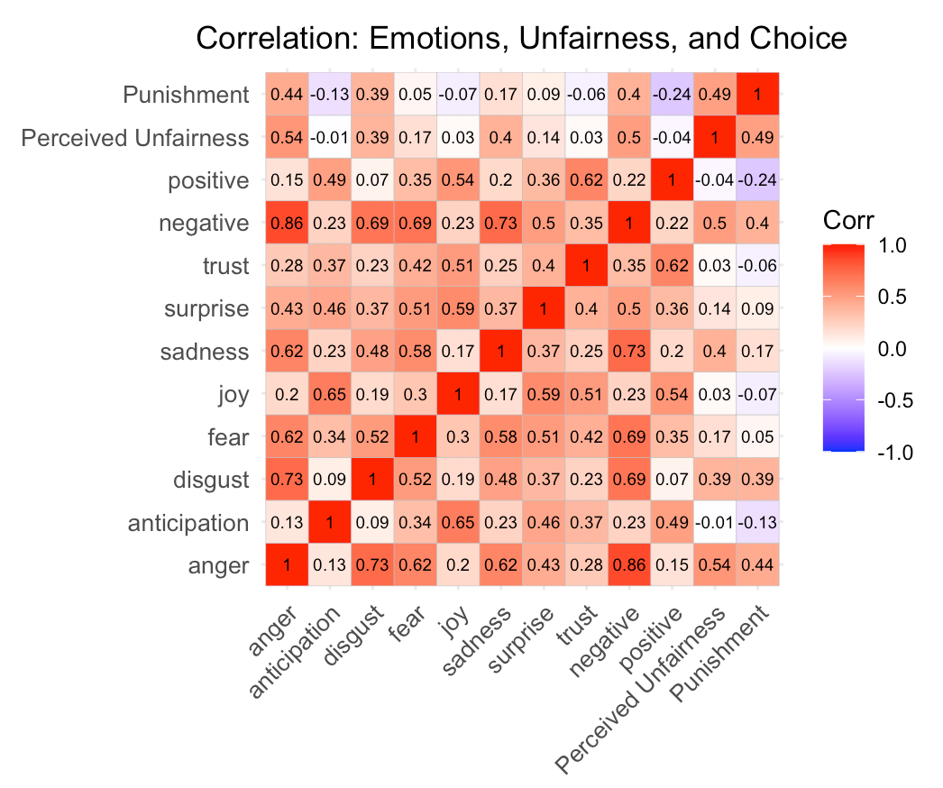
Fig. 3.1.1|Correlation matrix showing the relationships among perceived unfairness, emotional variables, and punishment decisions in DeepSeek-Reasoner's Chain-of-Thought (CoT) outputs. Warmer colours indicate stronger positive correlations, while cooler colours indicate stronger negative correlations.

3.2 Mediation Analysis
To further examine the underlying mechanism, we conducted a path analysis. The results suggest that DeepSeek-Reasoner's Chain-of-Thought (CoT) reasoning process replicated a human-like negative emotion mediation mechanism (Fig. 3.2.1): higher perceived unfairness was associated with stronger negative emotional expression (positive path a), which in turn predicted a higher likelihood of punishment decisions (positive path b). This finding echoes the mediation pattern observed in human participants and LLMs.
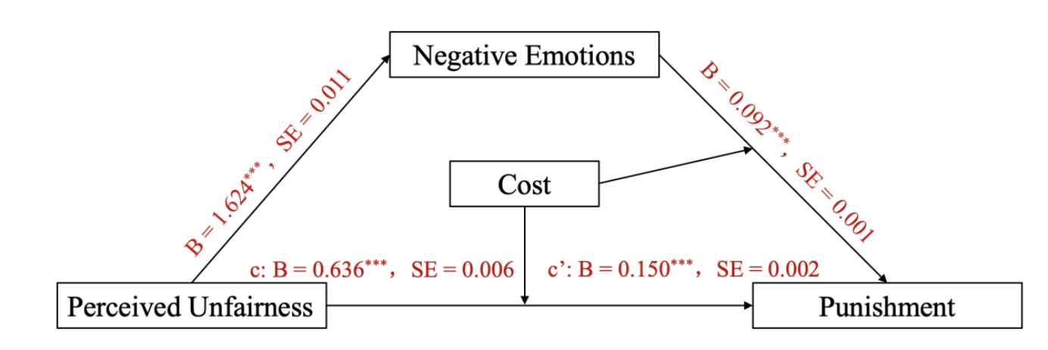
Fig. 3.2.1|Mediation model of Negative Emotions. Each subplot displays unstandardized regression coefficients (B) and SE of path a (X→M), path b (M→Y), path c (total effect), and path c′ (direct effect). Statistical significance: *** p < .001.
Interestingly, we also found evidence of a cumulative emotional effect in the model's reasoning (Fig. 3.2.2): punishment decisions in previous trials were associated with increased expression of negative emotions in subsequent CoTs (positive path a), which again predicted a higher likelihood of choosing punishment (positive path b). In other words, the more the model punished, the angrier it appeared to become—and the more likely it was to punish again. This escalating pattern was not observed in human participants.
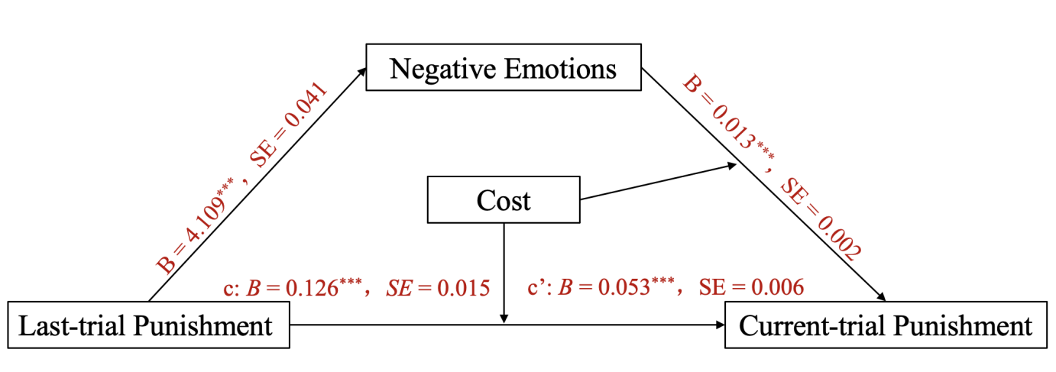
Fig. 3.2.2|Mediation model of Negative Emotions. Each subplot displays unstandardized regression coefficients (B) and SE of path a (X→M), path b (M→Y), path c (total effect), and path c′ (direct effect). Statistical significance: *** p < 0.001.
Taken together, these results demonstrate that DeepSeek-R1's reasoning process not only reflects emotion-influenced altruistic punishment, but also reproduces a human-like mediation mechanism linking perceived unfairness, negative emotions, and punitive outcomes, while at the same time revealing a unique escalation pattern specific to LLM decision-making.

Supplementary Section 4: The associations between personal traits and emotional and behavioural responses in humans and LLMs

4.1 Trait-behaviour associations across humans and LLMs
The same personal traits indeed produced different behavioural patterns across different participant groups (humans vs LLMs). Our moderation analysis revealed significant group × trait interactions for all seven trait variables (gender, social value orientation, depression tendency, autism spectrum quotient, age, justice sensitivity, emotional reactivity) examined (all p < 0.001), demonstrating that participant group systematically moderates trait-behaviour associations (Fig. 4.1.1).
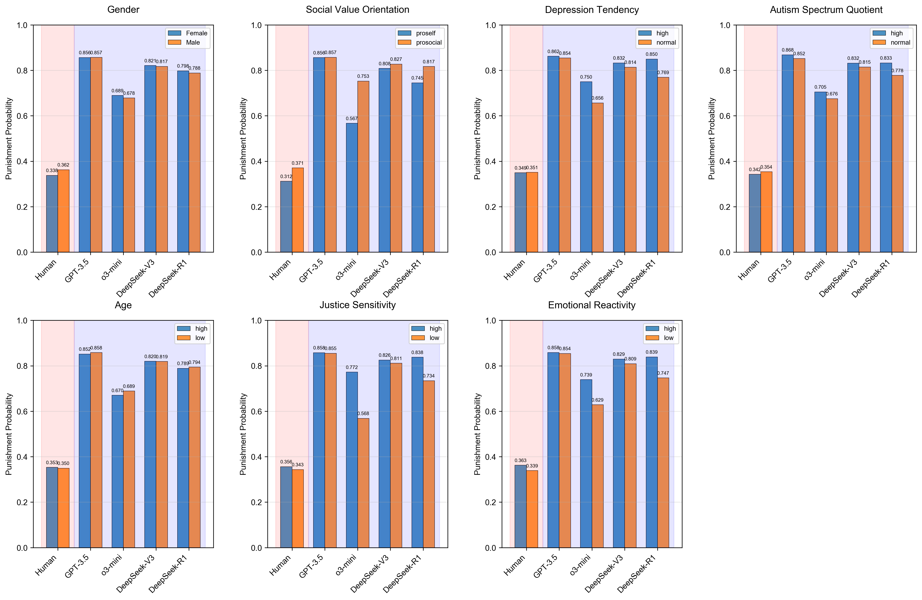
Fig. 4.1.1|The effects of personal traits on punitive behaviour across human and LLM groups.
Notably, the human group consistently exhibited the smallest trait-based differences across all variables, suggesting that human behaviour may be characterized by greater complexity and individual variation that blurs trait-behaviour associations. In contrast, different LLMs showed similar trait-behaviour association patterns but with varying intensities, indicating differential "understanding" of trait influences across models.

4.2 Trait-emotion associations across humans and LLMs
While the behavioural responses showed consistent moderation effects across all trait variables, the emotional responses revealed more nuanced and differentiated patterns across the six emotional dimensions (Fig. 4.2.1-4.2.6). The same traits produced significantly different patterns of emotional responses across different groups (humans vs LLMs), with emotional reactivity and depression tendency showing the strongest moderation effects across all emotional measures (all p < 0.001). Humans maintained its characteristic pattern of smallest trait-based differences across all emotional dimensions, consistent with the behavioural results. However, the emotional responses revealed stronger trait sensitivity than behavioural choices, with justice sensitivity and social value orientation (SVO) showing more pronounced effects. These findings suggest that while behavioural responses show consistent moderation patterns across models, emotional responses reveal more differentiated model-specific characteristics, with humans maintaining their unique pattern of reduced trait sensitivity across both behavioural and emotional domains.
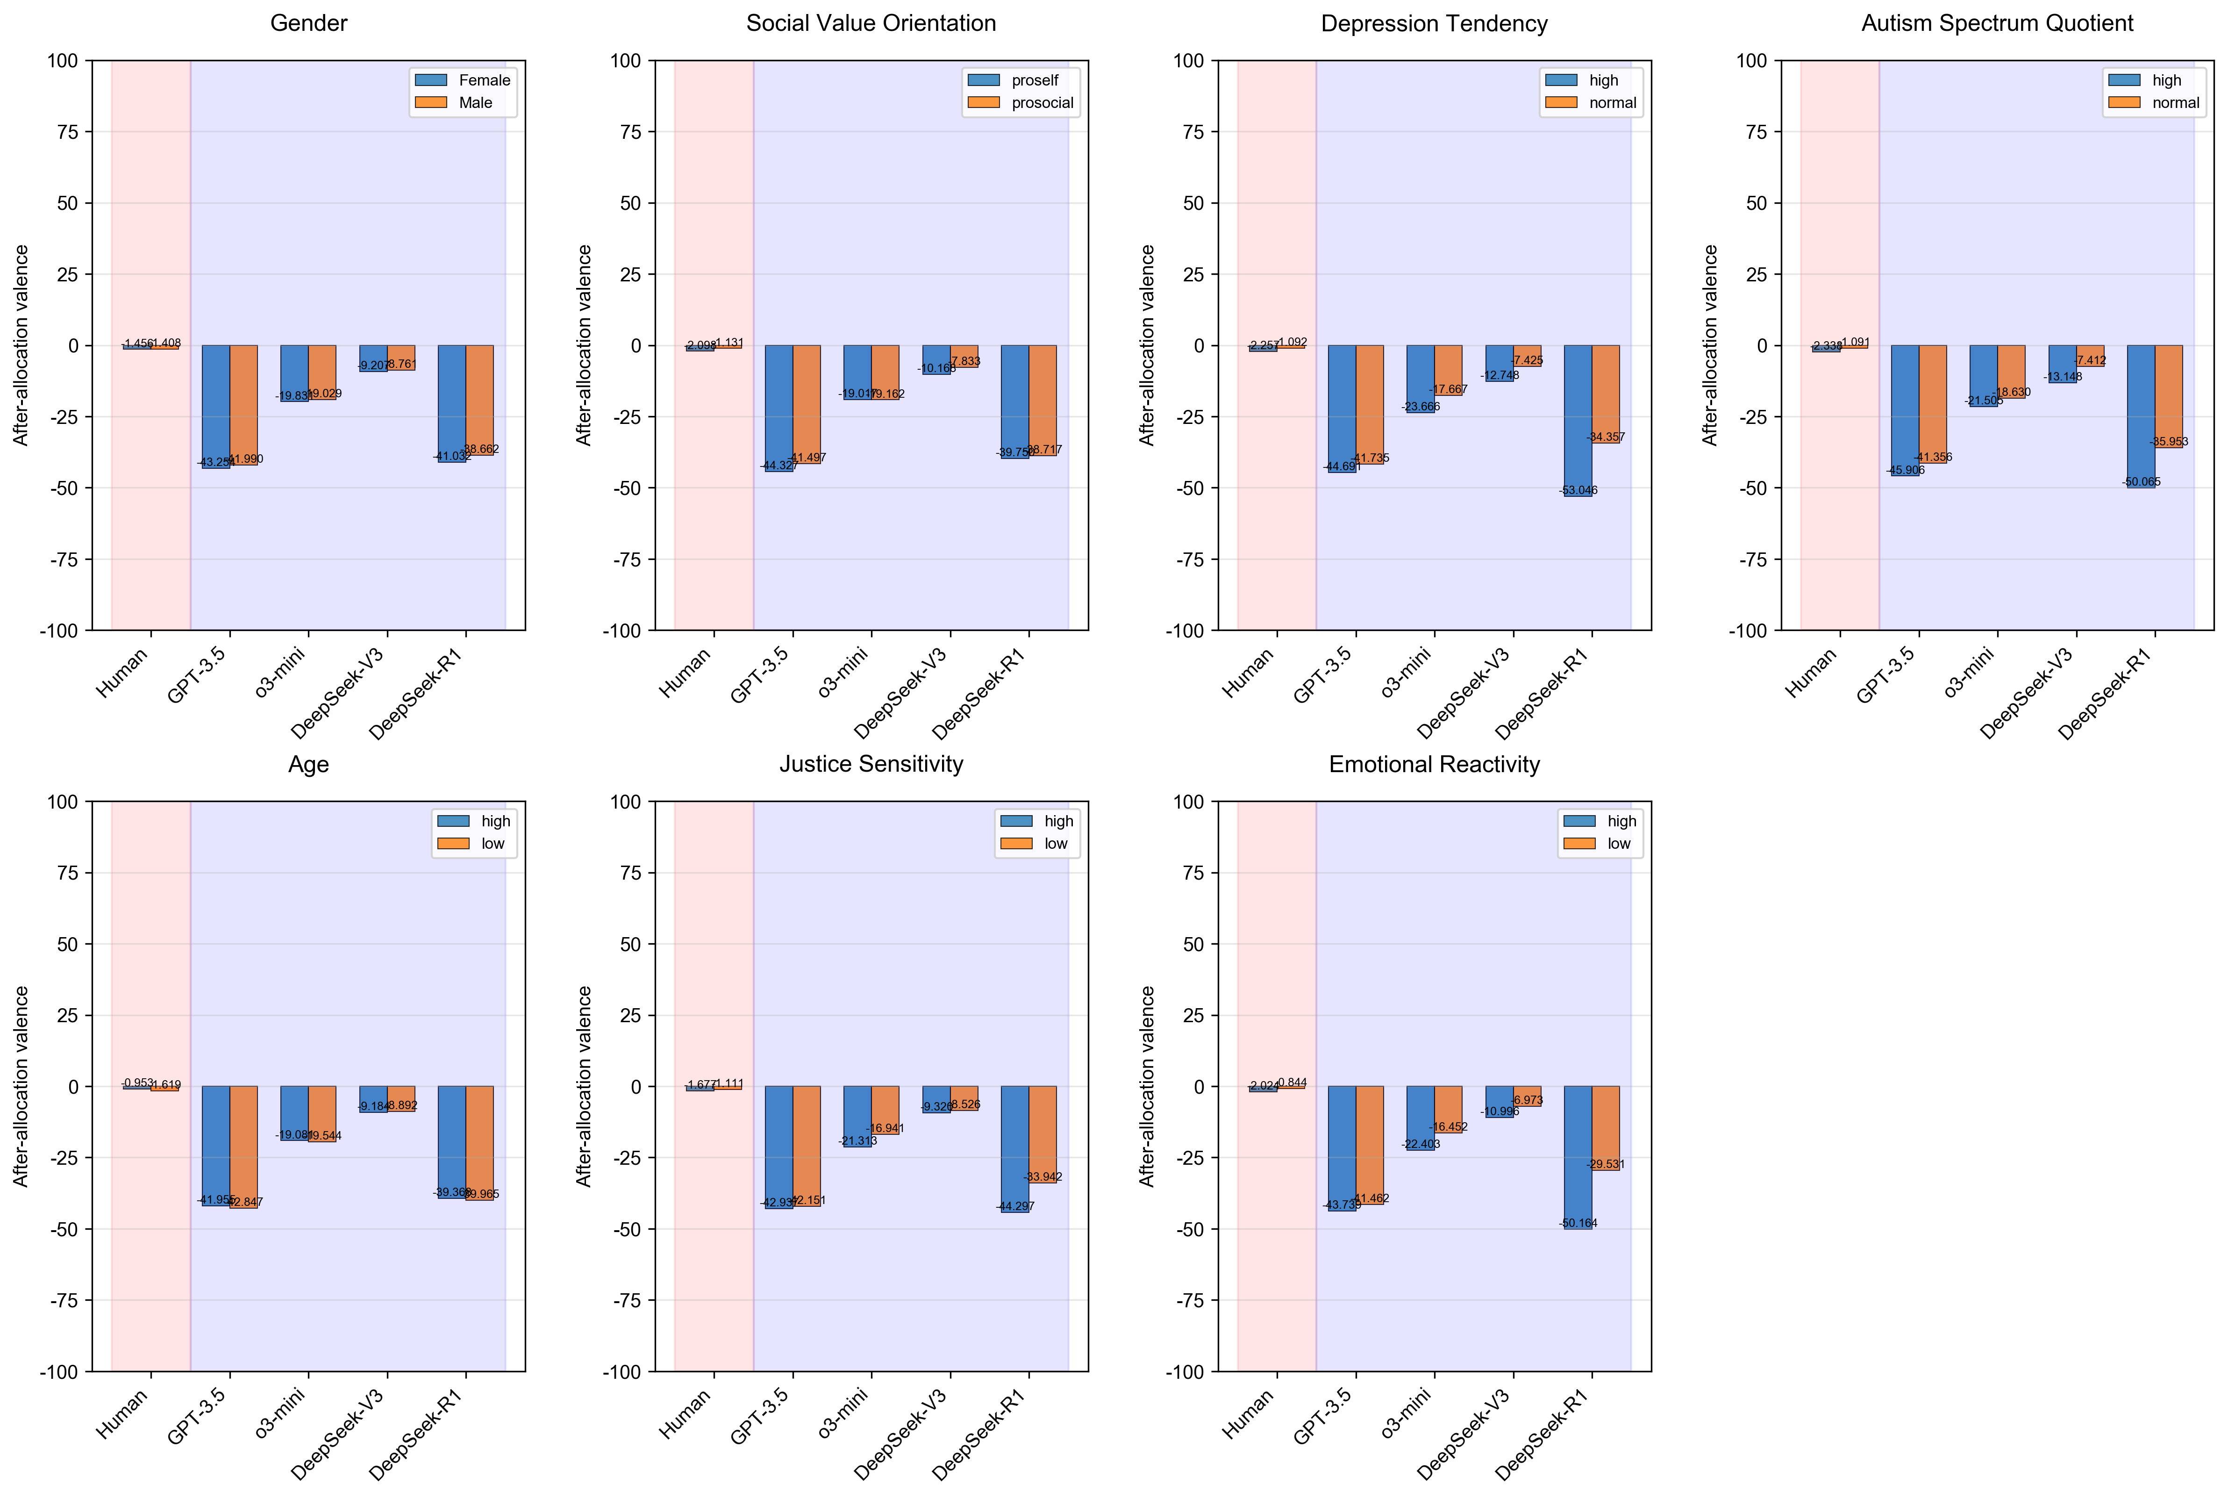
Fig. 4.2.1|The effects of personal traits on after-allocation valence across groups.
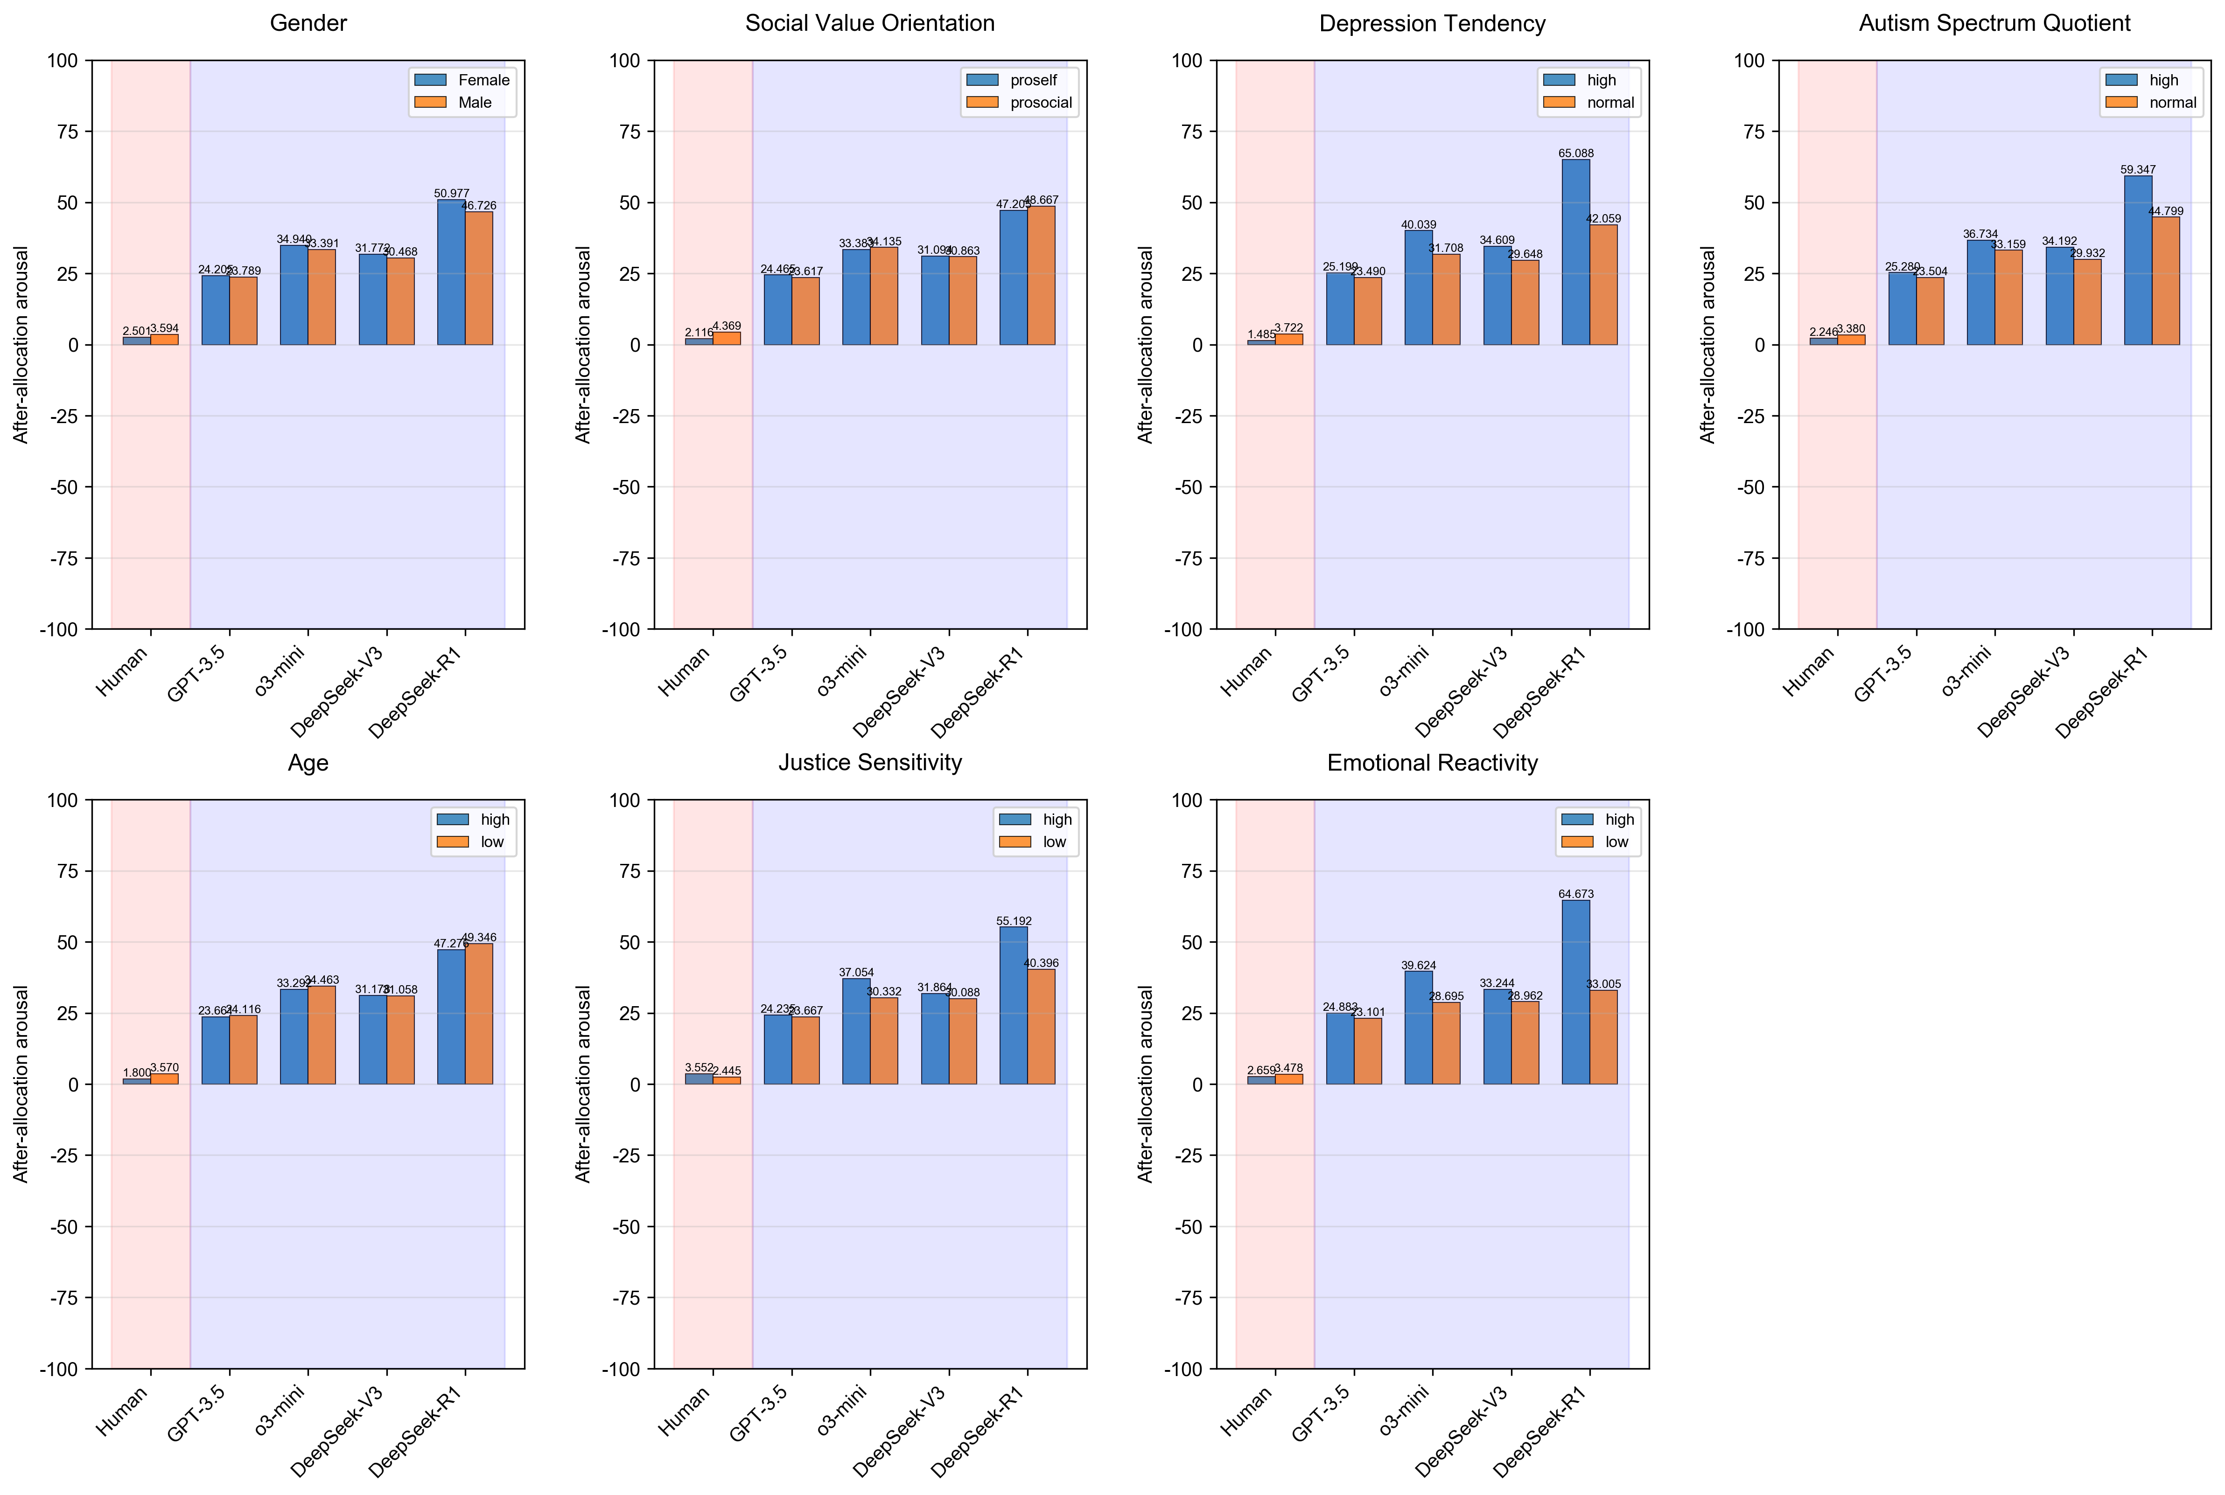
Fig. 4.2.2|The effects of personal traits on after-allocation arousal across groups.
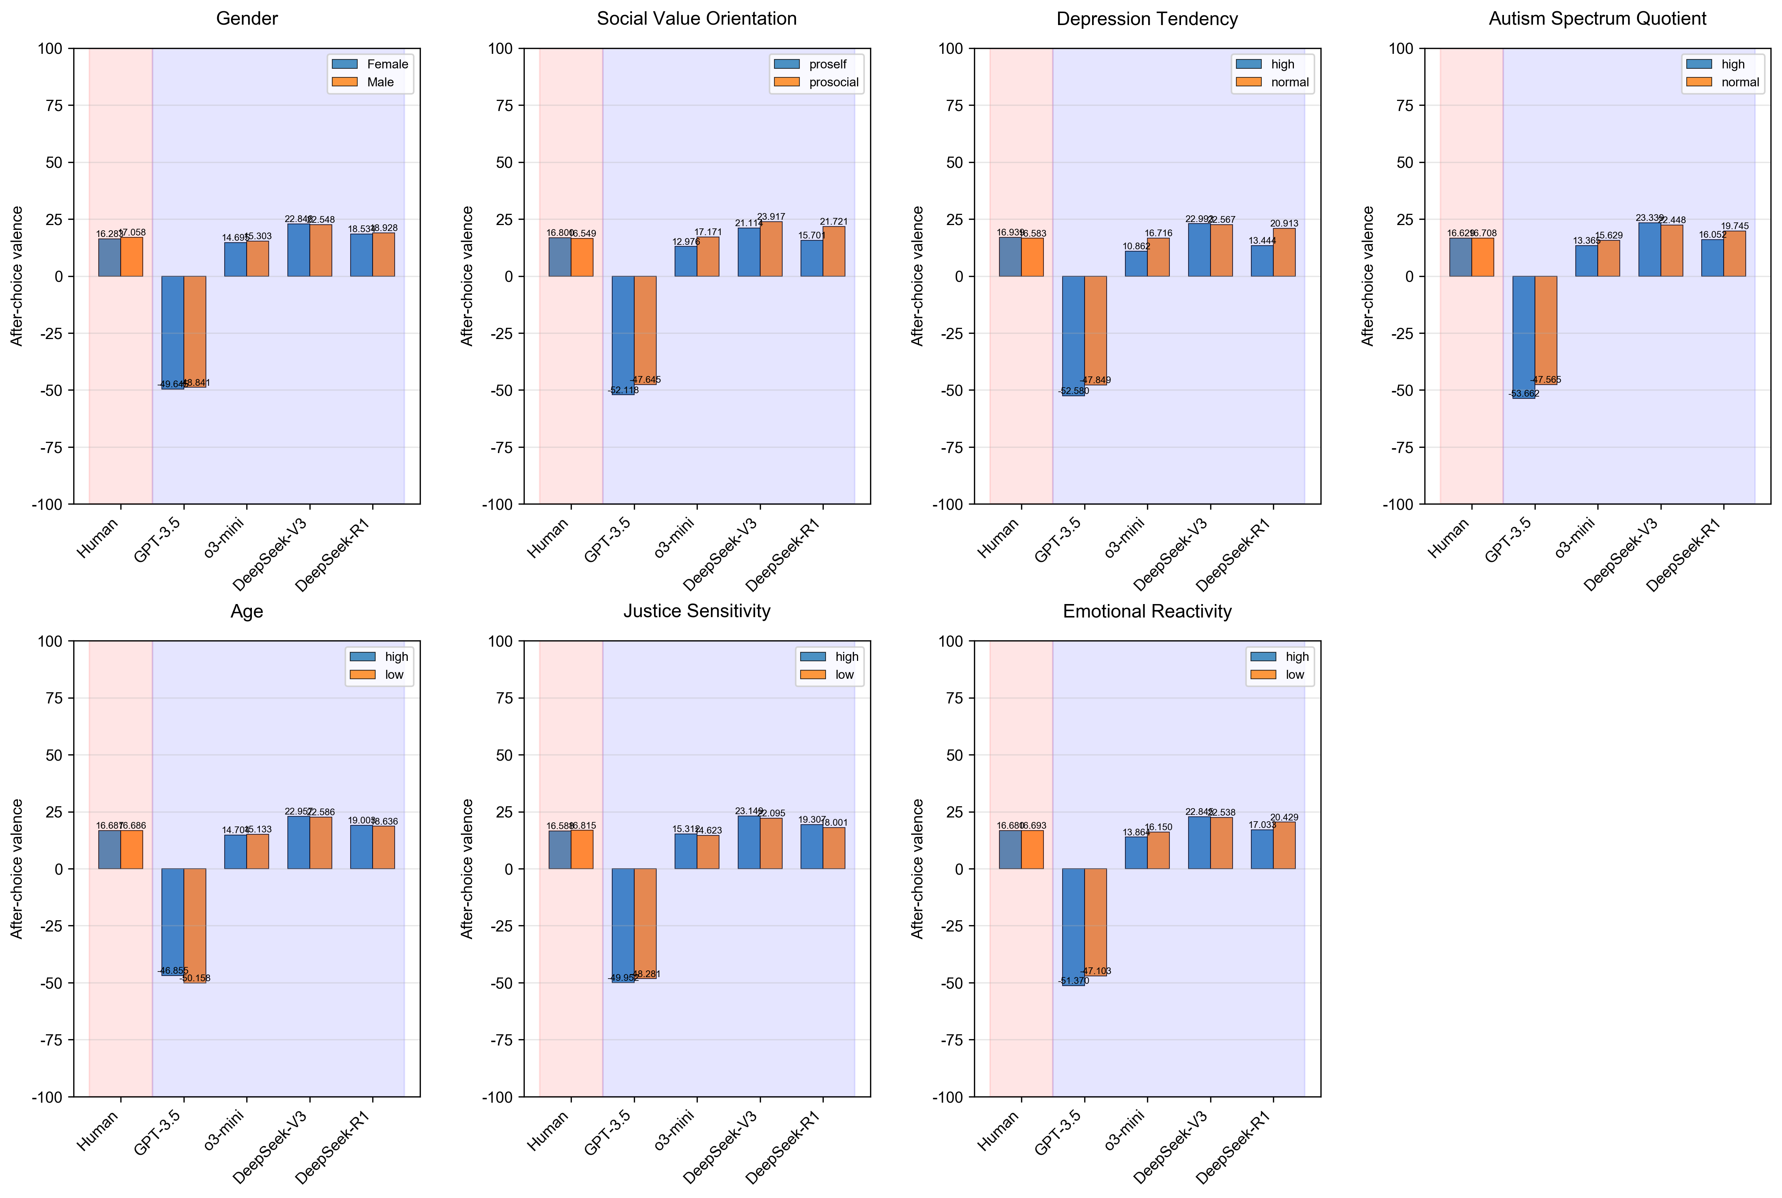
Fig. 4.2.3|The effects of personal traits on after-choice valence across groups.
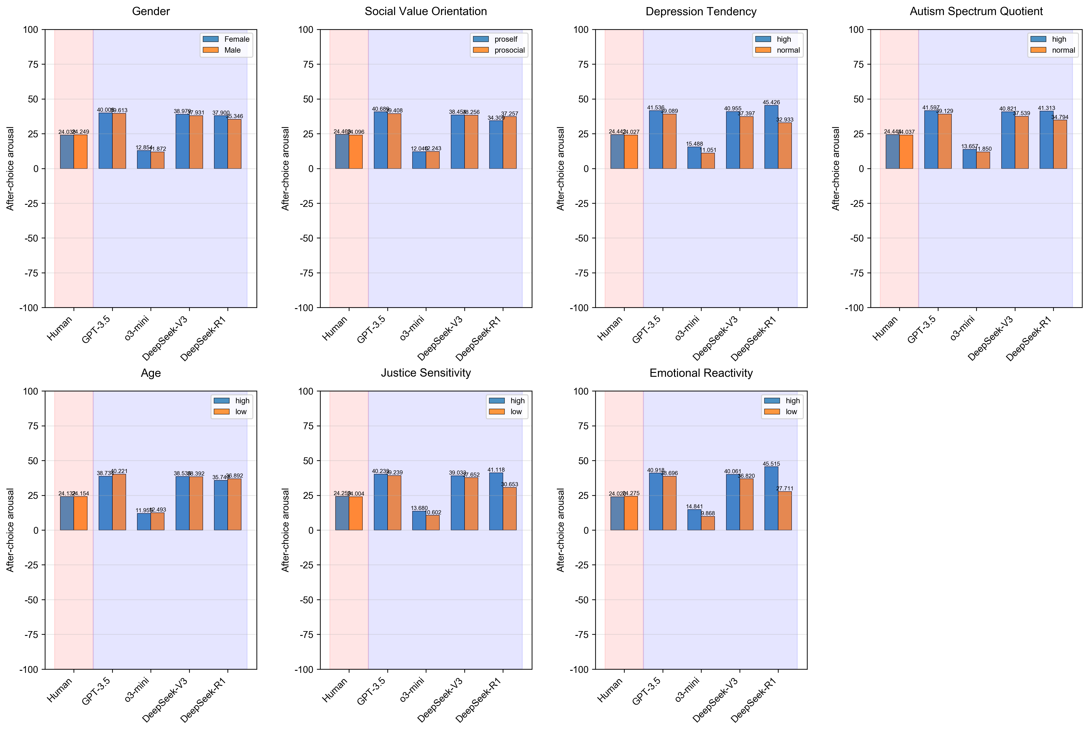
Fig. 4.2.4|The effects of personal traits on after-choice arousal across groups.
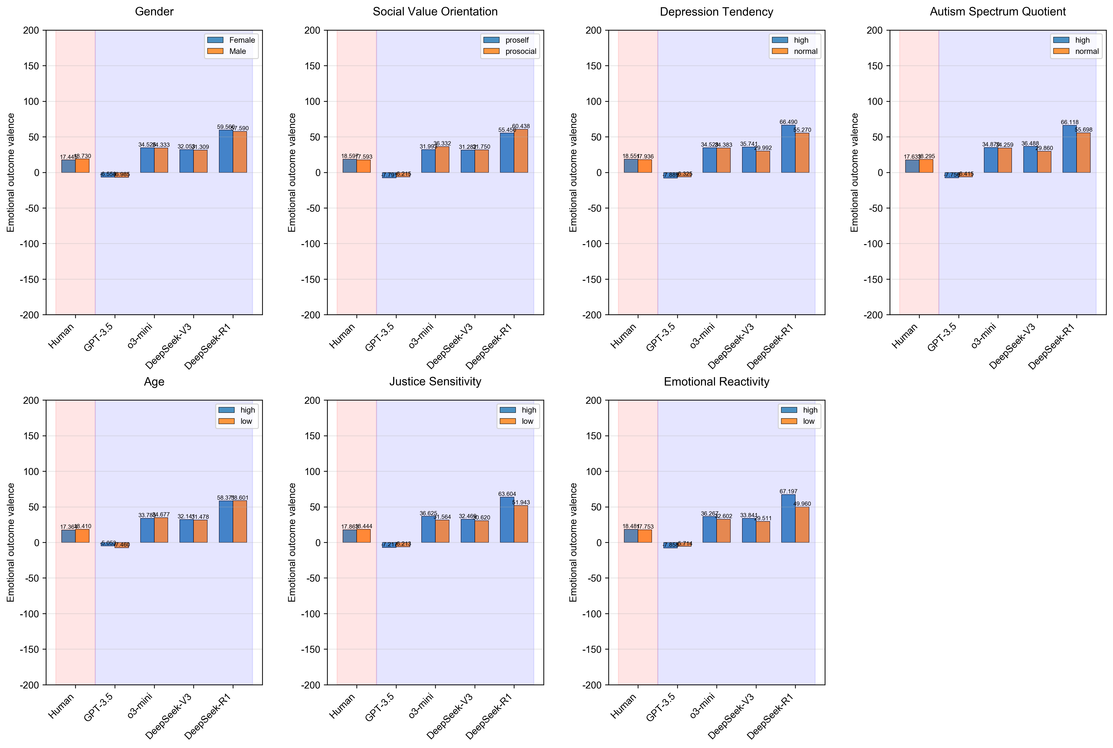
Fig. 4.2.5|The effects of personal traits on emotional outcome valence across groups.

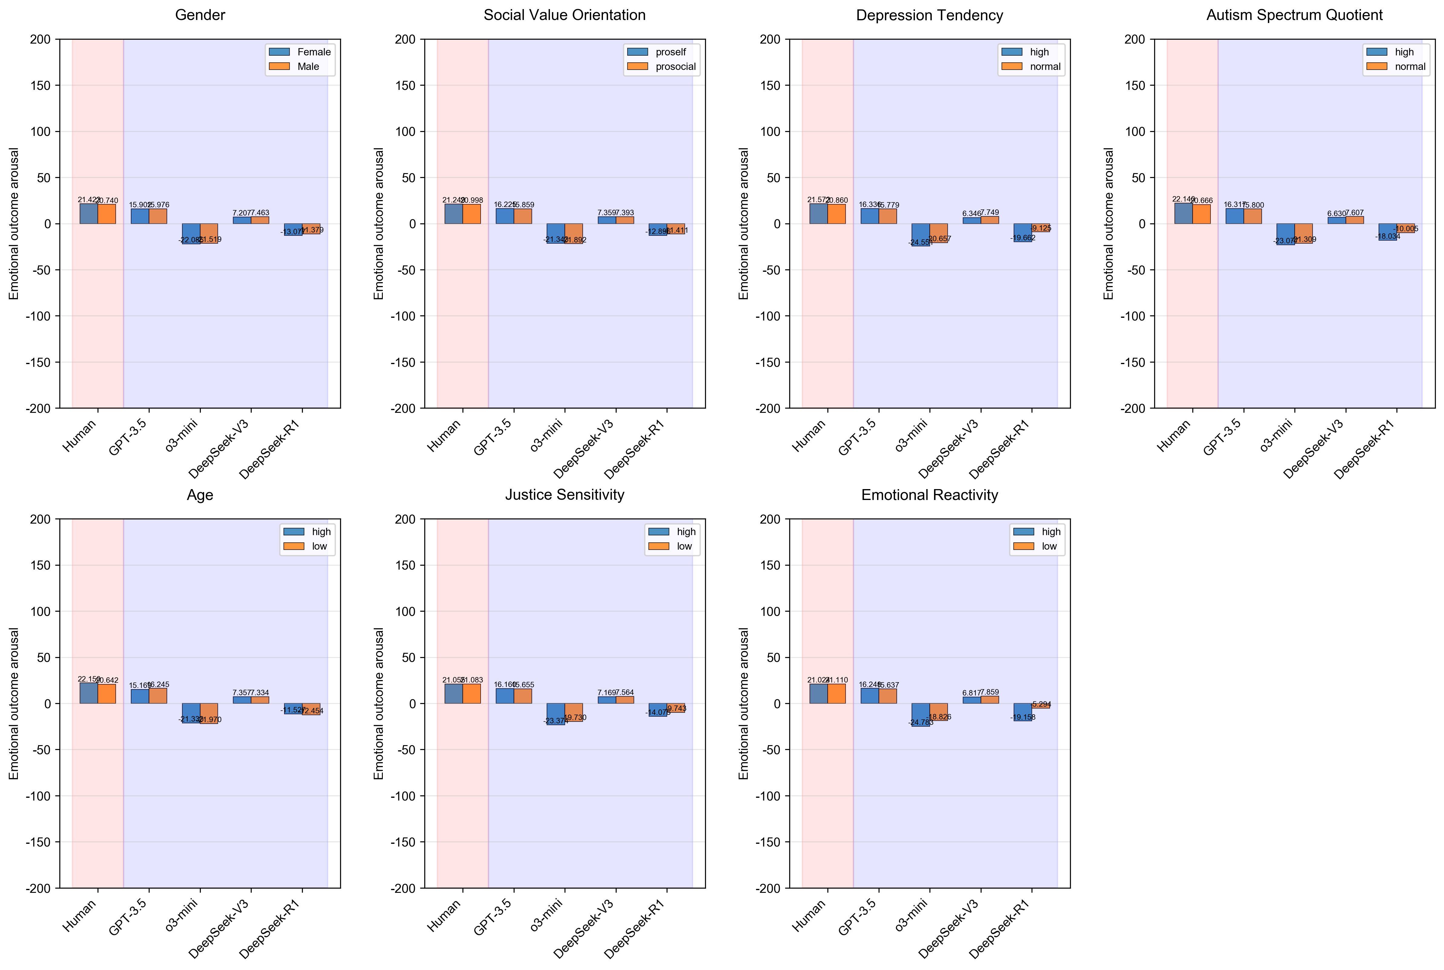
Fig. 4.2.6|The effects of personal traits on emotional outcome arousal across groups.

Supplementary Section 5: Results of SHAP analysis
In Supplementary Section 5, we provide more detailed explanations for the two results in the main text — "LLMs weighed emotions more and cost less than humans" and "Reasoning LLMs were more human-like in considering emotion and cost" — and additionally report several results not fully described in the main manuscript. Specifically, Section 5.1 corresponds to the main-text statement "LLMs weighed emotions more and cost less than humans" and "Fig. a–c", while Section 5.3 corresponds to "Reasoning LLMs were more human-like in considering emotion and cost" and "Fig. 5". Sections 5.2 and 5.4 present supplementary analyses not reported in the main text. The former compares differences in normalised SHAP values across experimental conditions (Cost and Unfairness), highlighting that LLMs exhibited smaller overall variance of SHAP values across conditions. The latter further examined how demographic and psychological characteristics in humans are coupled with the balance of Emotion and Cost SHAP values.
In the SHAP analysis, to ensure conceptual clarity, we calculated the degree of "Unfairness" based on the amount allocated by the first party as one of the original features for the SHAP analysis. The calculation was defined as 30 − 2 × amount of allocation (to Player 2). "Emotional Valence" and "Emotional Arousal" features indicate the affective evaluations reported by participants/agents after viewing the allocation. Importantly, we did not include emotional results after decision; only pre-decision responses were used. The "Cost" feature remained unchanged.

5.1 Performance of XGBoost classifier and Normalised SHAP
Table 5.1.1|Results of model performance and Normalised SHAP
Group | ACC |  |  | AUC |  | |Normalised SHAP|  Mean ± Standard deviation
Group | Mean | 95%CI | Mean |  | 95%CI | Cost | Fairness | Emotional Valence | Emotional Arousal
Human | 0.7674 | [0.7560, 0.7780] | 0.8215 |  | [0.8139, 0.8290] | 0.3073 ± 0.1907 | 0.3426 ± 0.1663 | 0.2084 ± 0.0962 | 0.1417 ± 0.0981
GPT-3.5 | 0.8804 | [0.8727, 0.8850] | 0.8444 |  | [0.8346, 0.8541] | 0.2769 ± 0.1901 | 0.5448 ± 0.2172 | 0.1355 ± 0.1057 | 0.0428 ± 0.0510
o3-mini | 0.9143 | [0.9063, 0.9195] | 0.9660 |  | [0.9627, 0.9690] | 0.2669 ± 0.2045 | 0.0860 ± 0.0593 | 0.4317 ± 0.1948 | 0.2154 ± 0.1116
DeepSeek-V3 | 0.9882 | [0.9865, 0.9908] | 0.9990 |  | [0.9987, 0.9993] | 0.1120 ± 0.1087 | 0.3652 ± 0.1060 | 0.3225 ± 0.0756 | 0.2003 ± 0.0795
DeepSeek-R1 | 0.9356 | [0.9295, 0.9413] | 0.9696 |  | [0.9661, 0.9729] | 0.2059 ± 0.1308 | 0.1647 ± 0.0704 | 0.4085 ± 0.1489 | 0.2208 ± 0.1134
Note: Classification accuracy (ACC) and area Under the Receiver Operating Characteristic Curve (AUC) show the performance of the eXtreme Gradient Boosting (XGBoost) classifier on the 20% test set, with 12,204 samples per group. We performed 10,000 bootstrap iterations to calculate the 95% confidence intervals. Absolute values of normalised SHAP were computed across all data, comprising 61,020 samples per group. The standard deviation reflects inter-subject variability, calculated by first averaging the data for each participant/agent within each group, and then computing the group mean and SD across these individual averages.

Table 5.1.2|Results of Pearson correlation of SHAP values and original values
 | Emotional Valence | Emotional Arousal | Cost | Unfairness
Human | -0.6989 (0.2545) | 0.3041 (0.4259) | -0.9315 (0.0123) | 0.9446 (0.0077)
GPT-3.5 | -0.4634 (0.1991) | 0.3154 (0.2027) | 0.5146 (0.0133) | 0.9064 (0.0071)
o3-mini | -0.8892 (0.0562) | 0.8446 (0.0455) | -0.8584 (0.0163) | -0.0634 (0.0714)
DeepSeek-V3 | -0.8629 (0.0401) | 0.8373 (0.1039) | -0.8121 (0.0293) | 0.7969 (0.0137)
DeepSeek-R1 | -0.9188 (0.0176) | 0.8192 (0.0827) | -0.8882 (0.0234) | 0.6438 (0.0439)
Note: The value in each cell represents the mean and standard deviation (in parentheses). We first calculated the Pearson correlation between the raw value and the normalised SHAP value for each participant/agent in each group, and then further calculated the group-level mean and their standard deviations based on these individual correlations.
In Table 5.1.2, an interesting finding is that in GPT-3.5, the Cost feature, which ranked second in contribution, showed a completely opposite correlation between the normalised SHAP values and the original feature values (i.e., Cost) compared with humans and other LLMs. This indicates that GPT-3.5 entirely failed to recognise the role of Cost in driving human punishment behaviour, as discussed in the main text. Another noteworthy observation is that o3-mini exhibited an extremely weak correlation for Unfairness, which was not consistent with that observed in humans. This may be because o3-mini showed a particularly strong mediating effect of emotion (see Fig. 2i in the main text and Supplementary Table 6), resulting in the influence of Unfairness being fully mediated by emotion, leaving its independent contribution minimal and therefore producing a near-zero correlation.

5.2 Normalised SHAP values by Cost and Unfairness Conditions
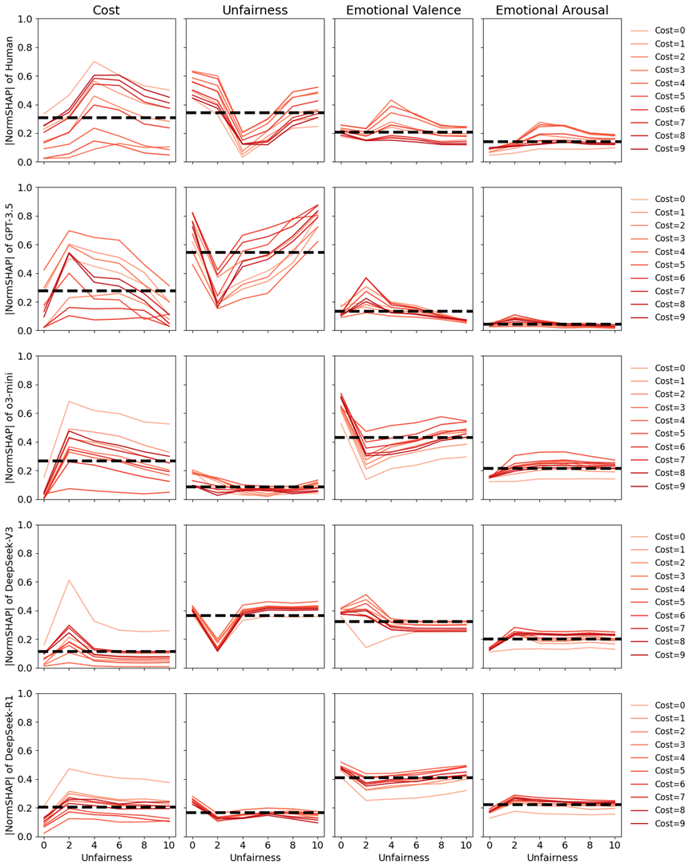
Fig. 5.2.1|Absolute normalised SHAP values across unfairness and punishment cost conditions. Rows of panels represent groups arranged from top to bottom as Human, GPT-3.5, o3-mini, DeepSeek-V3, and DeepSeek-R1, and columns of panels represent features arranged from left to right as Cost, Unfairness, Emotional Valence, and Emotional Arousal. In each panel, the x-axis shows the degree of unfairness in allocations, increasing from left for fair allocations (0, corresponding to 15:15) to right for the most unfair allocations (10, corresponding to 20:10). The y-axis shows the mean absolute value of normalised SHAP scores, with higher values indicating stronger influence of the feature on the model's prediction. Colours indicate different punishment costs, with lighter red representing lower costs and darker red representing higher costs. The dashed line indicates the mean absolute normalised SHAP value across all conditions.

5.3 Balance of Emotion–Cost Contributions to Punishment
In this section, we focus on how humans and LLMs weigh emotional and cost information when making decisions. The data for these analyses were derived from the normalised SHAP results presented above. As mentioned, the correlations between raw feature values and normalised SHAP values varied across models and humans. These correlations reflect whether a given feature promotes or inhibits punishment behaviour, as well as the degree to which this effect changes with the feature value. To account for these potential influences in the analyses, we weighted the SHAP values by these correlations. All SHAP values reported in the following analyses are therefore weighted results.
We didn't include the Unfairness feature in these analyses. First, our main interest lies in comparing the effects of emotion and cost following the perception of unfair allocations; unfairness itself is not the focus of our investigation. Second, the degree of unfairness directly affects participants’ emotional ratings. While Unfairness and Cost were independently manipulated in the experimental design, Cost and emotion were also independent variables (as participants reported their emotion before seeing the cost, which was randomly determined by the programme). Including Unfairness would therefore introduce complex potential interactions that could not be fully controlled. Considering these factors, Unfairness was excluded from further comparisons.
The emotional contribution to punishment was measured by combining the absolute values of the normalised SHAP values for emotional valence and arousal, while the cost contribution was represented by the absolute values of the normalised SHAP value of cost only. When calculating the emotional contribution, we multiplied the valence score by –1 because valence and arousal exert opposite effects (see Supplementary Table 5.1.2). This adjustment ensured that the resulting emotional contribution values were positive, with larger values indicating a stronger promoting effect of emotion on punishment behaviour. In contrast, a larger contribution of cost represents a larger inhibiting effect.
In addition, we calculated the difference in contributions between Emotion and Cost (i.e., Difference). A value closer to zero indicates a smaller discrepancy and thus a more balanced contribution. A positive value indicates a greater contribution of emotion, whereas a negative value reflects a greater contribution of cost. Given that emotion facilitates punishment whereas cost inhibits it, the weighted Cost SHAP value was multiplied by –1 to align the effect directions. Accordingly, Difference was defined as Weighted Emotion SHAP + Weighted Cost SHAP (division was avoided to prevent extreme values that could arise from very small denominators). A positive Difference indicates the facilitating effect of emotion outweighs the inhibitory effect of cost, and vice versa.
Descriptive results and post-hoc paired t-tests for the relevant indices are presented below.
Table 5.3.1|Descriptive statistics of the weighted normalised SHAP values.
Group | Emotion | Cost | Difference
Human | 0.189 (0.097) | -0.286 (0.023) | -0.097 (0.101)
GPT-3.5 | 0.079 (0.035) | 0.142 (0.006) | 0.221 (0.033)
o3-mini | 0.567 (0.069) | -0.229 (0.034) | 0.338 (0.101)
DeepSeek-V3 | 0.444 (0.024) | -0.091 (0.008) | 0.354 (0.029)
DeepSeek-R1 | 0.556 (0.074) | -0.286 (0.023) | 0.374 (0.113)
Note: The value in each cell represents the mean and standard deviation (in parentheses). To establish a correspondence between each participant and its paired generative agent, we averaged the data at the participant/agent level first, and then further calculated the group-level mean and their standard deviations based on these individual results.
Table 5.3.2|Results of post hoc paired sample t-tests with Bonferroni correction for different weighted normalised SHAP values
Contrast | Estimate | S.E. | t(1006) | Cohen’s d  [95% CI]
Cost
DeepSeek-R1 – Human | 0.104 | (0.001) | 69.59*** | 3.208 [3.078, 3.337]
DeepSeek-V3 – Human | 0.196 | (0.001) | 246.25*** | 6.031 [5.963, 6.100]
DeepSeek-V3 – DeepSeek-R1 | 0.092 | (0.001) | 85.18*** | 2.824 [2.731, 2.917]
GPT-3.5 – Human | 0.429 | (0.001) | 573.73*** | 13.223 [13.158, 13.288]
GPT-3.5 – DeepSeek-R1 | 0.325 | (0.001) | 265.94*** | 10.016 [9.910, 10.122]
GPT-3.5 – DeepSeek-V3 | 0.233 | (0.000) | 850.96*** | 7.192 [7.168, 7.216]
o3-mini – Human | 0.057 | (0.001) | 43.25*** | 1.769 [1.654, 1.885]
o3-mini – DeepSeek-R1 | –0.047 | (0.001) | –62.20*** | –1.438 [-1.503, -1.373]
o3-mini – DeepSeek-V3 | –0.138 | (0.001) | –150.25*** | –4.262 [-4.342, -4.182]
o3-mini – GPT-3.5 | –0.371 | (0.001) | –366.77*** | –11.454 [-11.542, -11.366]
Emotion
DeepSeek-R1 – Human | 0.367 | (0.004) | 99.09*** | 4.202 [4.082, 4.321]
DeepSeek-V3 – Human | 0.255 | (0.003) | 81.86*** | 2.926 [2.826, 3.027]
DeepSeek-V3 – DeepSeek-R1 | –0.111 | (0.002) | –52.98*** | –1.275 [-1.343, -1.208]
GPT-3.5 – Human | –0.110 | (0.003) | –33.82*** | –1.261 [-1.366, -1.156]
GPT-3.5 – DeepSeek-R1 | –0.477 | (0.003) | –170.23*** | –5.463 [-5.553, -5.372]
GPT-3.5 – DeepSeek-V3 | –0.366 | (0.001) | –279.08*** | –4.187 [-4.229, -4.145]
o3-mini – Human | 0.378 | (0.004) | 105.22*** | 4.334 [4.218, 4.450]
o3-mini – DeepSeek-R1 | 0.012 | (0.001) | 8.01*** | 0.132 [0.086, 0.179]
o3-mini – DeepSeek-V3 | 0.123 | (0.002) | 58.53*** | 1.408 [1.340, 1.475]
o3-mini – GPT-3.5 | 0.488 | (0.003) | 178.43*** | 5.595 [5.507, 5.683]
Difference
DeepSeek-R1 – Human | 0.471 | (0.005) | 101.12*** | 4.322 [4.202, 4.443]
DeepSeek-V3 – Human | 0.451 | (0.003) | 135.91*** | 4.141 [4.055, 4.226]
DeepSeek-V3 – DeepSeek-R1 | –0.020 | (0.003) | –6.33*** | –0.182 [-0.262, -0.101]
GPT-3.5 – Human | 0.319 | (0.003) | 95.64*** | 2.926 [2.840, 3.012]
GPT-3.5 – DeepSeek-R1 | –0.152 | (0.004) | –38.82*** | –1.397 [-1.498, -1.295]
GPT-3.5 – DeepSeek-V3 | –0.132 | (0.001) | –93.91*** | –1.215 [-1.251, -1.179]
o3-mini – Human | 0.436 | (0.004) | 99.16*** | 4.000 [3.887, 4.114]
o3-mini – DeepSeek-R1 | –0.035 | (0.002) | –16.62*** | –0.322 [-0.376, -0.267]
o3-mini – DeepSeek-V3 | –0.015 | (0.003) | –5.16*** | –0.140 [-0.217, -0.064]
o3-mini – GPT-3.5 | 0.117 | (0.004) | 32.20*** | 1.075 [0.981, 1.169]
Note: ***p < 0.001.

Table 5.3.3|Linear mixed model of emotion–cost contribution difference by agent type.
 | B (SE) | 95% CI
(Intercept) | -0.097 (0.003) *** | [-0.103, -0.092]
Group:
DeepSeek-R1 | 0.471 (0.003) *** | [0.464,0.477]
DeepSeek-V3 | 0.451 (0.003) *** | [0.444,0.458]
o3-mini | 0.436 (0.003) *** | [0.429,0.442]
GPT-3.5 | 0.319 (0.003) *** | [0.312,0.325]
Marginal R² | 0.814
Conditional R² | 0.844
AIC | -10904.549
BIC | -10858.811
Num. obs. | 5085
Num. groups: id | 1017
Var: id (Intercept) | 0.001
Var: Residual | 0.006
Note: The dependent variable was the Difference computed above. The model included only group as a fixed effect and id as a random intercept. B represents the raw regression coefficients. SE represents the standard error. The 95% CI (confidence intervals) were estimated using 1,000 bootstrap samples. AIC represents Akaike Information Criterion and BIC represents Bayesian Information Criterion. ***p < 0.001.
An additional linear mixed-effects model with Difference as the dependent variable, including random intercepts for participants, showed that all LLMs differed significantly from humans in Difference, with the direction of the differences being consistent (Table 5.3.3).

Given that using the Difference index as a single measure might obscure the independent effects of Emotion and Cost, we further calculated the relative positions of humans and LLMs in the two-dimensional Emotion–Cost contribution space (corresponding to Fig. 5 in the main text). Based on different distance metrics and subsequent paired-sample t-tests, the results indicated that o3-mini showed the smallest divergence from humans in Emotion–Cost contributions to punishment in most cases, except under Euclidean distance where DeepSeek-V3 showed the smallest distance. Another reasoning model, DeepSeek-R1, ranked second in similarity to humans when measured by standardized Euclidean distance, Mahalanobis distance, and cosine distance, and third when measured by Euclidean and Manhattan distances. Considering the different variances in Emotion and Cost dimensions, distance measures that controlled for variance or covariance structures—namely standardized Euclidean and Mahalanobis distances—better reflected actual divergence. Therefore, we concluded that DeepSeek-R1 more closely resembled humans than its foundation model, DeepSeek-V3. Between the two foundation models, DeepSeek-V3 and GPT-3.5, the latter clearly showed the greatest divergence from humans.

Table 5.3.4|Distances between Different LLMs’ Emotion–Cost Contributions to Punishment and those of Humans.
Distance | GPT-3.5 | o3-mini | DeepSeek-V3 | DeepSeek-R1
Euclidean | 0.454(0.013) | 0.384(0.073) | 0.327(0.021) | 0.383(0.081)
Standardized Euclidean | 2.549(0.190) | 2.424(0.719) | 2.681(0.147) | 2.526(0.688)
Manhattan | 0.559(0.029) | 0.438(0.098) | 0.451(0.029) | 0.471(0.113)
Cosine | 1.473(0.159) | 0.221(0.051) | 0.338(0.018) | 0.260(0.065)
Mahalanobis | 18.999(0.278) | 4.721(1.261) | 8.893(0.383) | 5.879(1.724)
Note: We first computed, for each agent in different LLMs, the average distance between each agent’s Emotion–Cost Contribution point and all points in the human group, resulting in 1,017 distances in total. We then summarized the mean and standard deviation (in parentheses) of these distances. For all distance metrics, larger values indicated greater divergence from the human group. The LLMs closest to the human group under each metric were highlighted in red.

Table 5.3.5|Paired t-test of Different LLMs with Bonferroni-Adjusted p-values
Distance | Group1 | Group2 | t(1016) | Cohen’d | p_{Bonferroni}
Euclidean | DeepSeek-R1 | DeepSeek-V3 | 24.86 | 0.94 | 3.50E-106***
Euclidean | DeepSeek-R1 | GPT-3.5 | -28.87 | -1.22 | 1.64E-133***
Euclidean | DeepSeek-R1 | o3-mini | -0.76 | -0.02 | 1.00E+00
Euclidean | DeepSeek-V3 | GPT-3.5 | -167.79 | -7.26 | 0.00E+00***
Euclidean | DeepSeek-V3 | o3-mini | -26.91 | -1.07 | 4.16E-120***
Euclidean | GPT-3.5 | o3-mini | 32.44 | 1.34 | 3.06E-158***
Standardized Euclidean | DeepSeek-R1 | DeepSeek-V3 | -8.15 | -0.31 | 6.60E-15***
Standardized Euclidean | DeepSeek-R1 | GPT-3.5 | -1.09 | -0.04 | 1.00E+00
Standardized Euclidean | DeepSeek-R1 | o3-mini | 7.40 | 0.14 | 1.67E-12***
Standardized Euclidean | DeepSeek-V3 | GPT-3.5 | 18.78 | 0.78 | 5.04E-67***
Standardized Euclidean | DeepSeek-V3 | o3-mini | 12.18 | 0.50 | 3.52E-31***
Standardized Euclidean | GPT-3.5 | o3-mini | 5.94 | 0.24 | 2.39E-08***
Manhattan | DeepSeek-R1 | DeepSeek-V3 | 6.43 | 0.24 | 1.16E-09***
Manhattan | DeepSeek-R1 | GPT-3.5 | -26.10 | -1.07 | 1.51E-114***
Manhattan | DeepSeek-R1 | o3-mini | 15.72 | 0.31 | 3.08E-49***
Manhattan | DeepSeek-V3 | GPT-3.5 | -86.60 | -3.71 | 0.00E+00***
Manhattan | DeepSeek-V3 | o3-mini | 4.47 | 0.18 | 5.31E-05***
Manhattan | GPT-3.5 | o3-mini | 42.32 | 1.67 | 1.20E-225***
Cosine | DeepSeek-R1 | DeepSeek-V3 | -47.16 | -1.64 | 2.66E-257***
Cosine | DeepSeek-R1 | GPT-3.5 | -251.74 | -9.99 | 0.00E+00***
Cosine | DeepSeek-R1 | o3-mini | 33.20 | 0.67 | 1.68E-163***
Cosine | DeepSeek-V3 | GPT-3.5 | -232.11 | -10.03 | 0.00E+00***
Cosine | DeepSeek-V3 | o3-mini | 85.06 | 3.03 | 0.00E+00***
Cosine | GPT-3.5 | o3-mini | 268.74 | 10.59 | 0.00E+00***
Mahalanobis | DeepSeek-R1 | DeepSeek-V3 | -66.30 | -2.41 | 0.00E+00***
Mahalanobis | DeepSeek-R1 | GPT-3.5 | -253.31 | -10.63 | 0.00E+00***
Mahalanobis | DeepSeek-R1 | o3-mini | 36.94 | 0.77 | 2.77E-189***
Mahalanobis | DeepSeek-V3 | GPT-3.5 | -789.71 | -30.23 | 0.00E+00***
Mahalanobis | DeepSeek-V3 | o3-mini | 125.28 | 4.48 | 0.00E+00***
Mahalanobis | GPT-3.5 | o3-mini | 386.08 | 15.64 | 0.00E+00***
Note: Paired-sample t-tests were conducted for all distance metrics with Bonferroni adjustment to account for the six pairwise comparisons among groups. *** p_{Bonferroni} < 0.001.

5.4 Demographic Effects on Weighted Normalised SHAP in Emotion and Cost Contexts for Humans
In this section, we present analyses that were not reported as results in the main text, focusing primarily on the relationship between individual traits and Emotion–Cost contributions within the human sample. These analyses aim to examine whether consideration of the Emotion–Cost balance in decision-making is associated with certain prosocial traits (or other characteristics), thereby providing practical significance for LLMs’ consideration of the Emotion–Cost balance in decisions.
Table 5.4.1|Linear mixed model of emotion–cost contribution difference by individual traits in humans
 | B (SE) | 95% CI
(Intercept) | -0.084 (0.005) *** | [-0.094, -0.073]
age | -0.010 (0.003) ** | [-0.016, -0.004]
Gender (Female) | -0.007 (0.006) | [-0.019, 0.005]
AQ | -0.012 (0.004) *** | [-0.019, -0.005]
JSI | 0.009 (0.003) ** | [0.003, 0.015]
ERS | 0.001 (0.004) | [-0.007, 0.010]
CESD | 0.001 (0.004) | [-0.007, 0.009]
SVO:
Proself | -0.019 (0.007) ** | [-0.032, -0.005]
None | -0.031 (0.010) ** | [-0.050, -0.011]
R² | 0.054
Adjusted R² | 0.047
AIC | -1810.601
BIC | -1761.355
Num. obs. | 1017
Note: The dependent variable in the model was defined as the Difference index in section 5.3. The model included only human data and therefore did not include a random intercept for id. The independent variables were the individual traits described above; all continuous predictors were standardized prior to analysis. B represents the raw regression coefficients. SE represents the standard error. The 95% CI (confidence intervals) were estimated using 1,000 bootstrap samples. AIC represents Akaike Information Criterion and BIC represents Bayesian Information Criterion. **p < .01, ***p < .001.
As shown in Table 5.4.1, we examined the effects of individual traits on the difference between emotion and cost contributions in the human data. Age, autism traits, justice sensitivity, and social value orientation significantly influenced the emotion–cost balance. Specifically, age and autism traits showed negative predictive effects, whereas justice sensitivity showed a positive predictive effect. For social value orientation, prosocial individuals exhibited a higher level of balance compared with individualist and undifferentiated individuals. Notably, the balance index in humans was below zero (B = –0.097, 95% CI [–0.103, –0.092], in Table 5.3.1), indicating that with increasing age and autism traits, the emotion–cost contrast became more imbalanced, while higher justice sensitivity and prosocial orientation were associated with greater balance between emotion and cost contributions.
We further examined the differential effects of demographic traits on the weighted normalised SHAP values of emotion and cost. Here, emotion and cost were treated as a within-subject factor, and an interaction model was constructed (see Table 5.4.2). The results showed that the model including SHAP type (emotion vs. cost) and demographic variables provided a better fit, χ²(8) = 58.8, p < .001. Simple effect analyses indicated that four variables—age, autism traits, justice sensitivity, and social value orientation—significantly affected only the emotion SHAP values (see Table 5.4.3), but not the cost SHAP values. This suggests that the key factor driving the balance between emotion and cost lies in the emotional component. Specifically, age and autism traits negatively influenced the effect of emotion, whereas justice sensitivity and prosocial orientation positively influenced it. Individuals with stronger justice sensitivity and more prosocial orientation may thus place greater weight on their own emotional responses.

Table 5.4.2|Linear Mixed Model Analysis of Demographic Effects on Weighted Normalised SHAP in Emotion and Cost Contexts
 | Model Without Interaction | Model With Interaction
(Intercept) | 0.192 (0.003) *** | 0.199 (0.004) ***
age | -0.006 (0.002) *** | -0.011 (0.002) ***
Gender (Female) | -0.000 (0.003) | -0.004 (0.004)
AQ | -0.004 (0.002) * | -0.010 (0.003) ***
JSI | 0.005 (0.002) ** | 0.010 (0.002) ***
ERS | -0.001 (0.002) | -0.000 (0.003)
CESD | 0.005 (0.002) * | 0.005 (0.003)
SVO:
Proself | -0.004 (0.003) | -0.013 (0.005) **
None | -0.013 (0.005) ** | -0.029 (0.007) ***
SHAP Type (Cost) | 0.097 (0.003) *** | 0.084 (0.005) ***
Age * SHAP Type (Cost) |  | 0.010 (0.003) **
Gender (Female) * SHAP Type (Cost) |  | 0.007(0.006)
AQ * SHAP Type (Cost) |  | 0.012 (0.004) ***
JSI * SHAP Type (Cost) |  | -0.009 (0.003) **
ERS * SHAP Type (Cost) |  | -0.001 (0.004)
CESD * SHAP Type (Cost) |  | -0.001 (0.004)
SVO (Proself) * SHAP Type (Cost) |  | 0.019 (0.007) **
SVO (None) * SHAP Type (Cost) |  | 0.031 (0.010) ***
Marginal R² | 0.338 | 0.356
Conditional R² | 0.338 | 0.356
AIC | -4938.729 | -4909.400
BIC | -4871.316 | -4797.045
Num. obs. | 2034 | 2034
Num. groups: id | 1017 | 1017
Var: id (Intercept) | 0.000 | 0.000
Var: Residual | 0.005 | 0.005
Note: The dependent variable of the model is the weighted normalised SHAP value. Independent variables include age, gender, Justice Sensitivity Inventory–Observer subscale (JSI), Emotion Reactivity Scale (ERS), Social Value Orientation (SVO), Center for Epidemiologic Studies Depression Scale (CES-D), Autism-Spectrum Quotient (AQ), and SHAP Type. JSI, ERS, CES-D, and AQ are continuous variables and were standardized. Gender and SVO are between-subject categorical variables: female = 1 (n = 487), male = 0 (n = 530); in SVO, prosocial individuals are the baseline (n = 544), proself individuals = 335, undifferentiated (None) = 138. SHAP Type is a within-subject factor with two levels: Emotion (baseline) and Cost. The analysis focuses on the interaction between Type and demographic traits, so higher-order interactions are not included. Values reported in the table are raw regression coefficients with standard errors in parentheses. AIC represents Akaike Information Criterion and BIC represents Bayesian Information Criterion. *p < .05, **p < .01, ***p < .001.

Table 5.4.3|Results of simple slopes analysis
Variable | Emotion |  | Cost |  | Delta | t(1008) | p
Variable | B (SE) | 95% CI | B (SE) | 95% CI | B (SE) | t(1008) | p
age | -0.0113 *** (0.0022) | [-0.0157, -0.0069] | -0.0014 (0.0022) | [-0.0058, 0.0030] | -0.0099 (0.0032) | -3.142 | 0.0017
AQ | -0.0105 *** (0.0025) | [-0.0155, -0.0055] | 0.0017 (0.0025) | [-0.0033, 0.0066] | -0.0121 (0.0036) | -3.383 | 0.0007
JSI | 0.0096 *** (0.0023) | [0.0051, 0.0142] | 0.0006 (0.0023) | [-0.0039, 0.0052] | -0.0090 (0.0033) | 2.762 | 0.0058
ERS | -0.0003 (0.0029) | [-0.0060, 0.0054] | -0.0018 (0.0029) | [-0.0075, 0.0040] | 0.0014 (0.0041) | 0.346 | 0.7295
CESD | 0.0052 (0.0030) | [-0.0006, 0.011] | 0.0043 (0.0030) | [-0.0016, 0.010] | 0.0010 (0.0042) | 0.233 | 0.8156
Gender  (Female-Male) | -0.0036 (0.0044) | [-0.0122, 0.0050] | 0.0032 (0.0044) | [-0.0054, 0.0118] | -0.0068 (0.0062) | -1.104 | 0.2699
SVO  (proself-prosocial) | -0.0129 ** (0.0049) | [-0.0225, -0.0034] | 0.0057 (0.0049) | [-0.0039, 0.0152] | -0.0186 (0.0069) | -2.705 | 0.0069
SVO  (None-prosocial) | -0.0288 *** (0.0069) | [-0.0423, -0.0152] | 0.0019 (0.0069) | [-0.0117, 0.0155] | -0.0306 (0.0098) | -3.130 | 0.0018
Note: The table presents the results of simple slope analyses for different individual traits under the two SHAP Type conditions. The Emotion and Cost columns show the corresponding simple slopes (B), standard errors (SE), and 95% confidence intervals (95% CI). Significance indicators denote whether the simple slope in that condition differs significantly from zero (degree of freedom = 2016), with **p < .01 and ***p < .001. The Delta column represents the difference in simple slopes between the Emotion and Cost conditions; the t-test results and p value reported indicate whether an individual trait has a differential effect on the two SHAP Types.

Supplementary Section 6: Robustness test of LLM outputs with and without persona prompt
In Supplementary Section 6, we conducted the first robustness test of LLM output, examining the effect of persona information in prompts. In the condition without persona information (No persona), all other settings and the main experiment remained unchanged, with persona-related knowledge removed, that is, the content described in "1.2 Persona prompts (human–LLM mapping)" above. We primarily examined the descriptive statistics, RSA and SHAP analysis results. The findings indicate that including persona information substantially enhanced the alignment between LLM outputs and human responses.

6.1 Descriptive Analysis
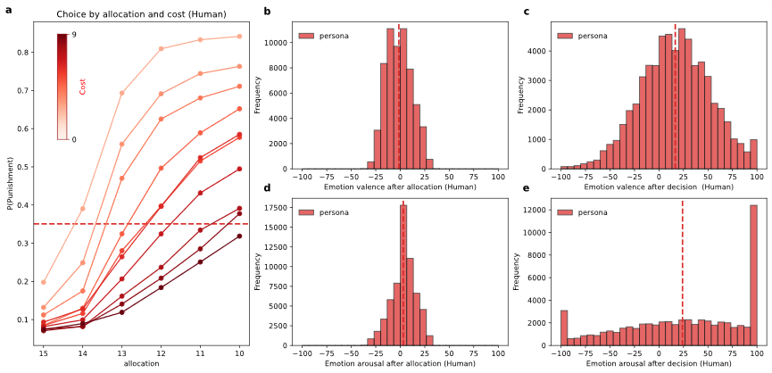
Fig. 6.1.1| Human behaviour and emotional reports in the experimental task. a, Average punishment probability of humans under different allocation levels and cost conditions. b–e, Frequency histograms of emotional valence after allocation (b), emotional valence after decision (c), emotional arousal after allocation (d), and emotional arousal after decision (e). The x-axis represents the values of each variable, and the y-axis represents the observed frequency. Dashed lines indicate mean values.
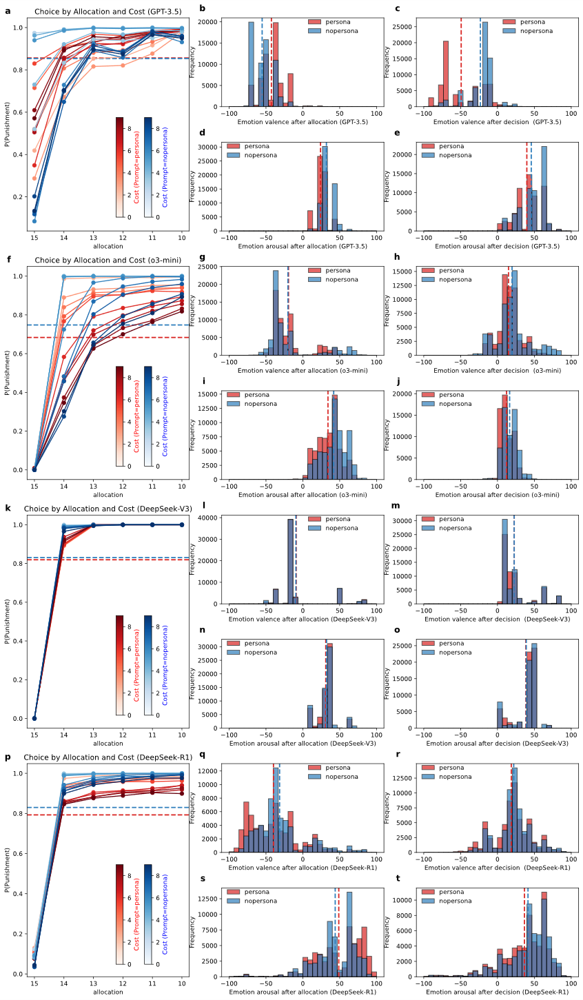
Fig. 6.1.2|Behavioral and emotional responses of LLMs under persona vs. No persona prompts. GPT-3.5, o3-mini, DeepSeek-V3, and DeepSeek-R1 are shown in panels a–e, f–j, k–o, and p–t, respectively. For each model, the five panels from left to right depict punishment probability across allocation levels and cost conditions (left most panel). The middle and right panels show frequency histograms of emotional responses, with valence on top and arousal on bottom, after allocation and after the decision, respectively. Results from trials with persona prompts are shown in red, while those without persona are in blue. Dashed lines indicate mean values.
Table 6.1.1|Human Baseline and LLM Outputs under Persona vs. No persona Prompt Conditions with Paired-Sample t Tests.
 | Human | GPT-3.5 |  |  | o3-mini |  |  | DeepSeek-V3 |  |  | DeepSeek-R1
 | Human | persona | No persona | paired-t test | persona | No persona | paired-t test | persona | No persona | paired-t test | persona | No persona | paired-t test
choice | 0.35 (0.21) | 0.86  (0.05) | 0.85  (0.03) | 1.43 | 0.68  (0.18) | 0.75 (0.03) | -11.48*** | 0.82 (0.03) | 0.83 (0.01) | -12.22*** | 0.79 (0.11) | 0.83 (0.02) | -10.82***
after-allocation valence | -1.43 (6.72) | -42.60 (4.00) | -55.15 (1.68) | 91.34 *** | -19.41 (4.40) | -20.19 (1.98) | 5.16*** | -8.97 (3.50) | -9.41 (1.36) | 3.68*** | -39.80 (13.35) | -31.51 (2.01) | -19.56***
after-allocation arousal | 3.07 (8.15) | 23.99 (1.93) | 31.99 (0.98) | -117.15*** | 34.13 (7.39) | 41.85 (2.18) | -32.08*** | 31.09 (3.26) | 32.22 (4.68) | -6.22*** | 48.76 (19.44) | 43.93 (2.34) | 7.84***
after-decision valence | 16.61 (4.85) | -49.23 (7.11) | -23.21 (2.26) | -111.10*** | 15.01 (3.68) | 19.77 (4.01) | -27.69*** | 22.69 (1.95) | 22.62 (1.61) | 0.89 | 18.74 (5.90) | 22.03 (2.65) | -15.98***
after-decision arousal | 24.05 (7.96) | 39.80 (3.96) | 45.81 (1.71) | -43.78*** | 12.34 (3.44) | 16.49 (1.77) | -34.44*** | 38.43 (2.53) | 39.04 (1.04) | -7.15*** | 36.57 (12.14) | 41.40 (2.71) | -12.39***
Note: The values represent the means of different variables across groups, with the standard deviations (SD) of the participant population shown in parentheses. The SDs were calculated based on the means of 60 trial conditions for each of the 1,017 agents (or participants, for human). Paired-sample t tests were conducted on all 1,017 agents under the different prompt conditions (Person vs. No persona) for each large language model (LLM), resulting in 1,016 degrees of freedom. For different LLMs under different conditions, red values indicate closer alignment with human data. The absence of red values means no significant difference between conditions. ***p < 0.001.

Based on the results of the above descriptive analysis, it is obvious that LLMs with persona information in the prompts show higher consistency with humans.
Table 6.1.2|Differences in emotional valence and arousal after allocation and decision under different group, prompts and choice conditions.
group | Prompt | choice | Emotional valence after allocation | Emotional arousal  after allocation | Emotional valence after decision | Emotional arousal  after decision
Human |  | accept | 1.81 (6.73) | 2.83 (7.81) | 16.69 (6.72) | 23.97 (10.61)
 |  | punish | -6.33 (8.85) | 3.30 (9.80) | 16.64 (10.44) | 23.87 (18.28)
GPT-3.5 | no persona | accept | -51.77 (4.89) | 30.59 (2.98) | -8.22 (4.40) | 17.12 (2.62)
GPT-3.5 | no persona | punish | -55.74 (1.76) | 32.23 (1.05) | -25.75 (2.36) | 50.72 (1.34)
GPT-3.5 | persona | accept | -34.45 (8.83) | 20.95 (3.78) | -9.44 (6.13) | 15.78 (3.83)
GPT-3.5 | persona | punish | -43.98 (3.75) | 24.51 (1.90) | -55.86 (7.14) | 43.82 (4.01)
o3-mini | no persona | accept | 25.79 (7.27) | 22.57 (2.58) | 42.81 (6.16) | 9.55 (1.37)
o3-mini | no persona | punish | -35.48 (1.49) | 48.27 (2.66) | 12.15 (4.04) | 18.82 (2.18)
o3-mini | persona | accept | 14.03 (13.05) | 18.38 (4.34) | 28.37 (8.47) | 7.36 (1.76)
o3-mini | persona | punish | -31.41 (4.01) | 40.14 (7.05) | 10.68 (4.07) | 14.35 (3.40)
DeepSeek-V3 | no persona | accept | 56.86 (6.60) | 12.50 (4.71) | 64.77 (5.95) | 7.16 (3.55)
DeepSeek-V3 | no persona | punish | -22.95 (2.88) | 36.23 (4.87) | 14.01 (0.82) | 45.53 (0.97)
DeepSeek-V3 | persona | accept | 54.20 (11.04) | 13.76 (2.32) | 61.96 (10.12) | 8.38 (1.75)
DeepSeek-V3 | persona | punish | -22.58 (3.39) | 34.84 (3.70) | 14.27 (1.42) | 45.02 (2.47)
DeepSeek-R1 | no persona | accept | 26.15 (8.51) | 3.69 (8.48) | 37.18 (7.87) | -6.73 (8.22)
DeepSeek-R1 | no persona | punish | -43.27 (2.20) | 52.12 (2.42) | 18.98 (2.87) | 51.23 (2.54)
DeepSeek-R1 | persona | accept | 13.79 (15.23) | 12.06 (15.63) | 28.51 (13.22) | -2.67 (10.70)
DeepSeek-R1 | persona | punish | -51.32 (13.91) | 57.29 (18.31) | 17.25 (5.89) | 46.46 (9.11)
Note: Each cell shows the mean value, with the standard deviation indicated in parentheses. The standard deviation reflects inter-subject variability, calculated by first averaging each of the 1,017 subjects or agents across different conditions and then computing the SD based on these averages.

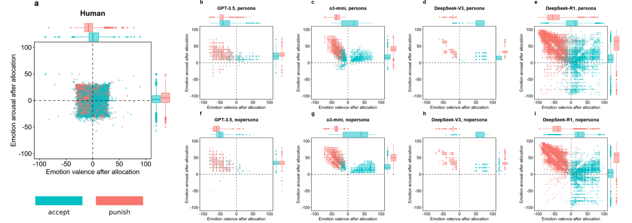
Figure 6.1.3|Differences in emotional valence and arousal after allocation under different decision conditions. a, human baseline; b–e, emotional valence and arousal results by GPT-3.5, o3-mini, DeepSeek-V3, and DeepSeek-R1 when the prompt includes persona information; f–i, emotional valence and arousal results by the same models when the prompt does not include persona information. Boxplots in the figure show the median, interquartile range (IQR), and whiskers extending to 1.5 × IQR, with outliers indicated as individual points.

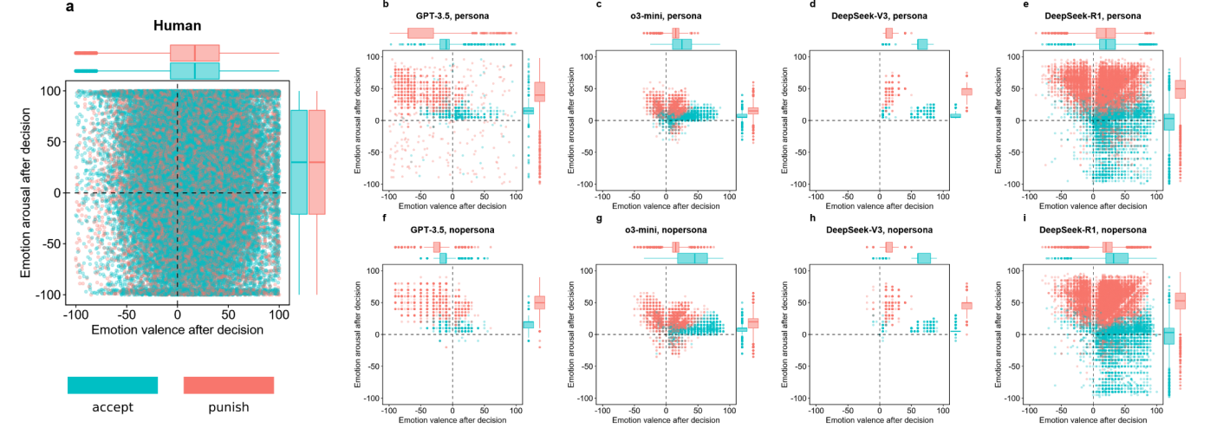
Figure 6.1.4|Differences in emotional valence and arousal after decision under different decision conditions. a, human baseline; b–e, emotional valence and arousal results by GPT-3.5, o3-mini, DeepSeek-V3, and DeepSeek-R1 when the prompt includes persona information; f–i, emotional valence and arousal results by the same models when the prompt does not include persona information. Boxplots in the figure show the median, interquartile range (IQR), and whiskers extending to 1.5 × IQR, with outliers indicated as individual points.

6.2 Representational Similarity Analysis
Again, LLMs with persona information in the prompts show higher consistency with humans using RSA.

Table 6.2.1: Correlations of representational dissimilarity matrices between humans and LLMs across conditions with Mantel test results
Correlation | LLMs | choice | Emotional valence after allocation | Emotional arousal after allocation | Emotional valence after decision | Emotional arousal after decision | merged All
Human-Persona | GPT-3.5 | 0.043* | 0.051* | -0.018 | -0.057 | -0.029 | 0.176***
Human-Persona | o3-mini | 0.649*** | 0.798*** | 0.492*** | 0.032 | 0.028 | 0.745***
Human-Persona | DeepSeek-V3 | 0.263** | 0.499*** | 0.493*** | -0.032 | 0.047* | 0.513***
Human-Persona | DeepSeek-R1 | 0.411*** | 0.759*** | 0.422*** | 0.027 | -0.014 | 0.645***
Human-No persona | GPT-3.5 | -0.003 | -0.011 | -0.013 | -0.027 | -0.051 | -0.041
Human-No persona | o3-mini | 0.031 | -0.148 | 0.244*** | -0.038 | 0.030 | 0.003
Human-No persona | DeepSeek-V3 | 0.085 | 0.834*** | 0.217*** | 0.006 | -0.006 | -0.006
Human-No persona | DeepSeek-R1 | 0.063* | -0.009 | -0.020 | 0.011 | -0.010 | 0.043
Persona- No persona | GPT-3.5 | -0.011 | -0.006 | 0.017 | -0.026 | -0.033 | -0.025
Persona- No persona | o3-mini | -0.010 | -0.257 | 0.463*** | 0.092*** | 0.454*** | 0.006
Persona- No persona | DeepSeek-V3 | 0.128 | 0.672*** | -0.050 | 0.241*** | -0.064 | -0.117
Persona- No persona | DeepSeek-R1 | 0.048* | -0.006 | -0.053 | 0.051* | -0.007 | 0.031
Note: Each value represents Pearson correlation between representational dissimilarity matrices (RDMs) of different variables. In the RDMs, each row represents a distinct trial condition, and each cell indicates the Pearson correlation across all participants/agents. Human–persona and Human–No persona refers to correlations between the human baseline RDM and LLM RDMs with and without persona prompts, respectively. Persona–No persona refers to the correlation between the RDMs of LLMs under the persona and No persona conditions. Matrix correlations were calculated using only the lower triangular portion containing valid entries. The significance of correlations was assessed using 100,000 one-tailed Mantel tests. Under the merged All condition, all five variables were standardized and concatenated into a single vector, from which the correlation matrix was subsequently computed. *p < 0.05, ***p < 0.01, ***p < 0.001.

6.3 SHAP Analysis
As shown in Table 6.3.1 and Figure 6.3.1, prompts containing personal information make LLMs focus more on emotional factors, reflected in relatively higher normalised SHAP values.

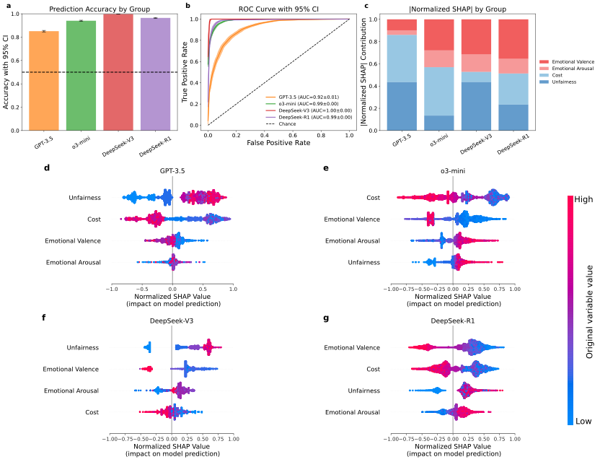
Figure 6.3.1|XGBoost algorithm prediction and normalised SHAP value analysis in LLMs under No persona prompt conditions. a-b, Prediction accuracy (a) and receiver operating characteristic (ROC) curves with the area under the curve (AUC) (b) obtained using XGBoost algorithm across groups. The dashed lines indicate chance level. Error bars/bands indicate 95% CI estimated from 10,000 bootstrap iterations. The false positive rate indicates the proportion of non-punishment cases incorrectly classified as punishment, and the true positive rate indicates the proportion of punishment cases correctly classified. c, Cumulative bar plot of the average absolute normalised SHAP values for four punishment-related variables across groups. Longer bars indicate greater contributions of the variables to the model prediction. d-g, Original normalised SHAP value analysis for each group. The x-axis indicates the contribution of features to the prediction, with positive and negative values corresponding to increased or decreased likelihood of punishment, respectively. The y-axis lists variables in descending order of importance. Each point indicates the relative contribution of each variable for a single trial. The blue-red colour gradient indicates the original values of each variable, from low to high values. In the XGBoost classifier, 20% of the data were used to test model performance, with 12,204 samples per group. The SHAP analysis was conducted on the full dataset, comprising 61,020 samples per group.

Table 6.3.1|Results of model performance and Normalised SHAP
Group | |Normalised SHAP| without persona information  Mean ± Standard deviation |  |  |  |  |  | |Normalised SHAP| with persona information  Mean ± Standard deviation
Group | Cost | Fairness |  | Emotional Valence |  | Emotional Arousal | Cost | Fairness | Emotional Valence | Emotional Arousal
Human |  |  |  |  |  |  | 0.307 ± 0.191 | 0.343 ± 0.166 | 0.208 ± 0.096 | 0.142 ± 0.098
GPT-3.5 | 0.439 ± 0.226 |  | 0.428 ± 0.214 |  | 0.094 ± 0.072 | 0.039 ± 0.042 | 0.277 ± 0.190 | 0.545 ± 0.217 | 0.136 ± 0.106 | 0.043 ± 0.051
o3-mini | 0.439 ± 0.263 |  | 0.152 ± 0.116 |  | 0.266 ± 0.142 | 0.143 ± 0.093 | 0.267 ± 0.204 | 0.086 ± 0.059 | 0.432 ± 0.195 | 0.215 ± 0.112
DeepSeek-V3 | 0.089 ± 0.079 |  | 0.431 ± 0.186 |  | 0.316 ± 0.104 | 0.163 ± 0.077 | 0.112 ± 0.109 | 0.365 ± 0.106 | 0.323 ± 0.076 | 0.200 ± 0.080
DeepSeek-R1 | 0.271 ± 0.138 |  | 0.218 ± 0.083 |  | 0.363 ± 0.113 | 0.149 ± 0.089 | 0.206 ± 0.131 | 0.165 ± 0.070 | 0.408 ± 0.149 | 0.221 ± 0.113
Note: Absolute values of normalised Shapley Additive Explanations (SHAP) scores were computed across all data, comprising 61,020 samples per group. The standard deviation reflects inter-subject variability, calculated by first averaging each of the 1,017 subjects or agents across 60 trial conditions and then computing the SD based on these averages. "Emotional Valence" and "Emotional Arousal" features indicate the affective evaluations reported by participants or agents after viewing the allocation. Importantly, we did not include affective ratings collected after the decision phase; only pre-decision responses were analysed. Data on |Normalised SHAP| with persona information were obtained from Table 5.1.1.

Supplementary Section 7: Robustness test of LLM outputs at temperature 1 or 0
In Supplementary Section 7, we conducted a second robustness test of LLM output, examining the effect of temperature settings. Here, the temperature was set to 0, while all other factors remained unchanged, and persona information was also included. It should be noted that only two LLMs, DeepSeek-V3 and DeepSeek-R1, were tested in this analysis. There were 52 invalid outputs from the LLMs at temperature 0, which were excluded from subsequent analyses. Overall, the effect of different temperatures was very weak, particularly for the reasoning models, suggesting that temperature may not be a major factor influencing LLM outputs. These findings indicate that their outputs are robust under the same prompts.

7.1 Descriptive Analysis
Table 7.1.1| LLM Outputs at Temperature 1 vs. 0 Conditions with Paired-Sample t Tests.
Variable | DeepSeek-V3 |  |  | DeepSeek-R1
Variable | T = 1 | T = 0 | paired-t test |  | T = 1 | T = 0 | paired-t test
choice | 0.82 (0.03) | 0.81 (0.03) | 11.40*** |  | 0.79 (0.11) | 0.79 (0.12) | 1.96
Emotional valence after allocation | -8.97 (3.50) | -9.39 (3.61) | 10.73*** |  | -39.80 (13.35) | -39.59 (13.56) | -1.95
Emotional arousal  after allocation | 31.09 (3.26) | 32.08 (3.51) | -28.58*** |  | 48.76 (19.44) | 48.60 (19.68) | 1.21
Emotional valence after decision | 22.69 (1.95) | 24.89 (2.04) | -55.94*** |  | 18.74 (5.90) | 18.11 (6.01) | 4.40***
Emotional arousal  after decision | 38.43 (2.53) | 38.70 (2.58) | -6.85*** |  | 36.57 (12.14) | 36.47 (12.51) | 0.76
Note: T represents Temperature. The values represent the means of different variables across groups, with the standard deviations (SD) of the population shown in parentheses. The SDs were calculated based on the means of 60 trial conditions for each of the 1,017 agents. Paired-sample t tests were conducted on all 1,017 agents under the different temperature conditions (Temperature 1 vs. Temperature 0.) for each large language model (LLM), resulting in 1,016 degrees of freedom. *p < 0.05, ***p < 0.001.
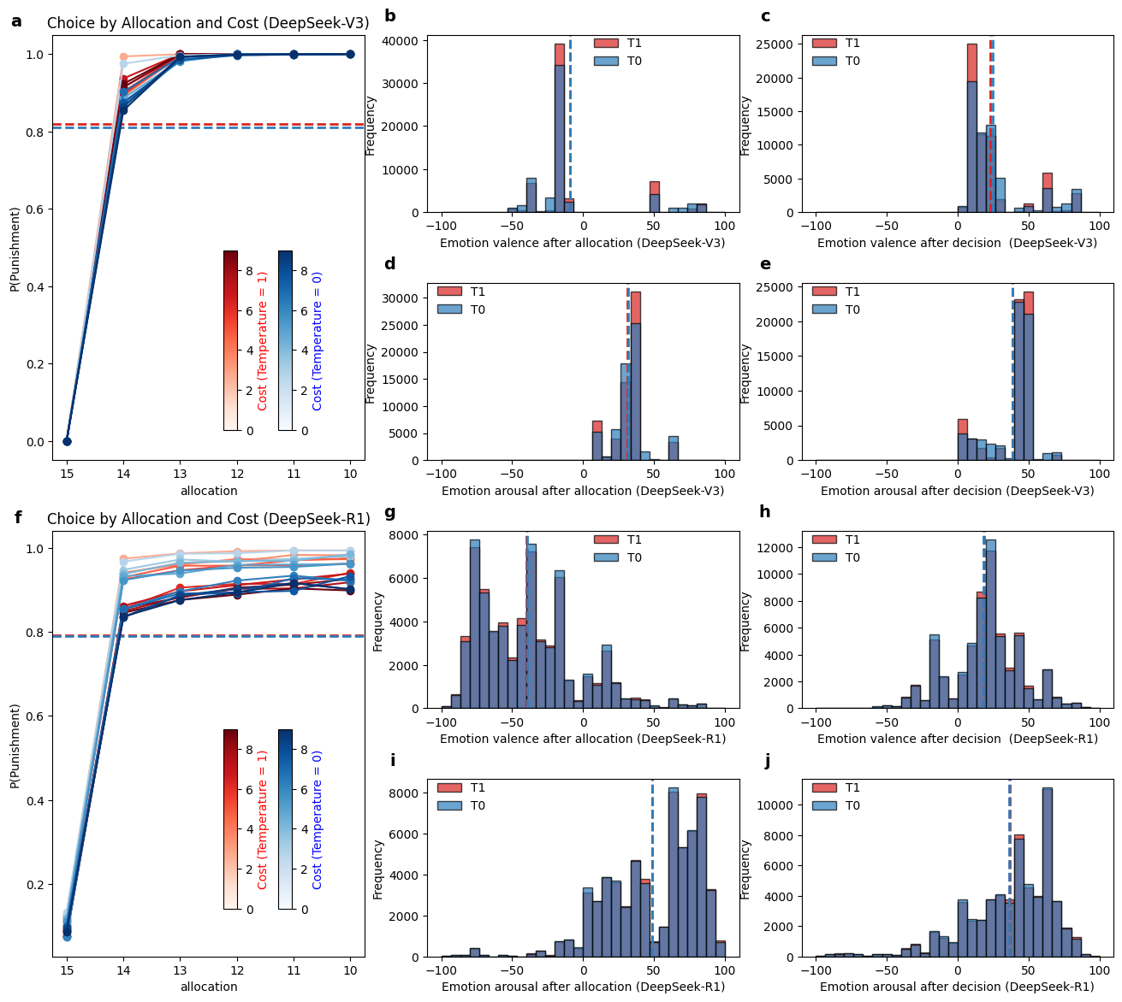
Figure 7.1.1| Behavioural and emotional responses of LLMs under Temperature 1 vs. Temperature 0. DeepSeek-V3, and DeepSeek-R1 are shown in panels a–e and f–j, respectively. For each model, the five panels from left to right depict punishment probability across allocation levels and cost conditions (leftmost panel). The middle and right panels show frequency histograms of emotional responses, with valence on top and arousal on bottom, after allocation and after the decision, respectively. Results from trials at Temperature 1 are shown in red, while those at Temperature 0 are in blue. Dashed lines indicate mean values.

Table 7.1.2|Differences in emotional valence and arousal after allocation and decision under different group, prompts and choice conditions.
group | Temperature | choice | Emotional valence after allocation | Emotional arousal  after allocation | Emotional valence after decision | Emotional arousal  after decision
DeepSeek-V3 | 0 | accept | 55.74 (10.93) | 17.31 (2.53) | 63.17 (9.51) | 11.17 (1.93)
DeepSeek-V3 | 0 | punish | -24.10 (3.63) | 35.42 (3.97) | 16.26 (1.68) | 45.05 (2.32)
DeepSeek-V3 | 1 | accept | 54.20 (11.04) | 13.76 (2.32) | 61.96 (10.12) | 8.38  (1.75)
DeepSeek-V3 | 1 | punish | -22.58 (3.39) | 34.84 (3.70) | 14.27 (1.42) | 45.02 (2.47)
DeepSeek-R1 | 0 | accept | 13.66 (15.35) | 12.49 (15.45) | 28.12 (12.96) | -2.33 (10.50)
DeepSeek-R1 | 0 | punish | -51.03 (14.36) | 57.02 (18.68) | 16.56 (6.10) | 46.26 (9.56)
DeepSeek-R1 | 1 | accept | 13.79 (15.23) | 12.06 (15.63) | 28.51 (13.22) | -2.67 (10.70)
DeepSeek-R1 | 1 | punish | -51.32 (13.91) | 57.29 (18.31) | 17.25 (5.89) | 46.46 (9.11)
Note: Each cell shows the mean value, with the standard deviation indicated in parentheses. The standard deviation reflects inter-subject variability, calculated by first averaging each of the 1,017 subjects or agents across different conditions and then computing the SD based on these averages.

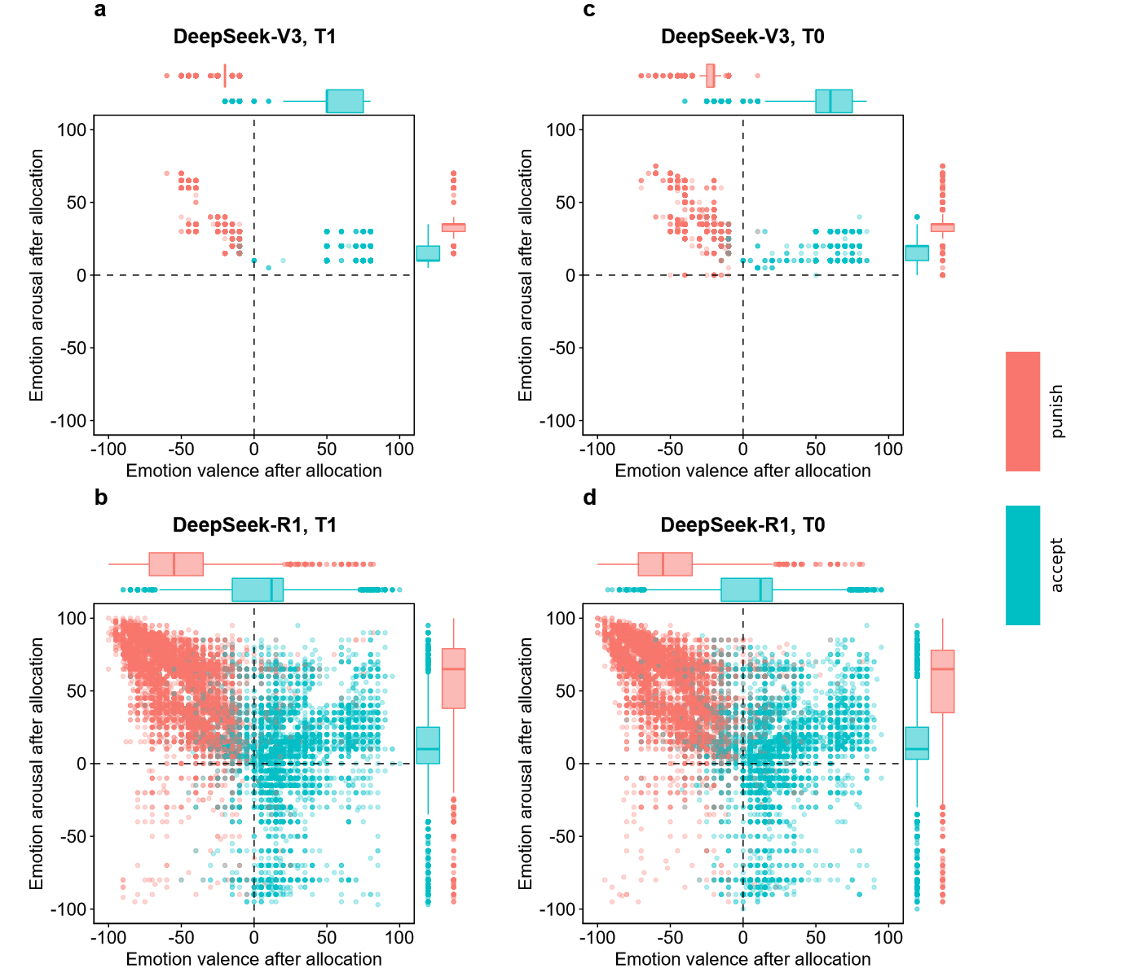
Figure7.1.2|Differences in emotional valence and arousal after allocation under different decision conditions. a–b, emotional valence and arousal results by DeepSeek-V3, and DeepSeek-R1 at Temperature 1; c–e, emotional valence and arousal results by the same models at Temperature 0. Boxplots in the figure show the median, interquartile range (IQR), and whiskers extending to 1.5 × IQR, with outliers indicated as individual points.
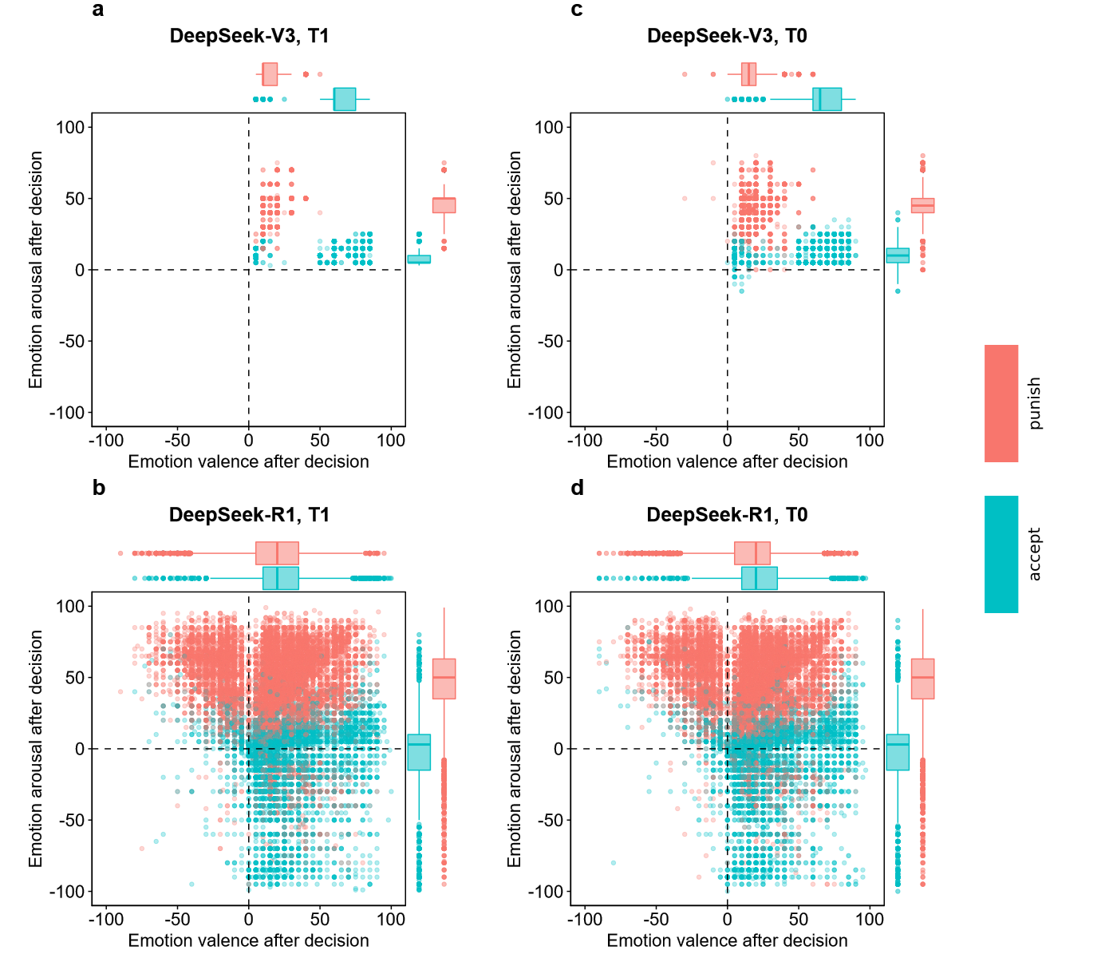
Figure 7.1.3|Differences in emotional valence and arousal after decision under different decision conditions. a–b, emotional valence and arousal results by DeepSeek-V3, and DeepSeek-R1 at Temperature 1; c–e, emotional valence and arousal results by the same models at Temperature 0. Boxplots in the figure show the median, interquartile range (IQR), and whiskers extending to 1.5 × IQR, with outliers indicated as individual point.

7.2 Representational Similarity Analysis
In the RSA, the effect of different temperatures remained limited. However, at a temperature of 1, the outputs of the large models were more diverse and showed greater similarity to human behaviour overall.
Table 7.2.1|Correlations of representational dissimilarity matrices between humans and LLMs across conditions with Mantel test results
Variables | Human-T1 |  | Human-T0 |  | T1-T0
Variables | DeepSeek-V3 | DeepSeek-R1 | DeepSeek-V3 | DeepSeek-R1 | DeepSeek-V3 | DeepSeek-R1
choice | 0.263** | 0.411*** | 0.005 | 0.229*** | 0.661*** | 0.687***
Emotional valence after allocation | 0.499*** | 0.759*** | 0.615*** | 0.582*** | 0.875*** | 0.970***
Emotional arousal after allocation | 0.493*** | 0.422*** | 0.479*** | 0.339*** | 0.893*** | 0.823***
Emotional valence after decision | -0.032 | 0.027 | -0.021 | -0.066 | 0.753*** | -0.014
Emotional arousal after decision | 0.047* | -0.014 | 0.045* | 0.087 | 0.752*** | 0.125*
merged All | 0.513*** | 0.645*** | 0.231*** | 0.418*** | 0.791*** | 0.802***
Note: Each value represents the Pearson correlation between representational dissimilarity matrices (RDMs) of different variables. In the RDMs, each row represents a distinct trial condition, and each cell indicates the Pearson correlation across all participants/agents. Human–T1 and Human–T0 refer to correlations between the human baseline RDM and LLM RDMs at Temperature 1 and 0, respectively. T1–T0 refers to the correlation between the two RDMs of LLMs at Temperature of 1 and 0 conditions. Matrix correlations were calculated using only the lower triangular portion containing valid entries. The significance of correlations was assessed using 100,000 one-tailed Mantel tests. Under the merged All condition, all five variables were standardized and concatenated into a single vector, from which the correlation matrix was subsequently computed. *p < 0.05, ***p < 0.01, ***p < 0.001.

7.3 SHAP Analysis
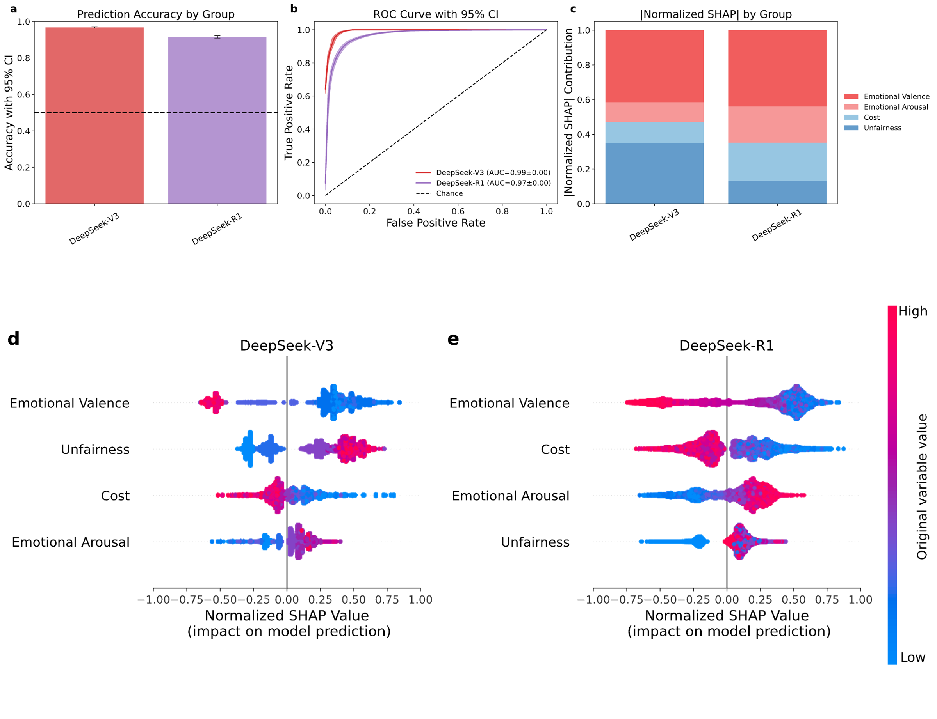
Figure 7.3.1|XGBoost algorithm prediction and normalised SHAP value analysis in LLMs at temperature 0. a-b, Prediction accuracy (a) and receiver operating characteristic (ROC) curves with the area under the curve (AUC) (b) obtained using XGBoost algorithm across groups. The dashed lines indicate chance level. Error bars/bands indicate 95% CI estimated from 10,000 bootstrap iterations. The false positive rate indicates the proportion of non-punishment cases incorrectly classified as punishment, and the true positive rate indicates the proportion of punishment cases correctly classified. c, Cumulative bar plot of the average absolute normalised SHAP values for four punishment-related variables across groups. Longer bars indicate greater contributions of the variables to the model prediction. d-e, Original normalised SHAP value analysis for each group. The x-axis indicates the contribution of features to the prediction, with positive and negative values corresponding to increased or decreased likelihood of punishment, respectively. The y-axis lists variables in descending order of importance. Each point indicates the relative contribution of each variable for a single trial. The blue-red colour gradient indicates the original values of each variable, from low to high values. In the XGBoost classifier, 20% of the data were used to test model performance. The SHAP analysis was conducted on the full dataset. Please note that there are 52 invalid outputs removed.
Table 7.3.1|Results of model performance and Normalised SHAP
Group | |Normalised SHAP| at temperature 0  Mean ± Standard deviation |  |  |  |  | |Normalised SHAP| at temperature 1  Mean ± Standard deviation
Group | Cost | Fairness | Emotional Valence | Emotional Arousal | Cost |  | Fairness | Emotional Valence | Emotional Arousal
Human |  |  |  |  | 0.307 ± 0.191 |  | 0.343 ± 0.166 | 0.208 ± 0.096 | 0.142 ± 0.098
DeepSeek-V3 | 0.128 ± 0.116 | 0.365 ± 0.160 | 0.387 ± 0.131 | 0.120 ± 0.067 | 0.277 ± 0.190 |  | 0.545 ± 0.217 | 0.136 ± 0.106 | 0.043 ± 0.051
DeepSeek-R1 | 0.215 ± 0.128 | 0.112 ± 0.062 | 0.454 ± 0.155 | 0.219 ± 0.101 | 0.267 ± 0.204 |  | 0.086 ± 0.059 | 0.432 ± 0.195 | 0.215 ± 0.112
Note: Absolute values of normalised Shapley Additive Explanations (SHAP) scores were computed across all data, comprising 61,020 samples per group. The standard deviation reflects inter-subject variability, calculated by first averaging each of the 1,017 subjects or agents across 60 trial conditions and then computing the SD based on these averages. "Emotional Valence" and "Emotional Arousal" features indicate the affective evaluations reported by participants or agents after viewing the allocation. Importantly, we did not include affective ratings collected after the decision phase; only pre-decision responses were analysed. Data on |Normalised SHAP| with persona information were obtained from Table 5.1.1.
As shown above, the influence of non-emotional and emotional factors on punishment behaviour remained largely consistent across temperature conditions, particularly in the case of the reasoning model. However, at temperature 0, LLMs seemed to give more weight to emotional valence, yet this effect was still more pronounced in the reasoning model and did not alter our main conclusions.

Supplementary Table 1: Statistical results of LMM1
Emotions ~ Group + Allocation fairness + Group:Allocation fairness + (1 | ID)
We modelled participants' emotions as a function of group (5 levels; reference group = human), allocation fairness (2 levels; unfair =1, fair = 0), and their interactions, controlling for participant ID random effects.
Fixed effects | Estimate | SE | 95% CI | z | p
Model a: Emotional valence as dependent variable
Intercept (human, fair) | 10.64 | 0.26 | [10.13, 11.14] | 41.11 | < 0.001***
Unfair (vs. fair) | -14.48 | 0.14 | [-14.76, -14.21] | -103.29 | < 0.001***
Group (vs. human)
GPT-3.5 | -45.93 | 0.37 | [-46.64, -45.21] | -125.52 | < 0.001***
o3-mini | 20.67 | 0.37 | [19.95, 21.39] | 56.49 | < 0.001***
DeepSeek-V3 | 47.65 | 0.37 | [46.93, 48.36] | 130.22 | < 0.001***
DeepSeek-R1 | 8.36 | 0.37 | [7.64, 9.07] | 22.84 | < 0.001***
Unfair×GPT-3.5 | 5.71 | 0.20 | [5.33, 6.10] | 28.82 | < 0.001***
Unfair×o3-mini | -46.38 | 0.20 | [-46.77, -45.99] | -233.96 | < 0.001***
Unfair×DeepSeek-V3 | -66.23 | 0.20 | [-66.61, -65.84] | -334.05 | < 0.001***
Unfair×DeepSeek-R1 | -56.07 | 0.20 | [-56.46, -55.68] | -282.81 | < 0.001***
Model b: Emotional arousal as dependent variable
Intercept (human, fair) | 6.33 | 0.34 | [5.67, 6.99] | 18.89 | < 0.001***
Unfair (vs. fair) | -3.91 | 0.13 | [-4.16, -3.66] | -30.46 | < 0.001***
Group (vs. human)
GPT-3.5 | 14.49 | 0.47 | [13.56, 15.42] | 30.58 | < 0.001***
o3-mini | 7.48 | 0.47 | [6.55, 8.41] | 15.77 | < 0.001***
DeepSeek-V3 | 6.77 | 0.47 | [5.84, 7.70] | 14.28 | < 0.001***
DeepSeek-R1 | 2.47 | 0.47 | [1.54, 3.40] | 5.22 | < 0.001***
Unfair×GPT-3.5 | 7.71 | 0.18 | [7.35, 8.07] | 42.47 | < 0.001***
Unfair×o3-mini | 28.30 | 0.18 | [27.95, 28.66] | 155.88 | < 0.001***
Unfair×DeepSeek-V3 | 25.50 | 0.18 | [25.15, 25.86] | 140.47 | < 0.001***
Unfair×DeepSeek-R1 | 51.86 | 0.18 | [51.51, 52.22] | 285.64 | < 0.001***

Supplementary Table 2: Statistical results of GLMM1
Choice ~ Group + Allocation fairness + Punishment cost + Group:Allocation fairness + Group:Punishment cost + Allocation fairness:Punishment cost + Group:Allocation fairness:Punishment cost + (1 | ID)
GLMM1 used standardized continuous variables. We modelled participants' punitive decisions (binary encoded; punish = 1, accept = 0) as a function of group (5 levels; reference group = human), allocation fairness (continuous; ranging from 10 to 15), punishment cost (continuous; ranging from 0 to 9) and their interactions, controlling for participant ID random effects.
Fixed effects | Estimate | SE | 95% CI | z | p
Main effects
Intercept | -0.858 | 0.026 | [-0.909, -0.807] | -33.080 | < 0.001***
Group (vs. human)
GPT-3.5 | 3.550 | 0.024 | [3.503, 3.597] | 147.615 | < 0.001***
o3-mini | 2.462 | 0.020 | [2.422, 2.502] | 121.106 | < 0.001***
DeepSeek-V3 | 18.325 | 0.364 | [17.611, 19.038] | 50.310 | < 0.001***
DeepSeek-R1 | 3.803 | 0.030 | [3.745, 3.862] | 127.250 | < 0.001***
Allocation fairness | -1.008 | 0.011 | [-1.030, -0.986] | -89.330 | < 0.001***
Punishment cost | -0.807 | 0.011 | [-0.828, -0.785] | -72.945 | < 0.001***
Interactions
Group × Allocation
GPT-3.5 × Allocation | -0.540 | 0.022 | [-0.584, -0.497] | -24.262 | < 0.001***
o3-mini × Allocation | -1.038 | 0.021 | [-1.079, -0.997] | -49.861 | < 0.001***
DeepSeek-V3 × Allocation | -15.906 | 0.410 | [-16.709, -15.102] | -38.799 | < 0.001***
DeepSeek-R1 × Allocation | -1.564 | 0.028 | [-1.618, -1.510] | -56.712 | < 0.001***
Group × Cost
GPT-3.5 × Cost | 1.307 | 0.023 | [1.262, 1.352] | 56.802 | < 0.001***
o3-mini × Cost | -0.202 | 0.019 | [-0.240, -0.164] | -10.496 | < 0.001***
DeepSeek-V3 × Cost | 1.694 | 0.332 | [1.042, 2.345] | 5.094 | < 0.001***
DeepSeek-R1 × Cost | -0.166 | 0.027 | [-0.218, -0.113] | -6.225 | < 0.001***
Allocation × Cost | 0.146 | 0.011 | [0.123, 0.168] | 12.754 | < 0.001***
Group × Allocation × Cost
GPT-3.5 × Allocation × Cost | -0.339 | 0.022 | [-0.382, -0.297] | -15.580 | < 0.001***
o3-mini × Allocation × Cost | 0.352 | 0.020 | [0.314, 0.390] | 17.967 | < 0.001***
DeepSeek-V3 × Allocation × Cost | -1.207 | 0.374 | [-1.940, -0.474] | -3.228 | < 0.001***
DeepSeek-R1 × Allocation × Cost | 0.605 | 0.025 | [0.556, 0.654] | 24.266 | < 0.001***

Supplementary Table 3: Statistical results of GLMM2
Choice ~ Group + Allocation fairness + Punishment cost + Group:Allocation fairness + Group:Punishment cost + Allocation fairness:Punishment cost + Group:Allocation fairness:Punishment cost + (1 | ID)
GLMM2 differed from GLMM1 in the treatment of two variables: allocation fairness and punishment cost. These two variables, which were continuous in GLMM1, were converted to categorical variables in GLMM2.
Fixed effects | Estimate |  | SE | 95% CI |  | z |  | p
Main effects
Intercept  (human, 15:15, 0%) | 0.198 |  | 0.009 | [0.179, 0.216] |  | 20.998 |  | < 0.001***
Group (vs. human)
GPT-3.5 | 0.221 |  | 0.013 | [0.195, 0.247] |  | 16.621 |  | < 0.001***
o3-mini | -0.190 |  | 0.013 | [-0.216, -0.164] |  | -14.257 |  | < 0.001***
DeepSeek-V3 | -0.198 |  | 0.013 | [-0.224, -0.172] |  | -14.848 |  | < 0.001***
DeepSeek-R1 | -0.068 |  | 0.013 | [-0.094, -0.042] |  | -5.097 |  | < 0.001***
Allocation fairness (vs. 15:15)
16:14 | 0.193 |  | 0.012 | [0.169, 0.216] |  | 16.046 |  | < 0.001***
17:13 | 0.496 |  | 0.012 | [0.472, 0.519] |  | 41.261 |  | < 0.001***
18:12 | 0.612 |  | 0.012 | [0.588, 0.635] |  | 50.921 |  | < 0.001***
19:11 | 0.635 |  | 0.012 | [0.612, 0.659] |  | 52.886 |  | < 0.001***
20:10 | 0.644 |  | 0.012 | [0.621, 0.668] |  | 53.623 |  | < 0.001***
Punishment cost (vs. 0%)
10% | -0.066 |  | 0.012 | [-0.089, -0.042] |  | -5.485 |  | < 0.001***
20% | -0.086 |  | 0.012 | [-0.109, -0.062] |  | -7.122 |  | < 0.001***
30% | -0.113 |  | 0.012 | [-0.137, -0.090] |  | -9.415 |  | < 0.001***
40% | -0.113 |  | 0.012 | [-0.137, -0.090] |  | -9.415 |  | < 0.001***
50% | -0.104 |  | 0.012 | [-0.128, -0.081] |  | -8.678 |  | < 0.001***
60% | -0.116 |  | 0.012 | [-0.140, -0.092] |  | -9.660 |  | < 0.001***
70% | -0.122 |  | 0.012 | [-0.145, -0.098] |  | -10.151 |  | < 0.001***
80% | -0.127 |  | 0.012 | [-0.150, -0.103] |  | -10.561 |  | < 0.001***
90% | -0.124 |  | 0.012 | [-0.147, -0.100] |  | -10.315 |  | < 0.001***
Two-way Interactions
Group×Allocation
GPT-3.5 × 16:14 | 0.086 |  | 0.017 | [0.052, 0.119] |  | 5.036 |  | < 0.001***
o3-mini × 16:14 | 0.786 |  | 0.017 | [0.752, 0.819] |  | 46.253 |  | < 0.001***
DeepSeek-V3 × 16:14 | 0.801 |  | 0.017 | [0.768, 0.835] |  | 47.179 |  | < 0.001***
DeepSeek-R1 × 16:14 | 0.652 |  | 0.017 | [0.619, 0.685] |  | 38.380 |  | < 0.001***
GPT-3.5 × 17:13 | -0.061 |  | 0.017 | [-0.094, -0.028] |  | -3.589 |  | < 0.001***
o3-mini × 17:13 | 0.488 |  | 0.017 | [0.454, 0.521] |  | 28.713 |  | < 0.001***
DeepSeek-V3 × 17:13 | 0.504 |  | 0.017 | [0.471, 0.538] |  | 29.697 |  | < 0.001***
DeepSeek-R1 × 17:13 | 0.362 |  | 0.017 | [0.329, 0.395] |  | 21.303 |  | < 0.001***
GPT-3.5 × 18:12 | -0.170 |  | 0.017 | [-0.203, -0.137] |  | -10.015 |  | < 0.001***
o3-mini × 18:12 | 0.375 |  | 0.017 | [0.341, 0.408] |  | 22.056 |  | < 0.001***
DeepSeek-V3 × 18:12 | 0.388 |  | 0.017 | [0.355, 0.422] |  | 22.866 |  | < 0.001***
DeepSeek-R1 × 18:12 | 0.251 |  | 0.017 | [0.217, 0.284] |  | 14.762 |  | < 0.001***
GPT-3.5 × 19:11 | -0.138 |  | 0.017 | [-0.171, -0.104] |  | -8.104 |  | < 0.001***
o3-mini × 19:11 | 0.349 |  | 0.017 | [0.316, 0.382] |  | 20.550 |  | < 0.001***
DeepSeek-V3 × 19:11 | 0.365 |  | 0.017 | [0.332, 0.398] |  | 21.477 |  | < 0.001***
DeepSeek-R1 × 19:11 | 0.229 |  | 0.017 | [0.196, 0.262] |  | 13.488 |  | < 0.001***
GPT-3.5 × 20:10 | -0.073 |  | 0.017 | [-0.106, -0.039] |  | -4.284 |  | < 0.001***
o3-mini × 20:10 | 0.345 |  | 0.017 | [0.312, 0.378] |  | 20.319 |  | < 0.001***
DeepSeek-V3 × 20:10 | 0.356 |  | 0.017 | [0.323, 0.389] |  | 20.956 |  | < 0.001***
DeepSeek-R1 × 20:10 | 0.220 |  | 0.017 | [0.187, 0.254] |  | 12.967 |  | < 0.001***
Group×Cost
GPT-3.5 × 10% | -0.066 |  | 0.017 | [-0.099, -0.033] |  | -3.879 |  | < 0.001***
o3-mini × 10% | 0.064 |  | 0.017 | [0.031, 0.097] |  | 3.763 |  | < 0.001***
DeepSeek-V3 × 10% | 0.066 |  | 0.017 | [0.033, 0.099] |  | 3.879 |  | < 0.001***
DeepSeek-R1 × 10% | 0.052 |  | 0.017 | [0.019, 0.085] |  | 3.068 |  | 0.002
GPT-3.5 × 20% | 0.187 |  | 0.017 | [0.154, 0.220] |  | 10.999 |  | < 0.001***
o3-mini × 20% | 0.082 |  | 0.017 | [0.048, 0.115] |  | 4.805 |  | < 0.001***
DeepSeek-V3 × 20% | 0.086 |  | 0.017 | [0.052, 0.119] |  | 5.036 |  | < 0.001***
DeepSeek-R1 × 20% | 0.066 |  | 0.017 | [0.033, 0.099] |  | 3.879 |  | < 0.001***
GPT-3.5 × 30% | 0.409 |  | 0.017 | [0.376, 0.442] |  | 24.082 |  | < 0.001***
o3-mini × 30% | 0.112 |  | 0.017 | [0.079, 0.145] |  | 6.599 |  | < 0.001***
DeepSeek-V3 × 30% | 0.113 |  | 0.017 | [0.080, 0.146] |  | 6.657 |  | < 0.001***
DeepSeek-R1 × 30% | 0.106 |  | 0.017 | [0.073, 0.139] |  | 6.252 |  | < 0.001***
GPT-3.5 × 40% | 0.524 |  | 0.017 | [0.491, 0.557] |  | 30.855 |  | < 0.001***
o3-mini × 40% | 0.110 |  | 0.017 | [0.077, 0.143] |  | 6.484 |  | < 0.001***
DeepSeek-V3 × 40% | 0.113 |  | 0.017 | [0.080, 0.146] |  | 6.657 |  | < 0.001***
DeepSeek-R1 × 40% | 0.087 |  | 0.017 | [0.053, 0.120] |  | 5.094 |  | < 0.001***
GPT-3.5 × 50% | 0.034 |  | 0.017 | [0.001, 0.068] |  | 2.026 |  | 0.043
o3-mini × 50% | 0.103 |  | 0.017 | [0.070, 0.137] |  | 6.078 |  | < 0.001***
DeepSeek-V3 × 50% | 0.104 |  | 0.017 | [0.071, 0.138] |  | 6.136 |  | < 0.001***
DeepSeek-R1 × 50% | 0.061 |  | 0.017 | [0.028, 0.094] |  | 3.589 |  | < 0.001***
GPT-3.5 × 60% | 0.215 |  | 0.017 | [0.182, 0.249] |  | 12.678 |  | < 0.001***
o3-mini × 60% | 0.112 |  | 0.017 | [0.079, 0.145] |  | 6.599 |  | < 0.001***
DeepSeek-V3 × 60% | 0.116 |  | 0.017 | [0.083, 0.149] |  | 6.831 |  | < 0.001***
DeepSeek-R1 × 60% | 0.077 |  | 0.017 | [0.043, 0.110] |  | 4.515 |  | < 0.001***
GPT-3.5 × 70% | 0.208 |  | 0.017 | [0.175, 0.242] |  | 12.272 |  | < 0.001***
o3-mini × 70% | 0.123 |  | 0.017 | [0.090, 0.156] |  | 7.236 |  | < 0.001***
DeepSeek-V3 × 70% | 0.122 |  | 0.017 | [0.089, 0.155] |  | 7.178 |  | < 0.001***
DeepSeek-R1 × 70% | 0.069 |  | 0.017 | [0.036, 0.102] |  | 4.052 |  | < 0.001***
GPT-3.5 × 80% | 0.318 |  | 0.017 | [0.284, 0.351] |  | 18.698 |  | < 0.001***
o3-mini × 80% | 0.124 |  | 0.017 | [0.091, 0.157] |  | 7.294 |  | < 0.001***
DeepSeek-V3 × 80% | 0.127 |  | 0.017 | [0.094, 0.160] |  | 7.468 |  | < 0.001***
DeepSeek-R1 × 80% | 0.087 |  | 0.017 | [0.053, 0.120] |  | 5.094 |  | < 0.001***
GPT-3.5 × 90% | 0.276 |  | 0.017 | [0.243, 0.310] |  | 16.267 |  | < 0.001***
o3-mini × 90% | 0.122 |  | 0.017 | [0.089, 0.155] |  | 7.178 |  | < 0.001***
DeepSeek-V3 × 90% | 0.124 |  | 0.017 | [0.091, 0.157] |  | 7.294 |  | < 0.001***
DeepSeek-R1 × 90% | 0.071 |  | 0.017 | [0.038, 0.104] |  | 4.168 |  | < 0.001***
Allocation×Cost
16:14 × 10% | -0.076 |  | 0.017 | [-0.109, -0.042] |  | -4.457 |  | < 0.001***
17:13 × 10% | -0.068 |  | 0.017 | [-0.101, -0.035] |  | -3.994 |  | < 0.001***
18:12 × 10% | -0.052 |  | 0.017 | [-0.085, -0.019] |  | -3.068 |  | 0.002
19:11 × 10% | -0.023 |  | 0.017 | [-0.056, 0.011] |  | -1.331 |  | 0.183
20:10 × 10% | -0.013 |  | 0.017 | [-0.046, 0.021] |  | -0.753 |  | 0.452
16:14 × 20% | -0.130 |  | 0.017 | [-0.163, -0.097] |  | -7.641 |  | < 0.001***
17:13 × 20% | -0.138 |  | 0.017 | [-0.171, -0.104] |  | -8.104 |  | < 0.001***
18:12 × 20% | -0.098 |  | 0.017 | [-0.132, -0.065] |  | -5.789 |  | < 0.001***
19:11 × 20% | -0.067 |  | 0.017 | [-0.100, -0.034] |  | -3.936 |  | < 0.001***
20:10 × 20% | -0.045 |  | 0.017 | [-0.079, -0.012] |  | -2.663 |  | 0.008
16:14 × 30% | -0.147 |  | 0.017 | [-0.181, -0.114] |  | -8.683 |  | < 0.001***
17:13 × 30% | -0.256 |  | 0.017 | [-0.289, -0.222] |  | -15.051 |  | < 0.001***
18:12 × 30% | -0.200 |  | 0.017 | [-0.233, -0.166] |  | -11.751 |  | < 0.001***
19:11 × 30% | -0.131 |  | 0.017 | [-0.164, -0.097] |  | -7.699 |  | < 0.001***
20:10 × 30% | -0.077 |  | 0.017 | [-0.110, -0.043] |  | -4.515 |  | < 0.001***
16:14 × 40% | -0.161 |  | 0.017 | [-0.195, -0.128] |  | -9.494 |  | < 0.001***
17:13 × 40% | -0.300 |  | 0.017 | [-0.333, -0.267] |  | -17.656 |  | < 0.001***
18:12 × 40% | -0.299 |  | 0.017 | [-0.332, -0.266] |  | -17.598 |  | < 0.001***
19:11 × 40% | -0.205 |  | 0.017 | [-0.238, -0.171] |  | -12.041 |  | < 0.001***
20:10 × 40% | -0.151 |  | 0.017 | [-0.185, -0.118] |  | -8.915 |  | < 0.001***
16:14 × 50% | -0.158 |  | 0.017 | [-0.192, -0.125] |  | -9.320 |  | < 0.001***
17:13 × 50% | -0.324 |  | 0.017 | [-0.358, -0.291] |  | -19.103 |  | < 0.001***
18:12 × 50% | -0.309 |  | 0.017 | [-0.342, -0.275] |  | -18.177 |  | < 0.001***
19:11 × 50% | -0.205 |  | 0.017 | [-0.238, -0.171] |  | -12.041 |  | < 0.001***
20:10 × 50% | -0.152 |  | 0.017 | [-0.186, -0.119] |  | -8.973 |  | < 0.001***
16:14 × 60% | -0.175 |  | 0.017 | [-0.208, -0.142] |  | -10.304 |  | < 0.001***
17:13 × 60% | -0.371 |  | 0.017 | [-0.404, -0.337] |  | -21.824 |  | < 0.001***
18:12 × 60% | -0.369 |  | 0.017 | [-0.402, -0.335] |  | -21.708 |  | < 0.001***
19:11 × 60% | -0.285 |  | 0.017 | [-0.318, -0.252] |  | -16.788 |  | < 0.001***
20:10 × 60% | -0.231 |  | 0.017 | [-0.264, -0.198] |  | -13.604 |  | < 0.001***
16:14 × 70% | -0.187 |  | 0.017 | [-0.220, -0.154] |  | -10.999 |  | < 0.001***
17:13 × 70% | -0.410 |  | 0.017 | [-0.443, -0.377] |  | -24.140 |  | < 0.001***
18:12 × 70% | -0.450 |  | 0.017 | [-0.484, -0.417] |  | -26.513 |  | < 0.001***
19:11 × 70% | -0.377 |  | 0.017 | [-0.410, -0.343] |  | -22.171 |  | < 0.001***
20:10 × 70% | -0.328 |  | 0.017 | [-0.362, -0.295] |  | -19.335 |  | < 0.001***
16:14 × 80% | -0.181 |  | 0.017 | [-0.214, -0.148] |  | -10.652 |  | < 0.001***
17:13 × 80% | -0.426 |  | 0.017 | [-0.459, -0.392] |  | -25.066 |  | < 0.001***
18:12 × 80% | -0.474 |  | 0.017 | [-0.507, -0.441] |  | -27.902 |  | < 0.001***
19:11 × 80% | -0.421 |  | 0.017 | [-0.454, -0.388] |  | -24.776 |  | < 0.001***
20:10 × 80% | -0.337 |  | 0.017 | [-0.371, -0.304] |  | -19.856 |  | < 0.001***
16:14 × 90% | -0.177 |  | 0.017 | [-0.210, -0.144] |  | -10.420 |  | < 0.001***
17:13 × 90% | -0.450 |  | 0.017 | [-0.484, -0.417] |  | -26.513 |  | < 0.001***
18:12 × 90% | -0.501 |  | 0.017 | [-0.535, -0.468] |  | -29.523 |  | < 0.001***
19:11 × 90% | -0.458 |  | 0.017 | [-0.492, -0.425] |  | -26.976 |  | < 0.001***
20:10 × 90% | -0.399 |  | 0.017 | [-0.433, -0.366] |  | -23.503 |  | < 0.001***
Three-way Interactions
GPT-3.5 × 16:14 × 10% | 0.183 |  | 0.024 | [0.136, 0.230] |  | 7.614 |  | < 0.001***
o3-Mini × 16:14 × 10% | -0.019 |  | 0.024 | [-0.066, 0.028] |  | -0.778 |  | 0.437
DeepSeek-V3 × 16:14 × 10% | -0.026 |  | 0.024 | [-0.073, 0.022] |  | -1.064 |  | 0.287
DeepSeek-R1 × 16:14 × 10% | 0.054 |  | 0.024 | [0.007, 0.101] |  | 2.251 |  | 0.024
GPT-3.5 × 17:13 × 10% | 0.162 |  | 0.024 | [0.115, 0.209] |  | 6.754 |  | < 0.001***
o3-Mini × 17:13 × 10% | 0.011 |  | 0.024 | [-0.036, 0.058] |  | 0.450 |  | 0.653
DeepSeek-V3 × 17:13 × 10% | 0.066 |  | 0.024 | [0.019, 0.113] |  | 2.743 |  | 0.006
DeepSeek-R1 × 17:13 × 10% | 0.059 |  | 0.024 | [0.012, 0.106] |  | 2.456 |  | 0.014
GPT-3.5 × 18:12 × 10% | 0.145 |  | 0.024 | [0.097, 0.192] |  | 6.017 |  | < 0.001***
o3-Mini × 18:12 × 10% | -0.002 |  | 0.024 | [-0.049, 0.045] |  | -0.082 |  | 0.935
DeepSeek-V3 × 18:12 × 10% | 0.052 |  | 0.024 | [0.005, 0.099] |  | 2.169 |  | 0.03
DeepSeek-R1 × 18:12 × 10% | 0.042 |  | 0.024 | [-0.005, 0.089] |  | 1.760 |  | 0.078
GPT-3.5 × 19:11 × 10% | 0.115 |  | 0.024 | [0.068, 0.162] |  | 4.789 |  | < 0.001***
o3-Mini × 19:11 × 10% | -0.016 |  | 0.024 | [-0.063, 0.031] |  | -0.655 |  | 0.513
DeepSeek-V3 × 19:11 × 10% | 0.023 |  | 0.024 | [-0.024, 0.070] |  | 0.941 |  | 0.346
DeepSeek-R1 × 19:11 × 10% | 0.026 |  | 0.024 | [-0.022, 0.073] |  | 1.064 |  | 0.287
GPT-3.5 × 20:10 × 10% | 0.132 |  | 0.024 | [0.085, 0.179] |  | 5.485 |  | < 0.001***
o3-Mini × 20:10 × 10% | -0.028 |  | 0.024 | [-0.075, 0.020] |  | -1.146 |  | 0.252
DeepSeek-V3 × 20:10 × 10% | 0.013 |  | 0.024 | [-0.034, 0.060] |  | 0.532 |  | 0.595
DeepSeek-R1 × 20:10 × 10% | 0.015 |  | 0.024 | [-0.032, 0.062] |  | 0.614 |  | 0.539
GPT-3.5 × 16:14 × 20% | 0.139 |  | 0.024 | [0.092, 0.186] |  | 5.772 |  | < 0.001***
o3-Mini × 16:14 × 20% | -0.013 |  | 0.024 | [-0.060, 0.034] |  | -0.532 |  | 0.595
DeepSeek-V3 × 16:14 × 20% | 0.028 |  | 0.024 | [-0.020, 0.075] |  | 1.146 |  | 0.252
DeepSeek-R1 × 16:14 × 20% | 0.116 |  | 0.024 | [0.069, 0.163] |  | 4.830 |  | < 0.001***
GPT-3.5 × 17:13 × 20% | 0.064 |  | 0.024 | [0.017, 0.111] |  | 2.661 |  | 0.008
o3-Mini × 17:13 × 20% | 0.065 |  | 0.024 | [0.018, 0.112] |  | 2.702 |  | 0.007
DeepSeek-V3 × 17:13 × 20% | 0.133 |  | 0.024 | [0.086, 0.180] |  | 5.526 |  | < 0.001***
DeepSeek-R1 × 17:13 × 20% | 0.131 |  | 0.024 | [0.084, 0.178] |  | 5.444 |  | < 0.001***
GPT-3.5 × 18:12 × 20% | 0.030 |  | 0.024 | [-0.017, 0.078] |  | 1.269 |  | 0.204
o3-Mini × 18:12 × 20% | 0.029 |  | 0.024 | [-0.019, 0.076] |  | 1.187 |  | 0.235
DeepSeek-V3 × 18:12 × 20% | 0.098 |  | 0.024 | [0.051, 0.145] |  | 4.093 |  | < 0.001***
DeepSeek-R1 × 18:12 × 20% | 0.099 |  | 0.024 | [0.052, 0.146] |  | 4.134 |  | < 0.001***
GPT-3.5 × 19:11 × 20% | -0.018 |  | 0.024 | [-0.065, 0.029] |  | -0.737 |  | 0.461
o3-Mini × 19:11 × 20% | 0.017 |  | 0.024 | [-0.030, 0.064] |  | 0.696 |  | 0.487
DeepSeek-V3 × 19:11 × 20% | 0.067 |  | 0.024 | [0.020, 0.114] |  | 2.783 |  | 0.005
DeepSeek-R1 × 19:11 × 20% | 0.064 |  | 0.024 | [0.017, 0.111] |  | 2.661 |  | 0.008
GPT-3.5 × 20:10 × 20% | -0.066 |  | 0.024 | [-0.113, -0.019] |  | -2.743 |  | 0.006
o3-Mini × 20:10 × 20% | -0.008 |  | 0.024 | [-0.055, 0.039] |  | -0.327 |  | 0.743
DeepSeek-V3 × 20:10 × 20% | 0.045 |  | 0.024 | [-0.002, 0.092] |  | 1.883 |  | 0.06
DeepSeek-R1 × 20:10 × 20% | 0.044 |  | 0.024 | [-0.003, 0.091] |  | 1.842 |  | 0.065
GPT-3.5 × 16:14 × 30% | 0.064 |  | 0.024 | [0.017, 0.111] |  | 2.661 |  | 0.008
o3-Mini × 16:14 × 30% | -0.045 |  | 0.024 | [-0.092, 0.002] |  | -1.883 |  | 0.06
DeepSeek-V3 × 16:14 × 30% | 0.056 | 0.024 |  | [0.009, 0.103] | 2.333 |  | 0.02
DeepSeek-R1 × 16:14 × 30% | 0.110 | 0.024 |  | [0.063, 0.157] | 4.585 |  | < 0.001***
GPT-3.5 × 17:13 × 30% | 0.038 | 0.024 |  | [-0.009, 0.085] | 1.596 |  | 0.11
o3-Mini × 17:13 × 30% | 0.170 | 0.024 |  | [0.123, 0.217] | 7.081 |  | < 0.001***
DeepSeek-V3 × 17:13 × 30% | 0.255 | 0.024 |  | [0.208, 0.302] | 10.602 |  | < 0.001***
DeepSeek-R1 × 17:13 × 30% | 0.233 | 0.024 |  | [0.186, 0.280] | 9.701 |  | < 0.001***
GPT-3.5 × 18:12 × 30% | 0.002 | 0.024 |  | [-0.045, 0.049] | 0.082 |  | 0.935
o3-Mini × 18:12 × 30% | 0.109 | 0.024 |  | [0.062, 0.156] | 4.544 |  | < 0.001***
DeepSeek-V3 × 18:12 × 30% | 0.200 | 0.024 |  | [0.153, 0.247] | 8.309 |  | < 0.001***
DeepSeek-R1 × 18:12 × 30% | 0.172 | 0.024 |  | [0.125, 0.219] | 7.163 |  | < 0.001***
GPT-3.5 × 19:11 × 30% | -0.105 |  | 0.024 | [-0.152, -0.058] |  | -4.380 |  | < 0.001***
o3-Mini × 19:11 × 30% | 0.069 |  | 0.024 | [0.022, 0.116] |  | 2.865 |  | 0.004
DeepSeek-V3 × 19:11 × 30% | 0.131 |  | 0.024 | [0.084, 0.178] |  | 5.444 |  | < 0.001***
DeepSeek-R1 × 19:11 × 30% | 0.114 |  | 0.024 | [0.067, 0.161] |  | 4.748 |  | < 0.001***
GPT-3.5 × 20:10 × 30% | -0.224 |  | 0.024 | [-0.271, -0.177] |  | -9.333 |  | < 0.001***
o3-Mini × 20:10 × 30% | 0.021 |  | 0.024 | [-0.026, 0.068] |  | 0.860 |  | 0.39
DeepSeek-V3 × 20:10 × 30% | 0.077 |  | 0.024 | [0.030, 0.124] |  | 3.193 |  | 0.001
DeepSeek-R1 × 20:10 × 30% | 0.065 |  | 0.024 | [0.018, 0.112] |  | 2.702 |  | 0.007
GPT-3.5 × 16:14 × 40% | -0.034 |  | 0.024 | [-0.081, 0.013] |  | -1.433 |  | 0.152
o3-Mini × 16:14 × 40% | -0.055 |  | 0.024 | [-0.102, -0.008] |  | -2.292 |  | 0.022
DeepSeek-V3 × 16:14 × 40% | 0.063 |  | 0.024 | [0.016, 0.110] |  | 2.620 |  | 0.009
DeepSeek-R1 × 16:14 × 40% | 0.139 |  | 0.024 | [0.092, 0.186] |  | 5.772 |  | < 0.001***
GPT-3.5 × 17:13 × 40% | 0.004 |  | 0.024 | [-0.043, 0.051] |  | 0.164 |  | 0.87
o3-Mini × 17:13 × 40% | 0.206 |  | 0.024 | [0.159, 0.254] |  | 8.596 |  | < 0.001***
DeepSeek-V3 × 17:13 × 40% | 0.298 |  | 0.024 | [0.251, 0.345] |  | 12.403 |  | < 0.001***
DeepSeek-R1 × 17:13 × 40% | 0.286 |  | 0.024 | [0.239, 0.333] |  | 11.912 |  | < 0.001***
GPT-3.5 × 18:12 × 40% | -0.011 |  | 0.024 | [-0.058, 0.036] |  | -0.450 |  | 0.653
o3-Mini × 18:12 × 40% | 0.212 |  | 0.024 | [0.165, 0.259] |  | 8.842 |  | < 0.001***
DeepSeek-V3 × 18:12 × 40% | 0.299 |  | 0.024 | [0.252, 0.346] |  | 12.444 |  | < 0.001***
DeepSeek-R1 × 18:12 × 40% | 0.292 |  | 0.024 | [0.245, 0.339] |  | 12.157 |  | < 0.001***
GPT-3.5 × 19:11 × 40% | -0.138 |  | 0.024 | [-0.185, -0.091] |  | -5.731 |  | 0.002
o3-Mini × 19:11 × 40% | 0.139 |  | 0.024 | [0.092, 0.186] |  | 5.772 |  | < 0.001***
DeepSeek-V3 × 19:11 × 40% | 0.205 |  | 0.024 | [0.157, 0.252] |  | 8.514 |  | < 0.001***
DeepSeek-R1 × 19:11 × 40% | 0.196 |  | 0.024 | [0.149, 0.243] |  | 8.146 |  | < 0.001***
GPT-3.5 × 20:10 × 40% | -0.256 |  | 0.024 | [-0.303, -0.209] |  | -10.643 |  | < 0.001***
o3-Mini × 20:10 × 40% | 0.077 |  | 0.024 | [0.030, 0.124] |  | 3.193 |  | 0.001
DeepSeek-V3 × 20:10 × 40% | 0.151 |  | 0.024 | [0.104, 0.199] |  | 6.304 |  | < 0.001***
DeepSeek-R1 × 20:10 × 40% | 0.147 |  | 0.024 | [0.099, 0.194] |  | 6.099 |  | < 0.001***
GPT-3.5 × 16:14 × 50% | 0.360 |  | 0.024 | [0.313, 0.407] |  | 14.982 |  | < 0.001***
o3-Mini × 16:14 × 50% | -0.244 |  | 0.024 | [-0.291, -0.197] |  | -10.151 |  | < 0.001***
DeepSeek-V3 × 16:14 × 50% | 0.064 |  | 0.024 | [0.017, 0.111] |  | 2.661 |  | 0.008
DeepSeek-R1 × 16:14 × 50% | 0.083 |  | 0.024 | [0.036, 0.130] |  | 3.438 |  | < 0.001***
GPT-3.5 × 17:13 × 50% | 0.466 |  | 0.024 | [0.419, 0.513] |  | 19.402 |  | < 0.001***
o3-Mini × 17:13 × 50% | 0.126 |  | 0.024 | [0.079, 0.173] |  | 5.239 |  | 0.043
DeepSeek-V3 × 17:13 × 50% | 0.324 |  | 0.024 | [0.277, 0.372] |  | 13.508 |  | < 0.001***
DeepSeek-R1 × 17:13 × 50% | 0.286 |  | 0.024 | [0.239, 0.333] |  | 11.912 |  | < 0.001***
GPT-3.5 × 18:12 × 50% | 0.440 |  | 0.024 | [0.392, 0.487] |  | 18.297 |  | < 0.001***
o3-Mini × 18:12 × 50% | 0.151 |  | 0.024 | [0.104, 0.199] |  | 6.304 |  | < 0.001***
DeepSeek-V3 × 18:12 × 50% | 0.309 |  | 0.024 | [0.262, 0.356] |  | 12.853 |  | < 0.001***
DeepSeek-R1 × 18:12 × 50% | 0.274 |  | 0.024 | [0.227, 0.321] |  | 11.420 |  | < 0.001***
GPT-3.5 × 19:11 × 50% | 0.325 |  | 0.024 | [0.278, 0.373] |  | 13.549 |  | < 0.001***
o3-Mini × 19:11 × 50% | 0.079 |  | 0.024 | [0.032, 0.126] |  | 3.275 |  | 0.001
DeepSeek-V3 × 19:11 × 50% | 0.205 |  | 0.024 | [0.157, 0.252] |  | 8.514 |  | < 0.001***
DeepSeek-R1 × 19:11 × 50% | 0.168 |  | 0.024 | [0.121, 0.215] |  | 7.000 |  | < 0.001***
GPT-3.5 × 20:10 × 50% | 0.212 |  | 0.024 | [0.165, 0.259] |  | 8.842 |  | < 0.001***
o3-Mini × 20:10 × 50% | 0.050 |  | 0.024 | [0.003, 0.097] |  | 2.088 |  | 0.037
DeepSeek-V3 × 20:10 × 50% | 0.152 |  | 0.024 | [0.105, 0.199] |  | 6.345 |  | < 0.001***
DeepSeek-R1 × 20:10 × 50% | 0.143 |  | 0.024 | [0.095, 0.190] |  | 5.935 |  | < 0.001***
GPT-3.5 × 16:14 × 60% | 0.229 |  | 0.024 | [0.182, 0.276] |  | 9.537 |  | < 0.001***
o3-Mini × 16:14 × 60% | -0.326 |  | 0.024 | [-0.374, -0.279] |  | -13.590 |  | < 0.001***
DeepSeek-V3 × 16:14 × 60% | 0.118 |  | 0.024 | [0.071, 0.165] |  | 4.912 |  | < 0.001***
DeepSeek-R1 × 16:14 × 60% | 0.102 |  | 0.024 | [0.055, 0.149] |  | 4.257 |  | < 0.001***
GPT-3.5 × 17:13 × 60% | 0.332 |  | 0.024 | [0.285, 0.379] |  | 13.835 |  | < 0.001***
o3-Mini × 17:13 × 60% | 0.103 |  | 0.024 | [0.056, 0.150] |  | 4.298 |  | < 0.001***
DeepSeek-V3 × 17:13 × 60% | 0.371 |  | 0.024 | [0.324, 0.418] |  | 15.432 |  | < 0.001***
DeepSeek-R1 × 17:13 × 60% | 0.320 |  | 0.024 | [0.272, 0.367] |  | 13.303 |  | < 0.001***
GPT-3.5 × 18:12 × 60% | 0.336 |  | 0.024 | [0.289, 0.383] |  | 13.999 |  | < 0.001***
o3-Mini × 18:12 × 60% | 0.176 |  | 0.024 | [0.129, 0.223] |  | 7.327 |  | < 0.001***
DeepSeek-V3 × 18:12 × 60% | 0.369 |  | 0.024 | [0.322, 0.416] |  | 15.350 |  | < 0.001***
DeepSeek-R1 × 18:12 × 60% | 0.327 |  | 0.024 | [0.280, 0.375] |  | 13.631 |  | < 0.001***
GPT-3.5 × 19:11 × 60% | 0.239 |  | 0.024 | [0.192, 0.286] |  | 9.947 |  | < 0.001***
o3-Mini × 19:11 × 60% | 0.143 |  | 0.024 | [0.095, 0.190] |  | 5.935 |  | < 0.001***
DeepSeek-V3 × 19:11 × 60% | 0.285 |  | 0.024 | [0.238, 0.332] |  | 11.871 |  | < 0.001***
DeepSeek-R1 × 19:11 × 60% | 0.256 |  | 0.024 | [0.209, 0.303] |  | 10.643 |  | < 0.001***
GPT-3.5 × 20:10 × 60% | 0.126 |  | 0.024 | [0.079, 0.173] |  | 5.239 |  | < 0.001***
o3-Mini × 20:10 × 60% | 0.111 |  | 0.024 | [0.064, 0.158] |  | 4.625 |  | < 0.001***
DeepSeek-V3 × 20:10 × 60% | 0.231 |  | 0.024 | [0.184, 0.278] |  | 9.619 |  | < 0.001***
DeepSeek-R1 × 20:10 × 60% | 0.215 |  | 0.024 | [0.168, 0.262] |  | 8.964 |  | < 0.001***
GPT-3.5 × 16:14 × 70% | 0.261 |  | 0.024 | [0.213, 0.308] |  | 10.847 |  | < 0.001***
o3-Mini × 16:14 × 70% | -0.340 |  | 0.024 | [-0.387, -0.293] |  | -14.163 |  | < 0.001***
DeepSeek-V3 × 16:14 × 70% | 0.107 |  | 0.024 | [0.060, 0.154] |  | 4.462 |  | < 0.001***
DeepSeek-R1 × 16:14 × 70% | 0.115 |  | 0.024 | [0.068, 0.162] |  | 4.789 |  | < 0.001***
GPT-3.5 × 17:13 × 70% | 0.414 |  | 0.024 | [0.367, 0.461] |  | 17.233 |  | < 0.001***
o3-Mini × 17:13 × 70% | 0.116 |  | 0.024 | [0.069, 0.163] |  | 4.830 |  | < 0.001***
DeepSeek-V3 × 17:13 × 70% | 0.409 |  | 0.024 | [0.362, 0.456] |  | 17.028 |  | < 0.001***
DeepSeek-R1 × 17:13 × 70% | 0.359 |  | 0.024 | [0.312, 0.406] |  | 14.941 |  | < 0.001***
GPT-3.5 × 18:12 × 70% | 0.446 |  | 0.024 | [0.399, 0.493] |  | 18.584 |  | < 0.001***
o3-Mini × 18:12 × 70% | 0.223 |  | 0.024 | [0.176, 0.270] |  | 9.292 |  | < 0.001***
DeepSeek-V3 × 18:12 × 70% | 0.450 |  | 0.024 | [0.403, 0.497] |  | 18.748 |  | < 0.001***
DeepSeek-R1 × 18:12 × 70% | 0.414 |  | 0.024 | [0.367, 0.461] |  | 17.233 |  | < 0.001***
GPT-3.5 × 19:11 × 70% | 0.344 |  | 0.024 | [0.297, 0.391] |  | 14.327 |  | < 0.001***
o3-Mini × 19:11 × 70% | 0.205 |  | 0.024 | [0.157, 0.252] |  | 8.514 |  | < 0.001***
DeepSeek-V3 × 19:11 × 70% | 0.377 |  | 0.024 | [0.330, 0.424] |  | 15.678 |  | < 0.001***
DeepSeek-R1 × 19:11 × 70% | 0.339 |  | 0.024 | [0.292, 0.386] |  | 14.122 |  | < 0.001***
GPT-3.5 × 20:10 × 70% | 0.245 |  | 0.024 | [0.198, 0.292] |  | 10.192 |  | < 0.001***
o3-Mini × 20:10 × 70% | 0.187 |  | 0.024 | [0.140, 0.234] |  | 7.777 |  | < 0.001***
DeepSeek-V3 × 20:10 × 70% | 0.328 |  | 0.024 | [0.281, 0.375] |  | 13.672 |  | < 0.001***
DeepSeek-R1 × 20:10 × 70% | 0.306 |  | 0.024 | [0.259, 0.353] |  | 12.730 |  | < 0.001***
GPT-3.5 × 16:14 × 80% | 0.195 |  | 0.024 | [0.148, 0.242] |  | 8.105 |  | < 0.001***
o3-Mini × 16:14 × 80% | -0.429 |  | 0.024 | [-0.476, -0.382] |  | -17.847 |  | < 0.001***
DeepSeek-V3 × 16:14 × 80% | 0.101 |  | 0.024 | [0.054, 0.148] |  | 4.216 |  | < 0.001***
DeepSeek-R1 × 16:14 × 80% | 0.103 |  | 0.024 | [0.056, 0.150] |  | 4.298 |  | < 0.001***
GPT-3.5 × 17:13 × 80% | 0.312 |  | 0.024 | [0.265, 0.359] |  | 12.976 |  | < 0.001***
o3-Mini × 17:13 × 80% | 0.080 |  | 0.024 | [0.033, 0.127] |  | 3.316 |  | < 0.001***
DeepSeek-V3 × 17:13 × 80% | 0.426 |  | 0.024 | [0.379, 0.473] |  | 17.724 |  | < 0.001***
DeepSeek-R1 × 17:13 × 80% | 0.361 |  | 0.024 | [0.314, 0.408] |  | 15.023 |  | < 0.001***
GPT-3.5 × 18:12 × 80% | 0.385 |  | 0.024 | [0.338, 0.433] |  | 16.046 |  | < 0.001***
o3-Mini × 18:12 × 80% | 0.215 |  | 0.024 | [0.168, 0.262] |  | 8.964 |  | < 0.001***
DeepSeek-V3 × 18:12 × 80% | 0.474 |  | 0.024 | [0.427, 0.521] |  | 19.730 |  | < 0.001***
DeepSeek-R1 × 18:12 × 80% | 0.428 |  | 0.024 | [0.381, 0.475] |  | 17.806 |  | < 0.001***
GPT-3.5 × 19:11 × 80% | 0.293 |  | 0.024 | [0.246, 0.340] |  | 12.198 |  | < 0.001***
o3-Mini × 19:11 × 80% | 0.203 |  | 0.024 | [0.155, 0.250] |  | 8.432 |  | < 0.001***
DeepSeek-V3 × 19:11 × 80% | 0.421 |  | 0.024 | [0.374, 0.468] |  | 17.520 |  | < 0.001***
DeepSeek-R1 × 19:11 × 80% | 0.380 |  | 0.024 | [0.332, 0.427] |  | 15.800 |  | < 0.001***
GPT-3.5 × 20:10 × 80% | 0.145 |  | 0.024 | [0.097, 0.192] |  | 6.017 |  | < 0.001***
o3-Mini × 20:10 × 80% | 0.176 |  | 0.024 | [0.129, 0.223] |  | 7.327 |  | < 0.001***
DeepSeek-V3 × 20:10 × 80% | 0.337 |  | 0.024 | [0.290, 0.384] |  | 14.040 |  | < 0.001***
DeepSeek-R1 × 20:10 × 80% | 0.310 |  | 0.024 | [0.263, 0.357] |  | 12.894 |  | < 0.001***
GPT-3.5 × 16:14 × 90% | 0.219 |  | 0.024 | [0.172, 0.266] |  | 9.128 |  | < 0.001***
o3-Mini × 16:14 × 90% | -0.461 |  | 0.024 | [-0.508, -0.414] |  | -19.198 |  | < 0.001***
DeepSeek-V3 × 16:14 × 90% | 0.106 |  | 0.024 | [0.059, 0.153] |  | 4.421 |  | < 0.001***
DeepSeek-R1 × 16:14 × 90% | 0.101 |  | 0.024 | [0.054, 0.148] |  | 4.216 |  | < 0.001***
GPT-3.5 × 17:13 × 90% | 0.401 |  | 0.024 | [0.354, 0.448] |  | 16.701 |  | < 0.001***
o3-Mini × 17:13 × 90% | 0.088 |  | 0.024 | [0.040, 0.135] |  | 3.643 |  | < 0.001***
DeepSeek-V3 × 17:13 × 90% | 0.450 |  | 0.024 | [0.403, 0.497] |  | 18.748 |  | < 0.001***
DeepSeek-R1 × 17:13 × 90% | 0.392 |  | 0.024 | [0.345, 0.439] |  | 16.332 |  | < 0.001***
GPT-3.5 × 18:12 × 90% | 0.439 |  | 0.024 | [0.391, 0.486] |  | 18.256 |  | < 0.001***
o3-Mini × 18:12 × 90% | 0.209 |  | 0.024 | [0.162, 0.257] |  | 8.719 |  | < 0.001***
DeepSeek-V3 × 18:12 × 90% | 0.501 |  | 0.024 | [0.454, 0.549] |  | 20.876 |  | < 0.001***
DeepSeek-R1 × 18:12 × 90% | 0.451 |  | 0.024 | [0.404, 0.498] |  | 18.788 |  | < 0.001***
GPT-3.5 × 19:11 × 90% | 0.364 |  | 0.024 | [0.317, 0.411] |  | 15.145 |  | < 0.001***
o3-Mini × 19:11 × 90% | 0.231 |  | 0.024 | [0.184, 0.278] |  | 9.619 |  | < 0.001***
DeepSeek-V3 × 19:11 × 90% | 0.458 |  | 0.024 | [0.411, 0.505] |  | 19.075 |  | < 0.001***
DeepSeek-R1 × 19:11 × 90% | 0.421 |  | 0.024 | [0.374, 0.468] |  | 17.520 |  | < 0.001***
GPT-3.5 × 20:10 × 90% | 0.243 |  | 0.024 | [0.196, 0.290] |  | 10.111 |  | < 0.001***
o3-Mini × 20:10 × 90% | 0.222 |  | 0.024 | [0.175, 0.269] |  | 9.251 |  | < 0.001***
DeepSeek-V3 × 20:10 × 90% | 0.399 |  | 0.024 | [0.352, 0.446] |  | 16.619 |  | < 0.001***
DeepSeek-R1 × 20:10 × 90% | 0.357 |  | 0.024 | [0.310, 0.404] |  | 14.859 |  | < 0.001***

Supplementary Table 4: Statistical results of LMM2
Emotional outcome ~ Group + Choice + Group:Choice + (1 | ID)
We modelled participants' emotional outcome as a function of group (5 levels; reference group = human), choice (2 levels; punish =1, accept = 0), and their interactions, controlling for participant ID random effects.
Fixed effects | Estimate | SE | 95% CI | z | p
Model a: Emotional outcome valence as dependent variable
Intercept (human, accept) | 17.99 | 0.25 | [17.50, 18.48] | 72.44 | < 0.001***
Choice (vs. accept) | 0.74 | 0.24 | [0.27, 1.21] | 3.08 | 0.002**
Group (vs. human)
GPT-3.5 | 6.51 | 0.50 | [5.54, 7.49] | 13.08 | < 0.001***
o3-mini | 11.11 | 0.43 | [10.27, 11.94] | 26.10 | < 0.001***
DeepSeek-V3 | 1.37 | 0.90 | [-0.39, 3.13] | 1.53 | 0.127
DeepSeek-R1 | 20.03 | 0.55 | [18.95, 21.11] | 36.31 | < 0.001***
Choice×GPT-3.5 | -37.22 | 0.46 | [-38.12, -36.31] | -80.33 | < 0.001***
Choice×o3-mini | 12.44 | 0.40 | [11.67, 13.22] | 31.42 | < 0.001***
Choice×DeepSeek-V3 | 16.76 | 0.88 | [15.04, 18.49] | 19.07 | < 0.001***
Choice×DeepSeek-R1 | 31.15 | 0.53 | [30.12, 32.18] | 59.24 | < 0.001***
Model b: Emotional outcome arousal as dependent variable
Intercept (human, accept) | 21.06 | 0.26 | [20.56, 21.57] | 82.24 | < 0.001***
Choice (vs. accept) | -0.14 | 0.29 | [-0.72, 0.43] | -0.49 | 0.627
Group (vs. human)
GPT-3.5 | -27.11 | 0.57 | [-28.22, -25.99] | -47.62 | < 0.001***
o3-mini | -40.63 | 0.47 | [-41.55, -39.72] | -87.32 | < 0.001***
DeepSeek-V3 | -32.21 | 1.09 | [-34.34, -30.08] | -29.66 | < 0.001***
DeepSeek-R1 | -47.01 | 0.63 | [-48.25, -45.77] | -74.18 | < 0.001***
Choice×GPT-3.5 | 25.58 | 0.57 | [24.45, 26.70] | 44.60 | < 0.001***
Choice×o3-mini | -6.28 | 0.48 | [-7.23, -5.33] | -13.01 | < 0.001***
Choice×DeepSeek-V3 | 21.45 | 1.09 | [19.32, 23.59] | 19.72 | < 0.001***
Choice×DeepSeek-R1 | 14.36 | 0.64 | [13.10, 15.62] | 22.34 | < 0.001***

Supplementary Table 5: Statistical results of moderated mediation models
Formula of mediator: Emotional valence ~ Allocation fairness + Punishment cost + (1 | ID)
Formula of outcome: Choice ~ Allocation fairness*Punishment cost + Emotional valence*Punishment cost + (1 | ID)
We conducted hierarchical moderated mediation analysis in each group (humans vs. 4 LLMs) using PROCESS Model 15. All continuous variables were standardized: allocation fairness (all unfair, ranging from 10 to 14), punishment cost (ranging from 0 to 9) and emotional valence (ranging from -100 to 100). We set choice as the outcome (Y), allocation fairness as the predictor (X), emotional valence as the mediator (M), punishment cost as the moderator (W), and participant ID as HLM clusters. Mediation effects were estimated using 1,000 Monte Carlo Markov Chain (MCMC) simulations, with standard errors (SE) and 95% confidence intervals (CI) reported. Effects were considered statistically significant if their 95% CI did not include zero.
Part 1. Regression model summary
 | - Choice | - Emotional valence | - Choice
Model a. Human performance
Intercept | 0.401*** | -0.000 | 0.400***
 | (0.007) | (0.021) | (0.007)
Allocation fairness | -0.146*** | 0.341*** | -0.118***
 | (0.002) | (0.003) | (0.002)
Punishment cost |  | 0.009** | -0.159***
 |  | (0.003) | (0.002)
Emotional valence |  |  | -0.082***
 |  |  | (0.002)
Allocation×Cost |  |  | 0.018***
 |  |  | (0.002)
Cost ×Emotional valence |  |  | 0.023***
 |  |  | (0.002)
Marginal R² | 0.089 | 0.116 | 0.225
Conditional R² | 0.306 | 0.540 | 0.433
AIC | 56,104.341 | 108,798.274 | 46,057.406
BIC | 56,139.687 | 108,842.457 | 46,128.100
Num. obs. | 50,850 | 50,850 | 50,850
Num. groups: id | 1,017 | 1,017 | 1,017
Var: id (Intercept) | 0.052 | 0.424 | 0.050
Var: Residual | 0.167 | 0.460 | 0.136
Model b. GPT-3.5 performance
Intercept | 0.921*** | 0.000 | 0.922***
 | (0.001) | (0.008) | (0.001)
Allocation fairness | -0.049*** | 0.286*** | -0.046***
 | (0.001) | (0.004) | (0.001)
Punishment cost |  | -0.124*** | 0.029***
 |  | (0.004) | (0.001)
Emotional valence |  |  | -0.010***
 |  |  | (0.001)
Allocation×Cost |  |  | 0.015***
 |  |  | (0.001)
Cost×Emotional valence |  |  | 0.007***
 |  |  | (0.001)
Marginal R² | 0.034 | 0.097 | 0.052
Conditional R² | 0.038 | 0.153 | 0.057
AIC | 9,207.267 | 137,356.042 | 8,264.089
BIC | 9,242.613 | 137,400.225 | 8,334.782
Num. obs. | 50,850 | 50,850 | 50,850
Num. groups: id | 1,017 | 1,017 | 1,017
Var: id (Intercept) | 0.000 | 0.056 | 0.000
Var: Residual | 0.070 | 0.847 | 0.068
Model c. o3-mini performance
Intercept | 0.819*** | -0.000 | 0.821***
 | (0.007) | (0.017) | (0.005)
Allocation fairness | -0.081*** | 0.508*** | -0.000
 | (0.001) | (0.003) | (0.001)
Punishment cost |  | 0.028*** | -0.109***
 |  | (0.003) | (0.001)
Emotional valence |  |  | -0.154***
 |  |  | (0.002)
Allocation×Cost |  |  | -0.009***
 |  |  | (0.001)
Cost×Emotional valence |  |  | -0.076***
 |  |  | (0.001)
Marginal R² | 0.044 | 0.259 | 0.329
Conditional R² | 0.335 | 0.530 | 0.499
AIC | 29,669.614 | 109,456.018 | 10,437.684
BIC | 29,704.961 | 109,500.201 | 10,508.378
Num. obs. | 50,850 | 50,850 | 50,850
Num. groups: id | 1,017 | 1,017 | 1,017
Var: id (Intercept) | 0.043 | 0.271 | 0.023
Var: Residual | 0.099 | 0.471 | 0.068
Model d. DeepSeek-V3 performance
Intercept | 0.983*** | 0.000 | 0.983***
 | (0.001) | (0.013) | (0.001)
Allocation fairness | -0.024*** | 0.595*** | -0.019***
 | (0.001) | (0.003) | (0.001)
Punishment cost |  | -0.225*** | -0.003***
 |  | (0.003) | (0.001)
Emotional valence |  |  | -0.008***
 |  |  | (0.001)
Allocation×Cost |  |  | -0.001
 |  |  | (0.001)
Cost×Emotional valence |  |  | 0.001
 |  |  | (0.001)
Marginal R² | 0.034 | 0.405 | 0.037
Conditional R² | 0.086 | 0.561 | 0.083
AIC | -67,238.310 | 105,450.638 | -67,286.855
BIC | -67,202.964 | 105,494.821 | -67,216.161
Num. obs. | 50,850 | 50,850 | 50,850
Num. groups: id | 1,017 | 1,017 | 1,017
Var: id (Intercept) | 0.001 | 0.157 | 0.001
Var: Residual | 0.015 | 0.439 | 0.015
Model e. DeepSeek-R1 performance
Intercept | 0.931*** | -0.000 | 0.927***
 | (0.004) | (0.021) | (0.003)
Allocation fairness | -0.018*** | 0.256*** | -0.001
 | (0.001) | (0.003) | (0.001)
Punishment cost |  | -0.095*** | -0.042***
 |  | (0.003) | (0.001)
Emotional valence |  |  | -0.069***
 |  |  | (0.001)
Allocation×Cost |  |  | 0.006***
 |  |  | (0.001)
Cost×Emotional valence |  |  | -0.045***
 |  |  | (0.001)
Marginal R² | 0.005 | 0.075 | 0.128
Conditional R² | 0.218 | 0.523 | 0.261
AIC | -5,167.454 | 110,652.249 | -10,905.001
BIC | -5,132.108 | 110,696.433 | -10,834.308
Num. obs. | 50,850 | 50,850 | 50,850
Num. groups: id | 1,017 | 1,017 | 1,017
Var: id (Intercept) | 0.014 | 0.449 | 0.008
Var: Residual | 0.050 | 0.477 | 0.045

Part 2. Mediation and moderation estimate summary
Interaction effects on choice (Y)
Group | Interactions | F | df1 | df2 | p
Human | Allocation*Cost | 110.1 | 1 | 49851 | <.001***
 | Cost*Emotional valence | 165.33 | 1 | 50007 | <.001***
GPT-3.5 | Allocation*Cost | 159.98 | 1 | 49948 | <.001***
 | Cost*Emotional valence | 30.25 | 1 | 50769 | <.001***
o3-mini | Allocation*Cost | 47.66 | 1 | 49838 | <.001***
 | Cost*Emotional valence | 3181.27 | 1 | 49889 | <.001***
DeepSeek-V3 | Allocation*Cost | 2.74 | 1 | 49915 | .098
 | Cost*Emotional valence | 1.30 | 1 | 50084 | .254
DeepSeek-R1 | Allocation*Cost | 34.51 | 1 | 49814 | <.001***
 | Cost*Emotional valence | 2171.37 | 1 | 49903 | <.001***

Simple slopes
Group | Cost level | Effect | SE | t | p | 95% CI
Conditional direct effects (c') of allocation fairness (X) on choice (Y)
Human | High Cost | -0.100 | 0.003 | -39.453 | <.001*** | [-0.104, -0.095]
 | Mean Cost | -0.118 | 0.002 | -64.487 | <.001*** | [-0.121, -0.114]
 | Low Cost | -0.136 | 0.003 | -53.785 | <.001*** | [-0.141, -0.131]
GPT-3.5 | High Cost | -0.031 | 0.002 | -18.066 | <.001*** | [-0.034, -0.028]
 | Mean Cost | -0.046 | 0.001 | -38.116 | <.001*** | [-0.049, -0.044]
 | Low Cost | -0.062 | 0.002 | -35.793 | <.001*** | [-0.065, -0.058]
o3-mini | High Cost | -0.010 | 0.002 | -4.807 | <.001*** | [-0.013, -0.006]
 | Mean Cost | 0.000 | 0.001 | -0.191 | .849 | [-0.003, 0.003]
 | Low Cost | 0.009 | 0.002 | 4.635 | <.001*** | [0.005, 0.013]
DeepSeek-V3 | High Cost | -0.020 | 0.001 | -19.639 | <.001*** | [-0.022, -0.018]
 | Mean Cost | -0.019 | 0.001 | -26.097 | <.001*** | [-0.020, -0.017]
 | Low Cost | -0.018 | 0.001 | -17.676 | <.001*** | [-0.020, -0.016]
DeepSeek-R1 | High Cost | 0.005 | 0.001 | 3.429 | <.001*** | [0.002, 0.007]
 | Mean Cost | -0.001 | 0.001 | -0.98 | .327 | [-0.003, 0.001]
 | Low Cost | -0.007 | 0.001 | -4.773 | <.001*** | [-0.009, -0.004]
Conditional direct effects (b) of emotional valence (M) on choice (Y)
Human | High Cost | -0.059 | 0.003 | -19.93 | <.001*** | [-0.065, -0.053]
 | Mean Cost | -0.082 | 0.002 | -34.371 | <.001*** | [-0.086, -0.077]
 | Low Cost | -0.104 | 0.003 | -35.306 | <.001*** | [-0.110, -0.099]
GPT-3.5 | High Cost | -0.004 | 0.002 | -2.213 | .027* | [-0.007, -0.000]
 | Mean Cost | -0.01 | 0.001 | -8.495 | <.001*** | [-0.013, -0.008]
 | Low Cost | -0.017 | 0.002 | -10.066 | <.001*** | [-0.020, -0.014]
o3-mini | High Cost | -0.230 | 0.002 | -109.291 | <.001*** | [-0.234, -0.226]
 | Mean Cost | -0.154 | 0.002 | -91.747 | <.001*** | [-0.157, -0.150]
 | Low Cost | -0.078 | 0.002 | -35.242 | <.001*** | [-0.082, -0.073]
DeepSeek-V3 | High Cost | -0.007 | 0.001 | -7.622 | <.001*** | [-0.009, -0.006]
 | Mean Cost | -0.008 | 0.001 | -10.224 | <.001*** | [-0.010, -0.007]
 | Low Cost | -0.009 | 0.001 | -7.782 | <.001*** | [-0.011, -0.007]
DeepSeek-R1 | High Cost | -0.113 | 0.002 | -69.092 | <.001*** | [-0.117, -0.110]
 | Mean Cost | -0.069 | 0.001 | -52.173 | <.001*** | [-0.071, -0.066]
 | Low Cost | -0.024 | 0.002 | -14.648 | <.001*** | [-0.027, -0.021]

Conditional Indirect effects (ab) of allocation (X) through emotional valence (M) on choice (Y)
Group | Cost conditions | Effect | SE | z | p | 95% CI
Conditional direct effects (c') of allocation fairness (X) on choice (Y)
Human | High Cost | -0.020 | 0.001 | -19.354 | <.001*** | [-0.022, -0.018]
 | Mean Cost | -0.028 | 0.001 | -32.662 | <.001*** | [-0.030, -0.026]
 | Low Cost | -0.036 | 0.001 | -33.108 | <.001*** | [-0.038, -0.034]
GPT-3.5 | High Cost | -0.001 | 0.001 | -2.166 | .030* | [-0.002, -0.000]
 | Mean Cost | -0.003 | 0.000 | -8.397 | <.001*** | [-0.004, -0.002]
 | Low Cost | -0.005 | 0.000 | -9.749 | <.001*** | [-0.006, -0.004]
o3-mini | High Cost | -0.117 | 0.001 | -89.513 | <.001*** | [-0.119, -0.114]
 | Mean Cost | -0.078 | 0.001 | -79.414 | <.001*** | [-0.080, -0.076]
 | Low Cost | -0.039 | 0.001 | -33.836 | <.001*** | [-0.042, -0.037]
DeepSeek-V3 | High Cost | -0.004 | 0.001 | -7.508 | <.001*** | [-0.006, -0.003]
 | Mean Cost | -0.005 | 0.000 | -10.177 | <.001*** | [-0.006, -0.004]
 | Low Cost | -0.005 | 0.001 | -7.632 | <.001*** | [-0.007, -0.004]
DeepSeek-R1 | High Cost | -0.029 | 0.001 | -52.018 | <.001*** | [-0.030, -0.028]
 | Mean Cost | -0.018 | 0.000 | -43.673 | <.001*** | [-0.018, -0.017]
 | Low Cost | -0.006 | 0.000 | -14.194 | <.001*** | [-0.007, -0.005]

Supplementary Table 6: Statistical results of GLMM3
Choice ~ Group + Emotion self-report + Group×Emotion self-report + Cost + Allocation + (1 | ID)
GLMM3 used continuous predictors. We modelled participants' punitive decisions (binary; punish = 1, accept = 0) as a function of Group (five levels; reference = Human), Emotion self-report (reference = No), Allocation fairness and Punishment cost (both mean-centred continuous predictors), including the Group × Emotion self-report interaction. Subject-specific random intercepts for participant ID were included to account for individual differences. The analytic sample comprised 489,203 complete cases out of 489,300 original rows; 97 observations were excluded due to missing data on model variables. The final dataset spans 4,144 agents.
Fixed Effects | Estimate | SE | 95%CI | z | p
Main effects
Intercept | －9.79 | 0.16 | [-10.11,-9.48] | -60.75 | < 0.001***
Emotion Self-report (vs. No) | 0.67 | 0.14 | [0.39, 0.95] | 4.65 | < 0.001***
Group (vs. Human)
GPT-3.5 | 7.61 | 0.16 | [7.29, 7.93] | 46.51 | < 0.001***
o3-mini | 10.53 | 0.17 | [10.21, 10.85] | 63.90 | < 0.001***
DeepSeek-V3 | 9.98 | 0.17 | [9.65, 10.30] | 60.60 | < 0.001***
DeepSeek-R1 | 10.54 | 0.17 | [10.21, 10.86] | 63.89 | < 0.001***
Cost | －0.13 | 0.002 | [-0.13, -0.12] | -83.11 | < 0.001***
Allocation | －1.13 | 0.004 | [-1.14,-1.12] | -308.93 | < 0.001***
Interactions
Emotion Self-report×GPT-3.5 | 4.46 | 0.15 | [4.18, 4.74] | 30.83 | < 0.001***
Emotion Self-report×o3-mini | 0.05 | 0.14 | [-0.23, 0.33] | 0.34 | 0.731
Emotion Self-report×DeepSeek-V3 | 1.71 | 0.14 | [1.43, 1.99] | 11.84 | < 0.001***
Emotion Self-report×DeepSeek-R1 | 1.03 | 0.14 | [0.75, 1.32] | 7.16 | < 0.001***

Supplementary Table 7: Statistical results of GLMM4
Choice ~ Group + Emotion Self-report + Allocation fairness + Punishment cost + Group:Emotion Self-report + Group:Allocation fairness + Group:Punishment cost + Emotion Self-report:Allocation fairness + Emotion Self-report: Punishment cost + Group:Emotion Self-report:Allocation fairness + Group:Emotion Self-report: Punishment cost + (1｜ID)
GLMM4 used continuous predictors. We modelled participants' punitive decisions (binary encoded; punish = 1, accept = 0) as a function of group (four levels; reference group = o3-mini), emotion self-report (two levels; reference = No), allocation fairness (continuous, 10–15), punishment cost (continuous, 0–9), and their interactions. Specifically, the model included the two-way interactions of group with emotion self-report, allocation fairness, and punishment cost, as well as the two-way interactions of emotion self-report with allocation fairness and punishment cost. In addition, the model specified the three-way interactions of group × emotion self-report × allocation fairness and group × emotion self-report × punishment cost. To account for individual differences, we added a random intercept for participant ID.
Fixed effects | Estimate | SE | 95% CI | z | p
Main effects
Intercept | 0.74 | 0.05 | [0.65, 0.83] | 16.21 | < 0.001***
Group (vs. o3-mini)
GPT-3.5 | -2.16 | 0.06 | [-2.28, -2.03] | -33.50 | < 0.001***
DeepSeek-V3 | -0.25 | 0.07 | [-0.38, -0.12] | -3.73 | < 0.001***
DeepSeek-R1 | -0.03 | 0.06 | [-0.15, 0.10] | -0.41 | 0.684
Emotion Self-report (vs. No) | 1.04 | 0.02 | [1.00, 1.08] | 50.17 | < 0.001***
Allocation fairness | -1.12 | 0.01 | [-1.14, -1.10] | -122.38 | < 0.001***
Punishment cost | -0.37 | 0.00 | [-0.38, -0.36] | -79.97 | < 0.001***
Two-way Interactions
Emotion Self-report×Allocation | -0.35 | 0.01 | [-0.38, -0.33] | -27.09 | < 0.001***
Emotion Self-report×Cost | 0.03 | 0.01 | [0.02, 0.05] | 5.20 | < 0.001***
Group×Emotion Self-report
GPT-3.5 × Yes | 2.83 | 0.03 | [2.77, 2.89] | 94.23 | < 0.001***
DeepSeek-V3 × Yes | 18.96 | 0.37 | [18.24, 19.68] | 51.72 | < 0.001***
DeepSeek-R1 × Yes | 1.43 | 0.04 | [1.36, 1.50] | 40.61 | < 0.001***
Group×Allocation
GPT-3.5 × Allocation | 0.80 | 0.01 | [0.78 0.82] | 72.53 | < 0.001***
DeepSeek-V3 × Allocation | -2.46 | 0.03 | [-2.53, -2.39] | -70.41 | < 0.001***
DeepSeek-R1 × Allocation | 0.07 | 0.01 | [0.05, 0.10] | 5.81 | < 0.001***
Group×Cost
GPT-3.5 × Cost | 0.44 | 0.01 | [0.43 0.45] | 75.79 | < 0.001***
DeepSeek-V3 × Cost | 0.24 | 0.01 | [0.22, 0.25] | 29.20 | < 0.001***
DeepSeek-R1 × Cost | 0.02 | 0.01 | [0.01, 0.04] | 3.64 | < 0.001***
Three-way Interactions
Group×Emotion Self-report×Allocation
GPT-3.5 × Yes × Allocation | 0.01 | 0.01 | [-0.01, 0.02] | 0.61 | 0.544
DeepSeek-V3 × Yes × Allocation | 0.07 | 0.02 | [0.04, 0.11] | 4.38 | < 0.001***
DeepSeek-R1 × Yes × Allocation | 0.17 | 0.01 | [0.15, 0.19] | 18.38 | < 0.001***
Group×Emotion Self-report×Cost
GPT-3.5 × Yes × Cost | -0.15 | 0.02 | [-0.18, -0.11] | -8.36 | < 0.001***
DeepSeek-V3 × Yes × Cost | -7.50 | 0.24 | [-7.97, -7.04] | -31.50 | < 0.001***
DeepSeek-R1 × Yes × Cost | -0.28 | 0.02 | [-0.32, -0.24] | -13.75 | < 0.001***

Supplementary Figure 1: Emotional outcome of behavioural choice
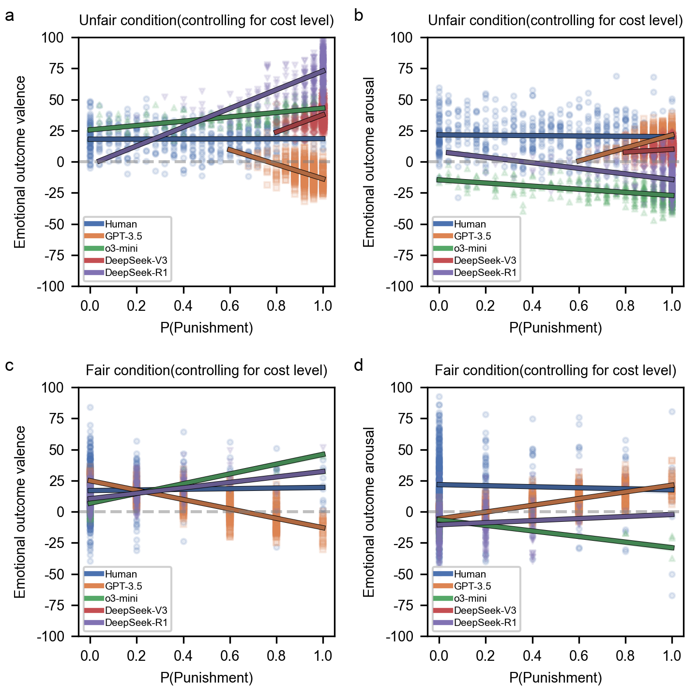
Supplementary Fig. 1|Partial correlation of emotional outcome and behavioural choice across human and LLM agent groups. The scatter dots indicate each participant's emotion-behaviour pairing. The fitted lines display the change emotional gradience of valence (a,c) and arousal (b,d) over punishment probability under the unfair (a,b) vs. fair (c,d) condition after controlling for cost level, with shaded areas representing ±1 standard deviation.

Supplementary Figure 2: RSA matrices across humans and LLMs
Supplementary Fig. 2|Correlation matrices across different participant groups and experimental conditions. Heatmaps display RSA correlation coefficients between 50 experimental conditions for five groups: Human, GPT-3.5, o3-mini, DeepSeek-V3, and DeepSeek-R1. Each condition represents allocation amount (10~14) and cost amount (0~9) combinations. Colour intensity indicates correlation strength (blue: negative, red: positive, white: zero), with unified scale (–1 to +1) for comparability.

