Extended data figures and tables
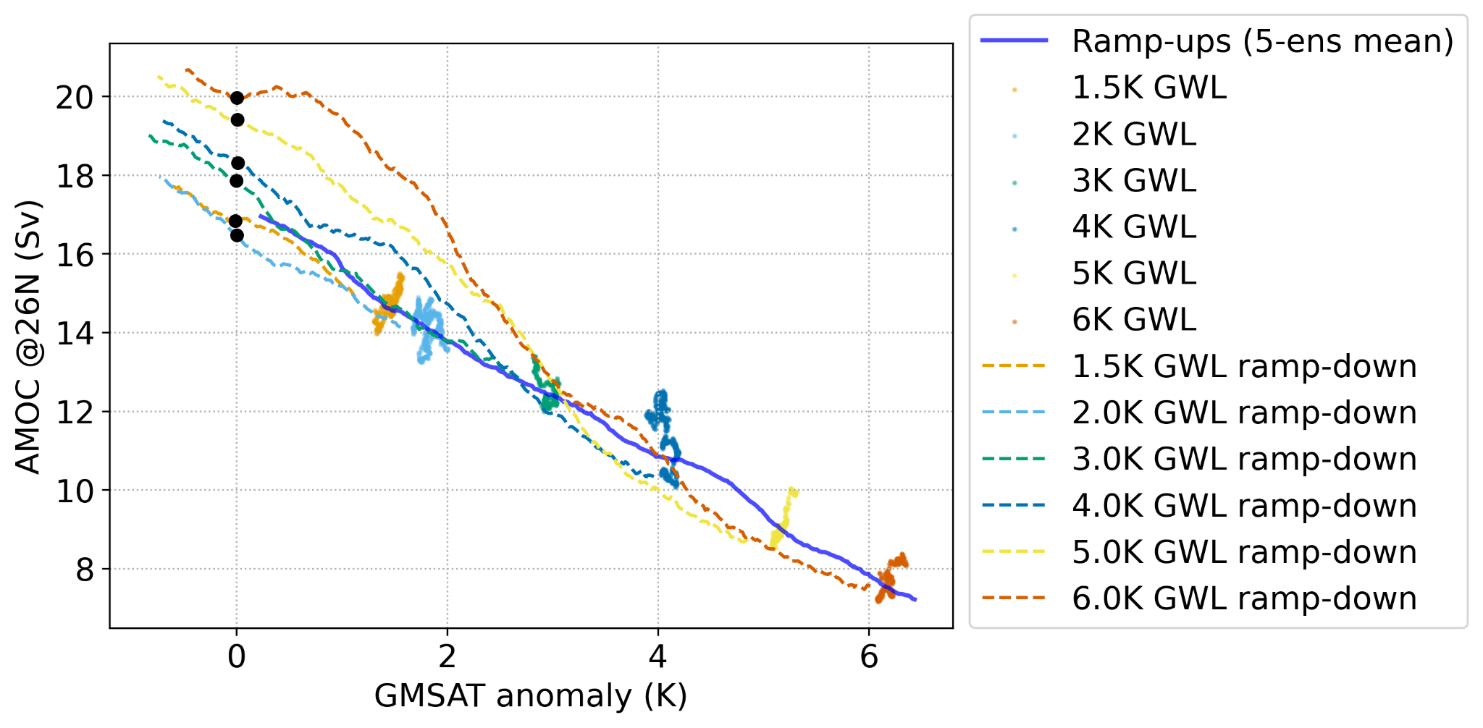
Extended Data Fig. 1: Sensitivity of AMOC strength to global mean surface air temperature.
AMOC strength at 26°N as a function of the global mean surface air temperature (GMSAT) anomaly for the ramp-up (warming), stabilisation, and ramp-down (cooling) simulations. The thick blue line shows the 5-member ensemble mean from the ramp-up simulations. The scattered dots denote the individual global warming levels from 1.5-6 K, and dashed lines show the corresponding ramp-down simulations. Black dots mark when the GMSATs return to the pre-industrial level. The nearly overlapping trajectories confirm that the AMOC response depends quasi-linearly on global warming levels, while ramp-downs from higher warming levels exhibit stronger transient overshoots upon recovery.
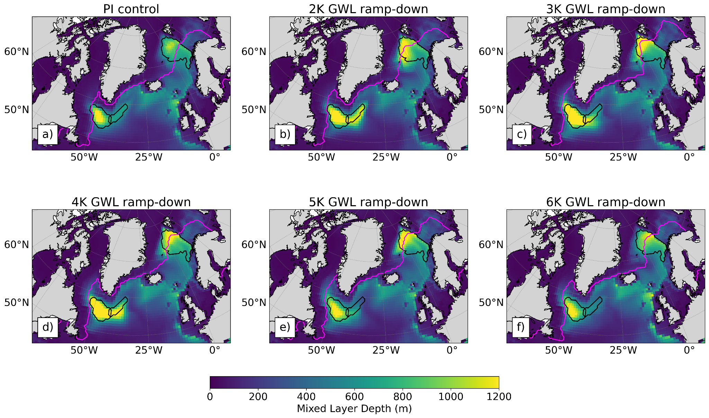
Extended Data Fig. 2: Spatial distributions of March mixed-layer depths of ramp-down simulations returning to pre-industrial temperatures.
March mean mixed-layer depth (MLD) maps for (a) the pre-industrial control simulation and (b-f) 30-year averages during ramp-down phases following global warming levels of 2-6 K, each evaluated when the global mean temperature returns to the pre-industrial level. Black contours mark areas where the pre-industrial MLD exceeds 650 m, indicating the main deep convection sites in the Labrador, Irminger, and Nordic Seas. Magenta contours indicate the March sea-ice edge, defined by the 15% sea-ice concentration threshold. The maps show that deep convection areas expand and reorganise spatially during recovery, consistent with the AMOC rebound. Note that these results are based on a single realisation of the model and therefore include contributions from internal variability.

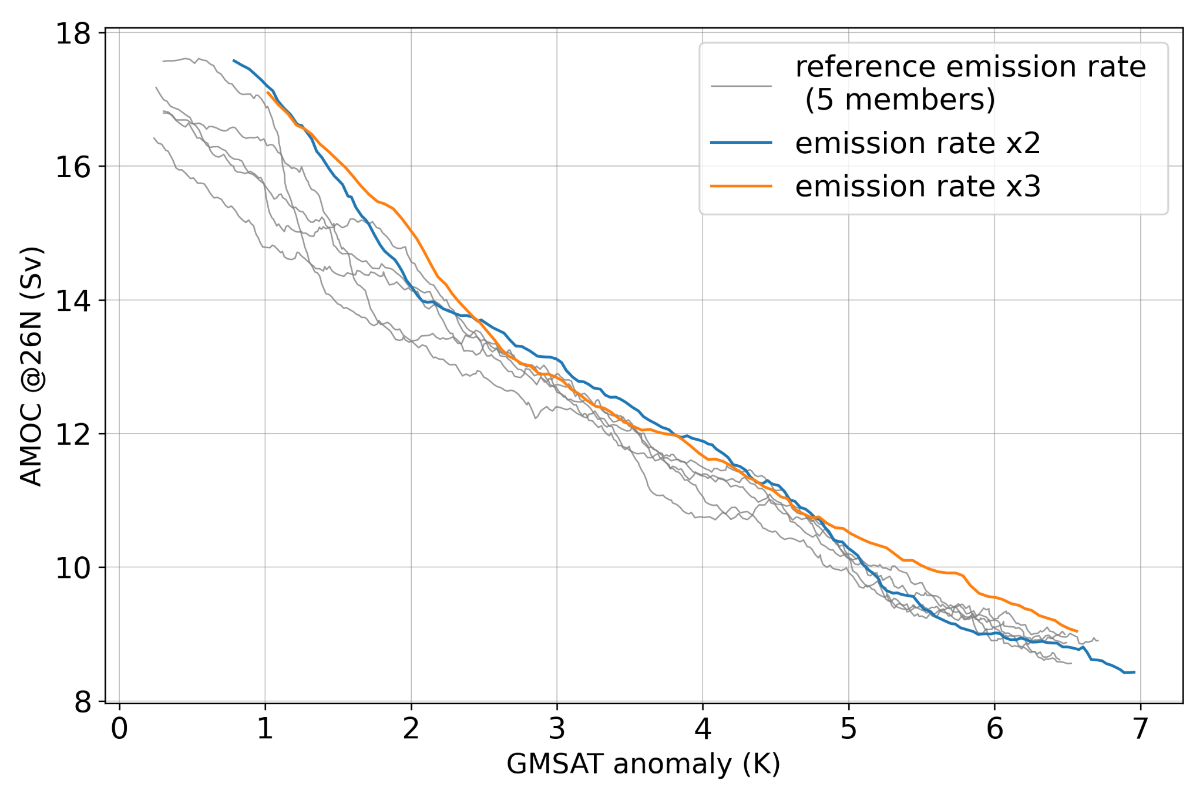
Extended Data Fig. 3: Sensitivity of AMOC response to CO₂ emission rate in ramp-up experiments.
AMOC strength at 26°N as a function of global mean surface air temperature (GMSAT) anomalies for the ramp-up experiments. The grey lines show the five-member ensemble with the reference CO₂ emission rate (12.4 PgC/yr), while blue and orange lines show additional sensitivity runs with doubled and tripled emission rates, which correspond to a warming rate of 0.37 and 0.54 K/decade, respectively. Despite the more rapid forcing, the AMOC trajectories collapse onto a nearly single curve when plotted against GMSAT, indicating that in EC-Earth3-ESM-1 the AMOC response scales primarily with the level of warming rather than its rate.
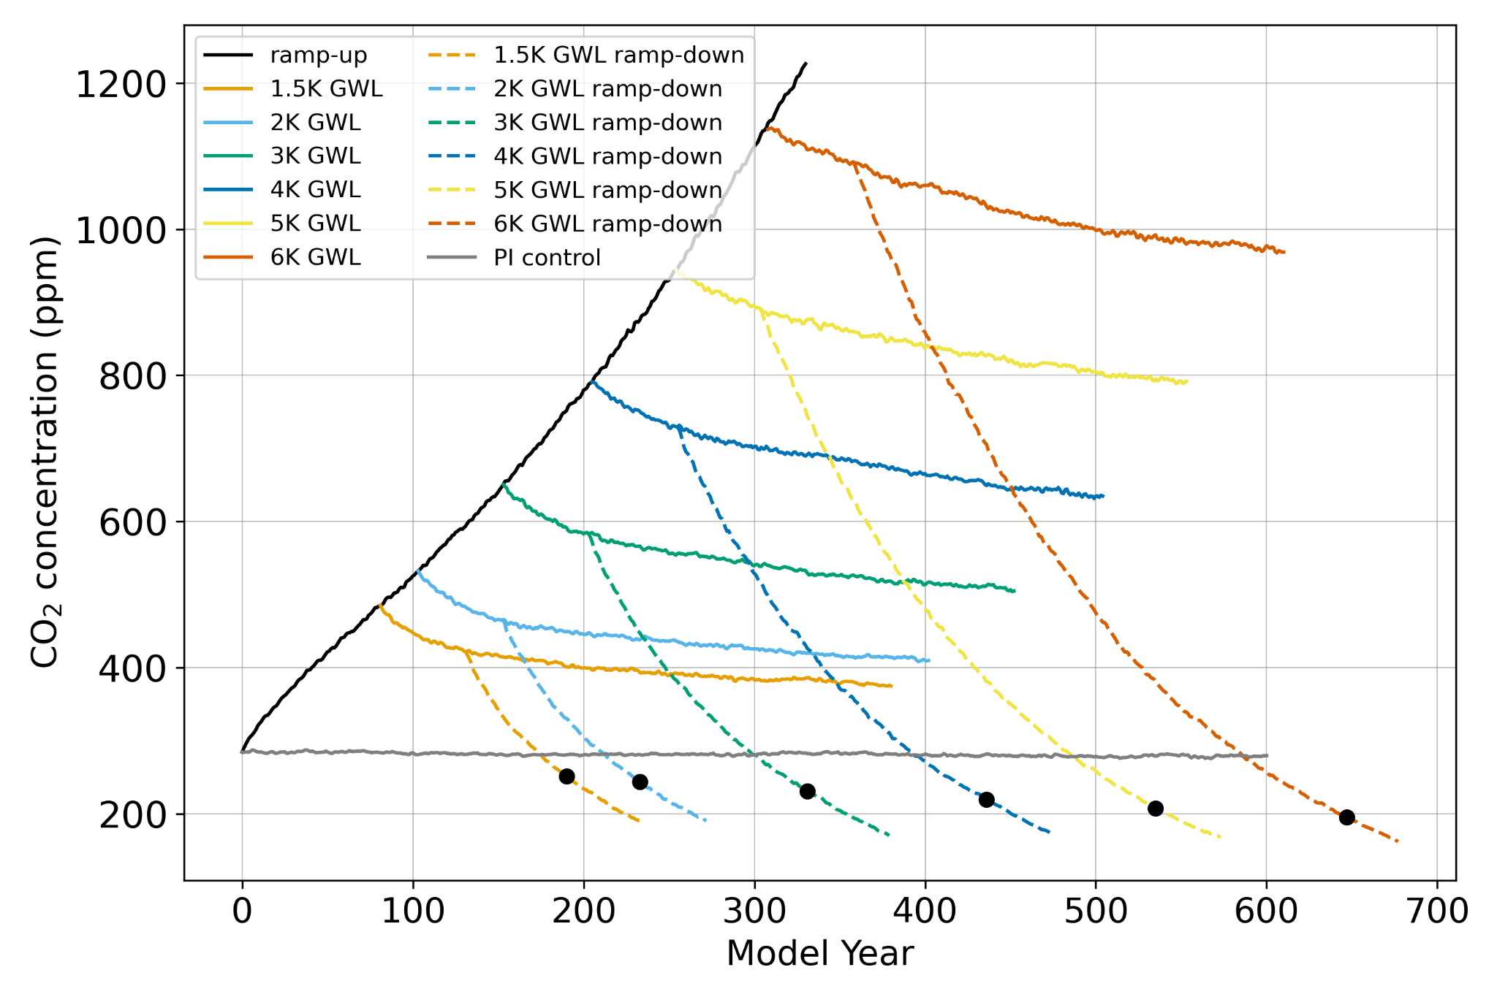
Extended Data Fig 4: Atmospheric CO₂ concentrations under idealised CO₂ emission scenarios.
Evolution of global mean atmospheric CO₂ concentration (parts per million; ppm) in the ramp-up (positive emissions), stabilisation (zero emissions), and ramp-down (negative emissions) experiments with EC-Earth3-ESM-1. Colours and line styles correspond to those in Fig. 1. Black dots mark when the GMSATs return to the pre-industrial level in the ramp-down experiments. CO₂ concentration is stable in the PI control simulation, and closely follows the observations in the historical period (Wyser et al., in prep). The concentration pathways confirm the model’s emission-driven configuration, linking imposed emissions directly to the transient temperature responses shown in Fig. 1a.

