Supplementary information
Decoupling ionic transfer kinetics via undercoordinated constraints for energy-efficient and high-quality zinc electrowinning
Hao Cheng^{1, 2}, Zheng Li^{1, 2}, Guoxuan Li^{1, 2}, Zibo Chen^{1, 2}, Xinyi Li^{1, 2}, Hailin Yu^{1, 2}, Jiebin Zheng^{1, 2}, Zhao Fang³, Zhexuan Liu⁴, Wei Zhang^{5*}, Guangmin Zhou^{4*}, Zhongliang Tian^{1, 2*}
¹School of Metallurgy and Environment, Central South University, Changsha 410083, China. ²National Engineering Research Centre of Low-carbon Nonferrous Metallurgy, Changsha 410083, China. ³School of Metallurgical Engineering, Xi'an University of Architecture and Technology, Xi'an 710055, Shaanxi, China. ⁴Tsinghua Shenzhen International Graduate School, Tsinghua University, Shenzhen 518055, China. ⁵Christopher Ingold Laboratory, Department of Chemistry, University College London, London WC1H 0AJ, UK.
*Corresponding authors. E-mail address: wei.zhang.21@ucl.ac.uk; guangminzhou@sz.tsinghua.edu.cn; tianzhongliang@csu.edu.cn.

Supplementary Fig. 1. Molecular dynamics (MD) simulations for different electrolytes. (a) The total energy of different electrolyte systems. (b) The life of hydrogen bonds. (c) Probability distributions of intermolecular hydrogen bond angles. Hydrogen bonds exhibit pronounced directionality and saturation, with a donor-acceptor distance shorter than 3.5 Å and a donor-hydrogen-acceptor angle smaller than 30° defining the interaction.

Supplementary Fig. 2. 3D snapshots of the electrolytes and typical solvation structures in the electrolyte without (a) and with 1 M ACN (b).

Supplementary Fig. 3. The FTIR of pure ACN.
Supplementary Fig. 4. The in-situ temperature-dependent FTIR of electrolytes with different ACN concentrations. (a) 0 M. (b) 0.2 M. (c) 0.6 M. (d) 1.0 M. (e) 1.4 M. (f) 1.8 M.

Supplementary Fig. 5. (a) The Raman spectrum of pure ACN. (b) Temperature-dependent Raman analysis for electrolytes with different ACN concentrations. (c) Detailed Raman spectra for SO₄²⁻ in (b).

Supplementary Fig. 6. ¹H NMR chemical shifts for pure ACN (a) and electrolytes with different ACN concentrations (b).

Supplementary Fig. 7. Physicochemical characterizations of different electrolytes. (a) Differential scanning calorimeter data. (b) Viscosity. (c) Electrical conductivity.

Supplementary Fig. 8. The LSV curves for the Na₂SO₄ electrolytes.

Supplementary Fig. 9. Nyquist plots of Al electrodes in various electrolytes.

Supplementary Fig. 10. Current-time transients obtained at predetermined potentials. t_{m}: time needed to achieve the peak current (I_{m}). Current-time transients were normalized using I_{m} and its corresponding time (t_{m}). These normalized data were compared with the Scharifker-Hills nucleation model¹. This well-established theory classifies nucleation into two distinct modes: instantaneous (I) and progressive (P). The mathematical expressions governing these modes² are:
$$\text{3DI:}{\left(\frac{\text{I}}{{\text{I}}_{\text{m}}}\right)}^{\text{2}}\text{=1.9542}{\left(\frac{\text{t}}{{\text{t}}_{\text{m}}}\right)}^{\text{-1}}{\left\{\text{1-exp}\left[\text{-1.2564}\left(\frac{\text{t}}{{\text{t}}_{\text{m}}}\right)\right]\right\}}^{\text{2}}\text{ (1)}$$
$$\text{3DP:}{\left(\frac{\text{I}}{{\text{I}}_{\text{m}}}\right)}^{\text{2}}\text{=1.2254}{\left(\frac{\text{t}}{{\text{t}}_{\text{m}}}\right)}^{\text{-1}}{\left\{\text{1-exp}\left[\text{-2.3367}\left(\frac{\text{t}}{{\text{t}}_{\text{m}}}\right)\right]\right\}}^{\text{2}}\text{ (2)}$$
Supplementary Fig. 11. The electrochemical performances of Pb-Ag anodes in different electrolytes. (a) LSV curves. (b) Galvanostatic voltage profiles at 500 A m⁻².

Supplementary Fig. 12. The current efficiencies (a, d), cell voltages (b, e), and energy consumptions (c, f) of zinc electrowinning at different current densities. The current efficiencies (g, j), cell voltages (h, k), and energy consumptions (i, l) of zinc electrowinning in the electrolytes with different Cl⁻/F⁻ concentrations.

Supplementary Fig. 13. The zinc deposit morphology post-stripping from the Al cathodes after electrowinning for 3 h.

Supplementary Fig. 14. Optical micrographs of zinc deposits after electrowinning at different current densities for 3 h.

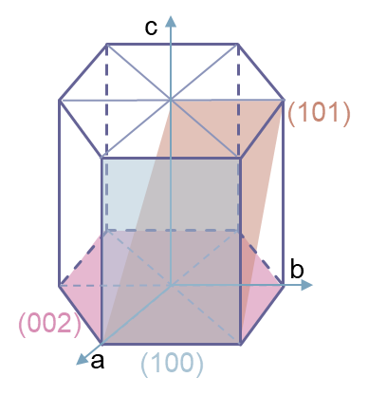
Supplementary Fig. 15. Schematic diagram of the HCP structure of Zn with a (002), (100), (101) crystal plane. Zinc crystallizes in the P6₃/mmc space group with a hexagonal close-packed (hcp) structure. During electrodeposition, zinc growth primarily occurs along three low-index facets: (100), (002), and (101). Among these, the (002) plane exhibits high atomic density and low surface energy, resulting in superior thermodynamic stability³. In contrast, the (101) plane enables stable vertical epitaxial growth with enhanced mass transfer kinetics, offering sustained and controllable deposition behavior⁴.

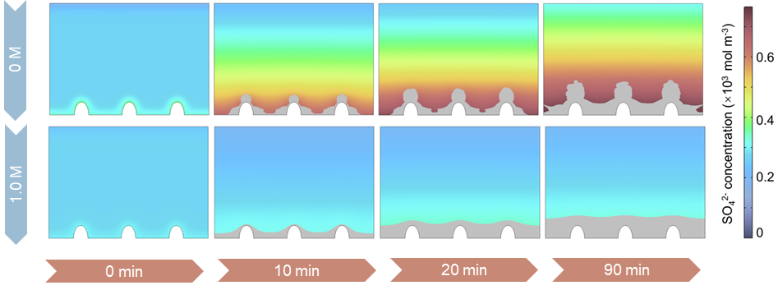
Supplementary Fig. 16. The finite element simulations for SO₄²⁻ concentration distributions.

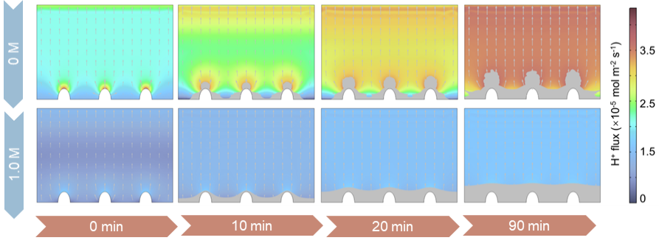
Supplementary Fig. 17. The finite element simulations for H⁺ flux.

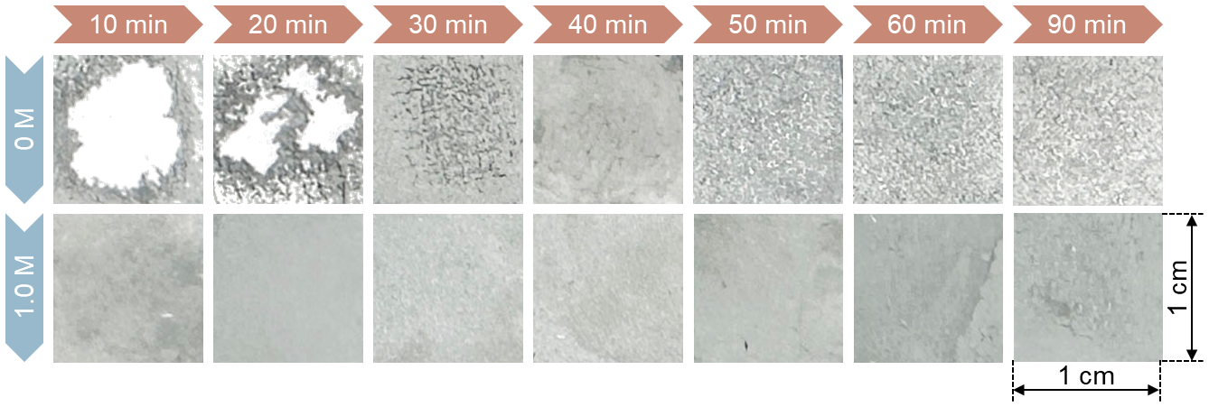
Supplementary Fig. 18. Time-varying images of deposited zinc after electrowinning in different electrolytes.

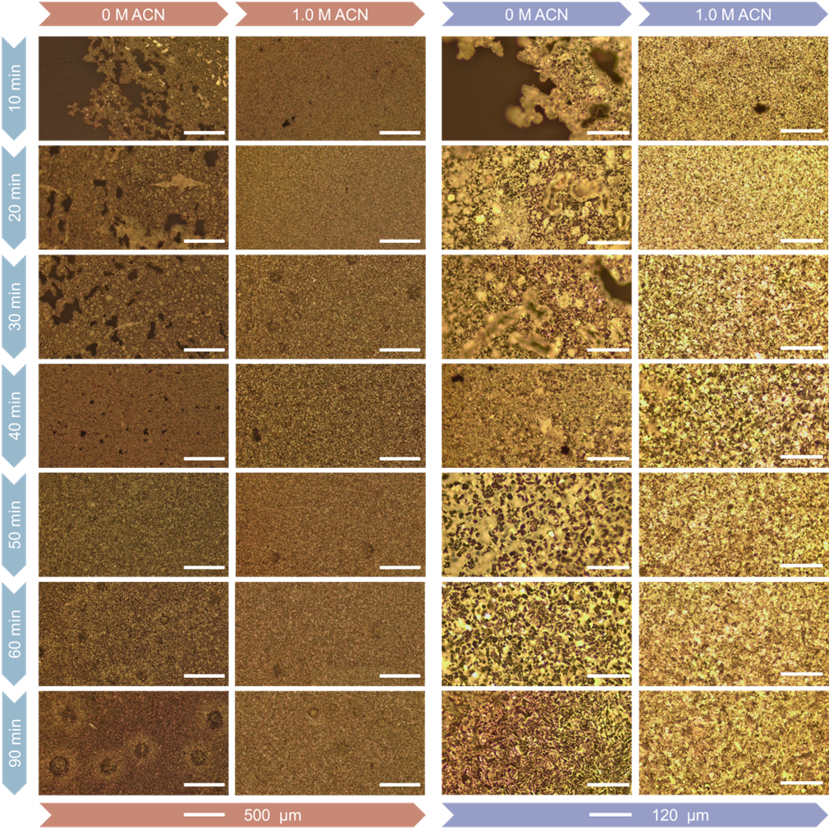
Supplementary Fig. 19. Time-varying optical micrographs of deposited zinc after electrowinning in different electrolytes.
Supplementary Fig. 20. The height variations and surface roughness across distinct regions of the CLSM images. (a) Horizontal line scanning. (b) Vertical line scanning. (c) Diagonal line scanning.

Supplementary Table 1. Tafel parameters derived from curve fitting analysis.
Concentration (M) | Corrosion potential (V) | Corrosion current density (mA cm⁻²)
0 | -0.633 | 87.10
0.2 | -0.610 | 60.67
0.6 | -0.588 | 46.99
1.0 | -0.580 | 41.11
1.4 | -0.559 | 39.54
1.8 | -0.560 | 38.28

Supplementary Table 2. Comparative evaluation of electrolyte additives for ZE.
Additive | Current density (A m⁻²) | Current efficiency (%) | Cell voltage (V) | Energy consumption (kWh t⁻¹) | Reference
1.0 M ACN without F⁻ | 500 | 94.3 | 2.91 | 2531.4 | This work
1.0 M ACN without F⁻ | 1500 | 82.6 | 3.34 | 3317.3 | This work
1.0 M ACN with 1 g L⁻¹ F⁻ | 500 | 90.8 | 2.93 | 2644.9 | This work
5 mg L⁻¹ gelatin | 500 | 96.2 | 3.80 | 3239.0 | ⁵
5 mg L⁻¹ Tannic acid | 500 | 89.3 | 3.11 | 2850.0 | ⁶
5 mg L⁻¹ FS-301 | 500 | 93.4 | 3.52 | 3090.0 | ⁷
1 mg L⁻¹ CTABr | 500 | 81.4 | 3.03 | 3053.4 | ⁸

References
1 Scharifker, B. & Hills, G. Theoretical and experimental studies of multiple nucleation. Electrochim. Acta 28, 879-889 (1983).
2 Zhao, Y. et al. Tailoring grain boundary stability of zinc-titanium alloy for long-lasting aqueous zinc batteries. Nat. Commun. 14, 7080 (2023).
3 Yang, X. et al. Crystallographic manipulation strategies toward reversible zn anode with orientational deposition. Adv. Energy Mater. 14, 2401293 (2024).
4 Liu, Z. et al. Construct robust epitaxial growth of(101) textured zinc metal anode for long life and high capacity in mild aqueous zinc-ion batteries. Adv. Mater. 36, 2305988 (2024).
5 Wu, X., Liu, Z. & Liu, X. The effects of additives on the electrowinning of zinc from sulphate solutions with high fluoride concentration. Hydrometallurgy 141, 31-35 (2014).
6 Lin, G. et al. Roles of tannic acid and gelatin in zn electrowinning and their inhibition mechanisms investigated via electrochemical methods. Hydrometallurgy 195, 105390 (2020).
7 Ji, Q. et al. An environmentally friendly and high current efficiency acid mist inhibitor for zinc electrowinning. Mater. Res. Express 10, 076507 (2023).
8 Xu, X. et al. Improve the energy efficiency: Effects of additives on longtime zinc electrowinning. Hydrometallurgy 193, 105326 (2020).

