Supplementary Material

Cost-Effectiveness of Colorectal Cancer Screening in the Dominican Republic
Alice Agyekum^{1,†}, Sophie Wagner^{1,†}, Karla Marie Disla Pineda², Dolores Mejia de la Cruz², Katherine Crew^{1,3}, Chin Hur^{1,‡}, Yoanna Pumpalova^{1,‡,}*
¹ Department of Medicine, Columbia University Irving Medical Center, New York, NY;
²Department of Medicine, Hospital General de la Plaza de la Salud, Santo Domingo, Dominican Republic;
³Herbert Irving Comprehensive Medical Center, New York, NY

† These authors contributed equally (co-first authors)
‡ These authors jointly supervised the work (co-senior authors)
*Corresponding author: yp2184@cumc.columbia.edu
Table of Contents
Supplementary Table 1. Model inputs table. 2
Supplementary Figure 1. Calibrated incidence curves for colorectal cancer natural history component. 4
Supplementary Table 2. Calibrated monthly transition probabilities. 5
Supplementary Table 3. Per-person costs, DALYs, CRC cases, and number of colonoscopies over the model lifetime at 60% and 100% adherence to screening. 6
Supplementary Figure 2. Colorectal cancer incidence and mortality reductions under various initial and follow-up adherence assumptions. 7
Supplementary Table 4. Per-person costs, DALYs, CRC cases, and number of colonoscopies over the model lifetime, for varying screening start ages. 8
Supplementary Figure 3. Cost-effectiveness plane of colorectal cancer screening strategies in the Dominican Republic, including FIT-Colo scenario analysis strategy. 9
Supplementary Table 5. Per-person costs, DALYs, CRC cases, and number of colonoscopies over the model lifetime, for varying surveillance stop ages. 10
Supplementary Table 6. Per-person costs, DALYs, CRC cases, and number of colonoscopies over the model lifetime, for various CRC incidence assumptions. 11
Supplementary Table 7. Per-person costs, DALYs, CRC cases, and number of colonoscopies over the model lifetime, for different CRC stage distribution assumptions. 12
References 13

Supplementary Table 1. Model inputs table.
Parameters |  | Base-case | OWSA Range | Distribution | Sources
CRC mortality rates
 | Localized CRC | 0.002 | 0.001 – 0.002 | Beta | ¹
 | Regional CRC | 0.005 | 0.004 – 0.006 | Beta | ¹
 | Distant CRC | 0.028 | 0.021 –0.035 | Beta | ¹
All-cause mortality |  | Age-based | +/- 25% | Beta | ²
Test performance characteristics
Colonoscopy
Sensitivity, low-risk polyp |  | 0.85 | 0.80 – 0.90 | Beta | ³
Sensitivity, high-risk polyp |  | 0.90 | 0.85 – 0.95 | Beta | ³
Sensitivity, CRC |  | 0.95 | 0.90 – 0.97 | Beta | ³
Complications |  | Age-based | 0.00345 – 0.02655 | Beta | ⁴
Death from complications |  | 6.68e-5 | 3.34e-5 – 0.0001 | Beta | ⁵
Sigmoidoscopy
Sensitivity, low-risk polyp |  | 0.51 | 0.48 – 0.54 | Beta | ³
Sensitivity, high-risk polyp |  | 0.54 | 0.51 – 0.57 | Beta | ³
Sensitivity, CRC |  | 0.57 | 0.54 – 0.58 | Beta | ³
Specificity |  | 0.92 | 0.89 – 0.95 | Beta | ³
Complications |  | Age-based | 0.00345 – 0.02655 | Beta | ⁵
Death from complications |  | 6.68e-5 | 3.34e-5 – 0.0001 | Beta | ⁴
FIT
Sensitivity, low-risk polyp |  | 0.10 | 0.08 – 0.24 | Beta | ³
Sensitivity, high-risk polyp |  | 0.24 | 0.16 – 0.48 | Beta | ³
Sensitivity, CRC |  | 0.738 | 0.615 – 0.84 | Beta | ⁶
Specificity |  | 0.95 | 0.93 – 0.98 | Beta | ³
FOBT
Sensitivity, low-risk polyp |  | 0.05 | 0.05 – 0.14 | Beta | ³
Sensitivity, high-risk polyp |  | 0.11 | 0.09 – 0.28 | Beta | ³
Sensitivity, CRC |  | 0.4 | 0.25 – 0.50 | Beta | ³
Specificity |  | 0.9 | 0.89 – 0.93 | Beta | ^{7, 8}
Disutilities
Disease-free |  | 0 | - | Beta | ⁻
All-cause and CRC death |  | 1 | - | Beta | ⁻
Local CRC |  | 0.1 | 0 – 0.325 | Beta | ³
Regional CRC |  | 0.2 | 0 – 0.4 | Beta | ³
Distant CRC |  | 0.8 | 0.734 – 0.867 | Beta | ⁹
Colonoscopy (applied for 2 days) |  | 0.00118 | 0.00059 – 0.00177 | Beta | ¹⁰
Sigmoidoscopy (applied for 1 day) |  | 0.00118 | 0.00059 – 0.00177 | Beta | ¹⁰
Colonoscopy or sigmoidoscopy complication (applied for 1 week) |  | 0.0055 | 0.00275 – 0.00825 | Beta | ¹⁰
Costs (USD)
Colonoscopy with biopsy |  | 236.89 | 118.45 - 355.34 | Gamma | ¹¹⁻¹⁴
Colonoscopy without biopsy |  | 212.34 | 106.17 - 318.51 | Gamma | ¹¹⁻¹⁴
Sigmoidoscopy |  | 106.17 | 53.09 - 159.26 | Gamma | ¹¹⁻¹⁴
FIT |  | 12.66 | 6.33 - 18.99 | Gamma | ¹¹⁻¹⁴
FOBT |  | 5.27 | 2.64 - 7.90 | Gamma | ¹¹⁻¹⁴
Chemotherapy |  | 685.76 | 342.88 - 1028.64 | Gamma | ¹¹⁻¹⁴
Hospitalization |  | 602.93 | 301.47 - 904.40 | Gamma | ¹¹⁻¹⁴
Surgery for complications |  | 363.50 | 181.75 - 545.25 | Gamma | ¹¹⁻¹⁴
Labs |  | 35.69 | 17.85 - 53.54 | Gamma | ¹¹⁻¹⁴
CT scan |  | 53.52 | 26.76 - 80.28 | Gamma | ¹¹⁻¹⁴
Doctor consultations |  | 5.83 | 2.92 - 8.75 | Gamma | ¹¹⁻¹⁴
Note. Abbreviations: OWSA (one-way sensitivity analysis), CRC (colorectal cancer), FIT (fecal immunochemical test), FOBT (fecal occult blood test), USD (US Dollars), CT (computerized tomography).

Supplementary Figure 1. Calibrated incidence curves for colorectal cancer natural history component.
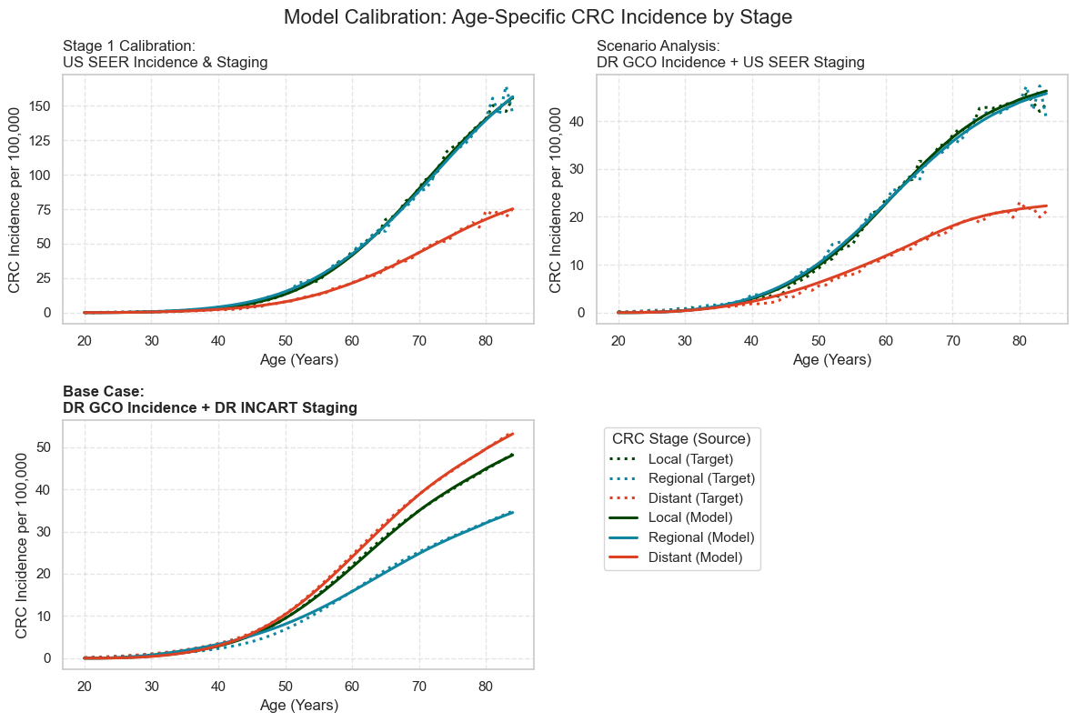
Note. Abbreviations: CRC (colorectal cancer), US (United States), SEER (Surveillance, Epidemiology, and End Results), DR (Dominican Republic), GCO (GLOBOCAN Global Cancer Observatory), INCART (Rosa Emilia Sánchez Pérez de Tavares National Cancer Institute).
Model calibration outputs show age-specific colorectal cancer (CRC) incidence by stage under three calibration scenarios. In the top-left panel, the model was calibrated to U.S. SEER incidence and stage distribution data (Stage 1 calibration). The bottom-left panel shows a scenario analysis in which the model was calibrated to Dominican Republic (DR) incidence estimates from GLOBOCAN (GCO) while retaining US SEER stage distribution. The bottom-right panel presents the base case model, calibrated to both DR incidence (GCO) and DR stage distribution from INCART. Dotted lines represent observed target data; solid lines represent model-predicted incidence by stage.

Supplementary Table 2. Calibrated monthly transition probabilities.
Transition | Mean | Median | 95% CI Lower | 95% CI Upper
Healthy to low-risk polyp | 0.000166 | 0.000168 | 0.000164 | 0.000169
Low-risk polyp to high-risk polyp | 0.001792 | 0.002081 | 0.001544 | 0.001835
High-risk polyp to localized CRC | 0.003707 | 0.003876 | 0.003412 | 0.003804
Localized CRC to regional CRC | 0.035145 | 0.033964 | 0.033634 | 0.035919
Regional CRC to distant CRC | 0.060268 | 0.064601 | 0.056351 | 0.061964
Localized CRC symptomatic detection | 0.015911 | 0.016104 | 0.015605 | 0.016136
Regional CRC symptomatic detection | 0.053736 | 0.043926 | 0.048656 | 0.054884
Distant CRC symptomatic detection | 0.213978 | 0.192184 | 0.199998 | 0.219205
Note. Abbreviations: CRC (colorectal cancer), CI (confidence interval).
Monthly transition probabilities shown in the table are for the base-case model, which was calibrated to age-based CRC incidence estimates for the Dominican Republic from the Global Cancer Observatory (GCO) and stage distribution from Rosa Emilia Sánchez Pérez de Tavares National Cancer Institute (INCART). Starting transition probabilities were derived from Hur et al.¹⁵ Due to the skewed nature of the data, we derived 95% confidence CIs using a log-normal distribution. This table excludes mortality transition probabilities as they were not calibrated. Instead, they were determined directly using either Surveillance, Epidemiology, and End Results (SEER)¹⁶ data or 2019 life tables from the World Health Organization (WHO).²

Supplementary Table 3. Per-person costs, DALYs, CRC cases, and number of colonoscopies over the model lifetime at 60% and 100% adherence to screening.
 |  |  |  |  |  | CRC cases |  | CRC deaths
Strategy ​ | Lifetime cost per person (USD) | Incremental cost (USD) | Avg. life expectancy (years) | DALYs averted | ICER/DALY averted ​ | N per 100k | % Averted  compared to NH ​ | N per 100k | % Averted compared to NH ​ | Lifetime  colonoscopies per 1000​
60% adherence (base case)
NH ​ | 73.89​ | -​ | 75.35​ | 0.00​ | -​ | 2333​ | -​ | 997​ | -​ | 23​
FIT​ | 101.39​ | 27.50​ | 75.37​ | 0.0129​ | 2,134.74 | 1636​ | 30%​ | 627​ | 37%​ | 371​
FOBT​ | 106.46​ | 5.07​ | 75.35​ | -0.0037​ | Dominated | 1849​ | 21%​ | 728​ | 27%​ | 579​
Colo ​ | 171.43​ | 70.04​ | 75.42​ | 0.0054​ | 12903.51​ | 1170​ | 50%​ | 477​ | 52%​ | 1953​
Sig ​ | 177.90​ | 6.47​ | 75.37​ | -0.0041​ | Dominated | 1408​ | 40%​ | 579​ | 42%​ | 307​
100% adherence
NH ​ | 73.89​ | -​ | 75.35​ | 0.00​ | -​ | 2333​ | -​ | 997​ | -​ | 23​
FIT​ | 119.26​ | 45.38 | 75.38 | 0.0213 | 2,134.75​ | 1183 | 49%​ | 387 | 61%​ | 597​
FOBT​ | 127.63 | 8.37 | 75.36 | -0.0062​ | Dominated | 1533 | 34%​ | 552 | 45%​ | 939
Sig | 245.52 | 126.25 | 75.38 | 0.0022 | Extended dominated | 806 | 65%​ | 307 | 69%​ | 491
Colo | 247.23 | 127.97 | 75.46 | 0.0090 | 14,285.69 | 414 | 82%​ | 139​ | 86%​ | 3208
Note. Abbreviations: CRC (colorectal cancer), DALY (disability-adjusted life-year), Avg. (Average), ICER (incremental cost-effectiveness ratio), NH (natural history), FIT (biennial fecal immunochemical test), FOBT (biennial fecal occult blood test), Colo (colonoscopy every 10 years), Sig (sigmoidoscopy every 5 years).

Supplementary Figure 2. Colorectal cancer incidence and mortality reductions under various initial and follow-up adherence assumptions.
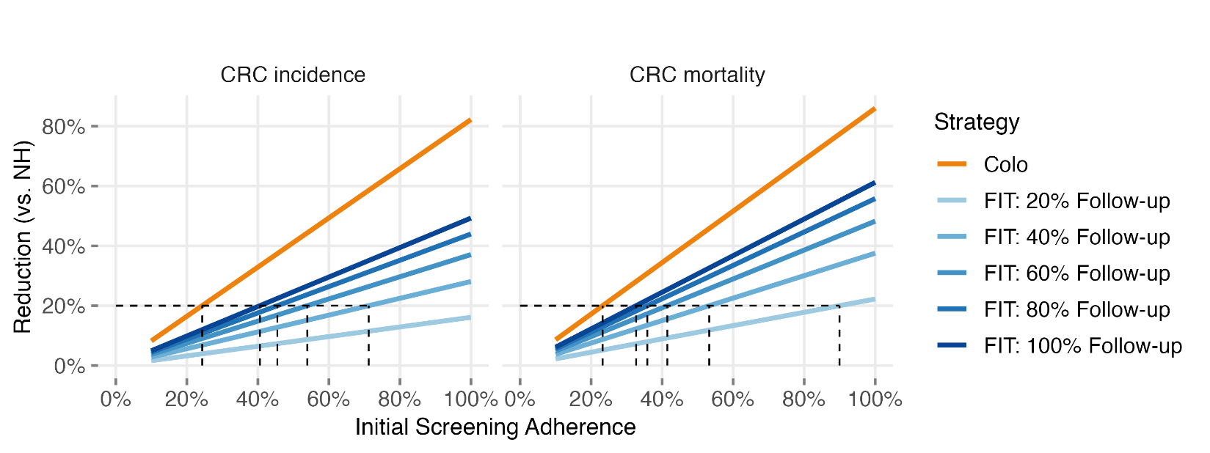
Note. Abbreviations: CRC (colorectal cancer), Colo (colonoscopy every 10 years), FIT (biennial fecal immunochemical test), NH (natural history).
Comparison of CRC outcomes under varying adherence scenarios. The x-axis reflects initial screening adherence—i.e., the proportion of the population participating in FIT or Colo screening. Blue lines represent the FIT strategy with varying levels of adherence follow-up colonoscopy after a positive test. The dashed lines indicate the initial screening adherence required to achieve a 20% reduction in CRC incidence or mortality compared to no screening (NH).

Supplementary Table 4. Per-person costs, DALYs, CRC cases, and number of colonoscopies over the model lifetime, for varying screening start ages.
 |  |  |  |  |  | CRC cases |  | CRC deaths
Strategy ​ | Lifetime cost per person (USD) | Incremental cost (USD) | Avg. life expectancy (years) | DALYs averted | ICER/DALY averted ​ | N per 100k | % Averted  compared to NH ​ | N per 100k | % Averted compared to NH ​ | Lifetime  colonoscopies per 1000​
Screening start age 40
NH ​ | 73.89 | - | 75.35 | - | - | 2333 | - | 997 | - | 23
FIT​ | 113.79 | 39.91 | 75.37 | 0.0143 | 2,792.61 | 1598 | 32% | 616 | 38% | 421
FOBT​ | 118.72 | 4.93 | 75.35 | -0.0040 | Dominated | 1815 | 22% | 717 | 28% | 663
Colo ​ | 201.37 | 87.57 | 75.42 | 0.0057 | 15,266.19 | 1150 | 51% | 472 | 53% | 2091
Sig ​ | 211.49 | 10.12 | 75.37 | -0.0041 | Dominated | 1356 | 42% | 559 | 44% | 347
Screening start age 45 (base case)
NH ​ | 73.89 | - | 75.35 | 0.00 | - | 2333 | - | 997 | - | 23
FIT​ | 101.39 | 27.50 | 75.37 | 0.0129 | 2,134.74 | 1636 | 30% | 627 | 37% | 371
FOBT​ | 106.46 | 5.07 | 75.35 | -0.0037 | Dominated | 1849 | 21% | 728 | 27% | 579
Colo | 171.43 | 70.04 | 75.42 | 0.0054 | 12,903.51 | 1170 | 50% | 477 | 52% | 1953
Sig | 177.90 | 6.47 | 75.37 | -0.0041 | Dominated | 1408 | 40% | 579 | 42% | 307
Screening start age 50
NH ​ | 73.89 | - | 75.35 | - | - | 2333 | - | 997 | - | 23
FIT​ | 91.19 | 17.31 | 75.37 | 0.0109 | 1,586.53 | 1712 | 27% | 658 | 34% | 306
FOBT​ | 96.20 | 5.01 | 75.35 | -0.0033 | Dominated | 1910 | 18% | 755 | 24% | 473
Colo ​ | 136.52 | 45.33 | 75.42 | 0.0048 | 9,390.74 | 1268 | 46% | 516 | 48% | 1510
Sig ​ | 150.68 | 14.16 | 75.37 | 0.0038 | Dominated | 1486 | 36% | 610 | 39% | 267
Note. Abbreviations: CRC (colorectal cancer), DALY (disability-adjusted life-year), Avg. (Average), ICER (incremental cost-effectiveness ratio), NH (natural history), FIT (biennial fecal immunochemical test), FOBT (biennial fecal occult blood test), Colo (colonoscopy every 10 years), Sig (sigmoidoscopy every 5 years).

Supplementary Figure 3. Cost-effectiveness plane of colorectal cancer screening strategies in the Dominican Republic, including FIT-Colo scenario analysis strategy.
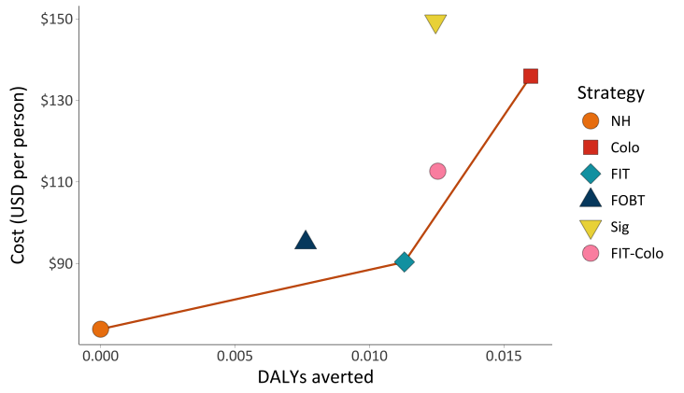
Note. Abbreviations: CRC (colorectal cancer), DALY (disability-adjusted life-year), NH (natural history), FIT (biennial fecal immunochemical test), FOBT (biennial fecal occult blood test), Colo (colonoscopy every 10 years), Sig (sigmoidoscopy every 5 years), FIT-Colo (FIT biennial from age 45-50, colonoscopy every 10 years starting age 50).
All costs and DALYs represent per-person estimates accumulated over the modeled time horizon. Strategies connected by the line (NH, FIT, and Colo) lie on the cost-effectiveness frontier, representing the most efficient options. Sig and FOBT are absolutely dominated, meaning they result in higher costs and fewer DALYs averted compared to other strategies. FIT-Colo is extendedly dominated, meaning that although it improves both cost and effectiveness, the incremental cost-effectiveness ratio (ICER) of switching from FIT-Colo to Colo is more favorable than from FIT to FIT-Colo.

Supplementary Table 5. Per-person costs, DALYs, CRC cases, and number of colonoscopies over the model lifetime, for varying surveillance stop ages.
 |  |  |  |  |  | CRC cases |  | CRC deaths
Strategy ​ | Lifetime cost per person (USD) | Incremental cost (USD) | Avg. life expectancy (years) | DALYs averted | ICER/DALY averted ​ | N per 100k | % Averted  compared to NH ​ | N per 100k | % Averted compared to NH ​ | Lifetime  colonoscopies per 1000​
Surveillance stop age 75
NH | 73.89 | - | 75.35 | - | - | 2333 | - | 997 | - | 23
FIT | 101.38 | 27.49 | 75.37 | 0.0129 | 2,135.98 | 1639 | 30% | 628 | 37% | 370
FOBT | 106.45 | 5.07 | 75.35 | -0.0037 | Dominated | 1851 | 21% | 728 | 27% | 578
Colo | 171.40 | 70.02 | 75.42 | 0.0054 | 12,918 | 1175 | 50% | 479 | 52% | 1952
Sig | 177.89 | 6.49 | 75.37 | -0.0041 | Dominated | 1411 | 40% | 580 | 42% | 306
Surveillance stop age 85 (base case)
NH ​ | 73.89 | - | 75.35 | 0.00 | - | 2333 | - | 997 | - | 23
FIT​ | 101.39 | 27.50 | 75.37 | 0.0129 | 2,134.74 | 1636 | 30% | 627 | 37% | 371
FOBT​ | 106.46 | 5.07 | 75.35 | -0.0037 | Dominated | 1849 | 21% | 728 | 27% | 579
Colo | 171.43 | 70.04 | 75.42 | 0.0054 | 12,903.51 | 1170 | 50% | 477 | 52% | 1953
Sig | 177.90 | 6.47 | 75.37 | -0.0041 | Dominated | 1408 | 40% | 579 | 42% | 307
Note. Abbreviations: CRC (colorectal cancer), DALY (disability-adjusted life-year), Avg. (Average), ICER (incremental cost-effectiveness ratio), NH (natural history), FIT (biennial fecal immunochemical test), FOBT (biennial fecal occult blood test), Colo (colonoscopy every 10 years), Sig (sigmoidoscopy every 5 years).

Supplementary Table 6. Per-person costs, DALYs, CRC cases, and number of colonoscopies over the model lifetime, for various CRC incidence assumptions.
 |  |  |  |  |  | CRC cases |  | CRC deaths
Strategy ​ | Lifetime cost per person (USD) | Incremental cost (USD) | Avg. life expectancy (years) | DALYs averted | ICER/DALY averted ​ | N per 100k | % Averted  compared to NH ​ | N per 100k | % Averted compared to NH ​ | Lifetime  colonoscopies per 1000​
0.5x Incidence
NH | 36.98 | - | 75.42 | - | - | 1164 | - | 498 | - | 11
FIT | 76.44 | 52.76 | 75.43 | 0.0065 | 6,110.98 | 812 | 30% | 311 | 37% | 350
FOBT | 78.72 | 2.06 | 75.42 | -0.0019 | Dominated | 919 | 21% | 362 | 27% | 571
Sig | 153.98 | 77.55 | 75.43 | 0.0007 | Extended dominated | 698 | 40% | 287 | 42% | 276
Colo | 156.62 | 80.19 | 75.45 | 0.0027 | 29,670.67 | 582 | 52% | 237 | 52% | 1945
1x Incidence (base case)
NH | 73.89 | - | 75.35 | 0.00 | - | 2333 | - | 997 | - | 23
FIT | 101.39 | 27.50 | 75.37 | 0.0129 | 2,134.74 | 1636 | 30% | 627 | 37% | 371
FOBT | 106.46 | 5.07 | 75.35 | -0.0037 | Dominated | 1849 | 21% | 728 | 27% | 579
Colo | 171.43 | 70.04 | 75.42 | 0.0054 | 12,903.51 | 1170 | 50% | 477 | 52% | 1953
Sig | 177.90 | 6.47 | 75.37 | -0.0041 | Dominated | 1408 | 40% | 579 | 42% | 307
2x Incidence
NH | 145.46 | - | 75.21 | - | - | 4578 | - | 1960 | - | 46
FIT | 152.74 | 7.29 | 75.25 | 0.0419 | 174.10 | 2324 | 49% | 761 | 61% | 648
FOBT | 169.60 | 16.86 | 75.22 | -0.0121 | Dominated | 3007 | 34% | 1084 | 45% | 946
Colo | 260.33 | 107.59 | 75.34 | 0.0176 | 6,107.10 | 828 | 82% | 280 | 86% | 3213
Sig | 275.87 | 15.54 | 75.25 | -0.0135 | Dominated | 1602 | 65% | 611 | 69% | 577
Note. Abbreviations: CRC (colorectal cancer), DALY (disability-adjusted life-year), Avg. (Average), ICER (incremental cost-effectiveness ratio), NH (natural history), FIT (biennial fecal immunochemical test), FOBT (biennial fecal occult blood test), Colo (colonoscopy every 10 years), Sig (sigmoidoscopy every 5 years).

Supplementary Table 7. Per-person costs, DALYs, CRC cases, and number of colonoscopies over the model lifetime, for different CRC stage distribution assumptions.
 |  |  |  |  |  | CRC cases |  | CRC deaths
Strategy ​ | Lifetime cost per person (USD) | Incremental cost (USD) | Avg. life cxpectancy (years) | DALYs averted | ICER/DALY averted ​ | N per 100k | % Averted  compared to NH ​ | N per 100k | % Averted compared to NH ​ | Lifetime  colonoscopies per 1000​
SEER-derived stage distribution
NH | 49.77 | - | 75.39 | - | - | 4578 | - | 1960 | - | 21
FIT | 87.40 | 37.63 | 75.39 | 0.0086 | 4,378.0 | 2198 | 27% | 726 | 33% | 364
FOBT | 90.20 | 2.80 | 75.38 | -0.0027 | Dominated | 2897 | 18% | 1050 | 23% | 576
Sig | 164.15 | 76.75 | 75.40 | 0.0013 | Extended dominated | 744 | 37% | 256 | 39% | 299
Colo | 164.45 | 77.05 | 75.43 | 0.0044 | 17,488.6 | 1430 | 48% | 546 | 50% | 1951
INCART-derived stage distribution (base case)
NH ​ | 73.89 | - | 75.35 | 0.00 | - | 2333 | - | 997 | - | 23
FIT​ | 101.39 | 27.50 | 75.37 | 0.0129 | 2,134.74 | 1636 | 30% | 627 | 37% | 371
FOBT​ | 106.46 | 5.07 | 75.35 | -0.0037 | Dominated | 1849 | 21% | 728 | 27% | 579
Colo | 171.43 | 70.04 | 75.42 | 0.0054 | 12,903.51 | 1170 | 50% | 477 | 52% | 1953
Sig | 177.90 | 6.47 | 75.37 | -0.0041 | Dominated | 1408 | 40% | 579 | 42% | 307
Note. Abbreviations: CRC (colorectal cancer), DALY (disability-adjusted life-year), Avg. (Average), ICER (incremental cost-effectiveness ratio), NH (natural history), FIT (biennial fecal immunochemical test), FOBT (biennial fecal occult blood test), Colo (colonoscopy every 10 years), Sig (sigmoidoscopy every 5 years), (Rosa Emilia Sánchez Pérez de Tavares National Cancer Institute).

References
1. SEER Program. SEER stat databases: SEER November 2020 submission. National Cancer Institute. Accessed October 10, 2023. https://seer.cancer.gov/data-software/documentation/seerstat/nov2020.
2. World Health Organization (WHO). Global Health Observatory (GHO) data – Legacy data. Geneva: World Health Organization. https://www.who.int/data/gho/legacy?profileCode=WHO&applicationCode=System&languageAlpha2=en&indicatorId=29. Accessed July 30, 2025.
3. Sharaf RN, Ladabaum U. Comparative effectiveness and cost-effectiveness of screening colonoscopy vs. sigmoidoscopy and alternative strategies. Am J Gastroenterol. 2013;108(1):120-32. Epub 20121218. doi: 10.1038/ajg.2012.380. PubMed PMID: 23247579.
4. Knudsen AB, Hur C, Gazelle GS, Schrag D, McFarland EG, Kuntz KM. Rescreening of persons with a negative colonoscopy result: results from a microsimulation model. Ann Intern Med. 2012;157(9):611-20. doi: 10.7326/0003-4819-157-9-201211060-00005. PubMed PMID: 23128861; PMCID: PMC3515652.
5. Fisher DA, Maple JT, Ben-Menachem T, Cash BD, Decker GA, Early DS, Evans JA, Fanelli RD, Fukami N, Hwang JH, Jain R, Jue TL, Khan KM, Malpas PM, Sharaf RN, Shergill AK, Dominitz JA. Complications of colonoscopy. Gastrointestinal Endoscopy. 2011;74(4):745-52. doi: https://doi.org/10.1016/j.gie.2011.07.025.
6. Imperiale TF, Ransohoff DF, Itzkowitz SH. Multitarget stool DNA testing for colorectal-cancer screening. N Engl J Med. 2014;371(2):187-8. doi: 10.1056/NEJMc1405215. PubMed PMID: 25006736.
7. Lee MW, Pourmorady JS, Laine L. Use of Fecal Occult Blood Testing as a Diagnostic Tool for Clinical Indications: A Systematic Review and Meta-Analysis. Am J Gastroenterol. 2020;115(5):662-70. doi: 10.14309/ajg.0000000000000495. PubMed PMID: 31972617.
8. Haug U, B. KA, Hermann B, and Kuntz KM. Is fecal occult blood testing more sensitive for left- versus right-sided colorectal neoplasia? A systematic literature review. Expert Review of Molecular Diagnostics. 2011;11(6):605-16. doi: 10.1586/erm.11.41.
9. Tan SX, Pumpalova Y, Rogers AM, Bhatt K, Herbst C-l, Ruff P, Neugut AI, Hur C. Cost-effectiveness of adjuvant chemotherapy for high-risk stage II and stage III colon cancer in South Africa. Cancer Medicine. 2023;12(14):15515-29. doi: https://doi.org/10.1002/cam4.6199.
10. Naber SK, Almadi MA, Guyatt G, Xie F, Lansdorp-Vogelaar I. Cost-effectiveness analysis of colorectal cancer screening in a low incidence country: The case of Saudi Arabia. Saudi J Gastroenterol. 2021;27(4):208-16. doi: 10.4103/sjg.sjg_526_20. PubMed PMID: 33835054; PMCID: PMC8448011.
11. ExchangeRates.org.uk. Dominican Peso (DOP) to US Dollar (USD) exchange rate history for 2024. ExchangeRates.org.uk. https://www.exchangerates.org.uk/DOP-USD-spot-exchange-rates-history-2024.html. Accessed July 21, 2025.
12. BEA Interactive Data Application. Accessed July 2, 2025. https://apps.bea.gov/iTable/?reqid=19&step=3&isuri=1&1921=survey&1903=84.
13. Instituto Nacional del Cáncer Rosa Emilia Sánchez Pérez de Tavares (INCART). Santo Domingo: INCART. https://www.incart.gob.do/. Accessed July 30, 2025.
14. Superintendencia de Salud y Riesgos Laborales (ARS SENASA). Santo Domingo: ARS SENASA. https://www.arssenasa.gob.do/. Accessed July 30, 2025.
15. Hur C, Chung DC, Schoen RE, Gazelle GS. The Management of Small Polyps Found by Virtual Colonoscopy: Results of a Decision Analysis. Clinical Gastroenterology and Hepatology. 2007;5(2):237-44. doi: https://doi.org/10.1016/j.cgh.2006.11.003.
16. Surveillance, Epidemiology, and End Results (SEER) Program (www.seer.cancer.gov) SEER*Stat Database: Incidence - SEER Research Data, 12 Registries, Nov 2022 Sub (1992-2020) - Linked To County Attributes - Time Dependent (1990-2021) Income/Rurality, 1969-2021 Counties, National Cancer Institute, DCCPS, Surveillance Research Program, released April 2023, based on the November 2022 submission.

