Supplementary Figures

Figure S1. Classification of axon routes and projectome cell types of NRe neurons
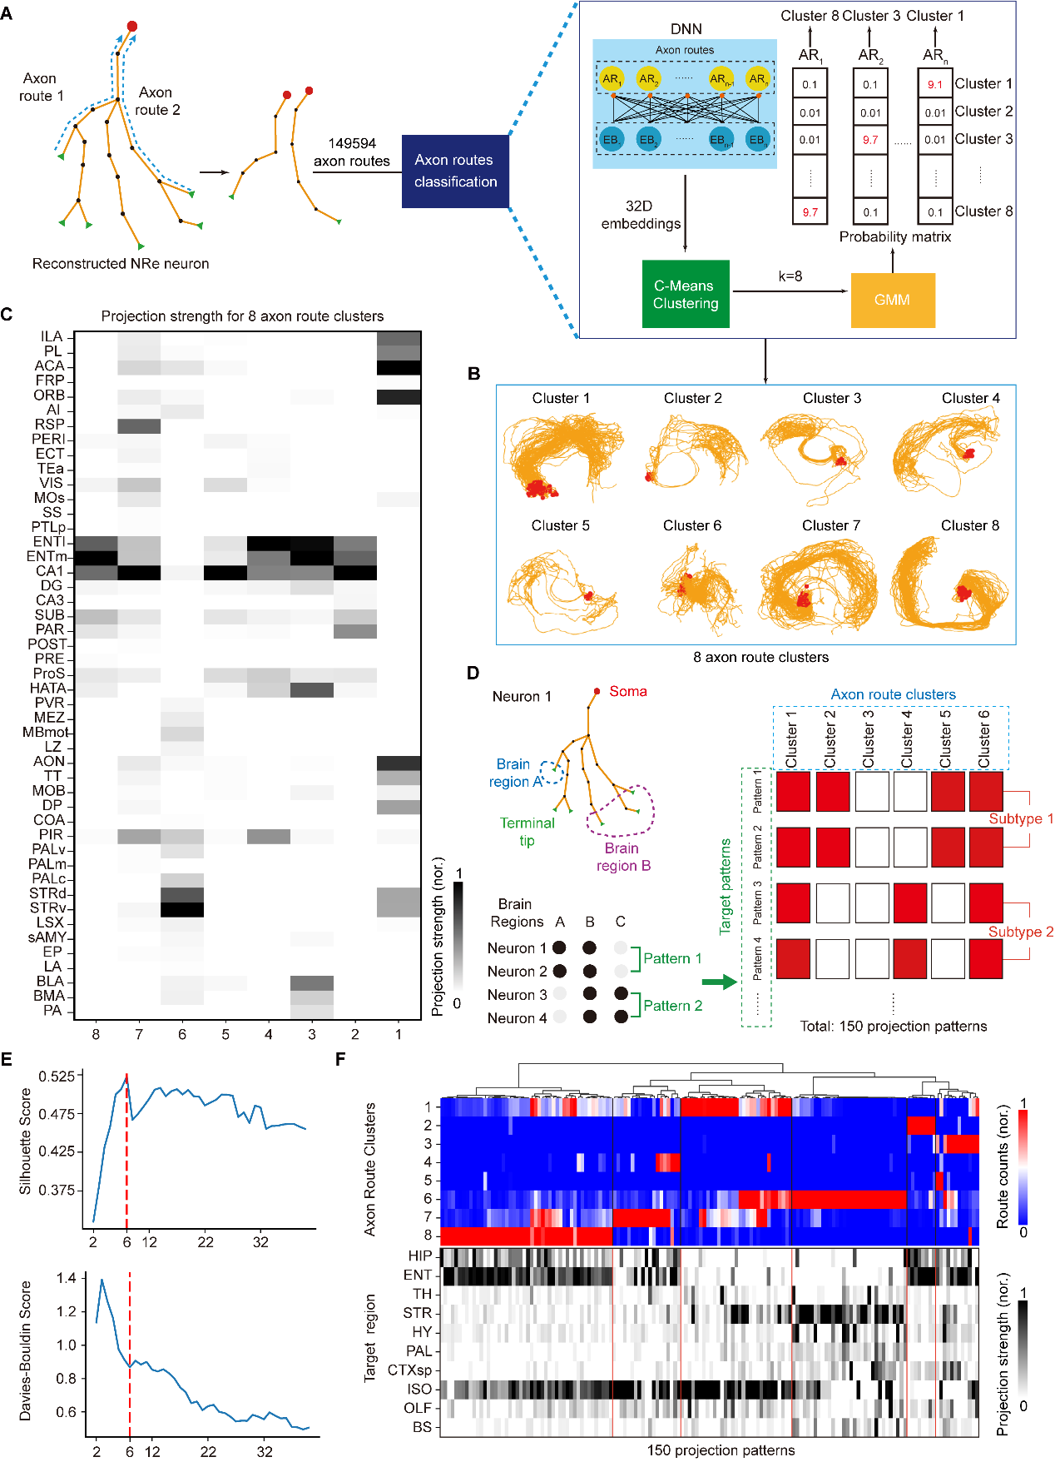
.

Figure S2. NRe^{vCA1d} neurons promote the expression of threat generalization.
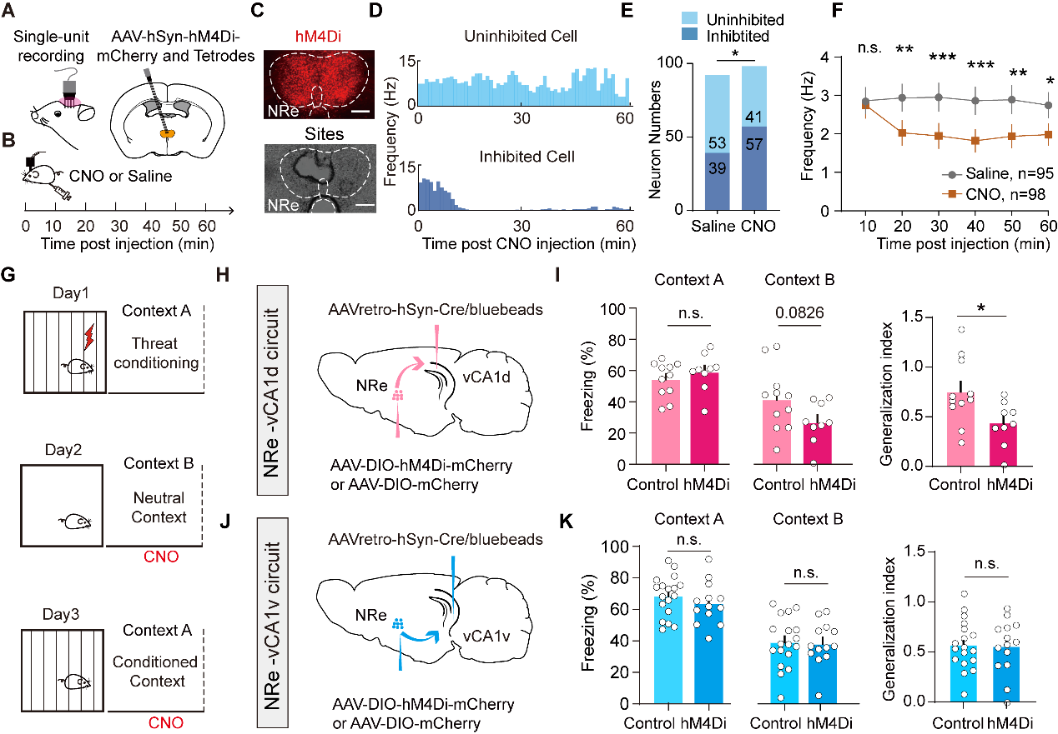

Figure S3. Summary of viral injection sites and tetrode recording sites.
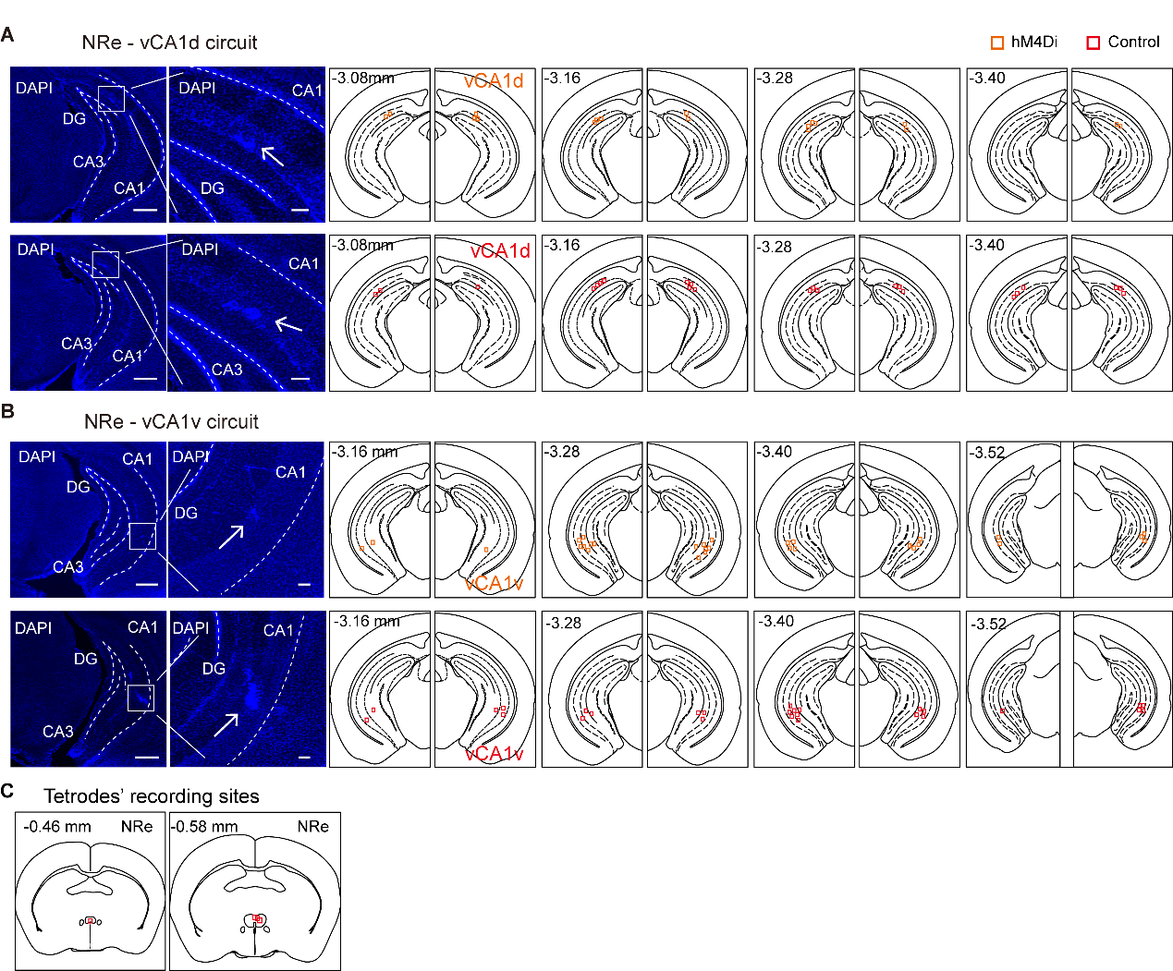

Figure S4: Spatial and single-cell transcriptome analysis in NRe

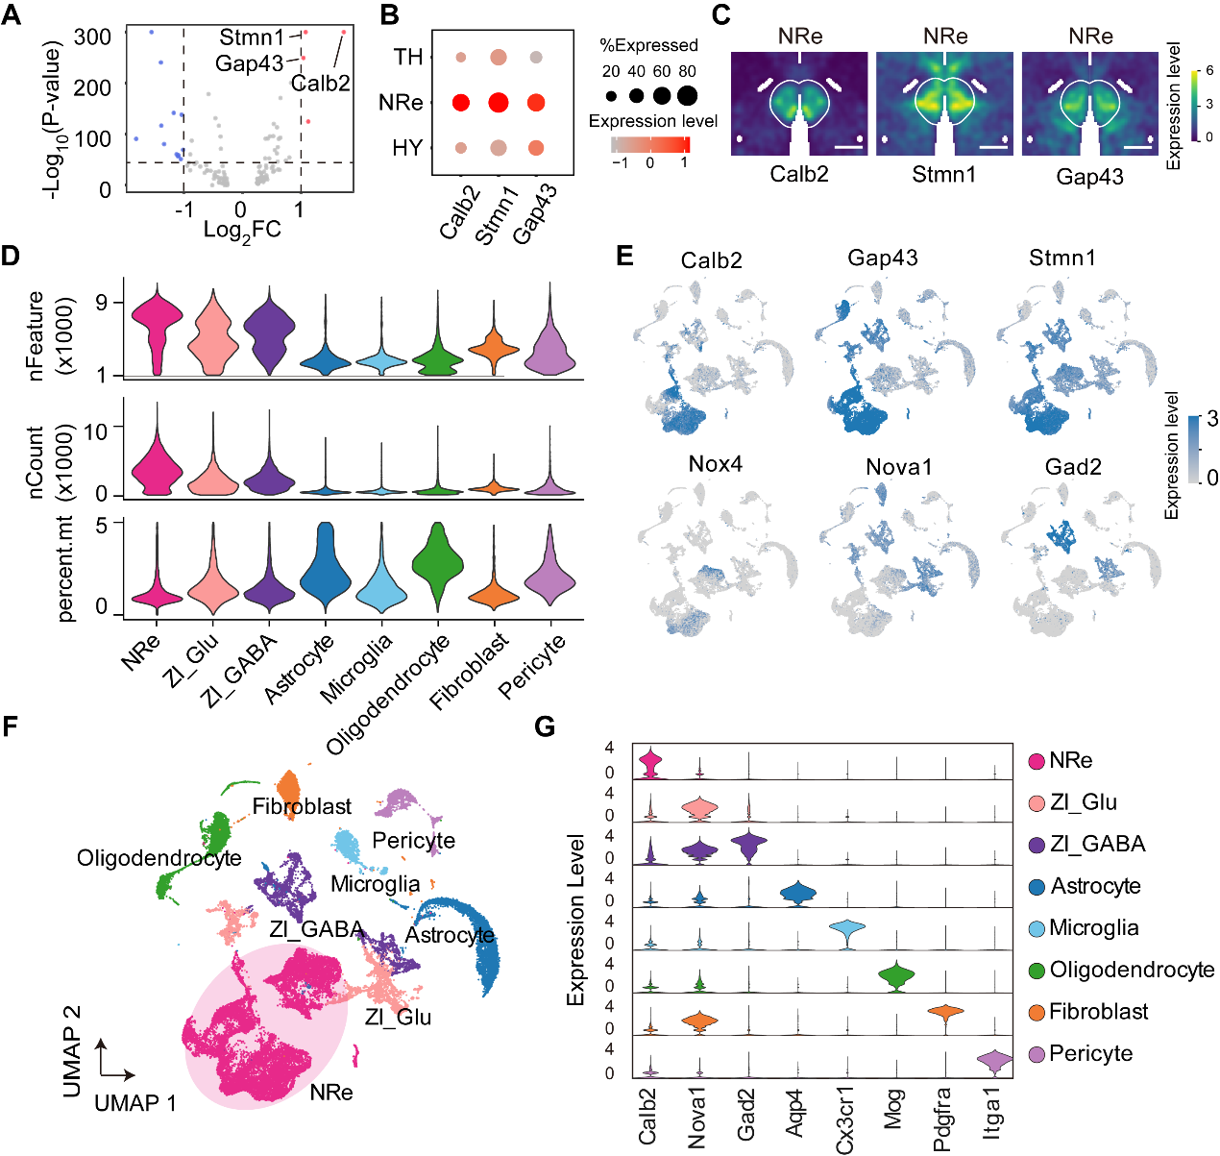

Figure S5: Transcriptomic analysis of barcoded NRe neurons.
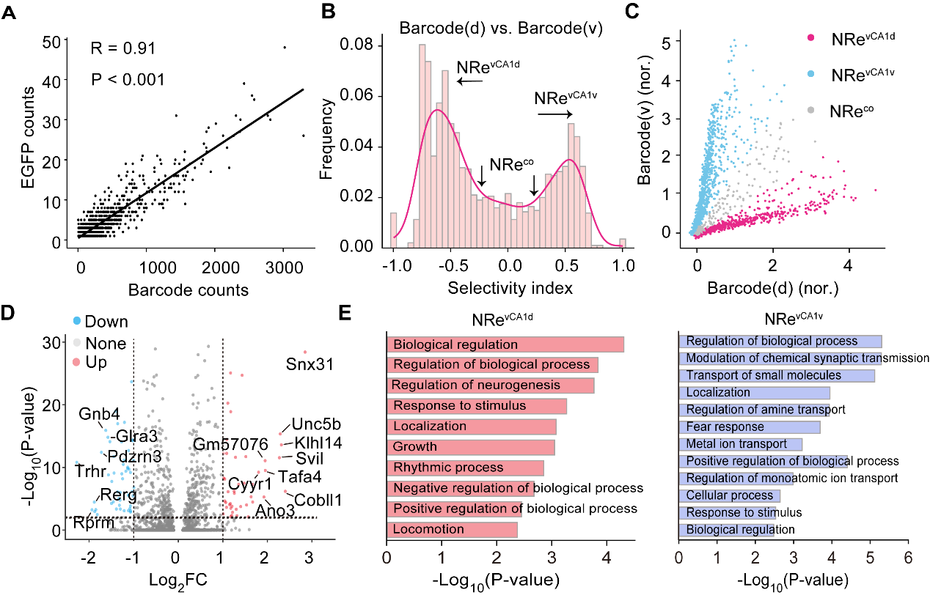

Figure S6. The impact of NRe^{vCA1d} neurons on context discriminability of vCA1d neurons in baseline condition.
