Figure S1
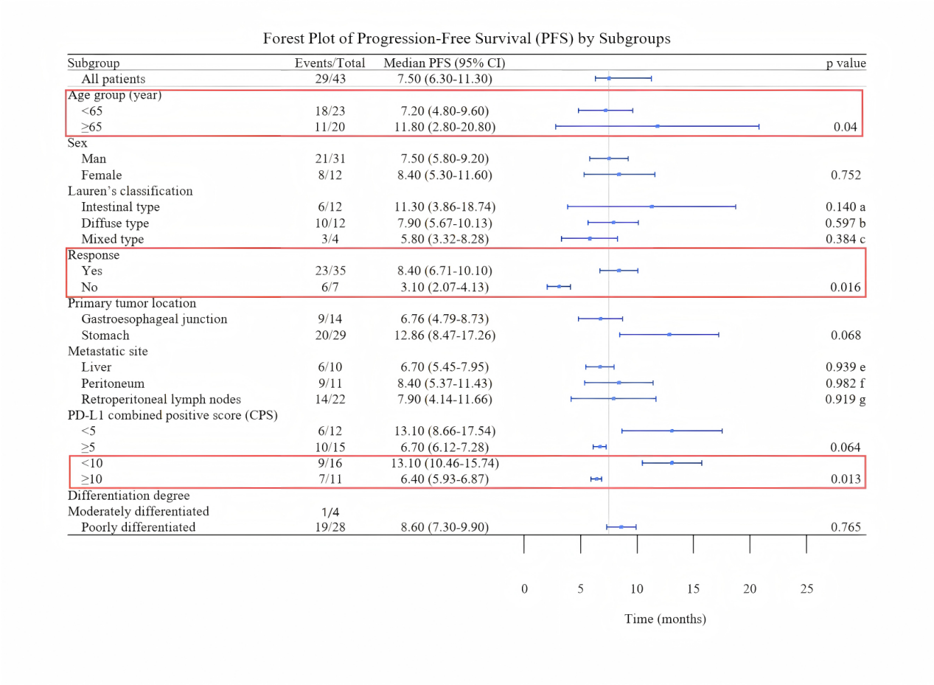
Supplementary Figure 1. Forest plot of progression-free survival (PFS) by subgroup analyses. (A) By Lauren’s classification: a, intestinal type vs mixed type; b, intestinal type vs diffuse tpye; c, mixed type vs diffuse tpye. (B) By metastatic site: e, live vs retroperitoneal lymph nodes; f, liver vs peritoneum; g, peritoneum vs retroperitoneal lymph nodes.

Figure S2
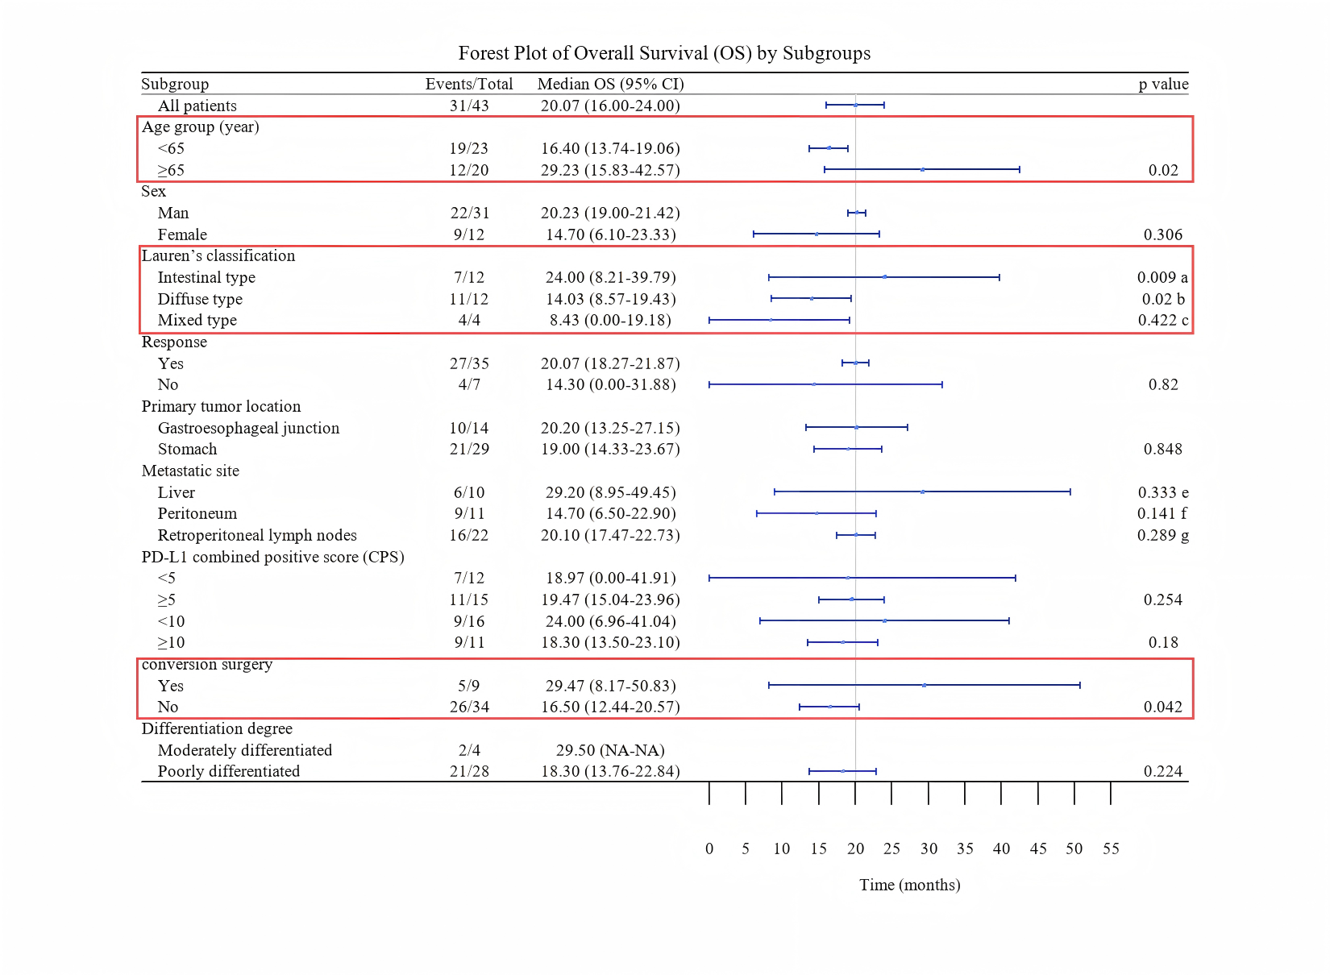
Supplementary Figure 2. Forest plot of overall survival (OS) by subgroup analyses. (A) By Lauren’s classification: a, intestinal type vs mixed type; b, intestinal type vs diffuse tpye; c, mixed type vs diffuse tpye. (B) By metastatic site: e, live vs retroperitoneal lymph nodes; f, liver vs peritoneum; g, peritoneum vs retroperitoneal lymph nodes.

Figure S3
Figure S3. Kaplan-Meier curves for PFS and OS according to Lauren's classification

Figure S4

Figure S4. Kaplan-Meier curves for PFS and OS according to metastatic site

Figure S5
Figure S5. Subgroup analyses of progression-free survival (PFS) and overall survival (OS). PFS and OS comparisons are shown for patients sex (A, B), differentiation degree (C, D), primary origin location (E, F), and those who PD-L1 CPS ˂ 5 versus PD-L1 CPS ≥ 5 (G, H).
Figure S6
Figure S6. Kaplan-Meier curves for PFS and OS according to neutrophil-to-lymphocyte ratio (NLR).

