Table1.AAPC in ASIR、ASMR and ASDR for different age groups from 1990 to 2021.
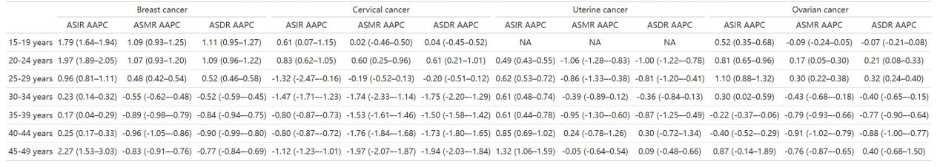
Table 2 .Percentage contribution of risk factors to DALYs of breast cancer among reproductive women in 2021.
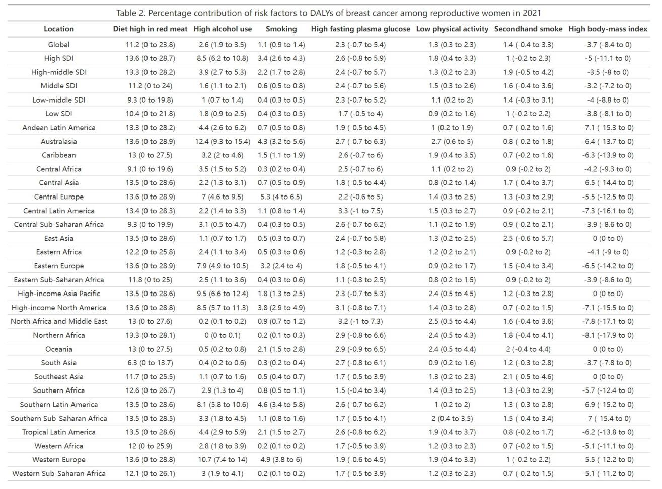
Table 3. Percentage contribution of risk factors to DALYs of cervical cancer, ovarian cancer and uterine cancer among reproductive women in 2021
