SUPPLEMENTARY MATERIAL

An integrated care model improved the quality of life of patients with chronic respiratory diseases living in rural areas with limited access to care: data from a prospective interventional cohort study

Marie Joyeux-Faure^{1,2#}, Raoua Ben Messaoud^{1#}, Robin Terrail², Sébastien Bailly^{1,2}, Jean-Claude Cornu³, Khier Amrani³, Jean-Charles Dron⁴, Pierrick Haan⁵, Yann Le Guillou⁶, Marie Pirotais⁶, Soumaya Balbolia⁶, Jean-Louis Pépin^{1,2}*, on behalf of e-Meuse project investigators

¹Univ. Grenoble Alpes, INSERM, CHU Grenoble Alpes, HP2 Laboratory, Grenoble, France.
²Pole Thorax et Vaisseaux, Laboratoire EFCR (Explorations Fonctionnelles Cardiovasculaire et Respiratoire), CHU Grenoble Alpes, Grenoble, France
³Pneumology Department, Verdun Hospital, Verdun, France
⁴Consortium e-Meuse santé, France
⁵SEFAM, Villers-lès-Nancy, France
⁶BIOSENCY, Cesson Sévigné, France

#Co-first authors

E-Meuse Investigators (in alphabetical order by last name)
Name | Affiliation
Rémi Aiguebone | Univ. Grenoble Alpes, INSERM, CHU Grenoble Alpes, HP2 Laboratory, Grenoble, France; Pole Thorax et Vaisseaux, Laboratoire EFCR (Explorations Fonctionnelles Cardiovasculaire et Respiratoire), CHU Grenoble Alpes, Grenoble, France
Khier Amrani | Service de Pneumologie, Centre Hospitalier de Verdun, Verdun, France
Sébastien Bailly | Univ. Grenoble Alpes, INSERM, CHU Grenoble Alpes, HP2 Laboratory, Grenoble, France; Pole Thorax et Vaisseaux, Laboratoire EFCR (Explorations Fonctionnelles Cardiovasculaire et Respiratoire), CHU Grenoble Alpes, Grenoble, France
Soumaya Balbolia | BIOSENCY, Cesson Sévigné, France
Raoua Ben Messaoud | Univ. Grenoble Alpes, INSERM, CHU Grenoble Alpes, HP2 Laboratory, Grenoble, France
Jean-Claude Cornu | Service de Pneumologie, Centre Hospitalier de Verdun, Verdun, France
Jean-Charles Dron | Consortium E-Meuse santé
Valérie Estève | DOR, Etain, France
Hugo Haan | SEFAM, Villers-lès-Nancy, France
Pierrick Haan | SEFAM, Villers-lès-Nancy, France
Marie Joyeux-Faure | Univ. Grenoble Alpes, INSERM, CHU Grenoble Alpes, HP2 Laboratory, Grenoble, France; Pole Thorax et Vaisseaux, Laboratoire EFCR (Explorations Fonctionnelles Cardiovasculaire et Respiratoire), CHU Grenoble Alpes, Grenoble, France
Sabine Laurent | DOR, Etain, France
Yann Le Guillou | BIOSENCY, Cesson Sévigné, France
Sylvain Le Liepvre | BIOSENCY, Cesson Sévigné, France
Thi Hong Van Ngo | Univ. Grenoble Alpes, INSERM, CHU Grenoble Alpes, HP2 Laboratory, Grenoble, France
Murielle Parant | Service de Pneumologie, Centre Hospitalier de Verdun, Verdun, France
Jean-Louis Pépin | Univ. Grenoble Alpes, INSERM, CHU Grenoble Alpes, HP2 Laboratory, Grenoble, France; Pole Thorax et Vaisseaux, Laboratoire EFCR (Explorations Fonctionnelles Cardiovasculaire et Respiratoire), CHU Grenoble Alpes, Grenoble, France
Marie Pirotais | BIOSENCY, Cesson Sévigné, France
Renaud Tamisier | Univ. Grenoble Alpes, INSERM, CHU Grenoble Alpes, HP2 Laboratory, Grenoble, France ; Pole Thorax et Vaisseaux, Laboratoire EFCR (Explorations Fonctionnelles Cardiovasculaire et Respiratoire), CHU Grenoble Alpes, Grenoble, France
Robin Terrail | Pole Thorax et Vaisseaux, Laboratoire EFCR (Explorations Fonctionnelles Cardiovasculaire et Respiratoire), CHU Grenoble Alpes, Grenoble, France

TABLE S1 Primary outcome in the overall population (univariate analysis)
 | Baseline (n=400) | 3 months (n=346) | 6 months (n=326) | p-value
SF-36 scores
MCS | 47.7±0.6 | 49.9±0.6 | 50.9±0.6 | <0.001
PCS | 40.4±0.5 | 42.5±0.5 | 43.4±0.5 | 0.422
Scores for SF-36 domains
Physical functioning | 56.0±1.4 | 57.1±1.5 | 59.2±1.5 | 0.022
Role limitations due to physical health | 63.6±2.1 | 78.5±1.9 | 82.8±1.9 | <0.01
Role limitations due to emotional problems | 71.2±2.1 | 80.3±2.0 | 82.9±2.0 | <0.001
Vitality | 50.9±1.1 | 57.4±1.0 | 59.8±1.1 | <0.001
Mental health | 64.6±1.1 | 67.7±1.1 | 69.7±1.1 | <0.001
Social functioning | 73.4±1.3 | 77.6±1.2 | 79.4±1.2 | <0.001
Body pain | 65.2±1.2 | 70.6±1.3 | 73.8±1.3 | <0.001
General health | 48.9±1.0 | 51.0±1.2 | 51.6±1.2 | 0.002
Health change | 46.9±1.1 | 59.0±1.4 | 59.8±1.4 | <0.001
Data are mean ± standard error of the mean.
MCS, mental component subscale; PCS, physical component subscale; SF-36, Short Form-36.

TABLE S2 Primary outcome by disease subgroup (univariate analysis)
 | COPD |  |  |  | OS |  |  |  | OSA
 | Baseline (n=147) | 3 months (n=120) | 6 months (n=111) | p-value | Baseline (n=105) | 3 months (n=98) | 6 months (n=89) | p-value | Baseline (n=148) | 3 months (n=128) | 6 months (n=126) | p-value
SF-36 scores
MCS | 50.0±1.1 | 50.5±1 | 51.0±1.1 | 0.184 | 46.8±1.2 | 50.7±1.0 | 50.0±1.1 | 0.909 | 46.0±0.9 | 48.8±1.0 | 51.3±0.9 | <0.001
PCS | 39.1±0.9 | 41±0.9 | 41.5±1 | 0.128 | 38.4±1 | 39.6±1.0 | 40.9±1 | 0.391 | 43.1±0.8 | 46.4±0.8 | 46.9±0.8 | 0.054
Scores for SF-36 domains
Physical functioning | 50.6±2.2 | 50.5±2.6 | 52.1±2.8 | 0.665 | 48.1±2.6 | 49.3±2.7 | 50.7±2.8 | 0.432 | 66.9±2.1 | 69.8±2.2 | 71.4±2.1 | 0.015
Role limitations due to physical health | 62.5±3.7 | 77.7±3.4 | 79.6±3.3 | <0.01 | 61.9±4.1 | 76.3±3.6 | 79.8±3.9 | <0.01 | 65.9±3.4 | 80.9±3.0 | 87.6±2.6 | <0.01
Role limitations due to emotional problems | 74.3±3.4 | 76.1±3.7 | 78.1±3.7 | 0.573 | 64.1±4.5 | 83.3±3.4 | 81.6±4 | 0.001 | 73.2±3.3 | 82.0±3.1 | 88.0±2.6 | <0.001
Vitality | 53.7±1.8 | 57.6±1.8 | 58±1.9 | 0.085 | 50.4±1.9 | 55.5±1.9 | 56.4±2.1 | 0.011 | 48.3±1.8 | 58.6±1.7 | 63.9±1.6 | <0.001
Mental health | 67.4±1.9 | 69.1±2.0 | 70.5±2.1 | 0.219 | 62.4±2.1 | 66.0±2.1 | 66.5±2.1 | 0.042 | 63.3±1.7 | 67.6±1.9 | 71.2±1.7 | <0.001
Social functioning | 76.4±2.2 | 77.4±2.0 | 78.7±2.1 | 0.747 | 69.9±2.5 | 76.9±2.2 | 75±2.5 | 0.128 | 73.1±2.0 | 78.5±2.0 | 83.1±1.8 | <0.001
Body pain | 68.6±2.2 | 72.3±2.2 | 73.7±2.3 | 0.03 | 62.4±2.1 | 67.2±2.3 | 71.1±2.6 | 0.002 | 63.8±1.9 | 71.7±2.3 | 75.8±1.9 | <0.001
General health | 48.1±1.6 | 49.2±1.9 | 47.3±1.9 | 0.97 | 43.6±2.0 | 46.4±2.0 | 46.1±2.4 | 0.294 | 53.4±1.7 | 56.2±2.1 | 59.4±1.9 | <0.001
Health change | 48.3±1.8 | 56.7±2.3 | 54.1±2.2 | 0.01 | 48.8±2.1 | 50.3±2.6 | 57.0±2.7 | 0.03 | 44.3±1.8 | 67.8±2.2 | 66.9±2.2 | <0.001
Data are mean ± standard error of the mean.
COPD, chronic obstructive pulmonary disease; MCS, mental component subscale; OS, overlap syndrome; OSA, obstructive sleep apnea; PCS, physical component subscale; SF-36, Short Form-36.

TABLE S3 Evolution of Short Form-36 items over time in multivariate linear mixed models for the overall population
 | β-coefficient [95% CI] | p-value
SF-36 scores
MCS | 0.484 [0.296;0.673] | <0.001
PCS | 0.410 [0.263;0.558] | <0.001
Scores for SF-36 domains
Physical functioning | 0.365 [0.064; 0.666] | 0.018
Role limitations due to physical health | 2.886 [2.102; 3.676] | <0.001
Role limitations due to emotional problems | 1.767 [0.998; 2.537] | <0.001
Vitality | 1.363 [1.028; 1.701] | <0.001
Mental health | 0.767 [0.458; 1.076] | <0.001
Social functioning | 0.867 [0.435; 1.302] | <0.001
Body pain | 1.433 [1.009; 1.859] | <0.001
General health | 0.446 [0.17; 0.723] | 0.002
Health change | 2.143 [1.603; 2.685] | <0.001
Data are mean ± standard error of the mean.
CI, confidence interval; MCS, mental component subscale; PCS, physical component subscale; SF-36, Short Form-36.

TABLE S4 Evolution of Short Form-36 items over time in multivariate linear mixed models by disease subgroup
 | COPD |  | OS |  | OSA
 | β-coefficient [95% CI] | p-value | β-coefficient [95% CI] | p-value | β-coefficient [95% CI] | p-value
SF-36 scores
MCS | 0.071 [–0.236;0.379] | 0.651 | 0.469 [0.126;0.817] | 0.008 | 0.856 [0.537;1.175] | <0.001
PCS | 0.305 [0.066;0.548] | 0.013 | 0.293 [–0.004;0.595] | 0.056 | 0.577 [0.341;0.812] | <0.001
Scores for SF-36 domains
Physical functioning | 0.132 [–0.371;0.635] | 0.608 | 0.232 [–0.302;0.771] | 0.397 | 0.658 [0.14;1.177] | 0.013
Role limitations due to physical health | 2.586 [1.25;3.942] | <0.001 | 2.637 [1.079;4.232] | 0.001 | 3.337 [2.107;4.567] | <0.001
Role limitations due to emotional problems | 0.447 [–0.812;1.706] | 0.487 | 2.671 [1.142;4.231] | 0.001 | 2.377 [1.134;3.626] | <0.001
Vitality | 0.507 [–0.055;1.075] | 0.079 | 0.736 [0.19;1.292] | 0.009 | 2.522 [1.947;3.099] | <0.001
Mental health | 0.351 [–0.158;0.861] | 0.177 | 0.611 [0.053;1.173] | 0.033 | 1.25 [0.722;1.781] | <0.001
Social functioning | 0.157 [–0.553;0.876] | 0.666 | 0.667 [–0.141;1.49] | 0.109 | 1.618 [0.896;2.338] | <0.001
Body pain | 0.626 [–0.135;1.396] | 0.109 | 1.396 [0.541;2.264] | 0.002 | 1.900 [1.190;2.612] | <0.001
General health | –0.14 [–0.641;0.363] | 0.585 | 0.302 [–0.251;0.855] | 0.286 | 0.881 [0.359;1.405] | 0.001
Health change | 0.932 [0.067;1.787] | 0.034 | 1.172 [0.119;2.252] | 0.032 | 3.656 [2.722;4.595] | <0.001
Data are mean ± standard error of the mean.
CI, confidence interval; COPD, chronic obstructive pulmonary disease; MCS, mental component subscale; OS, overlap syndrome; OSA, obstructive sleep apnea; PCS, physical component subscale; SF-36, Short Form-36.

TABLE S5 Factors affecting the change in Short Form-36 score over time for the overall population
Variables | Items | MCS |  |  | PCS
Variables | Items | β coefficient [95% CI] | p-value | Overall p-value | β coefficient [95% CI] | p-value | Overall p-value
Time effect (months) |  | 0.484 [0.296;0.673] | <0.001 |  | 0.410 [0.263;0.558] | <0.001
Group | OSA vs. COPD | –0.929 [–3.326;1.469] | 0.451 | 0.327 | 4.714 [2.534;6.894] | <0.001 | <0.001
Group | OS vs. COPD | –1.912 [–4.406;0.582] | 0.136 |  | –0.432 [–2.702;1.837] | 0.711
Age |  | 0.158 [0.054;0.262] | 0.003 |  | –0.04 [–0.134;0.055] | 0.413
Sex | Male vs. female | 3.243 [1.303;5.181] | 0.001 |  | 2.475 [0.71;4.238] | 0.007
Cardiovascular diseases | Yes vs. no | 0.027 [–2.076;2.129] | 0.980 |  | –1.327 [–3.241;0.587] | 0.178
Diabetes | Yes vs. no | –1.408 [–4.296;1.48] | 0.343 |  | –2.018 [–4.652;0.615] | 0.136
CI, confidence interval; COPD, chronic obstructive pulmonary disease; MCS, mental component subscale; OS, overlap syndrome; OSA, obstructive sleep apnea; PCS, physical component subscale.

TABLE S6 Factors affecting the change in Short Form-36 physical component subscale scores over time for the whole population
Variables | Items | β coefficient [95% CI] | p-value | Overall p-value
Physical functioning
Time effect (months) |  | 0.365 [0.064;0.666] | 0.018 | <0.001
Group | OSA vs. COPD | 16.678 [10.804;22.553] | <0.001 | <0.001
Group | OS vs. COPD | –1.472 [–7.606;4.664] | 0.641 | <0.001
Age |  | –0.157 [–0.412;0.097] | 0.229 | <0.001
Sex | Male vs. female | 12.993 [8.229;17.755] | <0.001 | <0.001
Cardiovascular diseases | Yes vs. no | –2.398 [–7.578;2.781] | 0.368 | <0.001
Diabetes | Yes vs. no | –7.336 [–14.48;–0.193] | 0.046 | <0.001
Role limitations due to physical health
Time effect (months) |  | 2.886 [2.102;3.676] | <0.001 | 0.298
Group | OSA vs. COPD | 5.120 [–2.018;12.25] | 0.163 | 0.298
 | OS vs. COPD | 0.016 [–7.385;7.417] | 0.997 | 0.298
Age |  | –0.029 [–0.341;0.283] | 0.855 | 0.298
Sex | Male vs. female | 0.966 [–4.806;6.725] | 0.745 | 0.298
Cardiovascular diseases | Yes vs. no | –1.495 [–7.733;4.745] | 0.641 | 0.298
Diabetes | Yes vs. no | –0.257 [–8.795;8.280] | 0.953 | 0.298
Body pain
Time effect (months) |  | 1.433 [1.009;1.859] | <0.001 | 0.199
Group | OSA vs. COPD | –0.719 [–5.385;3.943] | 0.764 | 0.199
 | OS vs. COPD | –4.296 [–9.147;0.551] | 0.085 | 0.199
Age |  | –0.016 [–0.22;0.187] | 0.876 | 0.199
Sex | Male vs. female | 7.603 [3.829;11.372] | <0.001 | 0.199
Cardiovascular diseases | Yes vs. no | –2.584 [–6.674;1.505] | 0.219 | 0.199
Diabetes | Yes vs. no | –4.365 [–9.972;1.246] | 0.131 | 0.199
General health
Time effect (months) |  | 0.446 [0.17;0.723] | 0.002 | <0.001
Group | OSA vs. COPD | 10.362 [5.878;14.848] | <0.001 | <0.001
 | OS vs. COPD | –3.058 [–7.735;1.620] | 0.204 | <0.001
Age |  | 0.269 [0.074;0.463] | 0.007 | <0.001
Sex | Male vs. female | 4.979 [1.343;8.611] | 0.008 | <0.001
Cardiovascular diseases | Yes vs. no | –3.012 [–6.959;0.937] | 0.138 | <0.001
Diabetes | Yes vs. no | –4.694 [–10.132;0.744] | 0.094 | <0.001
CI, confidence interval; COPD, chronic obstructive pulmonary disease; OS, overlap syndrome; OSA, obstructive sleep apnea.

TABLE S7 Factors affecting the change in Short Form-36 mental component subscale scores over time for the whole population
Variables | Items | β coefficient [95% CI] | p-value | Overall p-value
Role limitations due to mental health
Time effect (months) |  | 1.767 [0.998;2.537] | <0.001 | 0.130
Group | OSA vs. COPD | 5.885 [–1.476;13.249] | 0.121 | 0.130
Group | OS vs. COPD | –1.837 [–9.467;5.804] | 0.640 | 0.130
Age |  | 0.262 [–0.06;0.583] | 0.114 | 0.130
Sex | Male vs. female | 7.766 [1.811;13.706] | 0.011 | 0.130
Cardiovascular diseases | Yes vs. no | 1.963 [–4.47;8.398] | 0.553 | 0.130
Diabetes | Yes vs. no | –6.164 [–14.966;2.633] | 0.174 | 0.130
Vitality
Time effect (months) |  | 1.363 [1.028;1.701] | <0.001 | 0.324
Group | OSA vs. COPD | 1.0,13 [–3.269;5.296] | 0.645 | 0.324
 | OS vs. COPD | –2.475 [–6.933;1.984] | 0.280 | 0.324
Age |  | 0.146 [–0.04;0.332] | 0.128 | 0.324
Sex | Male vs. female | 4.548 [1.081;8.013] | 0.011 | 0.324
Cardiovascular diseases | Yes vs. no | –1.569 [–5.333;2.191] | 0.417 | 0.324
Diabetes | Yes vs. no | –2.107 [–7.276;3.061] | 0.428 | 0.324
Mental health
Time effect (months) |  | 0.767 [0.458;1.076] | <0.001 | 0.091
Group | OSA vs. COPD | –0.365 [–4.834;4.103] | 0.874 | 0.091
 | OS vs. COPD | –4.866 [–9.522;–0.208] | 0.043 | 0.091
Age |  | 0.257 [0.063;0.451] | 0.010 | 0.091
Sex | Male vs. female | 9.776 [6.156;13.393] | <0.001 | 0.091
Cardiovascular diseases | Yes vs. no | –1.004 [–4.936;2.925] | 0.619 | 0.091
Diabetes | Yes vs. no | –2.338 [–7.746;3.069] | 0.400 | 0.091
Social functioning
Time effect (months) |  | 0.867 [0.435;1.302] | <0.001 | 0.084
Group | OSA vs. COPD | 2.276[–2.334;6.884] | 0.337 | 0.084
 | OS vs. COPD | –3.394 [–8.182;1.395] | 0.168 | 0.084
Age |  | 0.209 [0.009;0.410] | 0.043 | 0.084
Sex | Male vs. female | 4.876 [1.149;8.601] | 0.011 | 0.084
Cardiovascular diseases | Yes vs. no | –1.199 [–5.24;2.838] | 0.564 | 0.084
Diabetes | Yes vs. no | –6.285 [–11.823;–0.75] | 0.028 | 0.084
CI, confidence interval; COPD, chronic obstructive pulmonary disease; OS, overlap syndrome; OSA, obstructive sleep apnea.

FIGURE S1 Flow diagram of the study. COPD, chronic obstructive pulmonary disease; OS, overlap syndrome; OSA, obstructive sleep apnea.

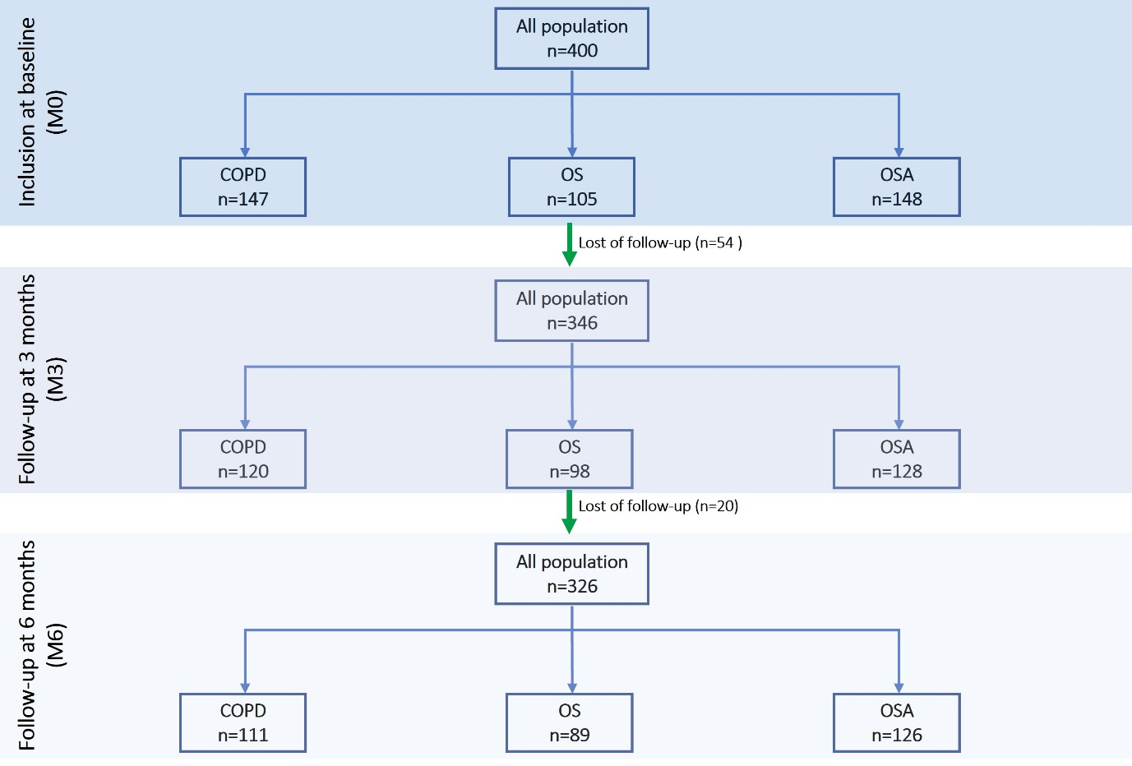

FIGURE S2 Summary of the determinants influencing the evolution of Short Form-36 domains in the overall population. COPD, chronic obstructive pulmonary disease; OS, overlap syndrome; OSA, obstructive sleep apnea.
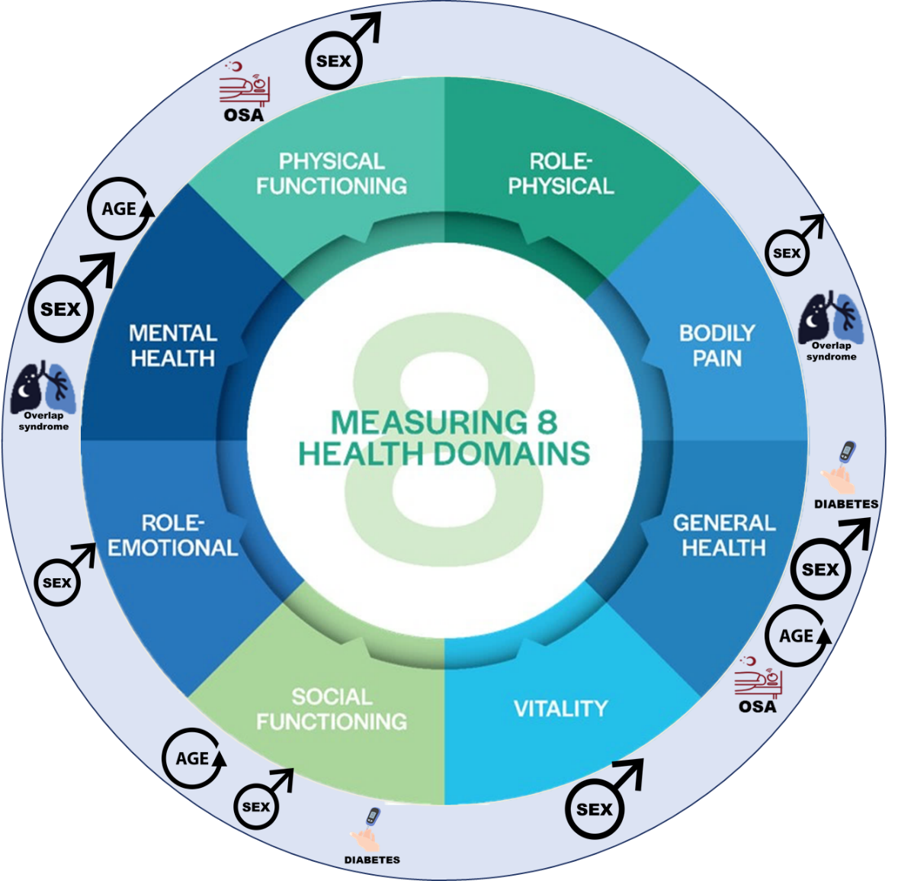

FIGURE S3 Heatmaps of β-coefficient values relating to predictive factors for the change in the Short Form-36 (SF-36) physical (PCS; blue) and mental (MCS; red) component scores. BP, body pain; COPD, chronic obstructive pulmonary disease; GH, general health; HC, health change; MH, mental health; OS, overlap syndrome; OSA, obstructive sleep apnea; PF, physical functioning; RE, role limitations due to emotional problems; RP, role limitations due to physical health; SF, social functioning; VI, vitality. A β-coefficient value <0 indicates a decrease in SF-36 score (i.e. worse health-related quality of life) and a β-coefficient value >0 indicates an increase in SF-36 score (i.e. better health-related quality of life) over time. *statistically significant at p<0.05.

