Supplementary Information

Batteries vs Fuel Cells for Decarbonizing Medium- and Heavy-Duty Vehicles Across Applications

Maxwell Woody^{1,2,3,*}, Spencer Checkoway^{1,3}, Gregory A. Keoleian^{1,2,3}, Robert De Kleine⁴, Hyung Chul Kim⁴, and James E. Anderson⁴

¹ Center for Sustainable Systems, School for Environment and Sustainability, University of Michigan, Ann Arbor, MI, USA
² Electric Vehicle Center, University of Michigan, Ann Arbor, MI, USA
³ MI Hydrogen Initiative, University of Michigan, Ann Arbor, MI, USA
⁴ Research and Innovation Center, Ford Motor Company, Dearborn, MI, USA
* maxwoody@umich.edu

12 Figures
5 Tables
18 Pages

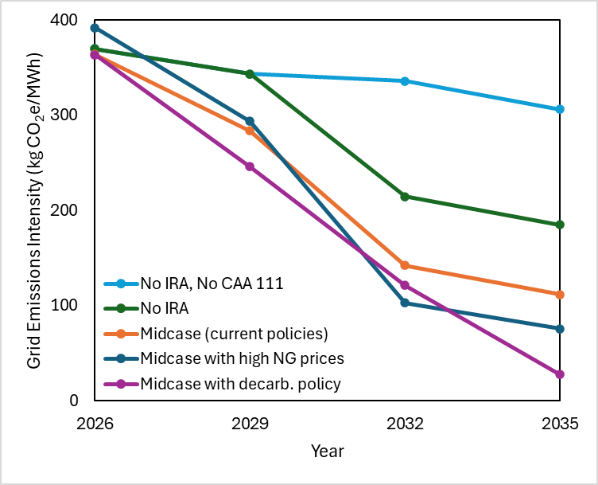
Figure S1. Average emissions factors for the United States.
The projected average grid intensity in the U.S. for four scenarios from 2026 to 2035 from NREL’s Standard Scenarios. The “Midcase” scenario is based on current policies. The “Midcase with high NG prices” scenario uses the same assumptions as the Midcase but uses a higher price for natural gas. The “Midcase with decarb. policy” scenario uses the same assumptions as the Midcase but assumes a policy enforcing 95% decarbonization of the electricity sector by 2035. The “No IRA” scenario uses the same assumptions as the Midcase but omits the tax credits in the Inflation Reduction Act. The “No IRA, No CAA 111” scenario uses the same assumptions as the Midcase but omits the tax credits in the Inflation Reduction Act and the Clean Air Act section 111 rules.

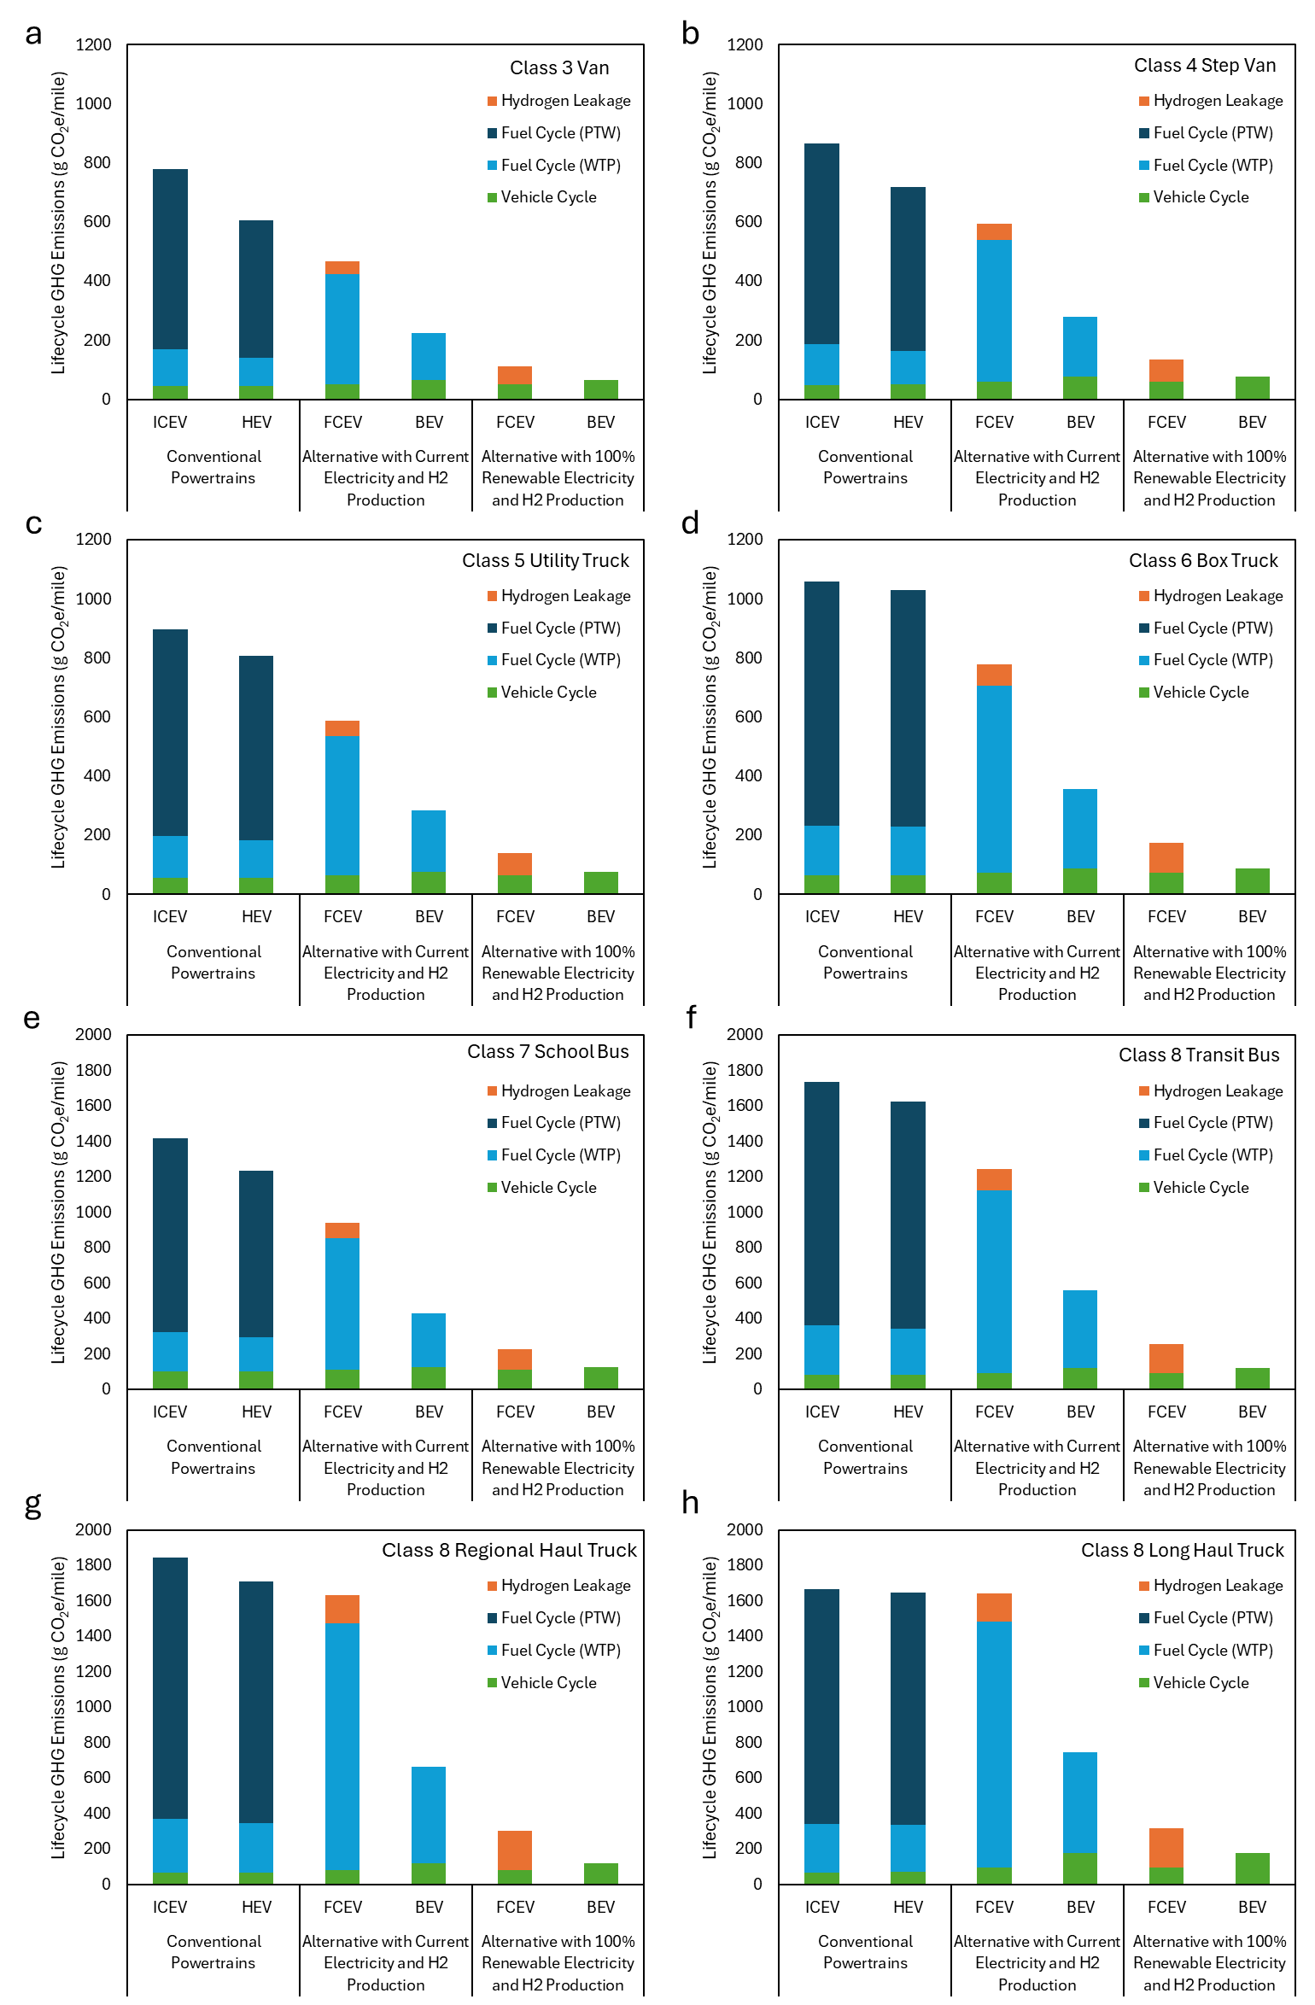
Figure S2. Life cycle greenhouse gas emissions of conventional and alternative powertrains
For an a) class 3 van, b) class 4 step van, c) class 5 utility truck, d) class 6 box truck, e) class 7 school bus, f) class 8 transit bus, g) class 8 regional truck (day cab), h) class 8 long-haul truck (sleeper cab), the life cycle greenhouse gas emissions in the low technology development scenario, without the inclusion of idling emissions (impacting a-f).
Table S1. Translating Autonomie component masses for use in the GREET model
GREET Components | Greet Translation of Autonomie Components
Powertrain System | Engine + Fuel Tank
Transmission System | Gearbox + Final Drive
Chassis | Chassis * Chassis / (Chassis + Body + Body of Trailer + Chassis of Trailer + Auxiliary of Trailer)
Traction Motor | Motor * Traction Motor / (Traction Motor + Electronic Controller)
Generator | -
Electronic Controller | Motor * Electronic Controller / (Traction Motor + Electronic Controller)
Hydrogen Tank Onboard Storage | H2 Tank
Van/Box | 0 except for class 6 box truck  Chassis * Van/Box / (Chassis + Body + Body of Trailer + Chassis of Trailer + Auxiliary of Trailer)
Body | Chassis * Body / (Chassis + Body + Body of Trailer + Chassis of Trailer + Auxiliary of Trailer)
Lift-gates | -
Lead-Acid Battery | Battery (ICEV), Battery 2 (HEV)
Li-Ion Battery | Battery (HEV, FCEV, and BEV)
Body of Trailer | Chassis * Body of Trailer / (Chassis + Body + Body of Trailer + Chassis of Trailer + Auxiliary of Trailer)
Chassis of Trailer | Chassis * Chassis of Trailer / (Chassis + Body + Body of Trailer + Chassis of Trailer + Auxiliary of Trailer)
Auxiliary of Trailer | Chassis * Auxiliary of Trailer / (Chassis + Body + Body of Trailer + Chassis of Trailer + Auxiliary of Trailer)
Fluids | Fluids * Total Weight / Total Weight * (each fluid)
Blue indicates a parameter within GREET while red indicates a parameter from Autonomie

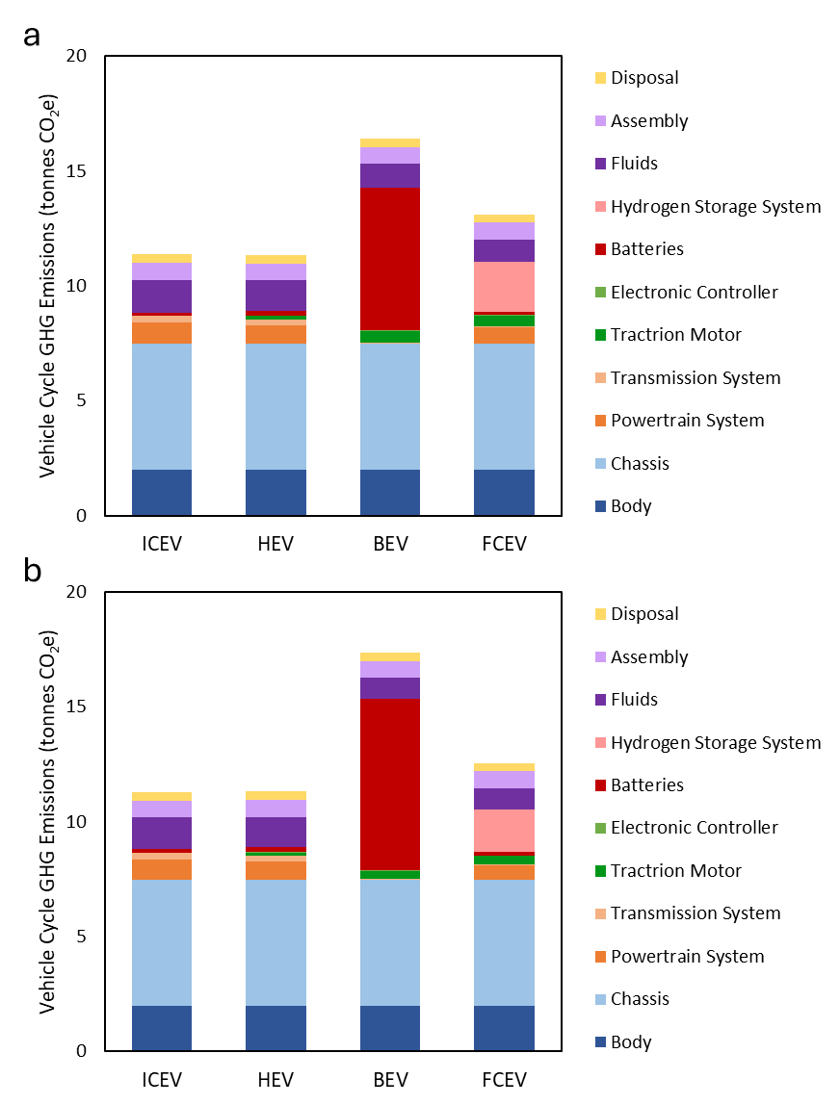
Figure S3. Class 3 van vehicle cycle emissions
The vehicle cycle emissions broken down by components for a class 3 van in a) the low technology development scenario, and b) the high technology development scenario
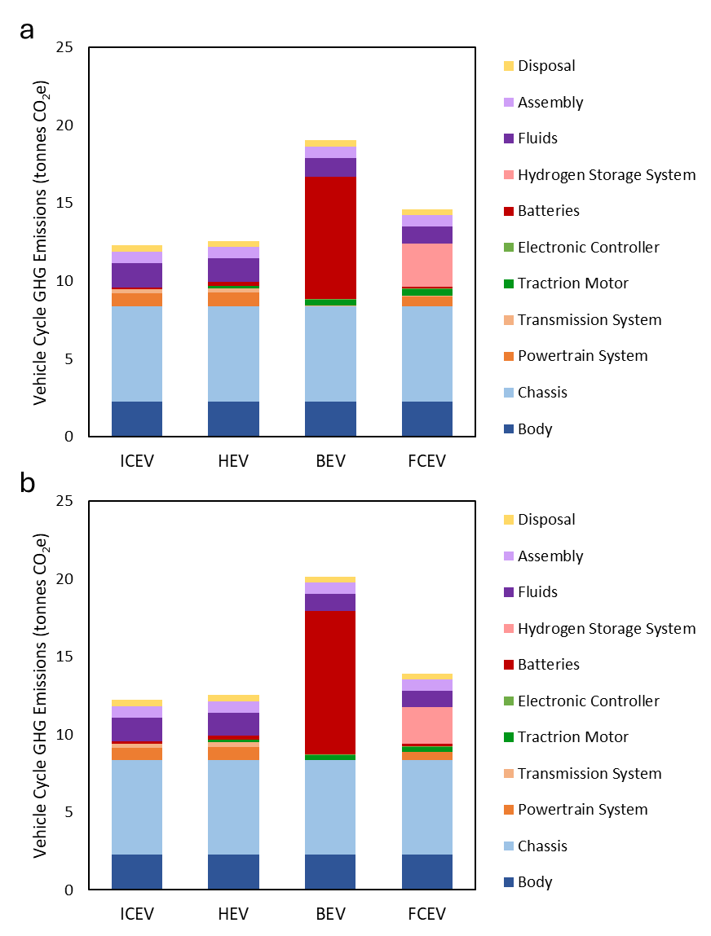
Figure S4. Class 4 step van vehicle cycle emissions
The vehicle cycle emissions broken down by components for a class 4 step van in a) the low technology development scenario, and b) the high technology development scenario

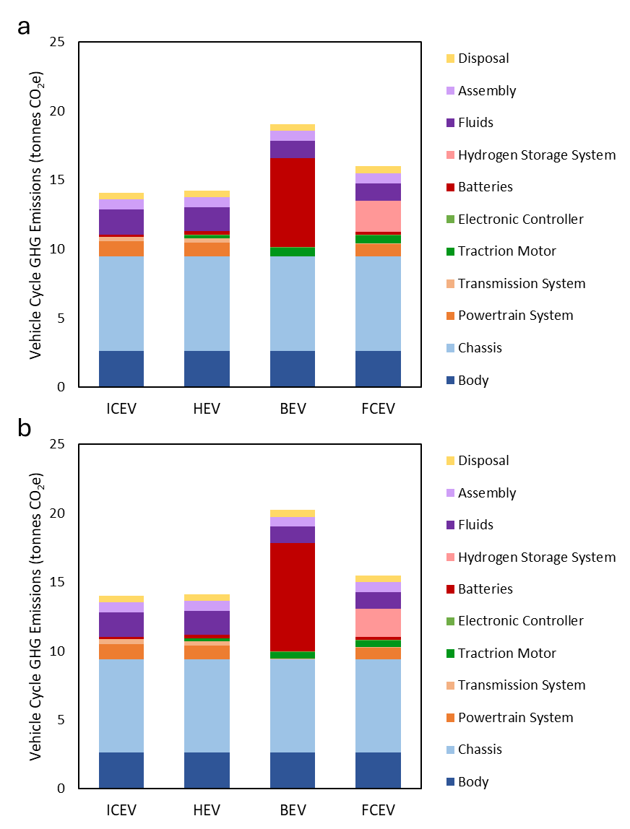
Figure S5. Class 5 utility truck vehicle cycle emissions
The vehicle cycle emissions broken down by components for a class 5 utility truck in a) the low technology development scenario, and b) the high technology development scenario

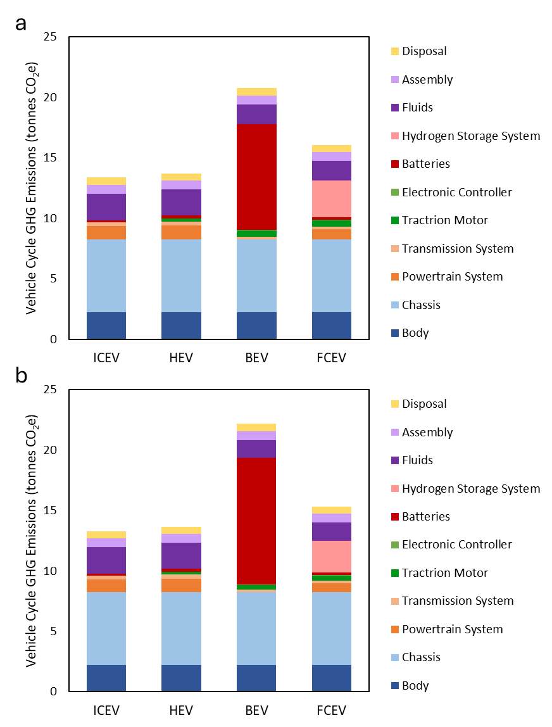
Figure S6. Class 6 box truck vehicle cycle emissions
The vehicle cycle emissions broken down by components for a class 6 box truck in a) the low technology development scenario, and b) the high technology development scenario

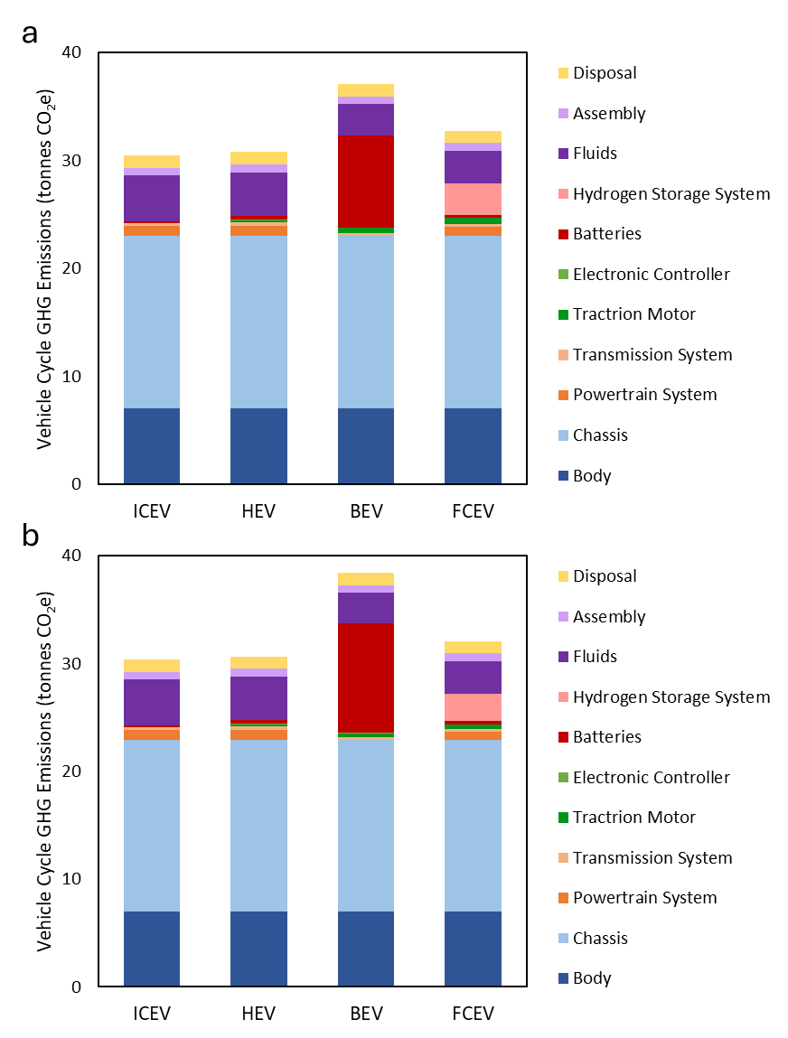
Figure S7. Class 7 school bus vehicle cycle emissions
The vehicle cycle emissions broken down by components for a class 7 school bus in a) the low technology development scenario, and b) the high technology development scenario

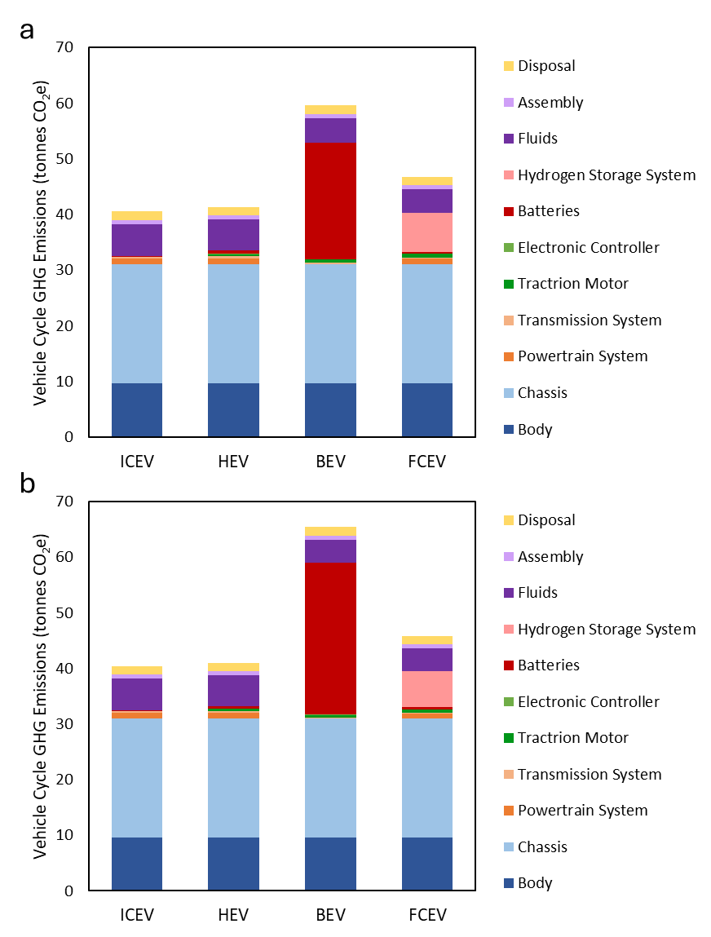
Figure S8. Class 8 transit bus vehicle cycle emissions
The vehicle cycle emissions broken down by components for a class 8 transit bus in a) the low technology development scenario, and b) the high technology development scenario

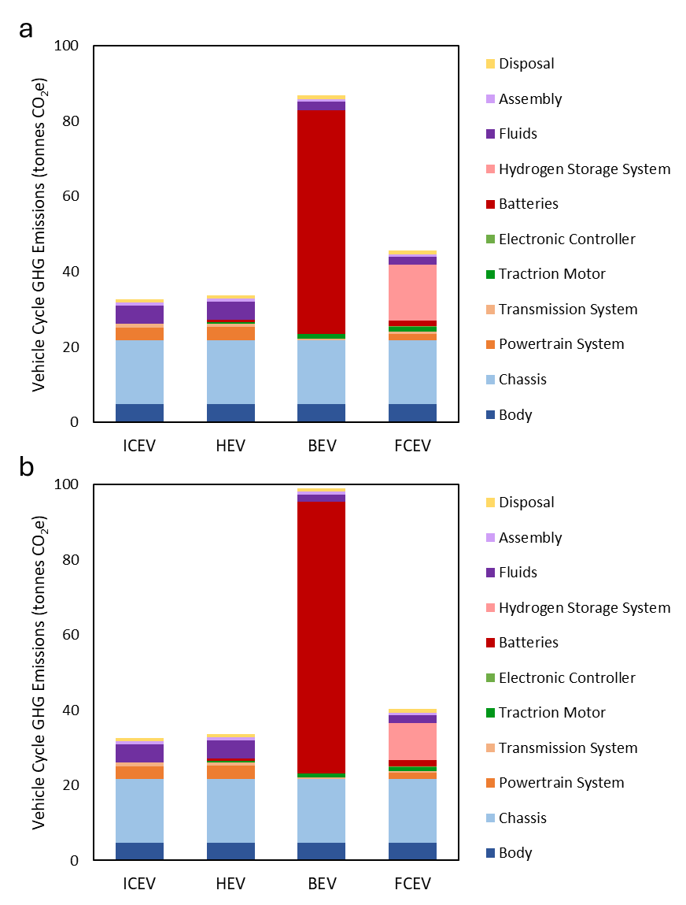
Figure S9. Class 8 regional haul truck vehicle cycle emissions
The vehicle cycle emissions broken down by components for a class 8 regional haul truck in a) the low technology development scenario, and b) the high technology development scenario

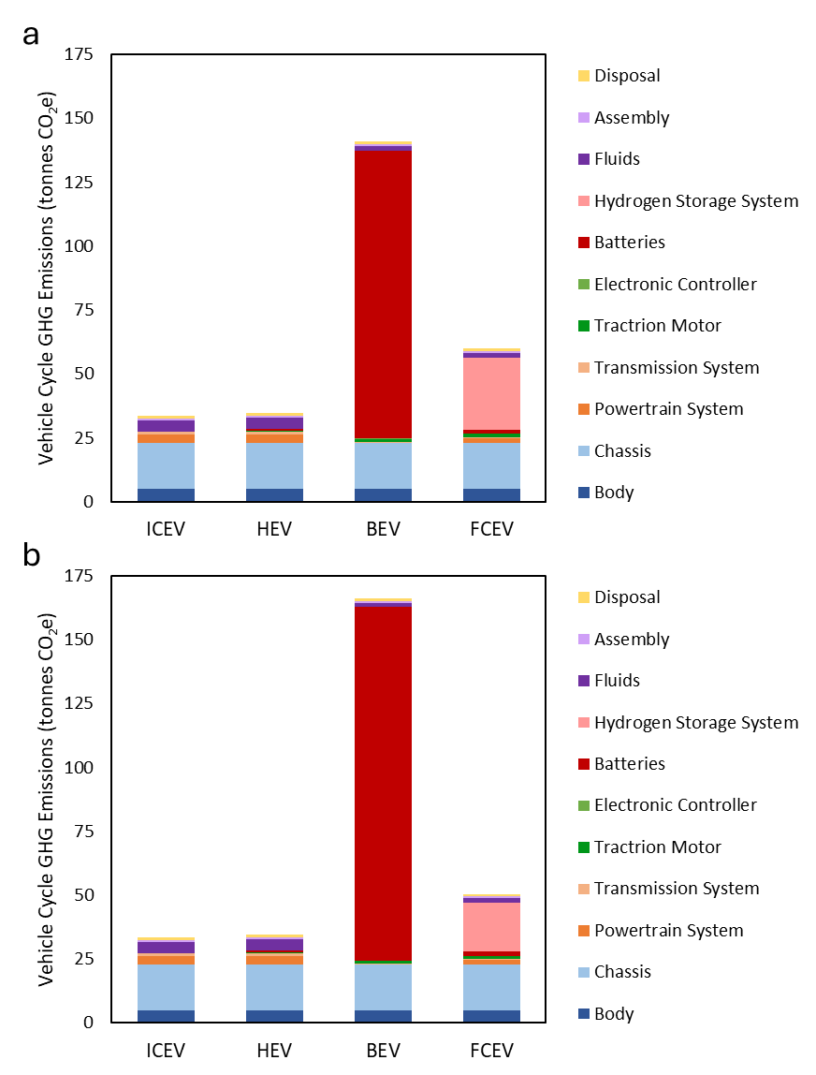
Figure S10. Class 8 long haul truck vehicle cycle emissions
The vehicle cycle emissions broken down by components for a class 8 long haul truck in a) the low technology development scenario, and b) the high technology development scenario

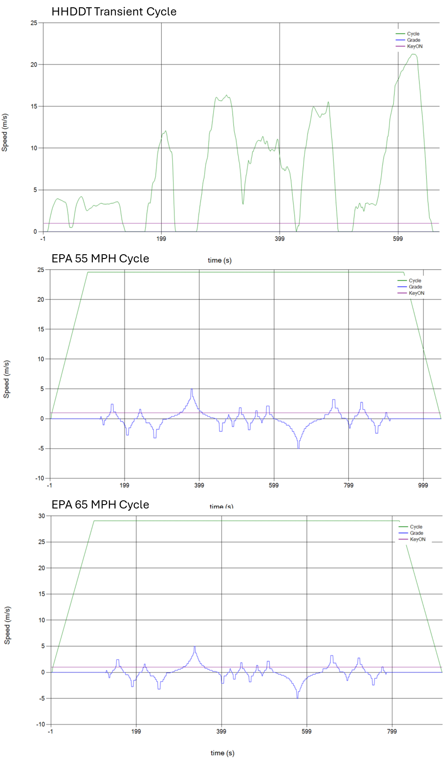
Figure S11. Standard EPA test cycles for medium- and heavy-duty vehicles
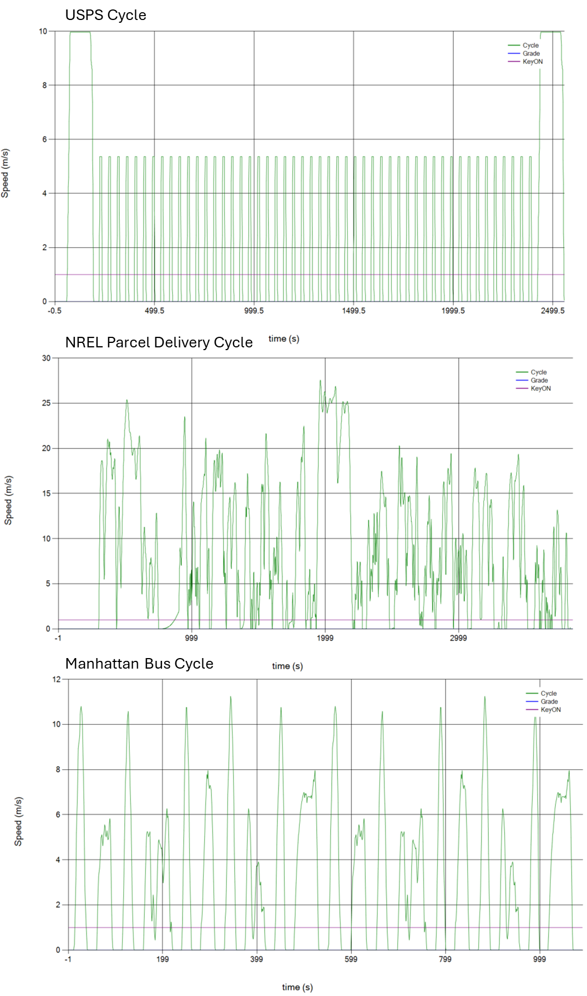
Figure S12. Additional test cycles used in this study for select vehicle classes

Table S2. Performance across drive cycles for recreated class 4 step van
Class 4 |  |  | Modeled | Goal | Error
Low | ICEV | Transient | 15.2 | 15.52 | 2.1%
 |  | EPA55 | 17 | 15.64 | -8.7%
 |  | EPA65 | 13.4 | 12.89 | -4.0%
 |  | Combined | 15.32057 | 15.03215 | -1.9%
 | HEV | Transient | 19.1 | 21.83 | 12.5%
 |  | EPA55 | 17.4 | 17.26 | -0.8%
 |  | EPA65 | 13.7 | 13.15 | -4.2%
 |  | Combined | 17.4375 | 18.3579 | 5.0%
 | FCEV | Transient | 37.848 | 38.72 | 2.2%
 |  | EPA55 | 22.344 | 21.47 | -4.1%
 |  | EPA65 | 16.644 | 15.71 | -5.9%
 |  | Combined | 26.69488 | 26.12662 | -2.2%
 | BEV | Transient | 564 | 560 | -0.7%
 |  | EPA55 | 980 | 1022 | 4.1%
 |  | EPA65 | 1270 | 1328 | 4.4%
 |  | Combined | 804.66 | 824.54 | 2.4%
High | ICEV | Transient | 17 | 17.46 | 2.6%
 |  | EPA55 | 20.7 | 19.13 | -8.2%
 |  | EPA65 | 16.5 | 16.47 | -0.2%
 |  | Combined | 17.8325 | 17.72654 | -0.6%
 | HEV | Transient | 21.5 | 25.29 | 15.0%
 |  | EPA55 | 21.2 | 21.36 | 0.7%
 |  | EPA65 | 16.8 | 16.66 | -0.9%
 |  | Combined | 20.44381 | 22.15639 | 7.7%
 | FCEV | Transient | 43.89 | 44.43 | 1.2%
 |  | EPA55 | 27.018 | 26.23 | -3.0%
 |  | EPA65 | 20.292 | 19.34 | -4.9%
 |  | Combined | 31.83217 | 31.24581 | -1.9%
 | BEV | Transient | 492 | 481 | -2.3%
 |  | EPA55 | 823 | 850 | 3.2%
 |  | EPA65 | 1060 | 1105 | 4.1%
 |  | Combined | 684.55 | 694.09 | 1.4%

The goal value is the fuel economy as reported in the Autonomie Medium- and Heavy-Duty vehicle report. The modeled value is our attempt to model a comparable vehicle in the Autonomie software to enable us to test different cargo weights and drive cycles.

Table S3. Performance across drive cycles for recreated class 6 box truck
Class 6 |  |  | Modeled | Goal | Error
Low | ICEV | Transient | 10.9 | 11.61 | 6.2%
 |  | EPA55 | 14.3 | 14.09 | -1.5%
 |  | EPA65 | 12.7 | 12.01 | -5.7%
 |  | Combined | 12.01824 | 12.3101 | 2.4%
 | HEV | Transient | 10.6 | 12.90 | 17.8%
 |  | EPA55 | 13.3 | 13.28 | -0.2%
 |  | EPA65 | 12.1 | 11.35 | -6.6%
 |  | Combined | 11.52107 | 12.71084 | 9.4%
 | FCEV | Transient | 21.66 | 21.80 | 0.7%
 |  | EPA55 | 20.406 | 19.90 | -2.6%
 |  | EPA65 | 15.96 | 15.38 | -3.8%
 |  | Combined | 20.08279 | 19.84338 | -1.2%
 | BEV | Transient | 1000 | 995 | -0.5%
 |  | EPA55 | 1070 | 1091 | 1.9%
 |  | EPA65 | 1310 | 1363 | 3.9%
 |  | Combined | 1073 | 1085.4 | 1.1%
High | ICEV | Transient | 12.1 | 12.92 | 6.3%
 |  | EPA55 | 16.9 | 16.98 | 0.5%
 |  | EPA65 | 15.4 | 14.86 | -3.6%
 |  | Combined | 13.7312 | 14.22164 | 3.4%
 | HEV | Transient | 11.9 | 14.89 | 20.1%
 |  | EPA55 | 15.7 | 16.13 | 2.7%
 |  | EPA65 | 14.6 | 14.02 | -4.2%
 |  | Combined | 13.2462 | 15.06412 | 12.1%
 | FCEV | Transient | 23.712 | 24.27 | 2.3%
 |  | EPA55 | 24.054 | 23.92 | -0.5%
 |  | EPA65 | 19.266 | 18.79 | -2.5%
 |  | Combined | 22.90776 | 23.03269 | 0.5%
 | BEV | Transient | 903 | 887 | -1.8%
 |  | EPA55 | 914 | 920 | 0.7%
 |  | EPA65 | 1110 | 1137 | 2.4%
 |  | Combined | 941.38 | 939.07 | -0.2%

Table S4. Performance across drive cycles for recreated class 8 long-haul truck
Class 8 Long-Haul |  |  | Modeled | Goal | Error
Low | ICEV | Transient | 4.6 | 4.51 | -2.1%
 |  | EPA55 | 8.4 | 8.83 | 4.8%
 |  | EPA65 | 7.6 | 7.90 | 3.8%
 |  | Combined | 7.421605 | 7.685318 | 3.4%
 | HEV | Transient | 5.6 | 6.39 | 12.3%
 |  | EPA55 | 9.2 | 9.23 | 0.3%
 |  | EPA65 | 7.8 | 7.74 | -0.8%
 |  | Combined | 7.753886 | 7.770519 | 0.2%
 | FCEV | Transient | 7.296 | 8.89 | 17.9%
 |  | EPA55 | 10.488 | 10.69 | 1.9%
 |  | EPA65 | 8.892 | 8.94 | 0.5%
 |  | Combined | 8.916593 | 9.0673 | 1.7%
 | BEV | Transient | 2230 | 2164 | -3.0%
 |  | EPA55 | 1980 | 1997 | 0.9%
 |  | EPA65 | 2280 | 2330 | 2.1%
 |  | Combined | 2250.5 | 2291.73 | 1.8%
High | ICEV | Transient | 5 | 4.97 | -0.6%
 |  | EPA55 | 9.6 | 10.41 | 7.8%
 |  | EPA65 | 8.9 | 9.49 | 6.2%
 |  | Combined | 8.620377 | 9.147598 | 5.8%
 | HEV | Transient | 6.2 | 7.36 | 15.8%
 |  | EPA55 | 10.8 | 11.25 | 4.0%
 |  | EPA65 | 9.3 | 9.54 | 2.5%
 |  | Combined | 9.185185 | 9.526023 | 3.6%
 | FCEV | Transient | 8.094 | 10.03 | 19.3%
 |  | EPA55 | 12.198 | 12.97 | 6.0%
 |  | EPA65 | 10.488 | 10.98 | 4.4%
 |  | Combined | 10.46527 | 11.07747 | 5.5%
 | BEV | Transient | 1960 | 1831 | -7.0%
 |  | EPA55 | 1720 | 1653 | -4.1%
 |  | EPA65 | 1950 | 1919 | -1.6%
 |  | Combined | 1929.8 | 1890.66 | -2.1%

Table S5. Performance across drive cycles for recreated class 8 transit bus
Class 8 Bus |  |  | Modeled | Goal | Error
Low | ICEV | Transient | 7.3 | 7.18 | -1.6%
 |  | EPA55 | 10.5 | 10.32 | -1.8%
 |  | EPA65 | 9 | 8.38 | -7.4%
 |  | Combined | 7.52947 | 7.408827 | -1.6%
 | HEV | Transient | 7.3 | 7.87 | 7.2%
 |  | EPA55 | 9.8 | 9.03 | -8.5%
 |  | EPA65 | 8.4 | 7.56 | -11.1%
 |  | Combined | 7.491099 | 7.969052 | 6.0%
 | FCEV | Transient | 11.856 | 12.16 | 2.5%
 |  | EPA55 | 12.996 | 12.76 | -1.9%
 |  | EPA65 | 10.602 | 10.35 | -2.5%
 |  | Combined | 11.96092 | 12.21449 | 2.1%
 | BEV | Transient | 1800 | 1789 | -0.6%
 |  | EPA55 | 1670 | 1699 | 1.7%
 |  | EPA65 | 1970 | 2018 | 2.4%
 |  | Combined | 1787 | 1780 | -0.4%
High | ICEV | Transient | 7.6 | 7.65 | 0.7%
 |  | EPA55 | 11.6 | 11.94 | 2.8%
 |  | EPA65 | 10.2 | 9.86 | -3.5%
 |  | Combined | 7.871429 | 7.937816 | 0.8%
 | HEV | Transient | 7.8 | 8.66 | 9.9%
 |  | EPA55 | 11 | 10.50 | -4.7%
 |  | EPA65 | 9.6 | 8.98 | -6.9%
 |  | Combined | 8.033708 | 8.810273 | 8.8%
 | FCEV | Transient | 12.882 | 13.42 | 4.0%
 |  | EPA55 | 14.82 | 15.02 | 1.3%
 |  | EPA65 | 12.426 | 12.36 | -0.5%
 |  | Combined | 13.05269 | 13.56892 | 3.8%
 | BEV | Transient | 1640 | 1597 | -2.7%
 |  | EPA55 | 1470 | 1453 | -1.2%
 |  | EPA65 | 1700 | 1713 | 0.8%
 |  | Combined | 1623 | 1582.6 | -2.6%

