Supplementary Material
Supplementary Table S1 Basic characteristics of included patients
Supplementary Table S2 Comparison of the goodness of fit between the consistency model and the inconsistency model of PSRF values and DIC values
Supplementary Table S3 Results of efficacy inconsistency test
Supplementary Table S4 Results of safety inconsistency test
Supplementary Table S5 Publication bias detection
Supplementary Figure S1 Literature risk of bias graph
Supplementary Figure S2 Literature risk of bias traffic light graph
Supplementary Figure S3 Safety league table (A) Grade ≥3 AEs; (B) Discontinuations due to AEs; (C) Hypertension; (D) Fatigue; (E) Hand-foot syndrome.
Supplementary Figure S4 OS convergence diagnostic diagram
Supplementary Figure S5 PFS convergence diagnostic diagram
Supplementary Figure S6 ORR convergence diagnostic diagram
Supplementary Figure S7 Grade ≥3 AEs convergence diagnostic diagram
Supplementary Figure S8 Discontinuations due to AEs convergence diagnostic diagram
Supplementary Figure S9 Hypertension convergence diagnostic diagram
Supplementary Figure S10 Fatigue convergence diagnostic diagram
Supplementary Figure S11 Hand-foot syndrome convergence diagnostic diagram
Supplementary Figure S12 (A) Diagnosis Chart for the Asian Subgroup; (B) Diagnosis Chart for the Non-Asian Subgroup
Supplementary Figure S13 (A) Low-risk subgroup diagnosis chart; (B) Intermediate-risk subgroup diagnosis chart; (C) Intermediate-high-risk subgroup diagnosis chart; (D) High-risk subgroup diagnosis chart.
Supplementary Figure S14 Forest plot of OS heterogeneity
Supplementary Figure S15 Forest plot of PFS heterogeneity
Supplementary Figure S16 Forest plot of ORR heterogeneity
Supplementary Figure S17 Forest plot of ≥3 AEs heterogeneity
Supplementary Figure S18 Forest plot of Discontinuations due to AEs heterogeneity
Supplementary Figure S19 Forest plot of Hypertension heterogeneity
Supplementary Figure S20 Forest plot of Fatigue heterogeneity
Supplementary Figure S21 Figure plot of Hand-foot syndrome heterogeneity
Supplementary Figure S22 ORR Sensitivity Analysis
Supplementary Figure S23 The funnel plot for efficacy and safety
Appendix

Supplementary Table S1 Basic characteristics of included patients
Study | Sample Size | Male Proportion | Median Age |  | ECOG Score | Follow-up Time (months) | Asian Population | Low Risk | Medium Risk |  | High Risk
Brian.I 2013 | 56/56 | 67%/67% |  | 62/62 | 0、1 | 26.5 | NA | NA | NA | NA
ECOG-ACR2023 | 45/37 | 67%/65% |  | 59/61 | 0-2 | NA | 0/1 | 8/10 | 16/11 | 14/12
TIVO-1 2013 | 260/257 | 71%/89% |  | 59/59 | 0、1 | NA | 10/7 | 70/87 | 173/160 | 17/10
IMmotion1512019 | 454/461 | 67%/79% |  | 62/59 | 0、1 | 15 | 80/73 | 89/90 | 311/318 | 54/53
CLEAR 2024 | 355/357 | 72%/78% |  | 64/61 | 0、1 | 49.8 | 75/65 | 110/124 | 210/192 | 32/32
Haanen.G2023 | 442/444 | 75%/85% |  | 60/57 | 0、1 | 33.6 | NA | 94/96 | 270/276 | 73/71
CheckMate9ER  2024 | 323/328 | 78%/78% |  | 62/62 | 0、1 | 44.0 | NA | 74/72 | 188/188 | 61/68
RENOTORCH  2023 | 210/211 | 77.%/74% |  | 60/60 | 0、1 | 14.6 | 210/211 | NA | 169/174 | 41/37
IMmotion150 2020 | 101/101 | 73%/78% |  | 62/61 | 0、1 | 20.7 | NA | 30/21 | 62/70 | 9/10
PAPMET 2024 | 44/46 | 76%/76% |  | 68/68 | 0、1 | 17.5 | NA | 38/14 | 89/26 | 20/6
KEYNOTE 2020 | 432/429 | 71%/75% |  | 62/61 | 0、1 | 30.6 | 62/68 | 138/131 | 238/246 | 56/52
CABOSUN 2018 | 79/78 | 84%/73% |  | 63/64 | NA | 34.5 | NA | NA | 64/63 | 15/15
RESTORE 2015 | 38/36 | 79%/89% |  | 57/60 | 0-2 | 30.0 | 38/36 | 7/7 | 19/19 | 12/10
RenalEFFECT 2012 | 146/146 | 69%/61% |  | 61/64 | NA | NA | NA | 37/29 | 87/84 | 22/33
Hutson.E 2017 | 192/96 | 73%/73% |  | 58/58 | 0、1 | NA | 72/48 | 28 | 4
COMPARZ2013 | 186/177 | 73%/77% |  | 59/59 | 0、1 | 14.1-14.3 | 186/177 | 151/152 | 322/  328 | 67/52
CABOSUNII2023 | 15/17 | 72%/72% |  | 57/61 | NA | 33.3 | NA | 133/14 | NA | NA
VEG1051922010 | 290/145 | 68%/75% |  | 59/60 | 0、1 | NA | NA | 113/57 | 159/77 | 9/5
ETER1002024 | 266/265 | NA |  | NA | 0、1 | 19.5 | 266/  265 | NA | NA | NA
Zhou.A.P2019 | 90/43 | 73%/79% |  | 53/57 | 0、1 | NA | 90/43 | 8/5 | 63/30 | 19/8
TARGET2007 | 451/452 | 70%/75% |  | 58/59 | 0、1 | 6.6 | NA | 223/228 | 228/223 | 0/1
CROSS-J 2020 | 57/63 | 81%/84% |  | 67/66 | 0-2 | NA | 57/63 | 12/14 | 45/49 | NA
SWITCHII2019 | 189/188 | 73%/73% |  | 68/68 | NA | NA | NA | 95/91 | 90/89 | NA
SWITCH2015 | 182/183 | 75%/75% |  | 65/65 | 0、1 | 10.3 | NA | 71/82 | 108/94 | 1/1

Supplementary Table S2 Comparison of the goodness of fit between the consistency model and the inconsistency model of PSRF values and DIC values
 |  | Model
 | PRSF | Consistency |  | Inconsistency
 |  | DIC | I² | DIC | I²
PFS | 1.0043 | 30.0291 | 0% | 31.3667 | 0%
OS | 1.0060 | 36.6843 | 0.2% | 39.5235 | 0.4%
ORR | 1.0002 | 90.1834 | 0.06% | 90.9163 | 0%
Grade ≥3 AEs | 1.0006 | 64.8159 | 0.9% | 67.1214 | 2%
Discontinuations due to AEs | 1.0005 | 69.3138 | 0.09% | 68.8095 | 0%
Hypertension | 1.0002 | 64.2993 | 4% | 63.9815 | 3%
Fatigue | 1.0014 | 51.7881 | 4% | 52.7614 | 6%
Hand-foot syndrome | 1.0006 | 58.9750 | 2% | 60.6029 | 4%
Asian subgroup | 1.0001 | 15.9593 | 12% | 16.0309 | 13%
Non-Asian subgroup | 1.0004 | 15.2013 | 9% | 15.2256 | 9%
Low-risk subgroup | 1.0009 | 19.5106 | 8% | 19.3941 | 8%
Intermediate-risk subgroup | 1.0002 | 15.3327 | 10% | 15.2586 | 10%
Intermediate-high-risk subgroup | 1.0002 | 8.0008 | 15% | 7.982237 | 15%
High-risk subgroup | 1.0001 | 8.0014 | 15% | 8.005243 | 15%

Supplementary Table S3 Results of efficacy inconsistency test
Outcomes | Comparison  group | Direct | Indirect | Network | P
OS | Sora vs Pazo | 1.20 (0.72-2.10) | 1.10 (0.60-2.10) | 1.20 (0.84-1.70) | 0.789
OS | Suni vs Pazo | 1.11 (0.67-1.80) | 1.20 (0.61-2.30) | 1.10 (0.81-1.60) | 0.790
OS | Suni vs Sora | 0.98 (0.65-1.4) | 0.90 (0.43-1.80) | 0.96 (0.71-1.30) | 0.782
PFS | Plac vs Pazo | 2.20 (1.40-3.40) | 1.90 (1.20-3.20) | 2.0 (1.60-2.70) | 0.657
PFS | Sora vs Pazo | 1.40 (0.92-2.00) | 1.20 (0.83-2.00) | 1.3 (1.00-1.70) | 0.674
PFS | Suni vs Pazo | 0.95.(0.67-1.40) | 1.10 (0.75-1.60) | 1.0 (0.81-1.30) | 0.482
PFS | Suni vs Plac | 0.51 (0.35-0.74) | 0.45 (0.27-0.78) | 0.50 (0.38-0.63) | 0.661
PFS | Suni vs Sora | 0.80 (0.57-1.10) | 0.72 (0.45-1.20) | 0.77 (0.61-0.96) | 0.670
ORR | Plac vs Axit | 0.43 (0.16-1.11) | 0.13(0.034-0.44) | 0.27(0.12-0.62) | 0.113
ORR | Sora vs Axit | 0.81 (0.33-2.00) | 2.90(0.77-11.0) | 1.20(0.55-2.7) | 0.105
ORR | Plac vs Pazo | 0.059(0.0140.19) | 0.15(0.055-0.4) | 0.11(0.048-0.22) | 0.204
ORR | Sora vs Pazo | 0.46(0.17-1.30) | 0.50(0.14-1.20) | 0.49(0.24-0.83) | 0.887
ORR | Suni vs Pazo | 0.74(0.32-1.7) | 0.46(0.18-1.2) | 0.64(0.34-1.10) | 0.344
ORR | Suni vs Plac | 6.30(2.00-21.0) | 5.50(1.8-18.0) | 5.80(2.90-12.0) | 0.853

Sora: Sorafenib; Pazo: Pazopanib; Suni: Sunitinib; Axit: Axitinib; Plac: placebo;OS: overall survival; PFS: progression free survival; ORR: objective remission rate.

Supplementary Table S4 Results of safety inconsistency test
Outcomes | Comparison  group | Direct | Indirect | Network | P
≥3 AEs | Sora vs Pazo | 0.82(0.20-3.5) | 0.67(0.10-3.5) | 0.76(0.32-1.60) | 0.751
≥3 AEs | Suni vs Pazo | 0.85(0.21-3.5) | 1.0(0.20-7.0) | 0.89(0.43-2.1) | 0.760
≥3 AEs | Suni vs Sora | 1.3(0.49-4.2) | 1.0(0.14-7.5) | 1.2(0.64-2.7) | 0.738
DAE | Plac vs Axit | 0.17(0.016-1.8) | 0.052(0.0013-2.3) | 0.12(0.02-0.74) | 0.398
DAE | Sora vs Axit | 0.45(0.043-4.6) | 1.4(0.031-60.0) | 0.59(0.10-3.6) | 0.396
DAE | Sora vs Pazo | 10(0.98-110) | 3.3(0.086-14) | 7.2(1.3-46) | 0.401
DAE | Suni vs Pazo | 1.2(0.24-6.9) | 4.0(0.066-25)1 | 1.5(0.38-6.1) | 0.397
DAE | Suni vs Plac | 1.30(0.62-2.7) | 0.85(0.082-11.0) | 1.30(0.62-2.40) | 0.753
DAE | Suni vs Sora | 0.59(0.31-1.2) | 0.54(0.21-1.6) | 0.57(0.36-0.94) | 0.881
HYP | Plac vs Pazo | 0.17(0.016-1.8) | 0.052(0.0013-2.3) | 0.12(0.02-0.74) | 0.398
HYP | Sora vs Pazo | 0.45(0.043-4.6) | 1.4(0.031-60.0) | 0.59(0.10-3.6) | 0.396
HYP | Suni vs Plac | 10(0.98-110) | 3.3(0.086-14) | 7.2(1.3-46) | 0.401
HYP | Suni vs Sora | 1.2(0.24-6.9) | 4.0(0.066-25)1 | 1.5(0.38-6.1) | 0.397
FAT | Sora vs Pazo | 0.73(0.22-2.4) | 0.92(0.21-3.9) | 0.81(0.40-0.1.6) | 0.683
FAT | Suni vs Pazo | 1.4(0.44-4.4) | 1.1(0.26-4.9) | 1.3(0.65-2.5) | 0.673
FAT | Suni vs Sora | 1.5(0.65-3.6) | 1.9(0.38-9.9) | 1.6(0.89-2.9) | 0.677
HFS | Sora vs Pazo | 0.69(0.51-13) | 4.8(0.27-86) | 5.2(1.3-27.0) | 0.790
HFS | Suni vs Pazo | 2.0(0.20-19.0) | 2.8(0.13-78) | 2.0(0.53-9.4) | 0.783
HFS | Suni vs Sora | 0.41(0.074-2.2) | 0.28(0.0072-9.1) | 0.39(0.12-1.3) | 0.799
Abbreviations: ≥3 AEs: ≥3 grade adverse events; DAE: due to discontinuation of AE treatment; HYP: hypertension; FAT: fatigue; HFS: hand-foot syndrome
Supplementary Table S5 Publication bias detection
Outcome Indicator | Egger Test P-value | Begg Test P-value
PFS | 0.278 | 0.820
OS | 0.686 | 0.902
ORR | 0.318 | 0.901
Grade ≥3 AEs | 0.712 | 0.343
Discontinuations due to AEs | 0.278 | 0.820
Hypertension | 0.509 | 0.685
Fatigue | 0.213 | 0.428
Hand-foot syndrome | 0.212 | 0.232
Asian subgroup | 0.442 | 0.386
Non-Asian subgroup | 0554 | 0.236
Low-risk subgroup | 0.103 | 0.210
Intermediate-risk subgroup | 0.314 | 0.764
Intermediate-high-risk subgroup | 0.552 | 0.470
High-risk subgroup | 0.111 | 0.221

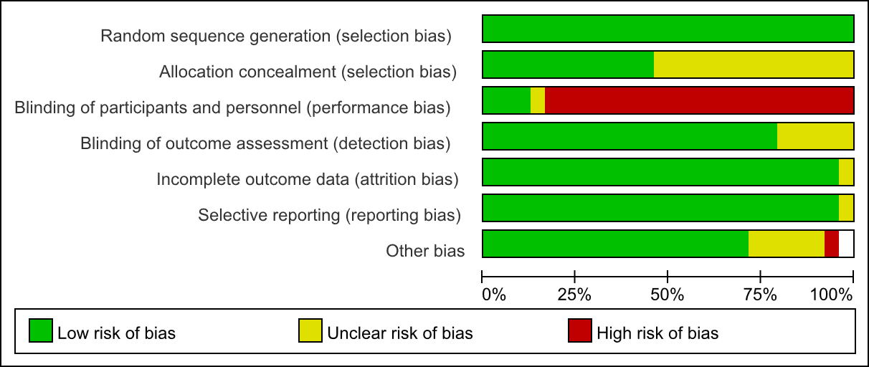
Supplementary Figure S1 Literature risk of bias graph
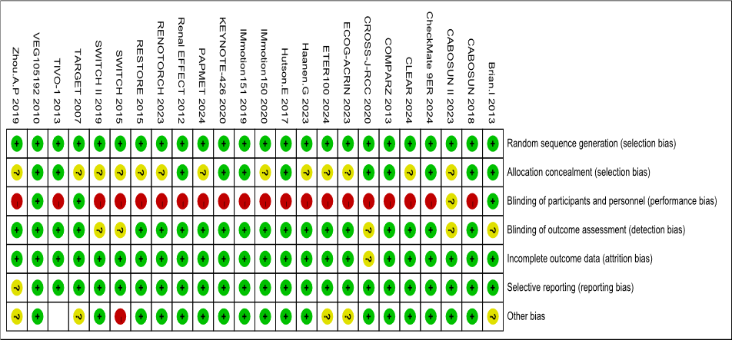
Supplementary Figure S2 Literature risk of bias traffic light graph
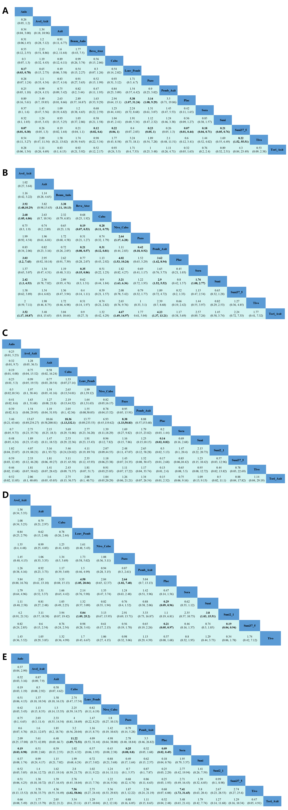

Supplementary Figure S3 Safety league table (A) Grade ≥3 AEs; (B) Discontinuations due to AEs; (C) Hypertension; (D) Fatigue; (E) Hand-foot syndrome.
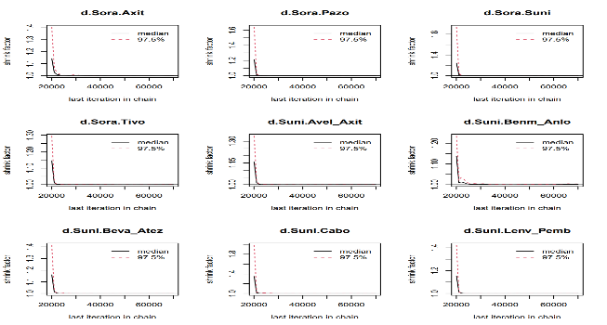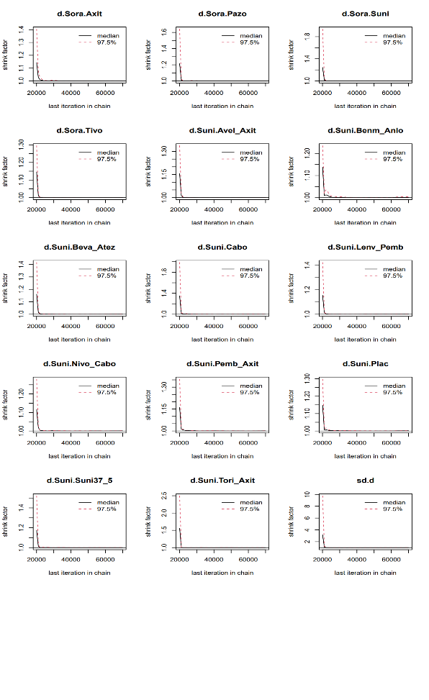
Supplementary Figure S4 OS convergence diagnostic diagram
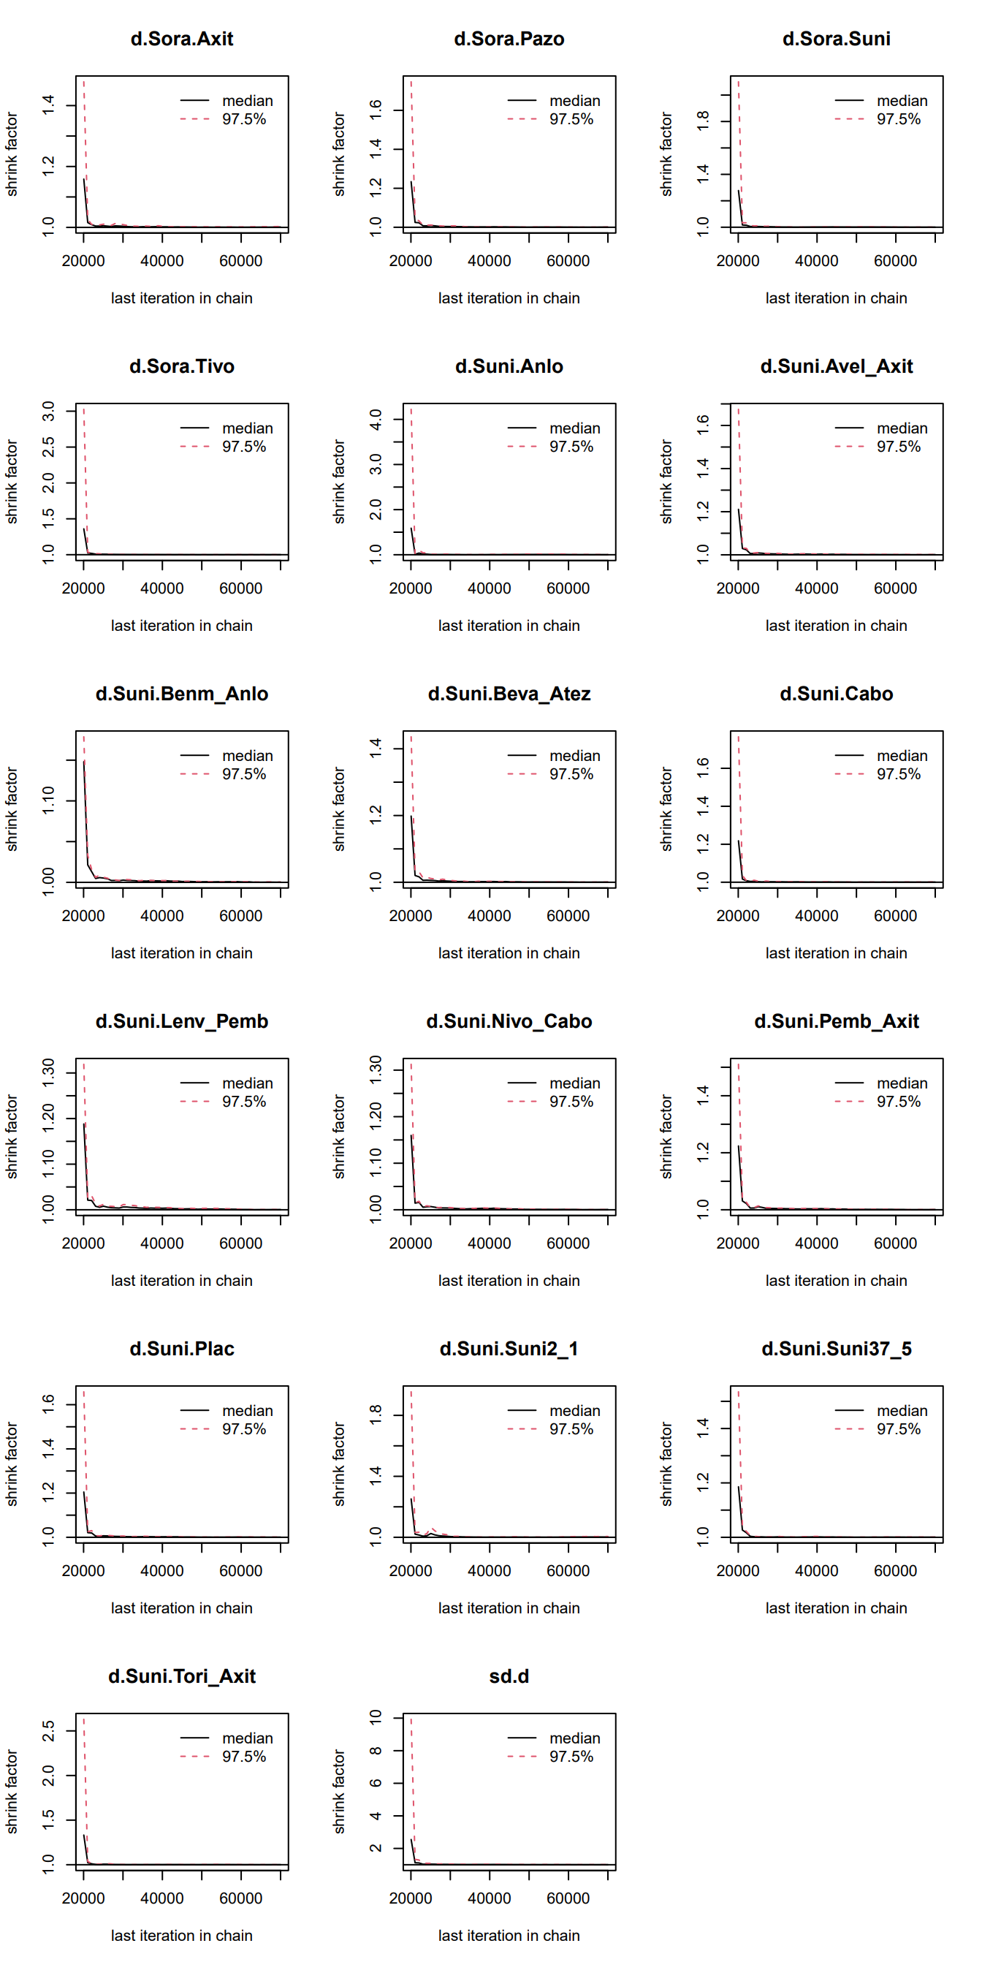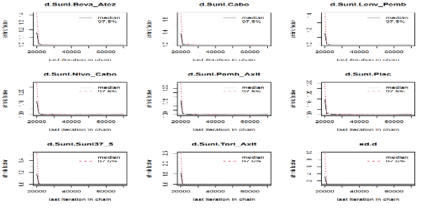
Supplementary Figure S5 PFS convergence diagnostic diagram
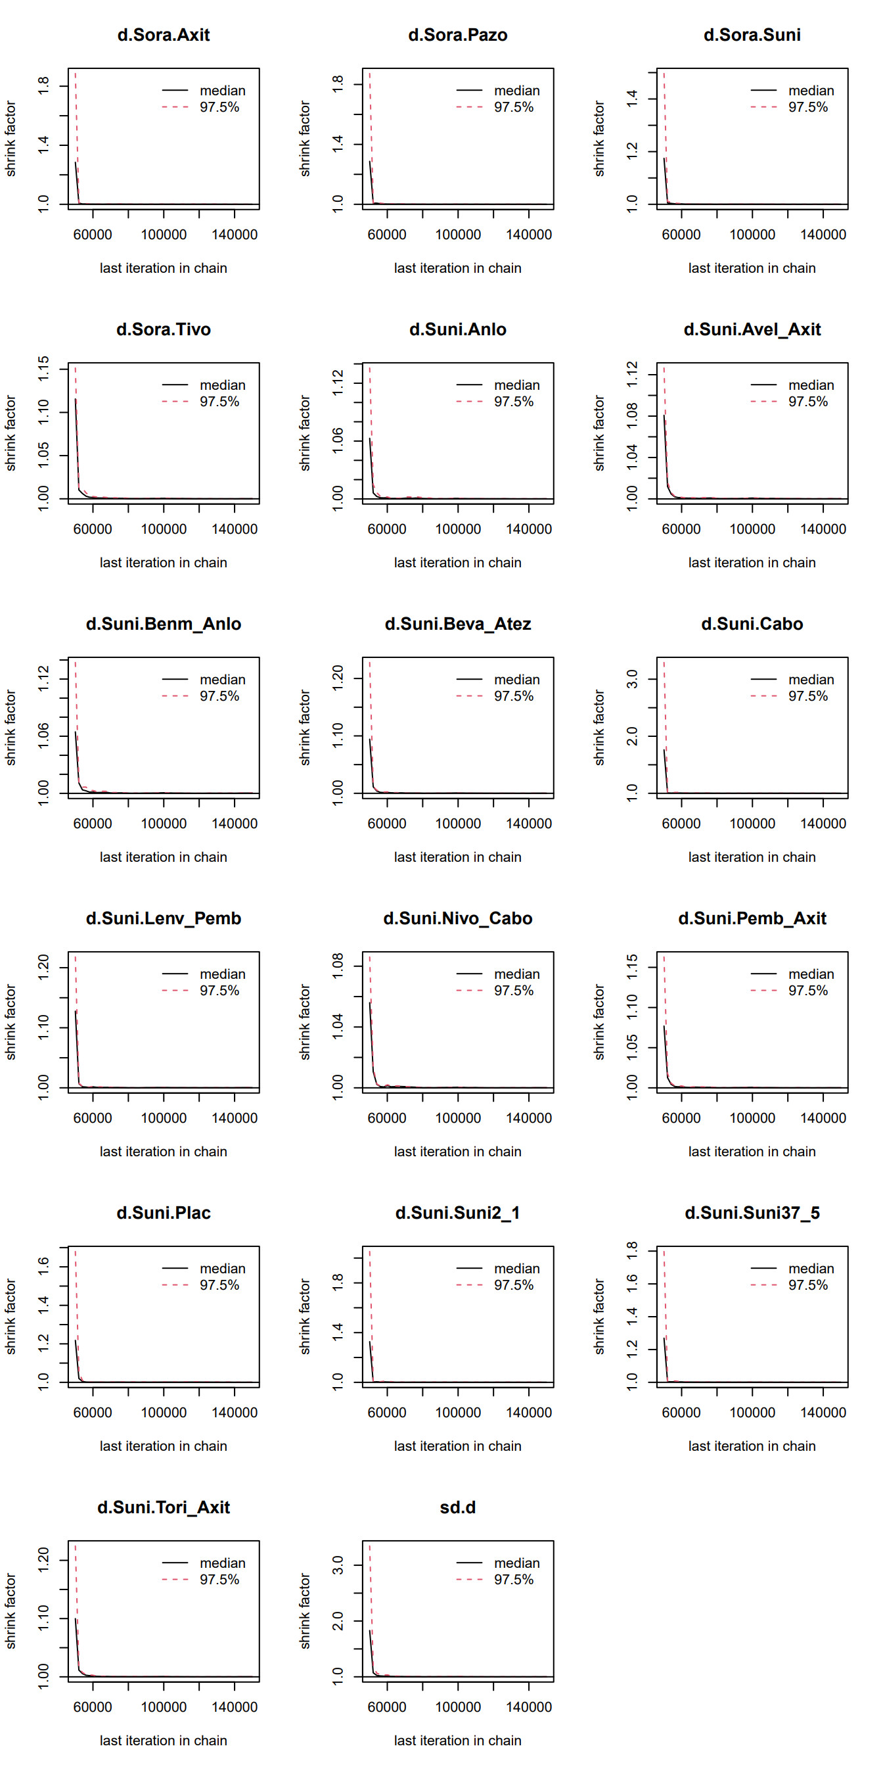
Supplementary Figure S6 ORR convergence diagnostic diagram
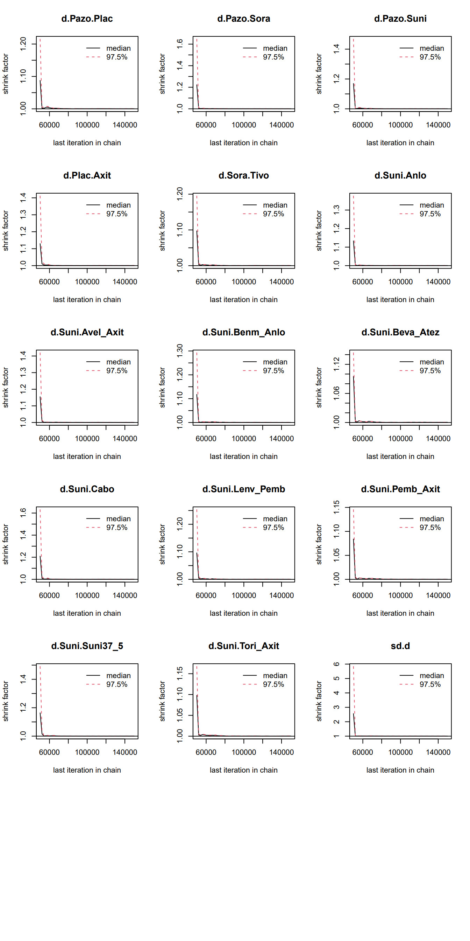
Supplementary Figure S7 Grade ≥3 AEs convergence diagnostic diagram
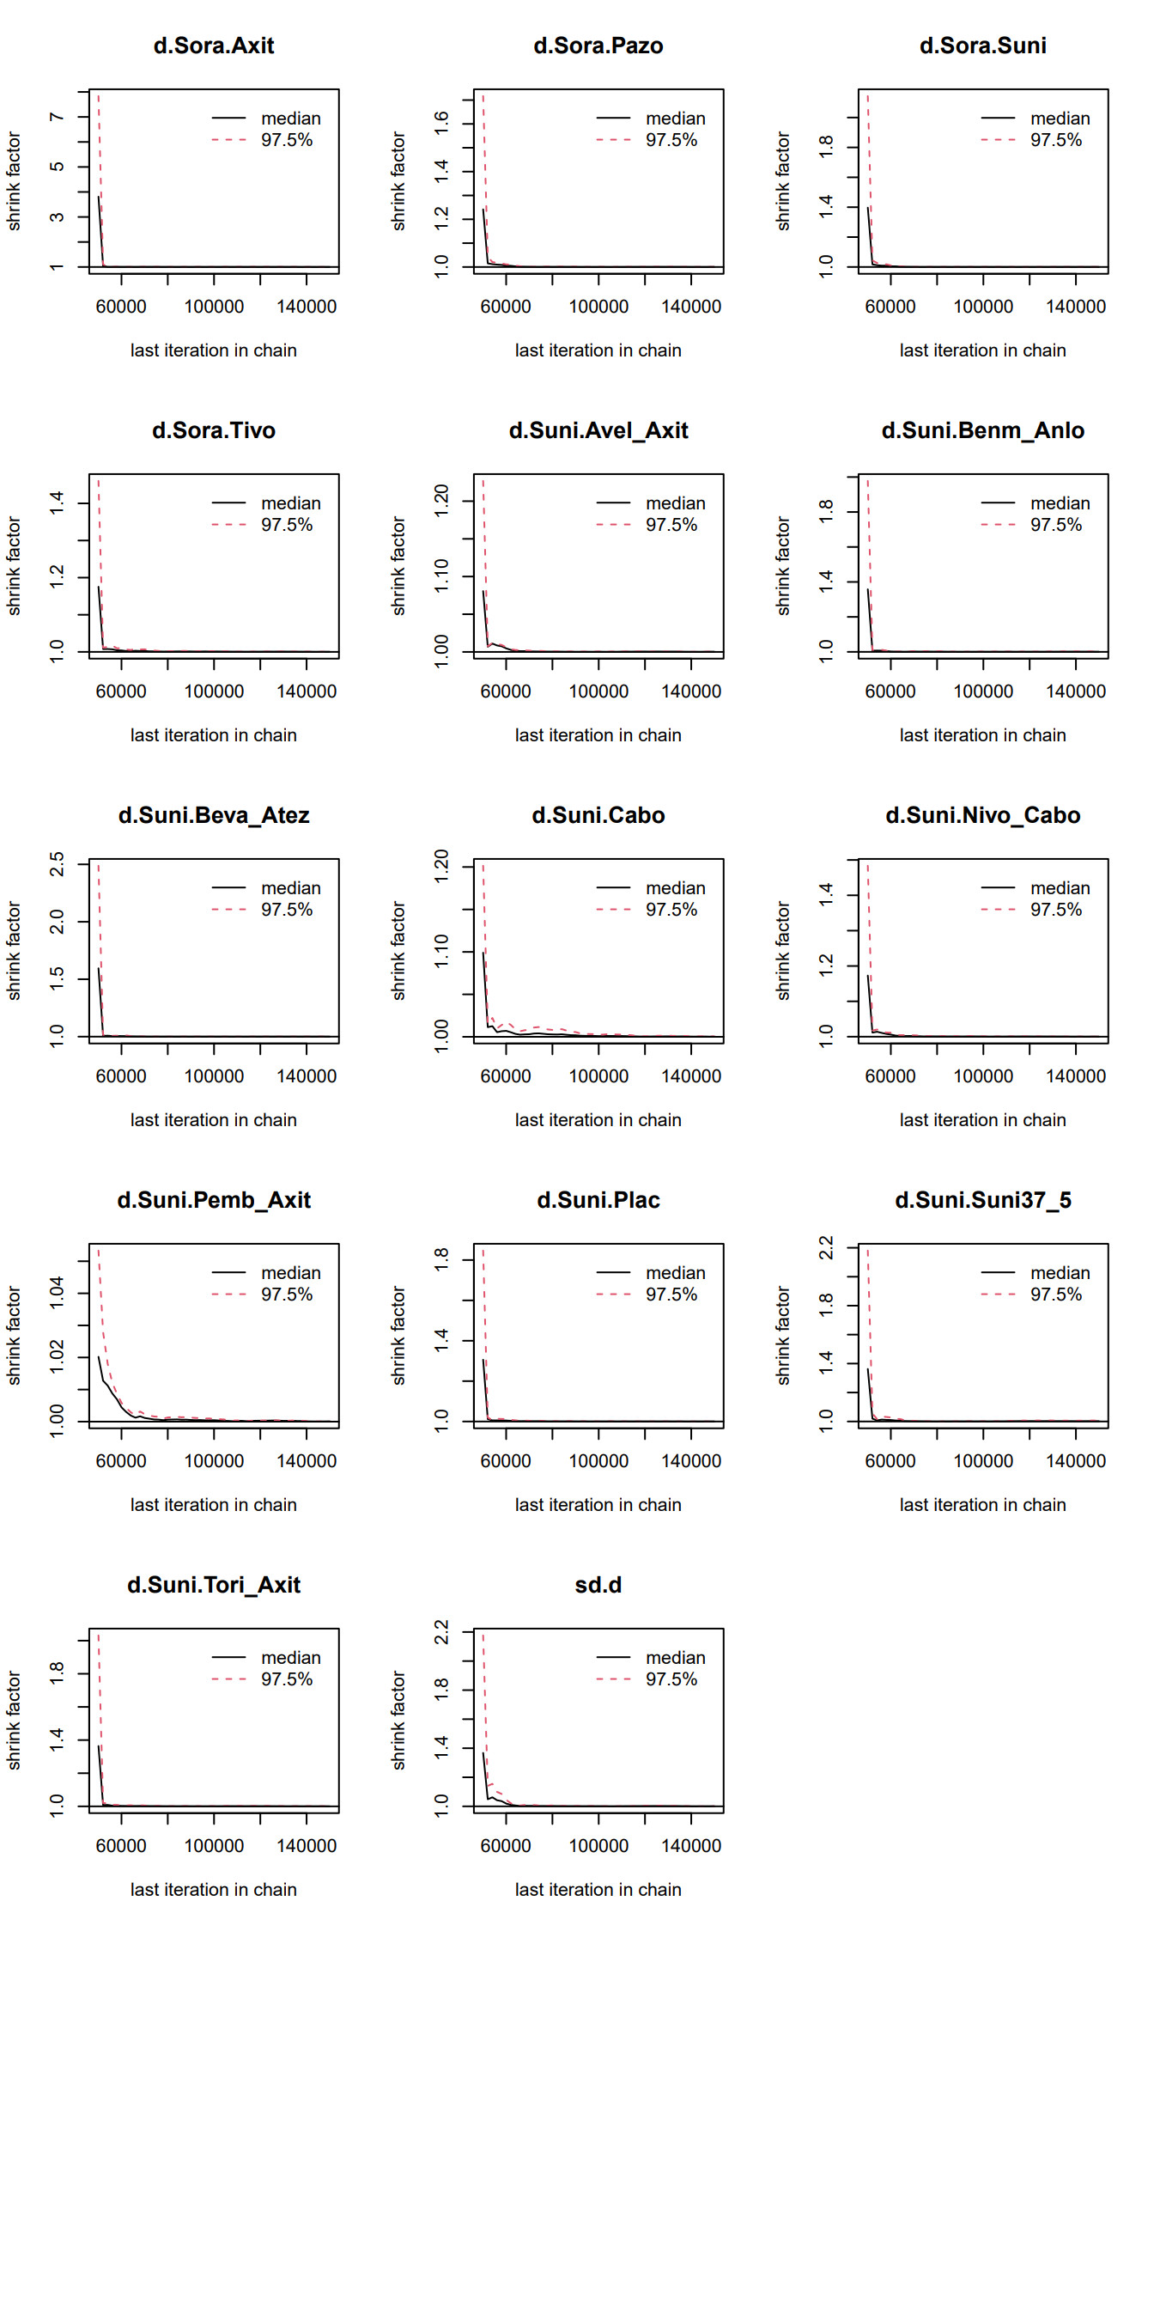
Supplementary Figure S8 Discontinuations due to AEs convergence diagnostic diagram
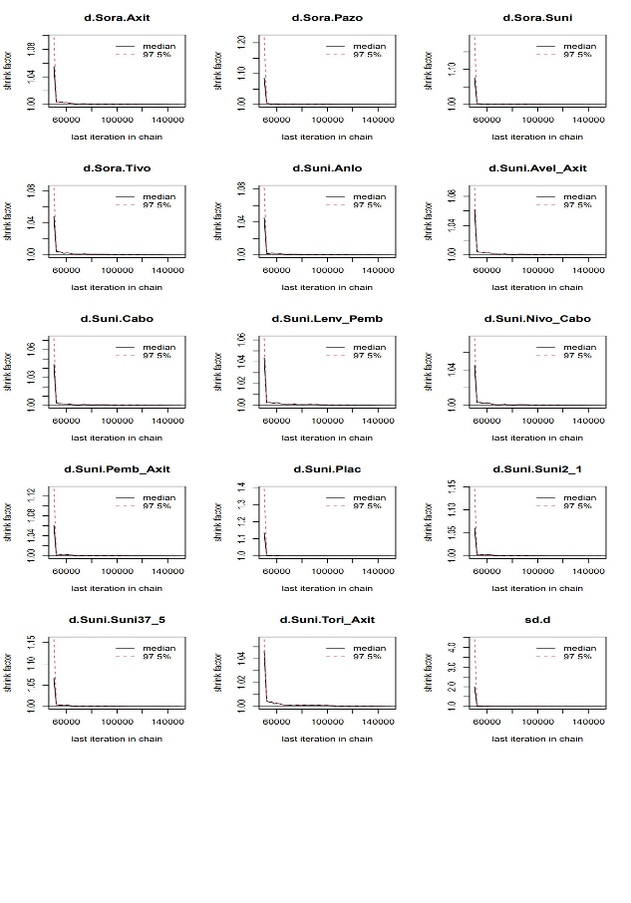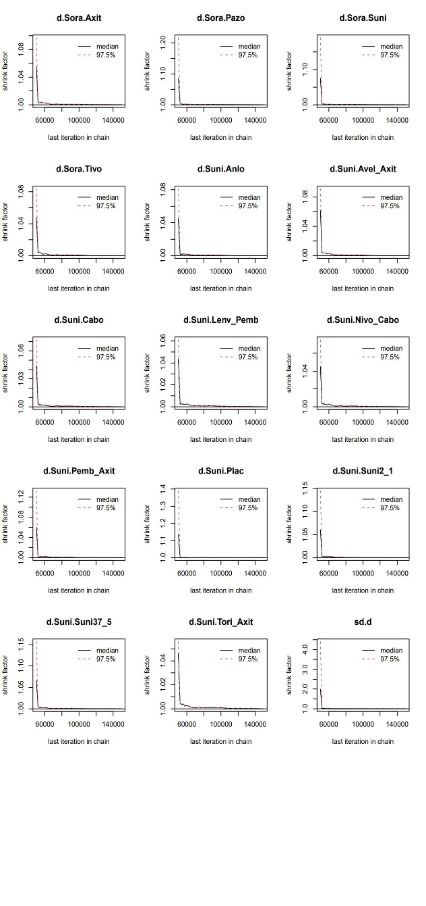
Supplementary Figure S9 Hypertension convergence diagnostic diagram

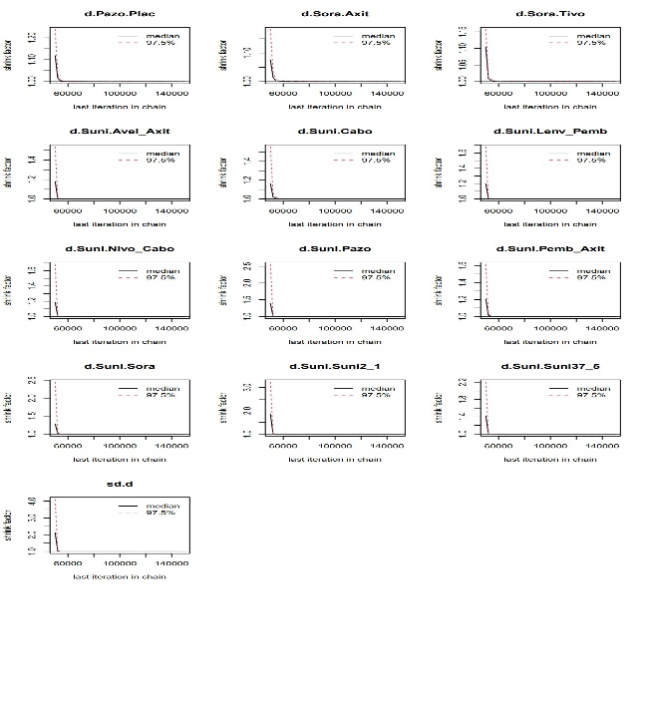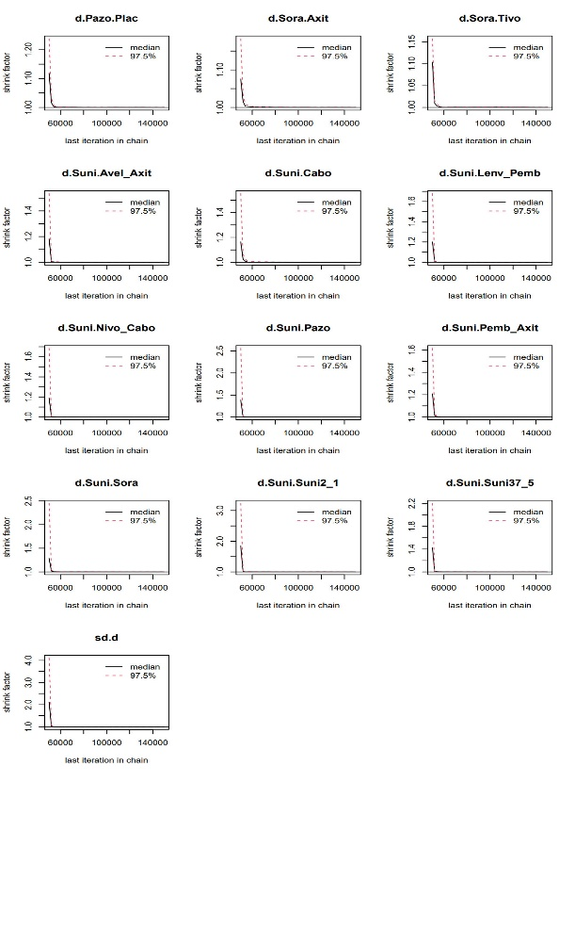
Supplementary Figure S10 Fatigue convergence diagnostic diagram
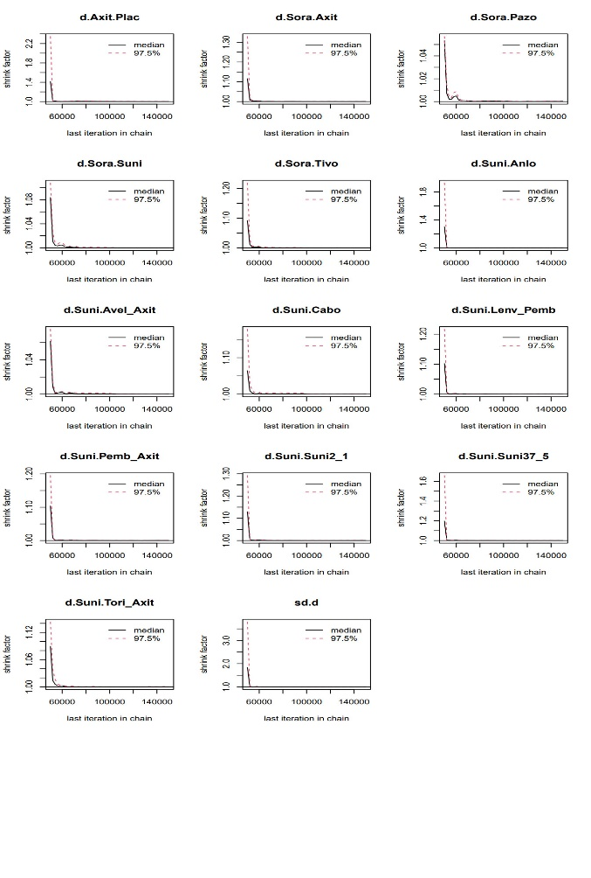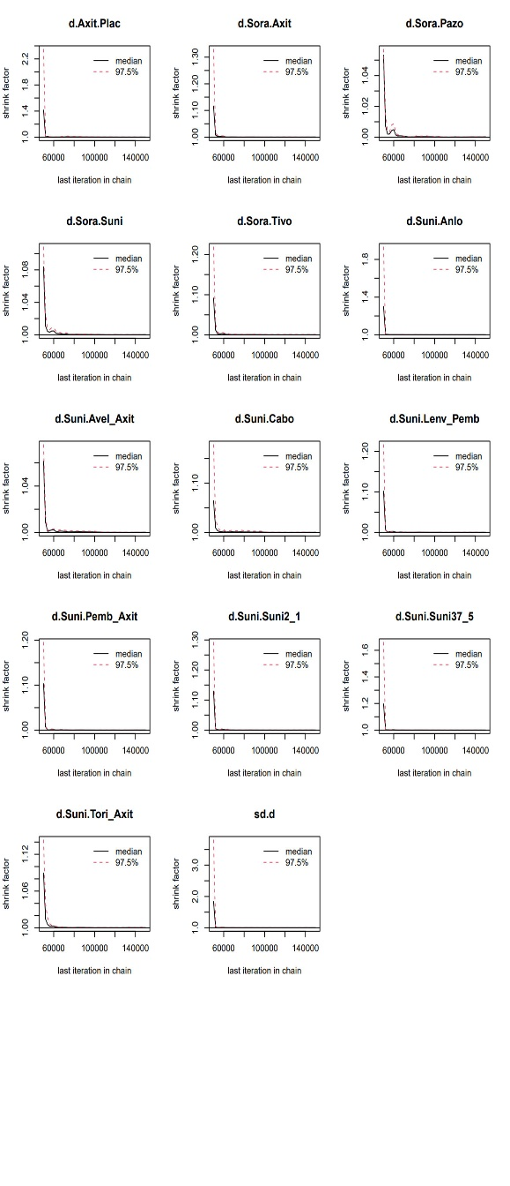
Supplementary Figure S11 Hand-foot syndrome convergence diagnostic diagram
A
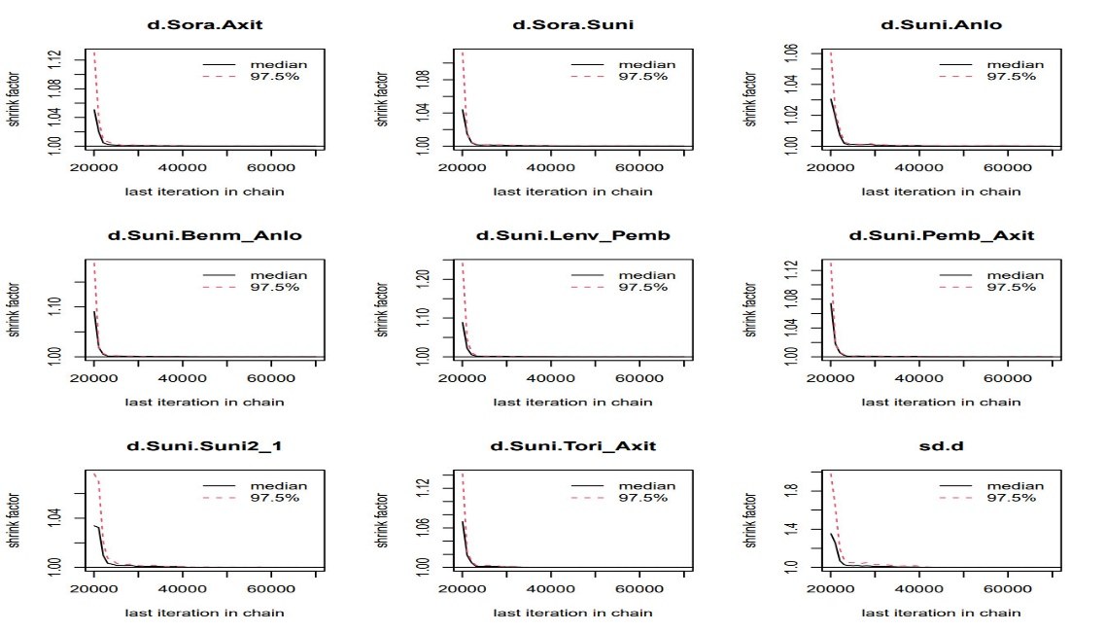
B
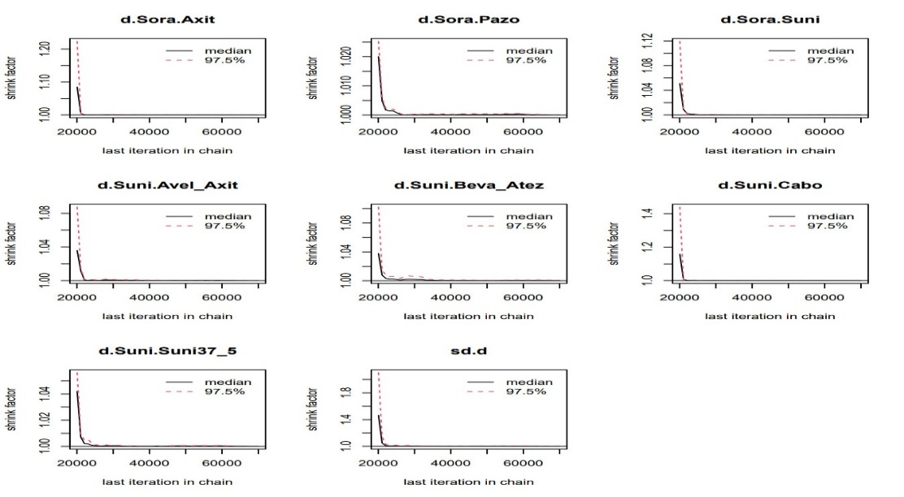
Supplementary Figure S12 (A) Diagnosis Chart for the Asian Subgroup; (B) Diagnosis Chart for the Non-Asian Subgroup
A
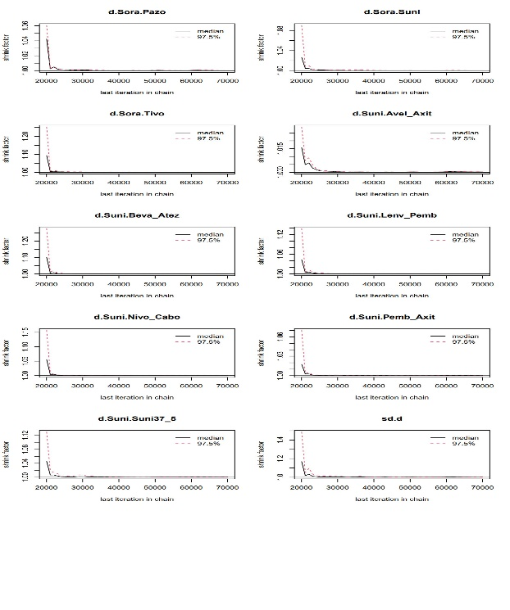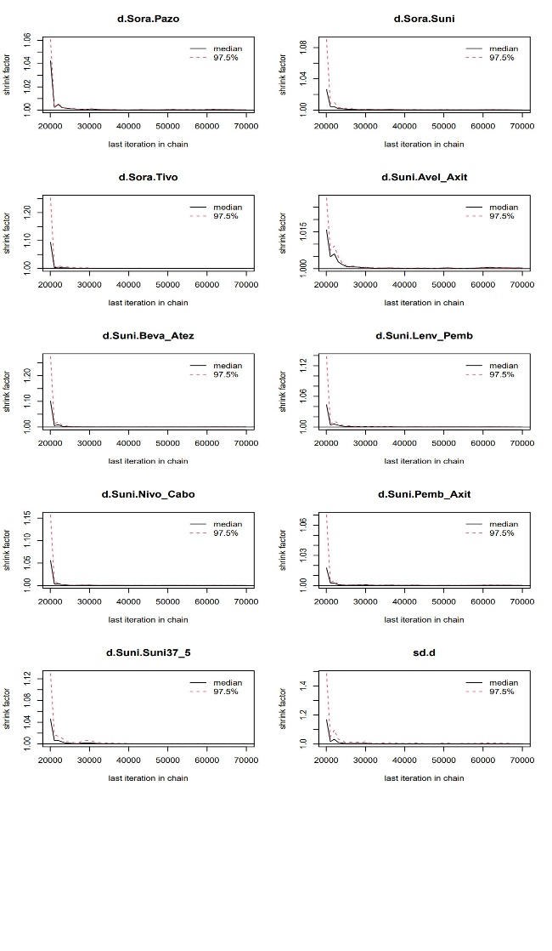B

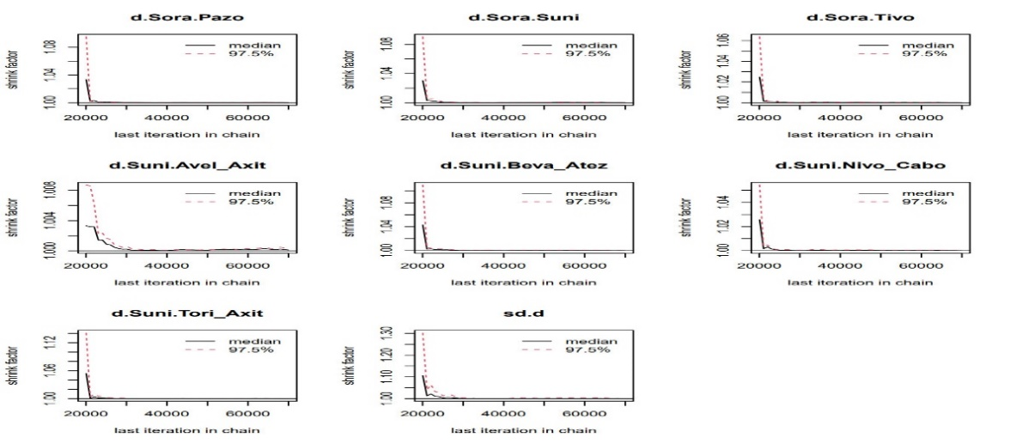
C
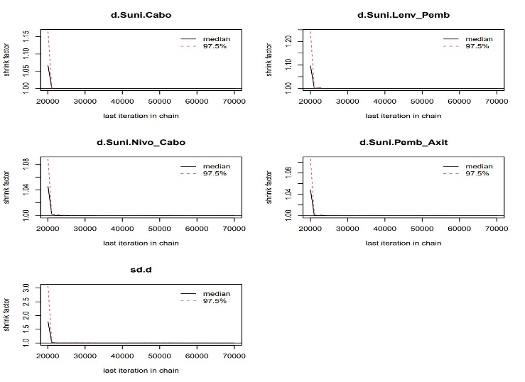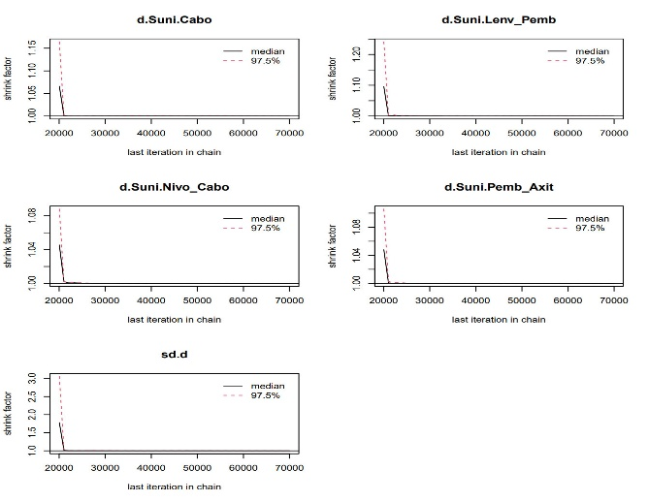

D
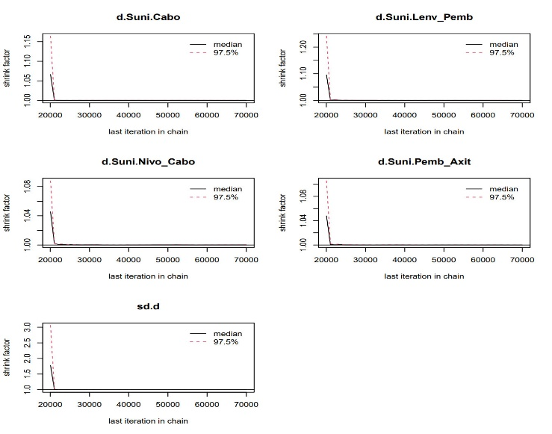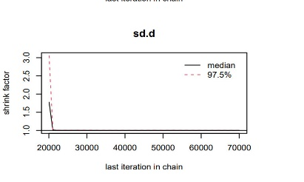
Supplementary Figure S13 (A) Low-risk subgroup diagnosis chart; (B) Intermediate-risk subgroup diagnosis chart; (C) Intermediate-high-risk subgroup diagnosis chart; (D) High-risk subgroup diagnosis chart.
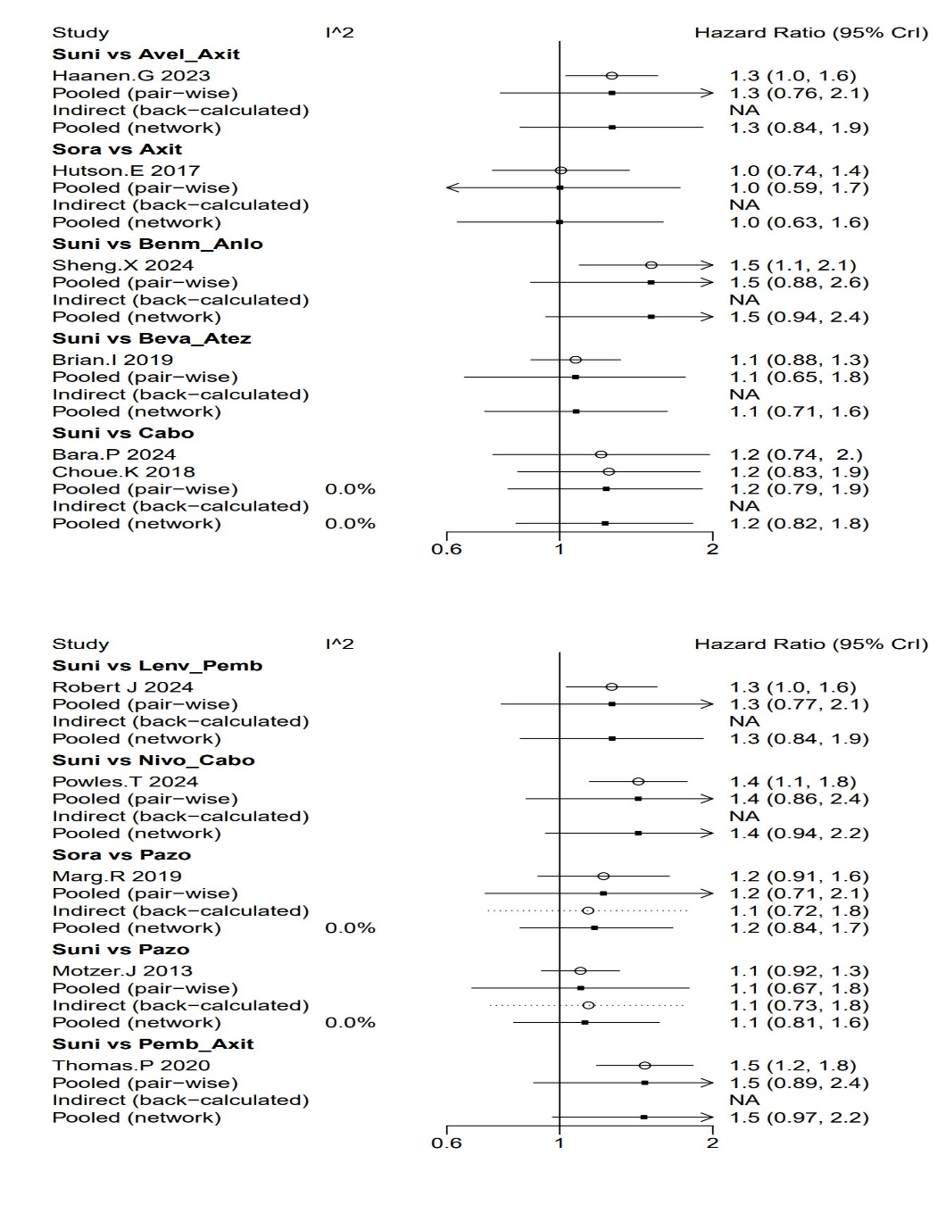
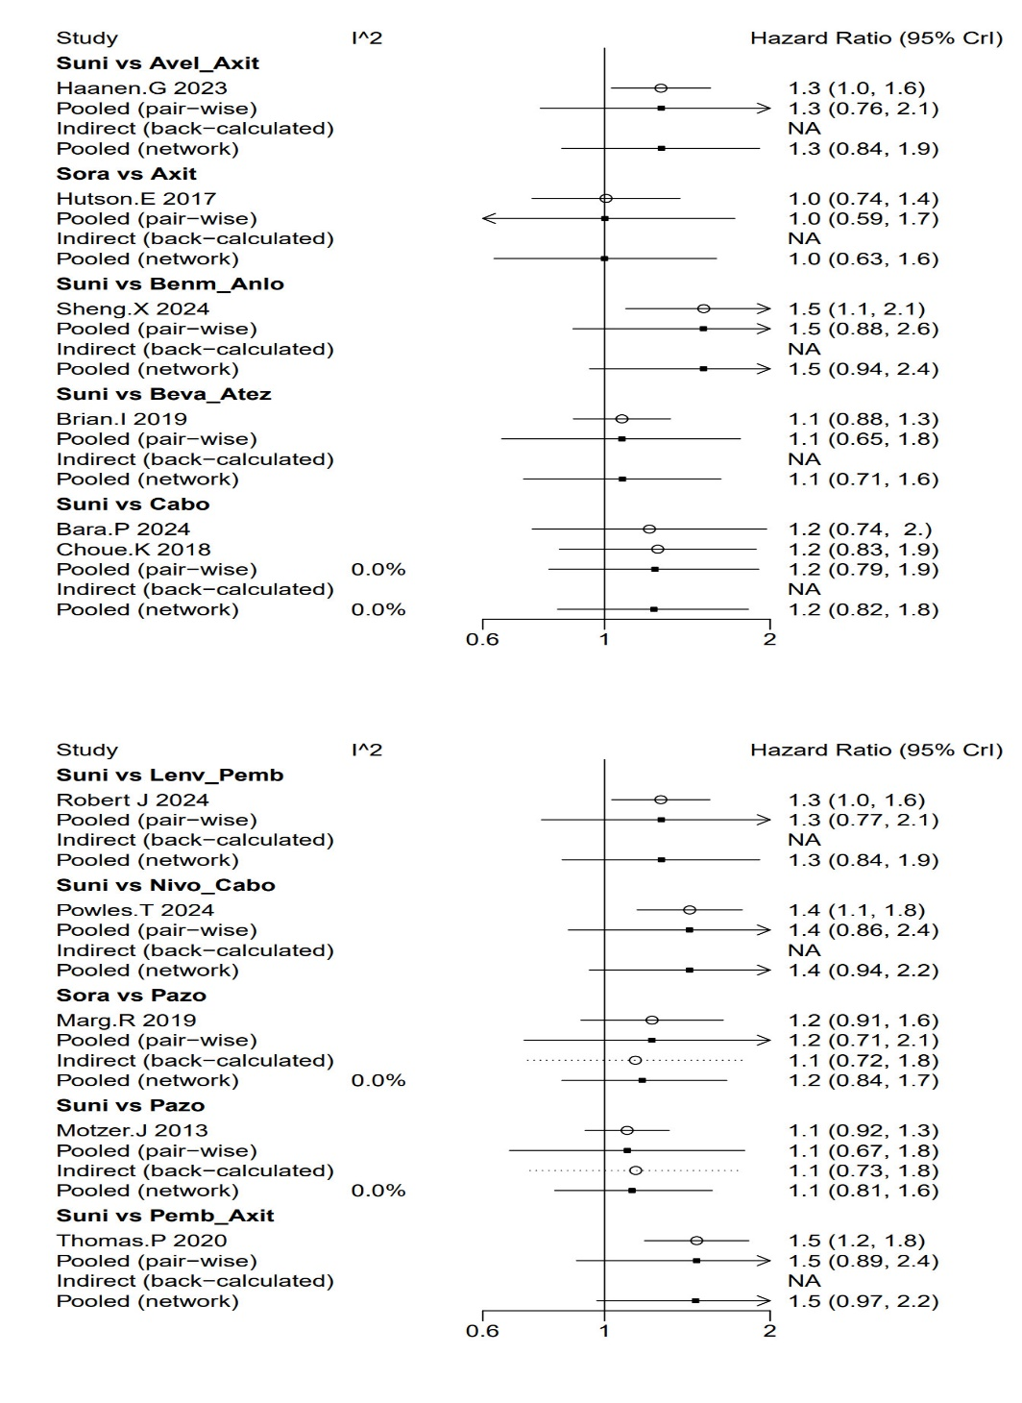
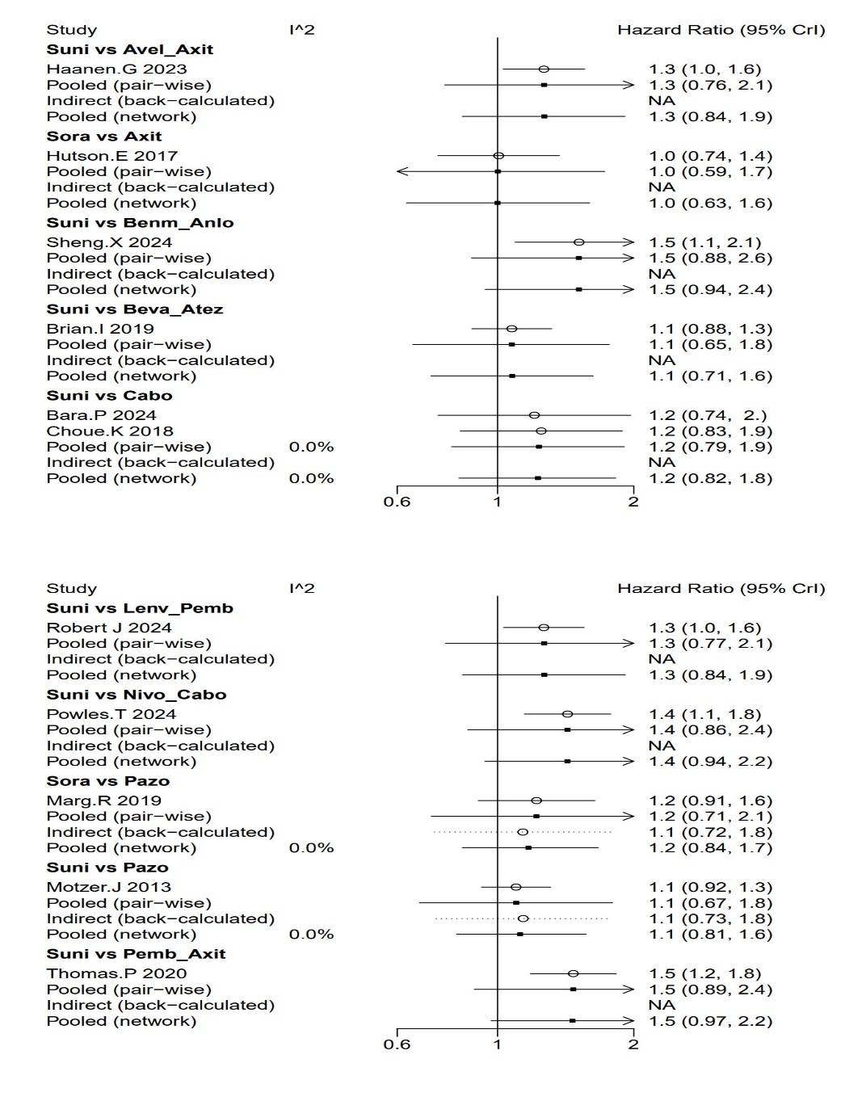
Supplementary Figure S14 Forest plot of OS heterogeneity
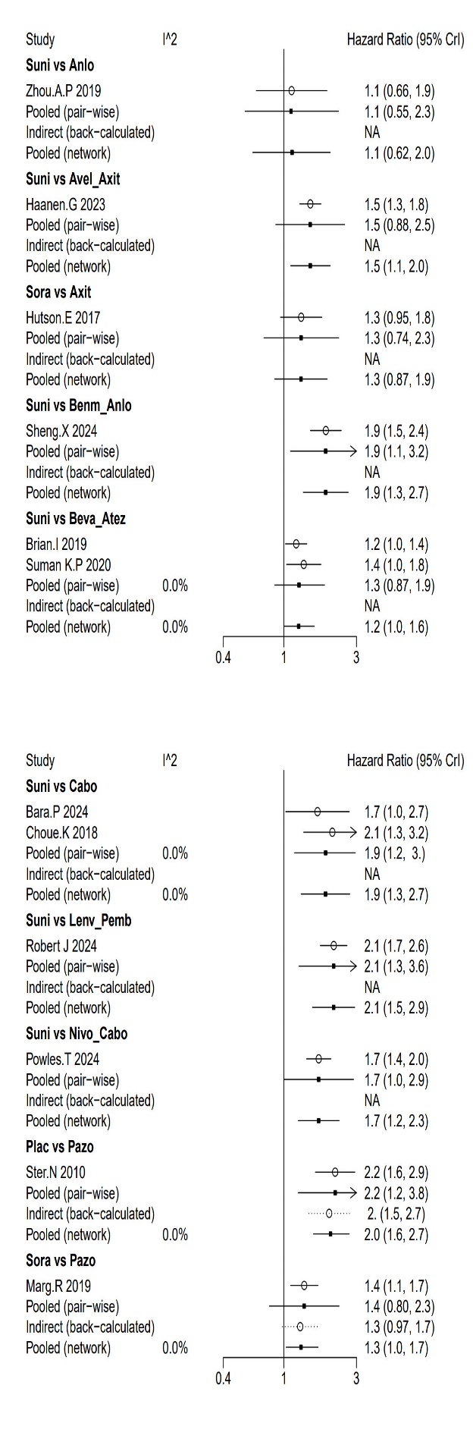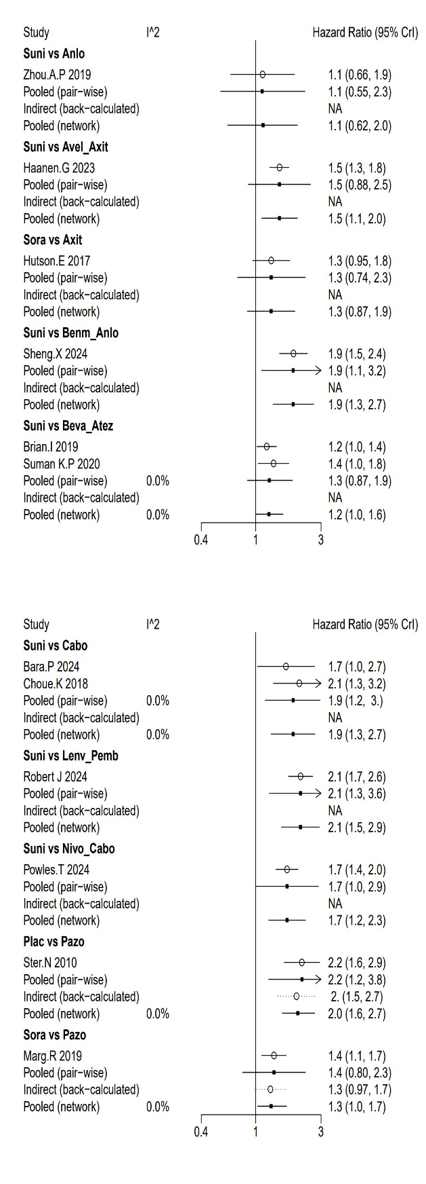
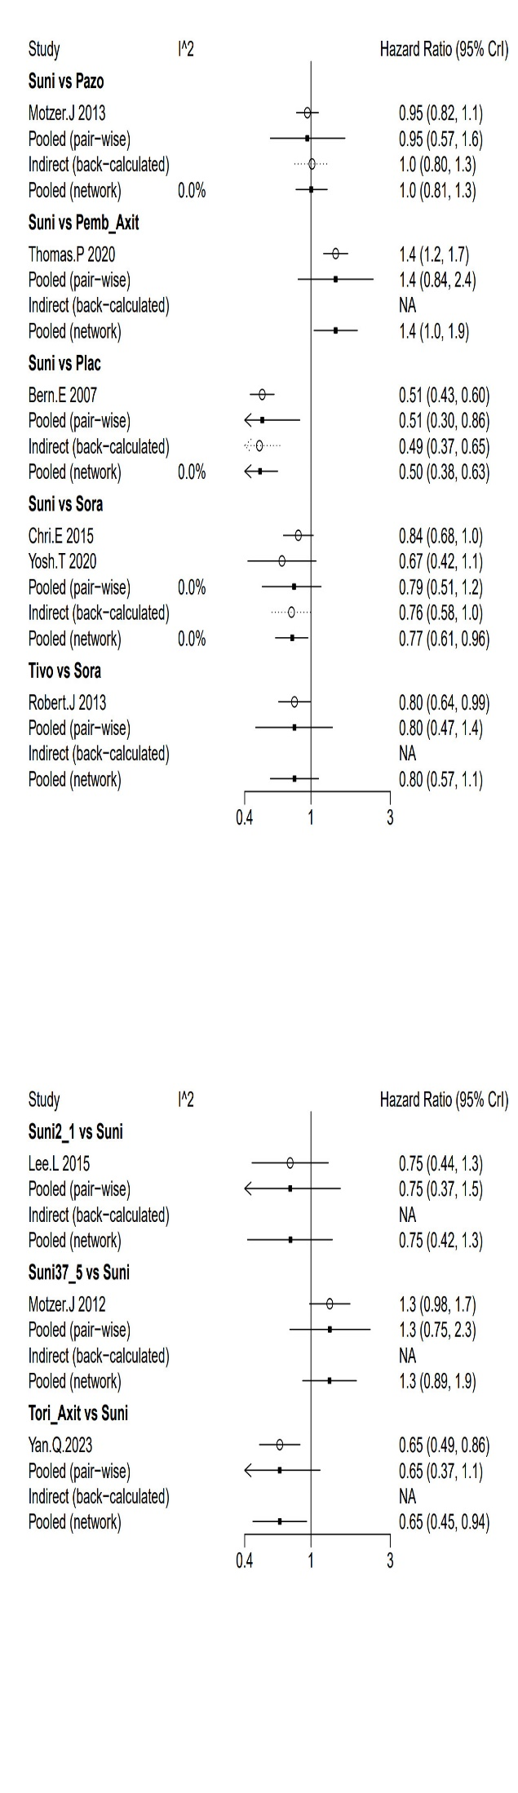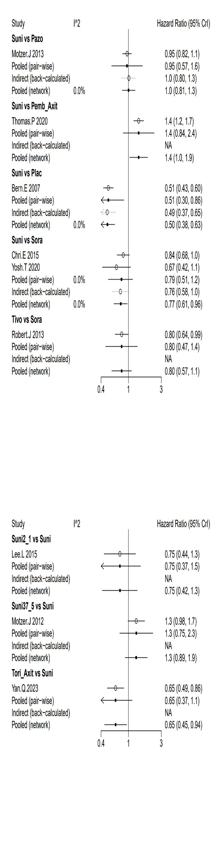
Supplementary Figure S15 Forest plot of PFS heterogeneity
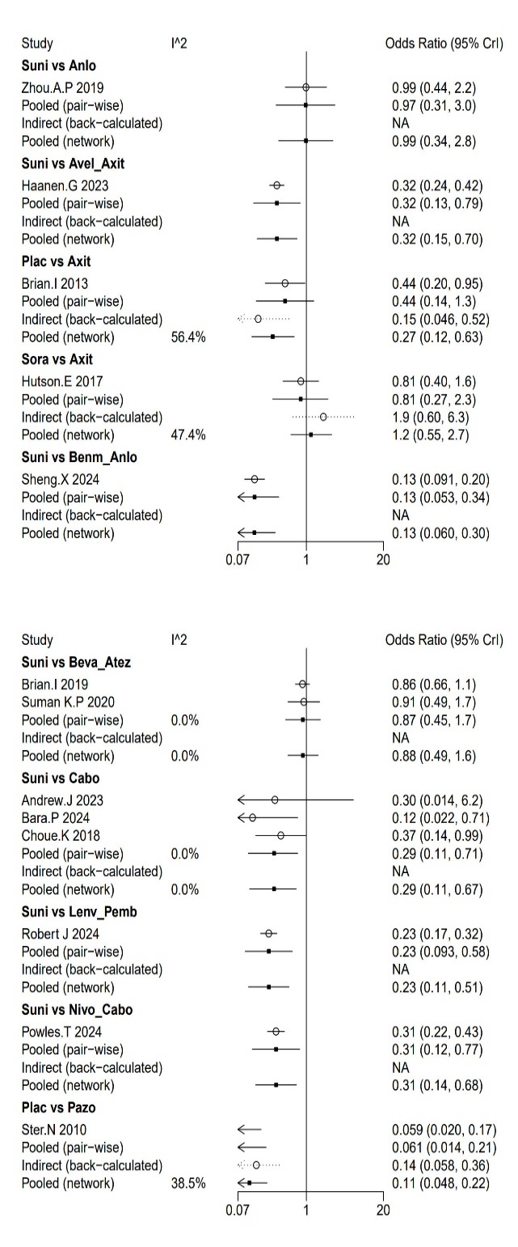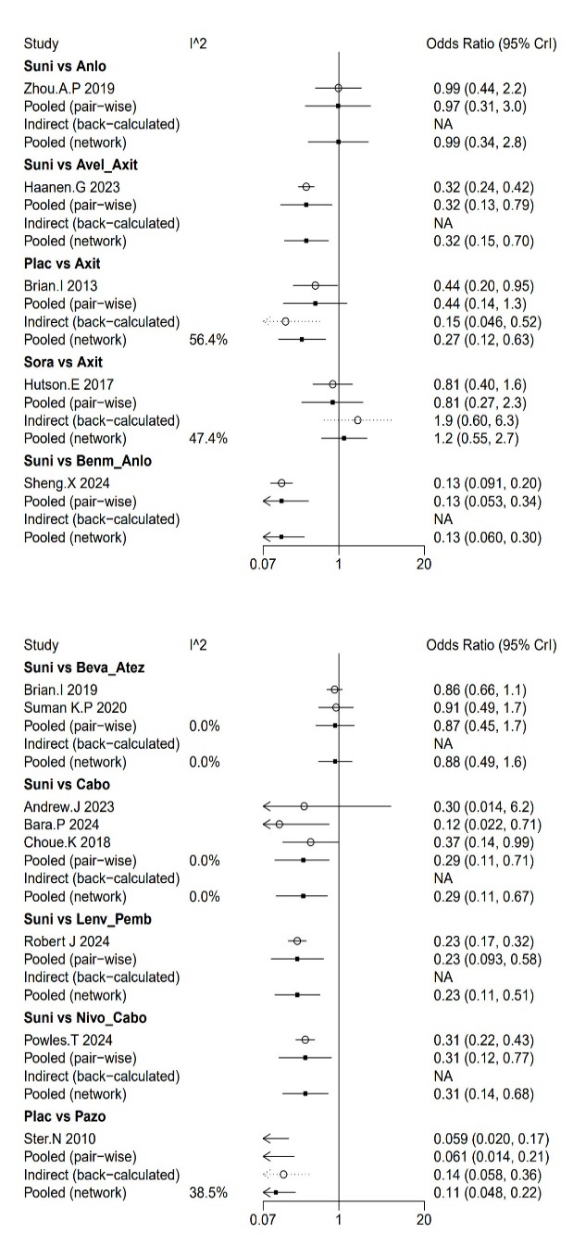
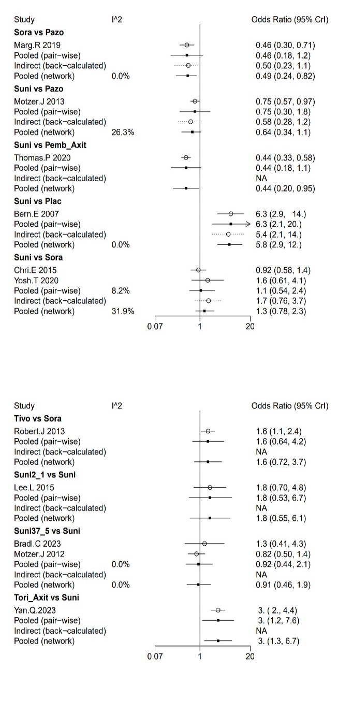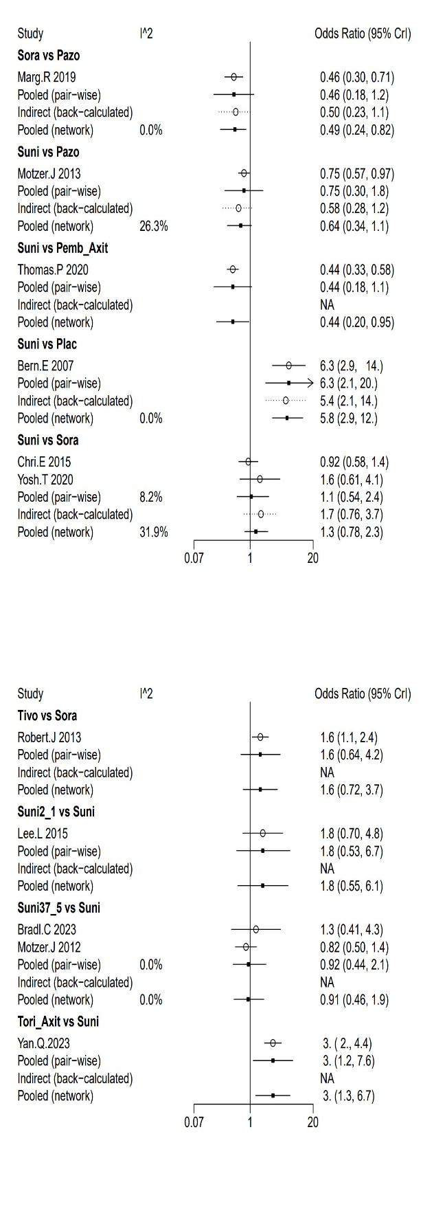
Supplementary Figure S16 Forest plot of ORR heterogeneity
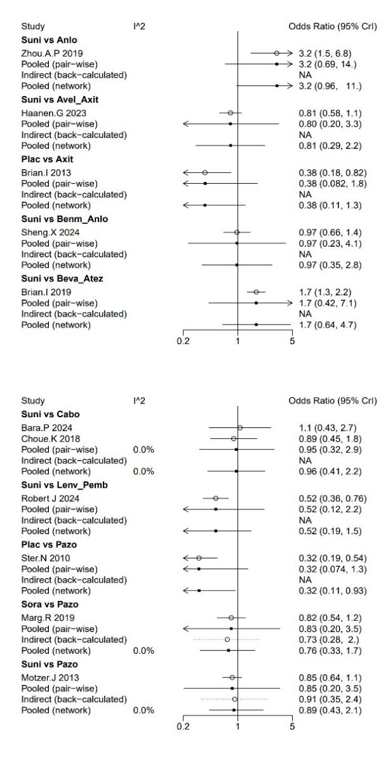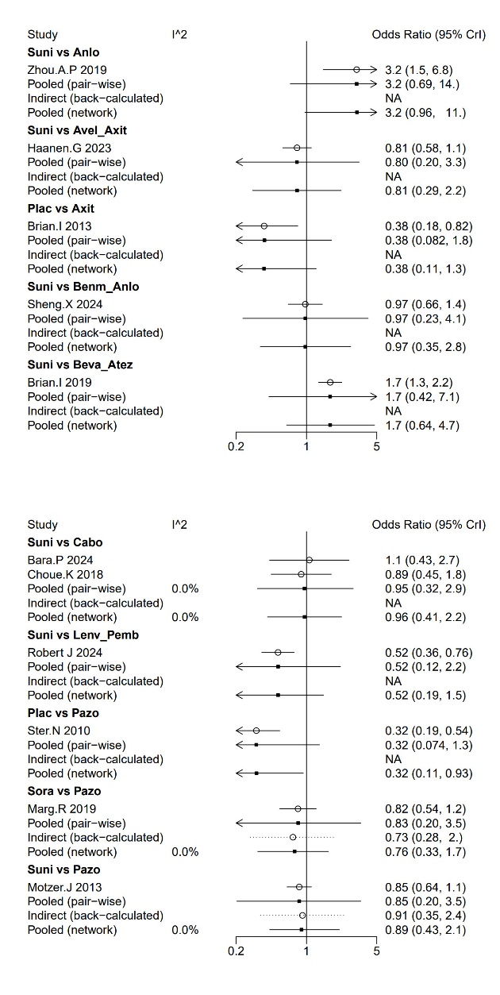
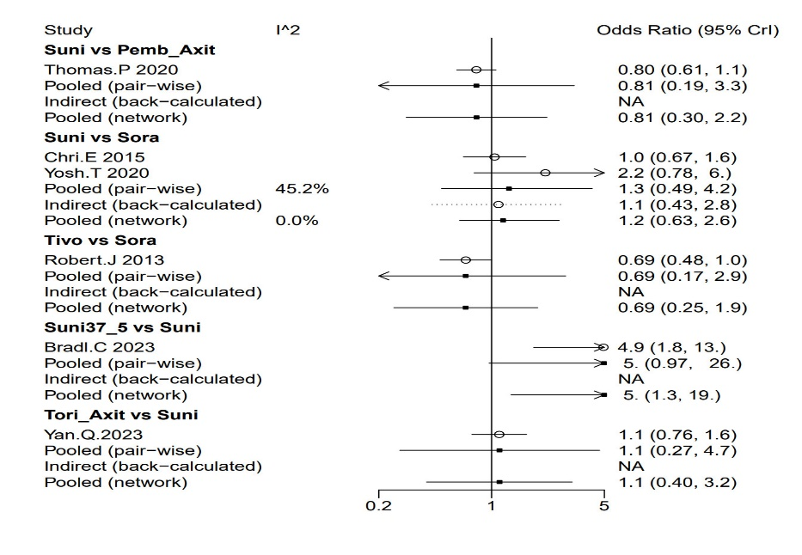
Supplementary Figure S17 Forest plot of ≥3 AEs heterogeneity
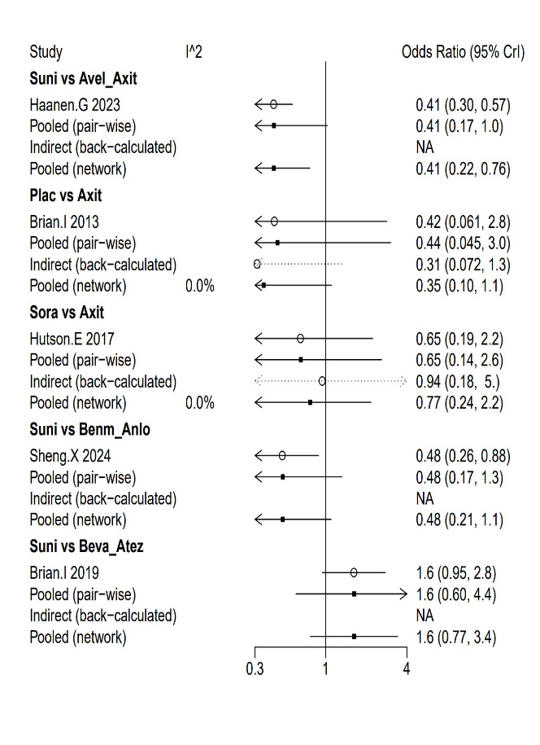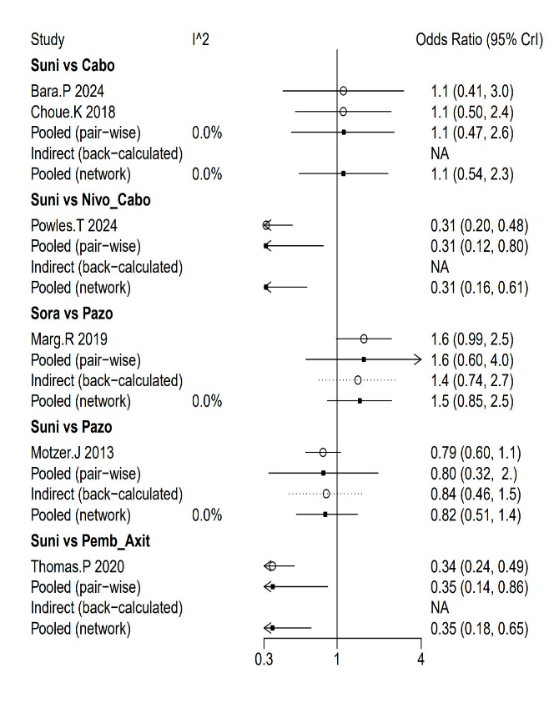
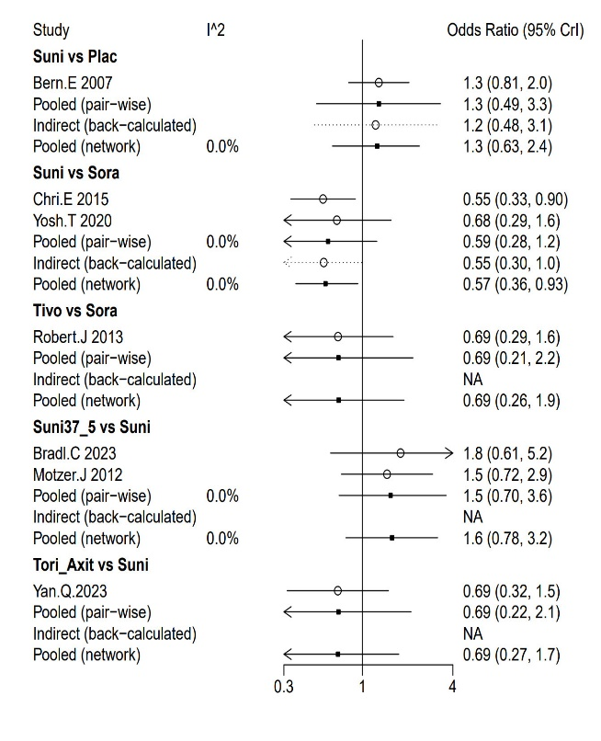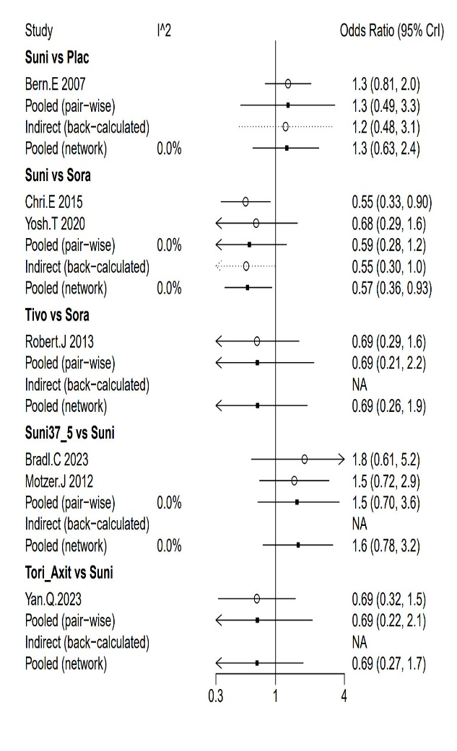
Supplementary Figure S18 Forest plot of Discontinuations due to AEs heterogeneity

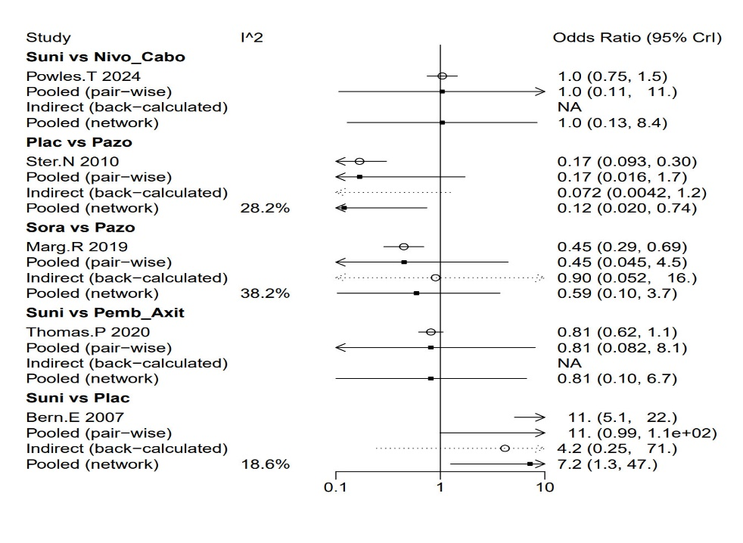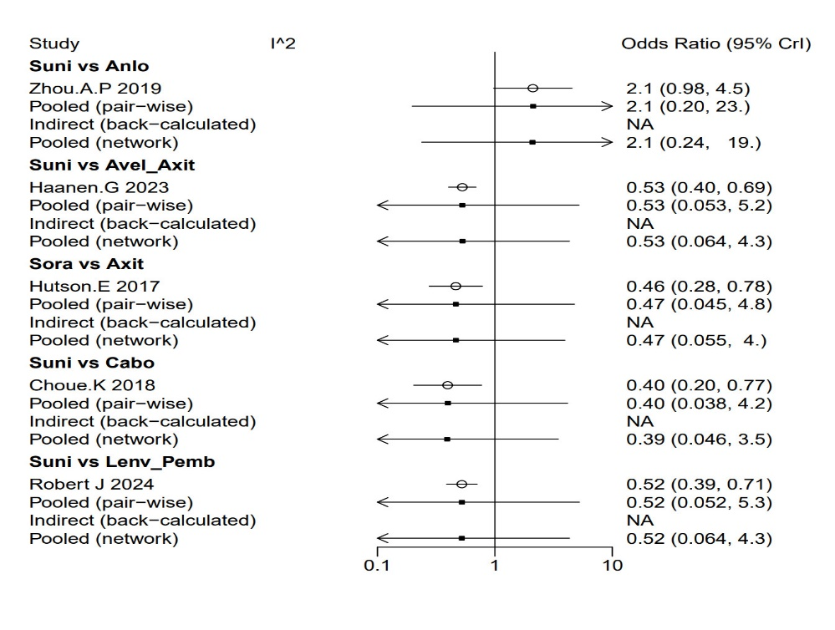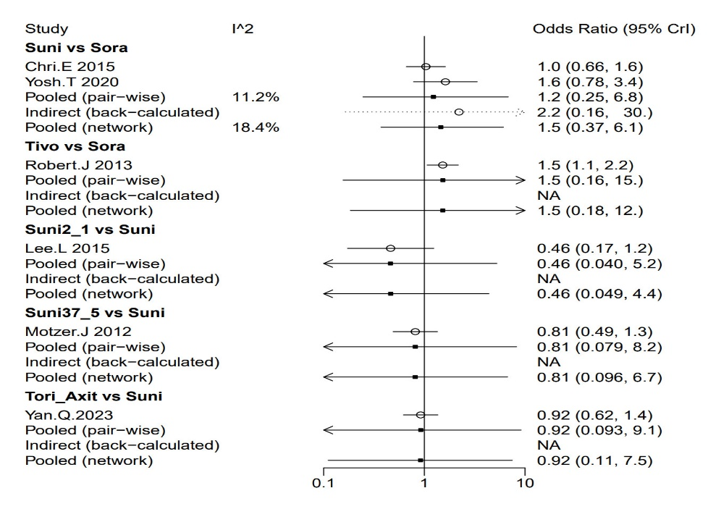
Supplementary Figure S19 Forest plot of Hypertension heterogeneity
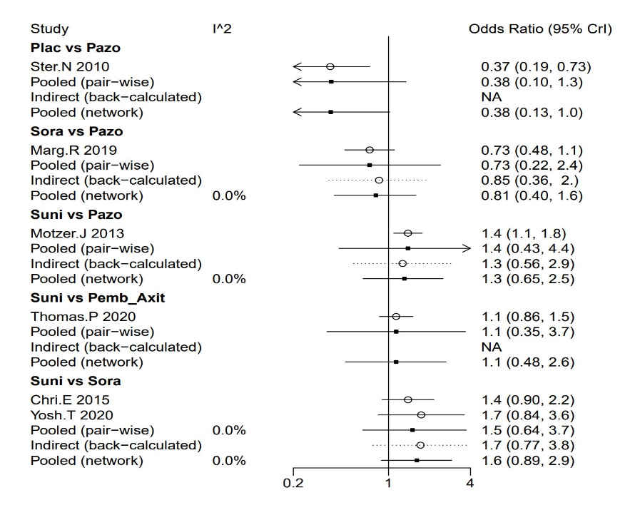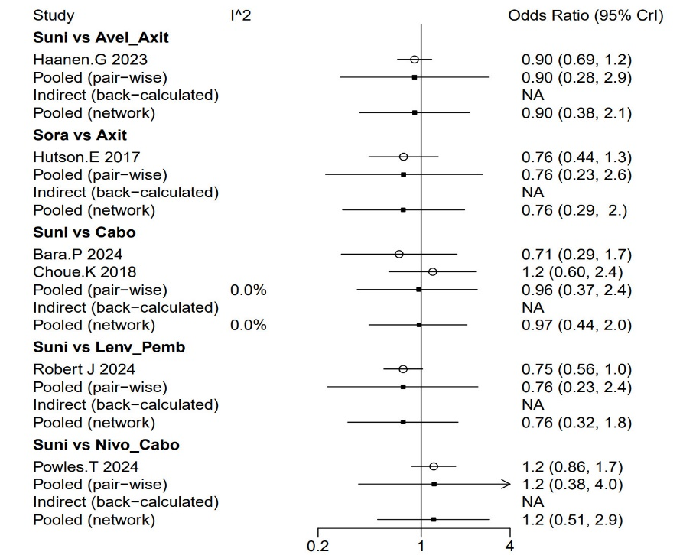
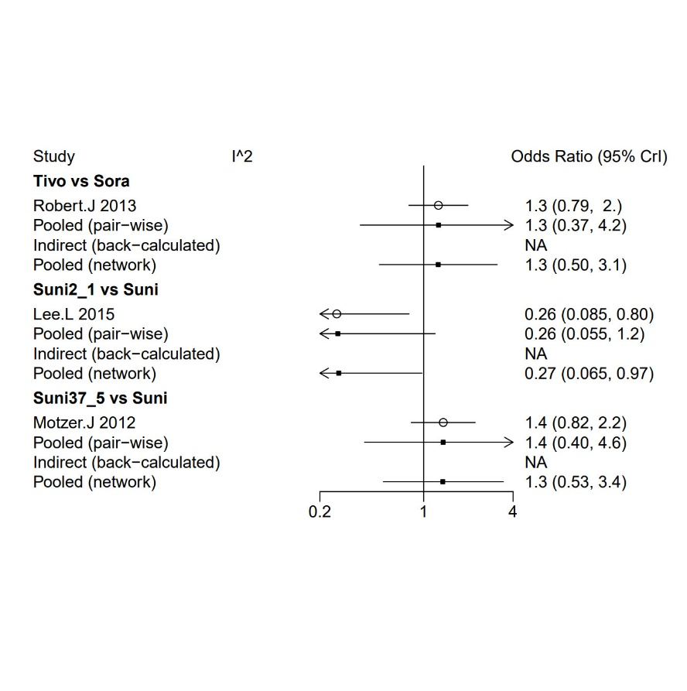
Supplementary Figure S20 Forest plot of Fatigue heterogeneity
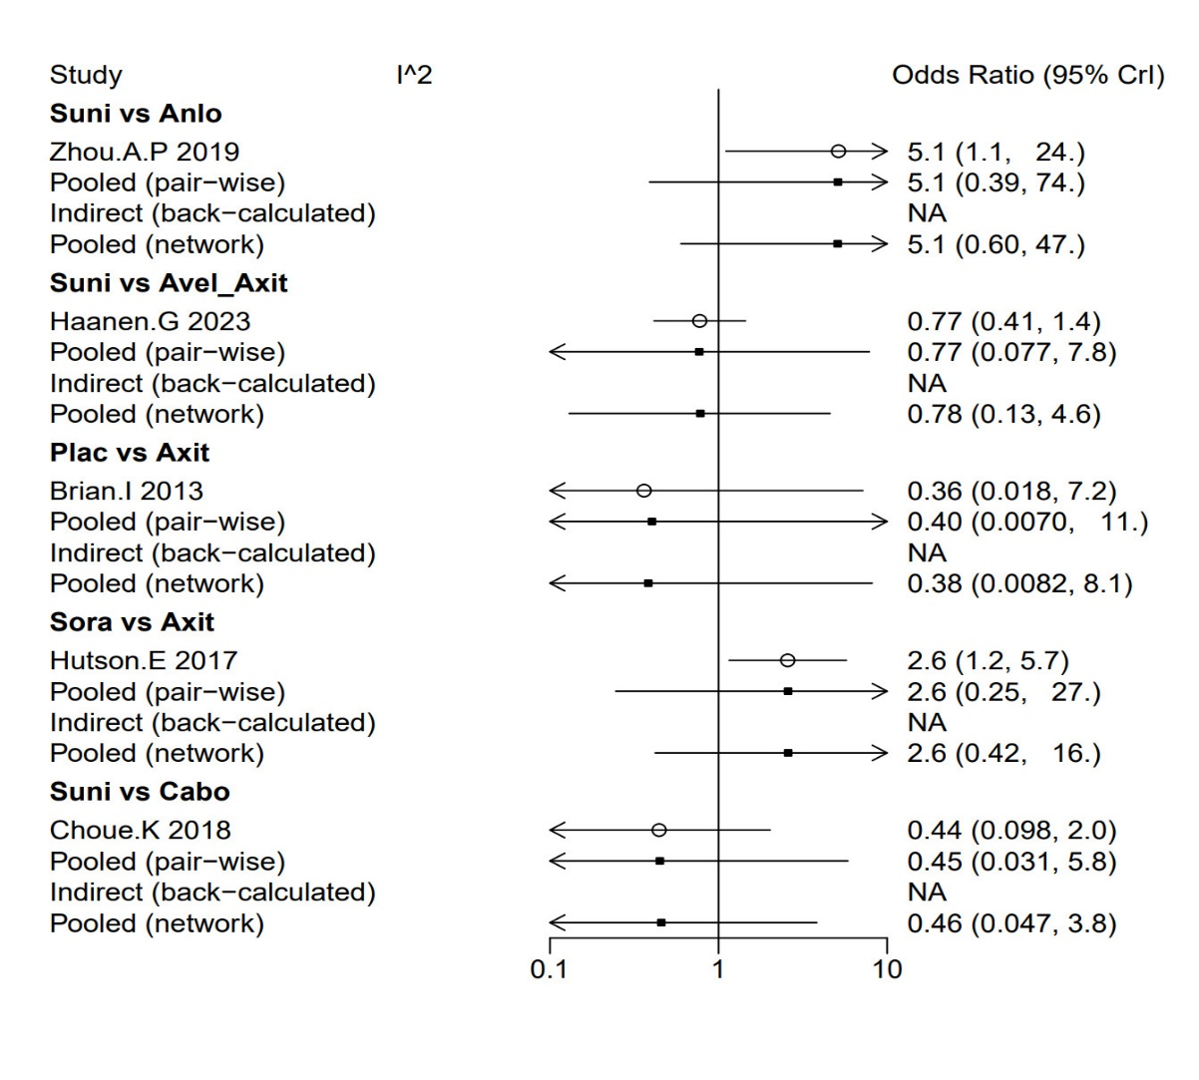
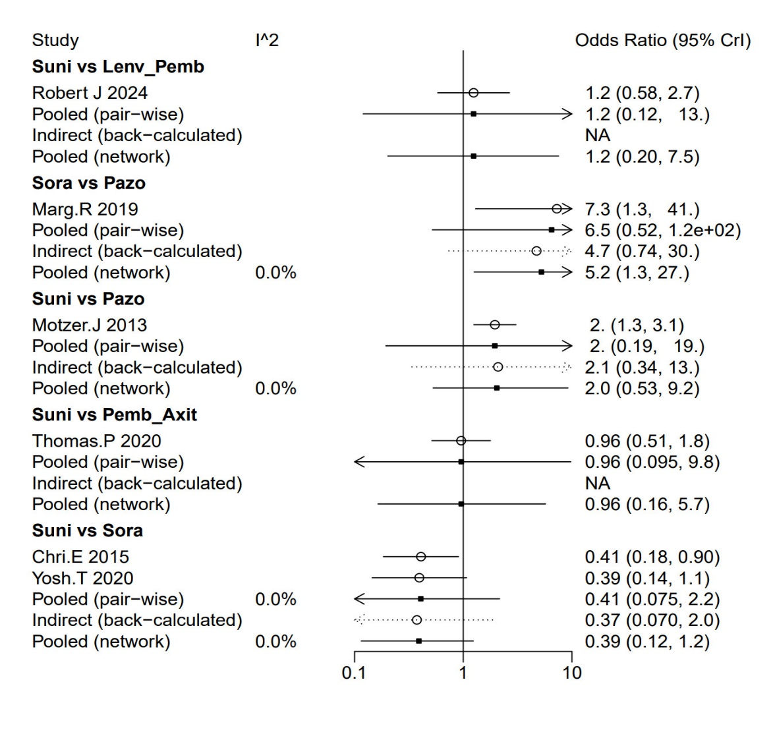
Supplementary Figure S21 Figure plot of Hand-foot syndrome heterogeneity
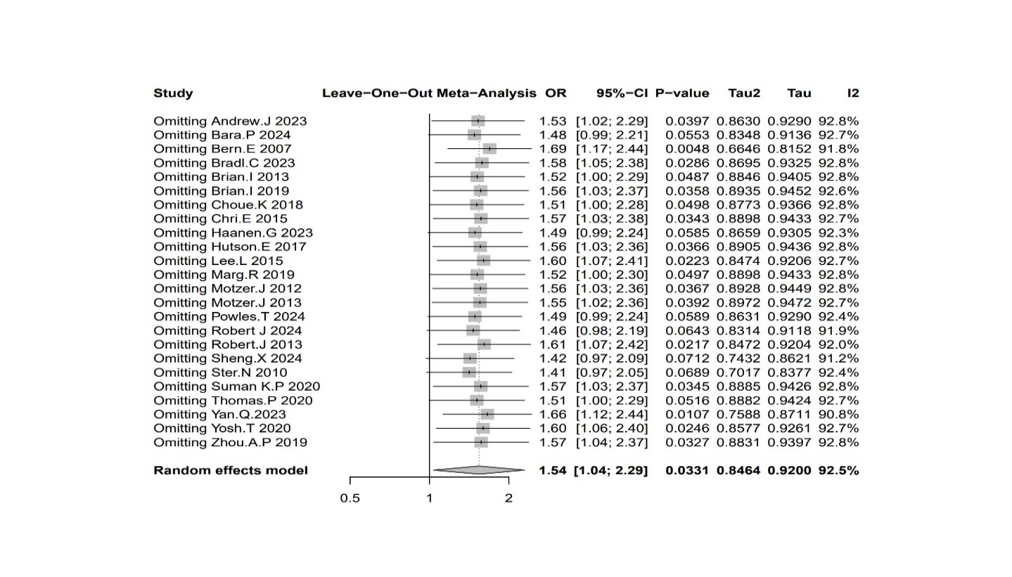

Supplementary Figure S22 ORR Sensitivity Analysis

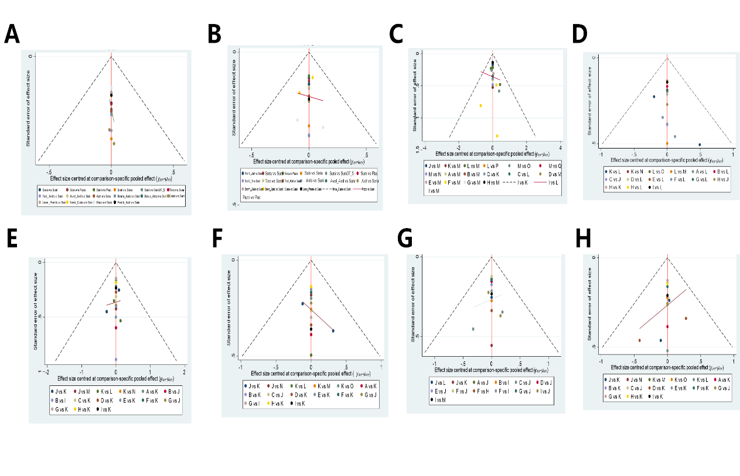

Supplementary Figure S23 The funnel plot for efficacy and safety: (A)OS; (B)PFS; (C)ORR; (D) Grade ≥3 AEs;(E) Discontinuations due to AEs; (F) Hypertension; (G) Fatigue; (H) Hand-foot syndrome

Appendix
1.PubMed
#1 randomized controlled trial
(Randomized Controlled Trial [Publication Type]) OR (((("Randomized Controlled Trials as Topic"[Mesh]) OR (Clinical Trials, Randomized[Title/Abstract])) OR (Trials, Randomized Clinical[Title/Abstract])) OR (Controlled Clinical Trials, Randomized[Title/Abstract]))
#2 renal cell carcinoma
("Carcinoma, Renal Cell"[Mesh]) OR ((((((((((((((((((((((((((((((((((((((((((((((Carcinomas, Renal Cell[Title/Abstract]) OR (Renal Cell Carcinomas[Title/Abstract])) OR (Renal Carcinoma[Title/Abstract])) OR (Carcinoma, Renal[Title/Abstract])) OR (Renal Carcinomas[Title/Abstract])) OR (Nephroid Carcinoma[Title/Abstract])) OR (Carcinoma, Nephroid[Title/Abstract])) OR (Nephroid Carcinomas[Title/Abstract])) OR (Adenocarcinoma, Renal Cell[Title/Abstract])) OR (Adenocarcinomas, Renal Cell[Title/Abstract])) OR (Renal Cell Adenocarcinoma[Title/Abstract])) OR (Renal Cell Adenocarcinomas[Title/Abstract])) OR (Renal Cell Carcinoma[Title/Abstract])) OR (Renal Cell Cancer[Title/Abstract])) OR (Cancer, Renal Cell[Title/Abstract])) OR (Renal Cell Cancers[Title/Abstract])) OR (Adenocarcinoma, Renal[Title/Abstract])) OR (Renal Adenocarcinoma[Title/Abstract])) OR (Renal Adenocarcinomas[Title/Abstract])) OR (Adenocarcinoma Of Kidney[Title/Abstract])) OR (Adenocarcinoma Of Kidneys[Title/Abstract])) OR (Kidney, Adenocarcinoma Of[Title/Abstract])) OR (Clear Cell Renal Cell Carcinoma[Title/Abstract])) OR (Carcinoma, Hypernephroid[Title/Abstract])) OR (Hypernephroid Carcinoma[Title/Abstract])) OR (Hypernephroid Carcinomas[Title/Abstract])) OR (Grawitz Tumor[Title/Abstract])) OR (Tumor, Grawitz[Title/Abstract])) OR (Hypernephroma[Title/Abstract])) OR (Hypernephromas[Title/Abstract])) OR (Clear Cell Renal Carcinoma[Title/Abstract])) OR (Papillary Renal Cell Carcinoma[Title/Abstract])) OR (Chromophil Renal Cell Carcinoma[Title/Abstract])) OR (Renal Cell Carcinoma, Papillary[Title/Abstract])) OR (Chromophobe Renal Cell Carcinoma[Title/Abstract])) OR (Collecting Duct Carcinoma (Kidney[Title/Abstract]))) OR (Carcinoma, Collecting Duct (Kidney[Title/Abstract]))) OR (Carcinomas, Collecting Duct (Kidney[Title/Abstract]))) OR (Collecting Duct Carcinomas (Kidney[Title/Abstract]))) OR (Collecting Duct Carcinoma[Title/Abstract])) OR (Carcinoma, Collecting Duct[Title/Abstract])) OR (Carcinomas, Collecting Duct[Title/Abstract])) OR (Collecting Duct Carcinomas[Title/Abstract])) OR (Collecting Duct Carcinoma of the Kidney[Title/Abstract])) OR (Renal Collecting Duct Carcinoma[Title/Abstract])) OR (Sarcomatoid Renal Cell Carcinoma[Title/Abstract]))
#3 medicine
(((((((((("Sorafenib"[Mesh]) OR ((((((((((((((Nexavar[Title/Abstract]) OR (BAY 545-9085[Title/Abstract])) OR (BAY 5459085[Title/Abstract])) OR (BAY 545 9085,[Title/Abstract])) OR (BAY-545-9085[Title/Abstract])) OR (BAY5459085[Title/Abstract])) OR (Sorafenib N-Oxide[Title/Abstract])) OR (Sorafenib N Oxide[Title/Abstract])) OR (BAY-673472[Title/Abstract])) OR (BAY 673472[Title/Abstract])) OR (BAY 43-9006[Title/Abstract])) OR (BAY 439006[Title/Abstract])) OR (BAY 43 9006[Title/Abstract])) OR (Sorafenib Tosylate[Title/Abstract]))) OR (("Sunitinib"[Mesh]) OR ((((((((SU 11248[Title/Abstract]) OR (SU11248[Title/Abstract])) OR (SU-11248[Title/Abstract])) OR (SU 011248[Title/Abstract])) OR (SU-011248[Title/Abstract])) OR (SU011248[Title/Abstract])) OR (Sunitinib Malate[Title/Abstract])) OR (Sutent[Title/Abstract])))) OR ((pazopanib [Supplementary Concept]) OR (((((((GW 780604[Title/Abstract]) OR (GW-780604[Title/Abstract])) OR (GW780604[Title/Abstract])) OR (GW 786034B[Title/Abstract])) OR (GW-786034B[Title/Abstract])) OR (GW786034B[Title/Abstract])) OR (Votrient[Title/Abstract])))) OR (("Axitinib"[Mesh]) OR ((((AG 013736[Title/Abstract]) OR (AG-013736[Title/Abstract])) OR (AG013736[Title/Abstract])) OR (Inlyta[Title/Abstract])))) OR (("Bevacizumab"[Mesh]) OR ((((Avastin[Title/Abstract]) OR (Mvasi[Title/Abstract])) OR (Bevacizumab-awwb[Title/Abstract])) OR (Bevacizumab awwb[Title/Abstract])))) OR (("cabozantinib" [Supplementary Concept]) OR (((((((XL 184[Title/Abstract]) OR (XL-184[Title/Abstract])) OR (XL184 cpd[Title/Abstract])) OR (BMS 907351[Title/Abstract])) OR (BMS-907351[Title/Abstract])) OR (BMS907351[Title/Abstract])) OR (Cometriq[Title/Abstract])))) OR (("lenvatinib" [Supplementary Concept]) OR ((((((((((((E 7080[Title/Abstract]) OR (ER-203492-00[Title/Abstract])) OR (E7080[Title/Abstract])) OR (E-7080[Title/Abstract])) OR (envatinib metabolite M2[Title/Abstract])) OR (lenvatinib mesylate[Title/Abstract])) OR (lenvatinib mesilate[Title/Abstract])) OR (lenvatinib methanesulfonate[Title/Abstract])) OR (monomethanesulfonate[Title/Abstract])) OR (E-7080 mesylate[Title/Abstract])) OR (E7080 mesylate[Title/Abstract])) OR (Lenvima[Title/Abstract])))) OR (("tivozanib" [Supplementary Concept]) OR (((((((AV 951[Title/Abstract]) OR (AV-951[Title/Abstract])) OR (AV951 cpd[Title/Abstract])) OR (KRN 951[Title/Abstract])) OR (KRN-951[Title/Abstract])) OR (KRN951[Title/Abstract])) OR (fotivda[Title/Abstract])))) OR (("aflutinib" [Supplementary Concept]) OR ((((AST2818[Title/Abstract]) OR (furmonertinib mesylate[Title/Abstract])) OR (furmonertinib[Title/Abstract])) OR (Ivesa[Title/Abstract])))) OR (("anlotinib" [Supplementary Concept]) OR (AL3818[Title/Abstract]))
#1AND#2AND#AND
2.Embase
Session Results
#30. #23 AND #24 AND #29 1,895 7 May 2025
#29. #25 OR #26 OR #27 OR #28 1,270,323 7 May 2025
#28. 'pragmatic clinical trials as topic' OR 363,022 7 May 2025
'randomized controlled trials' OR 'randomized
controlled trials as topic' OR 'randomized
controlled trial (topic)'
#27. 'randomized controlled trial (topic)'/exp 293,048 7 May 2025
#26. 'controlled trial, randomized' OR 'randomised 233,217 7 May 2025
controlled study' OR 'randomised controlled
trial' OR 'randomized controlled study' OR
'trial, randomized controlled' OR 'randomized
controlled trial':ab,ti
#25. 'randomized controlled trial'/exp 907,120 7 May 2025
#24. #3 OR #4 OR #5 OR #6 OR #7 OR #8 OR #9 OR #10 OR 151,106 7 May 2025
#11 OR #12 OR #13 OR #14 OR #15 OR #16 OR #17 OR
#18 OR #19 OR #20 OR #21 OR #22
#23. #1 OR #2 97,235 7 May 2025
#22. 'al 3818'/exp OR 'al 3818' OR 'al3818'/exp OR 2,783 7 May 2025
'al3818' OR 'anlotinib'/exp OR 'anlotinib' OR
'anlotinib hydrochloride'/exp OR 'anlotinib
hydrochloride' OR 'catequentinib
hydrochloride'/exp OR 'catequentinib
hydrochloride' OR 'focus v (drug)'/exp OR 'focus
v (drug)' OR 'catequentinib'/exp OR
'catequentinib'
#21. 'catequentinib'/exp 2,703 7 May 2025
#20. 'alflutinib'/exp OR 'alflutinib' OR 'alflutinib 288 7 May 2025
mesilate'/exp OR 'alflutinib mesilate' OR
'alflutinib mesylate'/exp OR 'alflutinib
mesylate' OR 'alflutinib methanesulfonate'/exp OR
'alflutinib methanesulfonate' OR 'ast 2818'/exp
OR 'ast 2818' OR 'ast2818'/exp OR 'ast2818' OR
'firmonertinib mesilate'/exp OR 'firmonertinib
mesilate' OR 'firmonertinib mesylate'/exp OR
'firmonertinib mesylate' OR 'firmonertinib
methanesulfonate'/exp OR 'firmonertinib
methanesulfonate' OR 'furmonertinib'/exp OR
'furmonertinib' OR 'ivesa'/exp OR 'ivesa' OR
'firmonertinib'/exp OR 'firmonertinib'
#19. 'firmonertinib'/exp 219 7 May 2025
#18. 'asp 4130'/exp OR 'asp 4130' OR 'asp4130'/exp OR 1,122 7 May 2025
'asp4130' OR 'av 951'/exp OR 'av 951' OR
'av951'/exp OR 'av951' OR 'fotivda'/exp OR
'fotivda' OR 'kil 8951'/exp OR 'kil 8951' OR
'kil8951'/exp OR 'kil8951' OR 'krn 951'/exp OR
'krn 951' OR 'krn951'/exp OR 'krn951' OR
'tivopath'/exp OR 'tivopath' OR 'tivozanib
hydrochloride'/exp OR 'tivozanib hydrochloride'
OR 'tivozanib hydrochloride hydrate'/exp OR
'tivozanib hydrochloride hydrate' OR 'tivozanib
monohydrochloride monohydrate'/exp OR 'tivozanib
monohydrochloride monohydrate' OR 'tivozanib'/exp
OR 'tivozanib'
#17. 'tivozanib'/exp 1,088 7 May 2025
#16. 'aiv 007'/exp OR 'aiv 007' OR 'aiv007'/exp OR 10,186 7 May 2025
'aiv007' OR 'e 7080'/exp OR 'e 7080' OR
'e7080'/exp OR 'e7080' OR 'er 203492-00'/exp OR
'er 203492-00' OR 'er203492-00'/exp OR
'er203492-00' OR 'kisplyx'/exp OR 'kisplyx' OR
'lenvatinib mesilate'/exp OR 'lenvatinib
mesilate' OR 'lenvatinib mesylate'/exp OR
'lenvatinib mesylate' OR 'lenvatinib
methanesulfonate'/exp OR 'lenvatinib
methanesulfonate' OR 'lenvima'/exp OR 'lenvima'
OR 'mk 7902'/exp OR 'mk 7902' OR 'ro 7071618'/exp
OR 'ro 7071618' OR 'ro7071618'/exp OR 'ro7071618'
OR 'lenvatinib'/exp OR 'lenvatinib'
#15. 'lenvatinib'/exp 9,827 7 May 2025
#14. 'bms 907351':ab,ti OR 'bms907351':ab,ti OR 3,871 7 May 2025
'cabometyx':ab,ti OR 'cabozantinib malate':ab,ti
OR 'cabozantinib s malate':ab,ti OR 'cabozantinib
s-malate':ab,ti OR 'cometriq':ab,ti OR 'xl
184':ab,ti OR 'xl184':ab,ti OR
'cabozantinib':ab,ti
#13. 'cabozantinib'/exp 9,336 7 May 2025
#12. ('bevacizumab':ab,ti OR 'abp 215':ab,ti OR 41,507 7 May 2025
'abp215':ab,ti OR 'ainex':ab,ti OR
'altuzan':ab,ti OR 'alymsys':ab,ti OR
'ankeda':ab,ti OR 'ask b1202':ab,ti OR
'askb1202':ab,ti OR 'avastin':ab,ti OR
'avegra':ab,ti OR 'avzivi':ab,ti OR
'aybintio':ab,ti OR 'ba 1101':ab,ti OR
'ba1101':ab,ti OR 'bambevi':ab,ti OR 'bat
1706':ab,ti OR 'bat1706':ab,ti OR 'bcd 021':ab,ti
OR 'bcd021':ab,ti OR 'bevacizumab adcd':ab,ti OR
'bevacizumab awwb':ab,ti OR 'bevacizumab
beta':ab,ti OR 'bevacizumab bvzr':ab,ti OR
'bevacizumab gamma':ab,ti OR 'bevacizumab
maly':ab,ti OR 'bevacizumab tnjn':ab,ti OR
'bevacizumab vikg':ab,ti OR
'bevacizumab-adcd':ab,ti OR
'bevacizumab-awwb':ab,ti OR
'bevacizumab-bvzr':ab,ti OR
'bevacizumab-maly':ab,ti OR
'bevacizumab-tnjn':ab,ti OR
'bevacizumab-vikg':ab,ti OR 'bevagen':ab,ti OR
'bevatas':ab,ti OR 'bevax':ab,ti OR 'bevz
92':ab,ti OR 'bevz92':ab,ti OR 'bi 695502':ab,ti
OR 'bi695502':ab,ti OR 'bow 030':ab,ti OR
'bow030':ab,ti OR 'boyounuo':ab,ti OR 'bp
01':ab,ti OR 'bp 102':ab,ti OR 'bp01':ab,ti OR
'bp102':ab,ti OR 'bryxta':ab,ti OR 'bs
503a':ab,ti OR 'bs503a':ab,ti OR 'bxt 2316':ab,ti
OR 'bxt2316':ab,ti OR 'byvasda':ab,ti OR 'cbt
124':ab,ti OR 'cbt124':ab,ti OR 'chs 305':ab,ti
OR 'chs 5217':ab,ti OR 'chs305':ab,ti OR
'chs5217':ab,ti OR 'cizumab':ab,ti OR 'ct
p16':ab,ti OR 'ctp16':ab,ti OR 'effivia':ab,ti OR
'elovie':ab,ti OR 'equidacent':ab,ti OR 'fkb
238':ab,ti OR 'fkb238':ab,ti OR 'gb 222':ab,ti OR
'gb222':ab,ti OR 'gbs 004':ab,ti OR
'gbs004':ab,ti OR 'hanbeitai':ab,ti OR 'hd
204':ab,ti OR 'hd204':ab,ti OR 'hlx 04':ab,ti OR
'hlx04':ab,ti OR 'hot 1010':ab,ti OR
'hot1010':ab,ti OR 'ibi 305':ab,ti OR
'ibi305':ab,ti OR 'idb 0072':ab,ti OR
'idb0072':ab,ti OR 'intp 24':ab,ti OR
'intp24':ab,ti OR 'ipique':ab,ti OR 'jhl
1149':ab,ti OR 'jhl1149':ab,ti OR 'js 501':ab,ti
OR 'js501':ab,ti OR 'jy 028':ab,ti OR
'jy028':ab,ti OR 'krabeva':ab,ti OR
'kyomarc':ab,ti OR 'lextemy':ab,ti OR
lumiere:ab,ti) AND drug:ab,ti OR 'ly 01008':ab,ti
OR 'ly01008':ab,ti OR 'lytenava':ab,ti OR
'mabionvegf':ab,ti OR 'mb 02':ab,ti OR 'mb 02
dm':ab,ti OR 'mb 02 sp':ab,ti OR 'mb 02sp':ab,ti
OR 'mb02':ab,ti OR 'mb02dm':ab,ti OR
'mb02sp':ab,ti OR 'md02 dm':ab,ti OR 'mil
60':ab,ti OR 'mil60':ab,ti OR 'mvasi':ab,ti OR
'myl 14020':ab,ti OR 'myl 1402o':ab,ti OR
'myl14020':ab,ti OR 'myl1402o':ab,ti OR 'nsc
704865':ab,ti OR 'nsc704865':ab,ti OR
'onbevzi':ab,ti OR 'ons 1045':ab,ti OR 'ons
5010':ab,ti OR 'ons1045':ab,ti OR 'ons5010':ab,ti
OR 'oyavas':ab,ti OR 'pf 06439535':ab,ti OR 'pf
6439535':ab,ti OR 'pf06439535':ab,ti OR
'pf6439535':ab,ti OR 'pmc 901':ab,ti OR
'pmc901':ab,ti OR 'pobevcy':ab,ti OR 'pro
169':ab,ti OR 'pro169':ab,ti OR 'pusintin':ab,ti
OR 'ql 1101':ab,ti OR 'ql1101':ab,ti OR 'r
435':ab,ti OR 'r tpr 023':ab,ti OR 'r435':ab,ti
OR 'rg 435':ab,ti OR 'rg435':ab,ti OR
'rhumab-vegf':ab,ti OR 'ro 4876646':ab,ti OR
'ro4876646':ab,ti OR 'rph 001':ab,ti OR
'rph001':ab,ti OR 'rtpr023':ab,ti OR 'sb 8':ab,ti
OR 'sb8':ab,ti OR 'sct 501':ab,ti OR 'sct
510':ab,ti OR 'sct501':ab,ti OR 'sct510':ab,ti OR
'stc 103':ab,ti OR 'stc103':ab,ti OR
'stivant':ab,ti OR 'tab 008':ab,ti OR 'tab
014':ab,ti OR 'tab008':ab,ti OR 'tab014':ab,ti OR
'tot 102':ab,ti OR 'tot102':ab,ti OR 'trs
003':ab,ti OR 'trs003':ab,ti OR 'tx 16':ab,ti OR
'tx16':ab,ti OR 'vegzelma':ab,ti OR
'versavo':ab,ti OR 'zirabev':ab,ti OR 'zrc
113':ab,ti OR 'zrc113':ab,ti OR 'zybev':ab,ti OR
'bevacizumab':ab,ti
#11. 'bevacizumab'/exp 83,493 7 May 2025
#10. 'ag 013736':ab,ti OR 'ag 13736':ab,ti OR 3,236 7 May 2025
'ag013736':ab,ti OR 'ag13736':ab,ti OR 'ar
14034':ab,ti OR 'ar14034':ab,ti OR 'inlyta':ab,ti
OR 'axitinib':ab,ti
#9. 'axitinib'/exp 8,619 7 May 2025
#8. 'armala':ab,ti OR 'gw 786034':ab,ti OR 'gw 4,757 7 May 2025
786034b':ab,ti OR 'gw 786034x':ab,ti OR
'gw786034':ab,ti OR 'gw786034b':ab,ti OR
'gw786034x':ab,ti OR 'pazopanib
hydrochloride':ab,ti OR 'sb 710468':ab,ti OR 'sb
710468a':ab,ti OR 'sb710468':ab,ti OR
'sb710468a':ab,ti OR 'votrient':ab,ti OR
'pazopanib':ab,ti
#7. 'pazopanib'/exp 12,150 7 May 2025
#6. 'sunitinib'/exp 30,033 7 May 2025
#5. 'gb 102':ab,ti OR 'gb 103':ab,ti OR 'gb102':ab,ti 13,976 7 May 2025
OR 'gb103':ab,ti OR 'pha 2909040ad':ab,ti OR 'pha
290940ad':ab,ti OR 'pha2909040ad':ab,ti OR
'pha290940ad':ab,ti OR 'pnu 290940':ab,ti OR
'pnu290940':ab,ti OR 'su 010398':ab,ti OR 'su
011248':ab,ti OR 'su 10398':ab,ti OR 'su
11248':ab,ti OR 'su010398':ab,ti OR
'su011248':ab,ti OR 'su10398':ab,ti OR
'su11248':ab,ti OR 'sunitinib cyclamate':ab,ti OR
'sunitinib hydrochloride':ab,ti OR 'sunitinib
malate':ab,ti OR 'suo 11248':ab,ti OR
'suo11248':ab,ti OR 'sutent':ab,ti OR
'sunitinib':ab,ti
#4. 'bay 43 9006':ab,ti OR 'bay 43-9006':ab,ti OR 22,260 7 May 2025
'bay 439006':ab,ti OR 'bay 54 9085':ab,ti OR 'bay
549085':ab,ti OR 'bay43 9006':ab,ti OR
'bay43-9006':ab,ti OR 'bay439006':ab,ti OR 'bay54
9085':ab,ti OR 'bay549085':ab,ti OR
'fenesa':ab,ti OR 'hynap-sora':ab,ti OR
'nexavar':ab,ti OR 'reniloxa':ab,ti OR
'revamox':ab,ti OR 'rexanib':ab,ti OR
'sorafeb':ab,ti OR 'sorafenib tosilate':ab,ti OR
'sorafenib tosylate':ab,ti OR 'soratina':ab,ti OR
'weldinin':ab,ti OR 'sorafenib':ab,ti
#3. 'sorafenib'/exp 42,370 7 May 2025
#2. ('adenocarcinoma of the kidney':ab,ti OR 78,593 7 May 2025
'adenocarcinoma, kidney':ab,ti OR 'carcinoma,
renal cell':ab,ti OR 'grawitz tumor':ab,ti OR
'grawitz tumour':ab,ti OR 'grawitz`s tumor':ab,ti
OR 'grawitz`s tumour':ab,ti OR
'hyper-nephroma':ab,ti OR 'hypernephroid
cancer':ab,ti OR 'hypernephroid carcinoma':ab,ti
OR 'hypernephroma':ab,ti OR kidney:ab,ti) AND
'renal cell':ab,ti AND cancer:ab,ti OR 'kidney
adenocarcinoma':ab,ti OR 'kidney cell
adenocarcinoma':ab,ti OR 'kidney cell
cancer':ab,ti OR 'kidney cell carcinoma':ab,ti OR
'kidney hypernephroma':ab,ti OR 'renal
adenocarcinoma':ab,ti OR 'renal cell
adenocarcinoma':ab,ti OR 'renal cell
cancer':ab,ti OR 'renal cell carcinoma':ab,ti
#1. 'renal cell carcinoma'/exp 48,358 7 May 2025

3．Cochrane library
ID Search Hits
#1 MeSH descriptor: [Carcinoma, Renal Cell] explode all trees 1582
#2 "Carcinoma, Renal Cell" OR " Carcinomas, Renal Cell" OR " Renal Cell Carcinomas" OR " Renal Carcinoma" OR " Carcinoma, Renal" OR " Renal Carcinomas" OR " Nephroid Carcinoma" OR "Carcinoma, Nephroid" OR "Nephroid Carcinomas" OR " Adenocarcinoma, Renal Cell" OR " Adenocarcinomas, Renal Cell" OR " Renal Cell Adenocarcinoma" OR " Renal Cell Adenocarcinomas" OR " Renal Cell Carcinoma" OR " Renal Cell Cancer" OR " Cancer, Renal Cell" OR " Renal Cell Cancers" OR " Adenocarcinoma, Renal" OR " Renal Adenocarcinoma" OR " Renal Adenocarcinomas" OR " Adenocarcinoma Of Kidney" OR " Adenocarcinoma Of Kidneys" OR " Kidney, Adenocarcinoma Of" OR " Clear Cell Renal Cell Carcinoma" OR " Carcinoma, Hypernephroid" OR " Hypernephroid Carcinoma" OR " Hypernephroid Carcinomas" OR " Grawitz TumOR " OR " TumOR , Grawitz" OR " Hypernephroma" OR " Hypernephromas" OR " Clear Cell Renal Carcinoma" OR " Papillary Renal Cell Carcinoma" OR " Chromophil Renal Cell Carcinoma" OR " Renal Cell Carcinoma, Papillary" OR " Chromophobe Renal Cell Carcinoma" OR " Collecting Duct Carcinoma Kidney" OR " Carcinoma, Collecting Duct Kidney" OR " Carcinomas, Collecting Duct Kidney" OR " Collecting Duct Carcinomas Kidney" OR " Collecting Duct Carcinoma" OR " Carcinoma, Collecting Duct" OR " Carcinomas, Collecting Duct" OR " Collecting Duct Carcinomas" OR "Collecting Duct Carcinoma of the Kidney" OR " Renal Collecting Duct Carcinoma" OR " Sarcomatoid Renal Cell Carcinoma" 3772
#3 MeSH descriptor: [Sorafenib] explode all trees 720
#4 ("Nexavar" OR " BAY 545-9085" OR " BAY 5459085" OR " BAY 545 9085," OR " BAY-545-9085" OR " BAY5459085" OR " Sorafenib N-Oxide" OR " Sorafenib N Oxide" OR " BAY-673472" OR " BAY 673472" OR " BAY 43-9006" OR " BAY 439006" OR " BAY 43 9006" OR " Sorafenib Tosylate"):ti,ab,kw 218
#5 MeSH descriptor: [Sunitinib] explode all trees 512
#6 ("SU 11248" OR " SU11248" OR " SU-11248" OR " SU 011248" OR " SU-011248" OR " SU011248" OR " Sunitinib Malate" OR " Sutent"):ti,ab,kw 193
#7 ("pazopanib" OR "GW 780604" OR "GW-780604" OR "GW780604" OR "GW 786034B" OR "GW-786034B" OR "GW786034B" OR "Votrient"):ti,ab,kw 652
#8 MeSH descriptor: [Axitinib] explode all trees 160
#9 ("AG 013736" OR "AG-013736" OR "AG013736" OR "Inlyta"):ti,ab,kw 55
#10 MeSH descriptor: [Bevacizumab] explode all trees 3059
#11 ("Mvasi" OR "Bevacizumab-awwb" OR "Bevacizumab awwb" OR "Avastin"):ti,ab,kw 971
#12 ("cabozantinib" OR "XL 184" OR "XL-184" OR "XL184 cpd" OR "BMS 907351" OR "BMS-907351" OR "BMS907351" OR "Cometriq"):ti,ab,kw 592
#13 ("lenvatinib" OR "E 7080" OR "ER-203492-00" OR "E7080" OR "E-7080" OR "envatinib metabolite M2" OR "lenvatinib mesylate" OR "lenvatinib mesilate" OR "lenvatinib methanesulfonate" OR "monomethanesulfonate" OR "E-7080 mesylate" OR "E7080 mesylate" OR "Lenvima"):ti,ab,kw 779
#14 ("tivozanib" OR "AV 951" OR "AV-951" OR "AV951 cpd" OR "KRN 951" OR "KRN-951" OR "KRN951" OR "fotivda"):ti,ab,kw 100
#15 ("anlotinib" OR "AL3818"):ti,ab,kw 377
#16 ("aflutinib" OR "AST2818" OR "furmonertinib mesylate" OR "Ivesa" OR "Anlotinibanlotinib "):ti,ab,kw 17
#17 #1 OR #2 3772
#18 #3 OR #4 OR #5 OR #6 OR #7 OR #8 OR #9 OR #10 OR #11 OR #12 OR #13 OR #14 OR #15 OR #16 7425
#19 #17 AND #18 1198
4.Web of Science
#1"Carcinoma, Renal Cell" OR " Carcinomas, Renal Cell" OR " Renal Cell Carcinomas" OR " Renal Carcinoma" OR " Carcinoma, Renal" OR " Renal Carcinomas" OR " Nephroid Carcinoma" OR "Carcinoma, Nephroid" OR "Nephroid Carcinomas" OR " Adenocarcinoma, Renal Cell" OR " Adenocarcinomas, Renal Cell" OR " Renal Cell Adenocarcinoma" OR " Renal Cell Adenocarcinomas" OR " Renal Cell Carcinoma" OR " Renal Cell Cancer" OR " Cancer, Renal Cell" OR " Renal Cell Cancers" OR " Adenocarcinoma, Renal" OR " Renal Adenocarcinoma" OR " Renal Adenocarcinomas" OR " Adenocarcinoma Of Kidney" OR " Adenocarcinoma Of Kidneys" OR " Kidney, Adenocarcinoma of" OR " Clear Cell Renal Cell Carcinoma" OR " Carcinoma, Hypernephroid" OR " Hypernephroid Carcinoma" OR " Hypernephroid Carcinomas" OR " Grawitz TumOR " OR " Hypernephroma" OR " Hypernephromas" OR " Clear Cell Renal Carcinoma" OR " Papillary Renal Cell Carcinoma" OR " Chromophil Renal Cell Carcinoma" OR " Renal Cell Carcinoma, Papillary" OR " Chromophobe Renal Cell Carcinoma" OR " Collecting Duct Carcinoma Kidney" OR " Carcinoma, Collecting Duct Kidney" OR " Carcinomas, Collecting Duct Kidney" OR " Collecting Duct Carcinomas Kidney" OR " Collecting Duct Carcinoma" OR " Carcinoma, Collecting Duct" OR " Carcinomas, Collecting Duct" OR " Collecting Duct Carcinomas" OR "Collecting Duct Carcinoma of the Kidney" OR " Renal Collecting Duct Carcinoma" OR " Sarcomatoid Renal Cell Carcinoma"
#2
"Nexavar" OR " BAY 545-9085" OR " BAY 5459085" OR " BAY 545 9085," OR " BAY-545-9085" OR " BAY5459085" OR " Sorafenib N-Oxide" OR " Sorafenib N Oxide" OR " BAY-673472" OR " BAY 673472" OR " BAY 43-9006" OR " BAY 439006" OR " BAY 43 9006" OR " Sorafenib Tosylate" OR "SU 11248" OR " SU11248" OR " SU-11248" OR " SU 011248" OR " SU-011248" OR " SU011248" OR " Sunitinib Malate" OR " Sutent" OR "pazopanib" OR "GW 780604" OR "GW-780604" OR "GW780604" OR "GW 786034B" OR "GW-786034B" OR "GW786034B" OR "Votrient" OR "AG 013736" OR "AG-013736" OR "AG013736" OR "Inlyta" OR "Mvasi" OR "Bevacizumab-awwb" OR "Bevacizumab awwb" OR "Avastin" OR "cabozantinib" OR "XL 184" OR "XL-184" OR "XL184 cpd" OR "BMS 907351" OR "BMS-907351" OR "BMS907351" OR "Cometriq" OR "lenvatinib" OR "E 7080" OR "ER-203492-00" OR "E7080" OR "E-7080" OR "envatinib metabolite M2" OR "lenvatinib mesylate" OR "lenvatinib mesilate" OR "lenvatinib methanesulfonate" OR "monomethanesulfonate" OR "E-7080 mesylate" OR "E7080 mesylate" OR "Lenvima" OR "tivozanib" OR "AV 951" OR "AV-951" OR "AV951 cpd" OR "KRN 951" OR "KRN-951" OR "KRN951" OR "fotivda" OR "aflutinib" OR "AST2818" OR "furmonertinib mesylate" OR "Ivesa" OR "Anlotinibanlotinib " OR "anlotinib" OR "AL3818" OR "Bevacizumab" OR " Axitinib " OR " Sunitinib " OR " Sorafenib "
#3
"Randomized Controlled Trial" OR "Randomized Controlled Trials as Topic" OR "Clinical Trials, Randomized" OR "Trials, Randomized Clinical" OR "Controlled Clinical Trials, Randomized"
#1AND#2AND#AND

