EXTENDED DATA
Extended Data Fig. 1: Cells/ml and VLP/ml measured with flow cytometry. a) Cells/ml of the five experiments measured using flow cytometry. b) VLP/ml of the experiments 3, 4 and 5 measured using flow cytometry. All experiments were performed in triplicate. Error bars represent the standard error of the biological replicates.

Extended Data Fig. 2: Sal. ruber strains M8, M31 and P18 were exposed to virus-free lysate of Sal. ruber M1-EM1. a) The Sal. ruber M1-EM1 virus-free lysate was obtained by centrifugation and filtration of the Sal. ruber M1-EM1 culture supernatant through a 0.022 µm filter. The lysate was added at 67 hours (red dotted line) to exponential phase cultures of M8, M31 and P18 strains. b) Growth curves of M8, M31 and P18 amended with lysate (grey) and their corresponding unamended controls (purple). All experiments were performed in triplicate. Error bars represent the standard error of the biological replicates. Figure created with Biorender.

Extended Data Fig. 3: Concentration of the different Sal. ruber strains in the long-term experiment. Genomes/ml of each strain in the long-term in experiments 1, 2, 3, 4 and 5 (top to bottom) measured by qPCR. All experiments were performed in triplicate. Error bars represent the standard error of the biological replicates.

Extended Data Fig. 4: Concentration of the different extracellular Sal. ruber viruses in the long-term experiment. Genomes/ml of each virus in the long-term in experiments 3, 4 and 5 (top to bottom) measured by qPCR. All experiments were performed in triplicate. Error bars represent the standard error of the biological replicates.
Extended Data Fig. 5: Mutations in EM1 virus genome in the three experiments at 84 days. The three panels outlined in black represent experiments 3, 4, and 5, from top to bottom. In each panel's upper section, mutations are marked as points across the EM1 genome, with the y-axis indicating mutation frequencies. Just below each mutation plot there is a representation of the genome of EM1, where arrows represent the open reading frames (ORFs). The middle plot depicts the ANIr along the viral genome, with the y-axis showing the ANIr. In the lower part of each panel, a fragment recruitment plot is shown, where the EM1 genome is positioned at the top as the reference, and gray points represent the reads recruited, with the y-axis showing the percentage of identity for each mapped read. A histogram on the right side of this section indicates the distribution of reads by identity. At the right of the figure, pie charts illustrate the mutated protein-coding genes identified in each experiment and the number of mutations in each ORF.

Extended Data Fig. 6: Mutations in the extracellular and intracellular EM1 virus genome across the three proteins selected for metabarcoding. Each column represents one of the three selected proteins. Rows correspond to extracellular and intracellular mutations from experiments 3, 4, and 5 (top to bottom). Mutations are shown as dots along the EM1 genome, with their frequencies indicated on the y-axis.
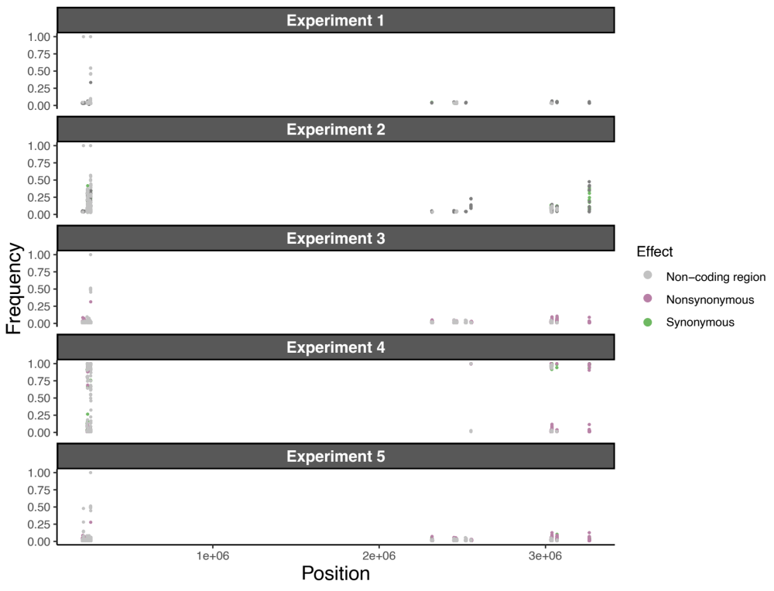 Extended Data Fig. 7: Mutations accumulated in the nine selected regions of the chromosome of Sal. ruber M1 at 150 days. The different panels represent experiments 1, 2, 3, 4, and 5, from top to bottom. Mutations are marked as points across the Sal. ruber M1 chromosome, with the y-axis indicating mutation frequencies.

