Supplement for “Systematic Single-Cell Dissection of Cell Cycle and TGFβ-Induced State Transitions Underlying Gemcitabine Resistance in 3D Pancreatic Tumor Tissue Models”

Maryam Almasi^{1,*}, Jesús Guillermo Nieves Pereira^{2,*}, Thomas Dandekar^{1,**}, Gudrun Dandekar^{2**}, Johannes Balkenhol^{1,**}
¹Department of Bioinformatics, Biocenter, University of Würzburg, Am Hubland, 97074 Würzburg, Germany, ²Department for Functional Materials in Medicine and Dentistry, University Hospital Würzburg, Röntgenring 11, 97070 Würzburg, Germany

*These authors contributed equally to this work as first authors.
**These authors contributed equally to this work as senior authors.

Contents:

Figure S1. Ribosome counts and UMAP clustering of single-cell pancreatic cancer data p. 2
Figure S2. Gene Set Enrichment and Differential Expression across Leiden Clusters. p. 3
Figure S3. Gene Set Enrichment and Differential Expression of GEM-Surviving Cells. p. 4
Figure S4. Cell cycle–associated gene expression and phase distribution
across clusters and treatments p. 5
Figure S5. Trajectory inference reveals progression of cell states under
different treatment conditions p. 6
Figure S6. Temporal transition profiles in 3D PANC tissues p. 7
Figure S7. CDK1 downstream targets reflect major key players in
Gemcitabine/drug resistance and bad prognosis in cancer. P. 8
Additional Material and Methods (PFA p. 9, Perceptron, p. 10) p. 9
Additional Discussion p.11

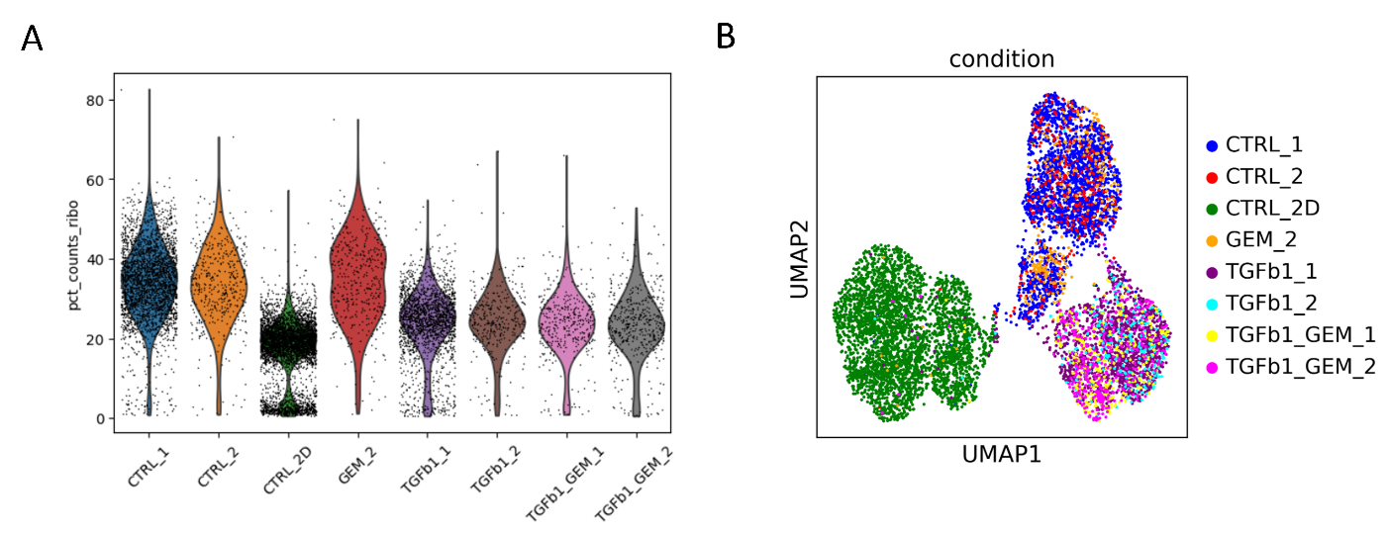
Figure S1. Ribosome counts and UMAP clustering of single-cell pancreatic cancer data.
(A) Distribution of ribosome content across control, GEM-treated, and TGFBI-induced cells.
(B) UMAP projections reveal distinct clustering: 2D and 3D control tissues form separate clusters from TGFBI-induced tissues. Notably, GEM-treated cells do not form new clusters but rather integrate into the existing control or control + TGFBI clusters; furthermore, GEM-treated cells are absent in 2D tissues.

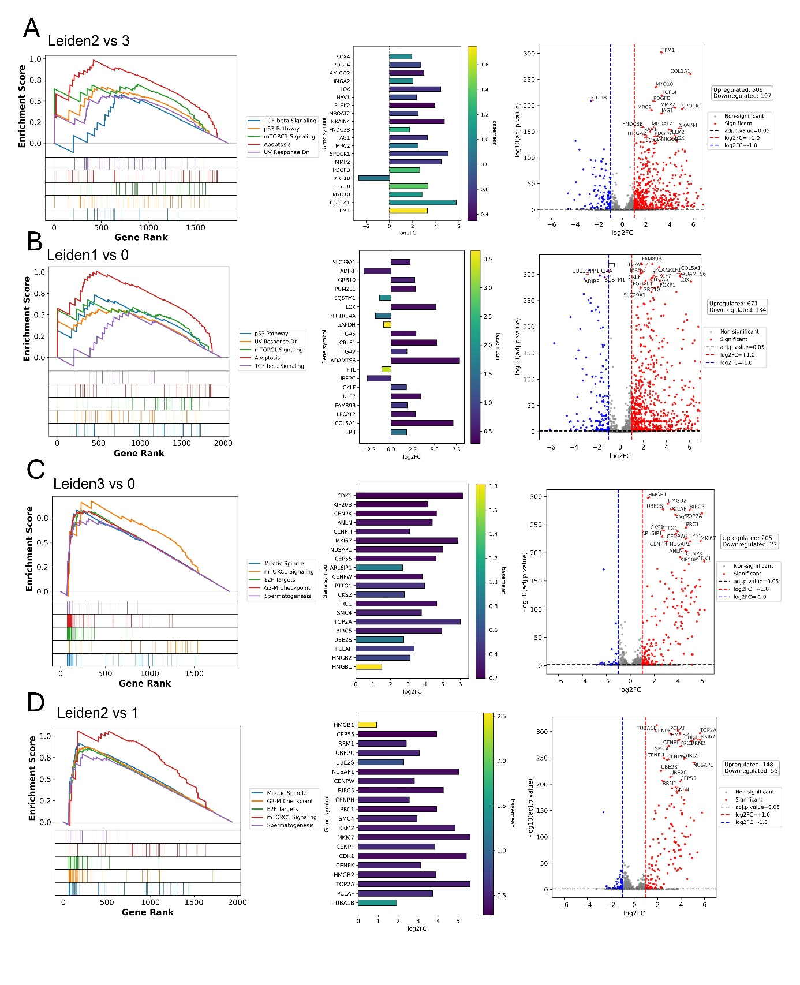
Figure S2. Gene Set Enrichment and Differential Expression Analysis Across Leiden Clusters.
first panel in all figures shows summarizing pathway enrichment the second panel shows differential gene expression across various Leiden clusters identified in the dataset.
the third panel in all figures shows volcano plot depicting the differential expression profile among clusters, highlighting the substantial heterogeneity in pathway activation and gene expression that complicates full contextualization of the cluster-specific differences.

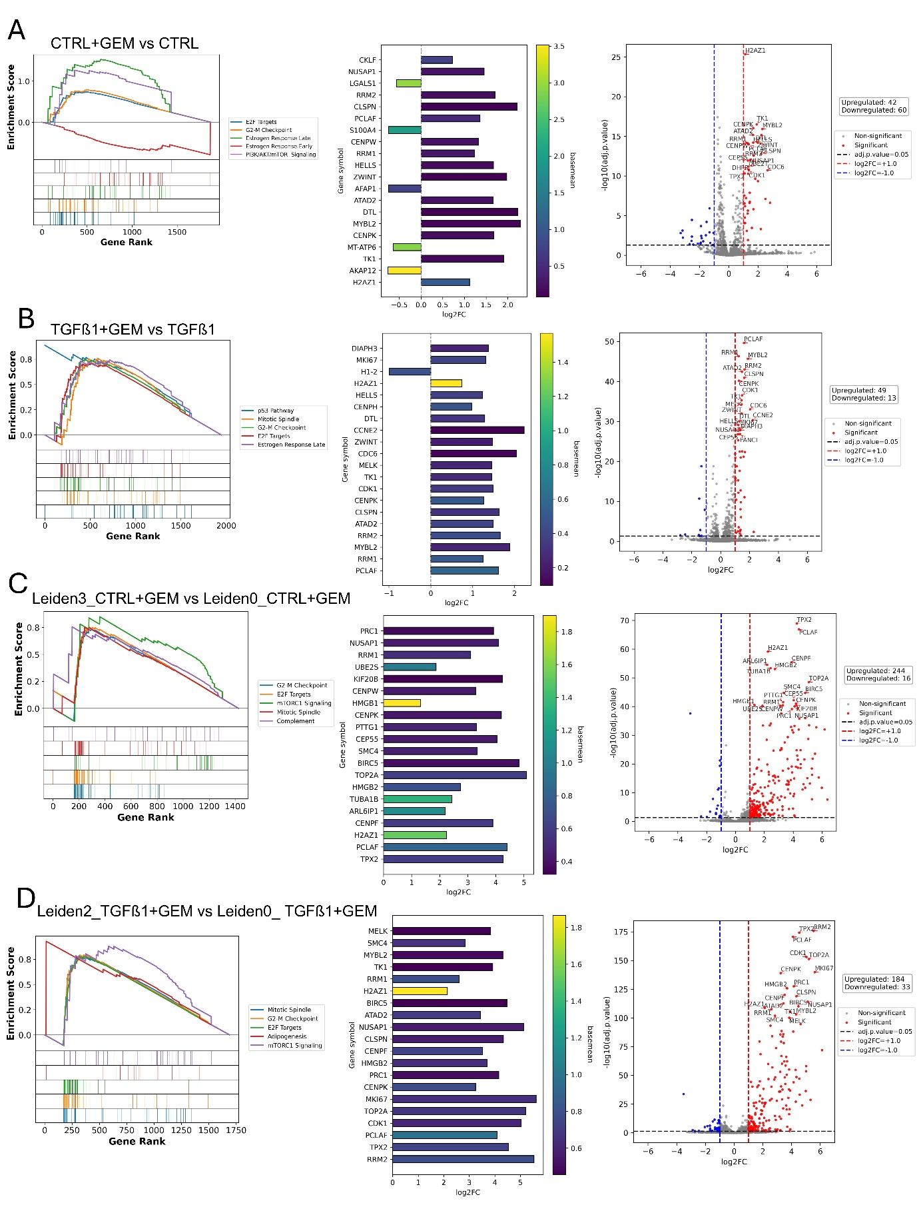
Figure S3. Gene Set Enrichment and Differential Expression Analysis of GEM-Surviving Cells. First panel in all figures shows summarizing pathway enrichment the second panel shows differential gene expression across various comparison of cell surviving GEM treatment.
the third panel in all figures shows volcano plot displaying the differential expression profile, highlighting the high heterogeneity in pathway activation and gene expression among GEM-surviving cells, which complicates full contextualization of the observed differences.
.
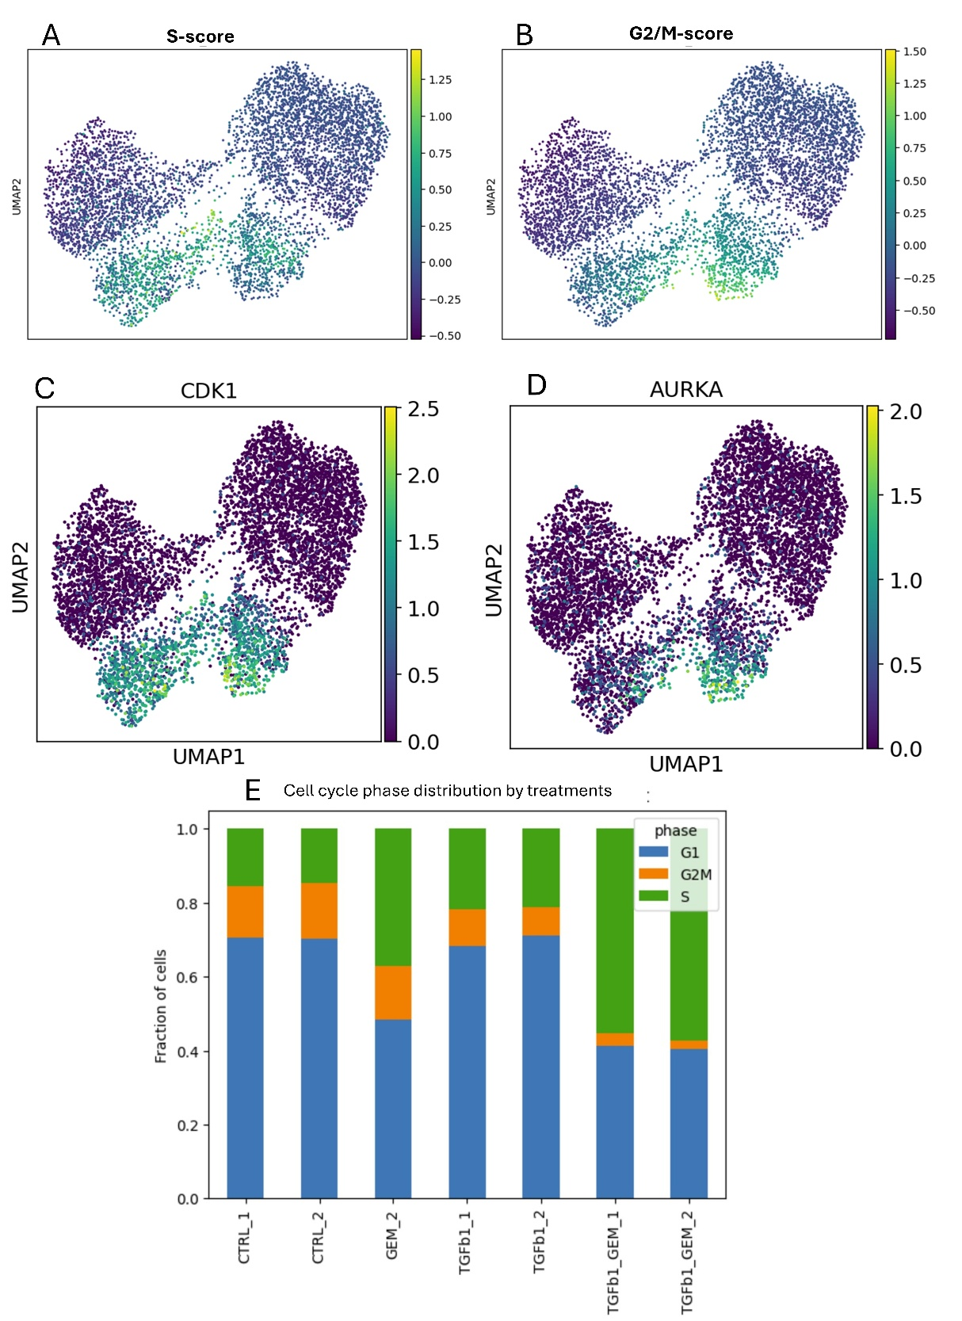
Figure S4. Cell cycle–associated gene expression and phase distribution across clusters and treatments.
(A–D) UMAP plots showing expression of key cell cycle–related genes: (A) S.score (S phase signature), (B) G2M.score (G2/M signature), (C) CDK1, and (D) AURKA. Cells with high expression of these genes are enriched in specific regions of the embedding corresponding to proliferative states.
(E) Cell cycle phase composition by treatment group, showing differences in proliferative states between control, TGFβ1, GEM, and TGFβ1 + GEM conditions.

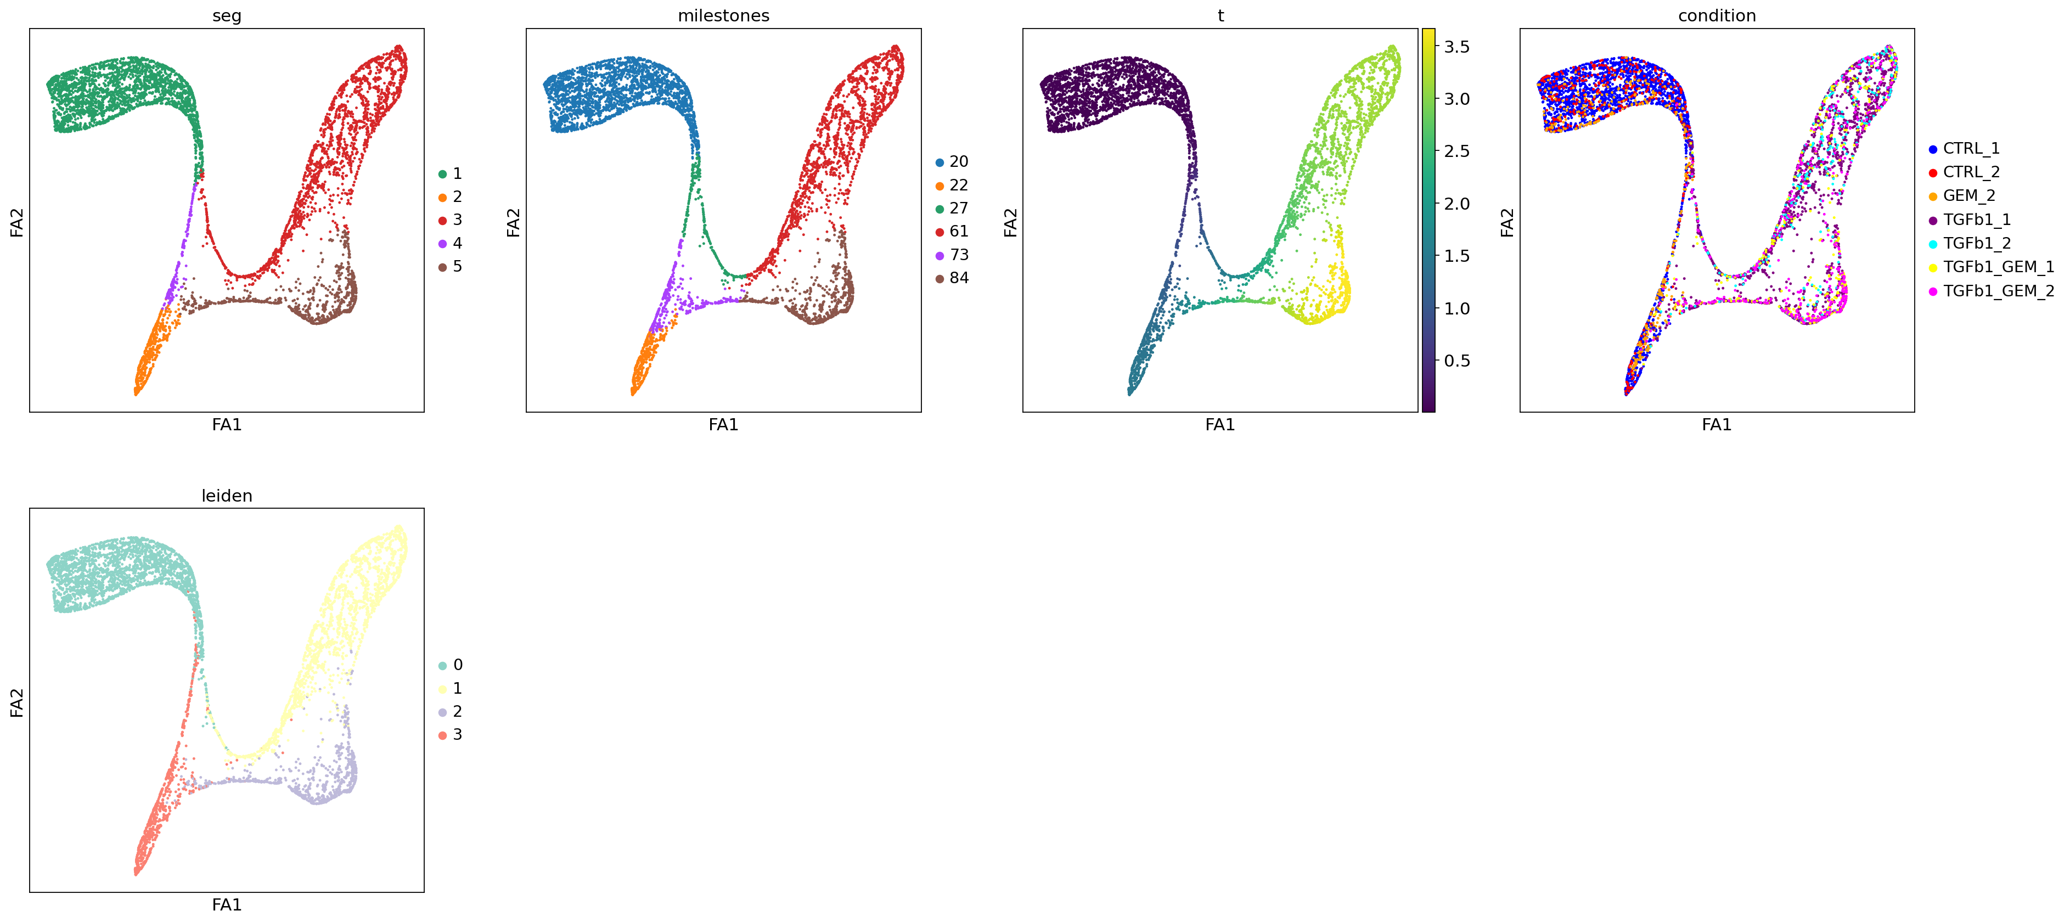
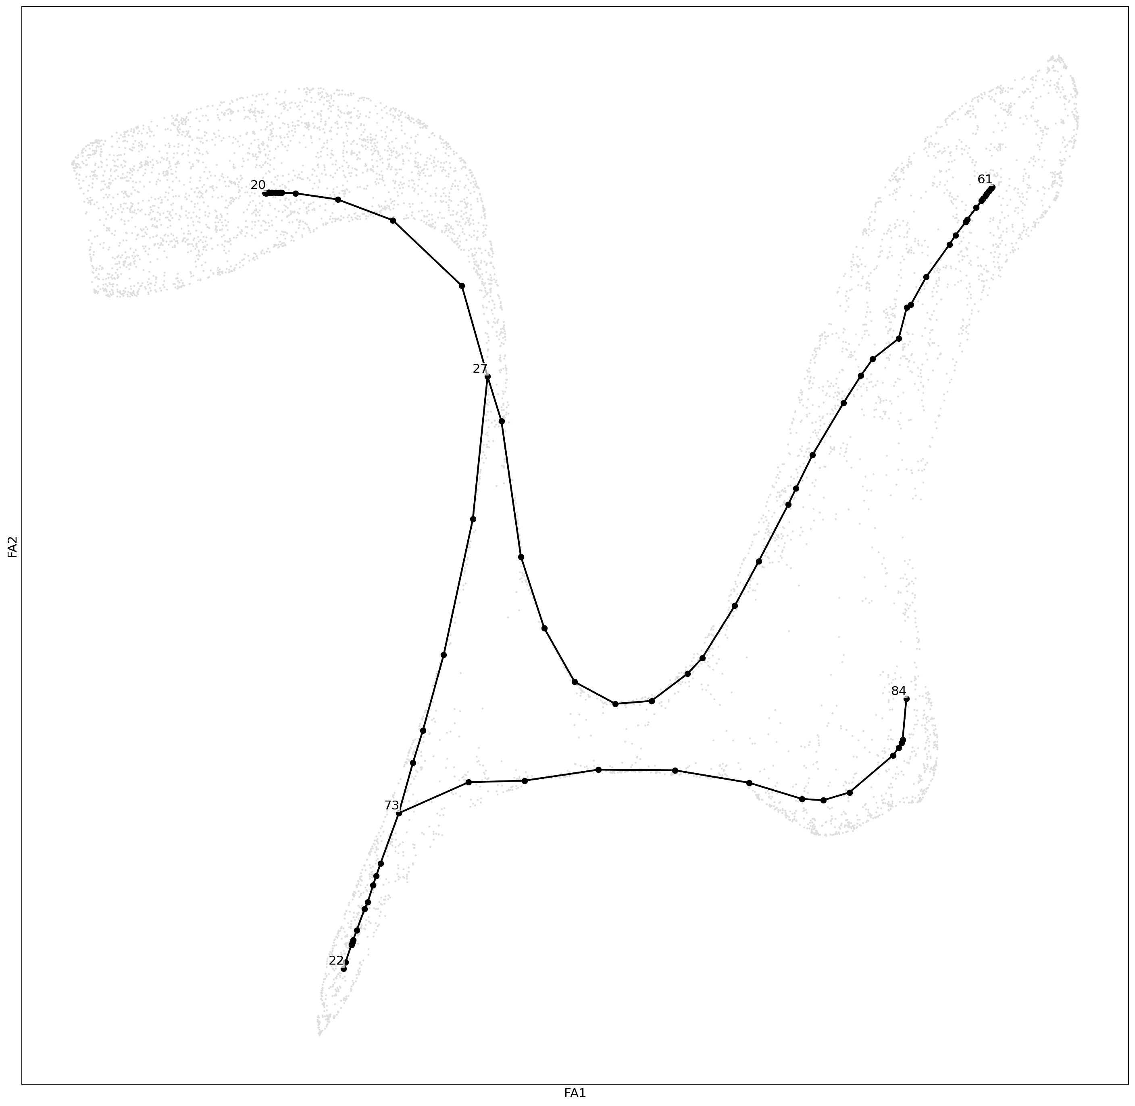
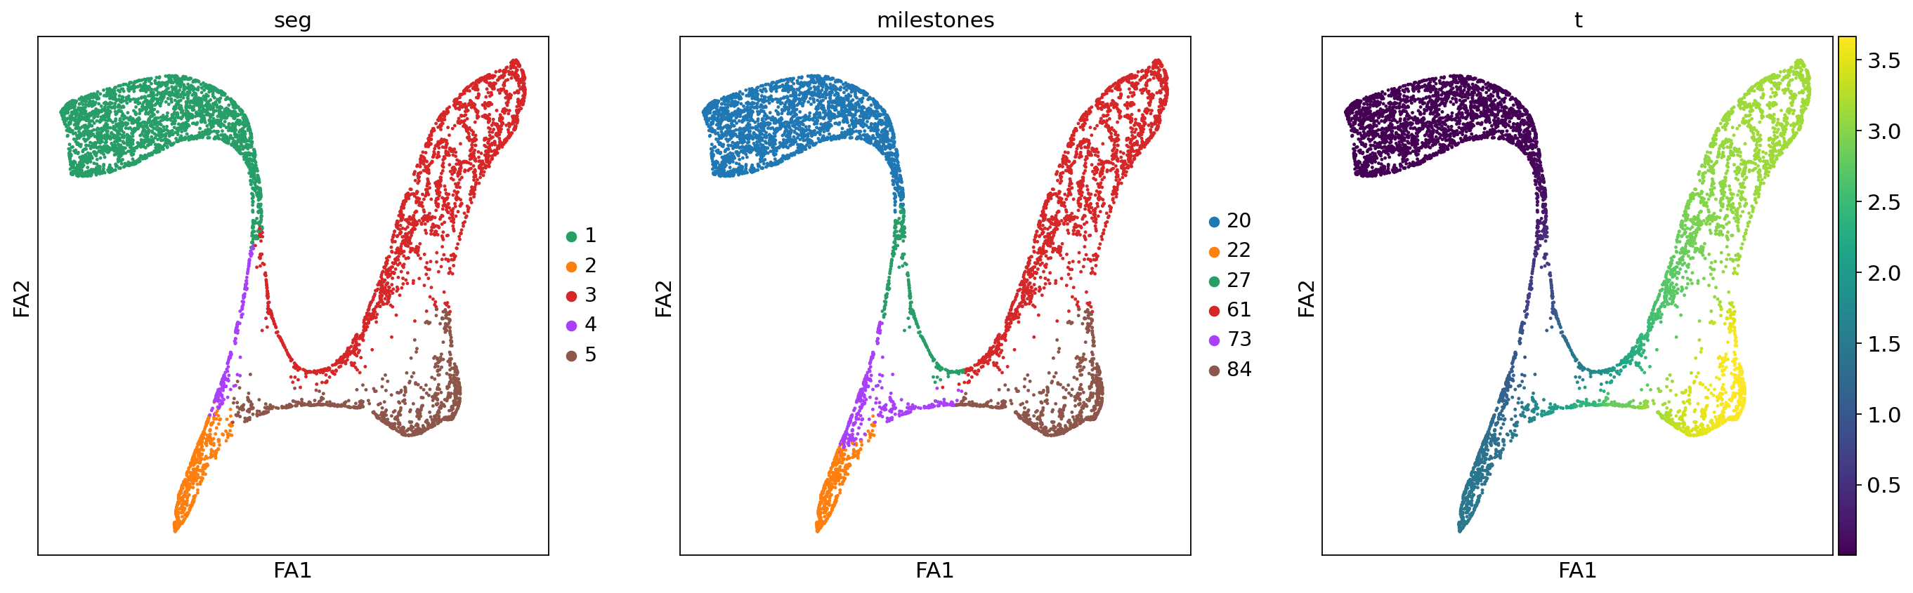
Figure S5. Trajectory inference reveals progression of cell states under different treatment conditions.
(A) Force-directed layout (FA) plot colored by experimental condition, showing the distribution of CTRL, TGFβ1, GEM, and TGFβ1 + GEM cells along the inferred trajectory. (B) Monocle3-derived pseudotime trajectory with root and branch points, indicating the inferred lineage relationships between cell states. (C) Pseudotime values mapped onto the FA plot, illustrating the gradual progression from early to late cell states along the trajectory.
FA1
A
B
C

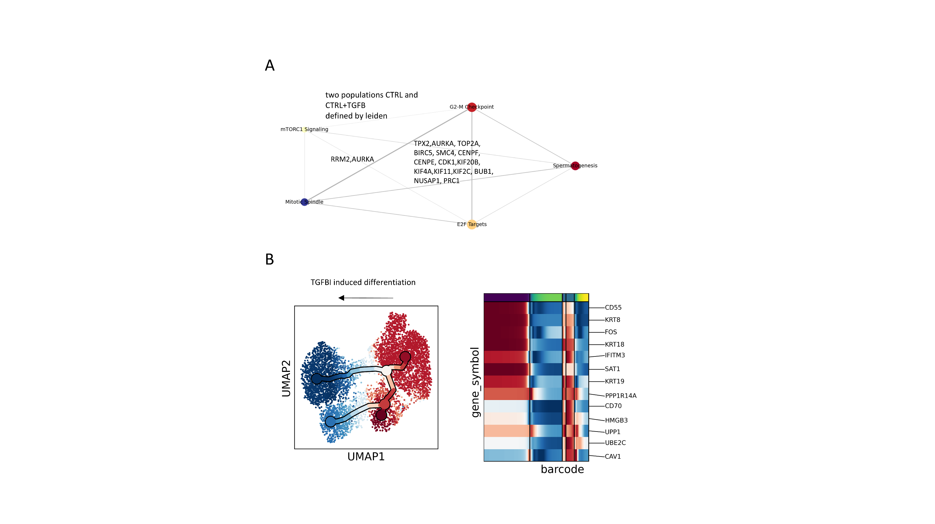
TGFß-1 induced state change

Figure S6. Temporal transition profiles in 3D PANC tissues. Cluster analysis identifies a subset of cells with reduced expression of epithelial markers, including KRT18 and KRT19, in response to TGFβ1 induction.

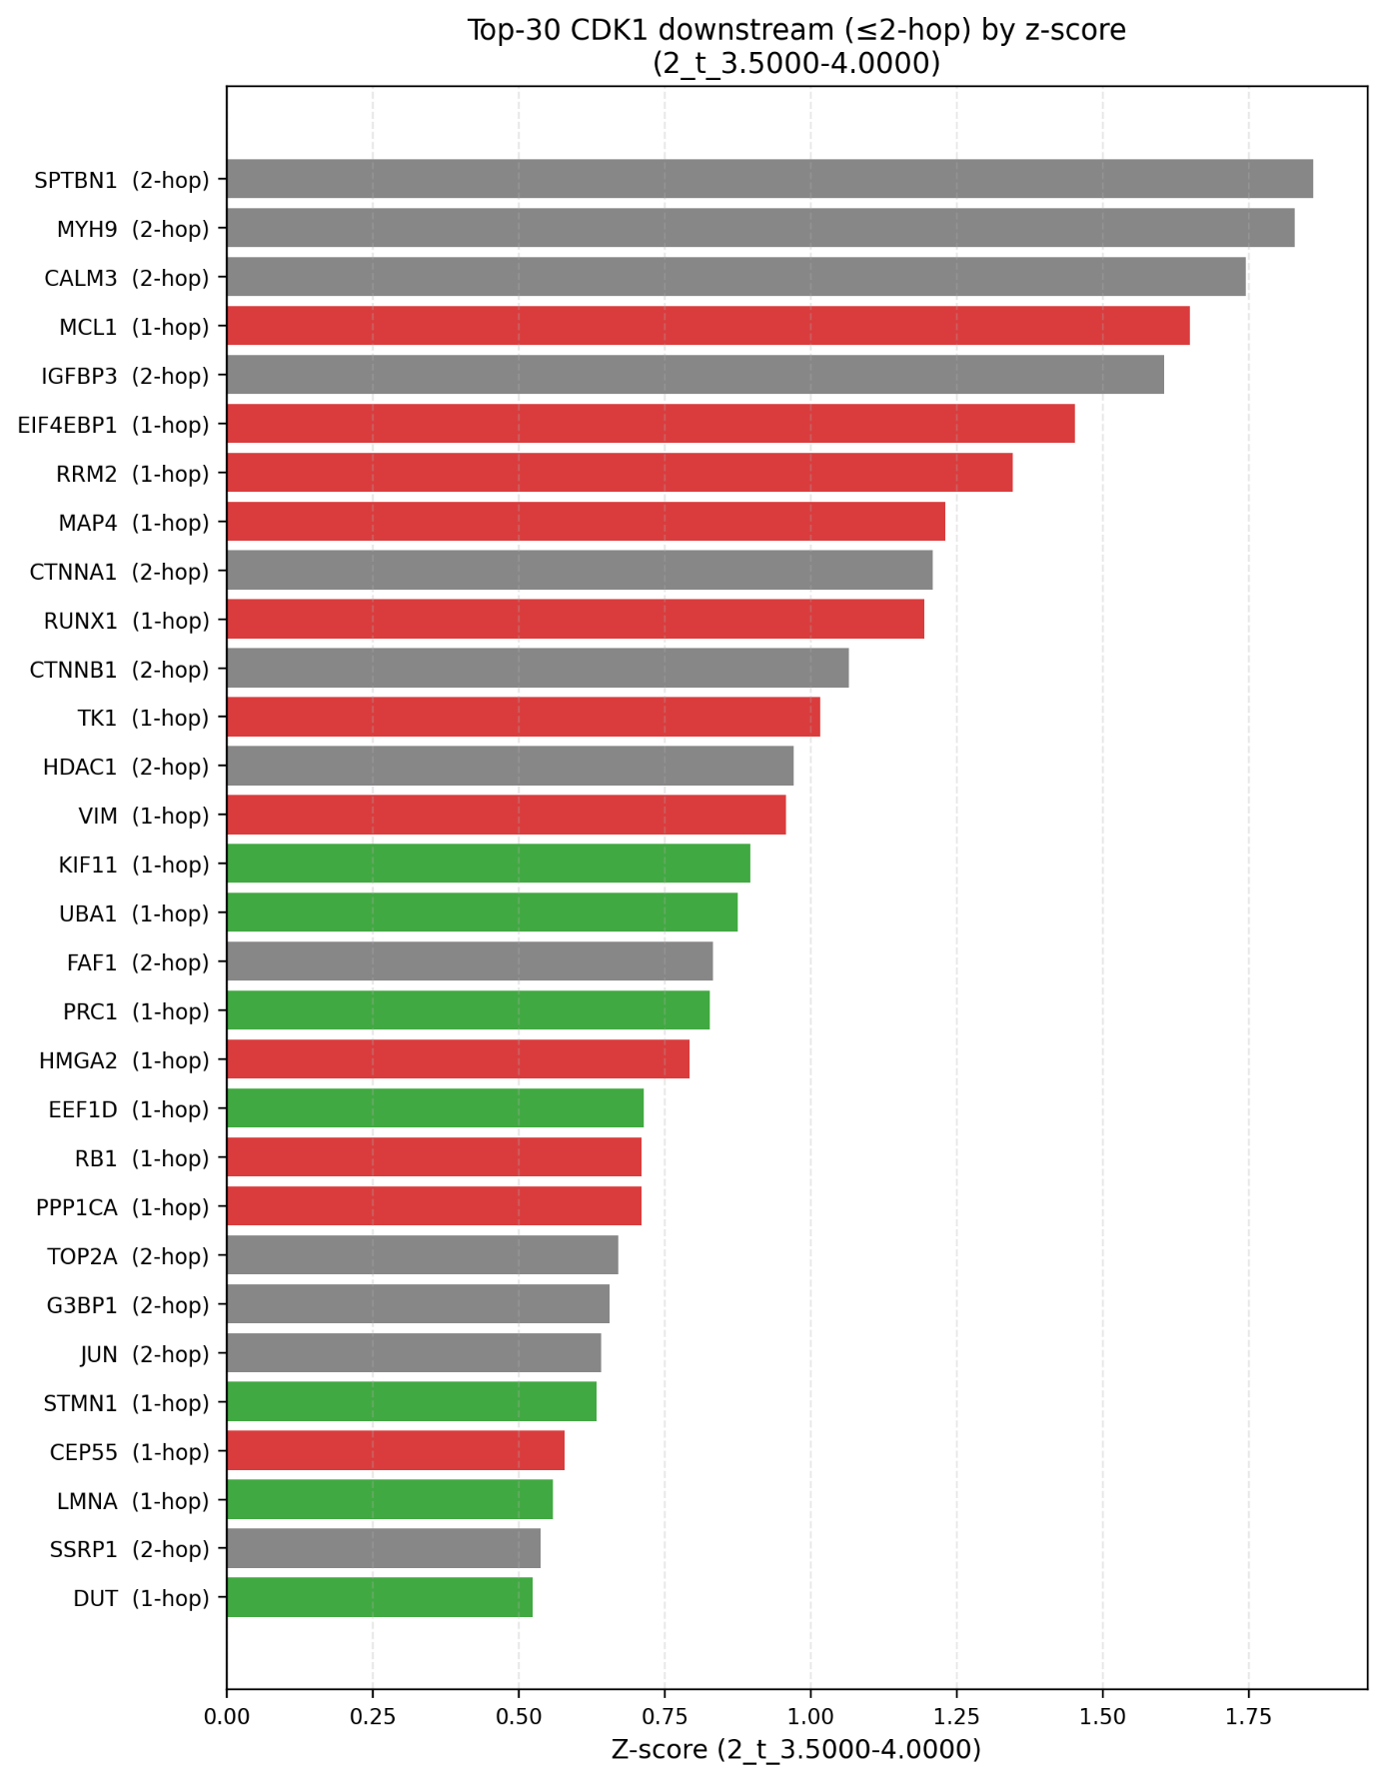
Figure S7. CDK1 downstream targets reflect major key players in Gemcitabine/drug resistance and bad prognosis in cancer.

Additional Material and Methods
Principal feature analysis (PFA)
Principal Feature Analysis was performed on the gene expression count matrix derived from our preprocessed AnnData object (adata_filtered_no2D_hvg_clust_time_pub.h5ad). The computational environment was configured with Python 3.8, and essential packages such as Pandas, Scanpy, and Anndata were installed via conda. Cells were first grouped into PFA categories based on their Leiden cluster membership using exact matching criteria; only cells assigned to groups 0 or 1 were retained for analysis.
A count matrix was then extracted, transposed, and converted into a Pandas DataFrame with gene names as rows and cell barcodes as columns, with the first row specifying the group labels required by the PFA algorithm. The PFA algorithm (Breitenbach et al., 2022) was executed with parameters including a cluster size of 200 and a minimum of 50 data points per bin, with mutual information between the output feature and each gene calculated to rank features. Principal features were refined by intersecting results across multiple sweeps and subsequently validated against a gene annotation file. All resulting principal features and their mutual information scores were saved for downstream analysis.

Multilayer Perceptron Classification
A multilayer perceptron (MLP) classifier from scikit-learn (Pedregosa et al., 2011) was employed to assess the discriminative power of selected gene sets for cell classification. Gene features were chosen based on a mutual information threshold (0.4) derived from the PFA analysis output, with alternative selections performed using random gene sampling or all non-constant genes for comparison. The input gene expression matrix was loaded from a CSV file (generated from PFA_analysis_data.csv), transposed so that genes formed the feature set and cells the samples, and then split into training (80%) and test sets.
Prior to model training, feature values were normalized to the [0, 1] range using scikit-learn’s MinMaxScaler. The MLP classifier was configured with an extensive maximum iteration limit (max_iter = 8×10⁶) to ensure convergence. For each of 10 independent sweeps, the classifier was trained on the selected gene features and evaluated using accuracy metrics and confusion matrices, with the number of misclassified samples recorded. Mean training and test accuracies, as well as standard deviations across sweeps, were computed to assess model stability.
1.Breitenbach T, et al. A principal feature analysis. J Comput Sci. 2022;58:101502. https://doi.org/10.1016/j.jocs.2021.101502
2. Pedregosa F, et al. Scikit-learn: machine learning in Python. J Mach Learn Res. 2011;12:2825–30.

Additional Discussion:
Evaluation of systemic single-cell analysis methods
Single-cell transcriptomics provides a powerful window into the vast state space of a cellular population. As an addition to relying on robust bulk RNA-seq analysis (Calsikan et al., 2025 (in preparation)), which captures an averaged expression profile, single-cell data can resolve myriad intermediate states—some closer, others farther from a given attractor—and the continuous transitions between these states. In our 3D tissue model, such granularity is especially beneficial for dissecting the dynamic behavior of cells under different treatments, as it enables detailed observation of stochastic variations and transitional subpopulations that bulk methods would obscure.
By applying methods such as Leiden clustering, we visualize the heterogeneity of conditions across ~10,000 individual cells, identifying major attractors (e.g., G1S1, G2–M clusters, G1+TGF-β1, S+TGF-β1) and “bridge” cells that lie between them. Trajectory analyses then enable us to reconstruct the principal paths by which cells transition from one state to another. This approach also uncovers parallel transitions—such as those induced by TGFβ-1 from distinct “root” states—highlighting how multiple, seemingly separate lineages can converge under a shared state change “pressure.” Importantly, we can track the earliest pseudotime phases of these trajectories to identify potential early markers of aggressiveness or therapy resistance, which may hold clinical relevance.
In addition to clustering cells, we can cluster genes by their co-expression patterns along these trajectories, revealing regulatory cascades. For instance, TGFβ-driven EMT involves a stepwise activation of downstream genes (e.g., TGFBI, SPOCK1, PMEPA1), each turning on at slightly different times, thus grasping the cascading effect in causalities that are separated in time. Likewise, pathway or gene set enrichment analyses (GSEA) use prior knowledge to capture the cascading effect. Classic static methods—such as differentially expressed genes (DEGs) under specific conditions or principal component analysis (PCA)—lack temporal resolution. For example, PFA highlights statistically informative genes, such as SPOCK1 and TGF-Β1 (EMT pathway), suggesting their statistical independence. This would only be true in a static world, but it would overlook the temporal dependencies inherent in biologically orchestrated pathways. SPOCK1 and TGF-β1 are clearly statistically connected, as one expression will ultimately cause the expression of the other (even if hours separate the correlation). This is a very old and common problem in analyzing gene co-expression networks (Serin et al., 2016), and a reason why they are no longer used as a metric for statistical dependence or independence. Using the NES (Number of enrichment axis from GSEA) here as a metric is a more reliable measure of statistical independence.
In summary, the combination of single-cell clustering (Leiden), pseudotime inference, trajectory reconstruction, gene set enrichment, and network analysis provides a complementary toolkit that captures both static 'snapshots' and dynamic transitions, enabling the construction of a systems-level decision-point map. Crucially, this approach also accounts for network dynamics: as gene expression continuously changes, cells update their regulatory logic, resulting in signaling behaviors that differ markedly across time points or cell states. By integrating expression trajectories with dynamic network changes, we can uncover the root causes of cascading gene-expression effects, even when these occur in separate time or space. This multi-angle framework is essential for a systems-level understanding—encompassing cascading effects, logically connected events over time, and branching lineage outcomes. For immediate clinical applications, such as rapid biomarker discovery, simpler static methods like DEGs or PCA may suffice due to their accessibility and interpretability. However, for fundamental research aimed at building mechanistic models or pinpointing early drivers of state transitions, deeper single-cell approaches are indispensable. Our study demonstrates how integrating these methods yields a comprehensive understanding of system behavior, providing critical insights into the biology of drug resistance and tumor progression.
Tissue surface and core
Determining whether the gene-expression patterns we observe correspond to cells located at the tumor surface or core will ultimately be answered in future after we can obtain spatial transciptomics data or analyse dissections e.g. by LASER catapulting experiments. However, currently there is scarcity of spatial transcriptomics datasets (Khaliq et al., 2024).
Nonetheless, certain clues suggest a possible connection between cell-cycle activity and localization. For instance, MKI67, enriched in Leiden clusters 2 and 3, is not only a robust proliferation marker but has also been associated with leading-edge cells (Uxa et al. 2021).
Recent spatial mapping of pancreatic tumors (Khaliq et al. 2024) found metastatic niches exhibit enrichment in E2F targets, mTOR activation, and glycolysis, along with reduced G2–M activity. These patterns parallel our findings (e.g., reduced AURKA activity in cells undergoing EMT, as indicated in Fig. S4), both systems highlight the interplay between cell-cycle regulation and tumor microenvironmental cues.
Future work, leveraging integrative spatial omics approaches or direct in situ gene tagging will even better illuminate how localized niches within the tumor contribute to differential chemoresistance, thereby guiding future therapeutic strategies.
References
- Namima D, Fujihara S, Iwama H, Fujita K, Matsui T, Nakahara M, Okamura M, Hirata M, Kono T, Fujita N, Yamana H, Kato K, Kamada H, Morishita A, Kobara H, Tsutsui K, Masaki T. The Effect of Gemcitabine on Cell Cycle Arrest and microRNA Signatures in Pancreatic Cancer Cells. In Vivo. 2020 Nov-Dec;34(6):3195-3203. doi: 10.21873/invivo.12155. PMID: 33144424; PMCID: PMC7811671.
- Striefler JK, Sinn M, Pelzer U, Jühling A, Wislocka L, Bahra M, Sinn BV, Denkert C, Dörken B, Oettle H, Riess H, Bläker H, Lohneis P. P53 overexpression and Ki67-index are associated with outcome in ductal pancreatic adenocarcinoma with adjuvant gemcitabine treatment. Pathol Res Pract. 2016 Aug;212(8):726-34. doi: 10.1016/j.prp.2016.06.001. Epub 2016 Jun 8. PMID: 27461834.
- Schuhwerk H, Brabletz T. Mutual regulation of TGFβ-induced oncogenic EMT, cell cycle progression and the DDR. Semin Cancer Biol. 2023 Dec;97:86-103. doi: 10.1016/j.semcancer.2023.11.009. Epub 2023 Nov 28. PMID: 38029866
- Kogan-Sakin, Y. Tabach, Y. Buganim, A. Molchadsky, H. Solomon, S. Madar, I. Kamer, P. Stambolsky, A. Shelly, N. Goldfinger, et al. Mutant p53(R175H) upregulates Twist1 expression and promotes epithelial-mesenchymal transition in immortalized prostate cells. Cell Death Differ., 18 (2011), pp. 271-281
- Mummery CL, van Rooijen MA, van den Brink SE, de Laat SW. Cell cycle analysis during retinoic acid induced differentiation of a human embryonal carcinoma-derived cell line. Cell Differ. 1987;20:153–160. doi: 10.1016/0045-6039(87)90429-5.
- Liu L, Michowski W, Kolodziejczyk A, Sicinski P. The cell cycle in stem cell proliferation, pluripotency and differentiation. Nat Cell Biol. 2019 Sep;21(9):1060-1067. doi: 10.1038/s41556-019-0384-4. Epub 2019 Sep 2. PMID: 31481793; PMCID: PMC7065707.
- Liu, Q., Song, C., Li, J., Liu, M., Fu, L., Jiang, J., Zeng, Z., & Zhu, H. (2022). E2F2 enhances the chemoresistance of pancreatic cancer to gemcitabine by regulating the cell cycle and upregulating the expression of RRM2. Medical Oncology, 39(9), 124. https://doi.org/10.1007/s12032-022-01715-x
- Dalton S. Linking the Cell Cycle to Cell Fate Decisions. Trends Cell Biol. 2015 Oct;25(10):592-600. doi: 10.1016/j.tcb.2015.07.007. PMID: 26410405; PMCID: PMC4584407.
- Singh AM, Dalton S. The cell cycle and Myc intersect with mechanisms that regulate pluripotency and reprogramming. Cell Stem Cell. 2009 Aug 7;5(2):141-9. doi: 10.1016/j.stem.2009.07.003. PMID: 19664987; PMCID: PMC2909475.
- Melisi, D., Garcia-Carbonero, R., Macarulla, T. et al. Galunisertib plus gemcitabine vs. gemcitabine for first-line treatment of patients with unresectable pancreatic cancer. Br J Cancer 119, 1208–1214 (2018). https://doi.org/10.1038/s41416-018-0246-z

