Supplementary Note S2: Tuning of random forest hyperparameters
We used out-of-bag (OOB) predictions for tuning random forest hyperparameters, which helps to avoid re-fitting models multiple times for each parameter setting⁹⁰. OOB predictions are calculated during model training as predictions by a tree on samples that were not used during its training. We used the area under the receiver operating characteristic curve (AUC) as a metric for measuring predictive performance. To weigh predictive performance in disturbed and undisturbed forest areas equally, we used a balanced sample containing the same number of locations per class for validation. In addition, we calculated separate AUC values per environmental cluster (see Methods section in the main text and Supplementary Note S1). To ensure the stability of performance scores, we repeated the sampling of validation points five times per environmental cluster before aggregating AUC values across clusters.
We tuned two hyperparameters that are considered among the most influential for random forest performance⁹⁰: the number of variables to randomly sample as candidates at each split (mtry) and the minimum node size, which controls the smallest number of observations required for a node to be split further during tree construction. For mtry, we tested values between 2 and 18 (increments of 2). For the minimum node size, we tested powers of two between 2 and 1024. We tuned parameters sequentially, first choosing the optimal mtry value before tuning the minimum node size parameter. To avoid overfitting models, we applied the one-standard-error rule for selecting optimal hyperparameter settings⁹¹. Specifically, we chose parameter values corresponding to the least complex model (i.e., lowest mtry and highest minimum node size) for which performance was within one standard error of the maximum performance score recorded per parameter (Fig. S2.1). For an overview of selected hyperparameters, see Table S2.1.
Table S2.1: Selected hyperparameters.
Species | Variables selected at each split | Minimum node size
European bison | 6 | 16
Moose | 4 | 16
Red deer | 4 | 16
Roe deer | 4 | 32
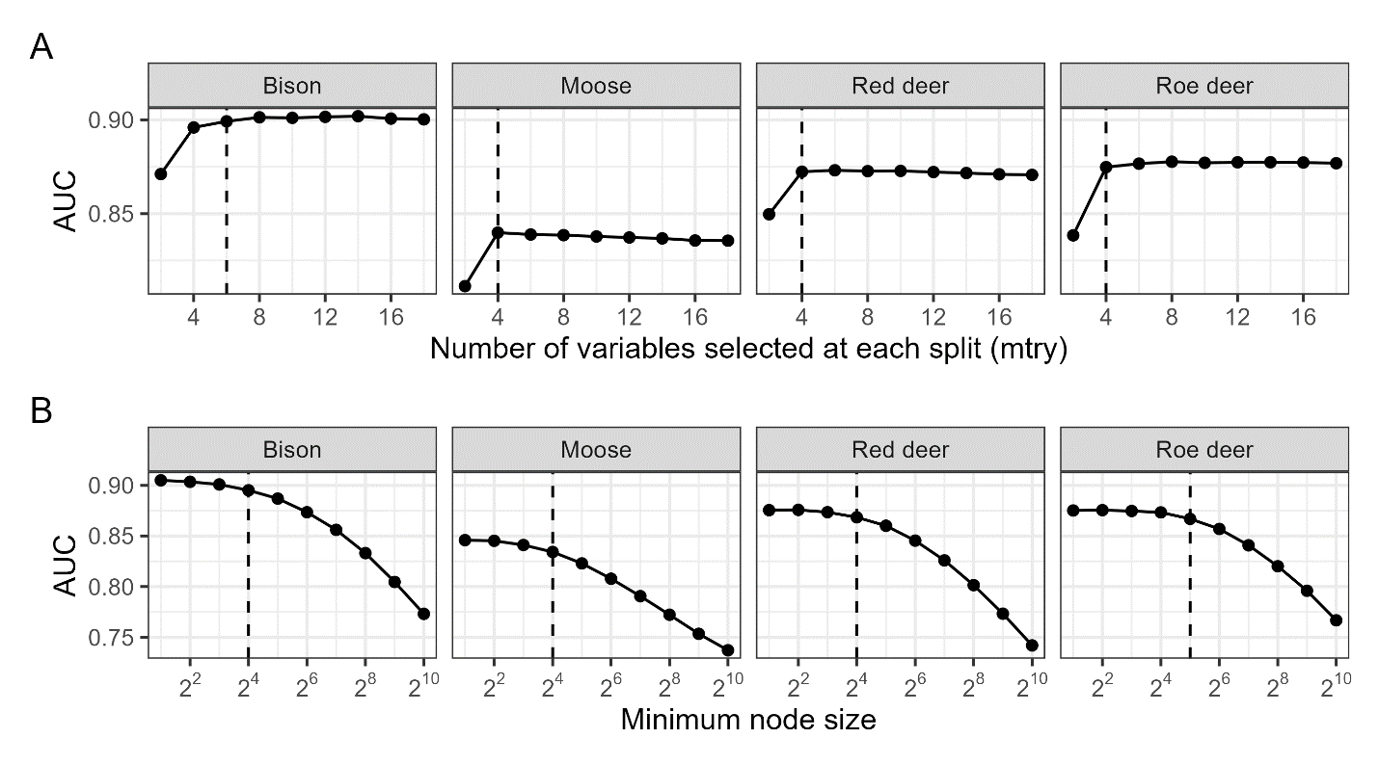
Figure S2.1: Performance curves for two random forest hyperparameters. A: number of variables selected at each split (mtry). B: minimum node size. Dotted lines indicate selected parameter settings at which performance was within one standard error of the highest performance recorded for the parameter. We evaluated models based on out-of-bag AUC values, balancing datasets across disturbed/undisturbed forest areas and environmental clusters for validation.

