Physical activity, cardiometabolic diseases, and cancer risk: a prospective analysis.
Gebremariam et al.

Additional File 1
List of tables
Table S1: Diagnostic codes for the definition of cancer, type 2 diabetes, and cardiovascular diseases 6
Table S2: Missing data distribution of covariates and outcome variables in EPIC and UKB cohorts. 7
Table S3: The distribution of physical activity-related cancers and all cancers recorded in EPIC and UK Biobank. 9
Table S4: Associations between physical activity (per 1 SD increase in MET-h/weekª) and the risk of cancer by cardiometabolic disease status. 16
Table S5: Subgroup analysis of associations between physical activity (ªper 1 SD increase in MET-h/week) and the risk of physical activity-related cancers by cardiometabolic disease status. 18
Table S6: Subgroup analysis of associations between physical activity (ªper 1 SD increase in MET-h/week) and the risk of all cancers by cardiometabolic disease status. 20
Table S7: Association between physical activity (ªper 1 SD increase in MET-h/week) and the risk of physical activity-related cancers and all cancers by cardiometabolic disease status in EPIC and UKB (complete case analysis). 22

List of Figures
Figure S1: Flow chart with inclusion and exclusion criteria of the study population in EPIC. 4
Figure S2: Flow chart with inclusion and exclusion criteria of the study population in UK Biobank. 5
Figure S3: The association between physical activity and risk of physical activity-related cancers in the fully adjusted model of EPIC (a) and UKB (b) cohorts. 10
Figure S4: The association between physical activity and risk of physical activity-related cancers in the fully adjusted model of EPIC (a) and UK Biobank (b) by cardiometabolic disease status. 11
Figure S5: The association between physical activity and risk of all cancers in the fully adjusted model of EPIC (a) and UKB (b) cohorts. 12
Figure S6: The association between physical activity and risk of all cancers in the fully adjusted model of EPIC (a) and UKB (b) by cardiometabolic status. 13
Figure S7: Transitions from baseline to physical activity-related cancers, CVD, T2D, and subsequent transition from T2D, and CVD to cancer in EPIC. 14
Figure S8: Transitions from baseline to physical activity-related cancers, CVD, T2D, and subsequent transition from T2D, and CVD to cancer in UKB. 15
Figure S9: Association between physical activity (per 1 SD increase in MET-h/week) and the risk of all cancers by cardiometabolic disease status. 17
Figure S10: Association between physical activity (per 1 SD increase in MET-h/week) and the risk of physical activity-related cancers by cardiometabolic disease status in EPIC and UKB cohorts (using complete case analysis). 23
Figure S11: Joint association of physical activity and cardiometabolic diseases with the risk of all cancers. 24

Figure S1: Flow chart with inclusion and exclusion criteria of the study population in EPIC.

Missing information on cancer, CVD or T2D
T2D = 63,823
Cancer = 2
No. follow-up = 243
No. of observations in the EPIC dataset (N = 490,030)
Number of participants included in the final analysis (n = 230,026)
Countries (Greece, France, Norway, and Sweden) = 165,485

Physical activity unknown = 4,241
Exclusion of countries not part of EPIC- CVD or EPIC-InterAct
Cancer = 9,085
T2D = 7,890
Heart attack = 3,092
Stroke = 1,726
Exclusion of prevalent cases of cancer, CVD, or T2D
Exclusion of participants with missing values in physical activity
*Extreme EI/ER = 4,437
Exclusion of extreme energy intake/requirement
Number of eligible participants (n = 238,704)
*Energy intake-to-energy requirement (EI/ER) calculated as the ratio of reported daily energy intake (from dietary assessment) to estimated energy requirement based on age, sex, body size, and physical activity. Participants in the top and bottom 1% of EI/ER values were excluded.
Abbreviations: CVD, cardiovascular diseases; EI/ER, energy intake/energy requirement; EPIC, European Prospective Investigation into Cancer and Nutrition; No., number; T2D, type 2 diabetes.

Figure S2: Flow chart with inclusion and exclusion criteria of the study population in UK Biobank.

Reported history of CVD = 22,469
No. of observations in UK Biobank (N = 465,467)
Number of participants included in the analysis (n = 334,596)
Reported history of T2D = 8,404

Physical activity unknown = 99,998
Exclusion of prevalent cases of T2D and CVD
Exclusion of participants with missing values in physical activity
Number of eligible participants (n = 434,594)
Abbreviations: CVD, cardiovascular diseases; No., number; T2D, type 2 diabetes.

Table S1: Diagnostic codes for the definition of cancer, type 2 diabetes, and cardiovascular diseases
 | ICD10 code | ICDO-3 code-histology
Physical activity-related cancers
Breast cancer | C50
Lung cancer | C34 | Excludes: 9050, 9051, 9052, 9053, 9054, 9055, 9140, 9590:9992
Colon cancer | C18, C26
Rectal cancer | C19, C20 | Excludes: 9050/3–9055/3, 9140/3
Oesophageal adenocarcinoma | C15 | 8140/3, 8144/3, 8480/3, 8481/3 & 8490/3
Bladder cancer | C67
Endometrial cancer | C54–C55
Kidney | C64, C65
Multiple myeloma | C90 | 9731/3, 9732/3, 9734/3
Myeloid leukemia | C92 | 9840/3, 9860/3, 9861/3, 9863/3, 9865/3, 9866/3, 9867/3, 9869/3, 9871/3–9876/3, 9891/3, 9895/3–9898/3, 9910/3, 9911/3, 9920/3, 9930/3, 9945/3, 9946/3
Liver cancer | C22
Gastric cardia cancer | C16.0
Small intestine cancer | C17
Gallbladder cancer | C23
Head and neck cancer | C00-C14, C30-C33
Overall cancer | C00-C96, except C44 (non-melanoma skin cancer)
Type 2 diabetes | E11
Cardiovascular disease
Stroke | I60:I69
Coronary artery disease | I20:I25

Table S2: Missing data distribution of covariates and outcome variables in EPIC and UKB cohorts.
EPIC (N = 230,026) |  |  | UKB (N = 334,596)
Variable | Number of missing | Missing Percentage | Variable | Number of missing | Missing Percentage
Highest school level (None, Primary school completed, Technical/professional school, Secondary school, longer education (incl. University deg.), Not specified/missing) | 4,290 | 1.9 | Qualifications (College or university degree, A levels/AS levels or equivalent, O levels/GCSEs or equivalent, CSES or equivalent, NVQ or HND or HNC or equivalent, other professional qualifications, none of the above, prefer not to answer/missing) | 2,017 | 0.6
Physical activity at work (Sedentary, standing, manual work, heavy manual work, non-worker, missing) | 3,439 | 1.5 | Current employment status (In paid employment or self-employed, retired, looking after home and/or family, unable to work because of sickness or disability, unemployed, doing unpaid or voluntary work, full or part-time student, none of the above, prefer not to answer/missing) | 2,454 | 0.7
Use of hormones for menopause* (No, Yes, Missing) | 1,915 | 1.3 | Ever used hormone-replacement therapy* (No, Yes, do not know, Prefer not to answer/Missing) | 469 | 0.3
Smoking status (Never, Former, Current, Unknown/Missing) | 696 | 0.3 | Smoking status (Never, Previous, Current, prefer not to answer/missing) | 776 | 0.23
Alcohol at recruitment (g/d) | 412 | 0.18 | Alcohol drinker status (Never, previous, current, prefer not to answer/missing) | 204 | 0.06
Modified Relative Mediterranean diet score (Low, Medium, High, Missing) | 412 | 0.18 | Diet score (scored 0 to 6) | 0 | 0
Body mass index (kg/m²) | 0 | 0 | Body mass index (kg/m²) | 1,287 | 0.38
Height (cm) | 0 | 0 | Height (cm) | 1,039 | 0.3
Menopausal status* (Premenopausal, postmenopausal, Perimenopausal, Surgical postmen (bilateral ovariectomy)) | 0 | 0 | Had menopause* (Yes, No, had a hysterectomy, Not sure-other reasons, prefer not to answer/missing) | 6,636 | 3.8
Sex (Male, Female) | 0 | 0 | Sex (Female, Male) | 0 | 0
Center (Florence, Varese, etc.) | 0 | 0 | UK Biobank assessment centre | 0 | 0
Any first CVD event (CHD/Stroke) (fatal/non-fatal) (No, Yes) | 0 | 0 | CVD Status (No, Yes) | 0 | 0
InterAct diabetes status at completion of verification (Non-case, Incident) | 0 | 0 | T2D Status (No, Yes) | 0 | 0
MET recreational and household activity (MET-h/week) | 0 | 0 | MET Total (MET-h/week) | 0 | 0
Age at recruitment (years) | 0 | 0 | Age at recruitment (years) | 0 | 0
 |  |  | Average total household income before tax (< £18,000; 18,000 to 30,999; 31,000 to 51,999; 52,000 to 100,000; >£100,000; do not know; prefer not to answer/missing) | 35,494 | 10.6
 |  |  | Townsend deprivation index at recruitment (scores) | 431 | 0.13
 |  |  | Overall health rating (Excellent, Good, Fair, Poor, Do not know, Prefer not to answer/missing | 820 | 0.24
 |  |  | Medication for cholesterol, blood pressure or diabetes (Blood pressure medication, Cholesterol lowering medication, Insulin, None of the above, Do not know, Prefer not to answer, missing) | 175,359 | 52.4
*Only in women, EPIC, European Prospective Investigation into Cancer and Nutrition; MET-h/week: metabolic equivalent task hours per week; CVD, cardiovascular diseases; T2D, type 2 diabetes; UKB, UK Biobank.
Table S3: The distribution of physical activity-related cancers and all cancers recorded in EPIC and UK Biobank.
Types of cancer | EPIC |  | UKB
Types of cancer | Frequency | Percentage
Breast cancer | 4,522 | 24.9 | 6,042 | 18.7
Lung cancer | 1,515 | 8.4 | 2,064 | 6.4
Colon cancer | 1,502 | 8.3 | 2,409 | 7.5
Rectal cancer | 873 | 4.8 | 1,261 | 3.9
Oesophageal adenocarcinoma | 81 | 0.4 | 393 | 1.2
Bladder cancer | 643 | 3.5 | 675 | 2.1
Endometrial cancer | 626 | 3.5 | 914 | 2.8
Head and neck cancer | 597 | 3.3 | 655 | 2.0
Kidney cancer | 446 | 2.5 | 874 | 2.7
Multiple myeloma | 229 | 1.3 | 543 | 1.7
Myeloid leukemia | 155 | 0.9 | 263 | 0.8
Liver cancer | 153 | 0.8 | 336 | 1.0
Gastric cardia cancer | 105 | 0.6 | 171 | 0.5
Small intestine cancer | 51 | 0.3 | 148 | 0.5
Gallbladder cancer | 38 | 0.2 | 61 | 0.2
Other cancers | 6,603 | 36.4 | 15,409 | 47.8
Total number of cancer cases | 18,139 | 100.0% | 32,218 | 100.0%
Cancers categorized as "other cancers" refer to those cancers not included in the physical activity-related cancers. EPIC, European Prospective Investigation into Cancer and Nutrition; UKB, UK Biobank.

Figure S3: The association between physical activity and risk of physical activity-related cancers in the fully adjusted model of EPIC (a) and UKB (b) cohorts.
a)  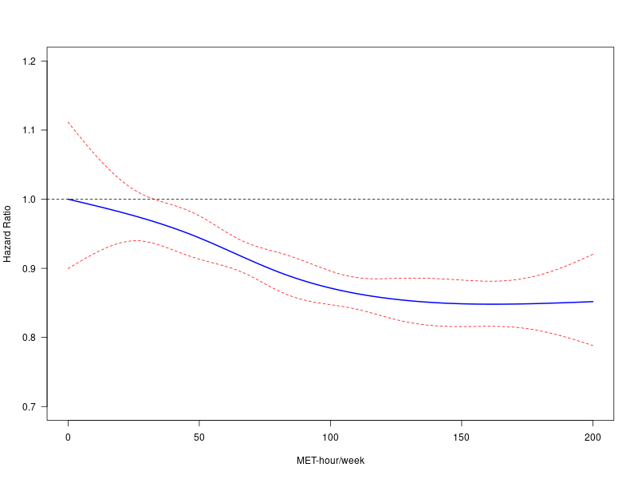 | b)  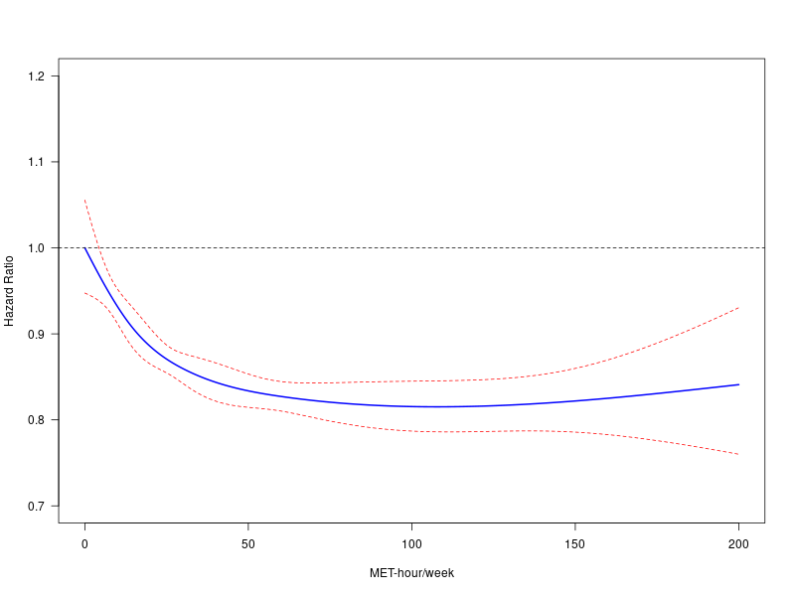
a) EPIC study; b) UK Biobank. The solid line represents the adjusted HRs, and the broken lines indicate the 95% CIs from the Cox regression with physical activity (PA) modelled as a natural spline with three knots positioned at the 25th, 50th, and 75th percentiles of PA, measured in MET-hour/week, capped at 200. Reference = 0 MET-h/week.
The models were stratified by age (5-year categories), sex, and recruitment centre, and adjusted for education, BMI, height, smoking status, alcohol consumption, diet quality, occupational work/employment, menopause status, and menopausal hormone use.
Abbreviations: BMI, body mass index; CI, confidence interval; EPIC, European Prospective Investigation into Cancer and Nutrition; MET-h/week, metabolic equivalent task hours per week; UKB, UK Biobank.

Figure S4: The association between physical activity and risk of physical activity-related cancers in the fully adjusted model of EPIC (a) and UK Biobank (b) by cardiometabolic disease status.
a)  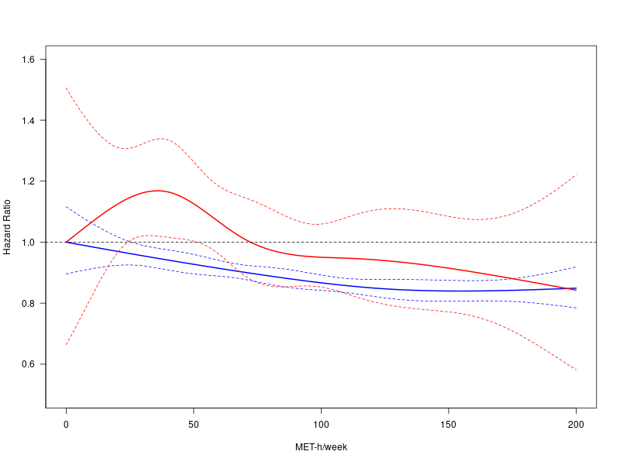 | b)  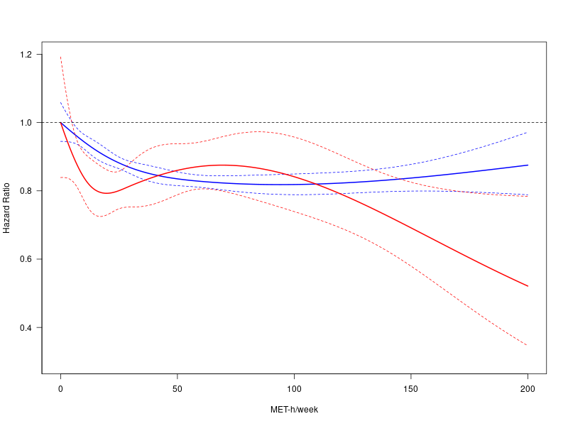
a) EPIC study; b) UK Biobank. The solid blue line represents the adjusted HRs for participants without cardiometabolic disease, while the red lines represent those with cardiometabolic disease, and the broken lines indicate the 95% CIs from the Cox regression with physical activity (PA) modelled as a natural spline with three knots positioned at the 25th, 50th, and 75th percentiles of PA, measured in MET-hour/week, capped at 200. Reference = 0 MET-h/week.
The models were stratified by age (5-year categories), sex, and recruitment centre, and adjusted for education, BMI, height, smoking status, alcohol consumption, diet quality, occupational work/employment, menopause status, and menopausal hormone use.
Abbreviations: BMI, body mass index; CI, confidence interval; CMD, T2D and/or CVD; CVD, cardiovascular disease; EPIC, European Prospective Investigation into Cancer and Nutrition; MET-h/week, metabolic equivalent task hours per week; T2D, type 2 diabetes; UKB, UK Biobank.

Figure S5: The association between physical activity and risk of all cancers in the fully adjusted model of EPIC (a) and UKB (b) cohorts.
a)  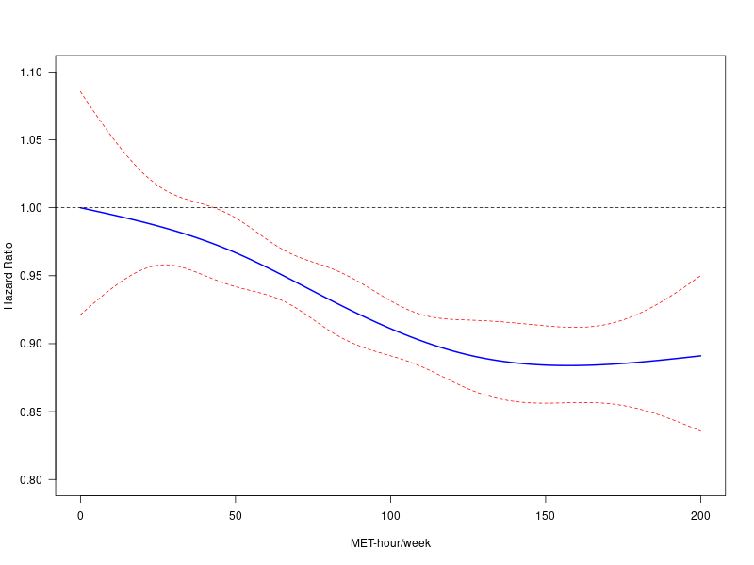 | b)  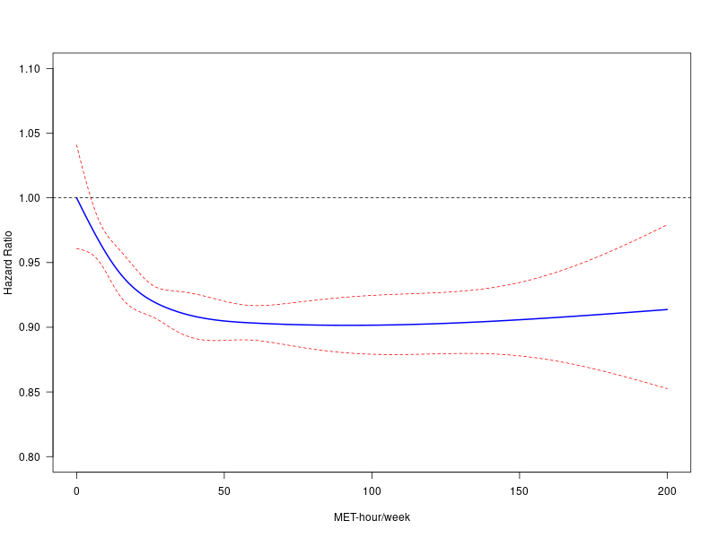
a) EPIC study; b) UK Biobank. The solid line represents the adjusted HRs, and the broken lines indicate the 95% CIs from the Cox regression with PA modelled as a natural spline with three knots positioned at the 25th, 50th, and 75th percentiles of PA, measured in MET-hour/week, capped at 200. Reference = 0 MET-h/week.
The models were stratified by age (5-year categories), sex, and recruitment centre, and adjusted for education, BMI, height, smoking status, alcohol consumption, diet quality, occupational work/employment, menopause status, and menopausal hormone use.
Abbreviations: BMI, body mass index; CI, confidence interval; EPIC, European Prospective Investigation into Cancer and Nutrition; MET-h/week, metabolic equivalent task hours per week; UKB, UK Biobank.

Figure S6: The association between physical activity and risk of all cancers in the fully adjusted model of EPIC (a) and UKB (b) by cardiometabolic status.
a)  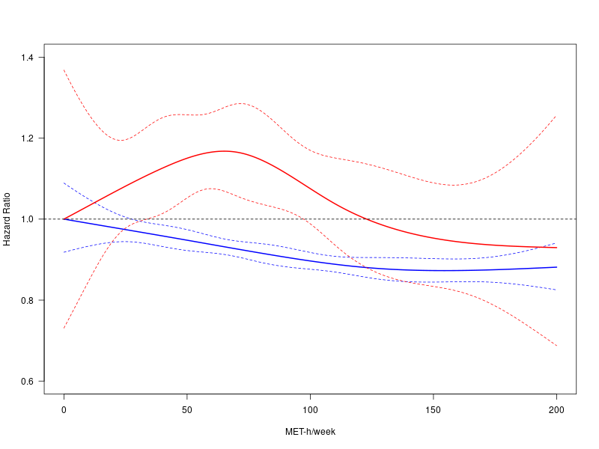 | b)  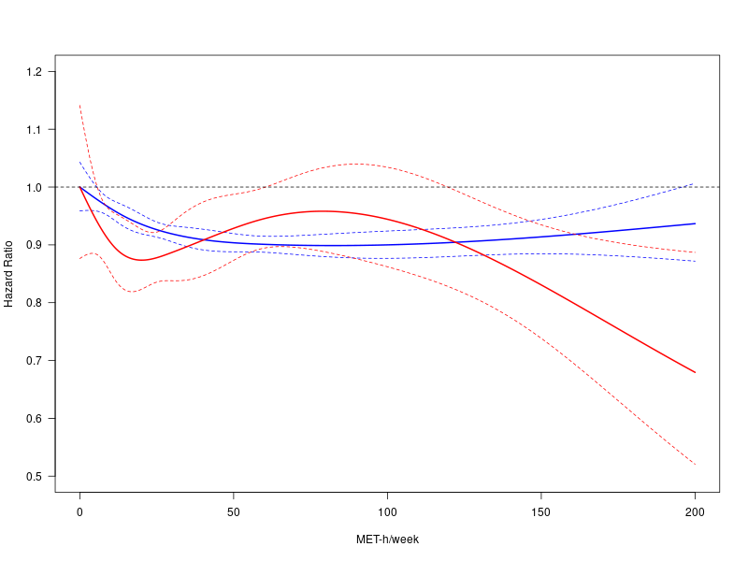
a) EPIC study; b) UK Biobank. The solid blue line represents the adjusted HRs for participants without cardiometabolic disease, while the red lines represent those with cardiometabolic disease, and the broken lines indicate the 95% CIs from the Cox regression with physical activity (PA) modelled as a natural spline with three knots positioned at the 25th, 50th, and 75th percentiles of PA, measured in MET-hour/week, capped at 200. Reference = 0 MET-h/week.
The models were stratified by age (5-year categories), sex, and recruitment centre, and adjusted for education, BMI, height, smoking status, alcohol consumption, diet quality, occupational work/employment, menopause status, and menopausal hormone use.
Abbreviations: BMI, body mass index; CI, confidence interval; CMD: T2D and/or CVD; CVD, cardiovascular disease; EPIC, European Prospective Investigation into Cancer and Nutrition; MET-h/week, metabolic equivalent task hours per week; T2D, type 2 diabetes; UKB, UK Biobank.

Figure S7: Transitions from baseline to physical activity-related cancers, CVD, T2D, and subsequent transition from T2D, and CVD to cancer in EPIC.
n=6,967 (2.30)
n=9,594 (2.44)
T2D (n=9,594)
CVD (n=6,967)
n=10,831 (3.17)
Baseline (N=230,026)
n=576 (33.0)
n=390 (3.60)
CMD (n=1,104)
n=418 (12.45)
n=252 (3.35)
n=63 (4.15)
Physical activity-related Cancers (n=11,536)
Transitions from baseline to physical activity-related cancers, type 2 diabetes (T2D), and cardiovascular disease (CVD).
physical activity-related cancers refer to a composite outcome of breast, adenocarcinoma of the oesophagus, endometrial, colon, kidney, gastric cardia, bladder, gallbladder, liver, lung, small intestine, multiple myeloma, myeloid leukemia, rectal, and head and neck cancer.
The state-specific number of events is reported in boxes, and the transition-specific number of events and age-standardized incidence rates per 1000 person-years (within brackets) are reported on the arrows.
Abbreviations: CMD; cardiometabolic disease (T2D and/or CVD); CVD, cardiovascular disease; EPIC, European Prospective Investigation into Cancer and Nutrition; T2D, type 2 diabetes.

Figure S8: Transitions from baseline to physical activity-related cancers, CVD, T2D, and subsequent transition from T2D, and CVD to cancer in UKB.
n= 13,329(1.92)
n=29,127 (4.19)
T2D (n=13,329
)
CVD (n=29,127)
n=15,539 (2.25)
Baseline (N=334,596)
n=3,265 (25.79)
n=359 (2.81)
CMD (n=4,357)
n=1092 (3.58)
n=774 (2.10)
n=137 (2.78)
Physical activity-related Cancers (n=16,809)
Transitions from baseline to physical activity (PA) related cancers, T2D, and CVD.
PA-related cancer refers to breast, adenocarcinoma of the oesophagus, endometrial, colon, kidney, gastric cardia, bladder, gallbladder, liver, lung, small intestine, multiple myeloma, myeloid leukemia, rectal, and head and neck cancer. Deaths were censored and not modelled as a separate outcome.
The state-specific number of events is reported in boxes, and the transition-specific number of events and age-standardized incidence rates per 1000 person-years (within brackets) are reported in arrows.
Abbreviations: CMD, cardiometabolic disease (i.e., T2D and/or CVD); CVD, cardiovascular disease; T2D, type 2 diabetes; UKB, UK Biobank.

Table S4: Associations between physical activity (per 1 SD increase in MET-h/weekª) and the risk of cancer by cardiometabolic disease status.
Outcomes | Models | EPIC |  |  |  |  |  |  | UKB
 | Models | N | Cases | HR | 95% CI | p1 | p2 | p3 | N | Cases | HR | 95% CI | p1 | p2 | p3
Physical activity-related cancer | Overall ⁴ | 230,026 | 11,536 | 0.956 | 0.935, 0.977 | < 0.001 |  |  | 334,596 | 16,809 | 0.959 | 0.943, 0.975 | < 0.001
Physical activity-related cancer | Overall, Adj T2D and CVD⁵ | 230,026 | 11,536 | 0.956 | 0.936, 0.978 | < 0.001 |  |  | 334,596 | 16,809 | 0.960 | 0.944, 0.975 | < 0.001
Physical activity-related cancer | Without T2D⁶ | 220,014 | 11,083 | 0.957 | 0.936, 0.978 | < 0.001 |  |  | 320,175 | 16,313 | 0.960 | 0.944, 0.975 | < 0.001
Physical activity-related cancer | With T2D⁶ | 10,012 | 453 | 0.944 | 0.853, 1.045 | 0.26 | 0.80 | 0.80 | 14,421 | 496 | 0.961 | 0.875, 1.056 | 0.41 | 0.96 | 0.96
Physical activity-related cancer | Without CVD⁶ | 222,483 | 11,221 | 0.956 | 0.935, 0.978 | < 0.001 |  |  | 302,204 | 15,898 | 0.961 | 0.945, 0.977 | < 0.001
Physical activity-related cancer | With CVD⁶ | 7,543 | 315 | 0.960 | 0.855, 1.077 | 0.48 | 0.86 | 0.86 | 32,392 | 911 | 0.944 | 0.883, 1.008 | 0.08 | 0.60 | 0.60
Physical activity-related cancer | Without CMD⁶ | 213,465 | 10,831 | 0.957 | 0.935, 0.979 | < 0.001 |  |  | 292,140 | 15,535 | 0.961 | 0.945, 0.977 | < 0.001
Physical activity-related cancer | With CMD⁶ | 16,561 | 705 | 0.951 | 0.879, 1.030 | 0.21 | 0.89 | 0.89 | 42,456 | 1,270 | 0.937 | 0.884, 0.992 | < 0.02 | 0.39 | 0.39
All cancers | Overall ⁴ | 230,026 | 18,139 | 0.964 | 0.947, 0.981 | < 0.001 |  |  | 334,596 | 32,218 | 0.983 | 0.972, 0.994 | < 0.01
All cancers | Overall Adj T2D and CVD⁵ | 230,026 | 18,139 | 0.964 | 0.947, 0.982 | < 0.001 |  |  | 334,596 | 32,218 | 0.983 | 0.972, 0.995 | < 0.01
All cancers | Without T2D⁶ | 220,179 | 17,363 | 0.964 | 0.947, 0.982 | < 0.001 |  |  | 321,062 | 31,332 | 0.984 | 0.973, 0.996 | < 0.01
All cancers | With T2D⁶ | 9,847 | 776 | 0.969 | 0.896, 1.048 | 0.43 | 0.89 | 0.89 | 13,534 | 886 | 0.956 | 0.893, 1.024 | 0.20 | 0.41 | 0.41
All cancers | Without CVD⁶ | 22,605 | 17,626 | 0.964 | 0.947, 0.981 | < 0.001 |  |  | 304,136 | 30,404 | 0.984 | 0.973, 0.996 | < 0.01
All cancers | With CVD⁶ | 7,421 | 513 | 0.978 | 0.893, 1.072 | 0.63 | 0.75 | 0.75 | 30,460 | 1,814 | 0.973 | 0.930, 1.017 | 0.22 | 0.61 | 0.61
All cancers | Without CMD⁶ | 213,729 | 16,964 | 0.964 | 0.947, 0.982 | < 0.001 |  |  | 294,681 | 29,753 | 0.985 | 0.973, 0.997 | 0.01
All cancers | With CMD⁶ | 16,297 | 1,175 | 0.970 | 0.912, 1.032 | 0.34 | 0.84 | 0.62 | 39,915 | 2,465 | 0.964 | 0.927, 1.003 | 0.06 | 0.30 | 0.30
ª One SD = 51.4 MET-h/week and 44.3 MET-h/week in EPIC and in UK Biobank, respectively.
¹ p-values for the association.
² p-values for local interaction tests (p-values in the full model with interaction).
³ p-value for the global interaction test (likelihood ratio test).
⁴ Model 1: adjusted for education, BMI, height, smoking status, alcohol consumption, diet quality, occupational work/employment, menopause status, menopausal hormone use, and stratified by age (5-year categories), sex, and recruitment centre.
⁵ Model 2: further adjusted for T2D and CVD, and the duration of these comorbidities.
⁶ Model 3: further including interaction terms between PA and T2D, CVD, and CMD (adjusted multiplicative interaction computed from the full model with interaction).
Abbreviations: BMI, body mass index, CI, confidence interval; CMD, cardiometabolic disease (T2D and/or CVD); CVD, cardiovascular disease; EPIC, European Prospective Investigation into Cancer and Nutrition; HR, hazard ratio; MET-h/week, metabolic equivalent task hours per week; SD, standard deviation; T2D, type 2 diabetes; UKB, UK Biobank.

Figure S9: Association between physical activity (per 1 SD increase in MET-h/week) and the risk of all cancers by cardiometabolic disease status.
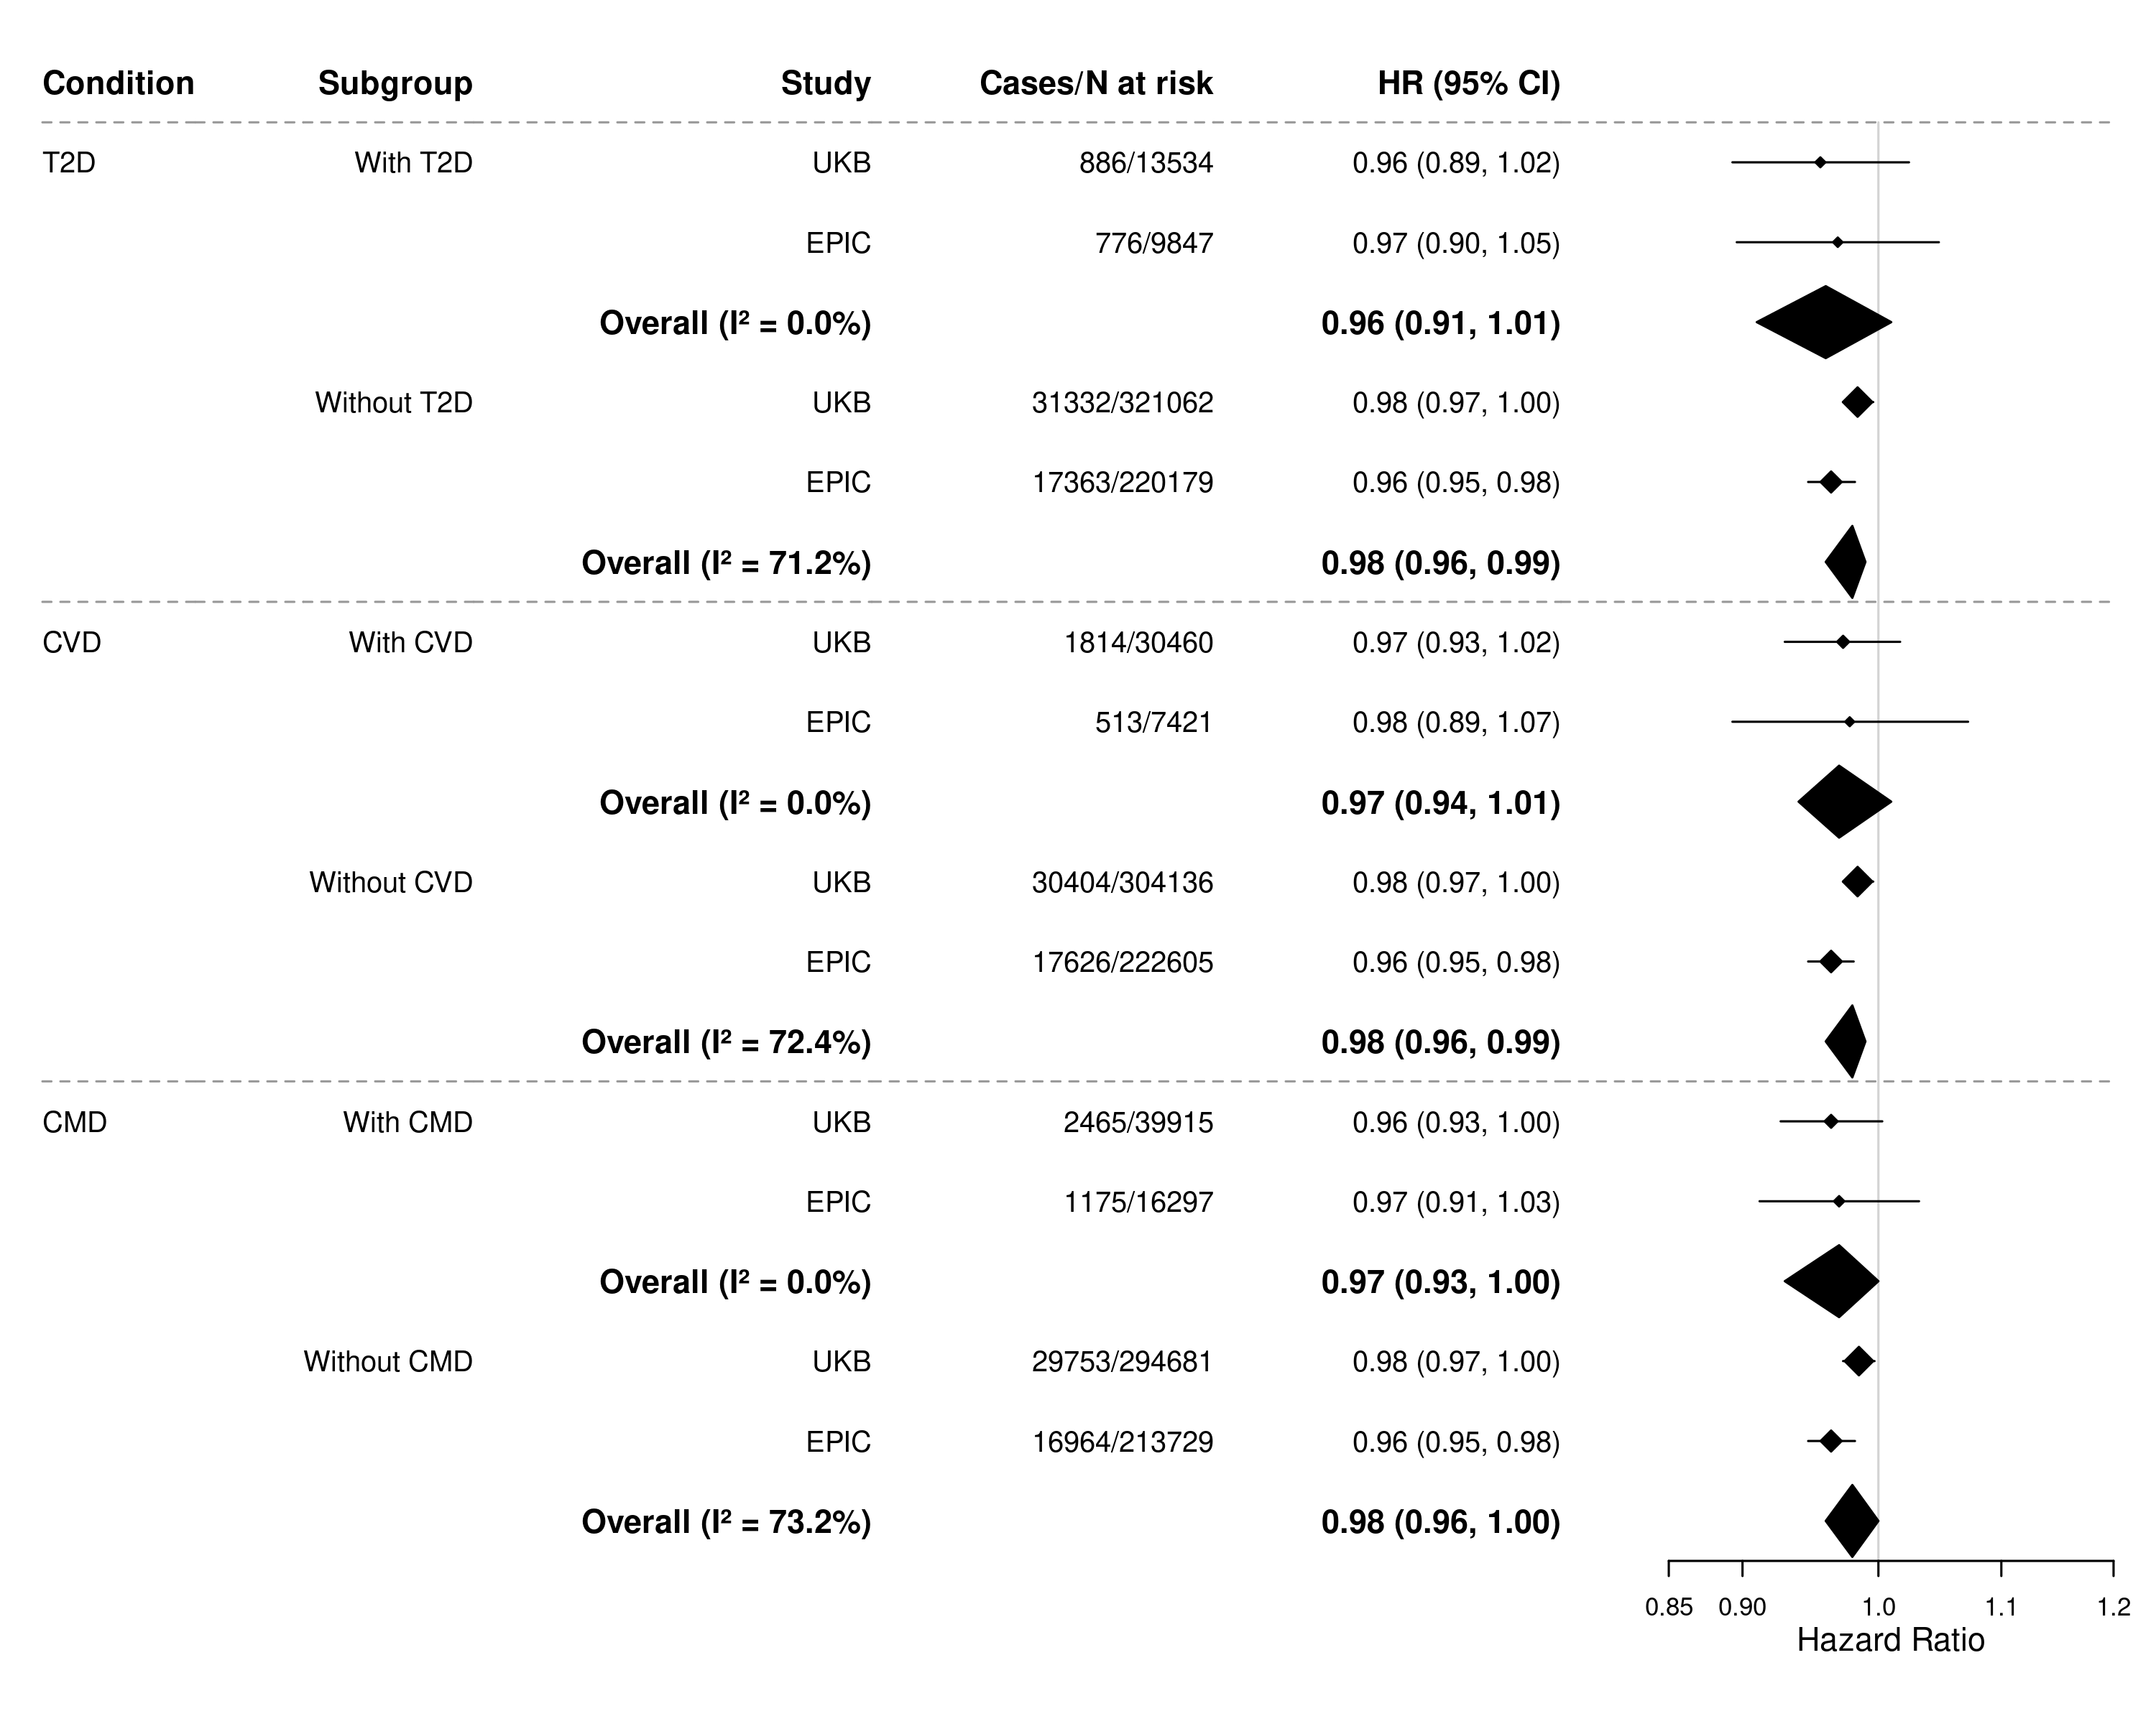
One SD = 51.4 MET-h/week and 44.3 MET-h/week in EPIC and UKB, respectively.
I²: The proportion of total variability due to between-study heterogeneity from random effects meta-analysis.
The models were stratified by age (5-year categories), sex, and recruitment centre, and adjusted for education, BMI, height, smoking status, alcohol consumption, diet quality, occupational work/employment, menopause status, menopausal hormone use, CVD and T2D (modelled as binary time-varying variables) and time since diagnosis of CVD and T2D, and interaction term between physical activity and each condition (T2D, CVD, and combined) in each model.
Abbreviations: BMI, body mass index, CI, confidence interval; CMD, cardiometabolic disease (T2D and/or CVD); CVD, cardiovascular disease; EPIC, European Prospective Investigation into Cancer and Nutrition; HR, hazard ratio; MET-h/week, metabolic equivalent task hours per week; SD, standard deviation; T2D, type 2 diabetes; UKB, UK Biobank.

Table S5: Subgroup analysis of associations between physical activity (ªper 1 SD increase in MET-h/week) and the risk of physical activity-related cancers by cardiometabolic disease status.
Subgroups | CMD status | EPIC |  |  |  |  | UKB
Subgroups | CMD status | N | Cases | HR (95% CI) | p1 | p2 | N | Cases | HR (95% CI) | p1 | p2
Ever smokers | No | 1,406,515 | 6,487 | 0.946 (0.918, 0.974) | < 0.001 |  | 1,721,709 | 8,093 | 0.970 (0.948, 0.992) | < 0.01
Ever smokers | Yes | 64,394 | 503 | 0.889 (0.803, 0.983) | 0.02 | 0.24 | 138,398 | 827 | 0.958 (0.895, 1.026) | 0.224 | 0.75
Never smokers | No | 1,192,032 | 4,344 | 0.963 (0.930, 0.998) | 0.03 |  | 2,274,059 | 7,446 | 0.951 (0.927, 0.975) | < 0.001
Never smokers | Yes | 36,620 | 202 | 1.056 (0.920, 1.211) | 0.44 | 0.19 | 120,885 | 443 | 0.884 (0.796, 0.983) | 0.02 | 0.19
Employed | No | 1,740,327 | 6,513 | 0.975 (0.945, 1.006) | 0.11 |  | 2,552,723 | 7,970 | 0.974 (0.951, 0.997) | 0.02
Employed | Yes | 63,696 | 408 | 1.019 (0.905, 1.147) | 0.75 | 0.48 | 117,796 | 472 | 0.979 (0.898, 1.067) | 0.63 | 0.90
Unemployed | No | 858,220 | 4,318 | 0.946 (0.915, 0.979) | < 0.01 |  | 1,443,045 | 7,569 | 0.951 (0.927, 0.974) | < 0.001
Unemployed | Yes | 37,318 | 297 | 0.890 (0.792, 0.999) | 0.05 | 0.31 | 141,487 | 798 | 0.912 (0.844, 0.985) | 0.02 | 0.31
BMI <25kg/m² | No | 1,118,537 | 4,602 | 0.976 (0.943, 1.011) | 0.17 |  | 1,379,835 | 5,073 | 0.965 (0.937, 0.993) | 0.01
BMI <25kg/m² | Yes | 19,278 | 141 | 0.965 (0.804, 1.158) | 0.70 | 0.90 | 50,223 | 205 | 0.883 (0.763, 1.022) | 0.09 | 0.24
BMI >25kg/m² | No | 1,480,010 | 6,229 | 0.944 (0.916, 0.972) | < 0.001 |  | 2,615,933 | 10,466 | 0.959 (0.939, 0.979) | < 0.001
BMI >25kg/m² | Yes | 81,736 | 564 | 0.936 (0.856, 1.022) | 0.14 | 0.84 | 209,060 | 1,065 | 0.951 (0.893, 1.012) | 0.11 | 0.79
Male | No | 958,574 | 3,229 | 0.969 (0.927, 1.013) | 0.16 |  | 1,879,438 | 5,399 | 0.965 (0.941, 0.991) | < 0.01
Male | Yes | 54,244 | 364 | 0.957 (0.845, 1.085) | 0.49 | 0.86 | 166,962 | 704 | 0.917 (0.852, 0.988) | 0.02 | 0.19
Female | No | 1,639,973 | 7,602 | 0.953 (0.929, 0.979) | < 0.001 |  | 2,116,330 | 10,140 | 0.953 (0.931, 0.974) | < 0.001
Female | Yes | 46,770 | 341 | 0.958 (0.859, 1.070) | 0.45 | 0.93 | 92,321 | 566 | 0.961 (0.876, 1.054) | 0.39 | 0.86
Using medication | No |  |  |  |  |  | 450,923 | 1,904 | 0.984 (0.940, 1.031) | 0.5
Using medication | Yes |  |  |  |  |  | 85,514 | 411 | 0.953 (0.864, 1.051) | 0.33 | 0.56
No medication | No |  |  |  |  |  | 3,544,845 | 13,635 | 0.960 (0.943, 0.977) | < 0.001
No medication | Yes |  |  |  |  |  | 173,769 | 859 | 0.932 (0.868, 1.000) | 0.05 | 0.42
Self-rated good/excellent health | No |  |  |  |  |  | 3,210,087 | 12,137 | 0.965 (0.947, 0.983) | < 0.001
Self-rated good/excellent health | Yes |  |  |  |  |  | 162,818 | 715 | 0.936 (0.869, 1.009) | 0.08 | 0.44
Self-rated fair/bad health | No |  |  |  |  |  | 785,681 | 3,402 | 0.967 (0.932, 1.004) | 0.08
Self-rated fair/bad health | Yes |  |  |  |  |  | 96,465 | 555 | 0.979 (0.895, 1.071) | 0.64 | 0.81
Low deprivation | No |  |  |  |  |  | 2,008,542 | 7,674 | 0.967 (0.944, 0.992) | < 0.01
Low deprivation | Yes |  |  |  |  |  | 121,989 | 554 | 0.955 (0.874, 1.044) | 0.31 | 0.79
High deprivation | No |  |  |  |  |  | 1,987,226 | 7,865 | 0.956 (0.934, 0.978) | < 0.001
High deprivation | Yes |  |  |  |  |  | 137,294 | 716 | 0.921 (0.854, 0.993) | 0.03 | 0.35
Low income | No |  |  |  |  |  | 1,754,586 | 8,364 | 0.958 (0.937, 0.978) | < 0.001
Low income | Yes |  |  |  |  |  | 153,155 | 857 | 0.906 (0.845, 0.972) | < 0.01 | 0.13
High income | No |  |  |  |  |  | 2,241,182 | 7,175 | 0.961 (0.935, 0.988) | < 0.01
High income | Yes |  |  |  |  |  | 106,128 | 413 | 1.002 (0.904, 1.110) | 0.97 | 0.44
ª One SD = 51.4 MET-h/week and 44.3 MET-h/week in EPIC and UKB, respectively. Empty cells: data not available.
¹ p-values for the association.
² p-values for local interaction tests (p-values in the full model with interaction between PA and CMD within each model).
Employment status: “employed” refers to those who reported any paid work in EPIC, while in UKB to those in paid employment or self-employed, doing unpaid or voluntary work, full or part-time student.
Medication status: “using medication” refers to those reporting use of blood pressure medication, cholesterol-lowering medication, or insulin; while no medication refers to those who do not know, none of the above, or prefer not to answer.
Deprivation: “low” refers to <= the median (-2.2686) while high if > the median (-2.2686).
Income: “low income” refers to household income <= 30,999 GBP; “high income” if > 31,000 GBP.
All models were adjusted for the duration of T2D and CVD, smoking, BMI, alcohol consumption, diet quality, occupational work, education, height, menopause status, and menopausal hormone use.
Abbreviations: BMI, body mass index; CI, confidence interval; CMD, cardiometabolic disease (T2D and/or CVD); CVD, cardiovascular disease; EPIC, European Prospective Investigation into Cancer and Nutrition; HR, hazard ratio; MET-h/week, metabolic equivalent task hours per week; SD, standard deviation; T2D, type 2 diabetes; UKB, UK Biobank.

Table S6: Subgroup analysis of associations between physical activity (ªper 1 SD increase in MET-h/week) and the risk of all cancers by cardiometabolic disease status.
Subgroups | CMD status | EPIC |  |  |  |  | UKB
Subgroups | CMD status | N | Cases | HR (95% CI) | p1 | p2 | N | Cases | HR (95% CI) | p1 | p2
Ever smokers | No | 1,396,082 | 10,212 | 0.959 (0.937, 0.982) | < 0.001 |  | 1,685,505 | 14,896 | 0.989 (0.973, 1.005) | 0.19
Ever smokers | Yes | 62,934 | 838 | 0.924 (0.855, 0.999) | 0.05 | 0.37 | 128,914 | 1,476 | 0.940 (0.893, 0.990) | 0.02 | 0.06
Never smokers | No | 1,185,060 | 6,752 | 0.968 (0.941, 0.996) | 0.03 |  | 2,234,238 | 14,857 | 0.980 (0.964, 0.997) | 0.02
Never smokers | Yes | 35,891 | 337 | 1.054 (0.946, 1.173) | 0.34 | 0.13 | 112,766 | 989 | 0.998 (0.938, 1.062) | 0.95 | 0.59
Employed | No | 1,729,440 | 10,383 | 0.964 (0.940, 0.989) | < 0.01 |  | 2,514,311 | 15,277 | 0.991 (0.975, 1.007) | 0.25
Employed | Yes | 62,238 | 724 | 1.045 (0.955, 1.142) | 0.34 | 0.09 | 110,916 | 963 | 0.974 (0.918, 1.033) | 0.38 | 0.58
Unemployed | No | 851,702 | 6,581 | 0.970 (0.943, 0.996) | 0.03 |  | 1,405,432 | 14,476 | 0.979 (0.963, 0.996) | 0.02
Unemployed | Yes | 36,587 | 451 | 0.907 (0.825, 0.997) | 0.04 | 0.17 | 130,764 | 1,502 | 0.958 (0.909, 1.010) | 0.11 | 0.44
BMI <25kg/m² | No | 1,111,676 | 6,917 | 0.977 (0.950, 1.006) | 0.12 |  | 1,356,928 | 9,164 | 0.977 (0.957, 0.998) | 0.03
BMI <25kg/m² | Yes | 18,889 | 228 | 0.947 (0.819, 1.094) | 0.46 | 0.67 | 46,984 | 415 | 0.961 (0.876, 1.055) | 0.40 | 0.73
BMI >25kg/m² | No | 1,469,466 | 10,047 | 0.956 (0.934, 0.979) | < 0.001 |  | 2,562,815 | 20,589 | 0.989 (0.975, 1.003) | 0.11
BMI >25kg/m² | Yes | 79,936 | 947 | 0.964 (0.900, 1.033) | 0.30 | 0.82 | 194,696 | 2,050 | 0.966 (0.924, 1.009) | 0.11 | 0.31
Male | No | 949,232 | 6,729 | 0.976 (0.947, 1.007) | 0.13 |  | 1,824,248 | 15,888 | 0.994 (0.979, 1.009) | 0.42
Male | Yes | 52,603 | 732 | 0.988 (0.906, 1.078) | 0.79 | 0.79 | 152,917 | 1,691 | 0.945 (0.902, 0.991) | 0.02 | 0.04
Female | No | 1,631,910 | 10,235 | 0.958 (0.937, 0.980) | < 0.001 |  | 2,095,495 | 13,865 | 0.967 (0.949, 0.986) | < 0.001
Female | Yes | 46,222 | 443 | 0.953 (0.865, 1.049) | 0.33 | 0.91 | 88,763 | 774 | 1.020 (0.946, 1.099) | 0.61 | 0.18
Using medication | No |  |  |  |  |  | 434,434 | 5,188 | 0.995 (0.968, 1.023) | 0.72
Using medication | Yes |  |  |  |  |  | 78,164 | 969 | 0.992 (0.933, 1.055) | 0.80 | 0.93
No medication | No |  |  |  |  |  | 3,485,309 | 24,565 | 0.984 (0.971, 0.997) | < 0.05
No medication | Yes |  |  |  |  |  | 163,516 | 1,496 | 0.945 (0.897, 0.995) | 0.03 | 0.13
Self-rated good/excellent health | No |  |  |  |  |  | 3,148,202 | 23,598 | 0.986 (0.973, 0.999) | 0.03
Self-rated good/excellent health | Yes |  |  |  |  |  | 150,567 | 1,498 | 0.979 (0.933, 1.028) | 0.40 | 0.79
Self-rated fair/bad health | No |  |  |  |  |  | 771,541 | 6,155 | 0.990 (0.964, 1.017) | 0.47
Self-rated fair/bad health | Yes |  |  |  |  |  | 91,113 | 967 | 0.957 (0.894, 1.025) | 0.21 | 0.367
Low deprivation | No |  |  |  |  |  | 1,967,541 | 15,255 | 0.988 (0.972, 1.005) | 0.17
Low deprivation | Yes |  |  |  |  |  | 112,906 | 1,180 | 0.984 (0.928, 1.043) | 0.58 | 0.88
High deprivation | No |  |  |  |  |  | 1,952,202 | 14,498 | 0.983 (0.967, 0.999) | 0.04
High deprivation | Yes |  |  |  |  |  | 128,774 | 1,285 | 0.947 (0.897, 0.999) | 0.04 | 0.19
Low income | No |  |  |  |  |  | 1,717,364 | 15,323 | 0.986 (0.971, 1.001) | 0.06
Low income | Yes |  |  |  |  |  | 142,556 | 1,581 | 0.961 (0.916, 1.008) | 0.10 | 0.31
High income | No |  |  |  |  |  | 2,202,379 | 14,430 | 0.981 (0.963, 1.000) | 0.05
High income | Yes |  |  |  |  |  | 99,124 | 884 | 0.964 (0.898, 1.036) | 0.32 | 0.64
ª One SD = 51.4 MET-h/week and 44.3 MET-h/week in EPIC and UKB, respectively. Empty cells: data not available.
¹ p-values for the association.
² p-values for local interaction tests (p-values in the full model with interaction between PA and CMD within each model).
Employment status: “employed” refers to those who reported any paid work in EPIC, while in UKB to those in paid employment or self-employed, doing unpaid or voluntary work, full or part-time student.
Medication status: “using medication” refers to those reporting use of blood pressure medication, cholesterol-lowering medication, or insulin; while no medication refers to those who do not know, none of the above, or prefer not to answer.
Deprivation: “low” refers to <= the median (-2.2686) while high if > the median (-2.2686).
Income: “low income” refers to household income <= 30,999 GBP; “high income” if > 31,000 GBP.
All models were adjusted for the duration of T2D and CVD, smoking, BMI, alcohol consumption, diet quality, occupational work, education, height, menopause status, and menopausal hormone use.
Abbreviations: BMI, body mass index; CI, confidence interval; CMD, cardiometabolic disease (T2D and/or CVD); CVD, cardiovascular disease; EPIC, European Prospective Investigation into Cancer and Nutrition; HR, hazard ratio; MET-h/week, metabolic equivalent task hours per week; SD, standard deviation; T2D, type 2 diabetes; UKB, UK Biobank.

Table S7: Association between physical activity (ªper 1 SD increase in MET-h/week) and the risk of physical activity-related cancers and all cancers by cardiometabolic disease status in EPIC and UKB (complete case analysis).
Outcomes | Models | EPIC |  |  |  |  |  |  | UK Biobank
Outcomes | Models | N | Cases | HR | 95% CI | p1 | p2 | p3 | N | Cases | HR | 95% CI | p1 | p2 | p3
Physical activity-related cancer | Overall ⁴ | 223,052 | 11,202 | 0.957 | 0.936, 0.979 | <0.001 |  |  | 321,468 | 16,132 | 0.960 | 0.944, 0.976 | <0.001
Physical activity-related cancer | Overall, Adj T2D and CVD⁵ | 223,052 | 11,202 | 0.958 | 0.937, 0.980 | <0.001 |  |  | 321,468 | 16,132 | 0.961 | 0.945, 0.977 | <0.001
Physical activity-related cancer | Without T2D⁶ | 213,298 | 10,759 | 0.958 | 0.937, 0.980 | <0.001 |  |  | 307,646 | 15,656 | 0.961 | 0.945, 0.977 | <0.001
Physical activity-related cancer | With T2D⁶ | 9,754 | 443 | 0.944 | 0.852, 1.046 | 0.27 | 0.78 | 0.78 | 13,822 | 476 | 0.947 | 0.859, 1.044 | 0.27 | 0.77 | 0.77
Physical activity-related cancer | Without CVD⁶ | 215,801 | 10,898 | 0.957 | 0.936, 0.979 | <0.001 |  |  | 290,034 | 15,255 | 0.961 | 0.945, 0.978 | <0.001
Physical activity-related cancer | With CVD⁶ | 7,251 | 304 | 0.960 | 0.853, 1.080 | 0.49 | 0.96 | 0.96 | 31,434 | 877 | 0.945 | 0.883, 1.011 | 0.10 | 0.12 | 0.12
Physical activity-related cancer | Without CMD⁶ | 207,011 | 10,517 | 0.958 | 0.936, 0.980 | <0.001 |  |  | 280,387 | 14,909 | 0.962 | 0.946, 0.979 | <0.001
Physical activity-related cancer | With CMD⁶ | 16,041 | 685 | 0.954 | 0.880, 1.034 | 0.25 | 0.92 | 0.92 | 41,071 | 1,223 | 0.937 | 0.883, 0.993 | 0.03 | 0.39 | 0.38
All cancers | Overall ⁴ | 219,632 | 17,267 | 0.965 | 0.947, 0.983 | <0.001 |  |  | 321,468 | 31,160 | 0.983 | 0.972, 0.994 | < 0.01
All cancers | Overall, Adj T2D and CVD⁵ | 219,632 | 17,267 | 0.965 | 0.948, 0.983 | <0.001 |  |  | 321,468 | 31,160 | 0.983 | 0.972, 0.995 | < 0.01
All cancers | Without T2D⁶ | 210,133 | 16,513 | 0.965 | 0.947, 0.983 | <0.001 |  |  | 308,511 | 30,313 | 0.984 | 0.973, 0.996 | < 0.01
All cancers | With T2D⁶ | 9,499 | 754 | 0.980 | 0.905, 1.061 | 0.62 | 0.70 | 0.70 | 12,957 | 847 | 0.947 | 0.882, 1.016 | 0.13 | 0.28 | 0.28
All cancers | Without CVD⁶ | 212,725 | 16,786 | 0.965 | 0.947, 0.983 | <0.001 |  |  | 291,925 | 29,399 | 0.984 | 0.973, 0.996 | < 0.01
All cancers | With CVD⁶ | 6,907 | 481 | 0.991 | 0.902, 1.089 | 0.85 | 0.58 | 0.58 | 29,543 | 1,761 | 0.97 | 0.927, 1.016 | 0.20 | 0.56 | 0.56
All cancers | Without CMD⁶ | 204,153 | 16,140 | 0.964 | 0.946, 0.982 | <0.001 |  |  | 282,880 | 28,775 | 0.985 | 0.973, 0.997 | < 0.05
All cancers | With CMD⁶ | 15,479 | 1,127 | 0.982 | 0.922, 1.047 | 0.58 | 0.57 | 0.57 | 38,588 | 2,385 | 0.963 | 0.925, 1.002 | 0.06 | 0.28 | 0.29
ª One SD = 51.4 MET-h/week and 44.3 MET-h/week in EPIC and in UK Biobank, respectively.
¹ p-values for the association.
² p-values for local interaction tests (p-values in the full model with interaction).
³ p-value for the global interaction test (likelihood ratio test).
⁴ Model 1: adjusted for education, BMI, height, smoking status, alcohol consumption, diet quality, occupational work/employment, menopause status, menopausal hormone use, and stratified by age (5-year categories), sex, and recruitment centre.
⁵ Model 2: further adjusted for T2D and CVD, and the duration of these comorbidities.
⁶ Model 3: further including interaction terms between PA and T2D, CVD, and CMD (adjusted multiplicative interaction computed from the full model with interaction).
Abbreviations: BMI, body mass index, CI, confidence interval; CMD, cardiometabolic disease (T2D and/or CVD); CVD, cardiovascular disease; EPIC, European Prospective Investigation into Cancer and Nutrition; HR, hazard ratio; MET-h/week, metabolic equivalent task hours per week; SD, standard deviation; T2D, type 2 diabetes; UKB, UK Biobank.
Figure S10: Association between physical activity (per 1 SD increase in MET-h/week) and the risk of physical activity-related cancers by cardiometabolic disease status in EPIC and UKB cohorts (complete case analysis).
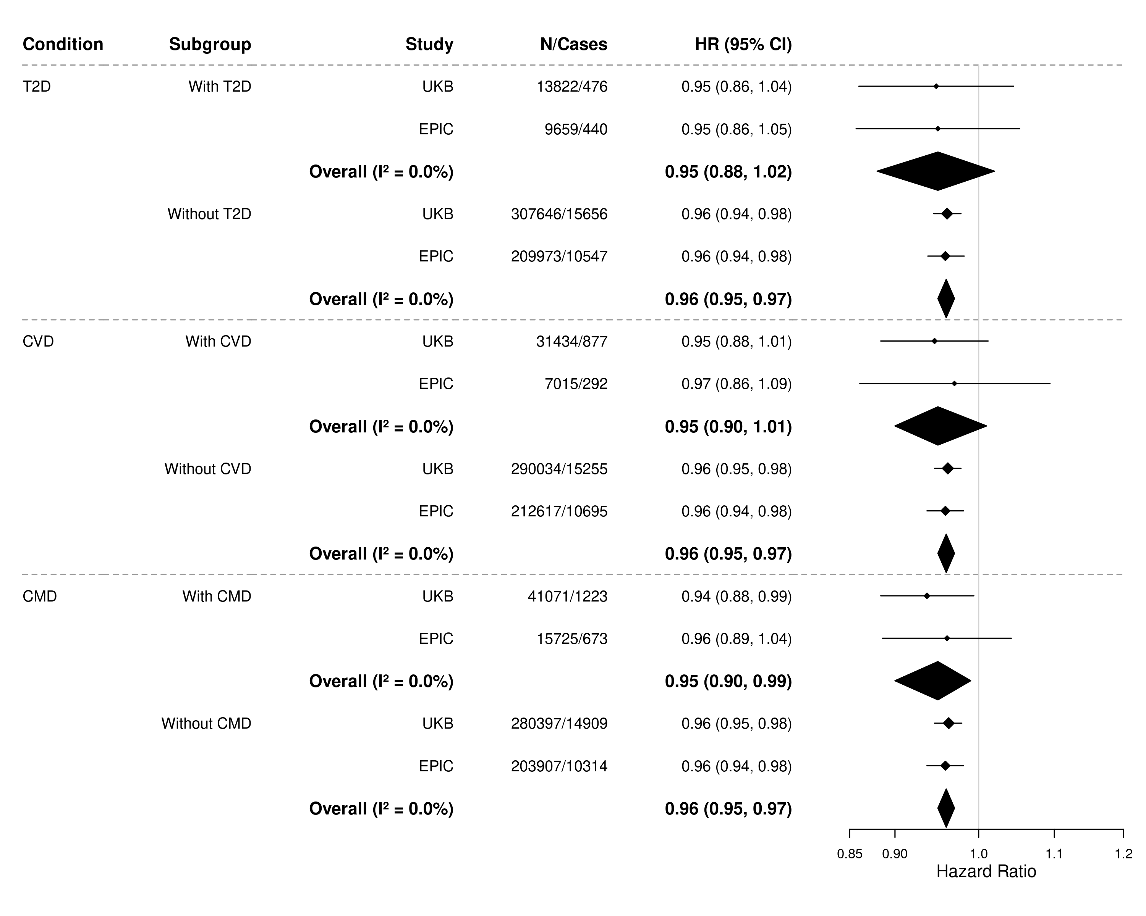
One SD = 51.4 MET-h/week and 44.3 MET-h/week in EPIC and UKB, respectively.
I²: The proportion of total variability due to between-study heterogeneity from random effects meta-analysis.
The models were stratified by age (5-year categories), sex, and recruitment centre, and adjusted for education, BMI, height, smoking status, alcohol consumption, diet quality, occupational work/employment, menopause status, menopausal hormone use, CVD and T2D (modelled as binary time-varying variables) and time since diagnosis of CVD and T2D, and interaction term between physical activity and each condition (T2D, CVD, and combined) in each model.
Abbreviations: BMI, body mass index, CI, confidence interval; CMD, cardiometabolic disease (T2D and/or CVD); CVD, cardiovascular disease; EPIC, European Prospective Investigation into Cancer and Nutrition; HR, hazard ratio; MET-h/week, metabolic equivalent task hours per week; SD, standard deviation; T2D, type 2 diabetes; UKB, UK Biobank.

Figure S11: Joint association of physical activity and cardiometabolic diseases with the risk of all cancers.
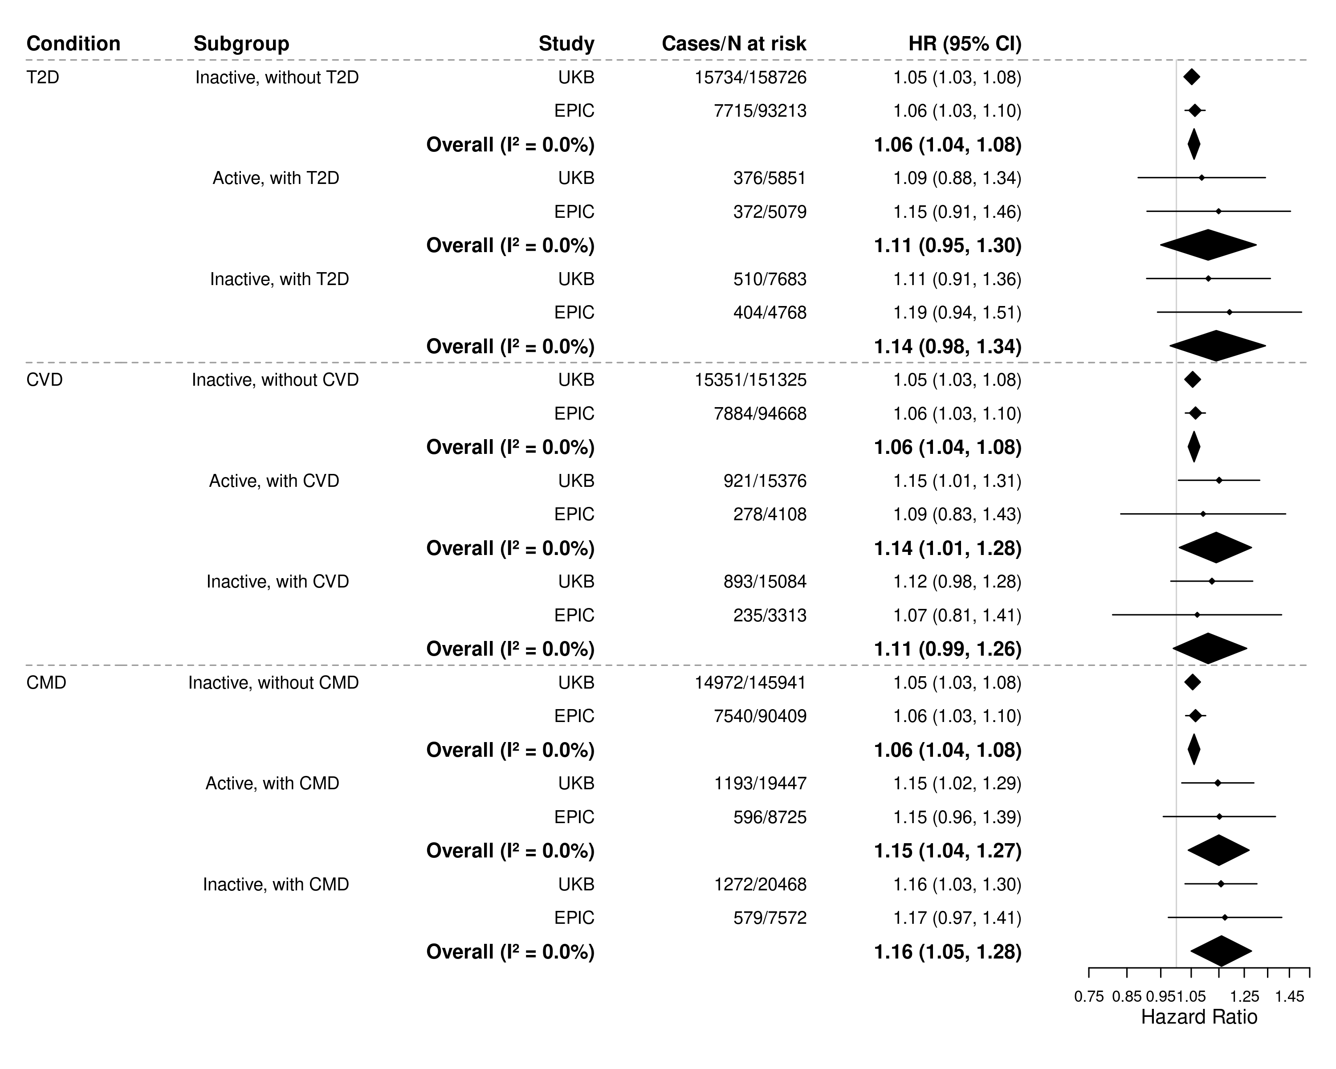
Reference category (not shown): Active without cardiometabolic disease.
Inactive was defined as having less than the median MET-h/week of physical activity.
I²: The proportion of total variability due to between-study heterogeneity from random effects meta-analysis.
The models were stratified by age (5-year categories), sex, and recruitment centre, and adjusted for education, BMI, height, smoking status, alcohol consumption, diet quality, occupational work/employment, menopause status, menopausal hormone use, CVD and T2D (modelled as binary time-varying variables) and time since diagnosis of CVD and T2D, and interaction term between physical activity and each condition (T2D, CVD, and combined) in each model.
Relative excess risk due to interactions (RERI) for those inactive with T2D, CVD, and CMD was -0.02 (95% CI: -0.14, 0.09), -0.08 (95% CI: -0.18, 0.01), and -0.04 (95% CI: -0.12, 0.03), respectively.
Abbreviations: CI, confidence interval; CMD, having incident T2D and/or CVD; CVD, cardiovascular disease; EPIC, European Prospective Investigation into Cancer and Nutrition; HR, hazard ratio; MET-h/week, metabolic equivalent task hours per week; PA, physical activity; T2D, type 2 diabetes; UKB, UK Biobank.

