Protonation-Guided Design and Evaluation of Selective PET Tracers for Light Chain Cardiac Amyloidosis
Jiangxue Tang^{1, 8}, Miao Wang¹, Yuying Li^{1, *}, Haonan Yu³, Xiaojun Zhang², Meijie Pan³, Qilei Zhang⁴, Jiaqi Wang⁵, Jiapei Dai⁶, Lu Yu⁷, Dong Chen⁵, Xiao-Xin Yan⁴, Jinming Zhang², Shaobo Yao^{3, *}, Mengchao Cui^{1, 8, *}

¹ Key Laboratory of Radiopharmaceuticals, Ministry of Education, College of Chemistry, Beijing Normal University, Beijing, 100875, China.
² Nuclear Medicine Department, The First Medical Center of Chinese PLA General Hospital, Beijing, 100853, China.
³ Department of PET/CT Diagnostic, Tianjin Medical University General Hospital, Tianjin, 300052, China.
⁴ Department of Anatomy and Neurobiology, School of Basic Medical Science, Central South University, Changsha, 410013, China.
⁵ Department of Pathology, Beijing Anzhen Hospital, Capital Medical University, Beijing, 100029, China.
⁶ Wuhan Institute for Neuroscience and Neuroengineering, South-Central Minzu University, Wuhan, 430074, China.
⁷ Department of Pathology, Xijing Hospital, Fourth Military Medical University, Xi'an, 710032, China.
⁸ Center for Advanced Materials Research, Beijing Normal University at Zhuhai, Zhuhai, 519087, China.

Corresponding author:
Mengchao Cui, Email: cmc@bnu.edu.cn
Shaobo Yao, Email: yaoshaobo008@163.com
Yuying Li, Email: liyuying@bnu.edu.cn

Table of Contents
1. Chemistry and radiochemistry. 5
2. Summary of human tissue specimens. 19
3. Chemical purity measurements. 20
4. HPLC analysis of ¹²⁵I-labeled tracers. 22
5. HPLC analysis of ¹⁸F-labeled tracers. 23
6. Fluorescence staining and pathological confirmation. 25
7. Measurement of IC₅₀ values to AL deposits. 25
8. Measurement of inhibition potency. 27
9. PET/CT imaging of ¹⁸F-labeled tracers in SD rats. 29
10. ARG images of ¹⁸F-labeled tracers. 30
11. NMR and HRMS spectra. 31

General information.
All solvents and reagents used for chemical synthesis were purchased and used without further purification. [¹²⁵I]NaI (molar activity (A_{m}) = 81.4 GBq/μmol) was purchased from PerkinElmer (USA). [¹⁸F]Fluoride was purchased from the HTA Co., Ltd. The chemical reactions were monitored by thin layer chromatography using silica gel 60 F254 plates (Merck, Germany) under an ultraviolet lamp (254 and 365 nm, Spectronics, USA). The purifications of crude products were carried out on the FLEXA rapid purification preparative chromatograph (Bonna-Agela Technologies, China). ¹H NMR, ¹³C NMR, ¹⁹F NMR data were obtained using a JNM-ECZ600R/S1 or JNM-ECZ400R/S1 NMR spectrometer (JEOL) in CDCl₃, DMSO-d₆ or Trifluoroacetic acid-d solutions at room temperature. All final products had a purity larger than 95% (Supplementary Figs. 1-3 and Supplementary Tables 2-3). High-resolution mass spectra (HRMS) were obtained using a Q-Exactive (ESI) mass spectrometer (Thermo Fisher Scientific, USA). Radiochemical reactions were analyzed and purified using an SCL-20AVP high-performance liquid chromatography (HPLC) system (Shimadzu, Japan) equipped with a Venusil MP C18 column (5 μm, 4.6 mm × 250 mm or 10 μm, 10 mm × 250 mm, Bonna-Agela Technologies, China). Autoradiography images were obtained by a Cyclone Plus storage phosphor system (PerkinElmer, USA) and analyzed using OptiQuant software. Radioactivity was measured on an automatic WALLAC/Wizard 1470 γ-counter (PerkinElmer, USA). Micro-PET/CT images were performed on an IRIS PET/CT scanner (Inviscan, France) and data analysis was obtained by PMOD 4.1 (PMOD Technologies, Switzerland). For immunofluorescence staining, anti-lambda light chain antibody (ab124719) was purchased from Abcam (UK), and anti-transthyretin antibody (11891-1-AP) was purchased from Proteintech (Japan). DAPI was purchased from TCI. Fluorescence images were captured using the DMi8 automated microscope imaging system (Leica, Germany) equipped with a Leica K8 (A23B726014) camera and appropriate filter sets. Congo Red stain solution (#G1531) was purchased from Solarbio. The polarized light images were captured using the DMi8 automated microscope imaging system (Leica, Germany) equipped with a FLEXACAM C3 (1923260073) camera and appropriate filter sets. Human specimens were sourced from the Capital Medical University (Department of Pathology), Central South University (Xiangya School of Medicine, Department of Anatomy and Neurobiology), South-Central Minzu University (Wuhan Institute for Neuroscience and Neuroengineering), and Fourth Military Medical University (Department of Pathology, Xijing Hospital). SD rats were purchased from Beijing Vital River Laboratories (China). All animal procedures complied with institutional and national guidelines and were approved by the Animal Care and Use Committee of Beijing Normal University (BNUCC-EAW-2023-0615-01).

Chemistry and radiochemistry.
Chemistry.
Supplementary Scheme 1 | Chemical and radiochemical synthesis of compounds 1-9 and [¹²⁵I]7-9.ª
ªReagents and conditions: (a) ethylene glycol, 120 °C, 12 h; (b) BINAP, Pd₂(dba₂)₃, t-BuOK, 1,4-dioxane, 110 °C, 12 h; (c) (n-Bu₃Sn)₂, Pd₂(PPh₃)₄, triethylamine, toluene, 110 °C, 12 h; (d) iodine, DCM, room-temperature (rt), 1 h; (e) (1) [¹²⁵I]NaI, HCl (1 M), H₂O₂ (3%), ethanol, rt, 15 min, (2) NaHCO₃, rt, 1 min.

1-(5-bromopyridin-2-yl)-4-(pyridin-4-yl)piperazine (1).
A mixture of 1-(pyridin-4-yl)piperazine (489.3 mg, 3.0 mmol) and 2,5-dibromopyridine (704.6 mg, 3.0 mmol) in 2 mL of ethylene glycol was heated at 120 °C for 12 hours until the conversion was complete. The reaction mixture was treated with saturated NaHCO₃ aqueous solution and extracted with DCM (20 mL × 4) after being cooled to room temperature. The combined organic layer was dried by Na₂SO₄, filtered, concentrated under reduced pressure, and then purified by silica gel flash chromatography using a gradient mixture of DCM-methanol (100% to 90% DCM) to give a white solid (421.3 mg, 44%). ¹H NMR (600 MHz, Chloroform-d) δ 8.29 (d, J = 5.9 Hz, 2H), 8.22 (d, J = 2.1 Hz, 1H), 7.58 (dd, J = 9.0, 2.4 Hz, 1H), 6.74 – 6.68 (m, 2H), 6.58 (d, J = 9.0 Hz, 1H), 3.72 – 3.68 (m, 4H), 3.50 (dd, J = 9.7, 4.5 Hz, 4H).
1-(5-bromopyridin-2-yl)-4-(pyridin-2-yl)piperazine (2).
Prepared by the same procedure as 1, using 1-(pyridin-2-yl)piperazine and 2,5-dibromopyridine as reactants to give a white solid (641.6 mg, 67%). ¹H NMR (600 MHz, Chloroform-d) δ 8.26 – 8.18 (m, 2H), 7.56 (dd, J = 9.0, 2.4 Hz, 1H), 7.54 (s, 1H), 6.76 – 6.65 (m, 2H), 6.59 (d, J = 8.9 Hz, 1H), 3.70 (s, 4H), 3.67 (d, J = 5.5 Hz, 4H).
1-(5-bromopyridin-2-yl)-4-phenylpiperazine (3).
A mixture of 1-(5-bromopyridin-2-yl)piperazine (723.0 mg, 3.0 mmol), iodobenzene (612.3 mg, 3.0 mmol), BINAP (186.9 mg, 0.3 mmol), Pd₂(dba₂)₃ (137.4 mg, 0.15 mmol) and t-BuOK (1009 mg,9.0 mmol) in 10 mL of 1,4-dioxane was reflux at 110 °C under nitrogen atmosphere for 12 hours. Upon complete conversion, the mixture was concentrated under reduced pressure and redispersed in DCM. After filtration, the filtrate was purified by silica gel flash chromatography using a gradient mixture of petroleum ether-ethyl acetate (100% to 70% petroleum ether) to give a white solid (649.1 mg, 68%). ¹H NMR (400 MHz, Chloroform-d) δ 8.22 (d, J = 2.4 Hz, 1H), 7.57 (dd, J = 9.0, 2.5 Hz, 1H), 7.31 (t, J = 7.8 Hz, 2H), 7.11 – 6.86 (m, 3H), 6.61 (d, J = 9.0 Hz, 1H), 3.70 (s, 4H), 3.31 (s, 4H).
1-(pyridin-4-yl)-4-(5-(tributylstannyl)pyridin-2-yl)piperazine (4).
A mixture of compound 1 (318.04 mg, 1.0 mmol), (n-Bu₃Sn)₂ (1740 mg, 3.0 mmol), Pd₂(PPh₃)₄ (173.3 mg, 0.15 mmol), and triethylamine (303.6 mg, 3.0 mmol) in 10 mL of toluene was refluxed at 110 °C under nitrogen atmosphere for 12 hours. Upon complete conversion, the mixture was concentrated under reduced pressure and redispersed in DCM. After filtration, the filtrate was purified by silica gel flash chromatography using a gradient mixture of DCM-methanol (100% to 90% DCM) to give a colorless liquid (126.2 mg, 24%).¹H NMR (600 MHz, Chloroform-d) δ 8.24 (s, 2H), 8.21 (s, 1H), 7.59 (d, J = 6.6 Hz, 1H), 6.88 (s, 2H), 6.67 (d, J = 8.4 Hz, 1H), 3.81 (t, J = 5.4 Hz, 4H), 3.73 (s, 4H), 1.55 – 1.50 (m, 6H), 1.35 – 1.30 (m, 6H), 1.09 – 1.00 (m, 6H), 0.90 – 0.86 (m, 9H).
1-(pyridin-2-yl)-4-(5-(tributylstannyl)pyridin-2-yl)piperazine (5).
Prepared by the same procedure as 4, using compound 2 as the reactant to give a light-yellow liquid (177.6 mg, 33%). ¹H NMR (600 MHz, Chloroform-d) δ 8.23 – 8.20 (m, 1H), 8.20 (s, 1H), 7.59 (d, J = 8.1 Hz, 1H), 7.54 – 7.48 (m, 1H), 6.73 (d, J = 7.8 Hz, 1H), 6.70 (d, J = 8.6 Hz, 1H), 6.68 – 6.63 (m, 1H), 3.71 (s, 8H), 1.55 – 1.50 (m, 6H), 1.38 – 1.30 (m, 6H), 1.06 – 0.90 (m, 6H), 0.90 – 0.87 (m, 9H).
1-phenyl-4-(5-(tributylstannyl)pyridin-2-yl)piperazine (6).
Prepared by the same procedure as 4, using compound 3 as the reactant to give a white liquid (251.9 mg, 48%). ¹H NMR (600 MHz, Chloroform-d) δ 8.19 (d, J = 17.6 Hz, 1H), 7.41 (d, J = 5.0 Hz, 1H), 7.28 (t, J = 7.9 Hz, 2H), 6.96 (d, J = 7.8 Hz, 2H), 6.89 (t, J = 6.9 Hz, 1H), 6.73 (d, J = 17.3 Hz, 1H), 3.71 (s, 4H), 3.32 (s, 4H), 1.52 (dd, J = 16.2, 8.3 Hz, 6H), 1.41 – 1.27 (m, 6H), 1.04 (s, 6H), 0.89 (dtd, J = 22.5, 7.3, 1.2 Hz, 9H).
¹H NMR (600 MHz, Chloroform-d) δ 8.19 (s, 1H), 7.42 (d, J = 5.0 Hz, 1H), 7.29 (t, J = 7.9 Hz, 2H), 6.98 (d, J = 7.8 Hz, 2H), 6.90 (t, J = 6.9 Hz, 1H), 6.74 (d, J = 17.3 Hz, 1H), 3.72 (s, 4H), 3.33 (s, 4H), 1.55 – 1.50 (m, 6H), 1.39 – 1.29 (m, 6H), 1.07 – 1.04 (m, 6H), 0.94 – 0.86 (m, 9H).
1-(5-iodopyridin-2-yl)-4-(pyridin-4-yl)piperazine (7).
Compound 4 (53.0 mg, 0.1 mmol) was dissolved in 10 mL of DCM, and iodine (50.0 mg, 0.2 mmol) in 10 mL of DCM was dropped under stirring, then reacted at room temperature for 1 hour. Upon complete conversion, the mixture was concentrated under reduced pressure and purified by silica gel flash chromatography using a gradient mixture of DCM-methanol (100% to 80% DCM) to give a white solid (26.7 mg, 73%). ¹H NMR (600 MHz, Trifluoroacetic acid-d) δ 8.35 (dd, J = 9.6, 1.9 Hz, 1H), 8.25 (d, J = 7.4 Hz, 3H), 7.16 (dd, J = 8.5, 5.8 Hz, 3H), 4.22 (s, 8H). ¹³C NMR (151 MHz, Trifluoroacetic acid-d) δ 157.77, 153.07, 150.95, 140.72, 139.28, 112.99, 107.37, 72.77, 43.56, 43.54. HRMS: m/z calcd. for [C₁₄H₁₆N₄I]⁺ 367.04142, found 367.04037.
1-(5-iodopyridin-2-yl)-4-(pyridin-2-yl)piperazine (8).
Prepared by the same procedure as 7, using compound 5 as the reactant to give a white solid (21.2 mg, 58%). ¹H NMR (600 MHz, DMSO-d₆) δ 8.25 (s, 1H), 8.09 (s, 1H), 7.76 (d, J = 8.7 Hz, 1H), 7.51 (s, 1H), 6.86 – 6.71 (m, 2H), 6.62 (s, 1H), 3.55 (s, 8H). ¹³C NMR (151 MHz, DMSO-d₆) δ 158.77, 157.66, 152.73, 147.48, 144.72, 137.47, 113.07, 109.79, 107.09, 77.63, 44.01, 43.99. HRMS: m/z calcd. for [C₁₄H₁₆N₄I]⁺ 367.04142, found 367.04077.
1-(5-iodopyridin-2-yl)-4-phenylpiperazine (9).
Prepared by the same procedure as 7, using compound 6 as the reactant to give a white solid (32.9 mg, 90%). ¹H NMR (400 MHz, Chloroform-d) δ 8.34 (d, J = 2.1 Hz, 1H), 7.68 (dd, J = 8.9, 2.2 Hz, 1H), 7.29 (t, J = 7.8 Hz, 2H), 6.97 (d, J = 8.0 Hz, 2H), 6.90 (t, J = 7.3 Hz, 1H), 6.53 (d, J = 8.9 Hz, 1H), 3.73 – 3.62 (m, 4H), 3.31 – 3.25 (m, 4H). ¹³C NMR (101 MHz, Chloroform-d) δ 158.17, 157.05, 153.71, 151.20, 145.13, 129.33, 120.36, 116.55, 109.45, 49.20, 45.14. HRMS: m/z calculated for [C₁₅H₁₇IN₃]⁺ 366.04617; found 366.04526.
Supplementary Scheme 2 | Chemical synthesis of compounds 10-26.ª
ªReagents and conditions: (a) BINAP, Pd₂(dba₂)₃, t-BuOK, 1,4-dioxane, 110 °C, 12 h; (b) BBr₃ (1 M), DCM, rt, 12 h; (c) 1-bromo-2-fluoroethane, NaH (60%), DMF, 0.5 h; (d) (R)-glycidyl-3-nosylate, NaH (60%), DMF, 0.5 h; (e) TBAF (1 M), toluene, 90 °C, 6 h; (f) ((4S,5S)-2,2-dimethyl-1,3-dioxolane-4,5-diyl)bis(methylene) bis(4-methylbenzenesulfonate), CsF, DMF, 65 °C, 1 h; (g) (1) TBAF (1 M), THF, 90 °C, 1 h, (2) HCl (1 M), 90 °C, 1 h; (h) 1-bromo-2-fluoroethane, K₂CO₃, DMF, 3 h.

1-(5-fluoropyridin-2-yl)-4-(pyridin-4-yl)piperazine (10, FT-1).
Prepared by the same procedure as 3, using 1-(pyridin-4-yl)piperazine and 2,5-difluoropyridine as reactants to give a light-yellow solid (153.6 mg, 63%). ¹H NMR (600 MHz, Chloroform-d) δ 8.30 (d, J = 5.6 Hz, 2H), 8.08 (d, J = 2.9 Hz, 1H), 7.29 (td, J = 8.4, 2.7 Hz, 1H), 6.70 (d, J = 4.8 Hz, 2H), 6.65 (dd, J = 9.2, 3.1 Hz, 1H), 3.64 (t, J = 5.3 Hz, 4H), 3.51 – 3.46 (t, J = 5.8 Hz, 4H). ¹³C NMR (151 MHz, Chloroform-d) δ 156.07, 154.84, 153.87 (d, J = 244.5 Hz), 150.34, 134.89 (d, J = 24.2 Hz), 125.22 (d, J = 20.2 Hz), 108.46, 107.86 (d, J = 3.9 Hz), 45.68, 45.43. ¹⁹F NMR (565 MHz, Chloroform-d) δ -141.91. HRMS: m/z calculated for [C₁₄H₁₆N₄F]⁺ 259.13535; found 259.13492.
1-(4-fluorophenyl)-4-(pyridin-4-yl)piperazine (11, FT-2).
Prepared by the same procedure as 3, using 1-(pyridin-4-yl)piperazine and 1-fluoro-4-iodobenzene as reactants to give a white solid (100.3 mg, 39%).¹H NMR (400 MHz, Chloroform-d) δ 8.30 (d, J = 5.7 Hz, 2H), 7.05 – 6.96 (m, 2H), 6.97 – 6.89 (m, 2H), 6.73 (d, J = 6.4 Hz, 2H), 3.56 – 3.48 (m, 4H), 3.27 – 3.21 (m, 4H). ¹³C NMR (101 MHz, Chloroform-d) δ 157.69 (d, J = 240.38 Hz), 155.13, 149.32, 147.57, 118.46 (d, J = 8.08 Hz), 115.83 (d, J = 22.2 Hz), 108.51, 50.05, 46.18. ¹⁹F NMR (376 MHz, Chloroform-d) δ -123.17. HRMS: m/z calculated for [C₁₅H₁₇N₃F]⁺ 258.14010; found 258.13947.
1-(6-fluoropyridin-3-yl)-4-(pyridin-4-yl)piperazine (12, FT-3).
Prepared by the same procedure as 3, using 1-(pyridin-4-yl)piperazine and 5-bromo-2-fluoropyridine as reactants to give a white solid (57.6 mg, 22%). ¹H NMR (600 MHz, Chloroform-d) δ 8.32 (d, J = 5.7 Hz, 2H), 7.85 (s, 1H), 7.40 (ddd, J = 9.2, 6.7, 3.2 Hz, 1H), 6.88 (dd, J = 8.9, 3.5 Hz, 1H), 6.73 (d, J = 5.8 Hz, 2H), 3.53 (t, J = 5.2 Hz, 4H), 3.29 (t, J = 5.2 Hz, 4H). ¹³C NMR (151 MHz, Chloroform-d) δ 158.26 (d, J = 233.4 Hz), 154.81, 150.36, 145.28 (d, J = 4.3 Hz), 135.35 (d, J = 14.9 Hz), 129.88 (d, J = 7.3 Hz), 109.46 (d, J = 39.4 Hz), 108.68, 49.39, 46.00. ¹⁹F NMR (565 MHz, Chloroform-d) δ -77.81. HRMS: m/z calculated for [C₁₄H₁₆N₄F]⁺ 259.13535; found 259.13486.
1-(6-fluoropyridin-2-yl)-4-(pyridin-4-yl)piperazine (13, FT-4).
Prepared by the same procedure as 3, using 1-(pyridin-4-yl)piperazine and 2-bromo-6-fluoropyridine as reactants to give a white solid (111.0 mg, 43%). ¹H NMR (400 MHz, Chloroform-d) δ 8.30 (d, J = 4.2 Hz, 2H), 7.65 – 7.56 (m, 1H), 6.71 (d, J = 6.1 Hz, 2H), 6.45 (dd, J = 8.2, 2.3 Hz, 1H), 6.24 (dd, J = 7.8, 2.7 Hz, 1H), 3.78 – 3.71 (m, 4H), 3.54 – 3.46 (m, 4H). ¹³C NMR (151 MHz, Chloroform-d) δ 162.89 (d, J = 237.07 Hz), 157.94 (d, J = 15.1 Hz), 154.76, 150.14, 142.22 (d, J = 7.55 Hz), 108.35, 102.79, 96.76 (d, J = 37.75 Hz), 45.45, 44.28. ¹⁹F NMR (376 MHz, Chloroform-d) δ -68.19. HRMS: m/z calculated for [C₁₄H₁₆N₄F]⁺ 259.13535; found 259.13550.
1-(5-methoxypyridin-2-yl)-4-(pyridin-4-yl)piperazine (14).
Prepared by the same procedure as 3, using 1-(pyridin-4-yl)piperazine and 2-bromo-5-methoxypyridine as reactants to give a white solid (715.8 mg, 53%). ¹H NMR (400 MHz, Chloroform-d) δ 8.28 (d, J = 6.3 Hz, 2H), 7.96 (d, J = 3.0 Hz, 1H), 7.19 (dd, J = 9.0, 3.0 Hz, 1H), 6.73 (d, J = 6.5 Hz, 2H), 6.69 (d, J = 9.1 Hz, 1H), 3.81 (s, 3H), 3.59 (dd, J = 6.6, 3.3 Hz, 4H), 3.52 (dd, J = 6.6, 3.3 Hz, 4H).
6-(4-(pyridin-4-yl)piperazin-1-yl)pyridin-3-ol (15).
Compound 14 (540.6 mg, 2.0 mmol) was dissolved in 10 mL of DCM, and a solution of 1 M of BBr₃ (20 mL, 20 mmol) in DCM was dropped under stirring at -78 °C, then reacted at room temperature for 1 hour. Upon complete conversion, the reaction mixture was treated with 20 mL of water, neutralized with NH₃⋅H₂O, and extracted with DCM (20 mL × 4). The combined organic layer was dried by Na₂SO₄, filtered, concentrated under reduced pressure, and then purified by silica gel flash chromatography using a gradient mixture of DCM-methanol (100%-80%) to give a white solid (246.1 mg, 48%). ¹H NMR (600 MHz, DMSO-d₆) δ 9.07 (s, 1H), 8.28 – 8.10 (m, 2H), 7.77 (s, 1H), 7.10 (d, J = 8.9 Hz, 1H), 6.92 (d, J = 5.5 Hz, 2H), 6.88 – 6.72 (m, 1H), 3.51 – 3.46 (m, 4H), 3.46 – 3.41 (m, 4H).
1-(5-(2-fluoroethoxy)pyridin-2-yl)-4-(pyridin-4-yl)piperazine (16, FT-5).
Compound 15 (256.1 mg, 1.0 mmol) was dissolved in 5 mL of anhydrous DMF. NaH (400 mg, 60%, 10.0 mmol) and 1-bromo-2-fluoroethane (380.9 mg, 3.0 mmol) were added under stirring at 0 °C sequentially, then reacted at room temperature for 10 minutes. Upon complete conversion, the reaction mixture was treated with 20 mL of water and extracted with DCM (20 mL × 4). The combined organic layer was dried by Na₂SO₄, filtered, concentrated under reduced pressure, and then purified by silica gel flash chromatography using a gradient mixture of DCM-methanol (100 to 80% DCM) to give a white solid (158.9 mg, 62%). ¹H NMR (400 MHz, DMSO-d₆) δ 8.19 (d, J = 5.5 Hz, 2H), 7.94 (d, J = 2.9 Hz, 1H), 7.34 (dd, J = 9.1, 3.0 Hz, 1H), 6.91 (t, J = 7.2 Hz, 3H), 4.72 (dt, J = 48.1, 3.9 Hz, 2H), 4.21 (dt, J = 30.2, 3.7 Hz, 2H), 3.50 -3.34 (m, 8H). ¹⁹F NMR (376 MHz, DMSO-d₆) δ -222.05. ¹³C NMR (101 MHz, DMSO-d₆) δ 154.63, 154.26, 148.51, 147.68, 134.14, 125.48, 108.27, 108.21, 82.16 (d, J = 167.7 Hz), 68.04 (d, J = 18.18 Hz), 44.99, 40.09. HRMS: m/z calculated for [C₁₆H₂₀ON₄F]⁺ 303.16157; found 303.16101.
(R)-1-(5-(oxiran-2-ylmethoxy)pyridin-2-yl)-4-(pyridin-4-yl)piperazine (17).
Compound 15 (256.1 mg, 1.0 mmol) was dissolved in 5 mL of anhydrous DMF. NaH (400 mg, 60%, 10.0 mmol) and (R)-Glycidyl-3-nosylate (518.4 mg, 2.0 mmol) were added under stirring at 0 °C sequentially, then reacted at room temperature for 10 minutes. Upon complete conversion, the reaction mixture was treated with 20 mL of water and extracted with DCM (20 mL × 4). The combined organic layer was dried by Na₂SO₄, filtered, concentrated under reduced pressure, and then purified by silica gel flash chromatography using a gradient mixture of DCM-methanol (100% to 92% DCM) to give a white solid (103.2 mg, 33%). ¹H NMR (400 MHz, Chloroform-d) δ 8.28 (d, J = 5.2 Hz, 2H), 7.96 (d, J = 2.9 Hz, 1H), 7.25 – 7.15 (m, 1H), 6.71 (d, J = 5.4 Hz, 2H), 6.66 (d, J = 9.0 Hz, 1H), 4.22 (dd, J = 11.1, 2.9 Hz, 1H), 3.90 (dd, J = 11.2, 5.8 Hz, 1H), 3.68 – 3.57 (m, 4H), 3.55 – 3.46 (m, 4H), 3.41 – 3.30 (m, 1H), 2.95 – 2.86 (m, 1H), 2.74 (dd, J = 4.7, 2.5 Hz, 1H).
(S)-1-fluoro-3-((6-(4-(pyridin-4-yl)piperazin-1-yl)pyridin-3-yl)oxy)propan-2-ol (18, FT-6).
Compound 17 (62.4 mg, 0.2 mmol) was dissolved in 10 mL of toluene, and TBAF (0.6 mL, 1 M in THF, 0.6 mmol) was added slowly under stirring, then refluxed for 6 hours. Upon complete conversion, the mixture was concentrated under reduced pressure and purified by silica gel flash chromatography using a gradient mixture of DCM-methanol (100 to 70% DCM) to give a white solid (25.9 mg, 39%). ¹H NMR (400 MHz, DMSO-d₆) δ 8.18 (d, J = 5.9 Hz, 2H), 7.96 – 7.89 (m, 1H), 7.36 – 7.29 (m, 1H), 6.88 (t, J = 6.5 Hz, 3H), 5.43 (d, J = 3.9 Hz, 1H), 4.53 (qd, J = 9.5, 4.5 Hz, 1H), 4.41 (qd, J = 9.6, 4.2 Hz, 1H), 4.07 – 3.89 (m, 3H), 3.58 – 3.47 (m, 4H), 3.47 – 3.39 (m, 4H). ¹³C NMR (101 MHz, DMSO-d₆) δ 155.01, 154.89, 150.40, 148.63, 134.81, 126.05, 108.98, 108.91, 84.90 (d, J = 168.67 Hz), 69.83 (d, J = 8.08 Hz), 68.21 (d, J = 19.19 Hz), 45.74, 45.61. ¹⁹F NMR (376 MHz, DMSO-d₆) δ -229.72. HRMS: m/z calculated for [C₁₇H₂₂O₂N₄F]⁺ 333.17213; found 333.17133.
((4S,5S)-2,2-dimethyl-5-(((6-(4-(pyridin-4-yl)piperazin-1-yl)pyridin-3-yl)oxy)methyl)-1,3-dioxolan-4-yl)methyl 4-methylbenzenesulfonate (19).
A mixture of compound 15 (256.1 mg, 1.0 mmol), ((4S,5S)-2,2-Dimethyl-1,3-dioxolane-4,5-diyl)bis(methylene) bis(4-methylbenzenesulfonate) (380.9 mg, 3.0 mmol), and CsF (455.7 mg,3.0 mmol) in 3 mL of DMF was heated at 65 °C for 2 hours. Upon complete conversion, the mixture was concentrated under reduced pressure and redispersed in DCM. After filtration, the filtrate was purified by silica gel flash chromatography using a gradient mixture of DCM-methanol (100 to 90% DCM) to give a white solid (310.6 mg, 56%). ¹H NMR (400 MHz, Chloroform-d) δ 8.29 (d, J = 6.2 Hz, 2H), 7.91 (d, J = 2.9 Hz, 1H), 7.80 (d, J = 8.2 Hz, 2H), 7.34 (d, J = 8.1 Hz, 2H), 7.19 (dd, J = 9.1, 3.0 Hz, 1H), 6.73 (d, J = 6.4 Hz, 2H), 6.67 (d, J = 9.1 Hz, 1H), 4.27 – 4.14 (m, 4H), 4.10 (dd, J = 9.8, 4.4 Hz, 1H), 4.00 (dd, J = 9.8, 4.2 Hz, 1H), 3.63 – 3.57 (m, 4H), 3.54 – 3.47 (m, 4H), 2.44 (s, 3H), 1.41 (s, 3H), 1.38 (s, 3H).
(2R,3S)-1-fluoro-4-((6-(4-(pyridin-4-yl)piperazin-1-yl)pyridin-3-yl)oxy)butane-2,3-diol (20, FT-7).
Compound 19 (110.8 mg, 0.2 mmol) was dissolved in 10 mL of THF, and TBAF (784.4 mg, 0.6 mmol) in 0.6 mL of THF was added slowly under stirring, then refluxed for 1 hour. Upon complete conversion, HCl was added to adjust pH = 1 and reacted at 80 °C for an additional hour, then neutralized using NH₃⋅H₂O. After THF was removed, the white fluorinated products with high purity were obtained by filtration (44.2 mg, 61%). ¹H NMR (400 MHz, DMSO-d₆) δ 8.18 (d, J = 6.3 Hz, 2H), 7.91 (d, J = 3.0 Hz, 1H), 7.31 (dd, J = 9.1, 3.0 Hz, 1H), 6.88 (d, J = 7.0 Hz, 3H), 4.45 (tdd, J = 48.9, 9.2, 5.2 Hz, 2H), 4.04 (dd, J = 9.6, 4.3 Hz, 1H), 3.88 (d, J = 6.3 Hz, 1H), 3.86 – 3.76 (m, 2H), 3.56 – 3.41 (m, 8H). ¹³C NMR (101 MHz, DMSO-d₆) δ 154.47, 154.10, 149.31, 148.15, 134.13, 125.32, 108.29, 84.31 (d, J = 167.7 Hz), 69.74, 69.55 (d, J = 18.2 Hz), 68.72 (d, J = 7.1 Hz), 45.12, 44.99. ¹⁹F NMR (376 MHz, DMSO-d₆) δ -226.17. HRMS: m/z calculated for [C₁₈H₂₄O₃N₄F]⁺ 363.18270; found 363.18195.
1-(4-methoxyphenyl)-4-(pyridin-4-yl)piperazine (21).
Prepared by the same procedure as 3, using 1-(pyridin-4-yl)piperazine and 4-iodoanisole as reactants to give a brown solid (1.68 g, 62%). ¹H NMR (400 MHz, Chloroform-d) δ 8.30 (d, J = 6.4 Hz, 2H), 6.95 (d, J = 9.1 Hz, 2H), 6.87 (d, J = 9.1 Hz, 2H), 6.73 (d, J = 6.5 Hz, 2H), 3.78 (s, 3H), 3.59 – 3.47 (m, 4H), 3.23 – 3.15 (m, 4H).
4-(4-(pyridin-4-yl)piperazin-1-yl)phenol (22).
Prepared by the same procedure as 15, using compound 21 as the reactant to give a brown solid (828.1 mg, 52%). ¹H NMR (600 MHz, DMSO-d₆) δ 8.92 (s, 1H), 8.33 – 8.24 (m, 2H), 7.27 (d, J = 7.2 Hz, 2H), 6.85 (d, J = 8.7 Hz, 2H), 6.69 (d, J = 8.7 Hz, 2H), 3.88 – 3.79 (m, 4H), 3.14 – 3.07 (m, 4H).
1-(4-(2-fluoroethoxy)phenyl)-4-(pyridin-4-yl)piperazine (23, FT-8).
Prepared by the same procedure as 16, using compound 22 as the reactant to give a light-yellow solid (114.4 mg, 38%).¹H NMR (600 MHz, Chloroform-d) δ 8.37 – 8.25 (m, 2H), 6.94 (d, J = 9.1 Hz, 2H), 6.90 (d, J = 9.1 Hz, 2H), 6.73 (d, J = 6.2 Hz, 2H), 4.74 (dt, J = 47.5, 4.1 Hz, 2H), 4.18 (dt, J = 27.9, 4.1 Hz, 2H), 3.53 – 3.49 (m, 4H), 3.24 – 3.17 (m, 4H). ¹³C NMR (101 MHz, Chloroform-d) δ 155.10, 153.19, 149.79, 145.79, 118.70, 115.67, 108.53, 82.2 (d, J = 171.7 Hz), 67.76 (d, J = 21.21 Hz), 50.39, 46.23. ¹⁹F NMR (565 MHz, Chloroform-d) δ -223.74. HRMS: m/z calculated for [C₁₇H₂₁ON₃F]⁺ 302.16632; found 302.16564.
1-(3-methoxyphenyl)-4-(pyridin-4-yl)piperazine (24).
Prepared by the same procedure as 3, using 1-(3-methoxyphenyl)piperazine and 4-iodopyridine as reactants to give a white solid (676.9 mg, 50%). ¹H NMR (400 MHz, Chloroform-d) δ 8.30 (d, J = 6.2 Hz, 2H), 7.21 (t, J = 8.1 Hz, 1H), 6.71 (d, J = 6.4 Hz, 2H), 6.57 (dd, J = 8.2, 2.0 Hz, 1H), 6.51 – 6.43 (m, 2H), 3.81 (s, 3H), 3.53 – 3.47 (m, 4H), 3.36 – 3.30 (m, 4H).
3-(4-(pyridin-4-yl)piperazin-1-yl)phenol (25).
Prepared by the same procedure as 15, using compound 24 as the reactant to give a white solid (345.5 mg, 68%). ¹H NMR (400 MHz, DMSO-d₆) δ 9.15 (s, 1H), 8.20 (d, J = 7.0 Hz, 2H), 6.98 (t, J = 8.1 Hz, 1H), 6.49 (s, 2H), 6.38 (dd, J = 8.1, 1.9 Hz, 1H), 6.30 (t, J = 1.9 Hz, 1H), 6.21 (dd, J = 7.9, 1.7 Hz, 1H), 3.69 – 3.62 (m, 4H), 3.24 – 3.17 (m, 4H).
1-(3-(2-fluoroethoxy)phenyl)-4-(pyridin-4-yl)piperazine (26, FT-9).
A mixture of 25 (255.3 mg, 1.0 mmol), 1-bromo-2-fluoroethane (380.9 mg, 3.0 mmol), and Cs₂CO₃ (977.5 mg, 3.0 mmol) in 3 mL of DMF was heated at 80 °C for 2 hours. Upon complete conversion, the mixture was concentrated under reduced pressure and redispersed in DCM. After filtration, the filtrate was purified by silica gel flash chromatography using a gradient mixture of DCM-methanol (100 to 90% DCM) to give a white solid (129.6 mg, 43%). ¹H NMR (400 MHz, DMSO-d₆) δ 8.19 (s, 2H), 7.15 (t, J = 8.2 Hz, 1H), 6.89 (d, J = 4.9 Hz, 2H), 6.60 (d, J = 8.3 Hz, 1H), 6.55 (s, 1H), 6.43 (d, J = 7.9 Hz, 1H), 4.73 (d, J = 47.8 Hz, 2H), 4.21 (d, J = 30.3 Hz, 2H), 3.46 (s, 4H), 3.27 (s, 4H). ¹³C NMR (101 MHz, DMSO-d₆) δ 159.02, 154.35, 152.01, 149.52, 129.70, 108.48, 108.32, 104.92, 102.20, 82.12 (d, J = 167.7 Hz), 66.77 (d, J = 19.2 Hz), 47.62, 45.15. ¹⁹F NMR (376 MHz, DMSO-d₆) δ -221.77. HRMS: m/z calculated for [C₁₇H₂₁ON₃F]⁺ 302.16632; found 302.16623.
Supplementary Scheme 3 | Chemical and radiochemical synthesis of compounds 27-33, [¹⁸F]10, [¹⁸F]12-13, [¹⁸F]16, and [¹⁸F]23.ª
ªReagents and conditions: (a) bis(pinacolato)diboron, PdCl₂(dppf), KOAc, 1,4-dioxane, 110 °C, 12 h; (b) [¹⁸F]F⁻, Cu(py)₄(OTf)₂, TBAB, DMA, n-BuOH, 110 °C, 20 min; (c) BINAP, Pd₂(dba₂)₃, t-BuOK, 1,4-dioxane, 110 °C, 12 h; (d) trimethylamine, trifluoroacetic anhydride, DCM, rt, 1 h; (e) [¹⁸F]F⁻, Kryptofix₂₂₂, K₂CO₃, MeCN, 80 °C, 10 min; (f) 1,2-Bis(p-tolylsulfonyloxy)ethane, NaH (60%), DMF, rt, 0.5 h; (g) [¹⁸F]F⁻, Kryptofix₂₂₂, K₂CO₃, MeCN, 100 °C, 10 min.

1-(pyridin-4-yl)-4-(5-(4,4,5,5-tetramethyl-1,3,2-dioxaborolan-2-yl)pyridin-2-yl)piperazine (27).
A mixture of compound 1 (319.2 mg, 1.0 mmol), Bis(pinacolato)diboron (761.8 mg, 3.0 mmol), PdCl₂(dppf) (36.6 mg, 0.05 mmol), and KOAc (294.3 mg, 3.0 mmol) in 10 mL of 1,4-dioxane was refluxed at 110 °C under nitrogen atmosphere for 12 hours. Upon complete conversion, the mixture was concentrated under reduced pressure and redispersed in DCM. After filtration, the filtrate was recrystallized by a mixed solvent of petroleum ether and DCM (v/v = 10/1) and washed with methanol to give a grey solid (124.5 mg, 34%). ¹H NMR (600 MHz, Chloroform-d) δ 8.57 (s, 1H), 8.30 (d, J = 5.7 Hz, 2H), 7.86 (d, J = 10.2 Hz, 1H), 6.69 (d, J = 5.1 Hz, 2H), 6.62 (d, J = 8.1 Hz, 1H), 3.80 (t, J = 5.3 Hz, 4H), 3.49 (t, J = 5.0 Hz, 4H), 1.33 (s, 12H).
3-(4-(pyridin-4-yl)piperazin-1-yl)pyridine 1-oxide (28).
Prepared by the same procedure as 3, using 1-(pyridin-4-yl)piperazine and 3-bromopyridine 1-oxide as reactants to give a white solid (266.2 mg, 52%). ¹H NMR (400 MHz, Chloroform-d) δ 8.33 (dd, J = 4.9, 1.6 Hz, 2H), 7.93 (t, J = 2.0 Hz, 1H), 7.82 – 7.73 (m, 1H), 7.15 (dd, J = 8.7, 6.2 Hz, 1H), 6.85 (dd, J = 8.2, 2.2 Hz, 1H), 6.76 – 6.65 (m, 2H), 3.58 – 3.45 (m, 4H), 3.40 – 3.37 (m, 4H).
N,N,N-trimethyl-5-(4-(pyridin-4-yl)piperazin-1-yl)pyridin-2-aminium trifluoroacetate (29).
Compound 28 (128.1 mg, 0.5 mmol) was dissolved in 10 mL of DCM. Next, trimethylamine (177.3 mg, 3.0 mmol) in 1.5 mL of THF and trifluoroacetic anhydride (316.0 mg, 1.5 mmol) were dropped sequentially under stirring, then reacted at room temperature for 1 hour. Upon complete conversion, the reaction mixture was treated with 10 mL of water and extracted with DCM (10 mL × 4). The combined organic layer was dried by Na₂SO₄, filtered, concentrated under reduced pressure, and then recrystallized by a mixed solvent of ether and DCM (v/v = 10:1) and washed with DCM to give a white solid (127.5 mg, 62.0%). ¹H NMR (400 MHz, Methanol-d₄) δ 8.26 (d, J = 3.1 Hz, 1H), 8.19 (d, J = 7.0 Hz, 2H), 7.79 (d, J = 9.1 Hz, 1H), 7.56 (dd, J = 9.4, 3.3 Hz, 1H), 7.21 (d, J = 7.0 Hz, 2H), 3.95 (t, J = 6.1 Hz, 4H), 3.65 (t, J = 5.4 Hz, 4H), 3.59 (s, 9H).
2-(4-(pyridin-4-yl)piperazin-1-yl)pyridine 1-oxide (30).
Prepared using the same procedure as 3, 1-(pyridin-4-yl)piperazine and 2-bromopyridine 1-oxide as reactants to give a white solid (245.8 mg, 48%). ¹H NMR (400 MHz, Chloroform-d) δ 8.35 – 8.26 (m, 2H), 8.22 (d, J = 6.1 Hz, 1H), 7.27 (s, 1H), 6.98 – 6.85 (m, 2H), 6.75 (d, J = 5.3 Hz, 2H), 3.66 – 3.58 (m, 4H), 3.58 – 3.51 (m, 4H).
N,N,N-trimethyl-6-(4-(pyridin-4-yl)piperazin-1-yl)pyridin-2-aminium trifluoroacetate (31).
Prepared by the same procedure as 29, using compound 30 as the reactant to give a white solid (148.0 mg, 34%). ¹H NMR (400 MHz, DMSO-d₆) δ 8.31 (d, J = 7.4 Hz, 2H), 7.90 (t, J = 8.1 Hz, 1H), 7.23 (d, J = 7.4 Hz, 2H), 7.17 (d, J = 7.8 Hz, 1H), 7.09 (d, J = 8.5 Hz, 1H), 3.86 (d, J = 5.8 Hz, 4H), 3.83 (d, J = 5.7 Hz, 4H), 3.53 (s, 9H).
2-((6-(4-(pyridin-4-yl)piperazin-1-yl)pyridin-3-yl)oxy)ethyl 4-methylbenzenesulfonate (32).
Compound 15 (256.1 mg, 1.0 mmol) was dissolved in 5 mL of anhydrous DMF. NaH (400 mg, 60%, 10.0 mmol) and 1,2-bis(p-tolylsulfonyloxy)ethane (740.8 mg, 2.0 mmol) were added under stirring at 0 °C sequentially, then reacted at room temperature for 10 minutes. Upon complete conversion, the reaction mixture was treated with 20 mL of water and extracted with DCM (20 mL × 4). The combined organic layer was dried by Na₂SO₄, filtered, concentrated under reduced pressure, and then purified by silica gel flash chromatography using a gradient mixture of DCM-methanol (100% to 90% DCM) to give a white solid (72.7 mg, 16%). ¹H NMR (400 MHz, Chloroform-d) δ 8.28 (d, J = 6.0 Hz, 2H), 7.85 (d, J = 3.0 Hz, 1H), 7.82 (d, J = 8.2 Hz, 2H), 7.35 (d, J = 8.1 Hz, 2H), 7.12 (dd, J = 9.1, 2.9 Hz, 1H), 6.74 (d, J = 6.5 Hz, 2H), 6.64 (d, J = 9.1 Hz, 1H), 4.37 – 4.30 (m, 2H), 4.17 – 4.11 (m, 2H), 3.61 (dd, J = 6.6, 3.2 Hz, 4H), 3.53 (dd, J = 6.4, 3.3 Hz, 4H), 2.45 (s, 3H).
2-(4-(4-(pyridin-4-yl)piperazin-1-yl)phenoxy)ethyl 4-methylbenzenesulfonate (33).
Prepared by the same procedure as 32, using compound 22 as the reactant to give a light-yellow solid (63.4 mg, 14%). ¹H NMR (400 MHz, DMSO-d₆) δ 8.18 (d, J = 6.2 Hz, 2H), 7.80 (d, J = 8.2 Hz, 2H), 7.53 – 7.46 (m, 2H), 6.90 (dd, J = 13.0, 7.8 Hz, 4H), 6.76 (d, J = 9.0 Hz, 2H), 4.30 (dd, J = 5.2, 3.1 Hz, 2H), 4.08 (dd, J = 5.1, 3.2 Hz, 2H), 3.51 – 3.43 (m, 4H), 3.16 – 3.06 (m, 4H), 2.43 (s, 3H).

Radiochemistry.
[¹²⁵I]7-9 were synthesized according to Supplementary Scheme 1.
¹²⁵I-Labeling of [¹²⁵I]7-9.
Tri-n-butyltin precursors of compounds 4, 5, and 6 (0.01 mg each) were dissolved in 100 μL of ethanol. To this solution, 3.7 MBq [¹²⁵I]NaI, 50 μL of 1 M HCl, and 100 μL of 3% aqueous H₂O₂ were added sequentially. The mixture was stirred at room temperature for 15 min, neutralized with NaHCO₃, and purified by HPLC using a Venusil MP C18 reverse-phase column (5 μm, 4.6 × 250 mm).

[¹⁸F]10, [¹⁸F]12-13, [¹⁸F]16, and [¹⁸F]23 were radiolabeled according to Supplementary Scheme 3.
¹⁸F-Labeling of [¹⁸F]10.
[¹⁸F]fluoride was trapped on a QMA anion-exchange cartridge (Waters, Germany) and eluted with 1 mL of tetrabutylammonium bicarbonate (6.8 mg/mL in MeOH). The eluate was azeotropically dried under nitrogen at 120 °C with three washes of anhydrous MeCN (3 × 1 mL). Precursor 27 (4.0 mg) and Cu(py)₄(OTf)₂ (7.0 mg) in anhydrous DMA/n-BuOH (200 μL/100 μL) were added to the dried residue, and the mixture was heated at 110 °C for 20 min under air. After cooling, the mixture was diluted with 20 mL of water, passed through a light C18 cartridge (Waters, Germany), washed with 10 mL of water, and eluted with 1 mL of ethanol. Final purification was performed by HPLC using a Venusil MP C18 reverse-phase column (10 μm, 10 × 250 mm).

¹⁸F-Labeling of [¹⁸F]12-13.
[¹⁸F]Fluoride trapped on a QMA anion-exchange cartridge (Waters, Germany) was eluted with 1 mL of a solution containing Kryptofix₂₂₂ (13 mg) and K₂CO₃ (1.1 mg) in MeCN (0.8 mL) and water (0.2 mL). The eluate was azeotropically dried under nitrogen at 120 °C with three washes of anhydrous MeCN (3 × 1 mL). To the dried residue, a solution of precursor 29 or 31 (1.0 mg) in anhydrous MeCN (500 μL) was added, and the mixture was heated at 80 °C for 10 min. After cooling to room temperature, the reaction mixture was purified by HPLC using a Venusil MP C18 reverse-phase column (10 μm, 10 × 250 mm).

¹⁸F-Labeling of [¹⁸F]16, and [¹⁸F]23.
The drying process followed the same protocol as for [¹⁸F]12. To the dried residue, a solution of precursor 32 or 33 (3.0 mg) in anhydrous MeCN (500 μL) was added, and the mixture was heated at 100 °C for 10 min. After cooling to room temperature, the reaction mixture was purified by HPLC using a Venusil MP C18 reverse-phase column (10 μm, 10 × 250 mm).

Automatic labeling of [¹⁸F]23.
The automatic synthesis of [¹⁸F]23 was carried out on a PET-MF-2 V-IT-I synthesis module. [¹⁸F]Fluoride trapped on a QMA anion-exchange cartridge (Waters, Germany) was eluted with 1 mL of a solution containing Kryptofix₂₂₂ (13 mg) and K₂CO₃ (1.1 mg) in MeCN (0.8 mL) and water (0.2 mL). The eluate was azeotropically dried under nitrogen at 116 °C with two washes of anhydrous MeCN (2 × 1 mL). After the heating temperature was reduced to 50 °C, a solution of 3.0 mg of precursor 33 in 1.5 mL of anhydrous MeCN was added to the reaction vessel, then heated at 100 °C for 10 min. 5 mL of 46% MeCN was added to the reaction vessel after completion. The reaction mixture was loaded onto a Venusil MP C18 reverse-phase column (10 μm, 10 × 250 mm) for purification.

The experimental conditions, including eluent, flow rate, and retention time, are summarized in Supplementary Figs. 2-3 and Supplementary Table 3. After HPLC purification, the product was diluted in 20 mL of water, passed through a light C18 cartridge, eluted with ethanol, and subsequently diluted with water for use. All final compounds exhibited high radiochemical purity (RCP > 95%). The non-decay-corrected radiochemical yields (RCYs) of [¹²⁵I]7-9, [¹⁸F]10, [¹⁸F]12-13, [¹⁸F]16, and [¹⁸F]23 were 83%, 72%, 66%, 0.6%, 9%, 11%, 13%, and 33%, respectively.

Summary of human tissue specimens.
Supplementary Table 1 | General information of human tissue specimens. #Case 1 – #Case 4, #Case 5-1 – #Case 5-7, and #Case 10-1 – #Case 10-4 were obtained from Central South University and South-Central Minzu University; #Case 6 – #Case 9, #Case 12-1 – #Case 12-2, #Case 13, and Plasmacytoma #Case 14 were obtained from Beijing Anzhen Hospital; #Case 11 was obtained from Xijing Hospital.
 | Gender | Age (y) | Conditions | Source
#Case 1 | F | 84 | healthy | cardiac autopsy
#Case 2 | M | 60 | healthy | cardiac autopsy
#Case 3 | M | 68 | healthy | cardiac autopsy
#Case 4 | F | 86 | healthy | cardiac autopsy
#Case 5-1 | F | 68 | AL-CA | cardiac autopsy
#Case 5-2
#Case 5-3
#Case 5-4
#Case 5-5
#Case 5-6
#Case 5-7
#Case 6 | M | 74 | AL-CA | cardiac biopsy
#Case 7 | F | 40 | AL-CA | cardiac biopsy
#Case 8 | M | 73 | AL-CA | cardiac biopsy
#Case 9 | F | 57 | AL-CA | cardiac biopsy
#Case 10-1 | M | 77 | ATTR-CA | cardiac autopsy
#Case 10-2
#Case 10-3
#Case 10-4
#Case 11 | F | 59 | ATTR-CA | cardiac biopsy
#Case 12-1 | F | 73 | ATTR-CA | cardiac biopsy
#Case 12-2
#Case 13 | F | 71 | ATTR-CA | cardiac biopsy
#Case 14 | F | 60 | Plasmacytoma with light chain restriction | bone marrow puncture

Chemical purity measurements.
Supplementary Fig. 1 | Chemical purity of key compounds. Purity analysis for compounds 7-9, 10-13, 16, 18, 20, 23, and 26 was performed on an HPLC system (Shimadzu, Japan) equipped with a Venusil MP C18 column (Agela Technologies, 10 µm, 10 × 250 mm) at a flow rate of 4.0 mL/min. Eluent conditions are provided in Supplementary Table 2.
Supplementary Table 2 | HPLC chromatographic data for chemical purity analysis.
Compound | Eluent  MeCNª/H₂O | UV  Retention time (min) | Purity
7 | 65%/40% | 12.58 | 95.27%
8 | 70%/30% | 12.85 | 98.64%
9 | 70%/30% | 19.28 | 95.51%
10 (FT-1) | 55%/45% | 10.30 | 99.72%
11 (FT-2) | 55%/45% | 14.98 | 98.80%
12 (FT-3) | 60%/40% | 8.11 | 99.06%
13 (FT-4) | 60%/40% | 10.89 | 99.37%
16 (FT-5) | 60%/40% | 7.55 | 97.15%
18 (FT-6) | 55%/45% | 10.46 | 96.02%
20 (FT-7) | 30%/70% | 10.48 | 98.56%
23 (FT-8) | 50%/50% | 14.34 | 99.84%
26 (FT-9) | 60%/40% | 13.10 | 98.38%
ª containing 0.1% TEA.

HPLC analysis of ¹²⁵I-labeled tracers.
Supplementary Fig. 2 | HPLC chromatograms of [¹²⁵I]7-9 for purification and quality control. Analysis was performed on an HPLC system (Shimadzu, Japan) equipped with a Venusil MP C18 column (Agela Technologies, 5 µm, 4.6 × 250 mm) at a flow rate of 1.0 mL/min. The left, middle, and right columns display analytical HPLC traces from purification, co-injection, and RCP analysis. Eluent conditions are provided in Supplementary Table 3.

HPLC analysis of ¹⁸F-labeled tracers.
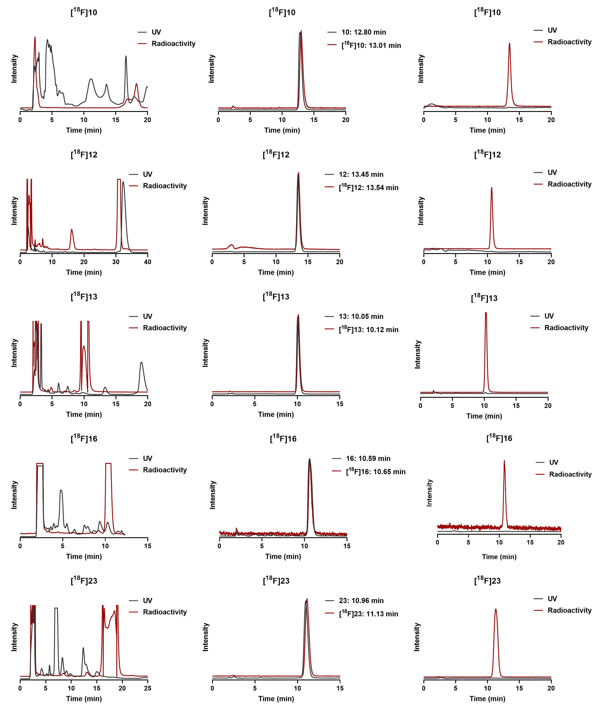
Supplementary Fig. 3 | HPLC chromatograms of ¹⁸F-labeled tracers for purification and quality control. Analysis was performed on an HPLC system (Shimadzu, Japan) equipped with a Venusil MP C18 column (Agela Technologies, 10 μm, 10 mm × 250 mm) at a flow rate of 4.0 mL/min. The left, middle, and right columns display analytical HPLC traces from purification, co-injection, and RCP analysis. Eluent conditions are provided in Supplementary Table 3.

Supplementary Table 3 | HPLC chromatogram data for purification and quality control.
Radiotracers | Eluent: MeCN/H₂O |  | Retention time for  co-injection (min) |  | RCP
Radiotracers | Purification | RCP | UV | Radioactivity | RCP
[¹²⁵I]7 | 60%ª/40% | 60%ª/40% | 15.23 | 15.37 | > 99%
[¹²⁵I]8 | 60%ª/40% | 60%ª/40% | 15.05 | 15.23 | > 99%
[¹²⁵I]9 | 70%/30% | 70%/30% | 14.71 | 14.78 | > 99%
[¹⁸F]10 ([¹⁸F]FT-1) | 45%ª/55% | 50%ª/50% | 12.80 | 13.01 | > 99%
[¹⁸F]12 ([¹⁸F]FT-3) | 30%ª/70% | 40%ª/60%^{b} | 13.45 | 13.54 | > 99%
[¹⁸F]13 ([¹⁸F]FT-4) | 60%ª/40% | 60%ª/40% | 10.05 | 10.12 | > 99%
[¹⁸F]16 ([¹⁸F]FT-5) | 50%ª/50% | 50%ª/50% | 10.59 | 10.65 | > 99%
[¹⁸F]23 ([¹⁸F]FT-8) | 46%ª/54% | 55%ª/45% | 10.96 | 11.13 | > 99%
ª containing 0.1% TEA.
^{b} 40%ª/60% for co-injection analysis and 45%ª/65% for RCP analysis.

Fluorescence staining and pathological confirmation.
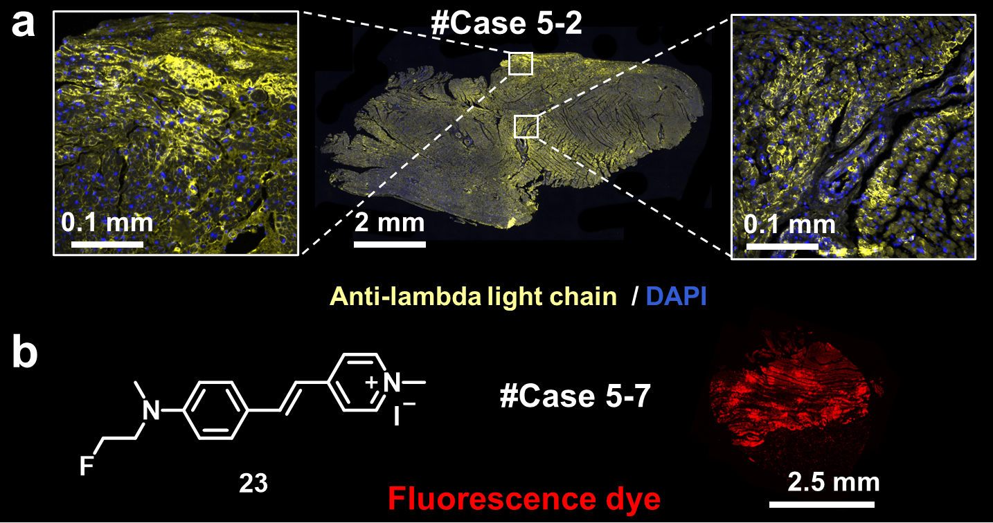
Supplementary Fig. 4 | Fluorescence and immunofluorescence staining. a, Immunofluorescence staining of myocardial slices from #Case 5-2 (AL-CA) using anti-lambda light chain antibody (ab124719, yellow) and nuclear counterstain using DAPI (blue). Merged images and corresponding magnified details are shown in boxes. b, Chemical structure of permeant cationic tracer 23 and fluorescence staining of myocardial sections from #Case 5-7 using fluorescence dye 23 (red).

Measurement of IC₅₀ values to AL deposits.
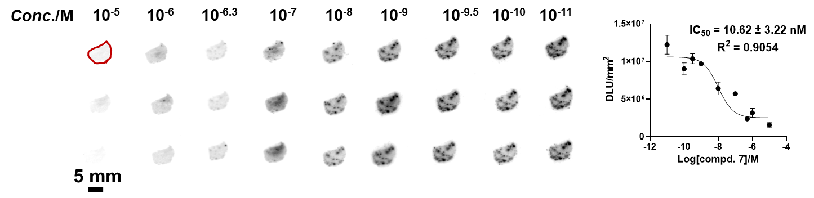
Supplementary Fig. 5 | Competitive binding curve of compound 7 to AL deposits. In vitro autoradiography (ARG) studies were conducted on serial myocardial slices from #Case 5-6 (AL-CA) using [¹²⁵I]7 (74 kBq/mL) as the radioligand. The region of interest (ROI) is indicated by red circles. Scale bar: 5 mm.
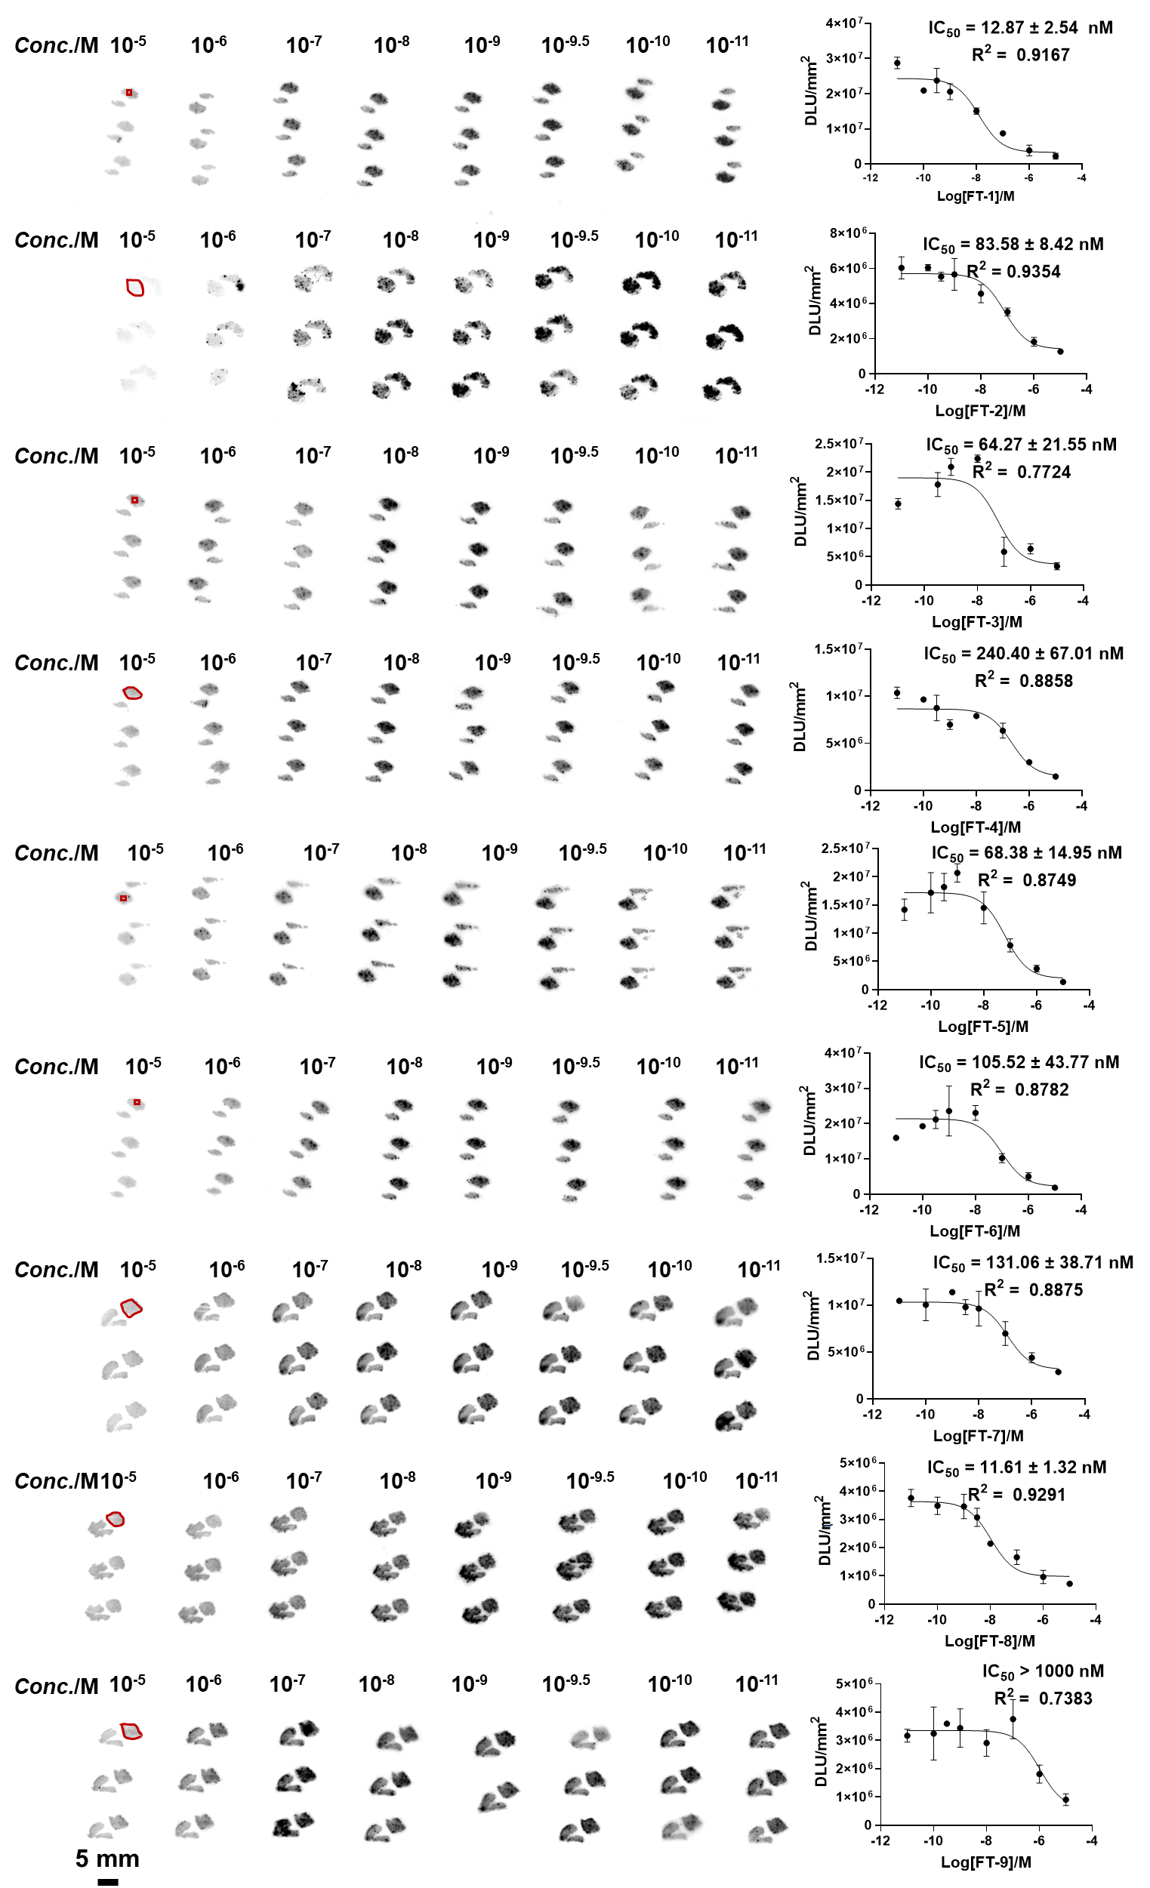
Supplementary Fig. 6 | Competitive binding curves of fluorinated compounds to AL deposits. In vitro ARG studies were conducted on serial myocardial slices from #Case 5-4 (AL-CA) using [¹²⁵I]7 (74 kBq/mL) as the radioligand. Regions of interest (ROIs) are indicated by red circles. Scale bar: 5 mm.

Measurement of inhibition potency.
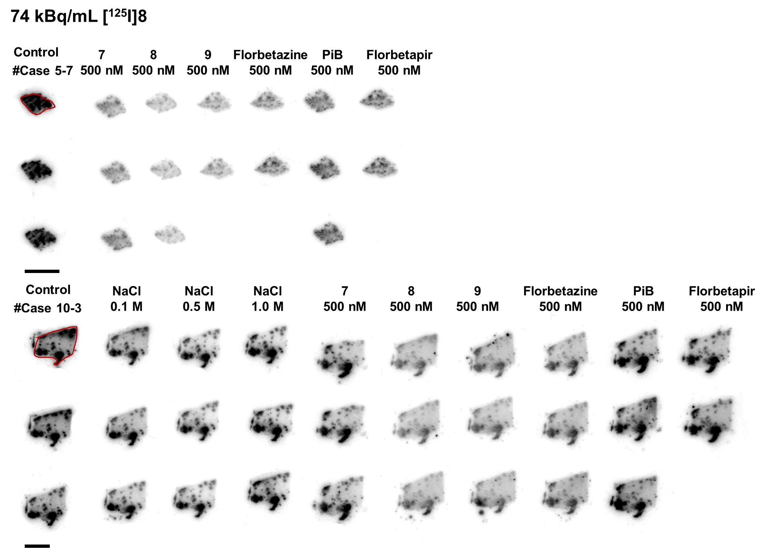
Supplementary Fig. 7 | Binding characteristics of [¹²⁵I]8. Inhibition potency of [¹²⁵I]8 was determined by ARG studies on human myocardial slices from #Case 5-7 (AL-CA) and #Case 10-3 (ATTR-CA). [¹²⁵I]8 was incubated under increasing NaCl conditions, or in the absence (control) or presence of 500 nM of compounds 7-9, Florbetazine, PiB, or Florbetapir. ROIs are indicated by red circles. Scale bar: 5 mm.

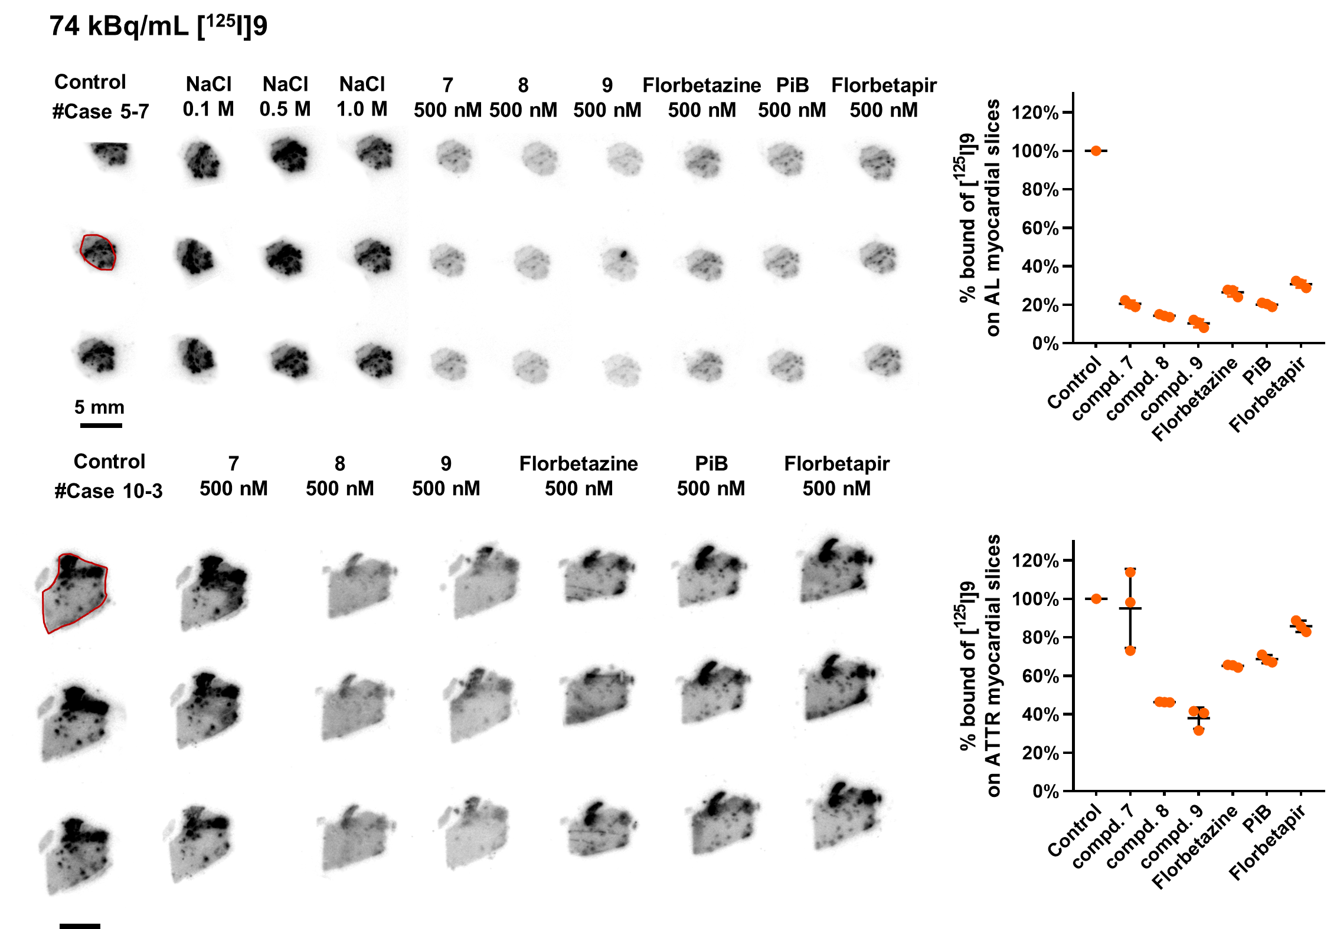
Supplementary Fig. 8 | Binding characteristics of [¹²⁵I]9. Inhibition potency of [¹²⁵I]9 was determined by ARG studies on human myocardial slices from #Case 5-7 (AL-CA) and #Case 10-3 (ATTR-CA). [¹²⁵I]9 was incubated under increasing NaCl conditions, or in the absence (control) or presence of 500 nM of compounds 7-9, Florbetazine, PiB, or Florbetapir. ROIs are indicated by red circles. Scale bar: 5 mm.

PET/CT imaging of ¹⁸F-labeled tracers in SD rats.
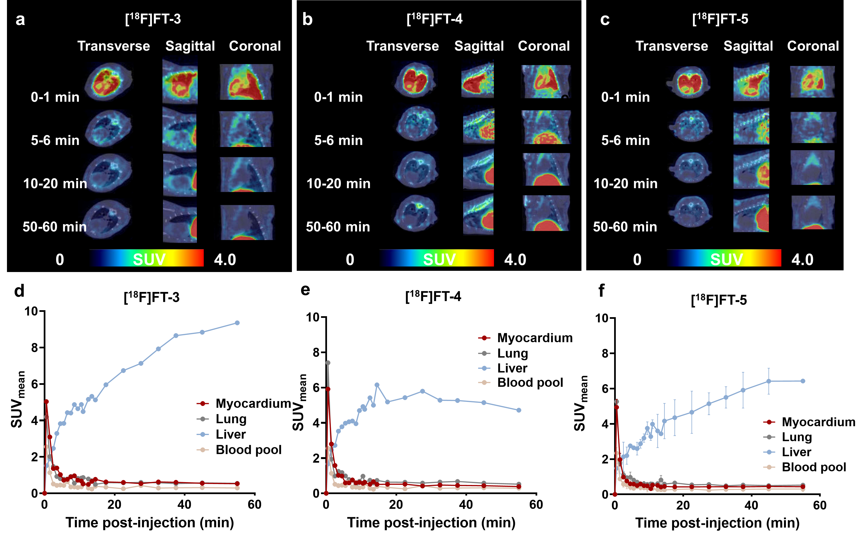
Supplementary Fig. 9 | Dynamic micro-PET/CT imaging in SD rats. Representative PET images in transverse, sagittal and coronal planes acquired at 0-1, 5-6, 10-20, and 50-60 min are shown for [¹⁸F]FT-3 (a; male, 8 weeks old; n = 1), [¹⁸F]FT-4 (b; male, 8 weeks old; n = 1), and [¹⁸F]FT-5 (c; male, 6 weeks old; n = 2). Corresponding time-activity curves (TACs; d-f) illustrate the uptake in myocardium (red), lung (grey), liver (blue), and blood pool (orange).
Supplementary Fig. 10 | Hepatic uptake profiles of ¹⁸F-labeled tracers. Liver uptake in SD rats after injection of [¹⁸F]FT-3 (grey), [¹⁸F]FT-4 (yellow), [¹⁸F]FT-5 (purple), and [¹⁸F]FT-8 (red), as quantified by dynamic PET imaging at 0-1, 14-15, and 50-60 min.

ARG images of ¹⁸F-labeled tracers.
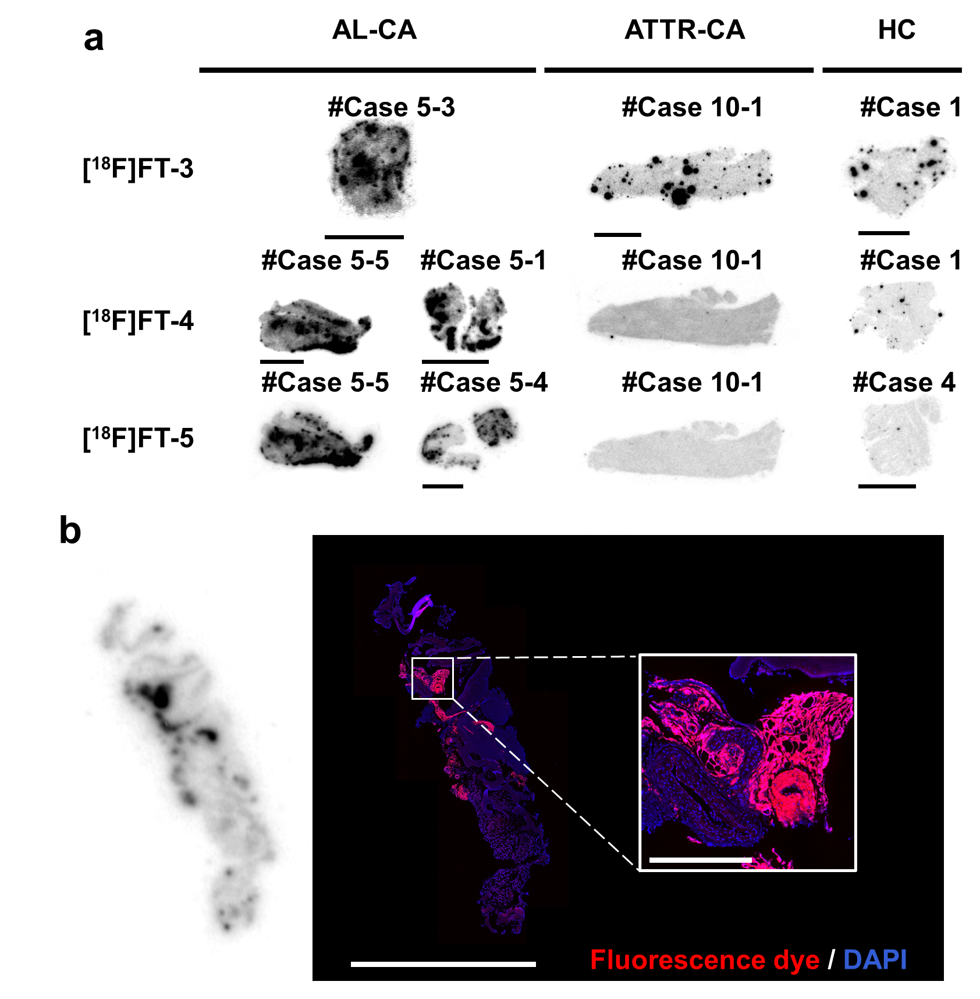
Supplementary Fig. 11 | ARG images of ¹⁸F-labeled tracers. a, ARG images of myocardial slices from various cases using [¹⁸F]FT-3, [¹⁸F]FT-4, and [¹⁸F]FT-5. b, ARG images of myocardial slices from #Case 14 (plasmacytoma with light chain restriction) using [¹⁸F]FT-8 and merged fluorescence images showing 23 (red) and DAPI (blue), with corresponding high-magnification detail. Scale bars for full and magnified views of the boxed regions are 5 mm and 0.5 mm, respectively.

NMR and HRMS spectra.
¹H NMR spectrum of compound 1
¹H NMR spectrum of compound 2
¹H NMR spectrum of compound 3
¹H NMR spectrum of compound 4
¹H NMR spectrum of compound 5
¹H NMR spectrum of compound 6
¹H NMR spectrum of compound 7
¹³C NMR spectrum of compound 7
HRMS spectrum of compound 7
¹H NMR spectrum of compound 8
¹³C NMR spectrum of compound 8
HRMS spectrum of compound 8
¹H NMR spectrum of compound 9
¹³C NMR spectrum of compound 9
HRMS spectrum of compound 9
¹H NMR spectrum of compound 10
¹³C NMR spectrum of compound 10
¹⁹F NMR spectrum of compound 10
HRMS spectrum of compound 10
¹H NMR spectrum of compound 11
¹³C NMR spectrum of compound 11
¹⁹F NMR spectrum of compound 11
HRMS spectrum of compound 11
¹H NMR spectrum of compound 12
¹³C NMR spectrum of compound 12
¹⁹F NMR spectrum of compound 12
HRMS spectrum of compound 12
¹H NMR spectrum of compound 13
¹³C NMR spectrum of compound 13
¹⁹F NMR spectrum of compound 13
HRMS spectrum of compound 13
¹H NMR spectrum of compound 14
¹H NMR spectrum of compound 15
¹H NMR spectrum of compound 16
¹⁹F NMR spectrum of compound 16
¹³C NMR spectrum of compound 16
HRMS spectrum of compound 16
¹H NMR spectrum of compound 17
¹H NMR spectrum of compound 18
¹³C NMR spectrum of compound 18
¹⁹F NMR spectrum of compound 18
HRMS spectrum of compound 18
¹H NMR spectrum of compound 19
¹H NMR spectrum of compound 20
¹³C NMR spectrum of compound 20
¹⁹F NMR spectrum of compound 20
HRMS spectrum of compound 20
¹H NMR spectrum of compound 21
¹H NMR spectrum of compound 22
¹H NMR spectrum of compound 23
¹³C NMR spectrum of compound 23
¹⁹F NMR spectrum of compound 23
HRMS spectrum of compound 23
¹H NMR spectrum of compound 24
¹H NMR spectrum of compound 25
¹H NMR spectrum of compound 26
¹³C NMR spectrum of compound 26
¹⁹F NMR spectrum of compound 26
HRMS spectrum of compound 26
¹H NMR spectrum of compound 27
¹H NMR spectrum of compound 28
¹H NMR spectrum of compound 29
¹H NMR spectrum of compound 30
¹H NMR spectrum of compound 31
¹H NMR spectrum of compound 32
¹H NMR spectrum of compound 33

