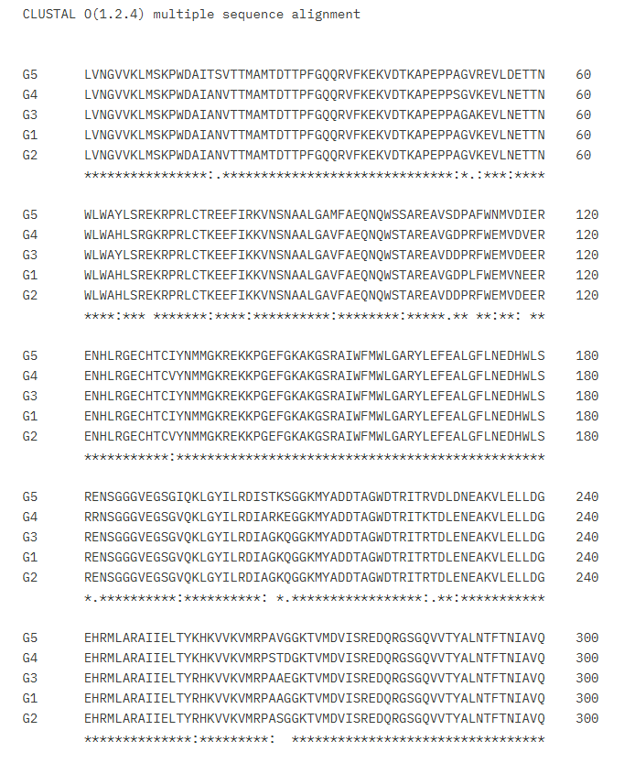
S1. Multiple sequence alignment of RdRp Domain across the JEV genotype

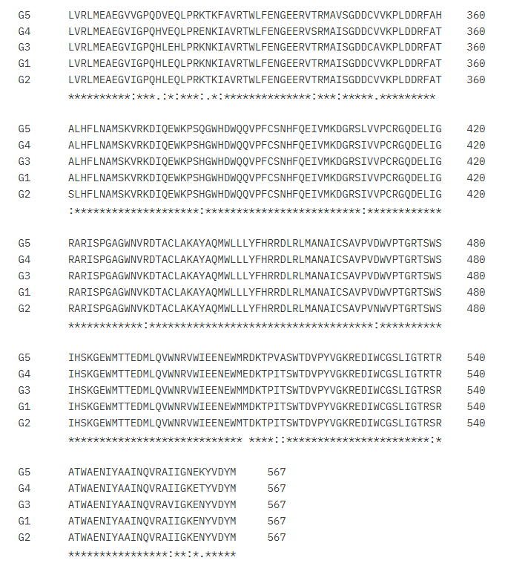
Cont.…
S1. Multiple sequence alignment of the RdRp Domain across the JEV genotype

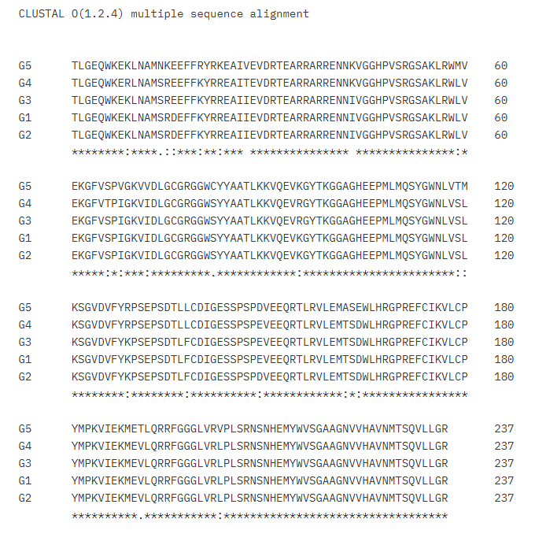

S2. Multiple Sequence alignment of the MTase Domain across the JEV genotype

