Supplementary Figure 1 : Boxplot of two α-diversity indexes, Chao1 and Shannon, according to the specimen stages (A,B), the species (C,D) and the site (E,F) for the first metabarcoding analysis (R. chacei and R. exoculata juvenile specimens and R. exoculata adult from BICOSE2 cruise).

Supplementary Figure 2 : PCoA ordination plot of the bacterial diversity for the first metabarcoding analysis R. chacei and R. exoculata juvenile specimens and R. exoculata adult from BICOSE2 cruise). (A,C,E) PCoA ordination plot of the bacterial diversity based on Unifrac distance at the ASV level and colored according to the site (A), species (C) and life stage (E). (B,D,F) PCoA ordination plot of the bacterial diversity based on Weighted Unifrac distance at the ASV level and colored according to the site (B), species (D) and life stage (F). Ellipses represent 95% confidence interval for each group.

Supplementary Figure 3 : Boxplot of two α-diversity indexes, Chao1 and Shannon, according to the specimen stages (A,B) and the species (C,D) for the second metabarcoding analysis (R. chacei and R. exoculata adult specimens from BICOSE2014 cruise).

Supplementary Figure 4 : PCoA ordination plot of the bacterial diversity for the second metabarcoding analysis (R. chacei and R. exoculata adult specimens from BICOSE2014 cruise). (A,C) PCoA ordination plot of the bacterial diversity based on Unifrac distance at the ASV level and colored according to the site (A) and species (C). (B,D) PCoA ordination plot of the bacterial diversity based on Weighted Unifrac distance at the ASV level and colored according to the site (B) and species (D). Ellipses represent 95% confidence interval for each group.
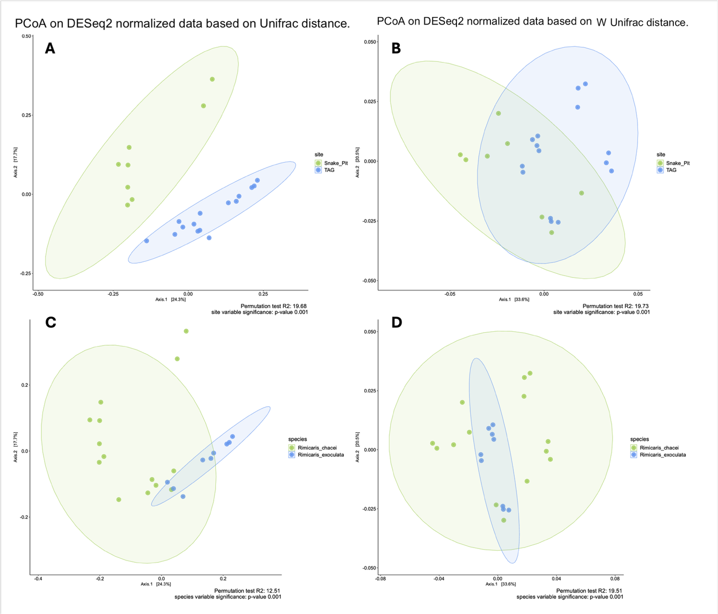

Supplementary Figure 5 : Bacterial composition at the order-level in the midgut tube samples of shrimp at different species and sites for the second metabarcoding analysis (R. chacei and R. exoculata adult specimens from BICOSE2014 cruise).
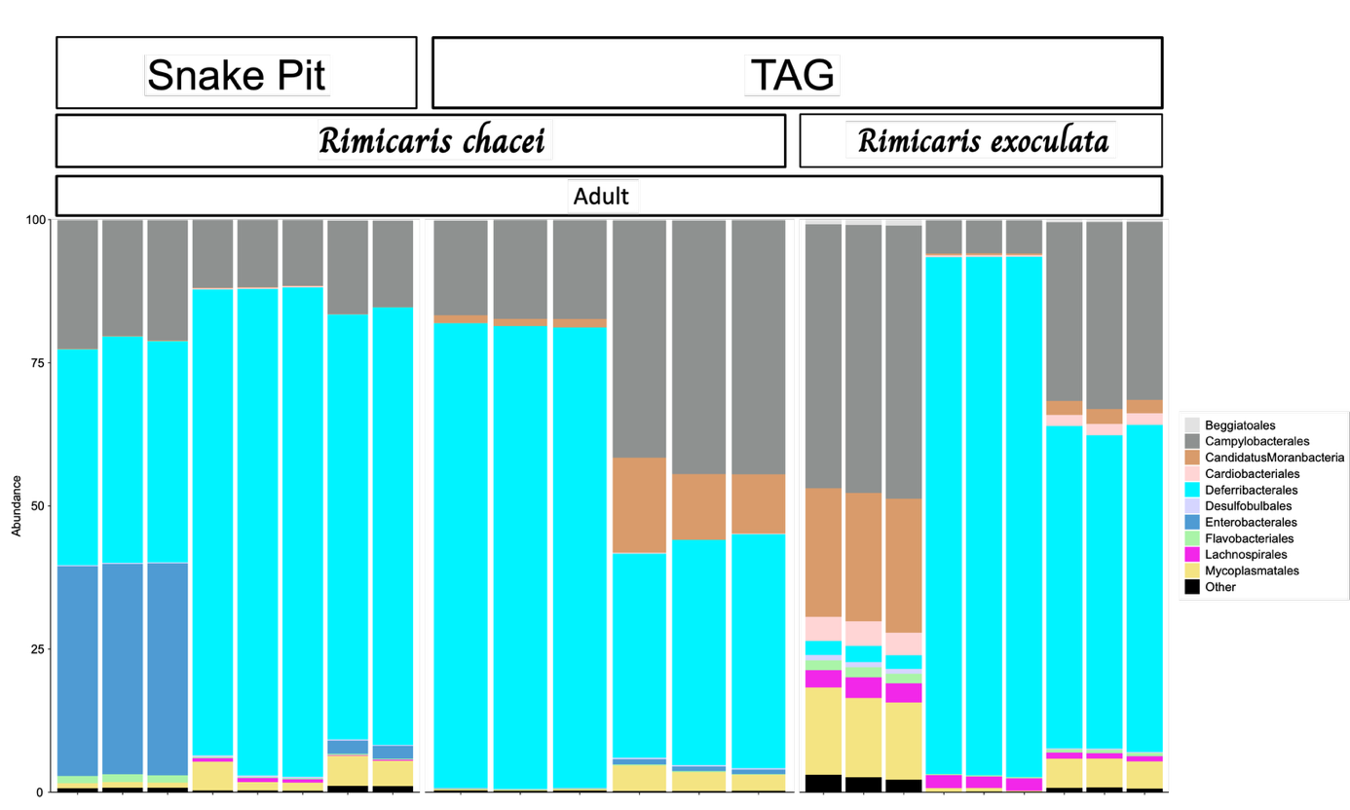
Supplementary Figure 6 : Probe specificity and optimal hybridization. A and B represent the branchiostegite of a R. exoculata subadult specimen. (A) Campylobacteria were hybridized with the specific probe Epsy549-Cy5 (green), Gammaproteobacteria were hybridized with the specific probe GAM42a-Cy5 (red) and Lachnospirales were hybridized with the specific probe Clostri-Lachno109-Cy3 (yellow, no hybridization). (B) is the same photography as the A, with only the canal Cy3. There is not hybridization with the probe Clostri109 on bacteria. C and D represent sections of an adult R. exoculata specimen midgut tube. (C) Candidatus Microvillispirillaceae were hybridized with the specific probe Def1229-Cy5 (red) and Lachnospirales were hybridized with the specific probe Clostri-Lachno109-Cy3 (yellow). (D) Bacteria were hybridized with the universal probe Eub388-Cy5 (red) and Lachnospirales were co-hybridized with the specific probe Clostri-Lachno109-Cy3 and Eub338-Cy5(orange). All the photography were taken with the Apotome ® (and DIC only for D) and epithelium nuclei cells were labelled with DAPI. Scale bars = 20 μm).

