Correlations of [¹¹C]PiB, [¹¹C]PK11195 and structural imaging variables
Table S1. Correlations between imaging variables in the whole sample
 | Cortex | HC | PHC | ER | AMY |  | PIB
PIB | 0.061 | -0.22 | -0.21 | -0.11 |  | 0.017
PK | 0.27* | 0.061 | 0.029 | -0.059 |  | 0.26 | -0,02
Cortex=Cerebral cortex volume, HC=Hippocampus volume, PHC=Parahippocampus volume, ER=Entorhinal volume, Amy=Amygdala volume, PIB=[¹¹C]PiB score, PK=[¹¹C]PK11195 DVR,* = p < 0.05

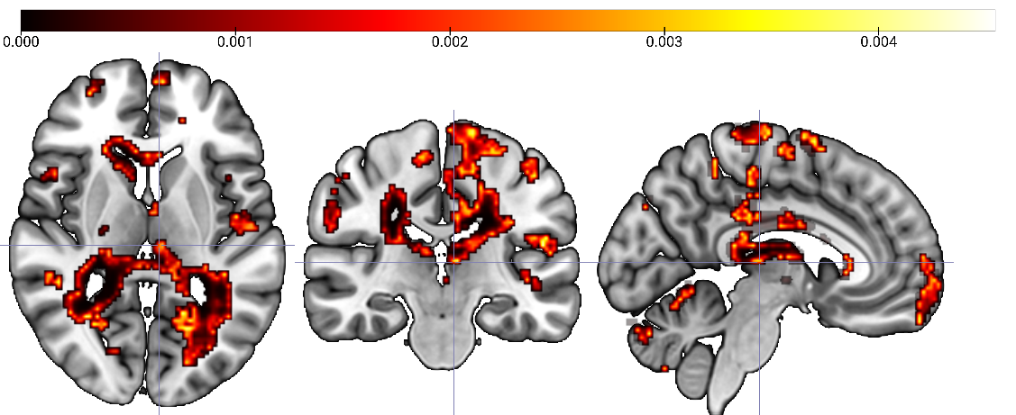
Figure S1 Voxel-level correlations between [¹¹C]PiB and [¹¹C]PK11195 in the whole sample. The colour scale shows the p-value of the cluster.

Structural MRI

Table S2. Volumetric MRI results
 |  | ABI3^{S209F}/ε4 | ABI3^{S209F}/ε3 | NC | Group difference
Cerebral Cortex Volume | Mean (sd) | 436.6 (34.5) | 425.6 (39.6) | 423.3 (35.7) | 0.30
Entorhinal volume | Mean (sd) | 3.9 (0.6) | 4.0 (0.7) | 3.8 (0.6) | 0.47
Parahippocampal volume | Mean (sd) | 3.9 (0.4) | 3.9 (0.3) | 4.0 (0.6) | 0.50
Amygdala volume | Mean (sd) | 3.1 (0.4) | 3.2 (0.5) | 3.0 (0.5) | 0.57
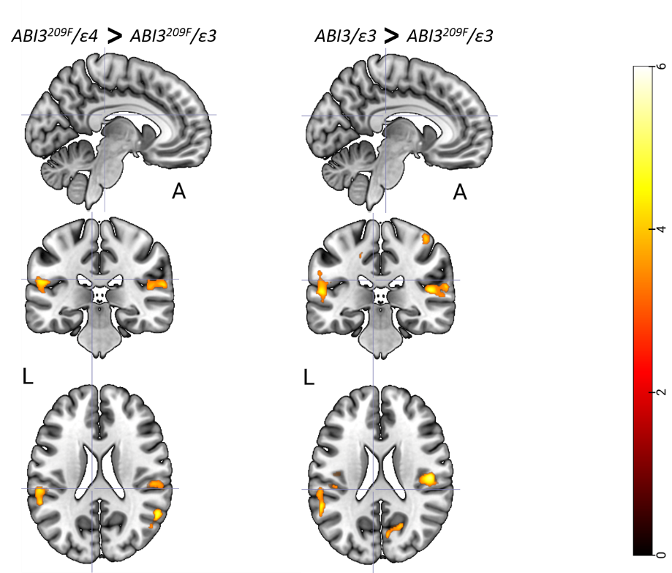
Figure S2 ABI3^{S209F}/ε3 group had lower grey matter volume than the ABI3^{S209F}/ε4 and NC. FDR corrected p<0.001 in red-yellow.

