Supplementary Figure 1. Data quality control flow chart with exclusion criteria.

(a) | 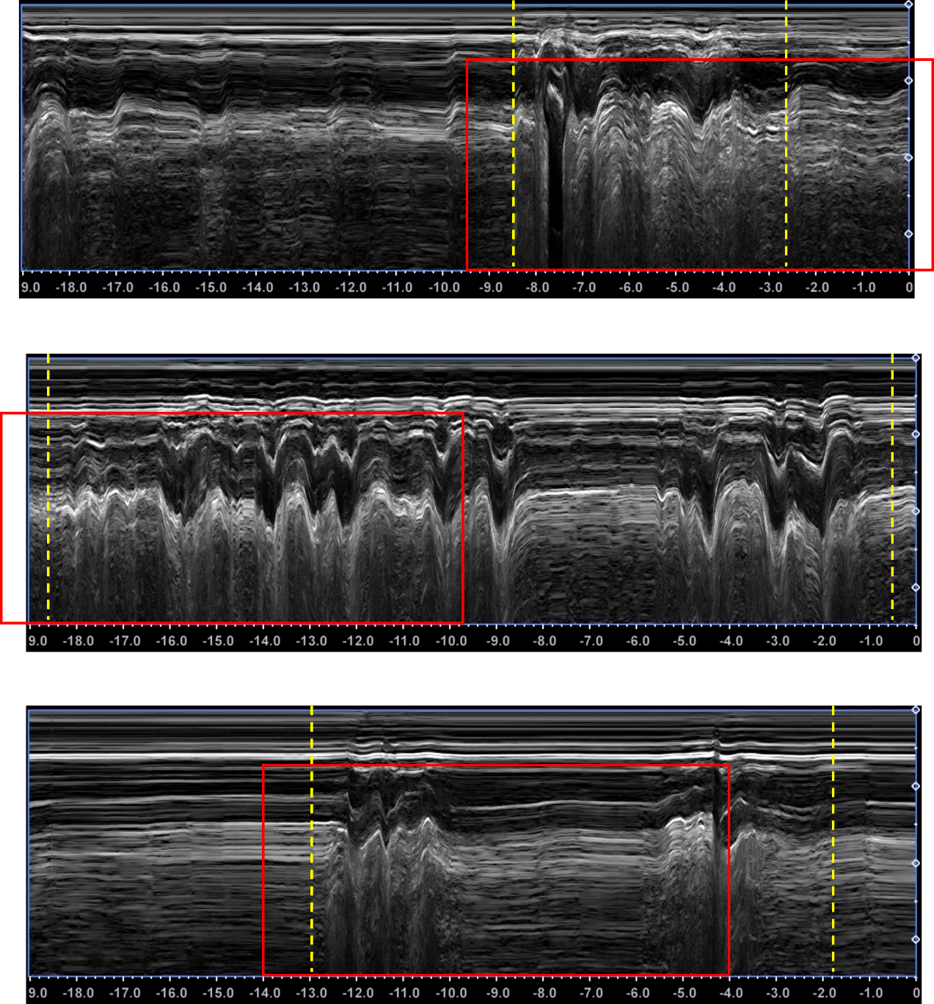
(b)
(c)
Supplementary Figure 2. Examples of M-mode ultrasound image quality control criteria. Dashed boxes indicate the standardized 10 s recording window; solid vertical lines indicate swallowing process boundaries (onset to offset) annotated by sonographer. (a) Excluded image: Incomplete swallowing process - the full 10 s recording window (1 s before swallowing onset + swallowing duration) could not be captured completely. (b) Excluded image: Preparation time shorter than 1 s - inadequate baseline period before swallowing onset. (c) Excluded image: Total swallowing duration exceeding 9 s - swallowing process too prolonged to fit within the standardized 10 s window.

(a)
(b)
Supplementary Figure 3. QMD parameter extraction process. (a) M-mode ultrasound image; (b) QMD measurement setup showing 10 horizontal measurement lines positioned at different anatomical levels. Solid vertical lines indicate swallowing process boundaries; dashed vertical lines indicate the first and last intersection points of the muscle boundary with each horizontal line. QMD features represent the temporal duration between these intersection points at each anatomical level. Parameter names (right) correspond to each measurement line (sup: superior, ref: reference, inf: inferior).

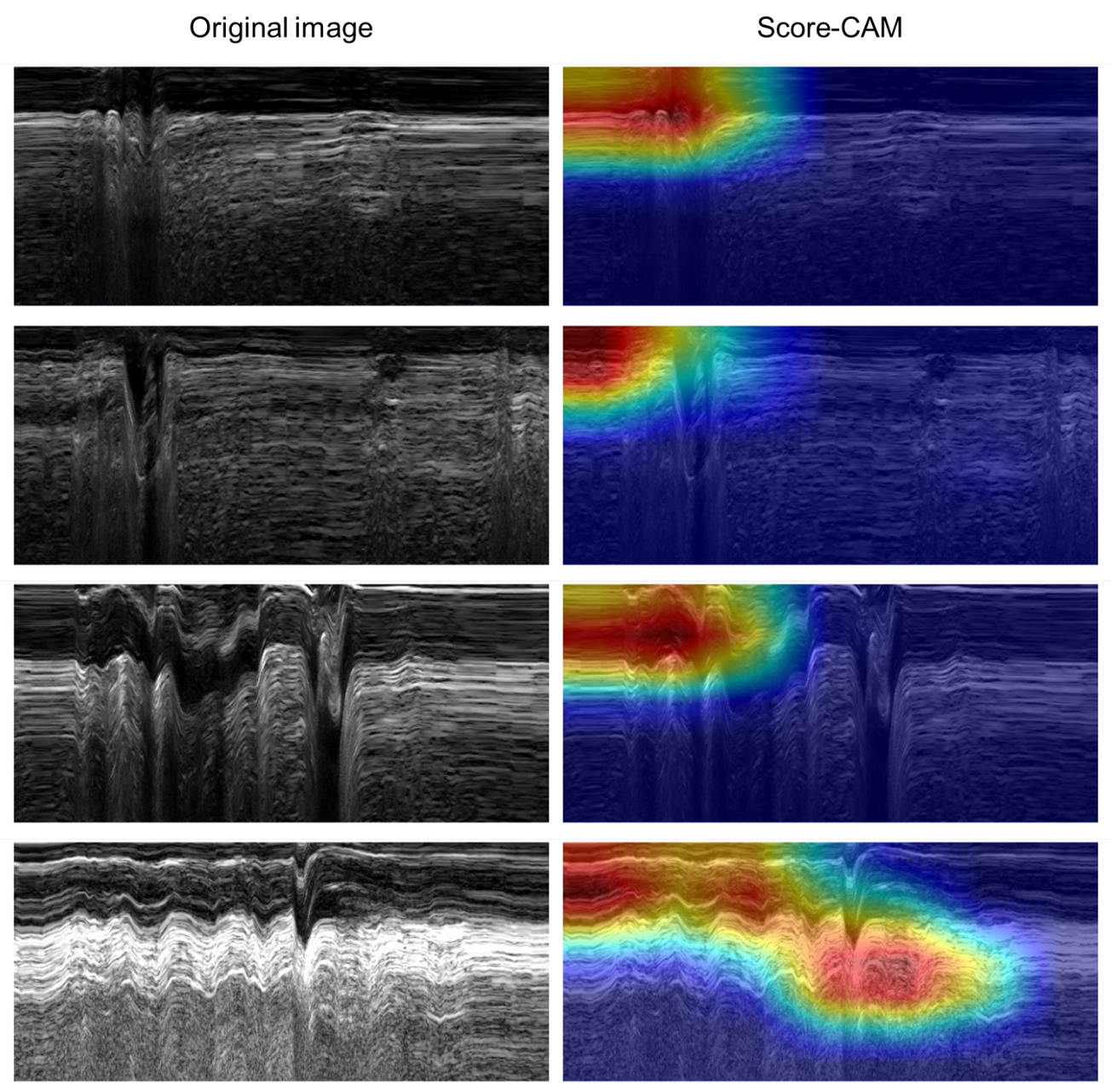
(a)
(b)
(c)
(d)
Supplementary Figure 4. Score-CAM visualizations for the image-only model: (a) True negative (correct mild prediction), (b) False positive (mild predicted as severe), (c) False negative (severe predicted as mild), (d) True positive (correct severe prediction). Heatmaps highlight anatomically relevant regions contributing to model decisions.

