Supplementary Data
Associations between Cognitive Frailty and Circulating Cardiovascular Biomarkers in a Memory Clinic
Xin Tong Tan, BSocSci^{a,b}; Joyce R. Chong, PhD^{a,b}; Eddie J.Y. Chong, BSocSci^{a,b}; Ming Ann Sim, MBBS^{a,b,c}; Jiangbo Cui, MMed^{a,b}; Siew Pang Chan, PhD^{d,e}; Oi Wah Liew, PhD^{d,e}; Boon Yeow Tan, MMed^{f}; Narayanaswamy Venketasubramanian, MMed^{a,g}; Arthur Mark Richards, DSc^{d,e,h}; Mitchell K. P. Lai, PhD^{a,b}; Christopher Li-Hsian Chen, BMBCh^{a,b}
ª Memory, Ageing & Cognition Centre, National University Health System, Singapore
^{b} Department of Pharmacology, Yong Loo Lin School of Medicine, National University of Singapore, Singapore, Singapore.
^{c} Department of Intensive Care Medicine, Ng Teng Fong General Hospital & Department of Anesthesia, National University Health System, Singapore, Singapore.
^{d} Cardiovascular Research Institute, Department of Medicine, Yong Loo Lin School of Medicine, National University of Singapore, National University Health System, Singapore, Singapore.
^{e} Department of Cardiology, National University Heart Centre, Singapore, Singapore.
^{f} Department of Medicine, St Luke's Hospital, Singapore, Singapore.
^{g} Raffles Neuroscience Centre, Raffles Hospital, Singapore, Singapore.
^{h} Christchurch Heart Institute, University of Otago, Christchurch, New Zealand.
Journal: European Geriatric Medicine
Correspondence
Christopher L.H. Chen, FRCPE Department of Pharmacology, Yong Loo Lin School of Medicine Centre for Translational Medicine (MD6), Unit 09-01, 14 Medical Drive, S117599 Singapore, Singapore. E-mail: phccclh@nus.edu.sg

Content:
Supplementary Methods S1. Supplementary details on cognitive tests covering six domains
Supplementary Table S1. List of the 30 items included in Frailty Index (FI)
Supplementary Table S2. Associations between CF (using both FI ≥0.18 and FI ≥0.21 thresholds) and Plasma Biomarkers after adjusting for age, sex, education, and cardiovascular disease
Supplementary Figure S1. Plasma Biomarker concentrations stratified by stricter CF status (CF = CDR 0.5 and FI > 0.21)
Supplementary Table S3. Multivariable linear regression models examining the independent and interactive effects of Frailty (FI score) and MCI status (CDR score) on log-transformed cardiovascular biomarker levels, adjusted for age, sex, education, and cardiovascular disease
Supplementary Figure S2. Interaction between MCI status (CDR score) and Frailty (FI score) on log-transformed GDF-15 levels, adjusted for age, sex, and education
Supplementary Figure S3. Interaction between MCI status (CDR score) and Frailty (FI score) on log-transformed hs-cTnT levels, adjusted for age, sex, and education
Supplementary Table S4. Linear mixed-effects models of two-way interactions on longitudinal cognition Z-scores, adjusted for covariates
Supplementary Table S5. Linear mixed-effects models of CF × cardiac biomarker × time on longitudinal cognition Z-scores, adjusted for covariates

Supplementary Methods S1. Supplementary details on cognitive tests covering six domains
Cognitive assessment covered six domains. Attention was assessed using the Digit Span (forward and backward) [1]. Language was evaluated with the 15-item modified Boston Naming Test [2]. Executive function was tested using Verbal Fluency and the Colour Trails Test (parts A and B) [3,4]. Visuomotor speed was measured with the Symbol Digit Modalities Test [5], while visuospatial ability was assessed with the Rey Complex Figure Test (copy trial) [6]. Memory was evaluated with the Rey Complex Figure Test (immediate and delayed recall, and recognition) as well as the Hopkins Verbal Learning Test (immediate and delayed recall, and recognition) [6,7].
Raw scores from each test were transformed into standardized Z-scores using the mean and standard deviation of a cognitively unimpaired reference group. For each of the six cognitive domains (memory, attention, visuomotor speed, visuospatial function, executive function, and language), domain Z-scores were calculated by averaging the Z-scores of the relevant tests. These domain scores were then re-standardized against the reference group, following previously published method [8]. Global cognition scores were derived by averaging domain-specific Z-scores and re-standardizing them against the control group mean and standard deviation. At follow-up, both global and domain Z-scores were calculated using baseline control group parameters.

Supplementary Table S1. List of the 30 items included in Frailty Index (FI)
Health-Related Variable included | Recoded 0 (no deficit) through 1 (deficit)
transient ischemic attack | 0 absent 1 present
diabetes | 0 absent 1 present
thyroid disease | 0 absent 1 present
memory loss | 0 absent 1 present
dementia diagnosis | 0 no dementia 1 demented
ability to Feed oneself | 0 independent 0.5 Needs help 1 unable
ability to Bathe oneself | 0 Independent 1 Needs help
ability to Groom oneself | 0 Independent 1 Needs help
ability to Dress oneself | 0 independent 0.5 Needs help 1 unable
ability to control Bowels | 0 independent 0.5 Needs help 1 unable
ability to control Bladder | 0 independent 0.5 Needs help 1 unable
ability to use the toilet | 0 independent 0.5 Needs help 1 unable
ability to climb stairs | 0 independent 0.5 Needs help 1 unable
ability to Transfer oneself | 1 unable 0.67 major help 0.33 minor help 0 independent
mobility | 1 unable 0.67 major help 0.33 minor help 0 independent
heart attack | 0 absent 1 present
congestive heart failure | 0 absent 1 present
hyperlipidaemia | 0 absent 1 present
B12 deficiency: | 0 absent 1 present
neurological conditions | 0 absent 1 present
arterial fibrillation | 0 absent 1 present
stroke | 0 absent 1 present
diagnosed hypertension | 0 absent 1 present
high Systolic blood pressure | 0 not high blood pressure (< 140) 1 high blood pressure (>= 140)
high diastolic blood pressure | 0 not high blood pressure (< 90) 1 high blood pressure (>= 90)
body mass index | 0 not underweight 1 underweight (<18.5 BMI)
initiation to decide what to eat | 0 yes 1 no
planning of appropriate utensil to use | 0 yes 1 no
initiation of toilet usage at appropriate time | 0 yes 1 no
ability to choose appropriate clothing | 0 yes 1 no

Supplementary Table S2. Associations between CF (using both FI ≥0.18 and FI ≥0.21 thresholds) and Plasma Biomarkers after adjusting for age, sex, education, and cardiovascular disease
Outcome (log-transformed biomarker) | CF defined as CDR 0.5 and FI ≥ 0.18 | CF defined as CDR 0.5 and FI ≥ 0.21
 | β (95% CI) | β (95% CI)
NT-proBNP | 0.20 (0.06 – 0.34) ** | 0.31 (0.10 – 0.52) **
GDF-15 | 0.12 (0.04 – 0.21) ** | 0.15 (0.02 – 0.27) *
hs-cTnT | 0.10 (0.01 – 0.18) * | 0.17 (0.05 – 0.29) **

Note. Multivariable linear regression models were conducted with each log-transformed biomarker as the dependent variable and cognitive frailty status as the primary independent variable. CF was defined either as CDR = 0.5 and FI ≥ 0.18 or CDR = 0.5 and FI ≥ 0.21. All models were adjusted for age, sex, years of education, and cardiovascular disease (CVD). CVD was defined as a history of myocardial infarction, atrial fibrillation, or congestive heart failure. Abbreviations: NT-proBNP = N-terminal pro–B-type natriuretic peptide; GDF-15 = growth differentiation factor 15; hs-cTnT = high-sensitivity cardiac troponin T. Asterisks denote statistical significance: *p < 0.05; **p < 0.01; ***p < 0.001.
Supplementary Figure S1. Plasma Biomarker concentrations stratified by stricter CF status (CF = CDR 0.5 and FI ≥ 0.21)
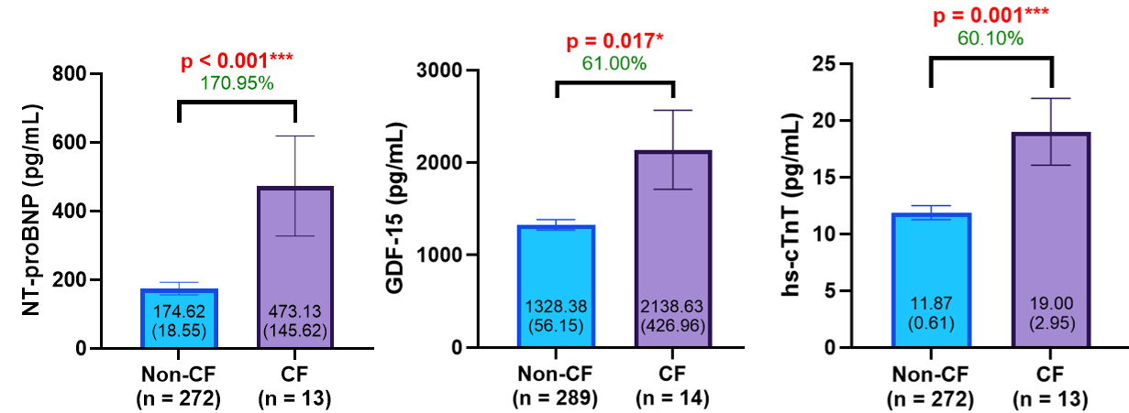

Note. CF was defined as the presence of both CDR 0.5 and a Frailty Index score ≥ 0.21. For visualization purposes, bars represent group means with whiskers indicating the standard error of the mean (SEM). Mean (SEM) values are also displayed within each bar. P-values were derived using the Mann–Whitney U test. Percentage differences were calculated as: ((mean of CF – mean of non-CF) / mean of non-CF) × 100. Abbreviations: CF, cognitive frailty; NT-proBNP, N-terminal pro–B-type natriuretic peptide; GDF-15, growth differentiation factor 15; hs-cTnT, high-sensitivity cardiac troponin T. Asterisks indicate statistical significance: * p < 0.05; ** p < 0.01; *** p < 0.001.

Supplementary Table S3. Multivariable linear regression models examining the independent and interactive effects of Frailty (FI score) and MCI status (CDR score) on log-transformed cardiovascular biomarker levels, adjusted for age, sex, education, and cardiovascular disease
 |  | Model 1: without interaction term | Model 2: with interaction term
Outcome | Predictors | β (95% CI) | β (95% CI)
NT-proBNP | CDR 0.5 | 0.08 (-0.00 – 0.17) | -0.10 (-0.30 – 0.10)
NT-proBNP | FI score | 1.19 (0.43 – 1.96) ** | 0.61 (-0.36 – 1.57)
NT-proBNP | CDR score X FI score | - | 1.46 (0.01 – 2.91) *
GDF-15 | CDR 0.5 | -0.03 (-0.07 – 0.02) | -0.06 (-0.18 – 0.05)
GDF-15 | FI score | 1.58 (1.14 – 2.01) *** | 1.45 (0.90 – 2.00) ***
GDF-15 | CDR score X FI score | - | 0.30 (-0.52 – 1.12)
hs-cTnT | CDR 0.5 | -0.02 (-0.07 – 0.03) | -0.03 (-0.15 – 0.08)
hs-cTnT | FI score | 1.13 (0.69 – 1.58) *** | 1.10 (0.53 – 1.66) ***
hs-cTnT | CDR score X FI score | - | 0.08 (-0.76 – 0.93)

Note. Model 1 includes the main effects of frailty (continuous Frailty Index score) and cognitive status (CDR 0.5, with CDR 0 as the reference); Model 2 additionally includes the interaction term (FI × CDR). All models are adjusted for age, sex, years of education, and cardiovascular disease, defined as a history of myocardial infarction, atrial fibrillation, or congestive heart failure. Abbreviations: NT-proBNP, N-terminal pro–B-type natriuretic peptide; GDF-15, growth differentiation factor 15; hs-cTnT, high-sensitivity cardiac troponin T; CDR, Clinical Dementia Rating; FI, Frailty Index. Asterisks denote statistical significance: *p < 0.05; **p < 0.01; ***p < 0.001.

Supplementary Figure S2. Interaction between MCI status (CDR score) and Frailty (FI score) on log-transformed GDF-15 levels, adjusted for age, sex, and education
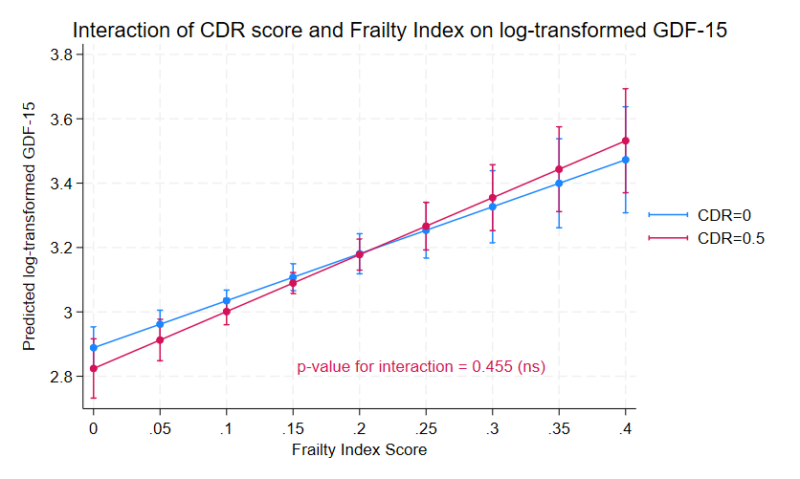

Note. Lines depict predicted plasma GDF-15 values across the FI continuum, stratified by CDR status (0 vs. 0.5). Vertical bars represent 95% confidence intervals. Abbreviations: CDR, Clinical Dementia Rating; GDF-15, growth differentiation factor 15; 95% CI, 95% confidence intervals.

Supplementary Figure S3. Interaction between MCI status (CDR score) and Frailty (FI score) on log-transformed hs-cTnT levels, adjusted for age, sex, and education
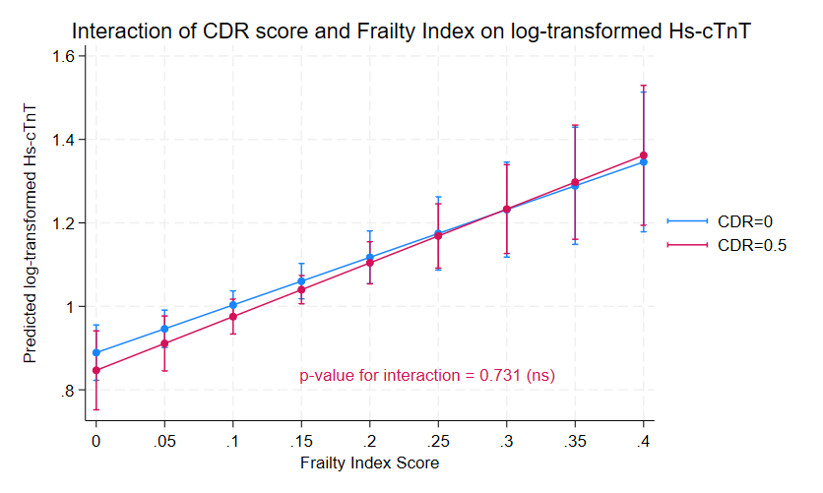

Note. Lines depict predicted plasma hs-cTnT values across the FI continuum, stratified by CDR status (0 vs. 0.5). Vertical bars represent 95% confidence intervals. Abbreviations: CDR, Clinical Dementia Rating; hs-cTnT, high-sensitivity cardiac troponin T; 95% CI, 95% confidence intervals.

Supplementary Table S4. Linear mixed-effects models of two-way interactions on longitudinal cognition Z-scores, adjusted for covariates
Predictor  (Interaction Term) | CF x Time  β (95% CI) | NT-proBNP x Time  β (95% CI) | GDF-15 x Time  β (95% CI) | Hs-cTnT x Time  β (95% CI)
Model 1 | -0.15  (-0.27 to -0.03) * | -0.15  (-0.24 to -0.05) ** | -0.22  (-0.37 to -0.06) ** | -0.34  (-0.51 to -0.18) ***
Model 2 | -0.15  (-0.27 to -0.03) * | -0.15  (-0.24 to -0.06) ** | -0.22  (-0.38 to -0.06) ** | -0.34  (-0.51 to -0.17) ***

Note. The outcome variable for all models is global cognition Z-scores from baseline to year 5. All plasma biomarkers have been log-transformed and included as a continuous variable. Results from Model 1 are adjusted for age, sex, and education. Results from Model 2 are adjusted for age, sex, education, cardiovascular disease (history of myocardial infarction, atrial fibrillation, or congestive heart failure), and baseline global cognition Z-score. Abbreviations: NT-proBNP, N-terminal pro–B-type natriuretic peptide; GDF-15, growth differentiation factor 15; hs-cTnT, high-sensitivity cardiac troponin T. Asterisks indicate statistical significance: *p < 0.05; **p < 0.01; ***p < 0.001.

Supplementary Table S5. Linear mixed-effects models of CF × cardiac biomarker × time on longitudinal cognition Z-scores, adjusted for covariates
Predictor  (Interaction Term) | NT-proBNP  β (95% CI) | GDF-15  β (95% CI) | Hs-cTnT  β (95% CI)
Model 1
CF x Time | 0.52 (-0.08 to 1.12) | -1.07 (-2.54 to 0.40) | 0.24 (-0.33 to 0.80)
Plasma biomarker x Time | -0.08 (-0.18 to 0.03) | -0.22 (-0.39 to -0.05) * | -0.27 (-0.45 to -0.08) **
CF x Plasma biomarker x Time | -0.27 (-0.53 to -0.01) * | 0.30 (-0.16 to 0.76) | -0.28 (-0.76 to 0.19)
Model 2
CF x Time | 0.52 (-0.09 to 1.15) | -1.11 (-2.63 to 0.41) | 0.22 (-0.36 to 0.80)
Plasma biomarker x Time | -0.08 (-0.19 to 0.03) | -0.23 (-0.41 to -0.05) * | -0.27 (-0.46 to -0.08) **
CF x Plasma biomarker x Time | -0.27 (-0.54 to -0.01) * | 0.31 (-0.16 to 0.79) | -0.27 (-0.76 to 0.22)
Note. The outcome variable for all models is global cognition Z-scores from baseline to year 5. All plasma biomarkers have been log-transformed and included as a continuous variable. Results from Model 1 are adjusted for age, sex, and education. Results from Model 2 are adjusted for age, sex, education, cardiovascular disease (history of myocardial infarction, atrial fibrillation, or congestive heart failure), and baseline global cognition Z-score. Abbreviations: NT-proBNP, N-terminal pro–B-type natriuretic peptide; GDF-15, growth differentiation factor 15; hs-cTnT, high-sensitivity cardiac troponin T. Asterisks indicate statistical significance: *p < 0.05; **p < 0.01; ***p < 0.001.

References.
[1] Wambach D, Lamar M, Swenson R, Penney DL, Kaplan E, Libon DJ. Digit Span. Encycl. Clin. Neuropsychol., Springer, New York, NY; 2011, p. 844–9. https://doi.org/10.1007/978-0-387-79948-3_1288.
[2] Mack WJ, Freed DM, Williams BW, Henderson VW. Boston Naming Test: shortened versions for use in Alzheimer’s disease. J Gerontol 1992;47:P154-158. https://doi.org/10.1093/geronj/47.3.p154.
[3] McKhann G, Drachman D, Folstein M, Katzman R, Price D, Stadlan EM. Clinical diagnosis of Alzheimer’s disease: report of the NINCDS-ADRDA Work Group under the auspices of Department of Health and Human Services Task Force on Alzheimer’s Disease. Neurology 1984;34:939–44. https://doi.org/10.1212/wnl.34.7.939.
[4] Tyburski E, Karabanowicz E, Mak M, Lebiecka Z, Samochowiec A, Pełka-Wysiecka J, et al. Color Trails Test: A New Set of Data on Cognitive Flexibility and Processing Speed in Schizophrenia. Front Psychiatry 2020;11:521. https://doi.org/10.3389/fpsyt.2020.00521.
[5] Smith A. Symbol Digit Modalities Test 1973. https://doi.org/10.1037/t27513-000.
[6] Zhang X, Lv L, Min G, Wang Q, Zhao Y, Li Y. Overview of the Complex Figure Test and Its Clinical Application in Neuropsychiatric Disorders, Including Copying and Recall. Front Neurol 2021;12:680474. https://doi.org/10.3389/fneur.2021.680474.
[7] Brandt J. The hopkins verbal learning test: Development of a new memory test with six equivalent forms. Clin Neuropsychol 1991;5:125–42. https://doi.org/10.1080/13854049108403297.
[8] Wu L-Y, Kan CN, Cheah IK, Chong JR, Xu X, Vrooman H, et al. Low Plasma Ergothioneine Predicts Cognitive and Functional Decline in an Elderly Cohort Attending Memory Clinics. Antioxid Basel Switz 2022;11:1717. https://doi.org/10.3390/antiox11091717.

