Supporting Information
Oxidase Activity-Enhanced Manganese (III) Oxide Nanozyme Grown in Dendritic Mesoporous Silica Nanoparticles for Sensitive Lateral Flow Immunoassay of C-Reactive Protein

Jiaqi Fang¹, Fang Gao², Ye Zhang¹, Yining Yao³, Shaonian Ye², Chao Liu¹, Chengzhong Yu^{1,3}

¹ School of Chemistry and Molecular Engineering, East China Normal University, Shanghai, 200241, PR China
² Institute of Energy Materials Science, University of Shanghai for Science and Technology, Shanghai, 200093, PR China
³ Australian Institute for Bioengineering and Nanotechnology, The University of Queensland Brisbane, Queensland 4072, Australia

*Corresponding Authors:
Fang Gao: fgao@usst.edu.cn
Chao Liu: cliu@chem.ecnu.edu.cn
Chengzhong Yu: c.yu@uq.edu.au

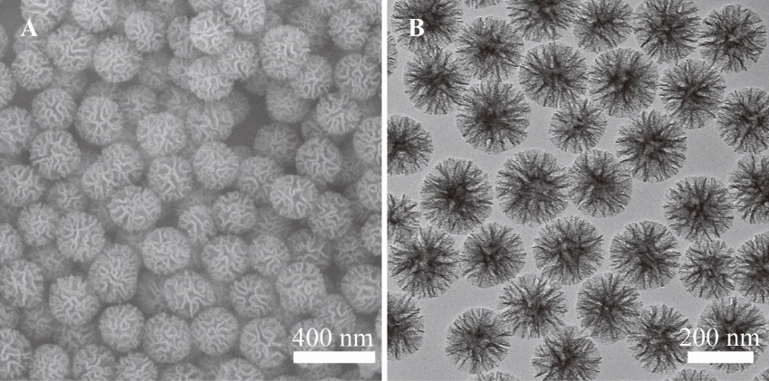

Fig. S1. (A) SEM and (B) TEM images of DMSN.
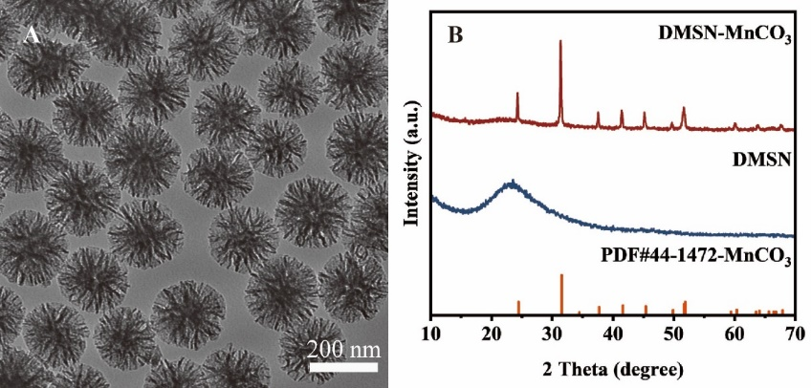

Fig. S2. (A) TEM image of DMSN-MnCO₃. (B) XRD patterns of DMSN and DMSN-MnCO₃.
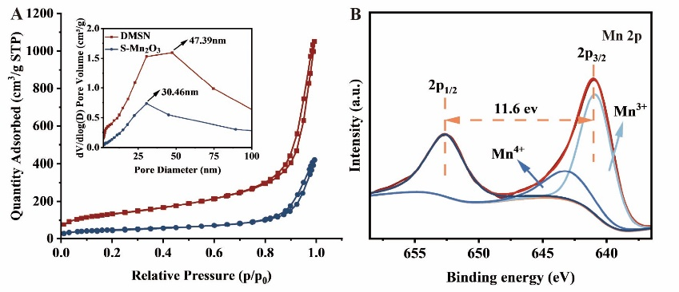

Fig. S3. (A) Nitrogen adsorption-desorption isotherms and corresponding pore size distribution curves (inset) for DMSN and S-Mn₂O₃. (B) Mn 2p XPS spectrum of S-Mn₂O₃.
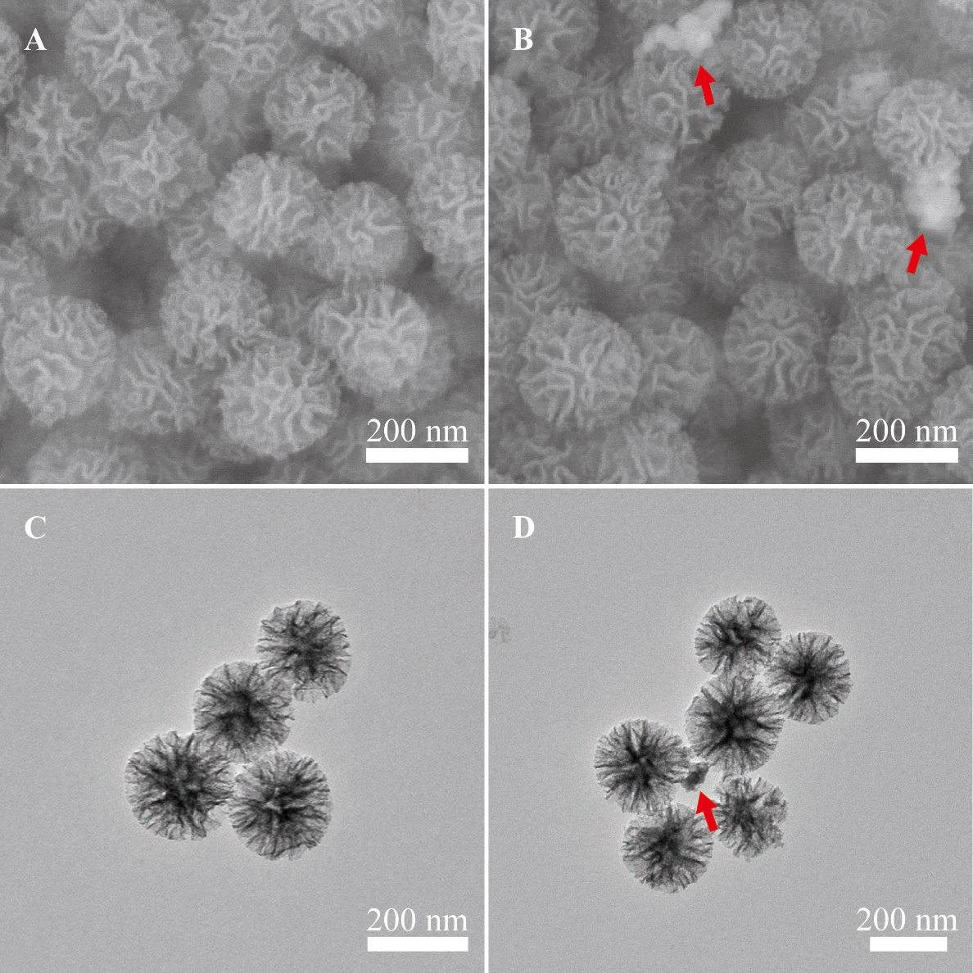

Fig. S4. SEM images of (A) S-Mn₂O₃-1 and (B) S-Mn₂O₃-2. TEM images of (C) S-Mn₂O₃-1 and (D) S-Mn₂O₃-2.
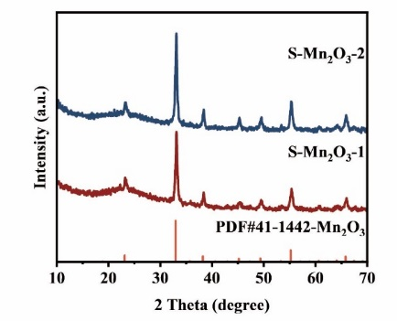

Fig. S5. XRD patterns of S-Mn₂O₃-1 and S-Mn₂O₃-2.
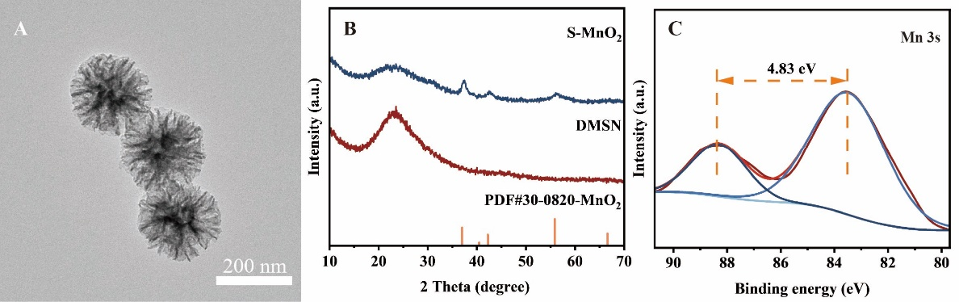

Fig. S6. (A) TEM image of S-MnO₂. (B) XRD patterns of DMSN and S-MnO₂. (C) Mn 3s XPS spectrum of S-MnO₂.
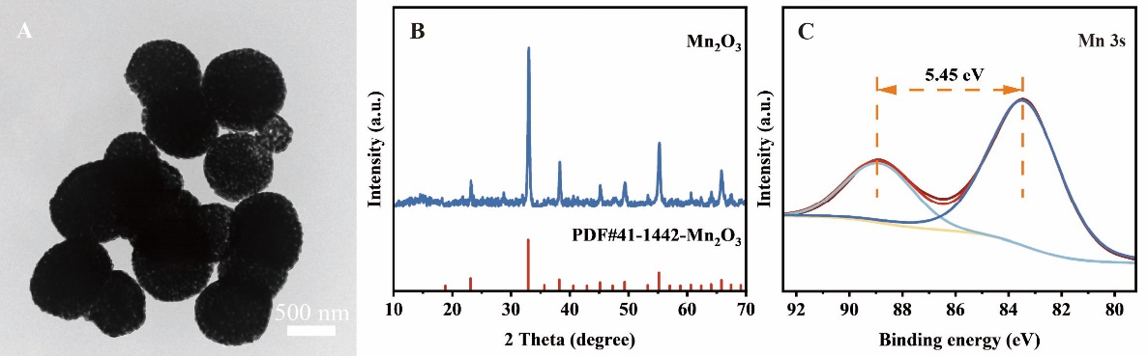

Fig. S7. (A) TEM image, (B) XRD pattern and (C) Mn 3s XPS spectrum of Mn₂O₃.
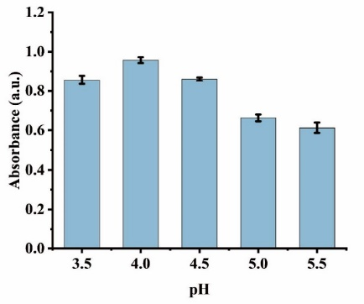

Fig. S8. Optimization of pH value.
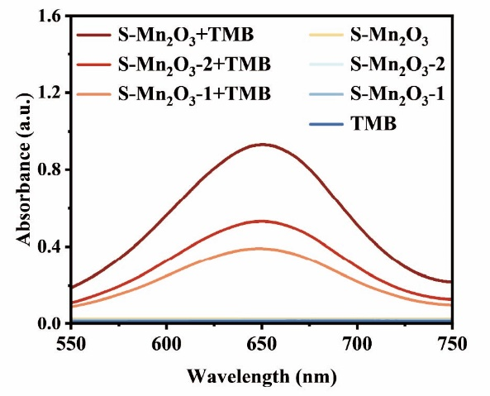

Fig. S9. UV–vis spectra of control solutions (sample-only), TMB working solution and catalyzed reaction solution of S-Mn₂O₃, S-Mn₂O₃-1 and S-Mn₂O₃-2.
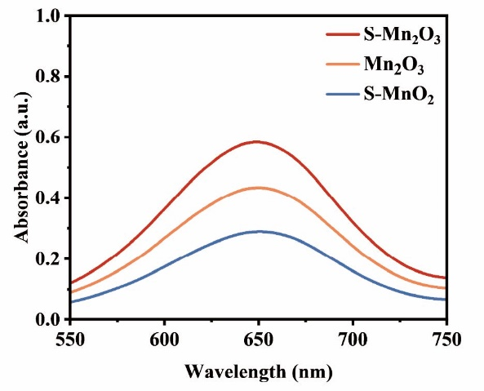

Fig. S10. Comparison of UV–vis spectra for TMB oxidation catalyzed by S-Mn₂O₃, Mn₂O₃ and S-MnO₂.
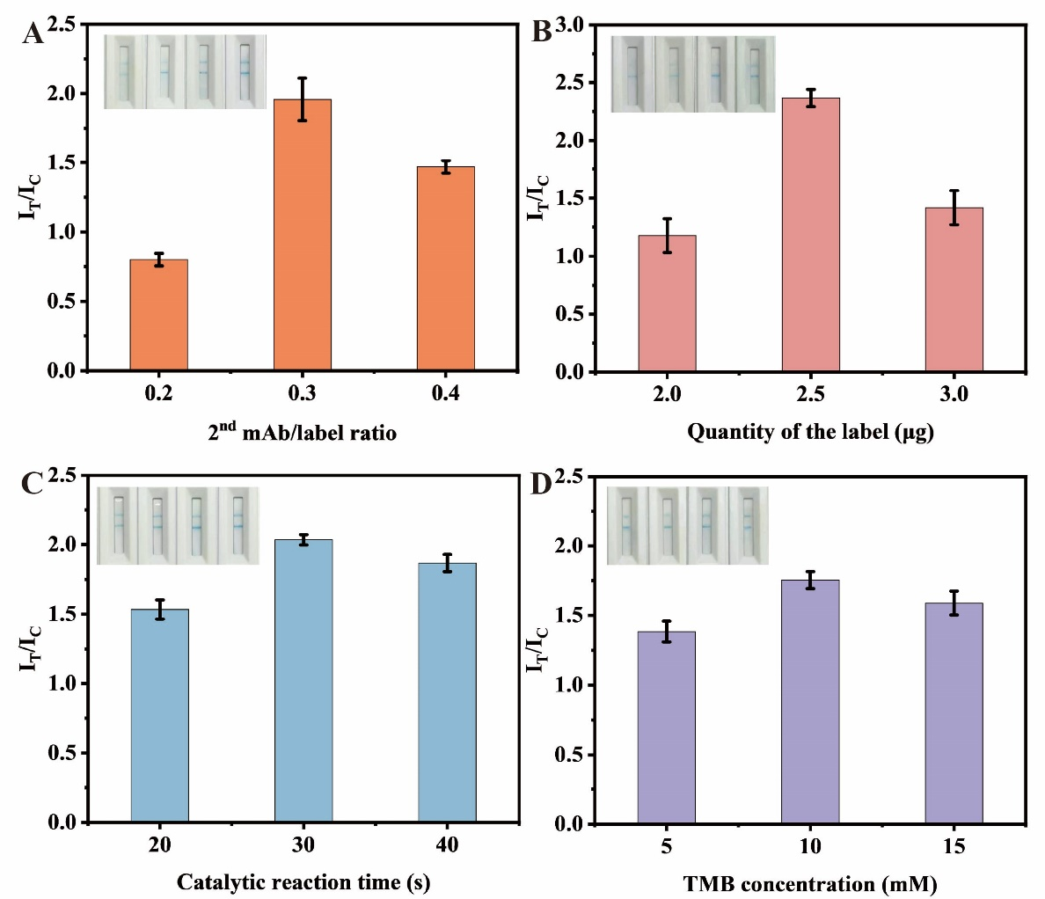

Fig. S11. Optimization of critical parameters for I-CS-Mn₂O₃-based LFIA. (A) The ratio of anti-CRP 2nd mAbs to CS-Mn₂O₃. (B) The quantity of I-CS-Mn₂O₃. (C) The catalytic reaction time. (D) The concentration of TMB.

Table S1. Manganese content of synthesized samples determined by ICP-OES
Samples | Content (%)
S-Mn₂O₃-1 | 28.76
S-Mn₂O₃ | 30.96
S-Mn₂O₃-2 | 38.56

Table S2. Apparent kinetic parameters of S-Mn₂O₃-x (x = 0.75 and 1.25) nanozyme for TMB oxidation
Samples | K_{m} (mM) | V_{max} (μM s⁻¹)
S-Mn₂O₃-1 | 0.232 | 0.503
S-Mn₂O₃-2 | 0.243 | 0.344

