Supplementary Materials for
Feather-inspired multi-stimulus-chromic multilayer composite films with selective modulation of solar spectrum and efficient thermal management for windows
Zefei Chengª, Lulu Leiª, Chunlin Fanª, Zhibiao Weiª, Xuanye Wangª, Wenquan Tongª, Haijie Yuanª, Tao Yu^{a,b,c,}*, Yan Liª, Jiang Du^{d}
^{a.} School of Aerospace Engineering and Applied Mechanics, Tongji University, Shanghai 200092, P. R. China
^{b.} Shanghai Institute of Aircraft Mechanics and Control, Shanghai, 200092, China
^{c} Key Laboratory of AI-aided Airworthiness of Civil Aircraft Structures, Shanghai, 200092, China
^{d} School of Materials Science and Engineering, Tongji University, Shanghai 201804, P.R. China
*Corresponding author e-mail addresses: yutao@tongji.edu.cn (T. Yu).

The PDF file includes:
Note S1
Figures S1 to S54
Tables S1 to S4
References [1-17]
Other Supplementary Materials for this manuscript include the following:
Movies S1 and S2
Note S1
Calculation of Transmittance, Modulation Capability and Haze:
The luminous transmittance (T_{lum}) and solar transmittance (T_{sol}) are calculated by the following equation [1, 2]:
(S1)
where, the is the standard luminosity function of human visual perception for brightness (380–780 nm, Supplementary Fig. 10a), is the Air Mass 1.5 Global (AM 1.5 G) solar irradiation spectrum (280–2500 nm, Supplementary Fig. 10b), is the spectral transmittance.
The visible (VIS) solar transmittance (T_{sol,VIS}, 380–780 nm) and near-infrared (NIR) solar transmittance (T_{sol,NIR}, 780–2500 nm) are also obtained based on equation S1 and the AM 1.5 G solar irradiation spectrum.
The luminous transmittance difference (ΔT_{lum}) and solar modulation efficiency (ΔT_{sol}) are calculated by the following equation:
(S2)
The Haze is calculated by the following equation [3, 4]:
(S3)
where , , and are total, diffuse and normal luminous transmittances, respectively.
The normal transmittance difference (ΔT_{n}) is calculated by the following equation [5]:
(S4)
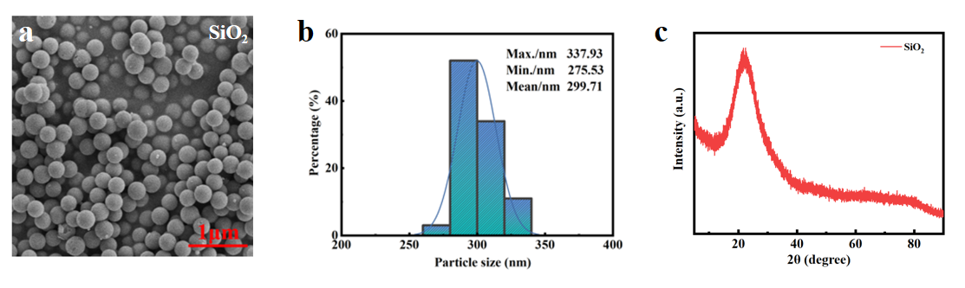
Fig. S1 Silicon dioxide nanoparticles (SiO₂ NPs) information.
a Scanning electron microscope (SEM) image, b particle size distribution and c X-ray diffraction (XRD) pattern of SiO₂ NPs

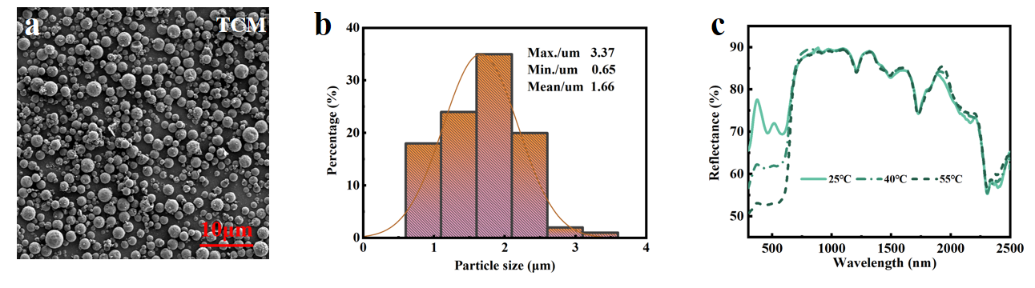
Fig. S2 Thermochromic microcapsules (TCM) information.
a SEM image and b particle size distribution of TCM. c Reflectance spectra of TCM at different temperatures

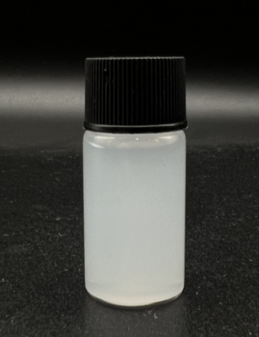
Fig. S3
Photograph of SiO₂ NPs suspension
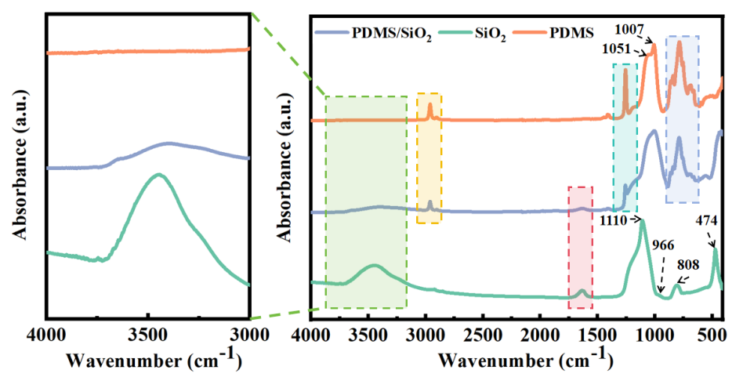
Fig. S4
Fourier transform infrared spectrophotometer (FTIR) spectra of SiO₂, polydimethylsiloxane (PDMS), and PDMS/SiO₂ surface

In the PDMS spectrum [6], Si–O–Si stretching vibrations are at 1051 and 1007 cm^{–1}，Si–C stretching vibrations and CH₃ rocking are at 789 cm^{–1} (blue area); CH₃ symmetric deformation of Si–CH₃ is at 1257 cm^{–1} (cyan area). The corresponding peaks of the methyl absorption band are at 2962 and 2904 cm^{–1} (yellow area) for Si–CH₃ stretching vibrations.
In the SiO₂ spectrum [6, 7], the peak at 1110 cm^{–1} is attributable to the antisymmetric stretching vibration of Si–O–Si, while its symmetric stretching vibration is at 808 cm^{–1}; Si–O bending vibration is at 474 cm^{–1}; Si–OH stretching vibration is at 966 cm^{–1}. Additionally, the absorption peaks at 3450 cm^{–1} (green area) and 1637 cm^{–1} (red area) correspond to the antisymmetric stretching vibration and bending vibration of –OH in structural water within SiO₂ NPs, respectively.
For the PDMS/SiO₂ composite layer, the intensity of PDMS absorption peak is weakened, while the absorption peak of SiO₂ appears (different colour areas), indicating that PDMS has completely filled the gaps between SiO₂ NPs.

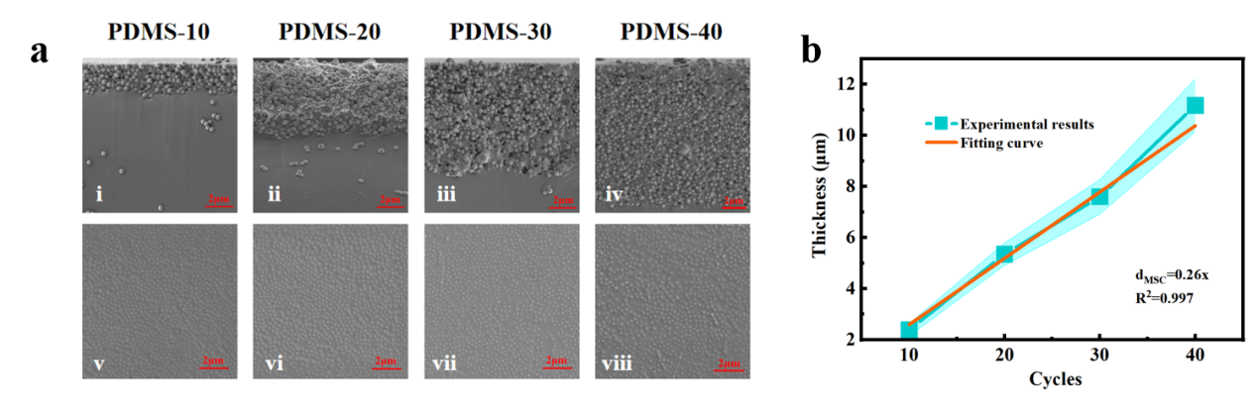
Fig. S5 Mechano-solvatochromic (MSC) layer thickness.
a SEM images of cross section and surface of MSC layers in the released state. b Diagram of spray cycles (x) with MSC layer thickness (d_{MSC})

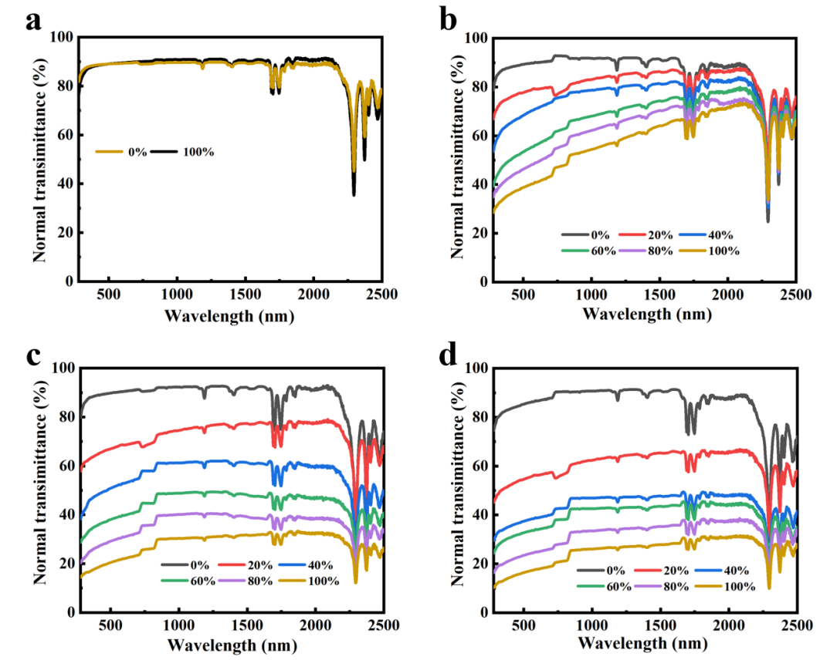
Fig. S6 Normal transmittance spectra.
Normal transmittance spectra of a PDMS, b PDMS-10, c PDMS-20, and d PDMS-30 films at different tensile strains
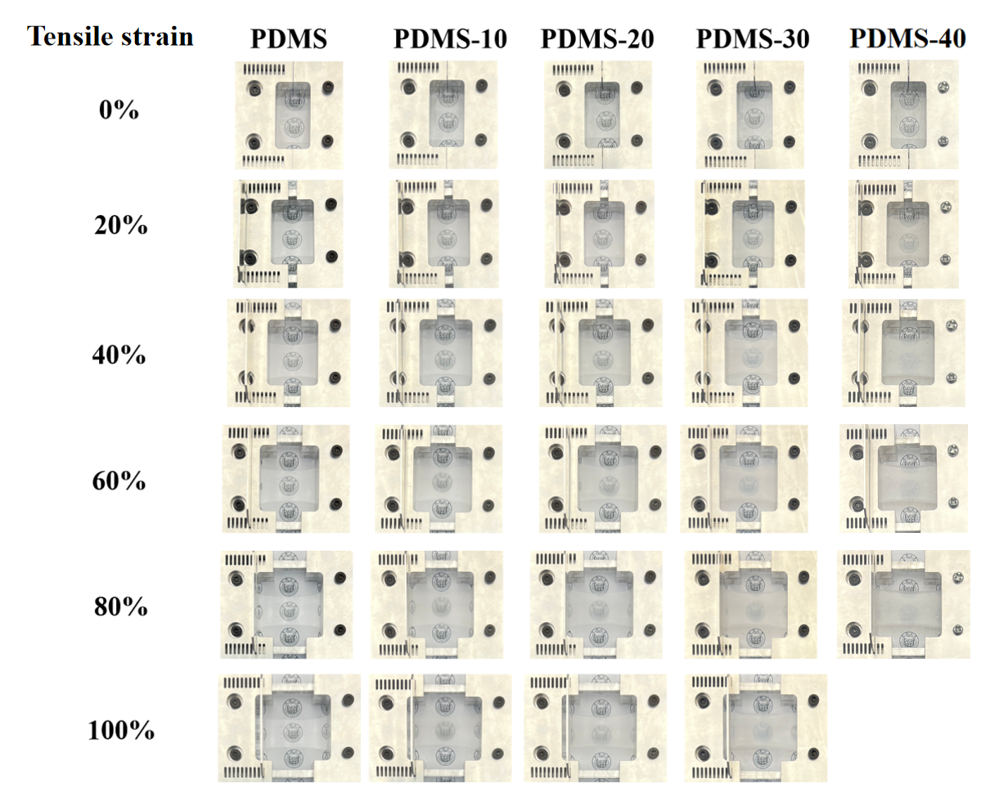
Fig. S7
Photographs of PDMS, PDMS-10, PDMS-20, PDMS-30 and PDMS-40 films at different tensile strains

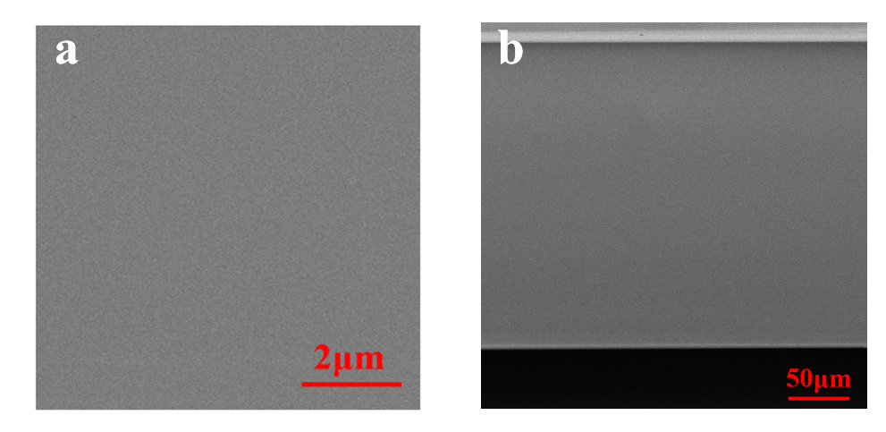
Fig. S8 SEM images.
SEM images of a surface and b cross section of PDMS film in the released state

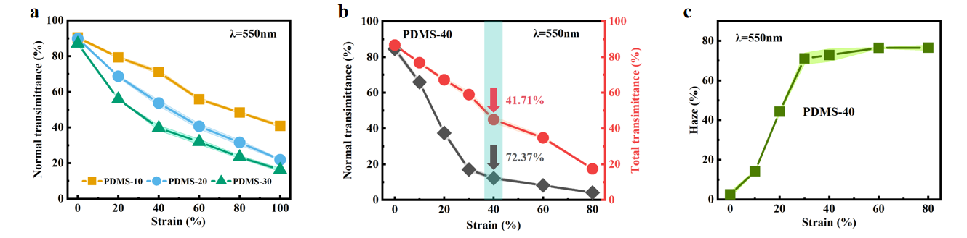
Fig. S9 Transmittance and haze.
a Variation of normal transmittance of PDMS-10, PDMS-20 and PDMS-30 films at different tensile strains, monitored at λ = 550 nm. b Variation of normal transmittance (black) and total transmittance (red) of PDMS-40 film at different tensile strains, monitored at λ = 550 nm. c Variation of haze of PDMS-40 film at different tensile strains, monitored at λ = 550 nm

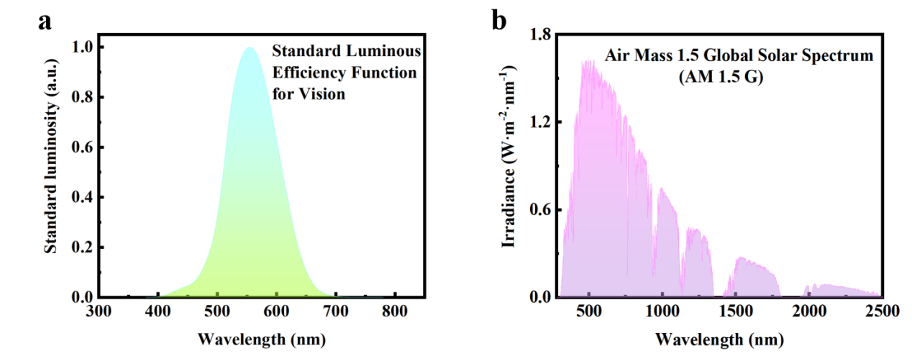
Fig. S10 Standard luminosity efficiency function for vision and Air Mass 1.5 Global (AM 1.5 G) solar spectrum.
a Standard luminosity function of human visual perception for brightness. b AM 1.5 G solar spectrum with energy distribution

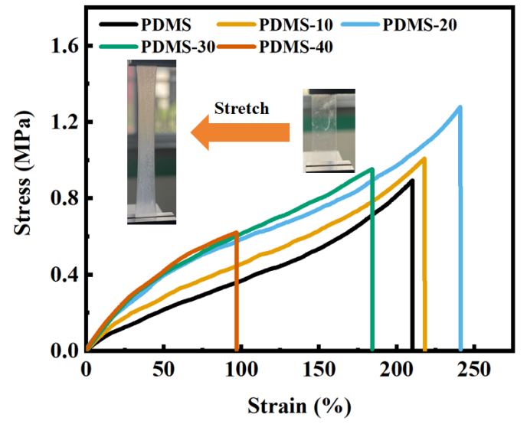
Fig. S11
Stress-strain curves of PDMS, PDMS-10, PDMS-20, PDMS-30 and PDMS-40 films during stretching. Insert: Stretching test process of PDMS-20 film

Pure PDMS film fails prematurely due to rapid crack propagation at low elongation during stretching [8]. SiO₂ can provide high tensile strength to the crosslinked PDMS [6]. During stretching, stress concentration areas in the MSC layer lead to the formation of voids, which evolve into cracks. When the MSC layer thickness is small (approximately 2–5 μm), the locally fractured MSC layer can stabilize the local interface due to the high stiffness of SiO₂ (approximately 73.1 GPa) [3] and the high SiO₂ volume ratio of the self-assembled structure, thereby inhibiting the rapid propagation of microcracks in BF layer. As a result, the composite film does not fail prematurely during stretching, thereby enhancing tensile strength and elongation at break. Similar improvements in mechanical properties have been reported in some studies [8, 9].
However, as the thickness of MSC layer increases to a certain extent (approximately > 7.5 μm), the phenomenon of strain mismatch between MSC and BF layer worsens, and defects such as voids and cracks continue to increase during the stretching process of the MSC layer, leading to a decline in mechanical properties.

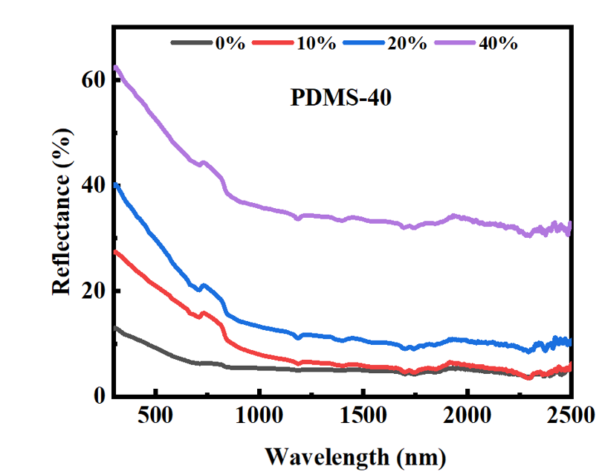
Fig. S12
Reflectance spectra of PDMS-40 film at different tensile strains
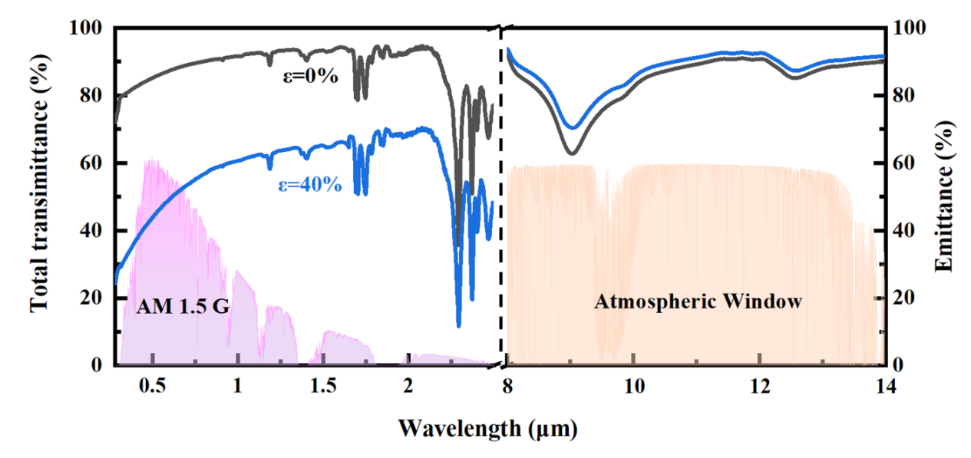
Fig. S13
Total transmittance and emittance spectra of PDMS-40 film before and after stretching
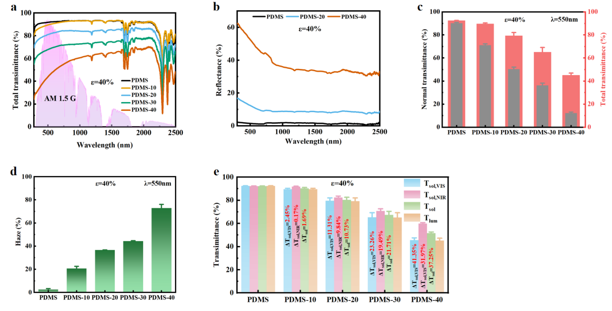
Fig. S14 Optical properties of films with different MSC layer thicknesses.
a Total transmittance spectra of PDMS, PDMS-10, PDMS-20, PDMS-30 and PDMS-40 films at 40% tensile strain. b Reflectance spectra of PDMS, PDMS-20 and PDMS-40 films at 40% tensile strain. c Variation of normal transmittance (black) and total transmittance (red) of PDMS, PDMS-10, PDMS-20, PDMS-30 and PDMS-40 films at 40% tensile strain, monitored at λ = 550 nm. d Variation of haze of PDMS, PDMS-10, PDMS-20, PDMS-30 and PDMS-40 films at 40% tensile strain, monitored at λ = 550 nm. e Variation of spectral transmittance of PDMS, PDMS-10, PDMS-20, PDMS-30 and PDMS-40 films at 40% tensile strain

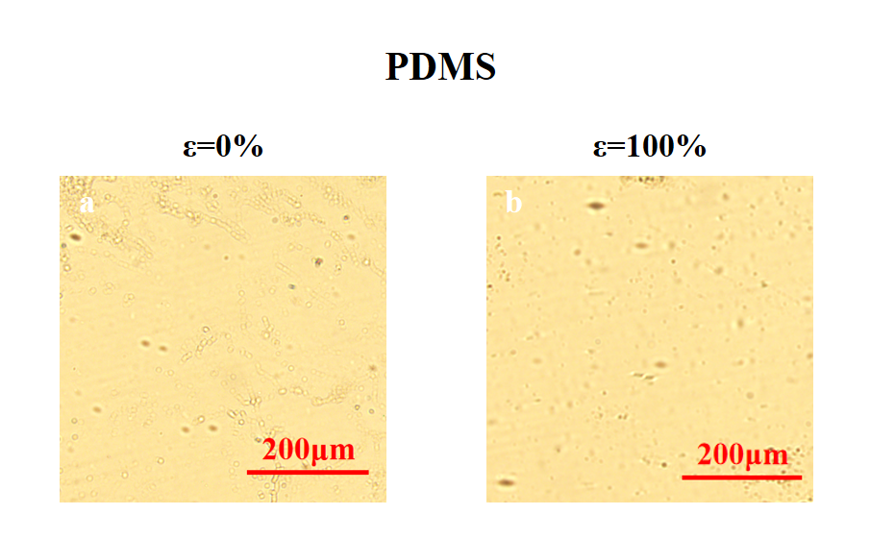
Fig. S15 Optical microscope (OM) images.
OM images of PDMS film at a tensile strain of a 0%, b 100%

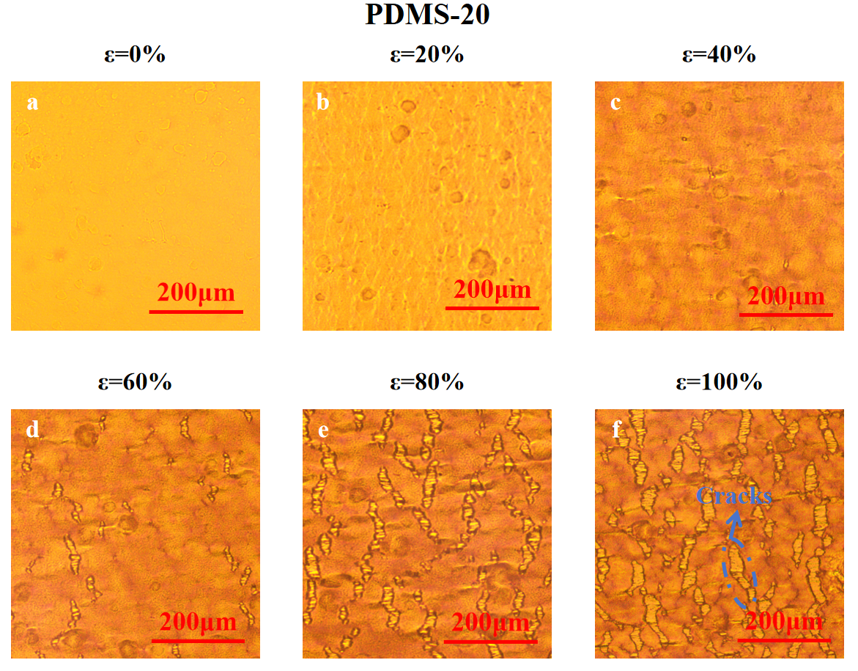
Fig. S16 OM images.
OM images of PDMS-20 film at a tensile strain of a 0%, b 20%, c 40%, d 60%, e 80%, f 100%
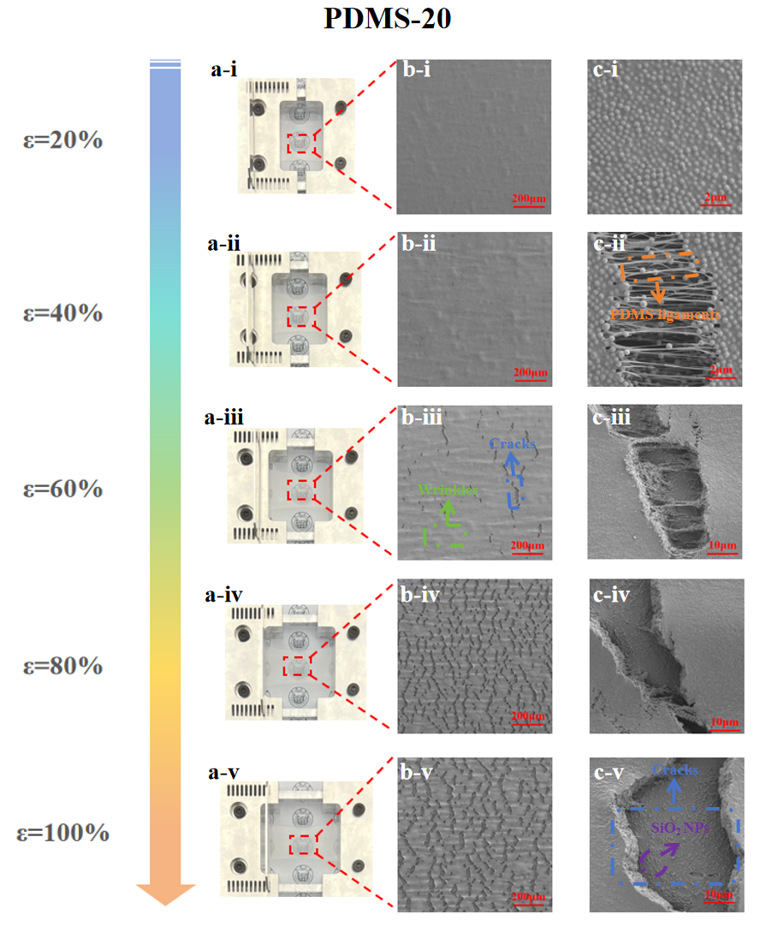
Fig. S17 Photographs and SEM images.
a Photographs, b SEM images, and c enlarged SEM images of surface of PDMS-20 film at different tensile strains

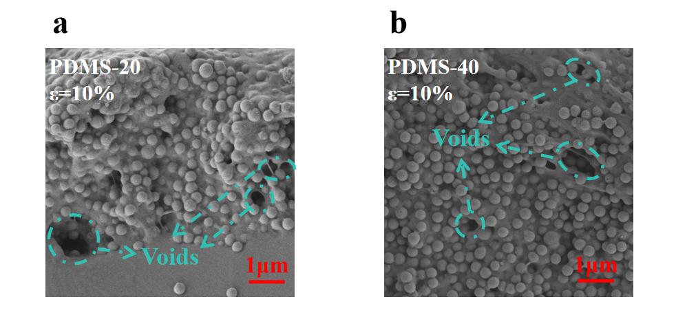
Fig. S18 SEM images.
SEM images of cross section of a PDMS-20 and b PDMS-40 films at a tensile strain of 10%
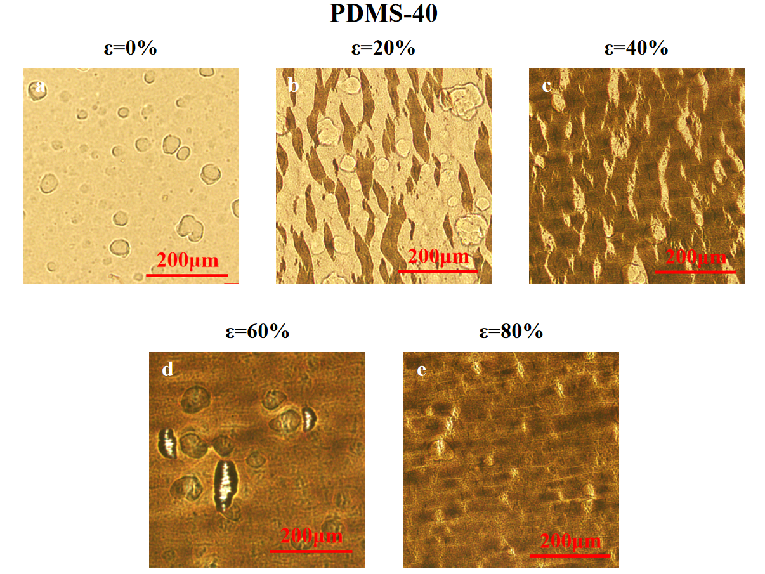
Fig. S19 OM images.
OM images of PDMS-40 film at a tensile strain of a 0%, b 20%, c 40%, d 60%, e 80%
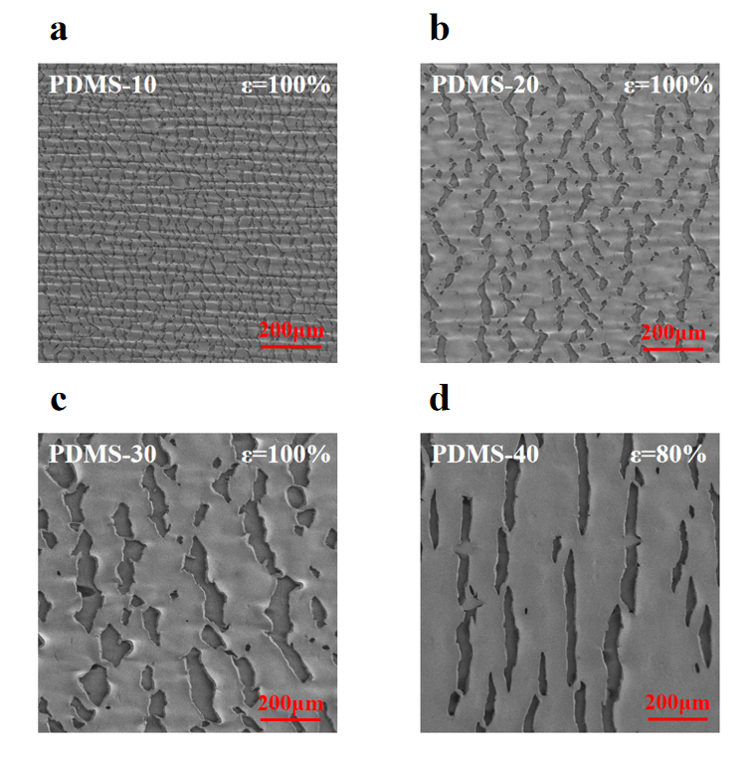
Fig. S20 SEM images.
SEM images of surface of a PDMS-10, b PDMS-20, c PDMS-30, and d PDMS-40 films in the stretched state

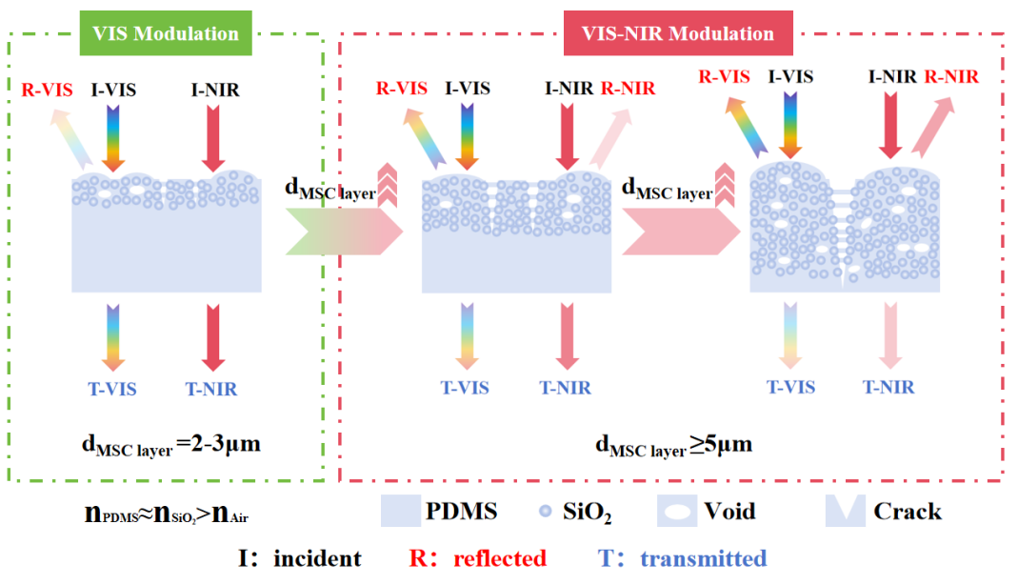
Fig. S21
Light modulation characteristic and mechanism of films with different MSC layer thicknesses

The light modulation characteristic and mechanism of different MSC layer thicknesses are shown in Supplementary Fig. 21. Taking a 40% tensile strain as the example, the scattering of incident light by the MSC layer at this strain primarily originates from three structures at nano-micro scale: wrinkles, voids and cracks with PDMS ligaments. When the MSC layer thickness is between 2 and 3 μm, it mainly exhibits light modulation capability within VIS spectrum and the light modulation effect is extremely weak. As the thickness increases, the cracks increase in size and depth, the number of voids increases and the size of the wrinkles also changes. These factors collectively enhance the scattering effect, leading to changes in the light modulation characteristics. When the MSC layer thickness exceeds 5 μm, the film exhibits light modulation capability within VIS-NIR spectrum. The total transmittance gradually decreases and the reflectance gradually increases with increasing thickness.
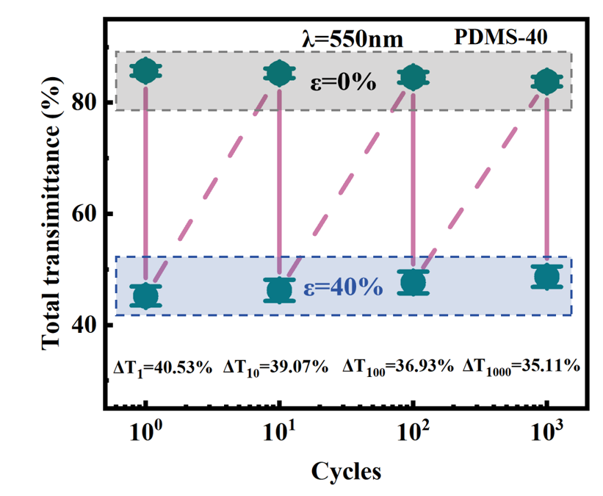
Fig. S22
Variations of total transmittance of PDMS-40 film during 1, 10, 100, and 1000 stretching cycles at 40% cyclic tensile strain, monitored at λ = 550 nm

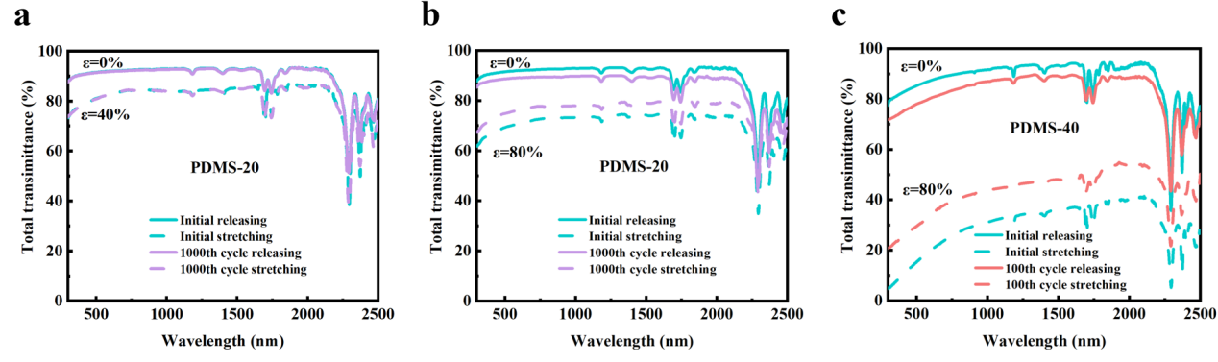
Fig. S23 Total transmittance spectra.
Total transmittance spectra of PDMS-20 film before and after 1000 stretching cycles at a 40% and b 80% cyclic tensile strain. c Total transmittance spectra of PDMS-40 film before and after 100 stretching cycles at 80% cyclic tensile strain
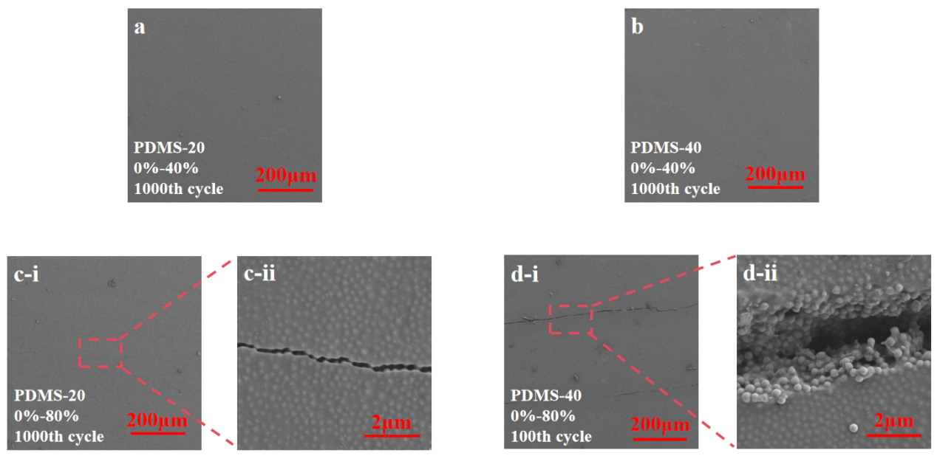
Fig. S24 SEM images.
SEM images of surface of a PDMS-20 and b PDMS-40 films in the released state after 1000 cycles of cyclic stretching at 40% cyclic tensile strain. c SEM images of the surface of PDMS-20 film in the released state after 1000 cycles of cyclic stretching at 80% cyclic tensile strain. d SEM images of the surface of PDMS-40 film in the released state after 100 cycles of cyclic stretching at 80% cyclic tensile strain

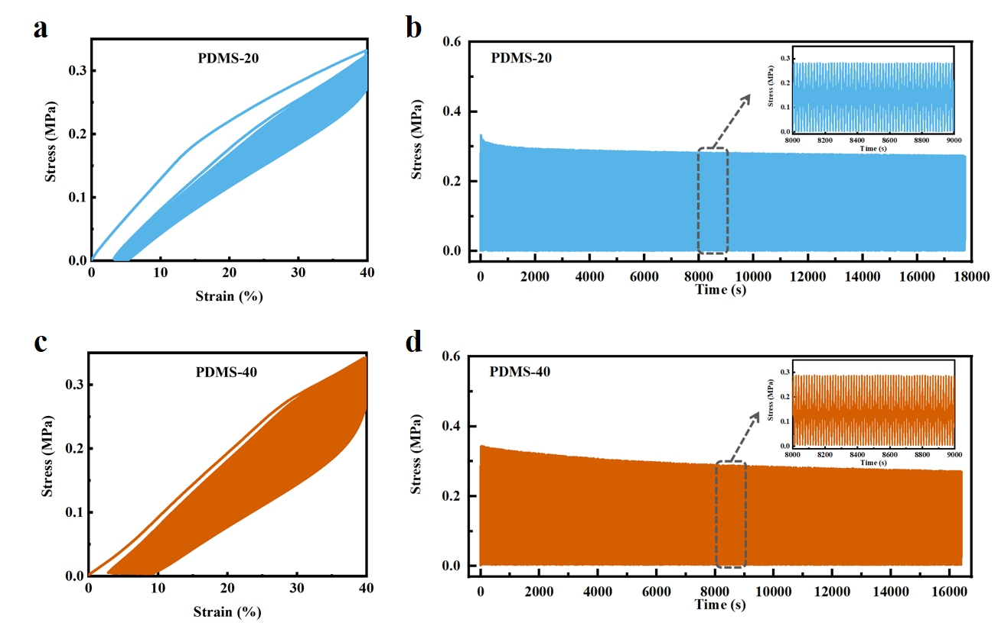
Fig. S25 Stress-strain and stress-time curves.
a Stress-strain and b stress-time curves of PDMS-20 film during 1000 stretching cycles at 40% cyclic tensile strain. c Stress-strain and d stress-time curves of PDMS-40 film during 1000 stretching cycles at 40% cyclic tensile strain
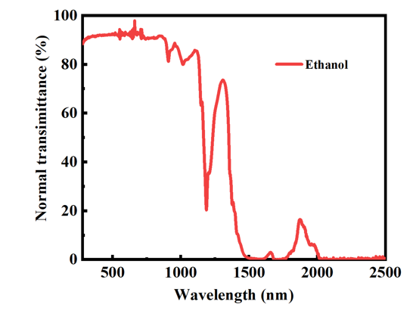
Fig. S26
Normal transmittance spectrum of ethanol
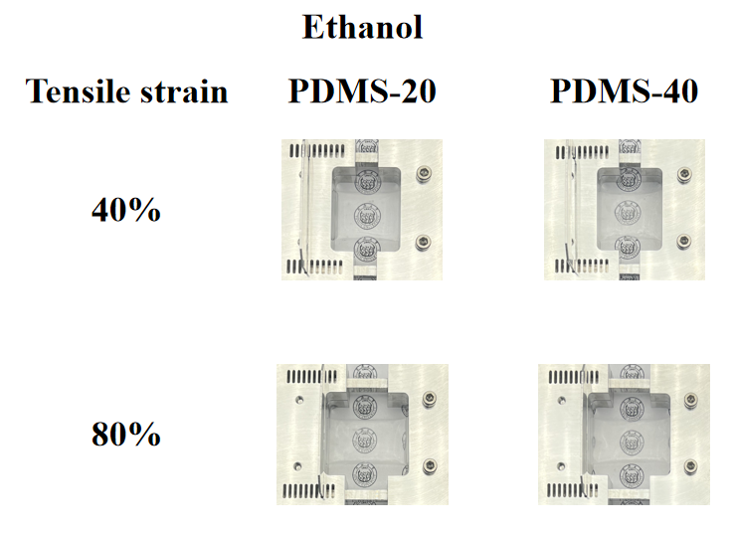
Fig. S27
Photographs of PDMS-20 and PDMS-40 films at different tensile strains after solvatochromic (ethanol)

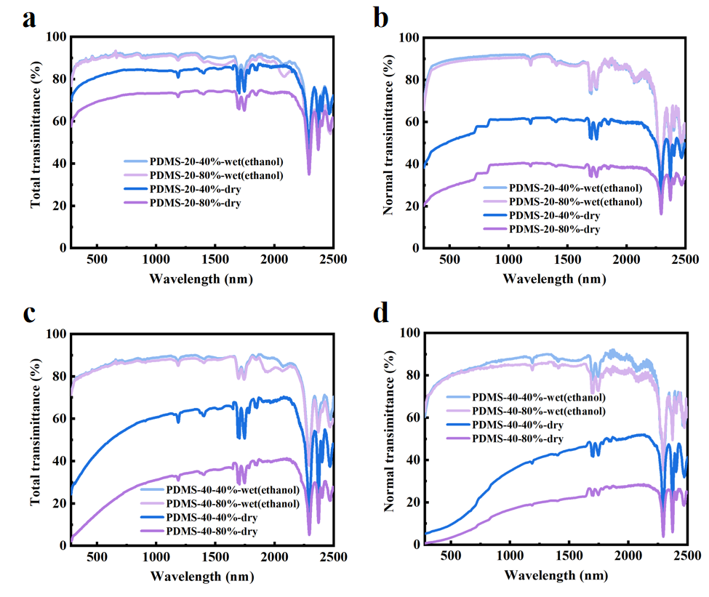
Fig. S28 Total transmittance spectra and normal transmittance spectra.
a Total transmittance spectra and b normal transmittance spectra of PDMS-20 film at different tensile strains before and after solvatochromic (ethanol). c Total transmittance spectra and d normal transmittance spectra of PDMS-40 film at different tensile strains before and after solvatochromic (ethanol)

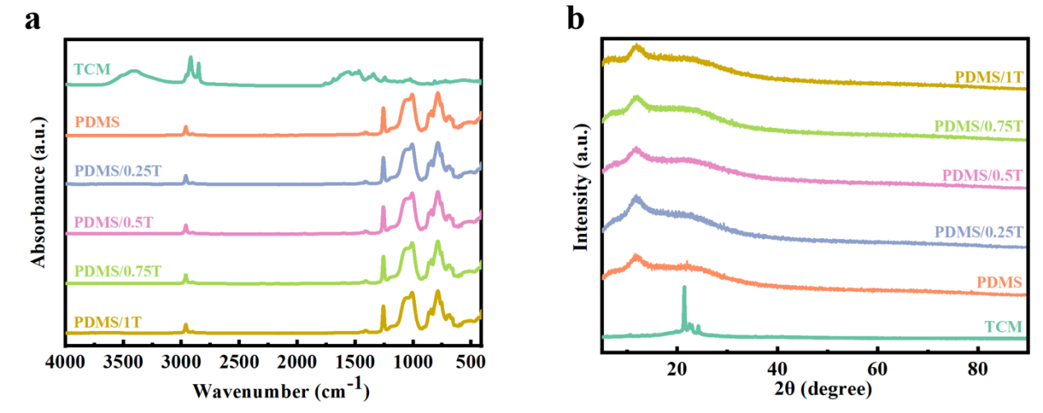
Fig. S29 FTIR spectra and XRD patterns.
a FTIR spectra and b XRD patterns of TCM, PDMS, PDMS/0.25T, PDMS/0.5T, PDMS/0.75T and PDMS/1T films

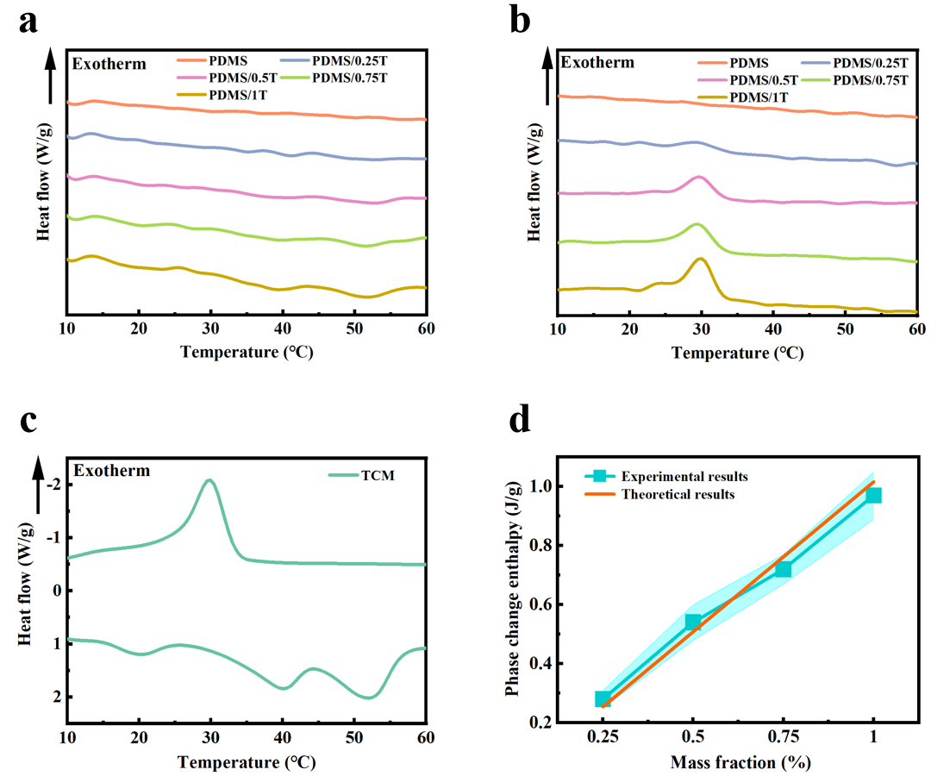
Fig. S30 DSC curves and related calculations.
Differential scanning calorimeter (DSC) curves of PDMS, PDMS/0.25T, PDMS/0.5T, PDMS/0.75T and PDMS/1T films during the process of a heating and b cooling. c DSC curves of TCM during the process of heating and cooling. d Diagram of experimental and theoretical results showing the relationship between TCM mass fraction and phase change enthalpy during the heating process

Taking the heating process as an example, the latent heat during the heating process is theoretically linearly related to the mass fraction of TCM, which can be expressed by the following equation [10]:
(S5)
where and represent the latent heat of the film and TCM during the heating process and represents the mass fraction of TCM in the film. is 101.58 J/g (Supplementary Fig. 30c).
As shown in Supplementary Fig. 30d, the experimental results are close to the theoretical results. This proves that TCM is fully mixed into the PDMS matrix.

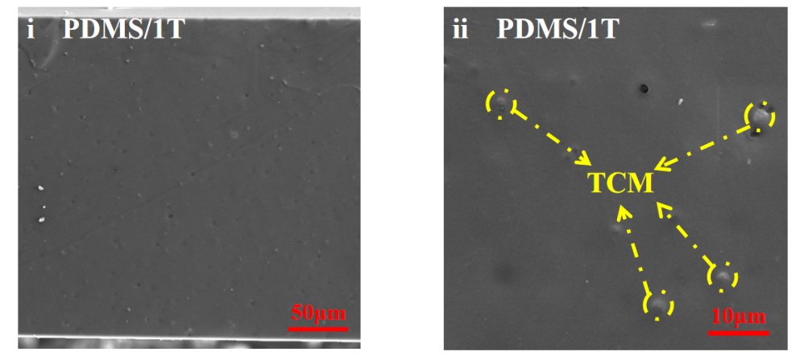
Fig. S31
SEM images of cross section of PDMS/1T film in the released state

As shown in Supplementary Fig. 31, unlike the smooth cross-section of PDMS, the cross-section of PDMS/1T film is relatively rough. It is evident that 1 wt% TCM is uniformly dispersed in the PDMS film without any agglomeration.

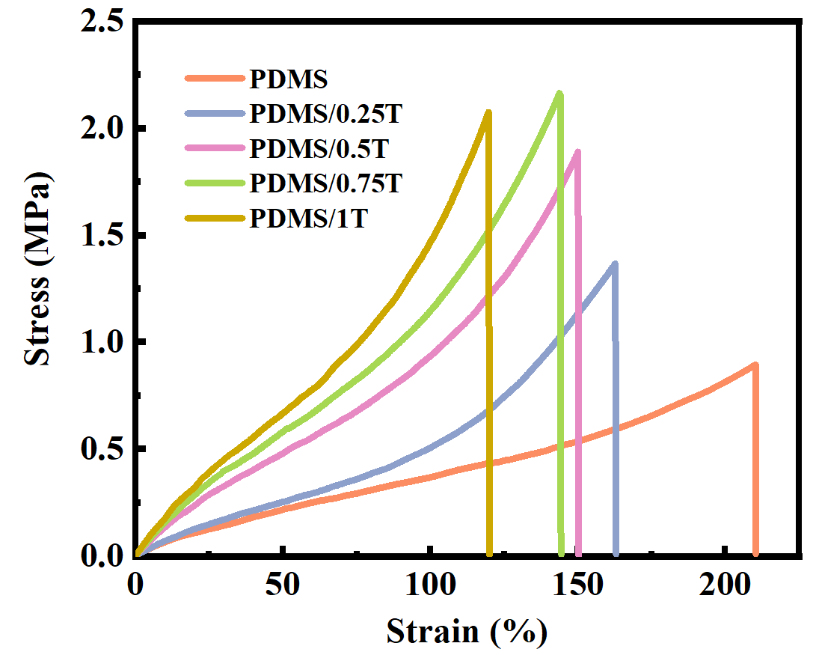
Fig. S32
Stress-strain curves of PDMS, PDMS/0.25T, PDMS/0.5T, PDMS/0.75T and PDMS/1T films during stretching

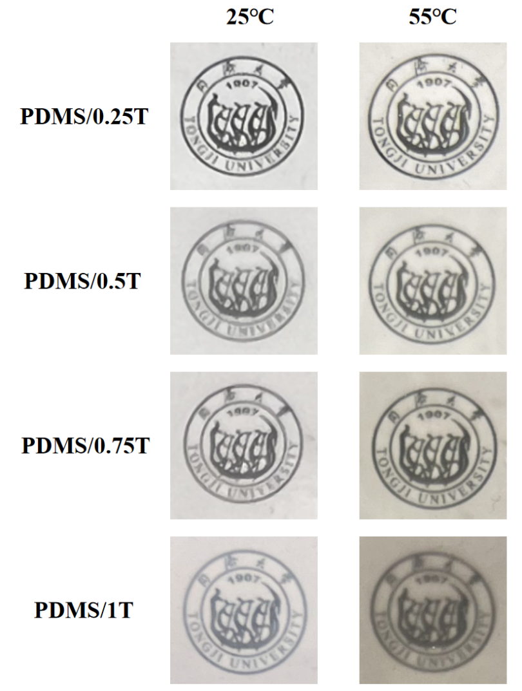
Fig. S33
Photographs of PDMS/0.25T, PDMS/0.5T, PDMS/0.75T and PDMS/1T films at 25 °C and 55 °C

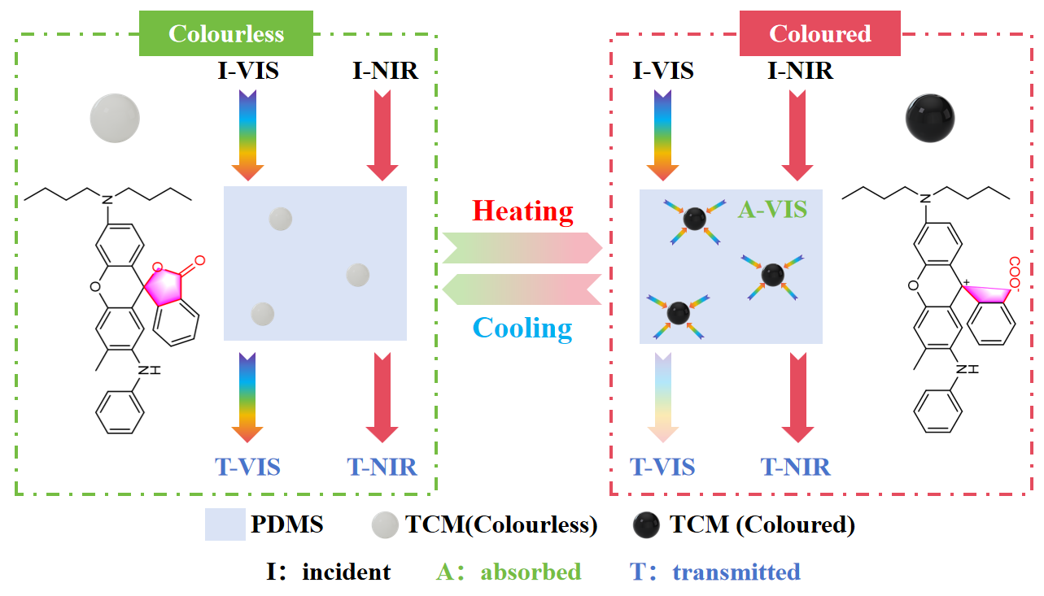
Fig. S34
Light modulation characteristic and mechanism of thermochromic (TC) layer

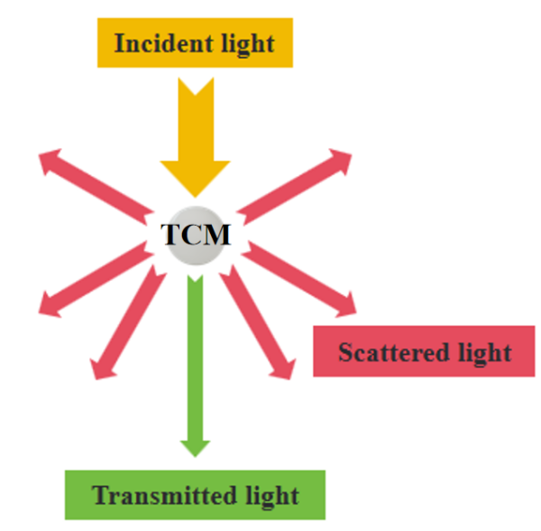
Fig. S35
Schematic of the situation when incident light through TCM

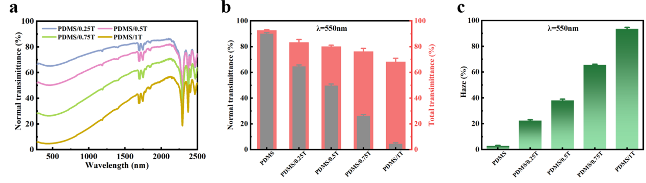
Fig. S36 Optical properties of films with different TCM mass fractions.
a Normal transmittance spectra of PDMS, PDMS/0.25T, PDMS/0.5T, PDMS/0.75T and PDMS/1T films at 25 °C. c Variation of normal transmittance (black) and total transmittance (red) of PDMS, PDMS/0.25T, PDMS/0.5T, PDMS/0.75T and PDMS/1T films at 25 °C, monitored at λ = 550 nm. d Variation of haze of PDMS, PDMS/0.25T, PDMS/0.5T, PDMS/0.75T and PDMS/1T films at 25 °C, monitored at λ = 550 nm

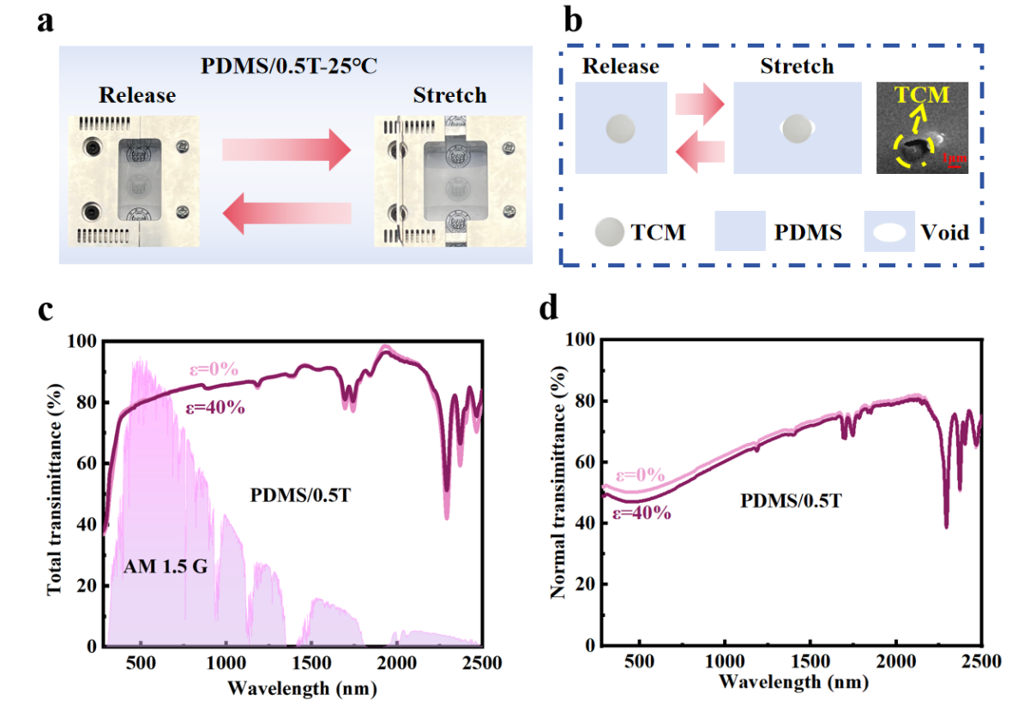
Fig. S37 Optical properties of thermochromic films before and after stretching.
a Photographs of PDMS/0.5T film before and after stretching at 25 °C. b Schematic diagram and SEM image of the voids generated between TCM and PDMS matrix in the stretched state. c Total transmittance spectra and d normal transmittance spectra of PDMS/0.5T film before and after stretching at 25 °C
As shown in Supplementary Fig. 37b, elliptical voids form between PDMS matrix and TCM after stretching. Similar local delamination has also been observed on vanadium dioxide (VO₂) in a stretched PDMS matrix [11]. However, the well-dispersed TCM with a low mass fraction in the PDMS matrix exhibit long distances next to each other, the voids formed during the stretching process have a negligible effect on the transmittance spectra of the film (Supplementary Fig. 37c and d).
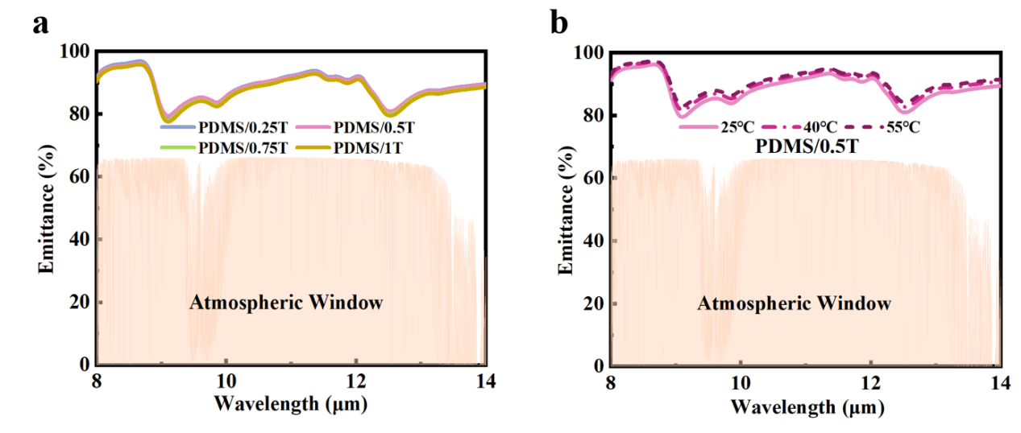
Fig. S38 Emittance spectra.
a Emittance spectra of PDMS/0.25T, PDMS/0.5T, PDMS/0.75T and PDMS/1T films at 25 °C. b Emittance spectra of PDMS/0.5T film at different temperatures

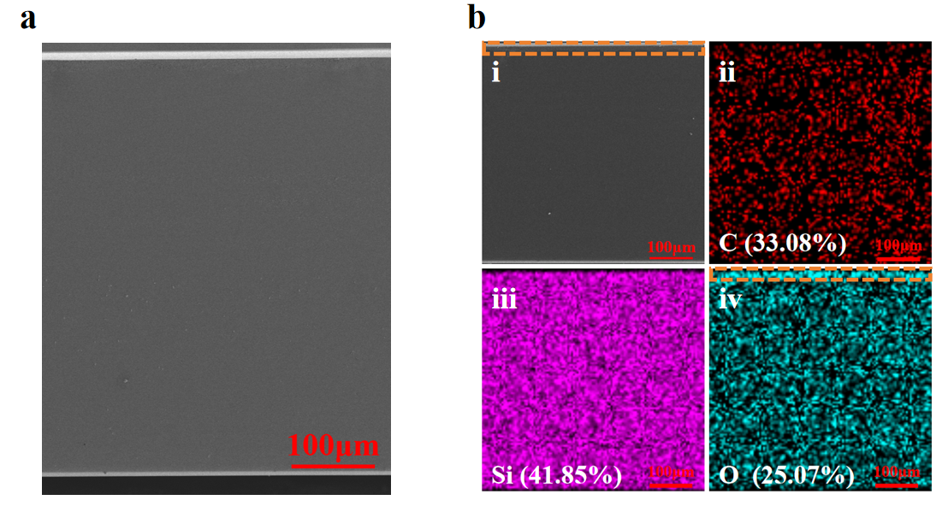
Fig. S39 SEM images.
a SEM image of cross section of PDMS-40/0.5T(1:1) film. b Distribution of C, Si and O elements in PDMS-40/0.5T(1:1) film

The orange frame indicates the MSC layer with uniform thickness.
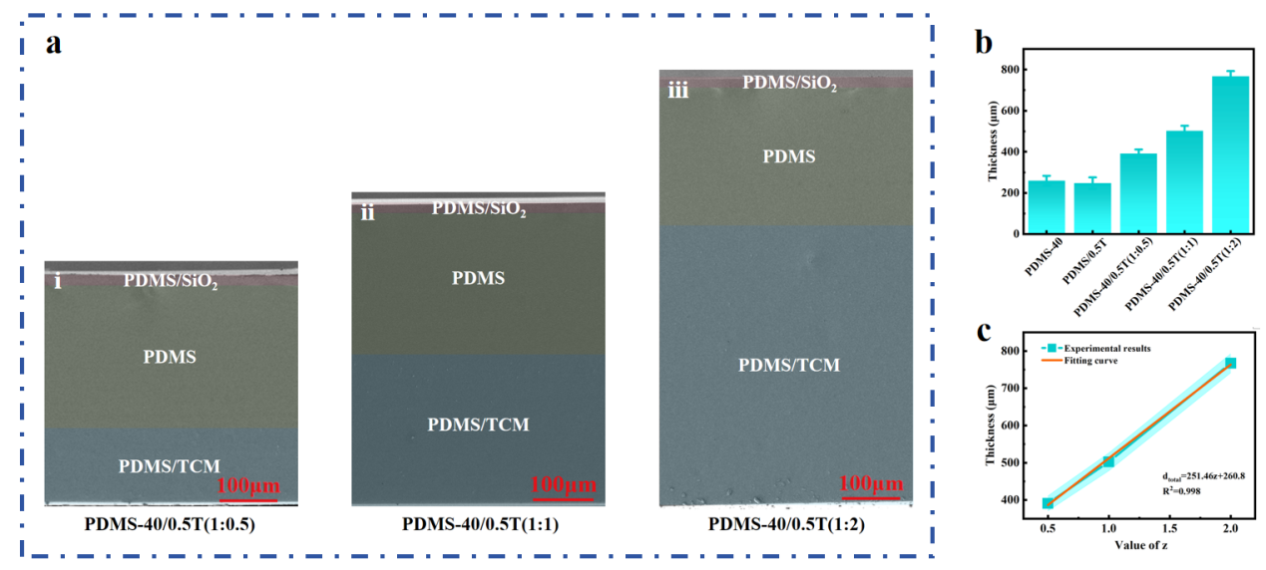
Fig. S40 TC layer thickness.
a Cross-sectional schematic SEM images of the three-layer structure of mechano-solvato-thermochromic (MSTC) films in the released state. b Total thickness of different films. c Diagram of value of z with total film thickness (d_{total})

Based on the definition of variable z in PDMS-40/0.5T (1:z) film, the total film thickness in this study can be calculated by the following equation:
(S6)
where , and represent the total film thickness, PDMS-40 film thickness and PDMS/0.5T film thickness, respectively.
As shown in Supplementary Fig. 40c, the intercept and slope of the fitted curve are very close to the experimental results of the thickness of PDMS-40 (259 μm) and PDMS/0.5T (248 μm) film (Supplementary Fig. 40b). This proves the successful preparation of MSTC films with different TC layer thicknesses.
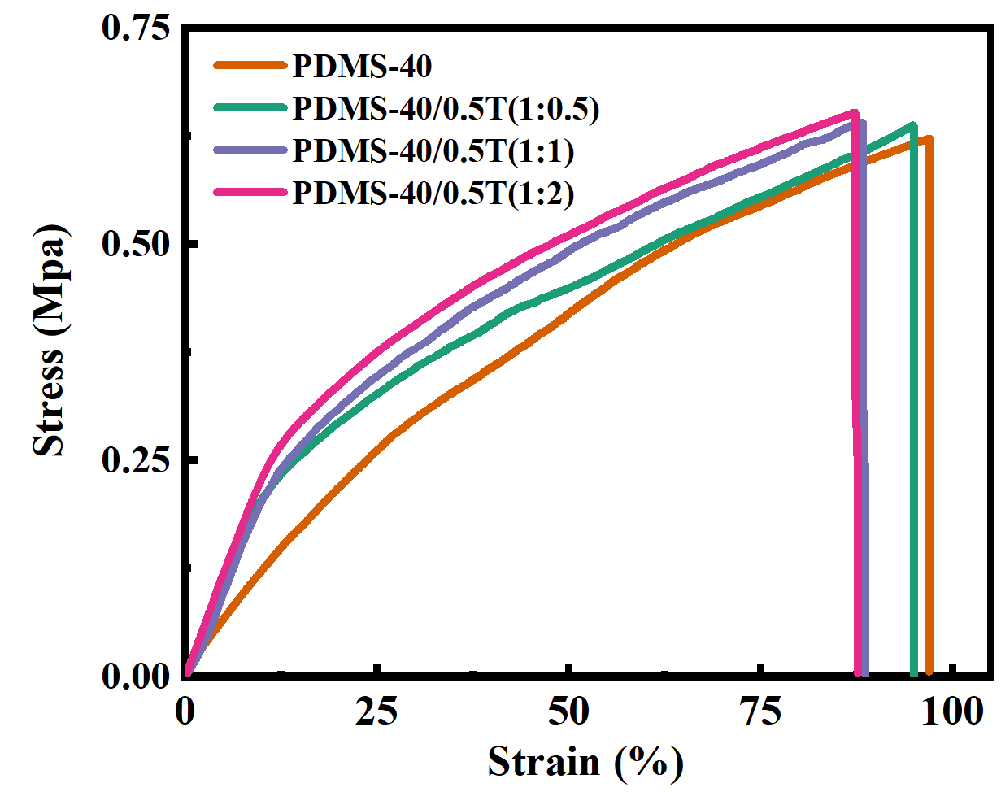
Fig. S41
Stress-strain curves of PDMS-40, PDMS-40/0.5T(1:0.5), PDMS-40/0.5T(1:1) and PDMS-40/0.5T(1:2) films during stretching

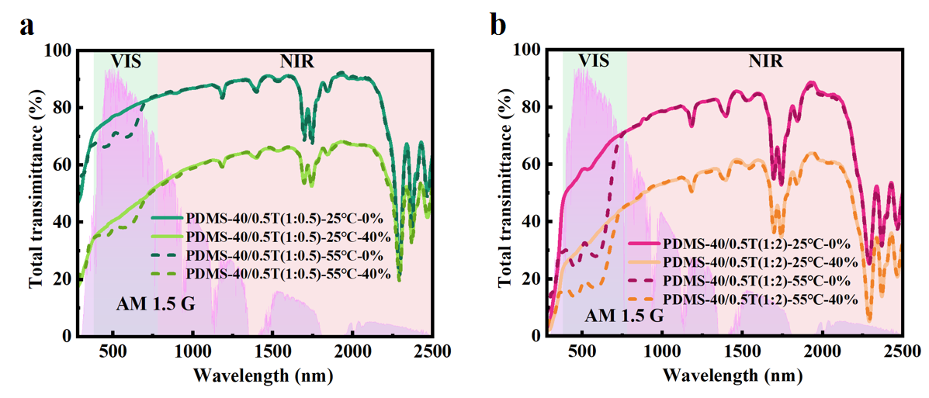
Fig. S42 Total transmittance spectra.
Total transmittance spectra of a PDMS-40/0.5T(1:0.5) and b PDMS-40/0.5T(1:2) films at different temperatures and strains
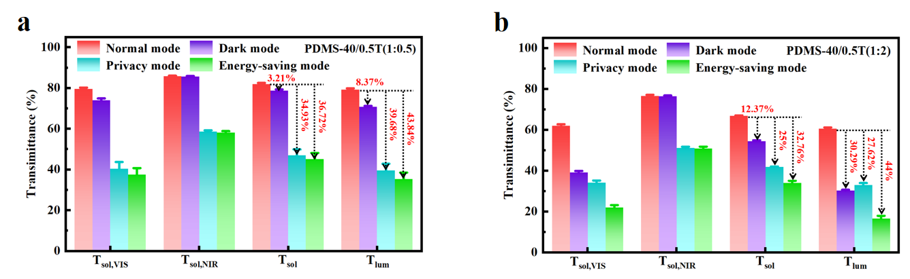
Fig. S43 Spectral transmittance.
Variation of spectral transmittance of a PDMS-40/0.5T(1:0.5) and b PDMS-40/0.5T(1:2) films in different modes

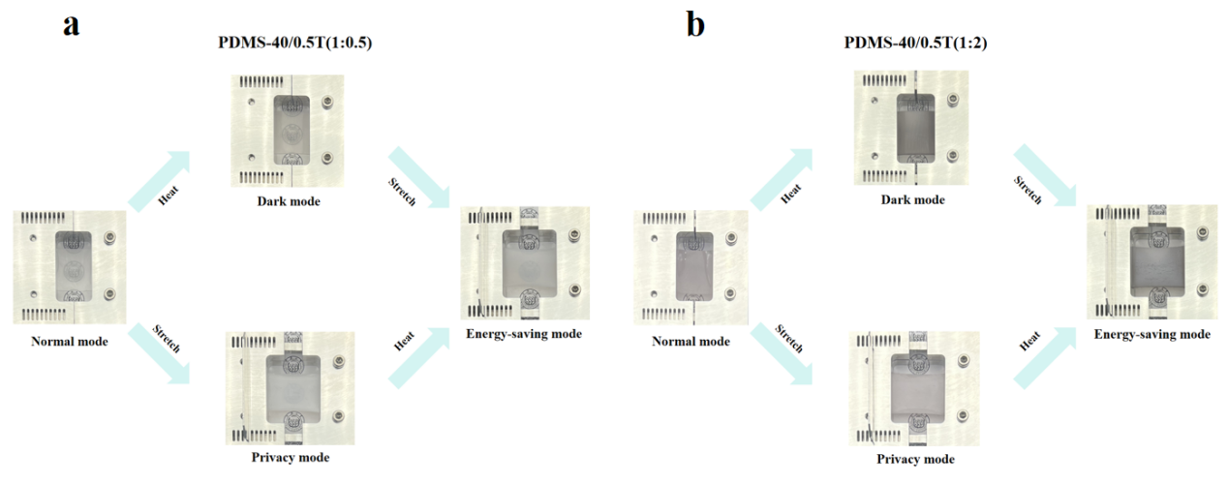
Fig. S44 Photographs.
Photographs of a PDMS-40/0.5T(1:0.5) and b PDMS-40/0.5T(1:2) films in different modes

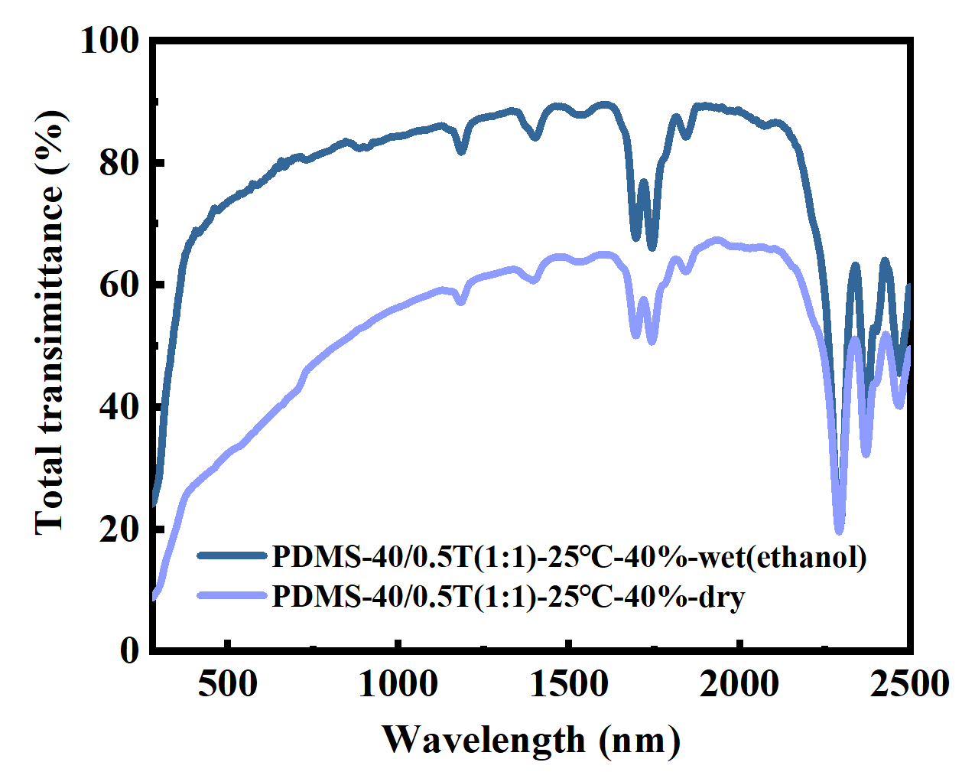
Fig. S45
Total transmittance spectra of PDMS-40/0.5T(1:1) film before and after solvatochromic (ethanol) in the stretched state at 25 °C
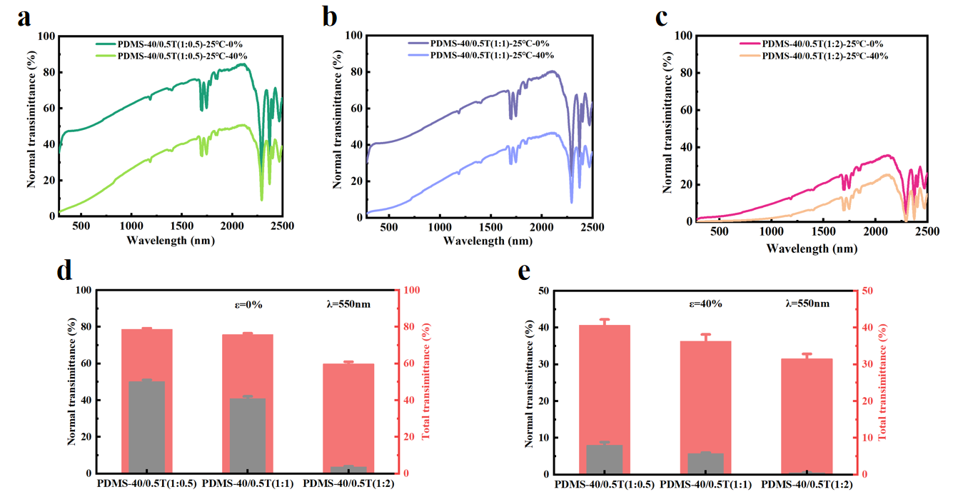
Fig. S46 Optical properties of films with different TC layer thicknesses.
Normal transmittance spectra of a PDMS-40/0.5T(1:0.5), b PDMS-40/0.5T(1:1) and c PDMS-40/0.5T(1:2) films before and after stretching at 25 °C. Variation of normal transmittance (black) and total transmittance (red) of PDMS-40/0.5T(1:0.5), PDMS-40/0.5T(1:1), and PDMS-40/0.5T(1:2) films d before and e after stretching at 25 °C, monitored at λ = 550 nm
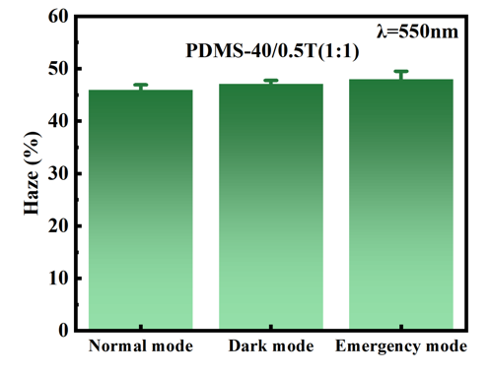
Fig. S47
Variation of haze of PDMS-40/0.5T(1:1) film in different modes, monitored at λ = 550 nm
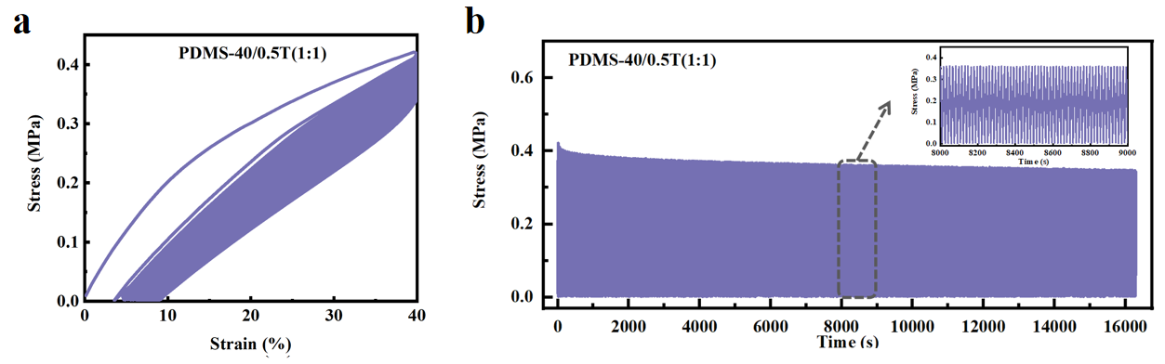
Fig. S48 Stress-strain and stress-time curves.
a Stress-strain and b stress-time curves of PDMS-40/0.5T(1:1) film during 1000 stretching cycles at 40% cyclic tensile strain

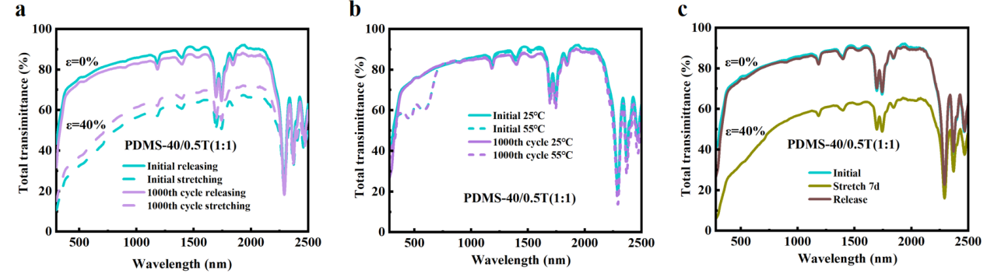
Fig. S49 Stability of PDMS-40/0.5T (1:1) film.
a Total transmittance spectra of PDMS-40/0.5T(1:1) film before and after 1000 stretching cycles at 40% cyclic tensile strain. b Total transmittance spectra of PDMS-40/0.5T(1:1) film before and after 1000 heating and cooling cycles between 25-55 °C. c Total transmittance spectra of PDMS-40/0.5T (1:1) film before and after stretching at 40% tensile strain for 7 days
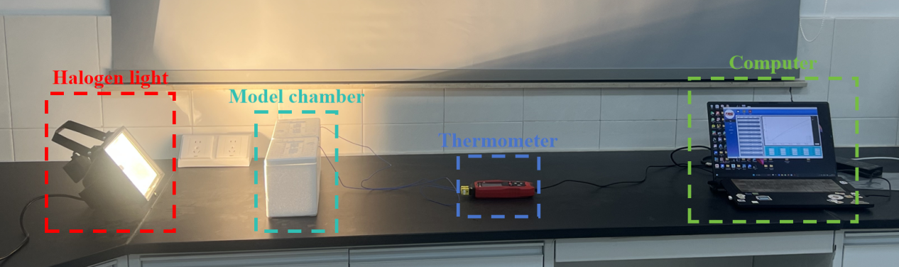
Fig. S50
Schematic diagram of the model chamber artificial light test setup
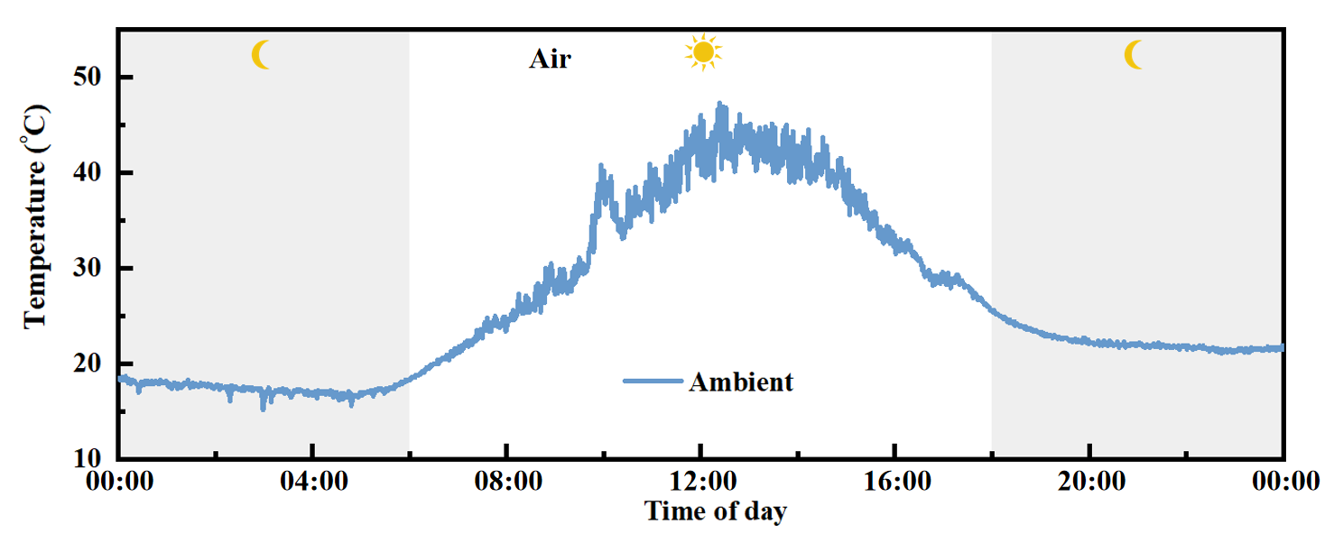
Fig. S51
Room temperature-time curves of model houses under sunlight illumination on sunny (Shanghai, May 2, 2025)
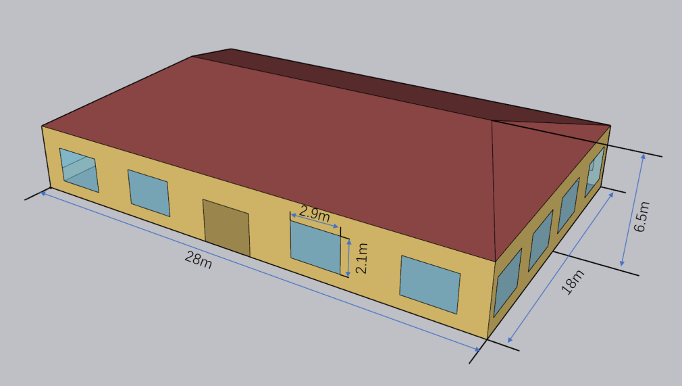
Fig. S52
Schematic diagram of the building model used in the simulation
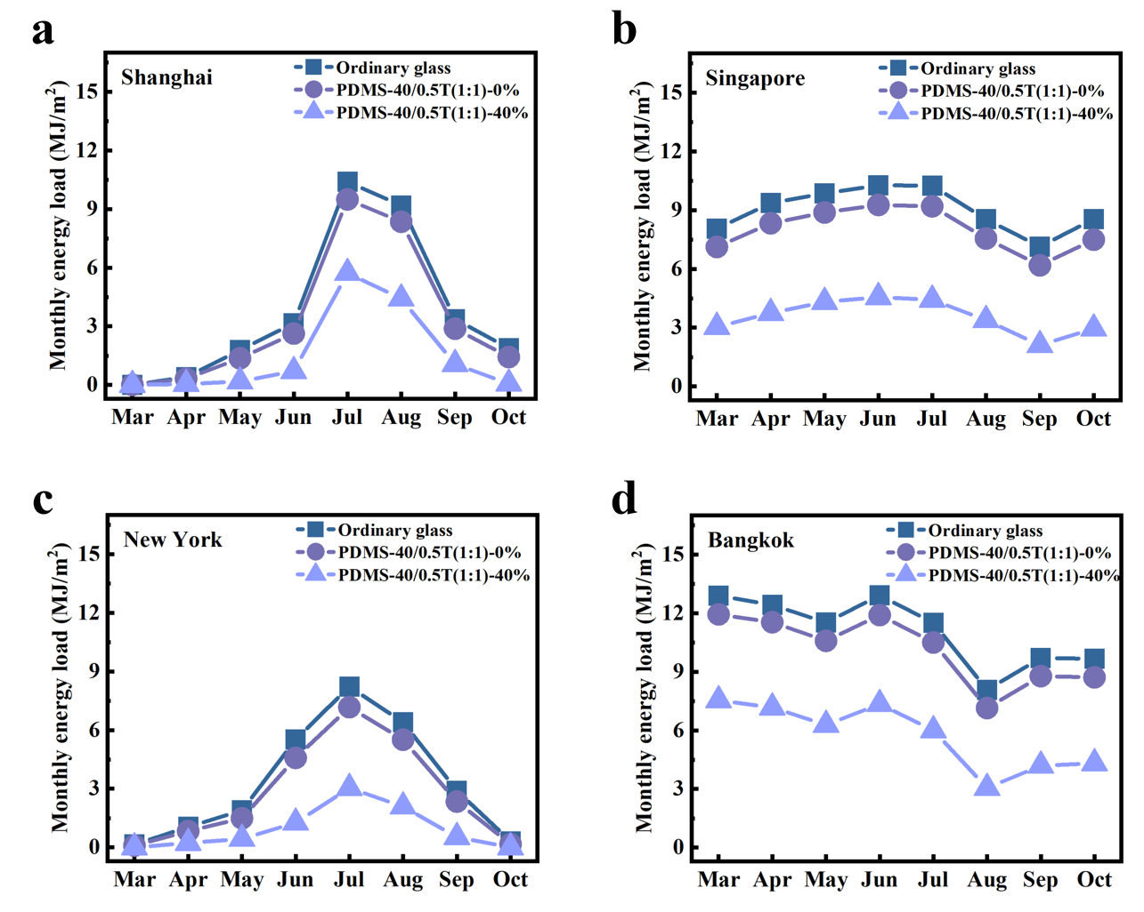
Fig. S53 Monthly energy loads.
Monthly energy loads of PDMS-40/0.5T (1:1)-0%, PDMS-40/0.5T (1:1)-40%, and ordinary glass windows in a Shanghai, China; b Singapore; c New York, USA; and d Bangkok, Thailand, during the spring, summer, and autumn seasons

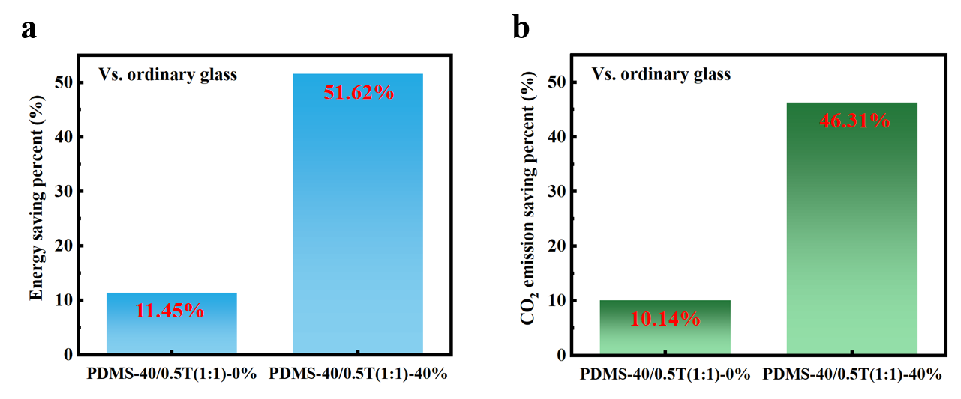
Fig. S54 Total energy saving percentage and total carbon dioxide (CO₂) emission saving percentage.
Globally, a total energy saving percentage and b total CO₂ emission saving percentage of PDMS-40/0.5T(1:1) smart windows before and after stretching compared to ordinary glass window
Table S1
Thermophysical parameters of the baseline building envelope
Construction | Material | Thickness  (mm) | Conductivity  (W/(m·K)) | Density  (kg/m³) | Specific heat  (J/(kg·K))
Wall | 1IN stucco | 25.3 | 0.7 | 1858 | 837
Wall | 8IN concrete HW | 203.3 | 1.73 | 2243 | 837
Wall | Wall insulation | 7.9 | 0.043 | 91 | 837
Wall | 1/2IN gypsum | 11.3 | 0.16 | 784.9 | 830
Floor | MAT-CC05 4 HW concrete | 101.6 | 1.31 | 2240 | 837
Floor | CP02 carpet pad | Thermal resistance is 0.21648 m²·K/W
Roof | Roof membrane | 9.5 | 0.16 | 1121.29 | 1460
Roof | Roof insulation | 210.5 | 0.05 | 265 | 837
Roof | Metal decking | 1.5 | 45 | 7680 | 418
Door | F08 metal surface | 0.8 | 45.28 | 7823 | 500
Door | I01 25mm insulation board | 25.4 | 0.003 | 43 | 1210

Table S2
Summary of various films in this work
Sample | Cyclic spraying number | TCM (wt%) | PDMS precursor solution (g) | PDMS/TCM precursor solution (g)
PDMS | / | / | 5.36 | /
PDMS-10 | 10 | / | 5.36 | /
PDMS-20 | 20 | / | 5.36 | /
PDMS-30 | 30 | / | 5.36 | /
PDMS-40 | 40 | / | 5.36 | /
PDMS/0.25T | / | 0.25 | / | 5.36
PDMS/0.5T | / | 0.5 | / | 5.36
PDMS/0.75T | / | 0.75 | / | 5.36
PDMS/1T | / | 1 | / | 5.36
PDMS-40/0.5T(1:0.5) | 40 | 0.5 | 5.36 | 2.68
PDMS-40/0.5T(1:1) | 40 | 0.5 | 5.36 | 5.36
PDMS-40/0.5T(1:2) | 40 | 0.5 | 5.36 | 10.72

Table S3
Comparison to state-of-the-art mechanochromic films regarding their functions and properties
Sample | |ΔT_{n}| (%) | Strain for |ΔT_{n}| (%) | Solvatochromic | Ref.
PDMS/SiO₂ | 61.83 | 90 | No | [5]
PDMS/SiO2-pre-strain | 60 | 40 | No | [12]
PDMS/Al₂O₃ NT/PDMS | 50.09 | 80 | No | [13]
SoftPDMS/HardPDMS | 63.9 | 80 | No | [14]
PDMS/KH570-SiO₂/PDMS | 56 | 70 | No | [15]
PDMS/Al₂O₃/PDMS | 68.43 | 40 | No | [16]
PDMS/PVA/Laponite | 54.44 | 40 | No | [17]
PDMS-40 | 72.37 | 40 | Yes | This work

Table S4
Thermal conductivity of different films at 25 °C
Sample | Thermal conductivity (W/(m·K))
PDMS | 0.2334
PDMS/0.5T | 0.2231
PDMS-40/0.5T(1:1) | 0.2286

Movie S1 Rapid solvatochromism of PDMS-40 film.
As demonstrated in Supplementary Movie 1, the PDMS-40 film rapidly undergoes solvatochromism upon ethanol droplet contact while at a certain tensile strain, subsequently recovering high transmittance.

Movie S2 Hamster pattern used for information encryption example.
As shown in supplementary video 2, the hamster pattern can be rapidly and reversibly hidden and revealed during stretching and release.

References
[1] Li B, Xu F, Guan T, Li Y, Sun J. Self-adhesive self-healing thermochromic ionogels for smart windows with excellent environmental and mechanical stability, solar modulation, and antifogging capabilities. Adv Mater 2023;35(20):2211456.
https://doi.org/10.1002/adma.202211456.
[2] Deng Y, Yang Y, Xiao Y, Zeng X, Xie HL, Lan R, et al. Annual energy‐saving smart windows with actively controllable passive radiative cooling and multimode heating regulation. Adv Mater 2024;36(27):2401869. https://doi.org/10.1002/adma.202401869.
[3] Ke Y, Li N, Liu Y, Zhu T, Wang S, Li Y, et al. Bio‐inspired, scalable, and tri‐mode stimuli‐chromic composite for smart window multifunctionality. Adv Funct Mater 2023;33(46):2305998. https://doi.org/10.1002/adfm.202305998.
[4] Zhao FX, Wang MH, Huang ZY, Zhu MH, Chen C, Pan QH, et al. Bio-inspired mechanically responsive smart windows for visible and near-infrared multiwavelength spectral modulation. Adv Mater 2024;36(40):2408192. https://doi.org/10.1002/adma.202408192.
[5] Ge D, Lee E, Yang L, Cho Y, Li M, Gianola DS, et al. A robust smart window: reversibly switching from high transparency to angle-independent structural color display. Adv Mater 2015;27(15):2489-2495. https://doi.org/10.1002/adma.201500281.
[6] Cordoba A, Rivera-Muñoz EM, Velázquez-Castillo R, Esquivel K. PDMS/TiO₂ and PDMS/SiO₂ nanocomposites: mechanical properties’ evaluation for improved insulating coatings. Nanomaterials 2023;13(10):1699. https://doi.org/10.3390/nano13101699.
[7] Wang L, Xie G, Mi X, Zhang B, Du Y, Zhu Q, et al. Surface-modified TiO₂@ SiO₂ nanocomposites for enhanced dispersibility and optical performance to apply in the printing process as a pigment. ACS omega 2023;8(22):20116-20124. https://doi.org/10.1021/acsomega.3c02679.
[8] Wang X, Tang Y, Cheng S, Gao Q, Yuan Y, Li A, et al. PDMS-based conductive elastomeric composite with 3D reduced graphene oxide conductive network for flexible strain sensor. Compos Part A Appl Sci Manuf 2022;161:107113. https://doi.org/10.1016/j.compositesa.2022.107113.
[9] Zhang C, Zhai T, Zhan C, Fu Q, Ma C. Actuation behavior of multilayer graphene nanosheets/polydimethylsiloxane composite films. Polymers 2018;10(11):1243. https://doi.org/10.3390/polym10111243.
[10] He Y, Li W, Han N, Wang J, Zhang X. Facile flexible reversible thermochromic membranes based on micro/nanoencapsulated phase change materials for wearable temperature sensor. Appl Energy 2019;247:615-629. https://doi.org/10.1016/j.apenergy.2019.04.077.
[11] Ke Y, Yin Y, Zhang Q, Tan Y, Hu P, Wang S, et al. Adaptive thermochromic windows from active plasmonic elastomers. Joule 2019;3(3):858-871. https://doi.org/10.1016/j.joule.2018.12.024.
[12] Kim HN, Ge D, Lee E, Yang S. Multistate and on‐demand smart windows. Adv Mater 2018;30(43):1803847. https://doi.org/10.1002/adma.201803847.
[13] Cho D, Jang JS, Nam SH, Ko K, Hwang W, Jung JW, et al. Focused electric-field polymer writing: toward ultralarge, multistimuli-responsive membranes. ACS nano 2020;14(9):12173-12183. https://pubs.acs.org/10.1021/acsnano.0c05843.
[14] Chen H, Cho D, Ko K, Qin C, Kim MP, Zhang H, et al. Interdigitated three-dimensional heterogeneous nanocomposites for high-performance mechanochromic smart membranes. ACS nano 2021;16(1):68-77. https://doi.org/10.1021/acsnano.1c06403.
[15] Zhan H, Cheng W, Liu F, Yang C, Wang Y, Yan K, et al. Resilient and robust mechanoresponsive polydimethylsiloxane/SiO₂ composites induced by interfacial enhancement. J Colloid Interface Sci 2025;690:137361. https://doi.org/10.1016/j.jcis.2025.137361.
[16] Cho D, Shim YS, Jung JW, Nam SH, Min S, Lee SE, et al. High‐contrast optical modulation from strain‐induced nanogaps at 3D heterogeneous interfaces. Adv Sci 2020;7(11):1903708. https://doi.org/10.1002/advs.201903708.
[17] Zeng S, Zhang D, Huang W, Wang Z, Freire SG, Yu X, et al. Bio-inspired sensitive and reversible mechanochromisms via strain-dependent cracks and folds. Nat Commun 2016;7(1):11802. https://pubs.acs.org/10.1038/ncomms11802.

