Supplementary materials
Journal of Plant Research
The name(s) of the author(s):
Momoka Wada, Chiaki Kuga, Kimie Atsuzawa, Atsuko Miyagi, Toshiki Ishikawa, Masatoshi Yamaguchi, Yuki Fujiki, Yasuko Kaneko, Maki Kawai-Yamada, Ikuo Nishida*
Title:
Genetic defects in the CDP-choline pathway for phosphatidylcholine biosynthesis cannot be transmitted to offspring via male gametophytes owing to interruption of autophagy-like processes required for pollen germination in Arabidopsis thaliana
*Ikuo Nishida (the corresponding author)
nishida@mail.saitama-u.ac.jp
https://orcid.org/0000-0002-9669-4005

Content
Fig. S1
Fig. S2
Fig. S3
Fig. S4 and Supplementary text for Fig. S4
Fig. S5 and Supplementary text for Fig. S5
Fig. S6 and Supplementary text for Fig. S6
Fig. S7 and Supplementary text for Fig. S7
Fig. S8 and Supplementary text for Fig. S8
Fig. S9 and Supplementary text for Fig. S9
Fig. S10 and Supplementary text for Fig. S10
Fig. S11 and Supplementary text for Fig. S11
Fig. S12
Fig. S13
Tables S1–S3

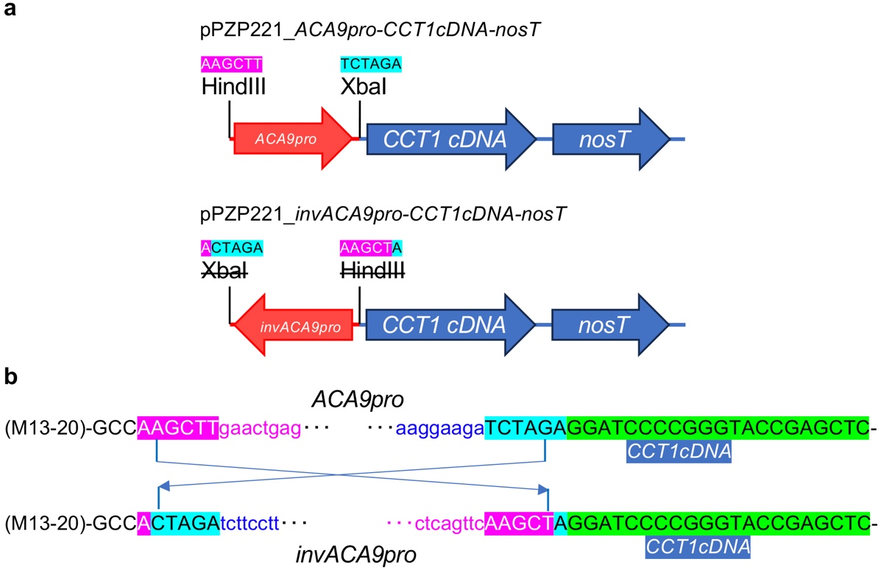

Fig. S1 A plasmid construct encoding CCT1 for genomic complementation of the defect of cct1-3 cct2-5 transmission via male gametophytes. Our attempts to produce pPZP221_ACA9pro-CCT1cDNA-nosT were not successful. Alternatively, pPZP221_invACA9pro-CCT1cDNA-nosT was inadvertently constructed and successfully used for genomic complementation.

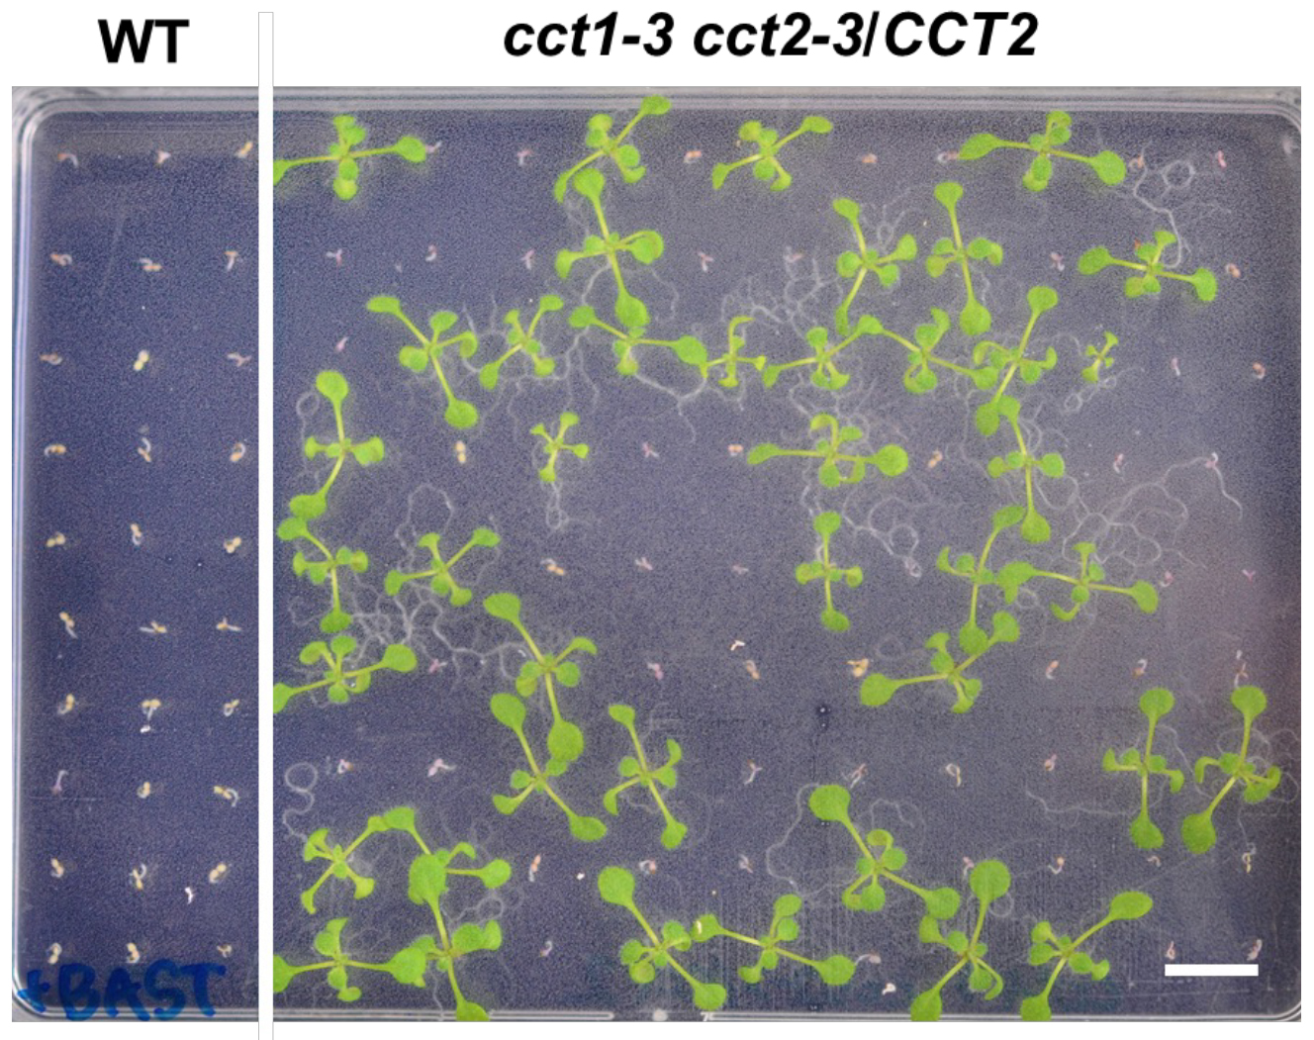

Fig. S2 Segregation analysis of CCT/CCT2 and cct2-3/CCT2 in the cct1-3 background based on survival rate on 1/2 MS agar plates containing 40 nmol ml^{–1} BASTA. Among 94 seeds harvested from a cct1-3 cct2-3/CCT2 plant, 53 seedings were dead (cct1-3 CCT2) and 41 survived (cct1-3 cct2-3/CCT2).

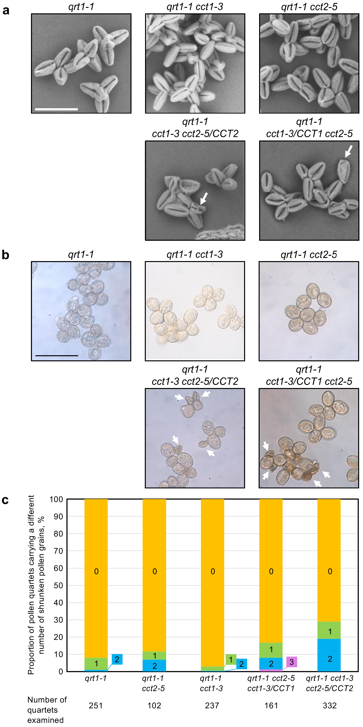
Fig. S3 Assessment of pollen shrinkage. Anthers from qrt1-1, qrt1-1 cct2-5, qrt1-1 cct1-3, qrt1-1 cct2-5 cct1-3/CCT1 and qrt1-1 cct1-3 cct2-5/CCT2 plants were examined. a Pollen quartets from anthers were observed under a scanning electron microscope. Bar = 100 µm. b, c Anthers were rubbed over the surface of agar plates made up of pollen germination medium. After a 15-min incubation at 23 ℃, pollen quartets were observed under a microscope. b Arrows point to shrunken pollen grains. Bar = 500 µm. c The proportion of pollen quartets carrying different numbers of shrunken pollen grains.

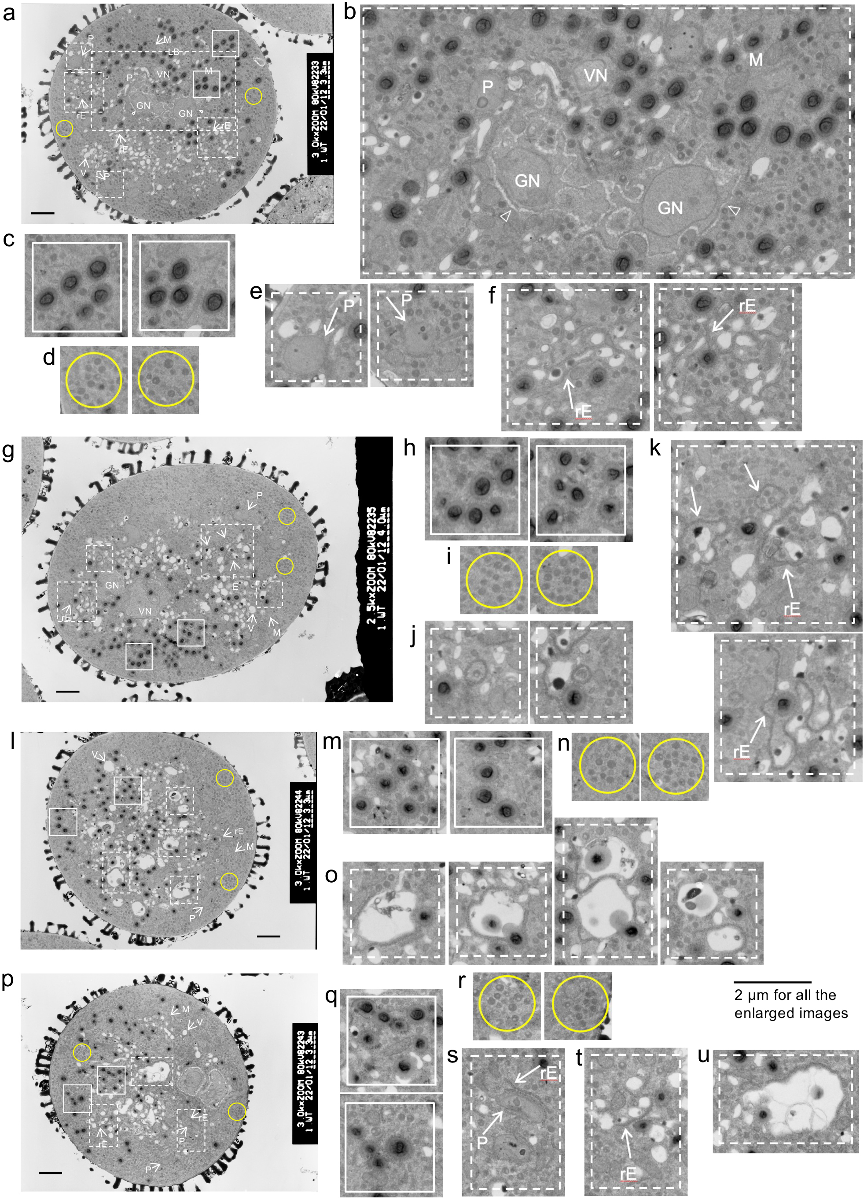
Fig. S4 TEM analysis of ultrathin sections of pollen grains from Arabidopsis wild-type plants. a, g, l, p Images of representative pollen grain cells. Bars = 2 µm. b–f, h–k, m–o, and q–u show enlarged images taken from panels a, g, l, and p, respectively. Open arrowheads indicate cell septa for GN. The same image in panel p is used in Fig. 5a. An enlarged image of panel l is used in Fig. 7a. GN, generative nuclei; M, mitochondrion; P, plastid; rE, rough endoplasmic reticulum; V, vacuole; VN, vegetative nucleus.
Supplementary text for Fig. S4
The wild-type pollen cell shown in Fig. S4a (or S4b for enlargement) had two generative nuclei (GN) and one vegetative nucleus (VN) as well as cellular septa (open arrowheads) enclosing generative cells. GN were also seen in the wild-type pollen cell shown in Fig. S4p (Fig. 5a), and GN and VN were seen in the single pollen cell shown in Fig. S4g. The following features were commonly seen in all the images of wild-type pollen cells shown in Figs. S4a, S4g, and S4l, and S4p (Fig. 5a). (1) LBs were seen as dark, round, electron-dense structures whose surface looked rather transparent compared with the inner bodies and, hence, could have a membranous boundary (Figs. S4c, S4h, S4m, and S4q). (2) The cytoplasm contained numerous moderately electron-dense SGSs that sometimes had a semi-transparent domain in the inner area (Figs. S4d, S4i, S4n, and S4r). (3) The cytoplasm had mitochondria (M) and plastids (P) (Figs. S4a, S4g, S4l, and S4p), and plastids often existed in contact with rough endoplasmic reticulum (rER; marked with rE in the figures) [Figs. S4e, S4p (Fig. 5a), and S4s]. (4) SGSs were sometimes entrapped by rER (Fig. S4l (Fig. 7a), S4g, S4j, and S4k) (5) There were many very-small vacuolar structures of <1 µm in diameter (vSVs), some of which contained structures similar to SGSs or LBs [Fig. 6a, black arrows; Figs. S4l (Fig. 7a), S4f , S4j, and S4k]. (6) rER was evident between vSVs or vacuoles to form a network [Figs. S4f, S4k, S4l (Fig. 7a), and S4t].
In the wild-type pollen cell shown in Fig. S4g, LBs were localized on one side of the cell, whereas vSVs were localized on the other side of the cell. However, some of these vSVs were incorporating electron-dense, small LB-like structures (Figs. S4j and S4k).
In wild-type pollen cells shown in Figs. S4g, S4l (Fig. 7a), and S4p, vSVs appeared to fuse with each other to generate a larger vacuolar body of 1~3 µm in diameter, which we designated herein as the small vacuolar body (SVB). SVBs were ingesting LBs for subsequent digestion (series of photos shown in Fig. S4o) while fusing with each other to generate a larger vacuolar body (Fig. S4u). Because LBs at this stage of pollen germination in vitro appeared to have a transparent boundary, this may have assisted fusion with SVBs (Figs. S4c, S4h, S4m, and S4q). The breakdown of LBs or SGSs into sucrose or other metabolites may be important for maintaining turgor pressure required for pollen-tube budding and elongation.

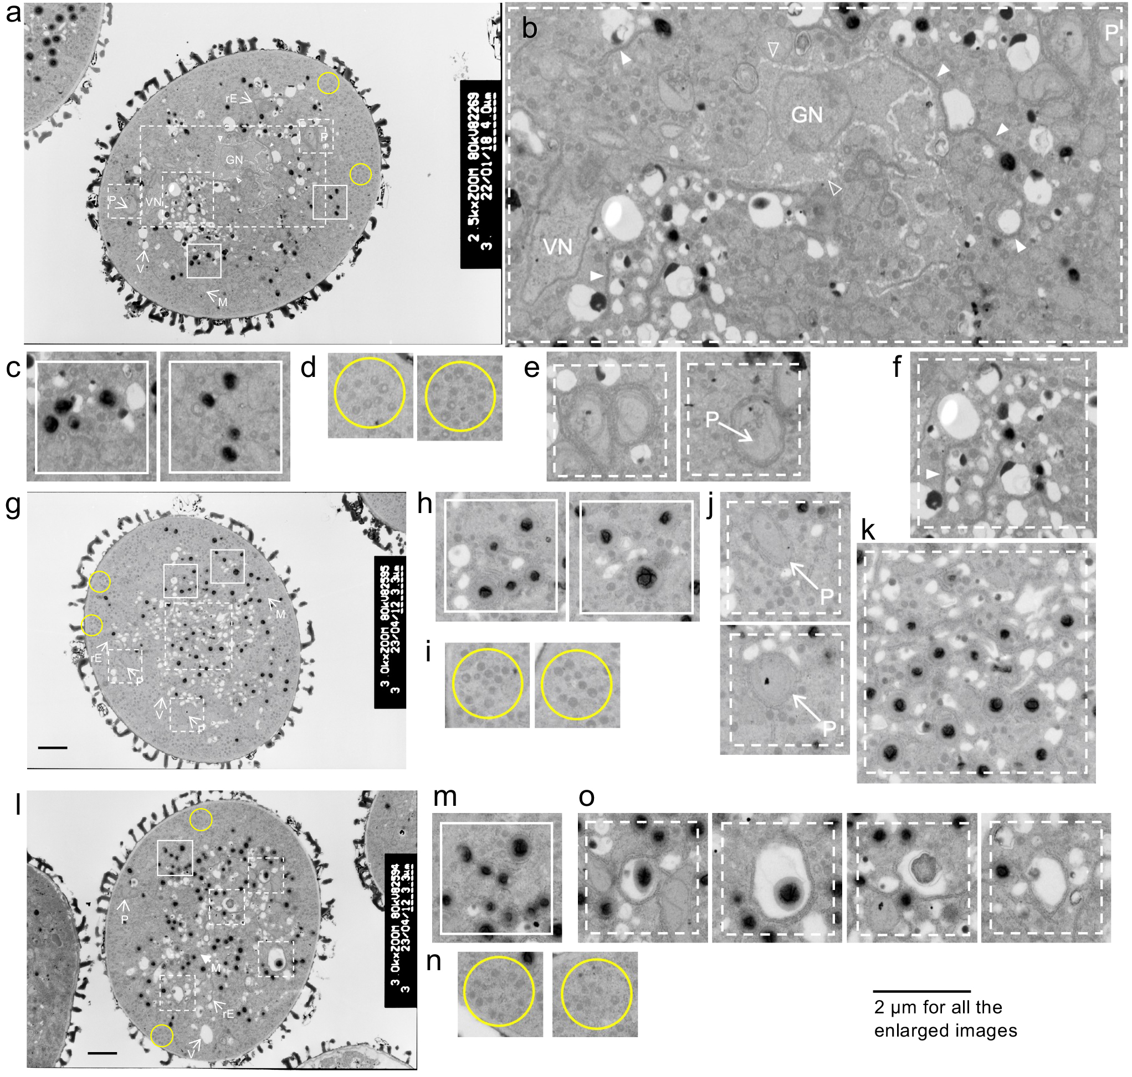
Fig. S5 TEM analysis of ultrathin sections of pollen grains from Arabidopsis cct2-5 plants. a, g, l, p, t Images of representative pollen grain cells. Bars = 2 µm. b–f, h–k, m–o, q–s, and u–w show enlarged images taken from panels a, g, l, p, and t, respectively. Open arrowheads indicate cell septa for GN. Closed arrowheads indicate endoplasmic reticula running through the cytoplasm. An image in panel t is rotated 90 degrees to the right in Fig. 5b. A An inverted image in panel l is used in Fig. 7b. GN, generative nuclei; M, mitochondrion; P, plastid; rE, rough endoplasmic reticulum; V, vacuole; VN, vegetative nucleus.

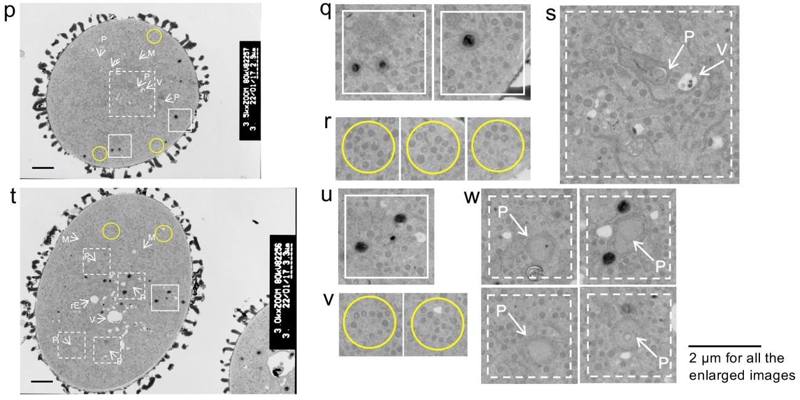

Fig. S5 (continued) TEM analysis of ultrathin sections of pollen grains from Arabidopsis cct2-5 plants. a, g, l, p, t Images of representative pollen grain cells. Bars = 2 µm. b–f, h–k, m–o, q–s, and u–w show enlarged images taken from panels a, g, l, p, and t, respectively. Open arrowheads indicate cell septa for GN. Closed arrowheads indicate endoplasmic reticula running through the cytoplasm. An image in panel t is rotated 90 degrees to the right in Fig. 5b. A An inverted image in panel l is used in Fig. 7b. GN, generative nuclei; M, mitochondrion; P, plastid; rE, rough endoplasmic reticulum; V, vacuole; VN, vegetative nucleus.

Supplementary text for Fig. S5
In a typical cct2-5 pollen cell from a cct2-5 plant, shown in Fig. S5a, GN and VN were seen together with cellular septa (Fig. S5b, open arrowheads), suggesting the completion of two rounds of mitosis in the cct2-5 pollen cell. As in the wild-type pollen cells [Fig. S4d, S4i, S4n, S4p (Figs. 5a and 6a), and S4r], the cytoplasm of cct2-5 pollen cells contained numerous moderately electron-dense SGSs [Fig. S5t (Fig. 6b)], and some of them also had a central, transparent small body [Figs. S5d, S5i, S5n, S5r, S5t (Fig. 6b), and S5v] as seen in the wild type (Figs. S4d, S4i, S4n, and S4r). LBs were electron-dense and surrounded by a transparent boundary (Figs. S5c, S5h, S5m, S5q, and S5u) as seen in the wild type (Figs. S4c, S4h, S4m, and S4q), but they looked smaller in cct2-5 pollen cells than in the wild-type cells. As in the wild-type cells [Figs. S4l (Fig. 7a) and S4o], LBs were digested by vSVs (of <1 µm in diameter) or larger SVBs [Fig. S5l (Fig. 7b, black arrows)]; see also a series of photos shown in Fig. S5o). In some photos [Figs. S5t (Fig. 5b) and S5p], there were much fewer LBs in the cytoplasm compared with wild-type cells, but even in such cells the images of SGSs looked moderately electron-dense or "solid" as seen in the wild-type cells. The cytoplasm of the cct2-5 pollen cells also included mitochondria and plastids (Figs. S5a, S5g, S5p, and S5t; M and P), and the plastids often existed in contact with rER (Figs. S5e, S5j, S5s, and S5w). rER [was evident throughout the cytoplasm (Fig. S5b, closed arrowheads) or in close proximity to vSVs, SVBs, and SGSs (Figs. S5f, and S5k).

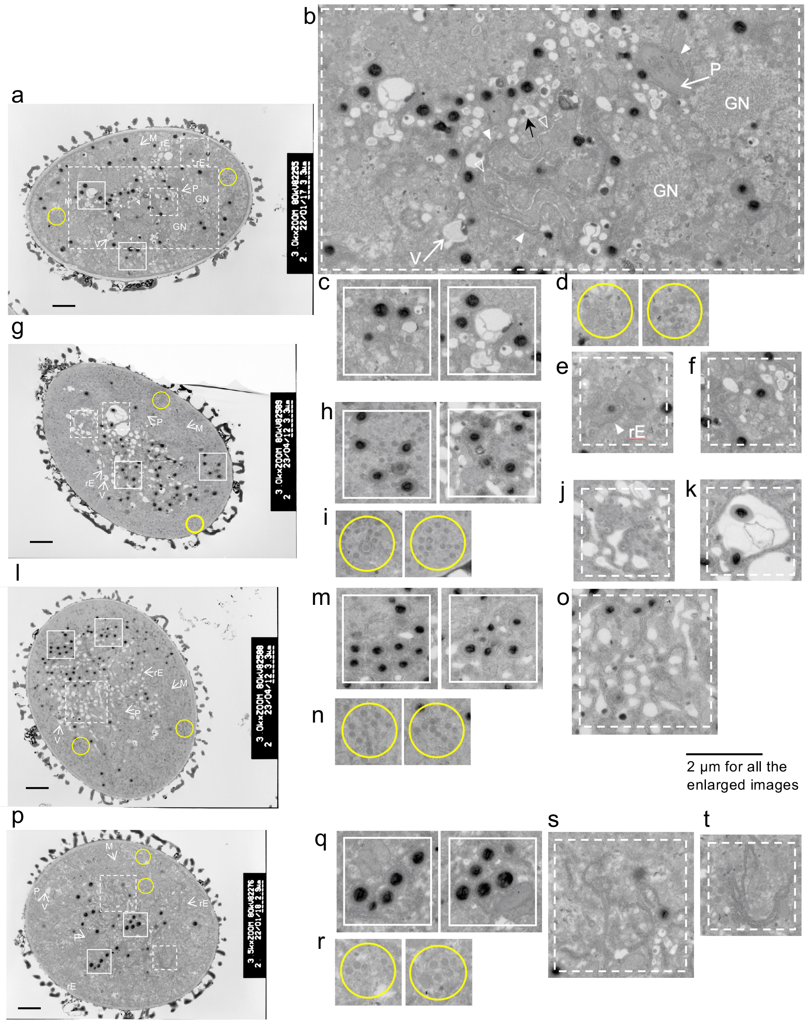
Fig. S6 TEM analysis of ultrathin sections of cct1-3 pollen grains from Arabidopsis cct1-3 plants. a, g, l, p Images of representative pollen grain cells. Bars = 2 µm. b–f, h–k, m–o, and q–t show enlarged images taken from panels a, g, l, and p, respectively. Open arrowheads indicate cell septa for GN. Closed arrowheads indicate endoplasmic reticula running through the cytoplasm. Panel a shows a laterally reversed image of the image shown in Fig. 5c. GN, generative nuclei; M, mitochondrion; P, plastid; rE, rough endoplasmic reticulum; V, vacuole; VN, vegetative nucleus.
Supplementary text for Fig. S6
In a typical cct1-3 pollen cell from a cct1-3 plant, shown in Fig. S6a (and S6b for enlargement), two GN were also seen together with cellular septa (open arrowheads), indicating the completion of two rounds of mitosis in the cct1-3 pollen cell. As in the wild-type cells [Figs. S4d, S4i, S4n, S4p (Fig. 5a), and S4r], the cytoplasm of cct1-3 pollen cells also contained moderately electron-dense or "solid" SGSs [Fig. S6a (Fig. 5c or 6c)], with a central, transparent small body in some SGSs [Figs. S6a (Fig. 6c), S6d, S6i, and S6n]. However, it should be noted that SGSs in some cells looked larger and "swollen" (Fig. S6r). As in cct2-5 pollen cells [Figs. S5c, S5h, S5m, S5q, S5t (Fig. 6b), and S5u], LBs were electron-dense, surrounded by a transparent boundary [Figs. S6c, S6h, S6m, S6r (Fig. 6c, SGS*), and S6q], and looked smaller than those in the wild-type cells. As in cct2-5 pollen cells [Figs. S5o and S5t (Fig. 6b)], LBs were digested by vSVs [Fig. S6b (Fig. 6c), black arrows, S6b and S6o] and SVBs (Fig. S6k). In some cct1-3 pollen cells from a cct1-3 plant (Fig. S6p), there were much fewer LBs compared with wild-type cells, but such cells included the "solid" SGSs together with partly "swollen" SGSs (Fig. S6r). The cytoplasm of cct1-3 pollen cells included mitochondria and plastids (Figs. S6a, S6g, S6l, and S6p; M and P), and the plastids existed in contact with rER (Figs. S6b, and S6e). rER was evident in the cytoplasm (Fig. S6b, closed arrowhead) or existed in the vicinity of vSVs and "swollen" SGSs (Figs. S6f, S6j, S6o, S6s, and S6t).

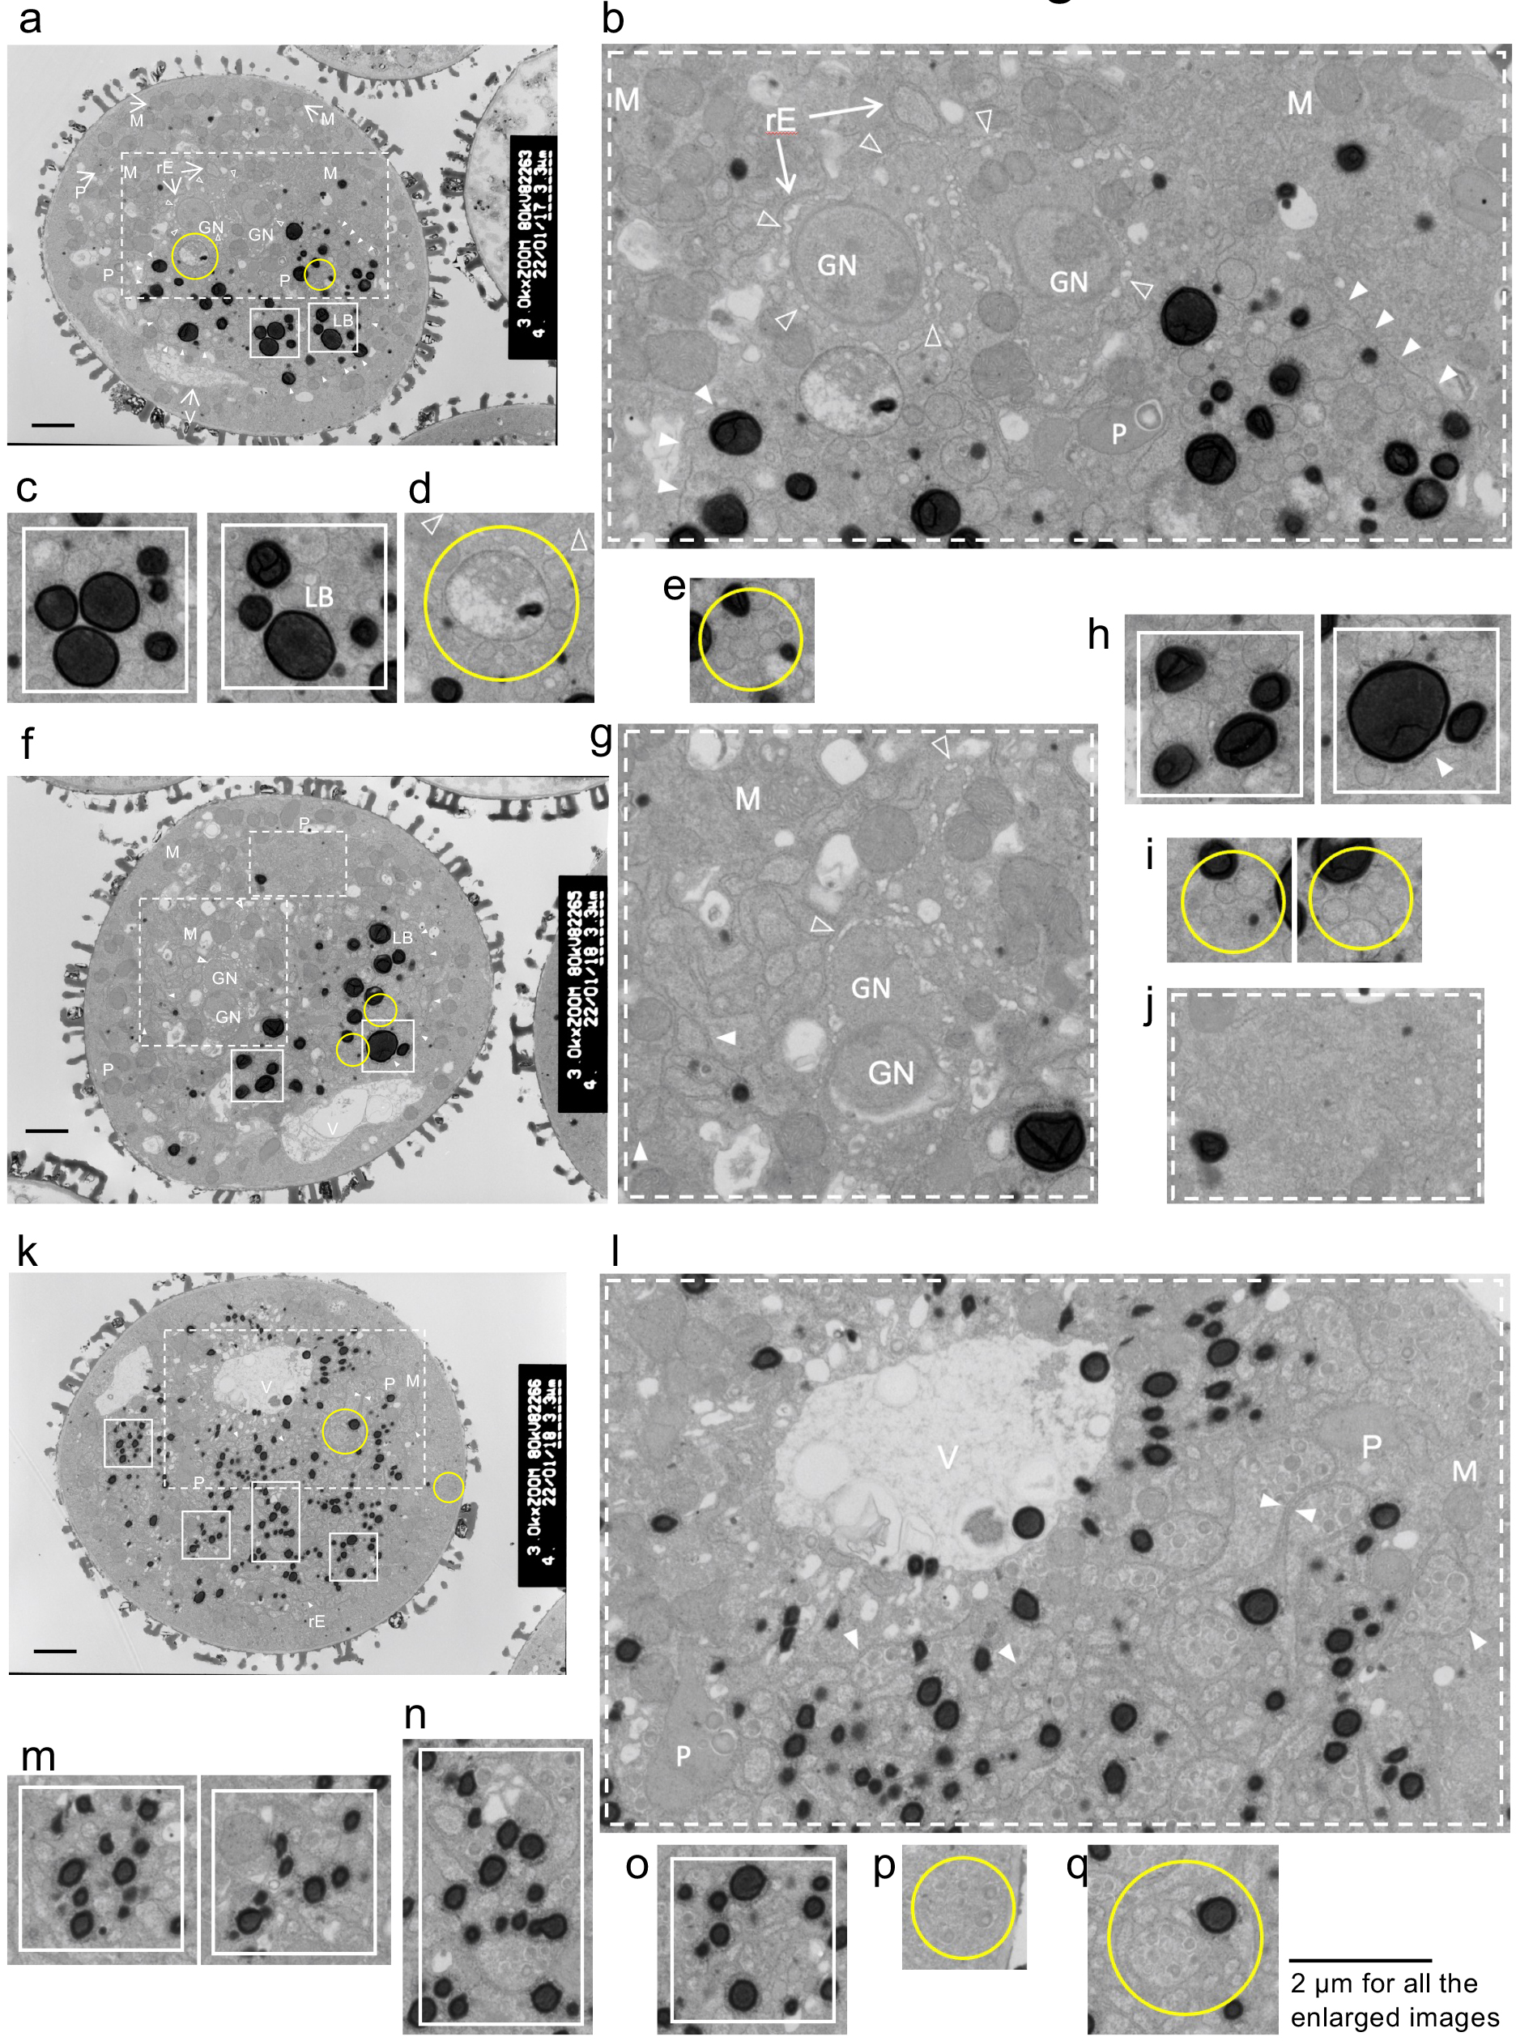
Fig. S7 TEM analysis of ultrathin sections of cct1-3 cct2-5 pollen grains from Arabidopsis cct2-5 cct1-3/CCT1 plants. a, f, k, r Images of representative pollen grain cells displaying abnormal ultrafine structures. Bars = 2 µm. b–e, g–j, l–q, and s show enlarged images taken from panels a, f, k, and r, respectively. Open arrowheads indicate cell septa for GN. Closed arrowheads indicate endoplasmic reticula running through the cytoplasm. An upside-down image of panel a is presented in Fig. 5d. GN, generative nuclei; M, mitochondrion; P, plastid; rE, rough endoplasmic reticulum; V, vacuole; VN, vegetative nucleus.

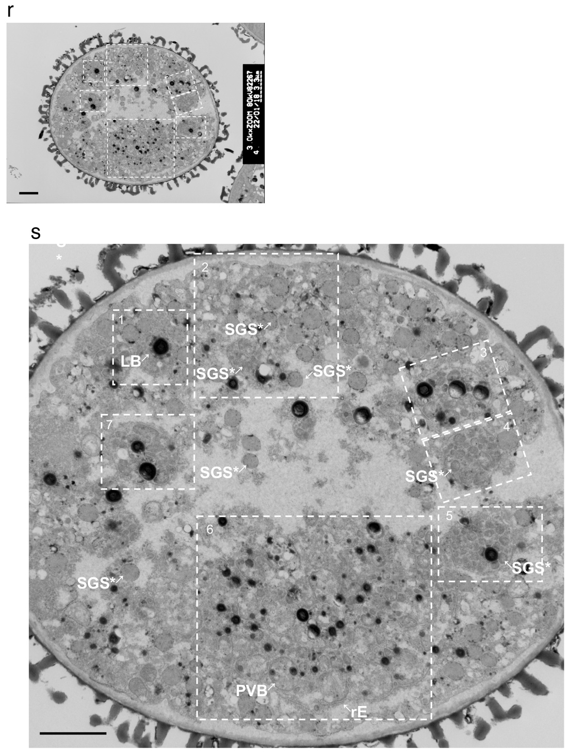

Fig. S7 (continued) TEM analysis of ultrathin sections of cct1-3 cct2-5 pollen grains from Arabidopsis cct2-5 cct1-3/CCT1 plants. a, f, k, r Images of representative pollen grain cells displaying abnormal ultrafine structures. Bars = 2 µm. b–e, g–j, l–q, and s show enlarged images taken from panels a, f, k, and r, respectively. Open arrowheads indicate cell septa for GN. Closed arrowheads indicate endoplasmic reticula running through the cytoplasm. An upside-down image of panel a is presented in Fig. 5d. GN, generative nuclei; M, mitochondrion; P, plastid; rE, rough endoplasmic reticulum; V, vacuole; VN, vegetative nucleus.
Supplementary text for Fig. S7
cct1-3 cct2-5 pollen cells from a cct2-5 cct1-3/CCT1 plant contained extremely enlarged LBs together with small or tiny LBs [Figs. S7a (Fig. 6d), S7c, S7f, and S7h]. Regardless of their size, these LBs had a rather electron-dense appearance near the surface, but they appeared to be surrounded by a semitransparent boundary although it was partly broken. Even in such abnormal pollen cells, however, two GN [Figs. S7a (Fig. 5d), S7b and S7g] and developing cellular septa [Figs. S7a (Fig. 5d), S7b, and S7g; open arrowheads] were evident, consistent with the results of DAPI staining (Fig. 3d). As opposed to wild-type, cct2-5, and cct1-3 pollen cells, such cct1-3 cct2-5 pollen cells contained diffused or "swollen" SGSs (Figs. S7e and S7i; Fig. 6d, SGS*), and little "solid" SGSs were seen in the cytoplasm. The remnants of "swollen" SGSs were also seen within some membranous bodies (Fig. S7d; Figs. 5d and 6d, black arrows), which we later referred to as a prevacuolar body (PVB). rER was evident in the cytoplasm (Fig. S7b, closed arrowheads; Fig. 5d, rE) and between cellular components (Fig. S7g, closed arrowheads; Fig. 6d, star).
The pollen cell shown in Fig. S7k could also be assigned as a cct1-3 cct2-5 pollen cell from a cct2-5 cct1-3/CCT1 plant. Although few extremely enlarged LBs could be seen, this pollen cell still contained very small LBs together with the smaller LBs seen in cct2-5 pollen cells [Figs. S5a, S5g, S5l, and S5t (Fig. 5b)]. Furthermore, the smaller LBs had a relatively electron-dense boundary (Fig. S7m), as seen in the cct1-3 cct2-5 pollen cells shown in Figs. S7a and S7f, and were in contact with one another as if they were in the process of fusing with each other to generate larger LBs (Figs. S7m, S7n, and S7o). It was also noticeable that this cct1-3 cct2-5 pollen cell contained a large number of "swollen" SGSs (Figs. S7l and S7q) together with a small number of "solid" SGSs (Fig. S7p). rER existed side by side (Fig. S7l, counter facing arrowheads) and was going to surround both "solid" and "swollen" SGSs (Figs. S7l and S7q). There occurred a large, but incomplete vacuole-like structure, in which we could see undigested LBs as well as remnants of undigested cellular components (Fig. S7l, V). All these features conformed to a view that the pollen cell shown in Fig. S7k should be assigned as a cct1-3 cct2-5 pollen cell.
Compared with the cct1-3 cct2-5 pollen cell shown in Fig. S7k, the cct1-3 cct2-5 pollen cell from a cct2-5 cct1-3/CCT1 plant shown in Fig. S7r appeared to display more pronounced cytoplasmic deformation. In this cct1-3 cct2-5 pollen cell, LBs had a rather electron-dense appearance near the surface, with disproportionate sizes, and some enlarged LBs appeared to be enclosed within membrane boundaries with discontinuous electron-dense staining [Fig. S7s (Fig. 8a), box 1). Many SGSs were entrapped within some type of membrane bodies of diameter less than ~2 µm, within which entrapped SGSs remained diffused and undigested [Fig. S7s (Fig. 8a), boxes 2, 4, and 5]. Two types of PVBs could be seen: one containing many undigested SGS* [Fig. S7s (Fig. 8a), box 2] might have been derived from a very swollen or a fused form of SGS*; another containing various kinds of cytoplasmic components was a typical PVB [Fig. S7s (Fig. 8a), box 6]. Each type of PVBs was gathered on opposite sides of the cytoplasm, as if they were attempting to fuse with each other to generate larger bodies [Fig. S7s (Fig. 8a), box 2, SGS*]. Although the cct1-3 cct2-5 pollen cell from a cct2-5 cct1-3/CCT1 plant shown in Fig. S7r (S7s) contained a large proportion of vacant space, SVBs were scarcely seen, whereas rER enclosed SGSs, SGS*s, LBs, and other cellular components to develop PVBs [Fig. S7s (Fig. 8a), box 6). Thus, we concluded that the transformation of PVBs to SVBs was suspended in cct1-3 cct2-5 pollen cells from a cct2-5 cct1-3/CCT1 plant. Apart from the two types of PVBs, SGSs, SGS*s, enlarged LBs, and other cellular components were all entrapped within another type of membrane body, which we referred to as autophagosome-like bodies [Fig. S7s (Fig. 8a), boxes 3, 5, and 7). The content of the autophagosome-like bodies remained undigested, possibly because there were no large vacuoles. Thus, the autophagic processes that normally occurred in the wild-type pollen cell were suspended in cct1-3 cct2-5 pollen cells from a cct2-5 cct1-3/CCT1 plants.

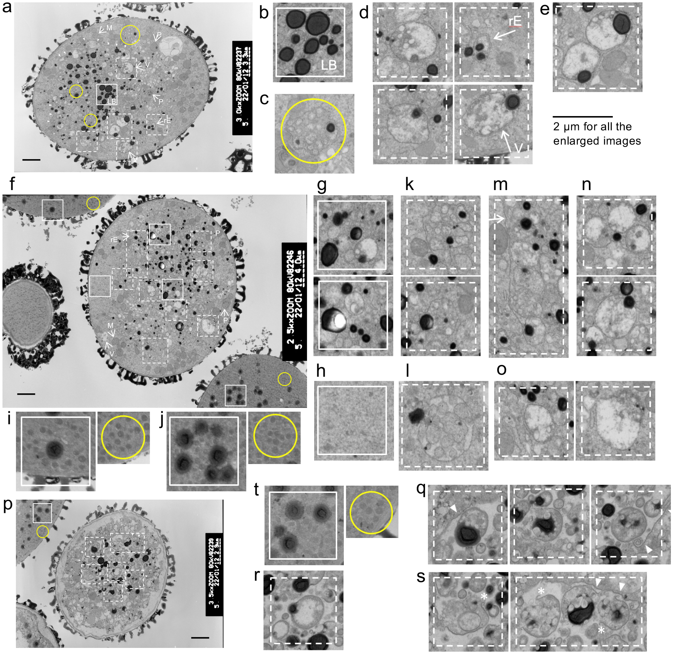
Fig. S8 TEM analysis of ultrathin sections of cct1-3 cct2-5 pollen grains from Arabidopsis cct1-3 cct2-5/CCT2 plants. a, f Images of representative pollen grain cells displaying abnormal ultrafine structures. p, u, aa Images of pollen grain cells displaying the most obvious ultrafine structures. Bars = 2 µm. b–e, g–o, q–t, v–z, and ab–af show enlarged images taken from panels a, f, p, u, and aa, respectively. Asterisks, unusual outward membrane curvature at both ends of autophagosome-like membrane bodies. An upside-down image of panel a is presented in Fig. 5e. GN, generative nuclei; M, mitochondrion; P, plastid; rE, rough endoplasmic reticulum; V, vacuole; VN, vegetative nucleus.

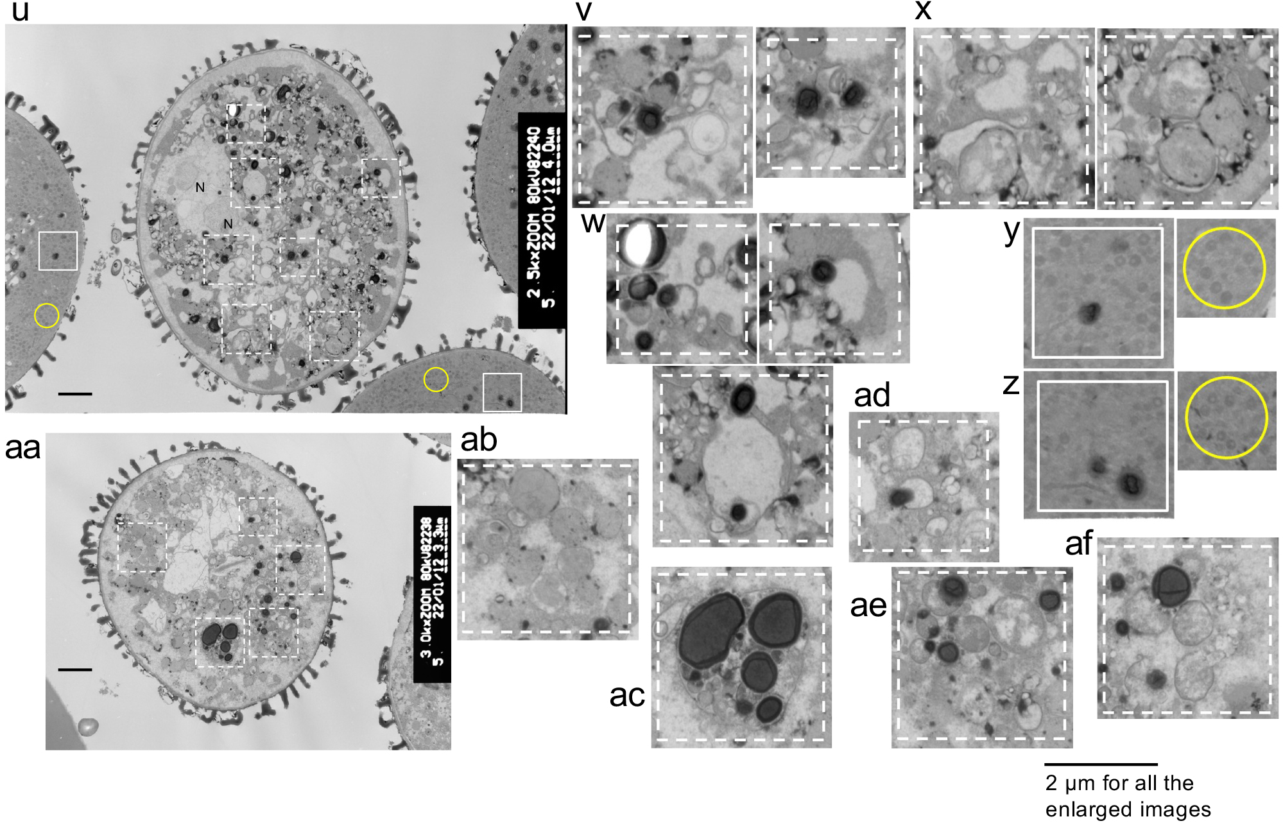
Fig. S8 (continued) TEM analysis of ultrathin sections of cct1-3 cct2-5 pollen grains from Arabidopsis cct1-3 cct2-5/CCT2 plants. a, f Images of representative pollen grain cells displaying abnormal ultrafine structures. p, u, aa Images of pollen grain cells displaying the most obvious ultrafine structures. Bars = 2 µm. b–e, g–o, q–t, v–z, and ab–af show enlarged images taken from panels a, f, p, u, and aa, respectively. Asterisks, unusual outward membrane curvature at both ends of autophagosome-like membrane bodies. An upside-down image of panel a is presented in Fig. 5e. GN, generative nuclei; M, mitochondrion; P, plastid; rE, rough endoplasmic reticulum; V, vacuole; VN, vegetative nucleus.
Supplementary text for Fig. S8
Similar to the cct1-3 cct2-5 pollen cell from a cct2-5 cct1-3/CCT1 plant [Fig. S7a (Figs. 5d and 6d)], cct1-3 cct2-5 pollen cells from a cct1-3 cct2-5/CCT2 plant contained extremely enlarged LBs together with small or tiny LBs [Figs. S8a (Figs. 5e and 6e), S8b, S8f, and S8g]. These LBs had a rather electron-dense surface boundary compared with those LBs having a more transparent boundary, which were seen in cct1-3 pollen cells from a cct1-3 plant and putative cct1-3 pollen cells that segregated from a cct1-3 cct2-5/CCT2 plant (Figs. S8f, S8i, and S8j). As opposed to wild-type, cct2-5, and cct1-3 pollen cells, cct1-3 cct2-5 pollen cells from a cct1-3 cct2-5/CCT2 plant contained diffused or "swollen" SGSs (Figs. S8c and S8k; Fig. 6e, SGS*). "Solid" SGSs, which were seen in cct1-3 pollen cells from a cct1-3 cct2-5/CCT2 plant (Figs. S8f, S8i, and S8j) and some cct1-3 cct2-5 pollen cells from a cct2-5 cct1-3/CCT1 plant, were not seen in the cytoplasm of cct1-3 cct2-5 pollen cells from a cct1-3 cct2-5/CCT2 plant (Fig. S8h). The "swollen" SGSs or SGS* were often entrapped within a type of membranous body [Figs. S8a (Fig. 7c), S8c, and S8k], sometimes together with various kinds of other cellular components (Figs. S8c, and S8l; Fig. 7c). These membrane bodies appeared to be involved in the digestion of inner materials, but the entrapped SGSs, SGS*s, and other cellular components remained undigested within developing SVBs (Figs. S8d, S8e, S8l, S8n, and S8o; Fig. 7c). Because all these types of membrane bodies did not fully develop into SVBs, they were referred to as PVBs. The PVBs also appeared to incorporate LBs for subsequent digestion [Figs. S8e (Fig. 7c) and S8n] while fusing with each other to generate larger bodies (Fig. S8o). It should be noted that rER was evident in the cytoplasm as if it was going to entrap several PVBs (Fig. S8m, arrow; Fig. 7c). The occurrence of many types of PVBs suggested that the entire process of SVB development from SGSs and/or PVBs was delayed in cct1-3 cct2-5 pollen cells from a cct1-3 cct2-5/CCT2 plant.
A small proportion of cct1-3 cct2-5 pollen cells from a cct1-3 cct2-5/CCT2 plant displayed the most prominently deformed cytoplasmic structures [Figs. S8p (Fig. 8b), S8u, and S8aa]. These pollen cells did not contain "solid" SGSs. In the same photographs of Figs. S8p and S8u, putative cct1-3 pollen cells had normal LBs and SGSs (Figs. S8t, S8y, and S8z). In the cct1-3 cct2-5 pollen cell shown in Fig. S8p (Fig. 8b), LBs were entrapped by autophagosome-like bodies (Fig. S8q; Fig. 8b, boxes 2–4), while some LBs were incorporated into vSVs or developing SVBs [Fig. S8r (Fig. 8b, box 1)]. However, it should be noted that the autophagosome-like bodies entrapping various cellular components appeared incompletely closed and had an unusual membrane opening, typically with an outward curvature at both ends [Fig. S8s (Fig. 8b, boxes 5 and 6, asterisks)]. Such features were never seen in the wild-type, cct2-5 and cct1-3 pollen cells or even in a cct1-3 cct2-5 pollen cell from a cct2-5 cct1-3/CCT1 plant and, hence, must have been specific to a cct1-3 cct2-5 pollen cell from a cct1-3 cct2-5/CCT2 plant.
In the cct1-3 cct2-5 pollen cell from a cct1-3 cct2-5/CCT2 plant, shown in Fig. S8u, there were many open spaces within the cytoplasm, between which other cellular components were randomly distributed (Fig. S8v). The smaller LBs were incorporated into PVBs/developing SVBs (Fig. S8w, three panels). Similar to the cct1-3 cct2-5 pollen cell from a cct2-5 cct1-3/CCT1 plant (Fig. S7s, box2), some PVBs containing the remnants of various kinds of cytoplasmic components were gathered, as if they were in the process of fusing with one another to generate a larger body (Fig. S8x). The remnants of nuclei were also seen in the cct1-3 cct2-5 pollen cell of Fig. S8u.
The cct1-3 cct2-5 pollen cell from a cct1-3 cct2-5/CCT2 plant, shown in Fig. S8aa, also had many open spaces together with larger vacuole-like structures. Although the extremely enlarged LBs were too big to be entrapped by vSVs, they appeared to be entrapped within an autophagosome-like body together with various kinds of cellular components (Fig. S8ac). Again, the content of autophagosome-like body remained undigested, suggesting suspension of autophagic activity induced in pollen cells undergoing germination. By contrast, the smaller LBs were in the process of fusing with PVBs (Figs. S8w, S8ae, S8af) and vSVs (Fig. S8ad). Similar to the cct1-3 cct2-5 cell from a cct2-5 cct1-3/CCT1 plant, shown in Fig. S7s (Fig. 8a), boxes 2 and 6), we also observed two types of PVBs—one containing SGS* and the other containing various kinds of cytoplasmic components. The former PVBs might have been a very swollen or fused form of SGS*. Both types of PVBs gathered separately at the opposite sides of the cell (Figs. S8ab, S8ad, S8ae, and S8af) as if they were in the process of fusing with one another to generate a larger body.
Photos of wild-type pollen cells, shown in Figs. S4a and S4g, revealed that vSVs were located on one side of the cell, whereas LBs were gathered on the other side of the cell. In parallel, in photos of cct1-3 cct2-5 pollen cells from a cct2-5 cct1-3/CCT1 (Fig. S7s) or a cct1-3 cct2-5/CCT2 plant (Fig. S8aa), PVBs exhibiting similar electron density with the cytoplasm were located on one side of the cell whereas PVBs entrapping LBs together with other cellular components were located on the other side of the cell. The former type of PVBs might be a form of vSVs in the wild-type pollen cell and be formed by fusion of smaller PVBs or swollen SGSs, although the vacuolation processes of these PVBs appeared to be suspended (Fig. 8a, box2). By contrast, the latter type of PVBs, which could be formed by entrapment of LBs and other smaller cytoplasmic components by rER, remained unprocessed most likely owing to the limited development of vSVs and SVBs.

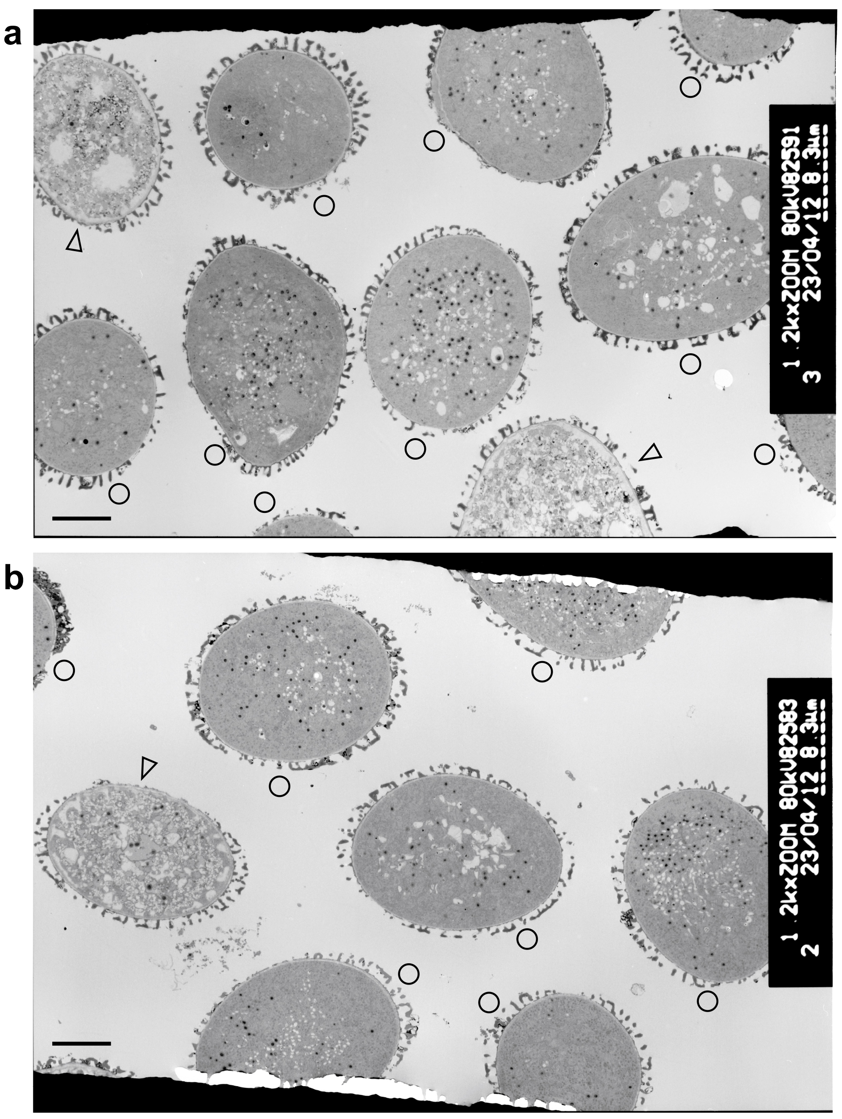
Fig. S9 Ultrathin sections of pollen grains from cct2-5 and cct1-3 plants. a Low-magnification image of cct2-5 pollen grains. b Low-magnification image of cct1-3 pollen grains. Pollen cells similar to wild-type cells (open circles) maintained relatively electron-dense cytoplasm, whereas unusual pollen cells (open arrowheads) contained less electron-dense, deformed cytoplasm. Bars = 5 µm
Supplementary text for Fig. S9
Fig. S9a shows a lower-magnification photo of an ultrathin section of cct2-5 pollen cells from a cct2-5 plant. A large proportion (9/11, 82%) of the cct2-5 pollen cells had relatively electron-dense cytoplasm (Fig. S9a, open circles) as seen in the wild-type pollen, and this proportion was higher than the germination rate of cct2-5 pollen (72.3%). By contrast, a minor proportion (2/11, 18%) of the cct2-5 pollen cells had less electron-dense, deformed cytoplasm (Fig. S9a, open arrowheads). Similarly, Fig. S9b shows a lower-magnification photo of an ultrathin section of cct1-3 pollen cells from a cct1-3 plant. A large proportion (7/8, 87.5%) of the cct1-3 pollen cells from a cct1-3 plant maintained relatively electron-dense cytoplasm as seen in the wild-type and cct2-5 cells (Fig. S9b, open circles), and this proportion was larger than the germination rate of cct1-3 pollen grains (66.0%). By contrast, a minor proportion (1/8, 12.5%) of the cct1-3 pollen cells showed less electron-dense and more deformed cytoplasm (Fig. S9b, the open arrowhead). Thus, the maintenance of normal cytoplasm was thought to be prerequisite to successful pollen germination. To determine which ultrafine structures might be important for pollen germination, we compared the ultrafine structures of pollen cells at high magnification.

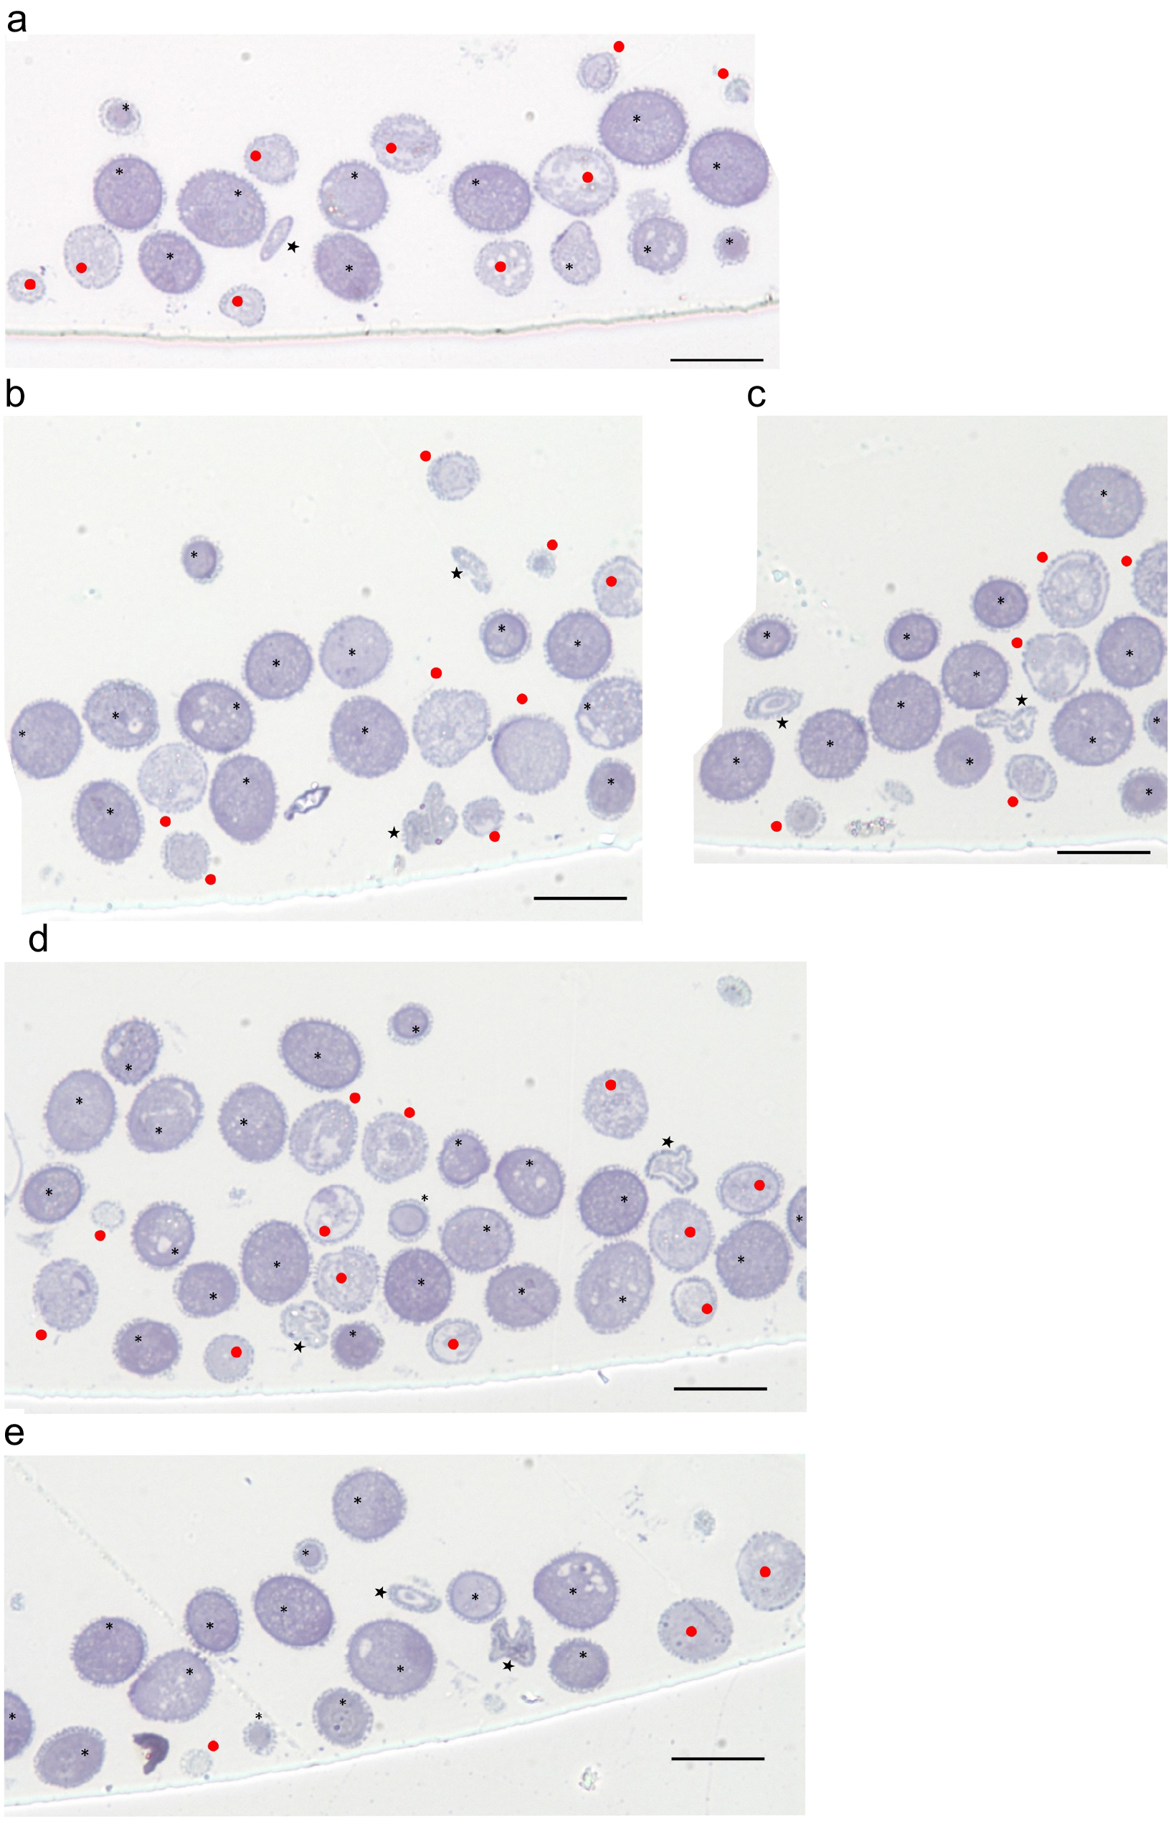
Fig. S10 Evaluation of the abnormality of pollen grain cells by toluidine blue staining. Pollen grain cells displaying relatively dark-stained cytoplasm were assigned as normal (asterisks), whereas those with light-stained cytoplasm (closed circles) or with a shrunken shape (stars) were assigned as abnormal. These photos were used to make Fig. S12.
Supplementary text for Fig. S10
Before describing the details of abnormal ultrafine structures of cct2-5 cct1-3 pollen cells, we evaluated whether all abnormal pollen grains could be assigned to cct2-5 cct1-3 pollen cells. First, the proportion of abnormal pollen grains exhibiting unusual cytoplasmic features was evaluated under an optical microscope after staining ultrathin sections with toluidine blue (Fig. S10). Among 119 independent pollen cells from a cct1-3 cct2-5/CCT2 plant (observed in five sections, Fig. S10a–S10e), 62.1% of pollen cells, which had densely stained cytoplasm, were judged as normal irrespective of the cell cross-section size (Fig. S10, asterisks), whereas the remaining 37.9% of pollen cells, which had lightly stained cytoplasm, deformed cytoplasmic structures (Fig. S10, closed circles), or a shrunken appearance (Fig. S10, stars), were judged as abnormal. Thus, less than 50% (37.9%) of the pollen cells from a cct1-3 cct2-5/CCT2 plant showed abnormal ultrafine structures by toluidine blue staining (Fig. S10; see also Fig. S12).

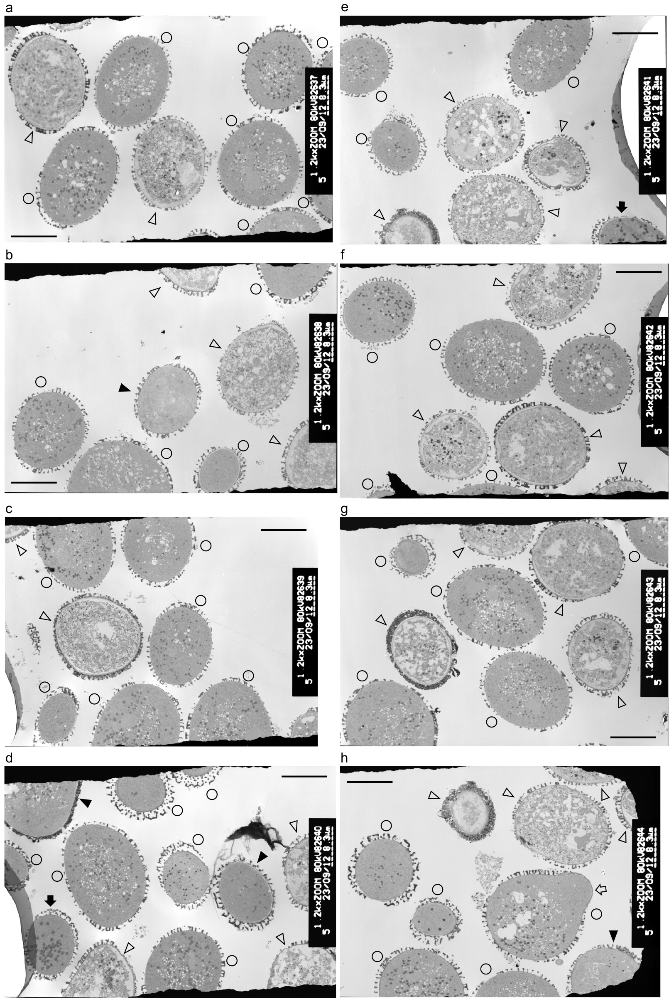
Fig. S11 Lower magnification images of pollen grain sections from cct1-3 cct2-5/CCT2 plants. Cells that included distinct small granular structures in the cytoplasm—as seen in wild-type cells—were classified as normal and are indicated by open circles. One of the normal cells in panel h is undergoing germination, as indicated by an open arrow. By contrast, abnormal cells that included small granular structures, unusual cytoplasmic structures and abnormally enlarged LBs are respectively indicated by closed arrowheads, open arrowheads and closed arrows. Bars = 10 µm. These photos were used to make Fig. S12.
Supplementary text for Fig. S11
TEM observation of 75 pollen cells from a cct1-3 cct2-5/CCT2 plant (taken in eight sections at lower magnification, Fig. S11) revealed that 56.2% of the pollen cells contained densely stained SGSs in the relatively electron-dense cytoplasm, as seen in wild-type cells. By contrast, 5.5 and 2.7% of the pollen cells contained few SGSs in the light, less electron-dense cytoplasm and enlarged LBs in the dark, more electron-dense cytoplasm, respectively (Fig. S11d, closed arrow); moreover, 35.6% of the pollen cells had deformed structures in the light, less electron-dense cytoplasm. Thus, less than 50% (43.8%) of the pollen cells from a cct1-3 cct2-5/CCT2 plant showed abnormal ultrafine structures by TEM analysis (Figs. S11; see also Fig. S12). These results demonstrated that all the pollen cells displaying abnormal ultrafine structures should be assigned to cct1-3 cct2-5.
It should be noted that the pollen cell shown in Fig. S11h had "solid" SGSs in the cytoplasm and had small buds indicative of the initiation of pollen germination. This result supported our view that pollen cells with "solid" SGSs were primed for germination. All these TEM results suggested that, after 30 min of pollen germination in vitro, germination was suspended or aborted in up to ~87.6% of cct1-3 cct2-5 pollen cells.

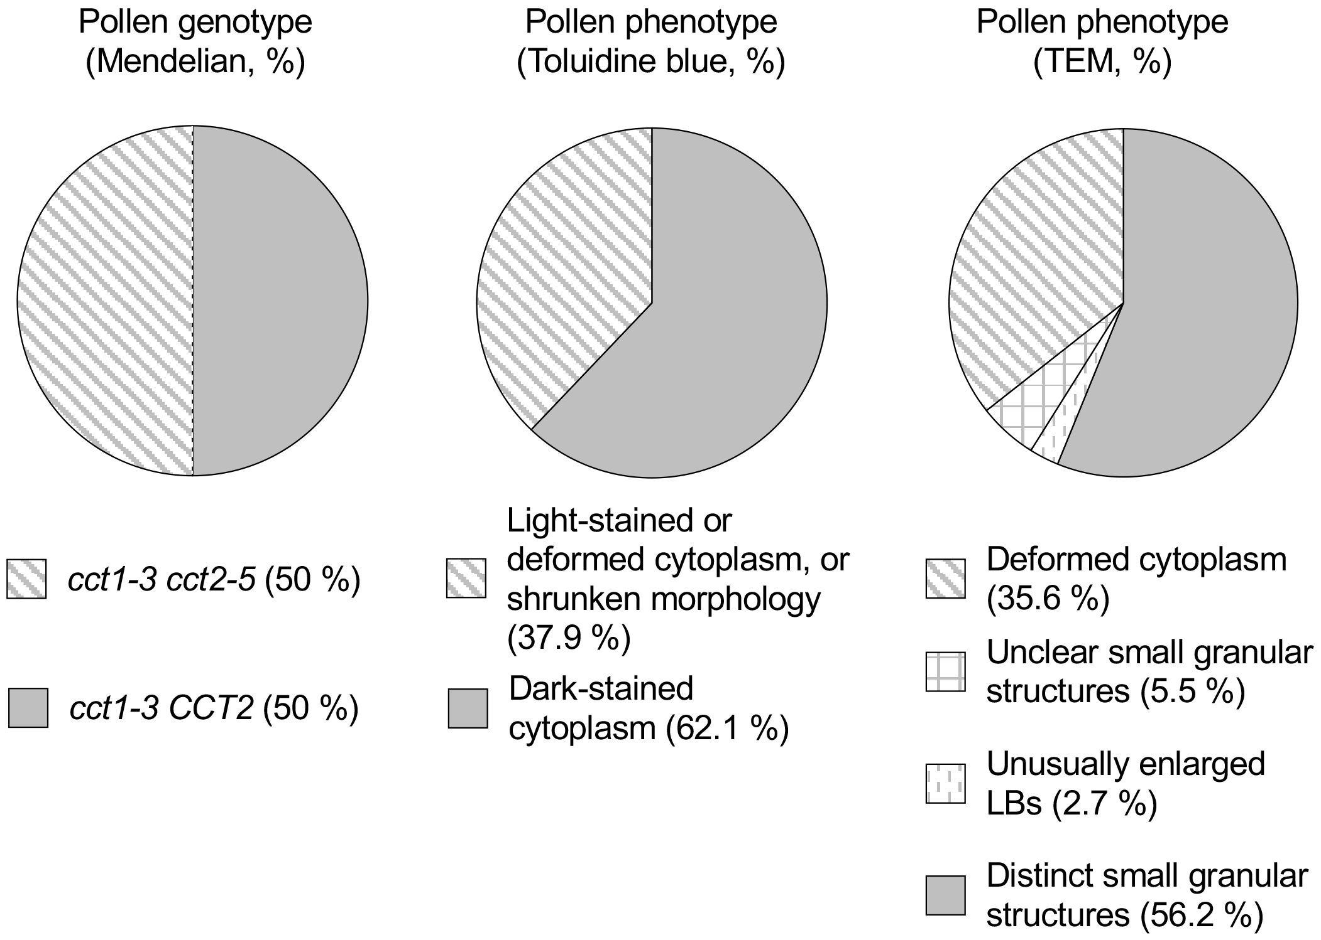
Fig. S12 Evaluation of abnormalities in pollen grains from cct1-3 cct2-5/CCT2 plants. Pollen grains with the dense-stained cytoplasm (toluidine blue staining) as well as those with distinct small granular structures (TEM analysis) were assigned as normal and hence cct1-3 CCT2. By contrast, pollen grains with light-stained or deformed cytoplasm or those displaying a shrunken morphology (toluidine blue staining) as well as those with deformed cytoplasm, unclear SGSs, or unusually enlarged LBs (by TEM analysis) were assigned as abnormal and hence cct1-3 cct2-5.

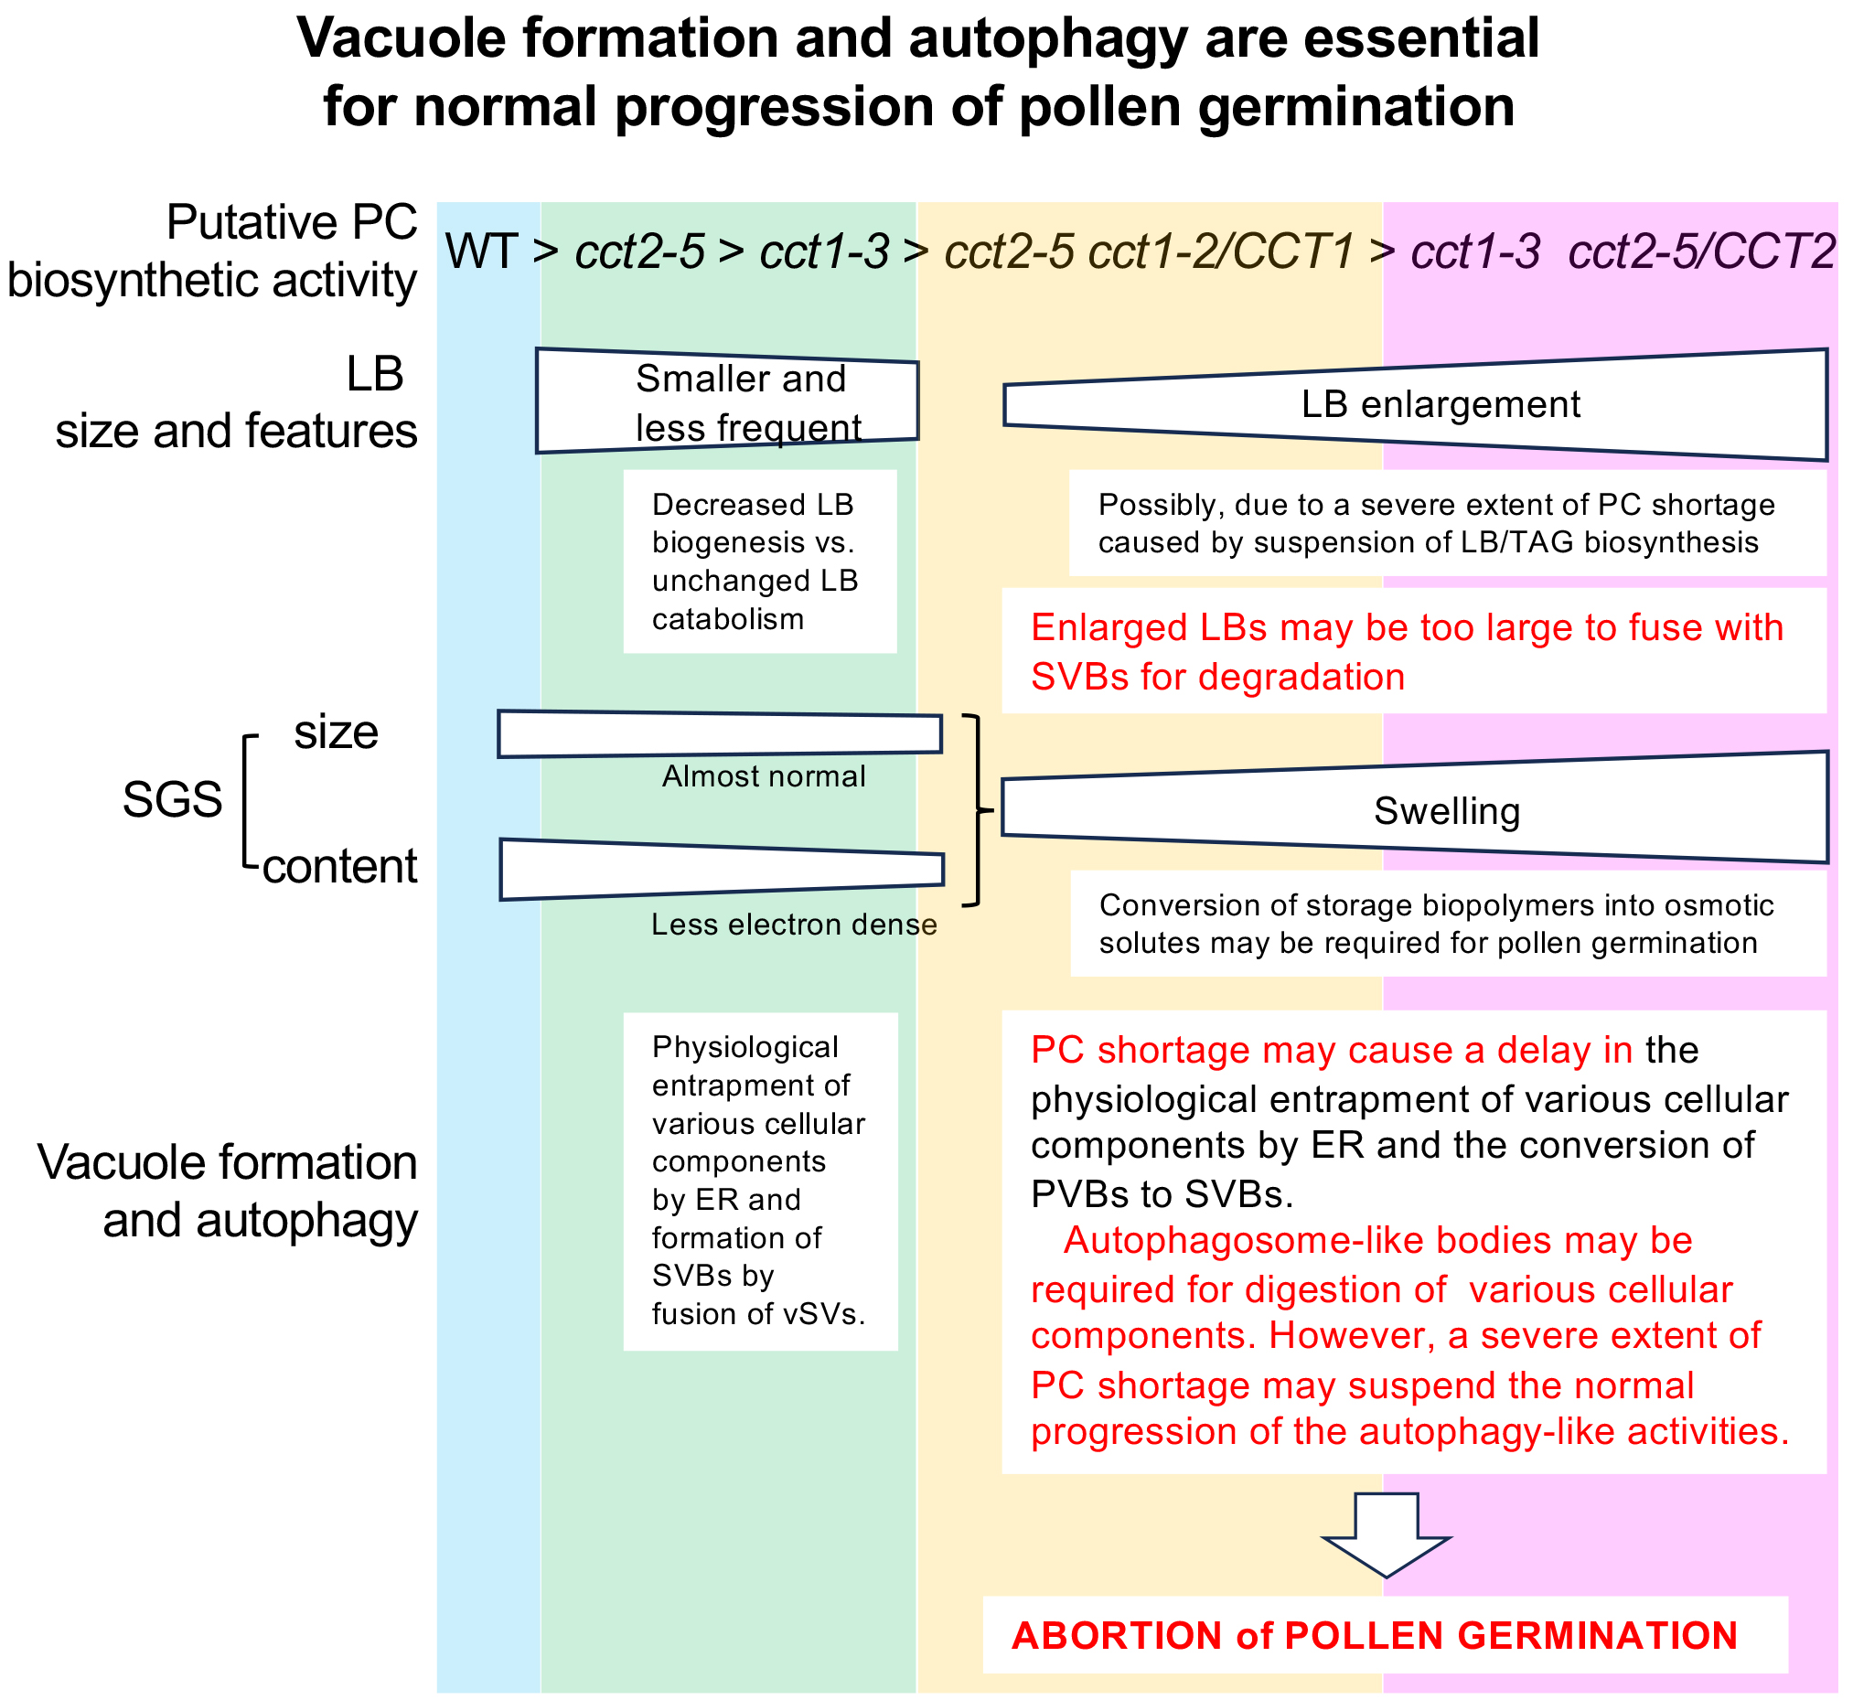
Fig. S13 Summary of the effects of cct mutations on vacuole formation and autophagy, both of which are essential for normal progression of pollen germination.

Table S1 Primers used in this study
No. | Name | Nucleotide sequence | Purpose
1 | GL12 | 5′-TGGGTGGTCAACCAGGAGTTTC-3′ | CCT1 genotyping
1 | GL13 | 5′-CACTCGTTGCGCAGCATTTTTACAG-3′ | CCT1 genotyping
2 | GL12 | 5′-TGGGTGGTCAACCAGGAGTTTC-3′ | cct1-3 genotyping
2 | 8409F | 5′-ATATTGACCATCATACTCATTGC-3′ | cct1-3 genotyping
3 | GL20 | 5′-TGCACCATGGGTTCTTACAACAGAG-3′ | CCT2 genotyping
3 | GL21 | 5′-CTGGAAATACTTCAACCATGACCCA-3′ | CCT2 genotyping
4 | GL21 | 5′-CTGGAAATACTTCAACCATGACCCA-3′ | cct2-3 genotyping
4 | pSK-L3 | 5′-ATACGACGGATCGTAATTTGTCG-3′ | cct2-3 genotyping
5 | cct2-5_fw | 5′-TGCGTTAATGATGCACGGCTTG-3′ | CCT2 genotyping
5 | cct2-5_rv | 5′-GCTGATGCCAAGCTTCTCG-3′ | CCT2 genotyping
6 | LBF3 | 5′-CCACCCCAGTACATTAAAAACGTCC-3′ | cct2-5 genotyping
6 | cct2-5_rv | 5′-GCTGATGCCAAGCTTCTCG-3′ | cct2-5 genotyping
7 | MWHindIII-ACA9profw | 5′-CCCAAGCTTGAACTGAGAAACCATTGGAAGC-3′ | ACA9pro cloning
7 | MWXbaI-ACA9prorv | 5′-GGTGAGACGAAGGAAGGAAGATCTAGAGC-3′ | ACA9pro cloning
8 | MWHindIII-ACA9profw | 5′-CCCAAGCTTGAACTGAGAAACCATTGGAAGC-3′ | Colony PCR for pPZP221 ACA9pro:CCT1
8 | GL13 | 5′-CACTCGTTGCGCAGCATTTTTACAG-3′ | Colony PCR for pPZP221 ACA9pro:CCT1

Table S2 Segregation analysis of offspring of a cct1-3 cct2-3/CCT2 plant
 | Number of offspring |  |  | χ² test for 1:2ª
Genotype | cct1-3 CCT2 | cct1-3 cct2-3/CCT2 | cct1-3 cct2-3 | χ² | P
Theoretical ratio | 1 | 2 | 1
Observed number | 39 | 30 | 0
Observed ratio | 1 ^{b} | 0.77 ^{b} | 0 | 18.379 | 1.02 × 10^{–4 c}
ª The χ² test was conducted to test the null hypothesis that cct1-3 and cct1-3 cct2-3/CCT2 plants segregate from each other in the predicted 1:2 Mendelian ratio.
^{b} The segregation ratio between CCT2 and cct2-3/CCT2 plants in the cct1-3 background was 1:0.77, which differed significantly from the predicted 1:2 Mendelian ratio, suggesting that the seed yield of cct2-3/CCT2 was decreased by 62% in the cct1-3 background.
^{c} The P value is small enough (P < 0.05) to reject the null hypothesis.

Table S3 Summary of reciprocal crossing of cct2-3/CCT2 plants in the cct1-3 background
Reciprocal cross |  | Number of F1 plants |  | χ² test for 1:1 ª
Female | Male | cct1-3  CCT2/CCT2 | cct1-3  cct2-3/CCT2 | χ² | P
cct1-3  CCT2/CCT2 | cct1-3  cct2-3/CCT2 | 56 | 0 | 56.00 | 7.25 × 10^{–14 b}
cct1-3  cct2-3/CCT2 | cct1-3  CCT2/CCT2 | 21 | 15 | 4.80 | 2.85 × 10^{–2 b}
In this table, cct2-3 is boldfaced to emphasize transmission via gametophytes.
ªχ² test was conducted to test the null hypothesis that CCT2/CCT2 and cct2-3/CCT2 plants segregate from each other in the predicted 1:1 Mendelian ratio.
^{b}The P values are small enough (P < 0.05) to reject the null hypothesis.

