Supplemental information

S1
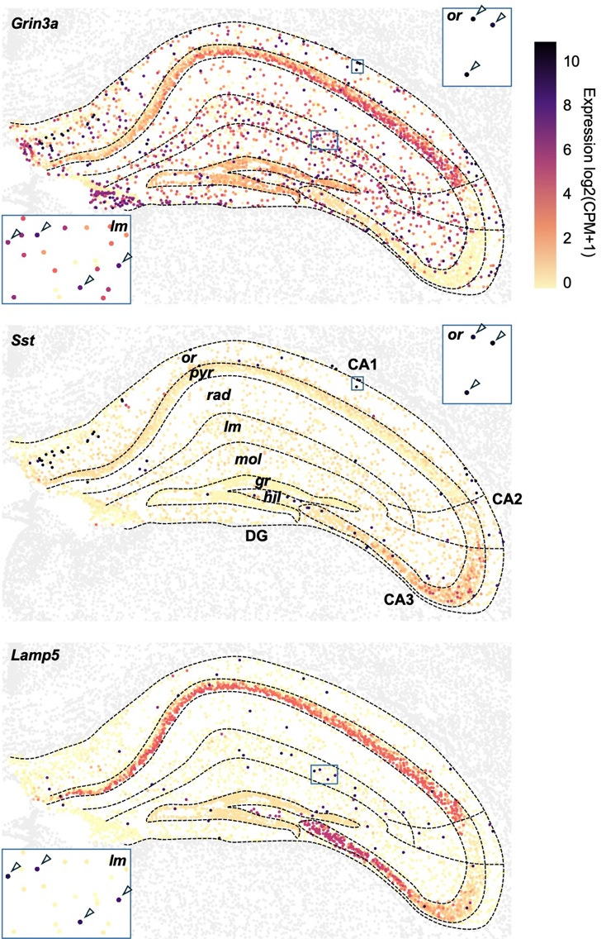
Grin3a is absent in CA3 PNs and enriched in Sst and Lamp5 expressing cells. Publicly available spatial transcriptomics MERFISH data from the Allen Brain Cell Atlas with imputed gene expression ¹. Visualized gene expression restricted to the hippocampal formation, showing (top) Grin3a, (middle) Sst, and (bottom) Lamp5. Insets highlight expression of putative Sst-INs in stratum oriens (or) and Lamp5-INs in stratum lacunosum-moleculare (lm). Arrows denote significant expression of Grin3A transcript in SST or Lamp5 expressing INs.
S2
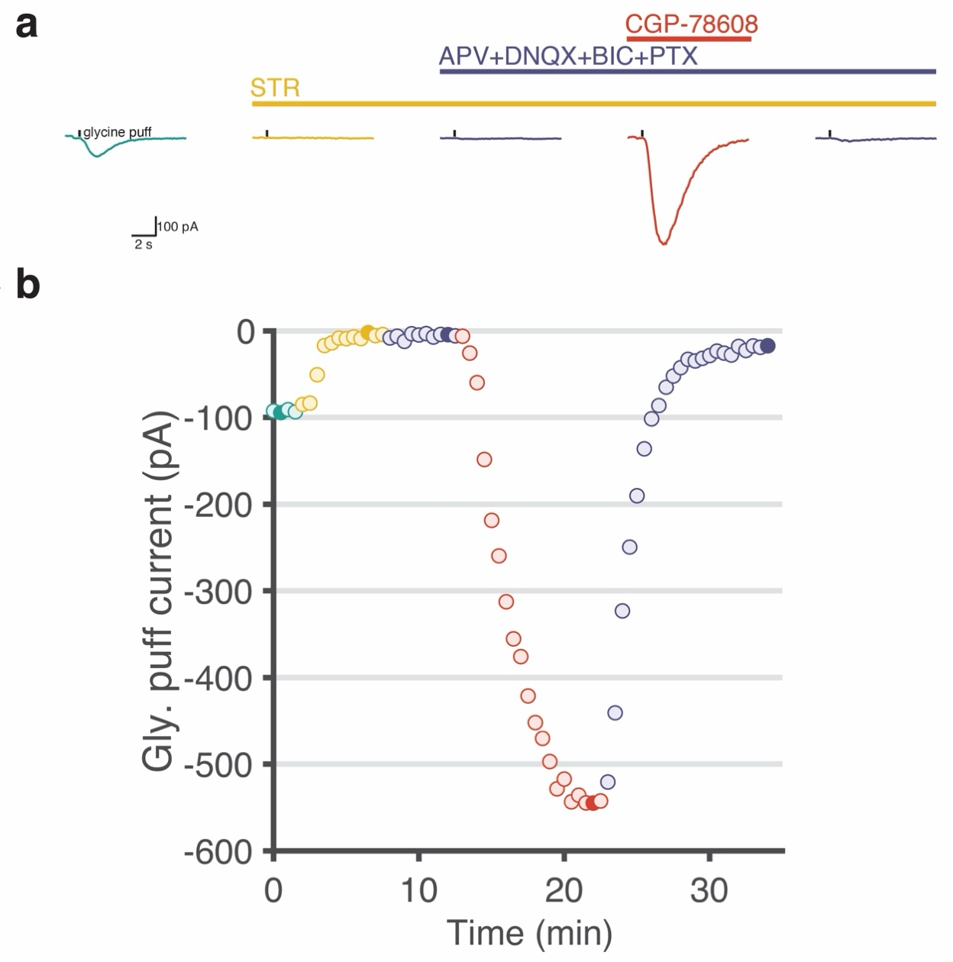
Experimental procedure employed to isolate strychnine-insensitive glycine evoked eGlyR mediated depolarizing currents. (a) Example current traces from a CA1 Sst-IN with glycine puff responses in presence of blockers and CGP-78608, filled circles in (b). Strychnine sensitive eGlyR-mediated current prominently contributed the glycine response current in ACSF. (b) Glycine puff currents in antagonists and CGP-78608. * STR 1 μM, APV 50 μM, DNQX 10 μM, BIC 10 uM and PTX 50 μM.
S3
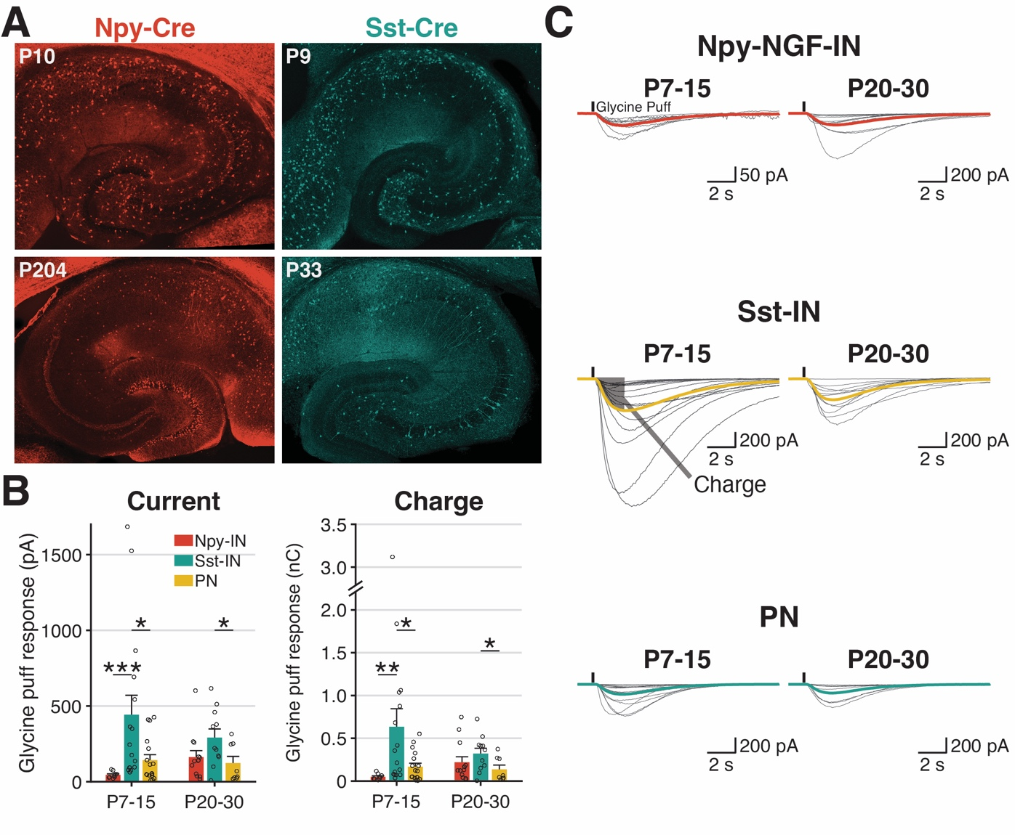
eGlyRs mediate functional responses in SST and NPY-NGFC INs throughout development. A. Sample images of postnatal (top)/adulthood (bottom), NPY-IRES-Cre (left)/Sst-IRES-Cre (right) mouse hippocampal slices. B. (left) Glycine puff response currents in NPY-INs, Sst-INs, and PNs from postnatal and adulthood mice. (right) Glycine puff response charge transfer in NPY-INs, Sst-INs, and PNs from postnatal and adulthood mice. C. Glycine puff responses in NPY -INs, Sst-INs and PNs in different ages. Thick lines are average puff responses of cells and gray lines are average puff responses of trials in each cell.

S4
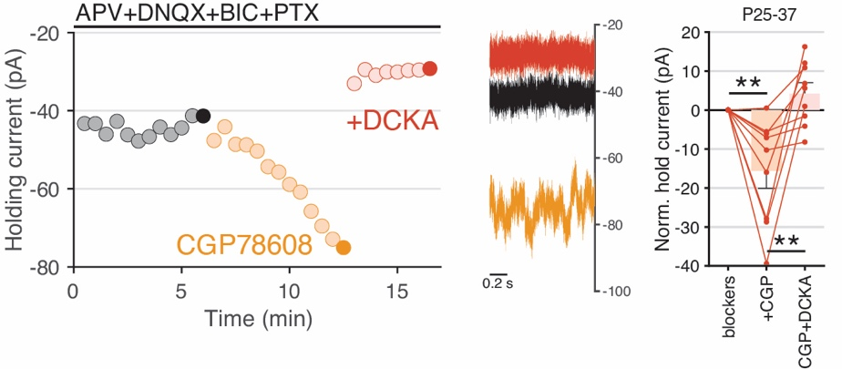
DCKA sensitivity of CGP78608-induced change holding current in hippocampal interneurons. Shown are the time course (left) and traces (middle) from a representative sample NGFC recording illustrating increased holding current (V_{h}=-70mV) in response to CGP78608 and subsequent reduction of holding current upon DCKA application. At right, is the group data summarizing the effects of CGP and subsequent DCKA application upon holding currents for Sst-INs and NGFCs combined.
S5
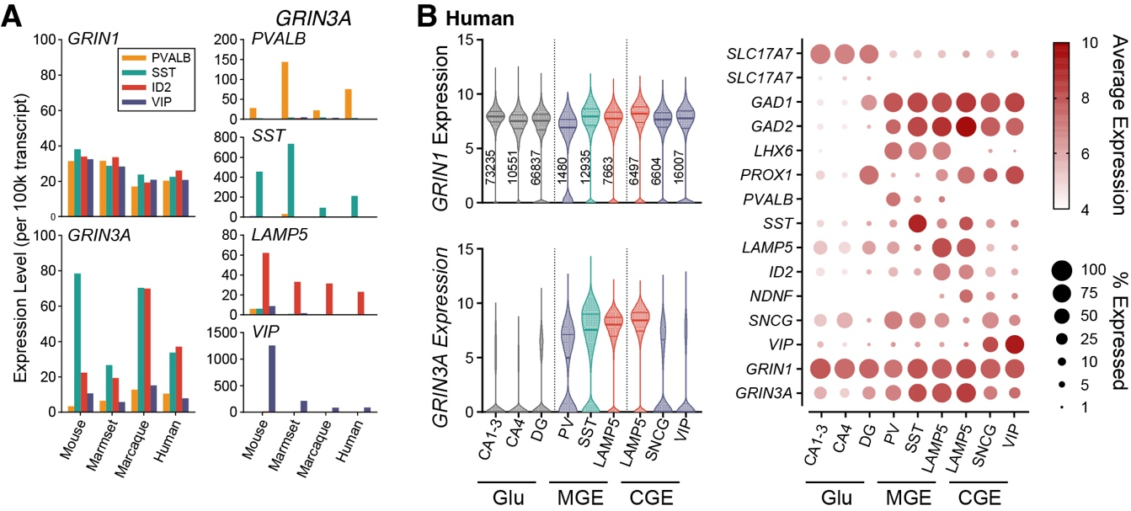
GRIN1 and GRIN3A expression cross species. A. Publicly-available snRNA-seq mean expression in neocortical IN subpopulations PVALB (orange), SST (cyan), ID2/LAMP5 (red) and VIP (purple) across mouse, marmoset, macaque, and human ², for (left) GRIN1 and GRIN3A and (right) distinguishing markers PVALB, SST, LAMP5, and VIP. B. Publicly-available snRNA-seq of human hippocampal neurons ³, with (left) GRIN1 and GRIN3A expression in glutamatergic (Glu) superclusters and grouped MGE and CGE clusters (see Methods), and (right) dot plot of distinguishing marker genes and GRIN1, GRIN3A.

1 Yao, Z. et al. A high-resolution transcriptomic and spatial atlas of cell types in the whole mouse brain. Nature 624, 317-332 (2023). https://doi.org/10.1038/s41586-023-06812-z
2 Krienen, F. M. et al. Innovations present in the primate interneuron repertoire. Nature 586, 262-269 (2020). https://doi.org/10.1038/s41586-020-2781-z
3 Siletti, K. et al. Transcriptomic diversity of cell types across the adult human brain. Science 382, eadd7046 (2023). https://doi.org/10.1126/science.add7046

