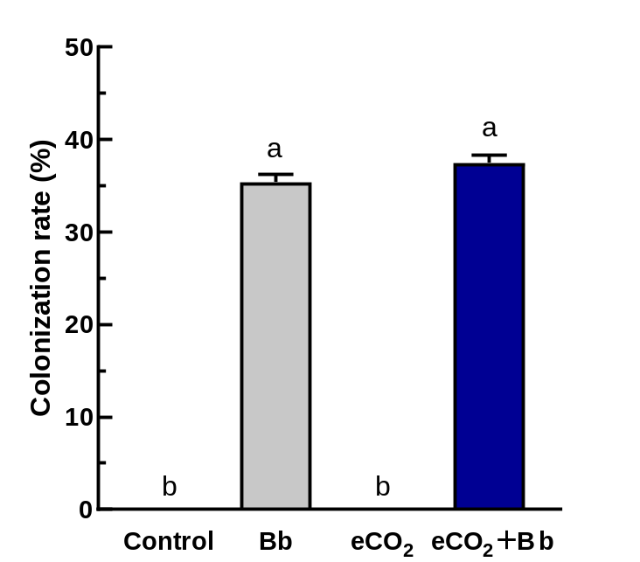
Fig. S1 Colonization of different treatment groups

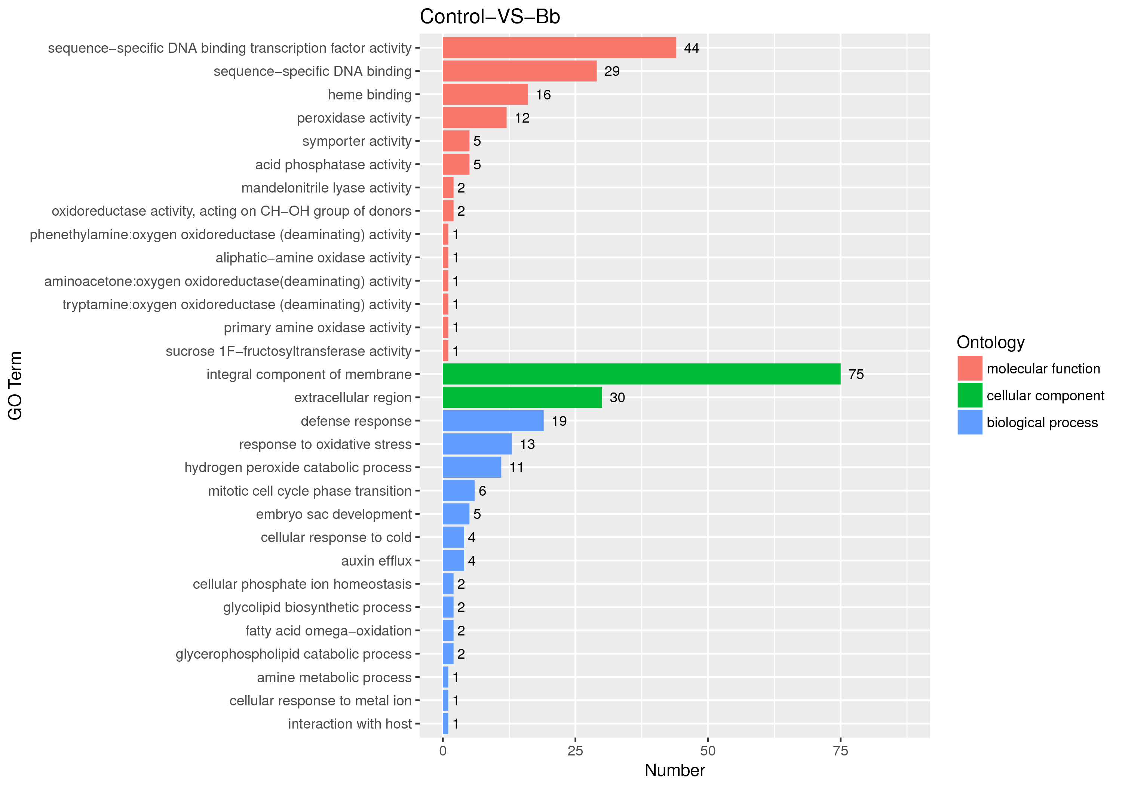
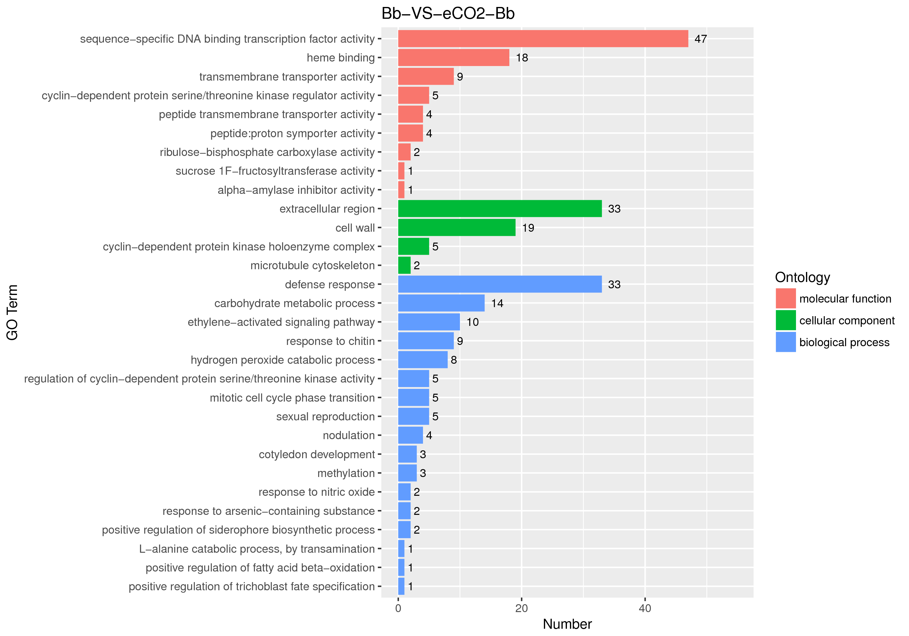
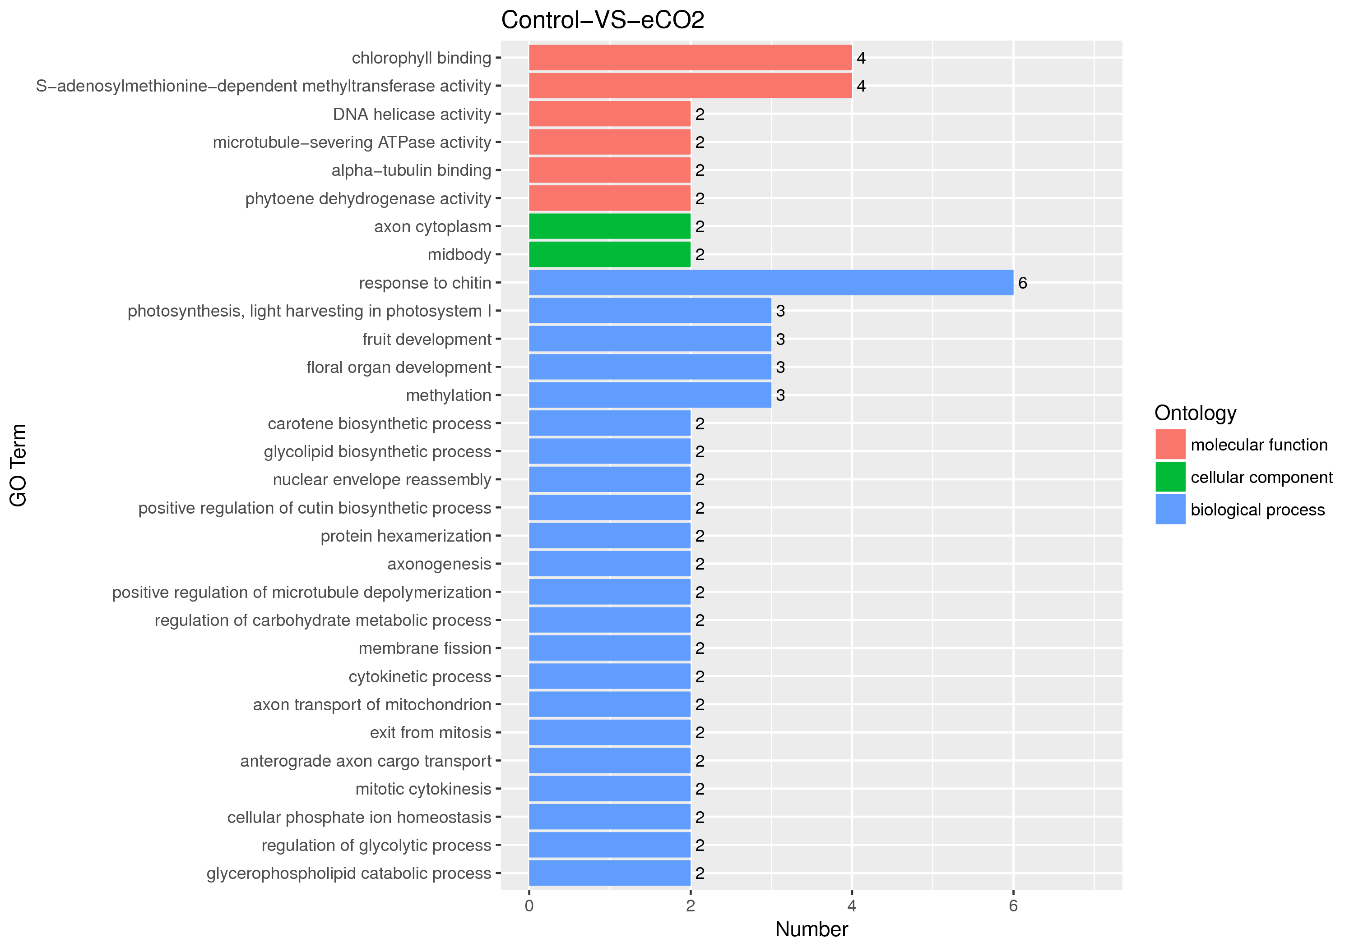
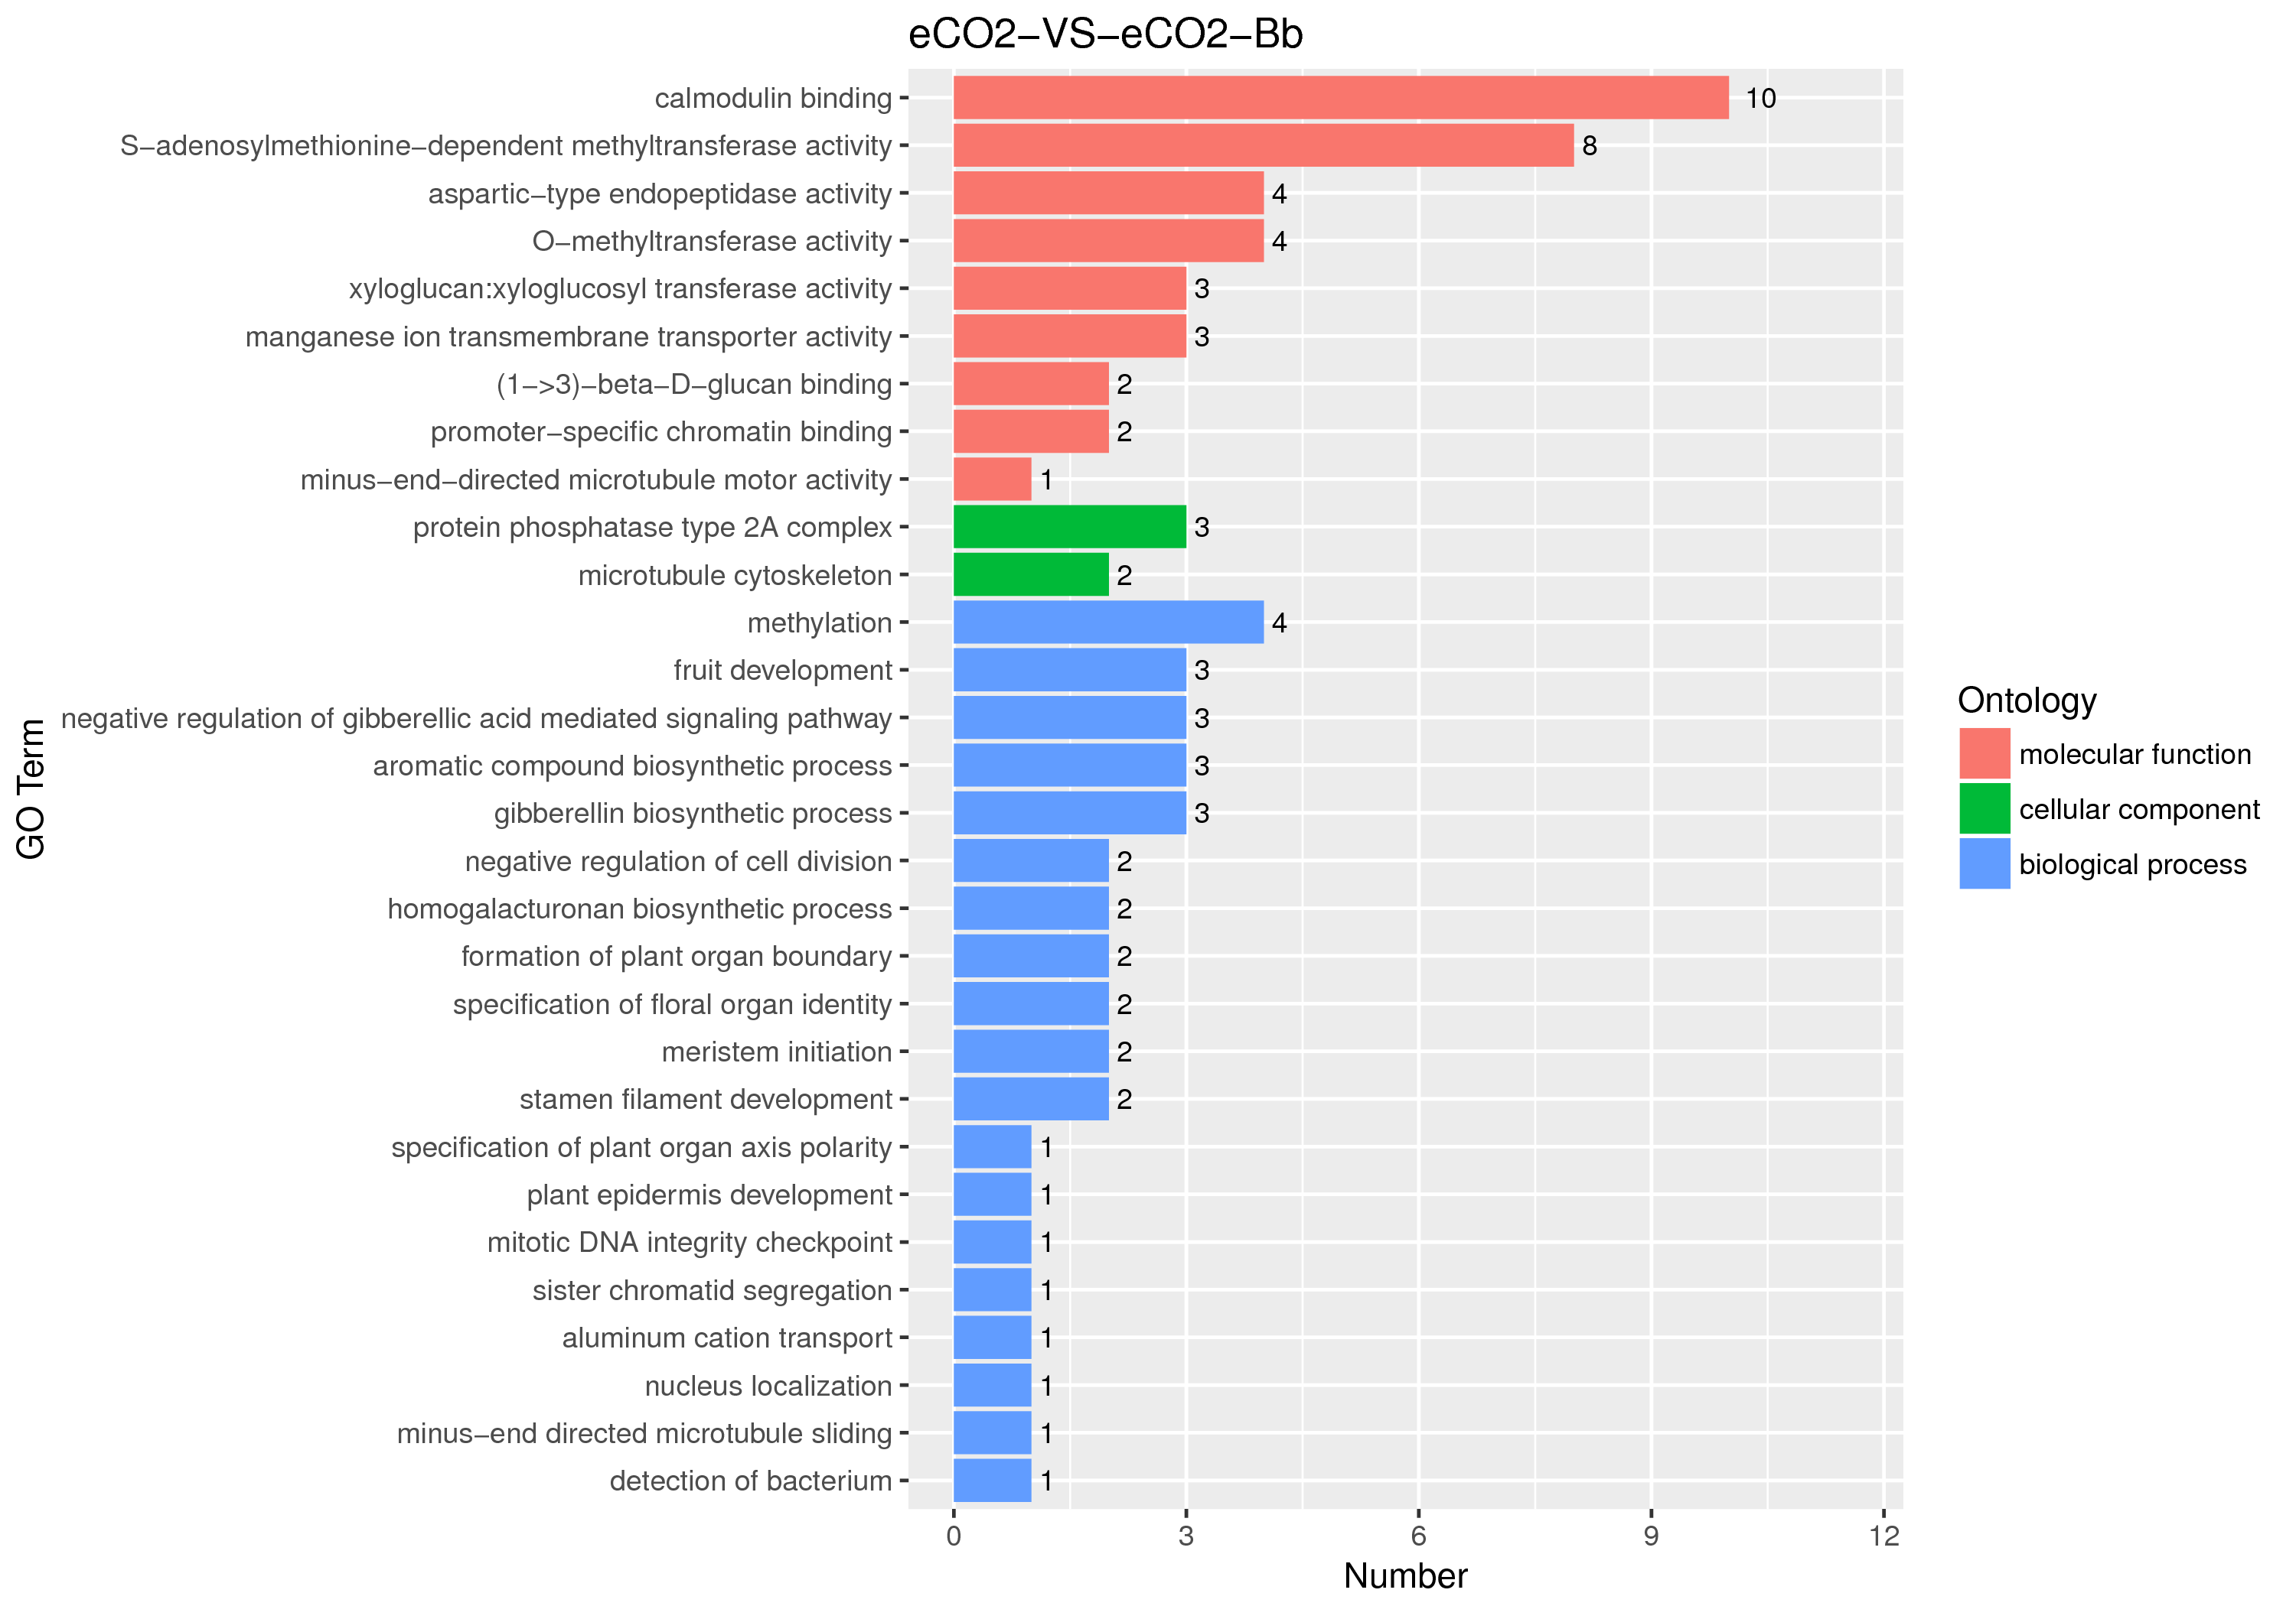
Fig. S2 Gene Ontology (GO) enrichment analysis of differential genes
The horizontal axis in the figure represents GO Term, and the vertical axis represents the significance level of GO Term enrichment, represented by - log₁₀ (padj). Biological process (BP), biological process; Cellular component (CC), cellular component; Molecular function (MF), molecular function

Fig. S3 Matchstick diagram of differential metabolites KEGG
The first 10 times of up-regulation and down-regulation of each change were taken to display the results. In the figure, the abscissa shows the change in multiple after logarithmic transformation, and the colour depth of the point represents the VIP value.
* Mean significance. * 0.01 < P < 0.05, ** 0.001 < P < 0.01, ***P < 0.001.

