APPENDIX 1

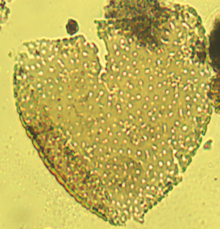
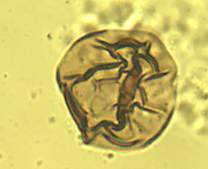
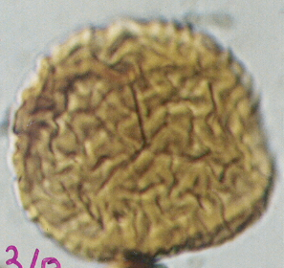
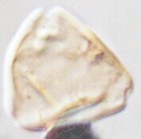
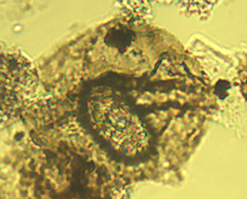
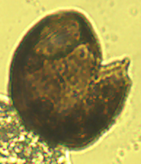
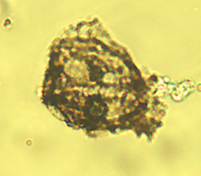
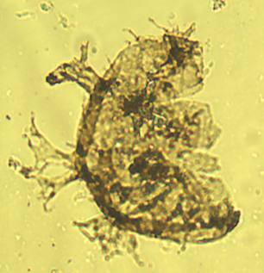
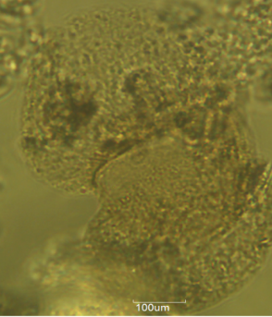
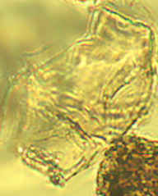
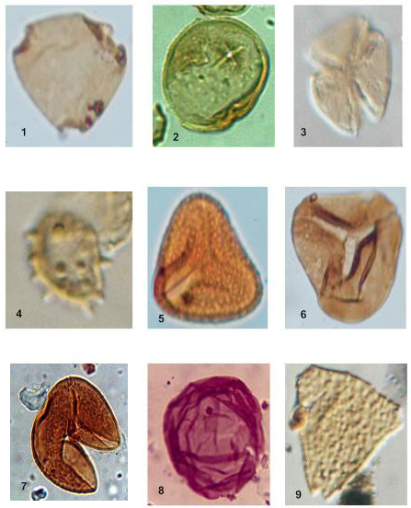
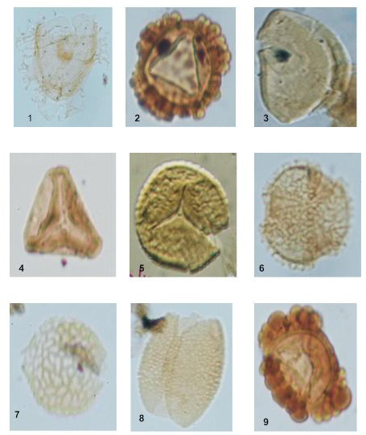
1
2
3
4
5
6
7
8
9
10
11
12

Selected palynomorphs recovered from the studied samples
1. Araucariacidites australis ×400
2. Rugulatisporites caperatus ×400
3. Triorites africaensis ×400
4. Longapertites cf. marginatus ×400
5. Lejeunecysta spp. ×400
6. Classopollis spp. ×400
7. Senegalinium spp. ×400
8. Oligosphaeridium spp. ×400
9. Podocarpidites sp. ×400
10. Dinogymnium sp. ×400
11. Proteacidites sigalii ×400
12. Cingulatisporites ornatus ×400

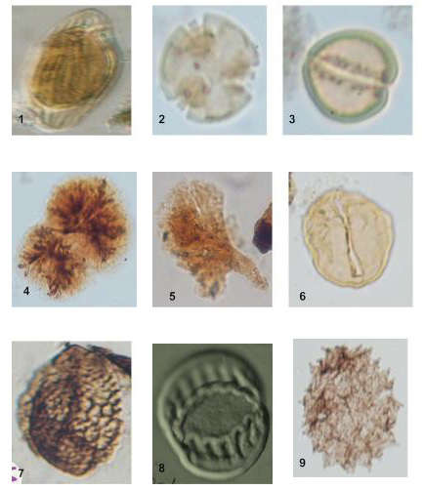
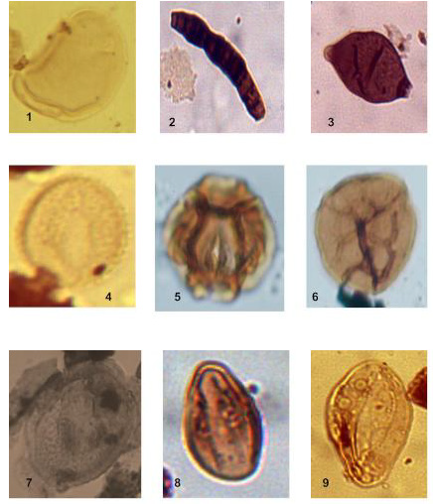
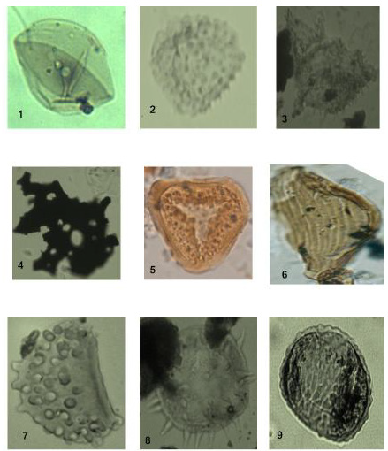
13
14
18
22
15
17
21
23
19
24
20
16
25

Selected palynomorphs recovered from the studied samples (Cont’d)
13. Monocolpite marginatus ×400
14. Retimonocolpites spp. ×400
15. Botryococcus braunii ×400
16. Fungal spore ×400
17. Germmamonoporites spp. ×400
18. Proxapertites cursus ×400
19. Cupanieidites spp. ×400
20. Tricolporopollenites spp. ×400
21. Cyathidites spp. ×400
22. Longapertites cf. microfoveolatus ×400
23. Charred graminae cuticle ×400
24. Polypodiaceoisporites spp. ×400
25. Verrucatosporites spp. ×400

