Accelerated and Localized Synucleinopathy in a Hybrid Mouse Model: Implications for Positron Emission Tomography Studies

Chunfang A Xia¹*, Hsiu-Ming Tsai¹, Sandra Diaz Garcia ², Shuanglong Liu^{3†}, Alessandra Matzeu², Mani Salarian¹, Wouter Bruinzeel⁴, Anna K Szardenings¹

¹ Discovery Technologies and Molecular Pharmacology, Johnson & Johnson, San Diego, CA, USA.
²Preclinical Sciences and Translational Safety, Johnson & Johnson, San Diego, CA, USA.
³Global Discovery Chemistry, Johnson & Johnson, San Diego, CA, USA.
⁴Neuroscience Discovery, Johnson & Johnson, Beerse, Belgium
† Current Affiliation: Radalliance Therapeutics Inc., Shanghai, China

Running title: Evaluating a Hybrid PD Mouse Model with Regional Key Pathologies for PET Imaging studies

*Corresponding Author:
Chunfang A Xia, PhD
Johnson & Johnson
3210 Merryfield Row, San Diego, CA 92121
Phone:858-320-3544
Email: cxia1@its.jnj.com

Supplementary Materials

Supplementary Fig. 1. Human p-syn aggregation after left-side SN injection of the AAV1/2-CMV/CBA-human-A53T-α-syn vector (2ul of 5x10¹²gc/mL). Representative immunostained coronal sections display the development of p-syn+ inclusions and aggregates in SN at 2 and 6 weeks (left), and at 4.5 and 10 months (middle) time points. The whole mouse brain section is highlighted (left and middle). Positive p-syn staining is observed until 4.5 months post-surgery. p-syn+ aggregation is detected at 4.5 and 10 months, as shown on the right. Scale bar = 50 µm.
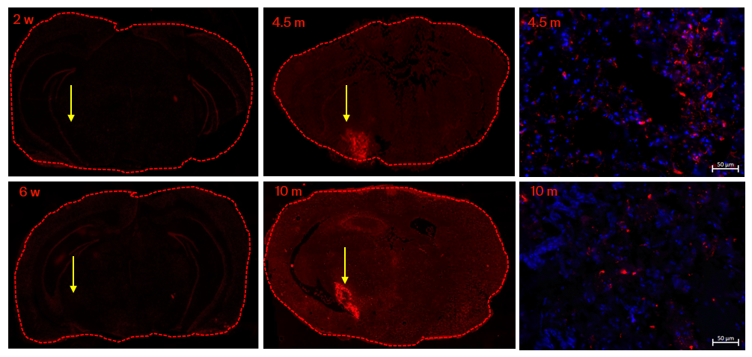

Supplementary Table 1: The quality control of [¹⁸F]JNJ-CSF1R-1, [¹⁸F]UCB-H, [¹⁸F]BCPP-EF, and [¹⁸F]AV133.
Target | Tracer | Decay corrected Yields (%) | Specific activity (mCi/µmol) | Radiochemical purity (%) | Retention time on analytical HPLC (min)
CSF1R | [¹⁸F]JNJ-CSF1R-1 | 20.7 | 1945 | 98.2 | 5.1
SV2A | [¹⁸F]UCB-H | 1.9 | 1830 | 100 | 6.0
MC1 | [¹⁸F]BCPP-EF | 16.7 | 3880 | 98.9 | 6.8
VMAT2 | [¹⁸F]AV133 | 24.1 | 1347 | 95.3 | 5.3

Supplementary Table 2: Antibodies used in immunohistochemistry.

Target | Antibody | Vendor | Catalogue # | Clone Name
Pathologic α-syn | α-syn | abcam | ab13850 | MJFR1
Pathologic α-syn | P-syn(p S129) | abcam | ab51253 | EP1536Y
DA Neuron loss | VMAT2 | ThermoFisher | OSV00111W-100UL | NA
DA Neuron loss | TH | abcam | ab75875 | EP1533Y
Neuroinflammation | Iba1 | Fujifilm | 019-19741 | NA
Neuroinflammation | TREM2 | Cell Signaling | #55739 | E4J7A
Neuroinflammation | CSF1R | abcam | ab271294 | YEYE311
Synaptic density | SV2A | Cell Signaling | #66724 | D1L8S
Mitochondrial function | ATP5A | abcam | ab14748 | 15H4C4

