SUPPLEMENTAL TABLES & FIGURES

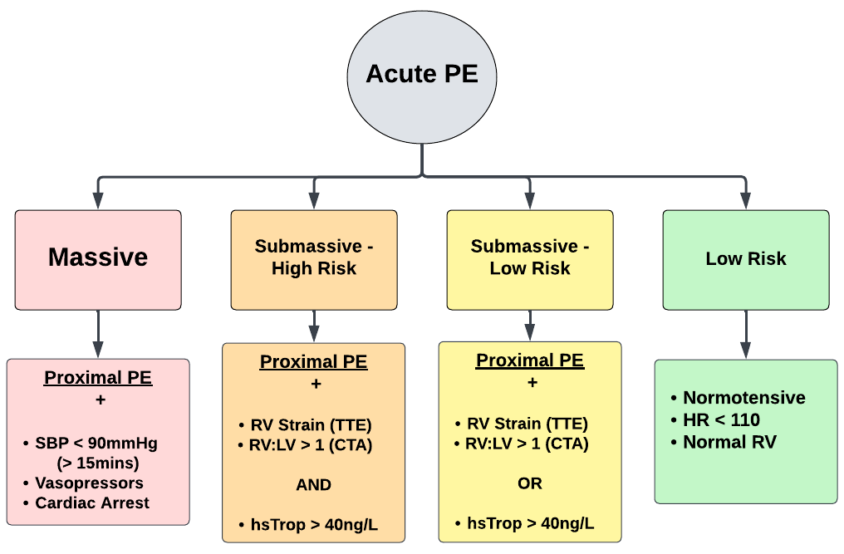
Supplement A: University of Miami - PERT Provider Handbook. PE Classification Diagram. Note: RV strain listed in classification pathway refers to traditional measurements of RV strain assessed on TTE and not RV FWS. Classification pathway adopted from guidelines published by the American Heart Association (AHA), European Society of Cardiology (ESC), and the national PERT Consortium [3, 4, 5].

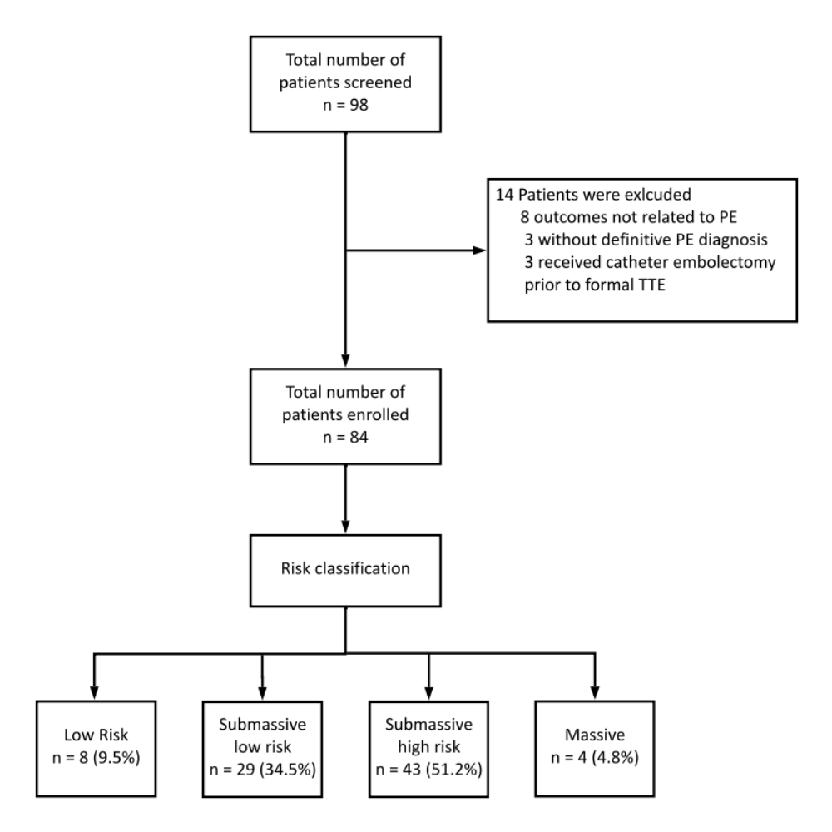
Supplement B: Enrollment diagram of participants including PE risk classification.

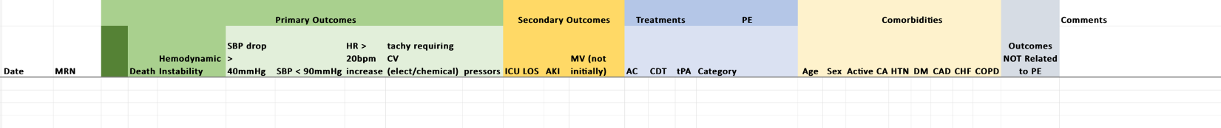
Supplement C1: Clinical outcome data collection sheet. Completed independently from echocardiographic data and reviewers were blinded to echocardiographic data.

Supplement C2: Echocardiographic data collection sheet. Completed independently from clinical outcome data.

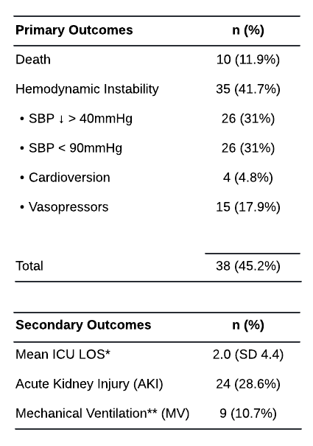
Supplement D: Primary outcome data by category, listed as total count as well as percent of total enrolled. Secondary outcome data by category, listed as total count as well as percent of total enrolled.
* ICU length of stay (LOS) listed in calendar days.
** Patients who later progressed to mechanical ventilation if not initially requiring at time of PE diagnosis.

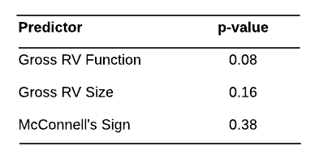

Supplement E: Association of qualitative echocardiographic predictors gross RV function, gross RV size, and McConnell's sign relative to primary outcome.

