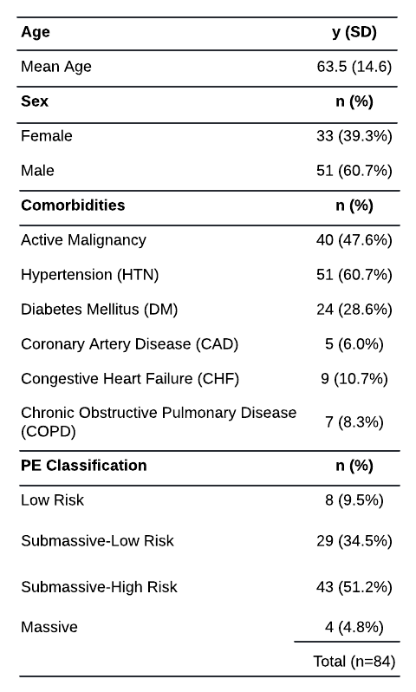
Table 1: PE Classification Information and Demographic Data of all included patients.

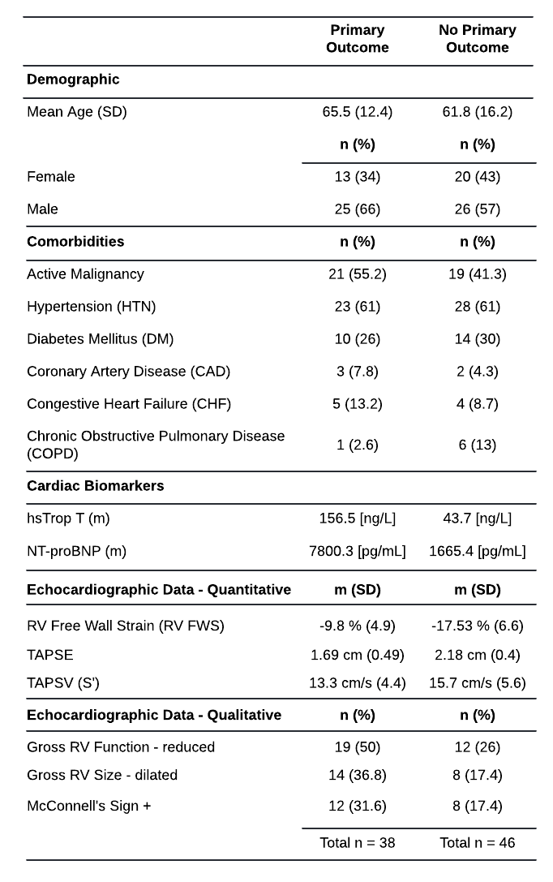
Table 2: Demographic and objective data of those meeting primary outcome (lefthand column) compared to those not meeting primary outcome (righthand column).

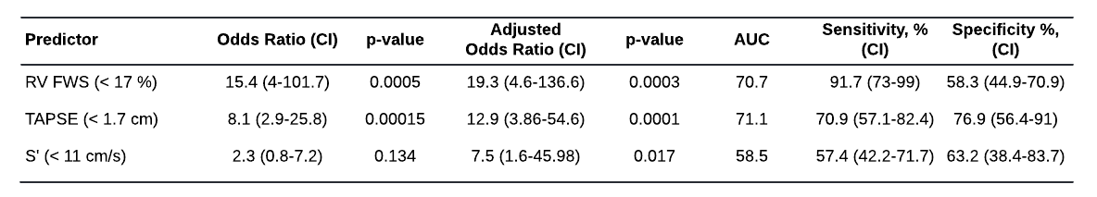
Table 3: Comparison of the predictors RV FWS, TAPSE, and S': Odds ratios relative to primary outcome calculated by univariate & multivariate logistic regression analysis adjusting for age, sex, and baseline comorbidities (Active malignancy, HTN, DM, CAD, CHF, COPD). AUC, sensitivity, and specificity numbers are stated for each predictor relative to primary outcome. For comparison purposes, RV FWS is reported as the absolute value with numbers less than 17% being considered abnormal.

