Supplementary Information

Fast growth of wafer-scale graphene on sapphire

Yinghan Li^{1,2,#}, Feifei Xu^{3,#}, Menglei Wang^{1,2,#}, Jincan Zhang^{1,4,#,}*, Jingyuan Shan^{2,5}, Bingyao Liu⁶, Kaixuan Zhou^{1,2}, Zaikun Xue^{1,2}, Li Jia², Wenze Wei², Chao Wen⁴, Yaqi Gao⁸, Zhaolong Chen⁹, Wen Zhao³, Tongbo Wei⁸, Peng Gao⁶, Yanfeng Zhang^{5,7,}*, Andrea C. Ferrari^{4,}*, Jingyu Sun^{1,2,}* & Zhongfan Liu^{2,5,}*

¹College of Energy, Soochow Institute for Energy and Materials Innovations, Key Laboratory of Advanced Carbon Materials and Wearable Energy Technologies of Jiangsu Province, Soochow University, Suzhou 215006, China.
²Beijing Graphene Institute, Beijing 100095, China.
³School of Materials Science and Engineering, China University of Petroleum (East China), Qingdao 266580, China.
⁴Cambridge Graphene Centre, University of Cambridge, Cambridge, CB3 0FA, United Kingdom.
⁵Center for Nanochemistry, College of Chemistry and Molecular Engineering, Peking University, Beijing 100871, China.
⁶Electron Microscopy Laboratory, International Center for Quantum Materials, School of Physics, Peking University, Beijing 100871, China.
⁷Academy for Advanced Interdisciplinary Studies, Peking University, Beijing 100871, China.
⁸Research and Development Center for Semiconductor Lighting Technology, Institute of Semiconductors, Chinese Academy of Sciences, Beijing 100083, China.
⁹Guangdong Provincial Key Laboratory of Nano-Micro Materials Research, School of Advanced Materials, Peking University Shenzhen Graduate School, Shenzhen 518055, China.
*Corresponding author. E-mail: zfliu@pku.edu.cn; sunjy86@suda.edu.cn; jczhang2024@suda.edu.cn; yanfengzhang@pku.edu.cn; acf26@eng.cam.ac.uk.
#These authors contributed equally to this work.

Supplementary Figures
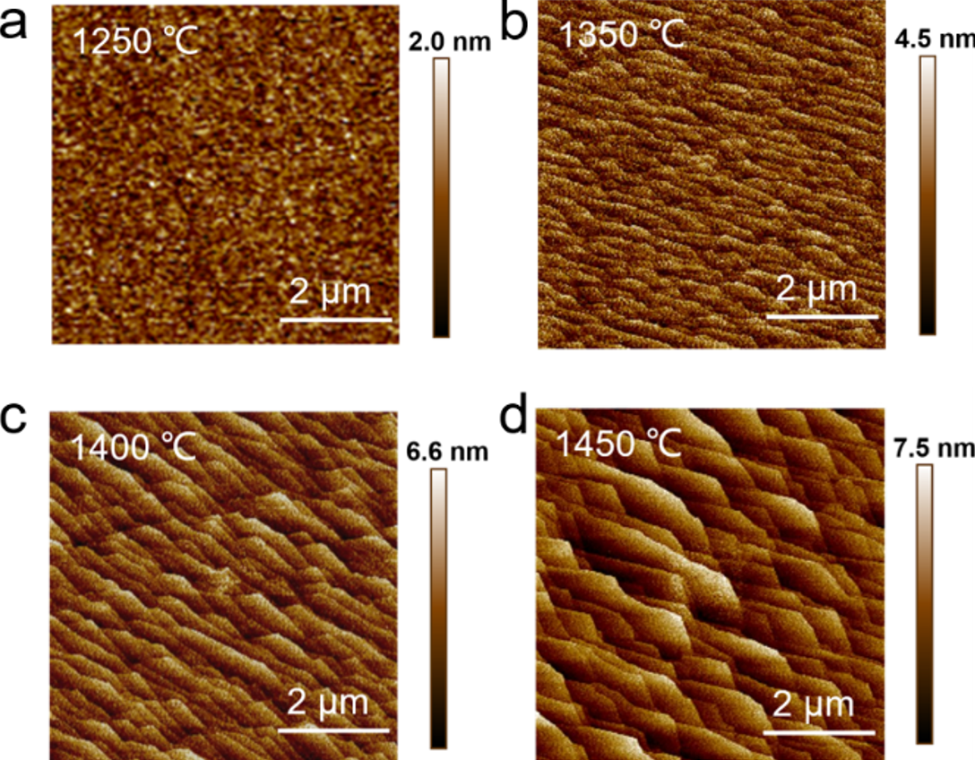
Supplementary Figure 1. a−d, AFM images of sapphire annealed at 1250, 1350, 1400 and 1450°C for 30 min.
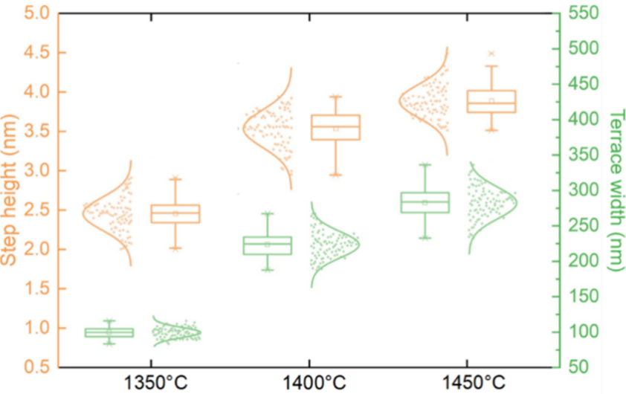
Supplementary Figure 2. Statistical analysis of step height and terrace width.
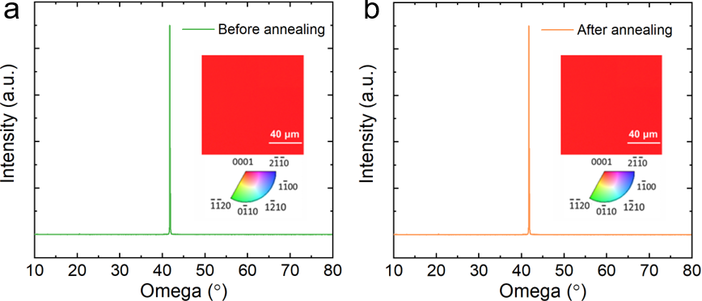
Supplementary Figure 3. X-ray diffraction patterns of sapphire (a) before and (b) after annealing. The insets display corresponding electron backscatter diffraction false-color maps.
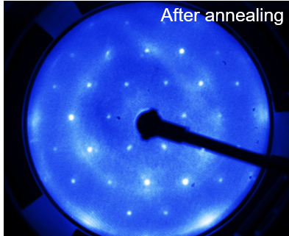
Supplementary Figure 4. Low-energy electron diffraction patterns of sapphire after annealing, revealing the unchanged lattice orientation of c-plane (0001).
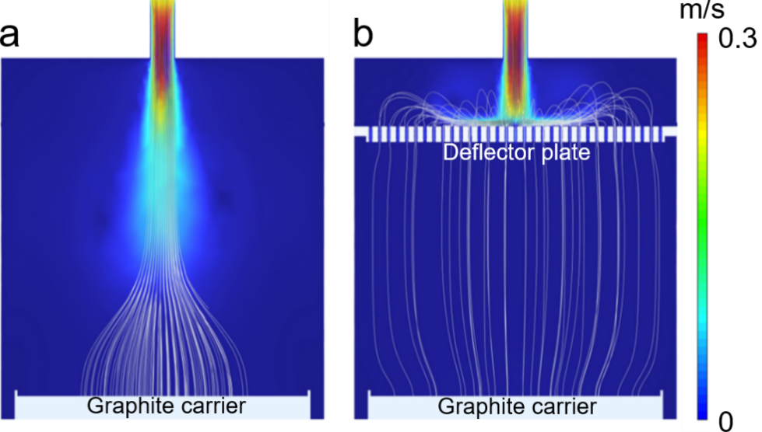
Supplementary Figure 5. Simulated gas distributions inside the CVD apparatus chamber (a) before and (b) after the incorporation of a gas deflector plate. The white lines represent the flow trajectories.
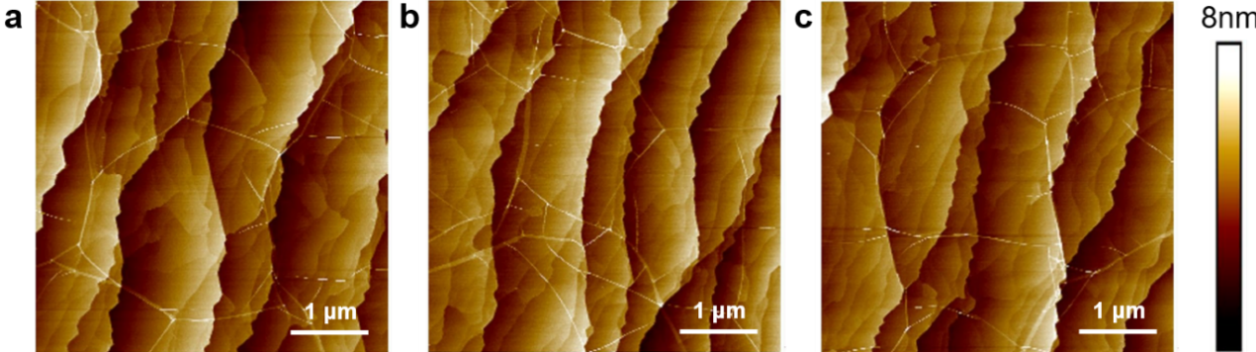
Supplementary Figure 6. AFM images of the grown SLG/sapphire samples at different positions.
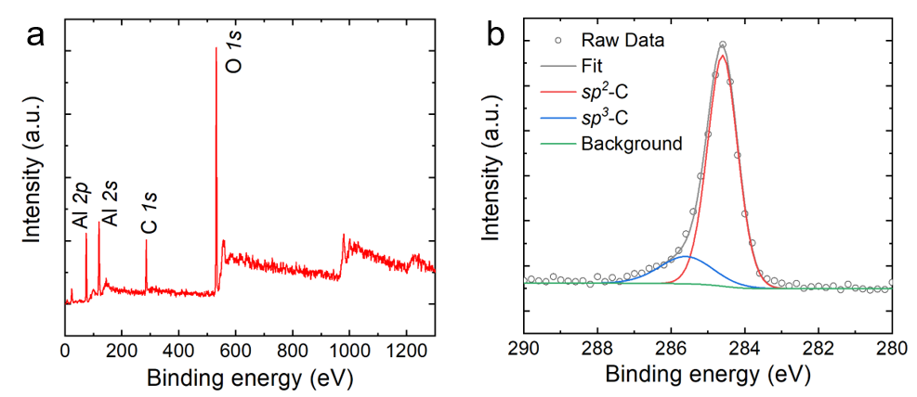
Supplementary Figure 7. a, XPS survey spectrum of SLG on sapphire. b, C 1s spectrum shows the characteristic signals of a predominant sp² carbon peak (~284.6 eV¹) and a sp³ carbon peak (~285.5 eV¹)
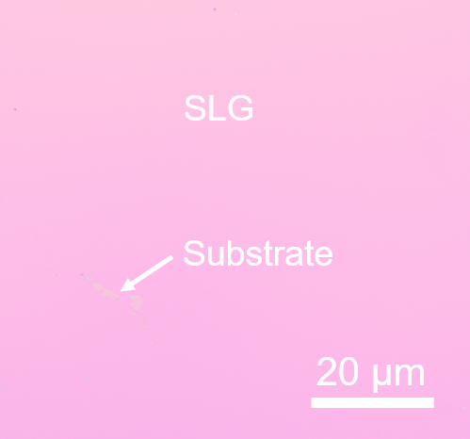
Supplementary Figure 8. OM image of SLG transferred onto SiO₂/Si.

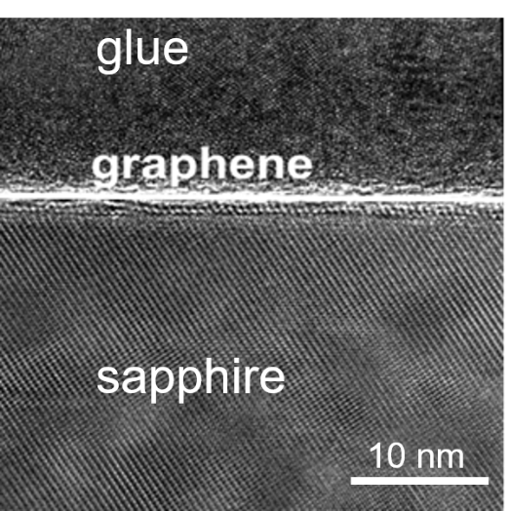
Supplementary Figure 9. Cross-sectional TEM image of the graphene/sapphire interface.

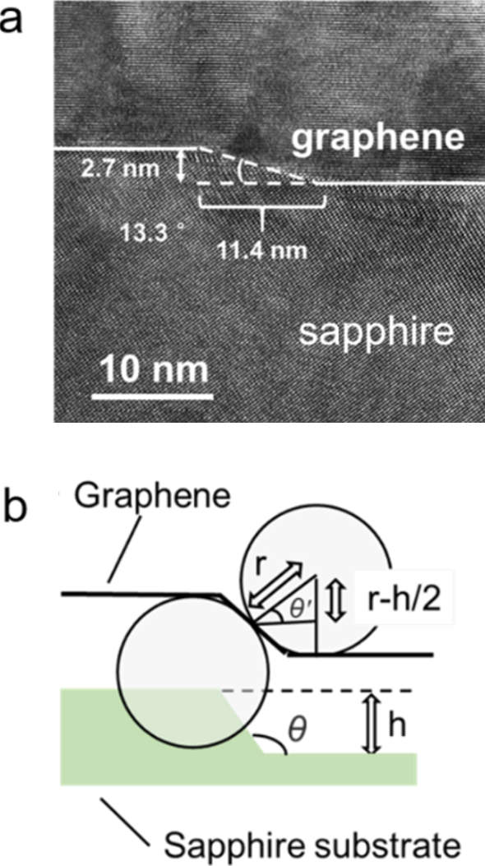
Supplementary Figure 10. a, Cross-sectional TEM image of as-grown SLG covering a sapphire step edge. b, Schematic of SLG growth across step edge, showing SLG bending over a substrate step, with a radius r and a step height h. The step structure on the sapphire features a slope of 13.3°, enabling SLG to bridge over steps and accomplishing the stitching of SLG domains.
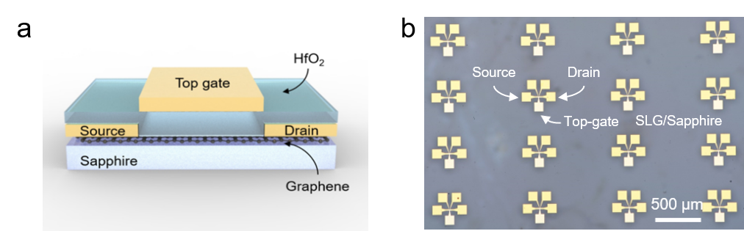
Supplementary Figure 11. a, Schematic of top-gated SLG device on sapphire using HfO₂ dielectric. b, A zoomed-in OM image of top-gated SLG device arrays on c-plane sapphire wafer.
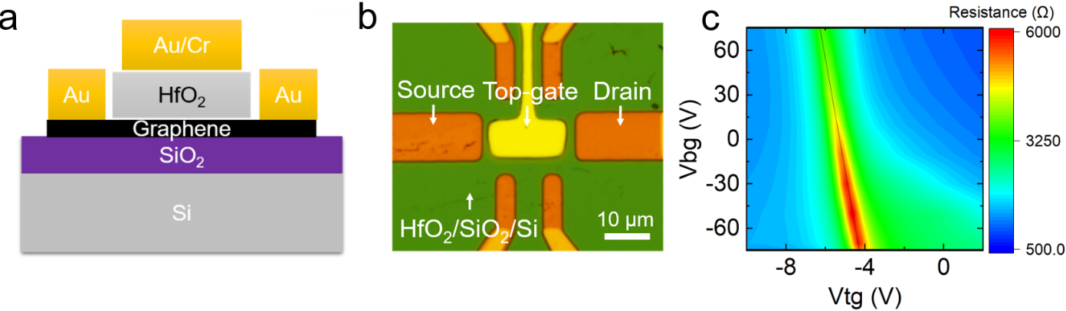
Supplementary Figure 12. a, Schematic of dual-gated GFET using HfO₂ and SiO₂ as top and back gating dielectrics. b, OM image of dual-gated GFET device. c, Dependence of resistance values on dual gates.
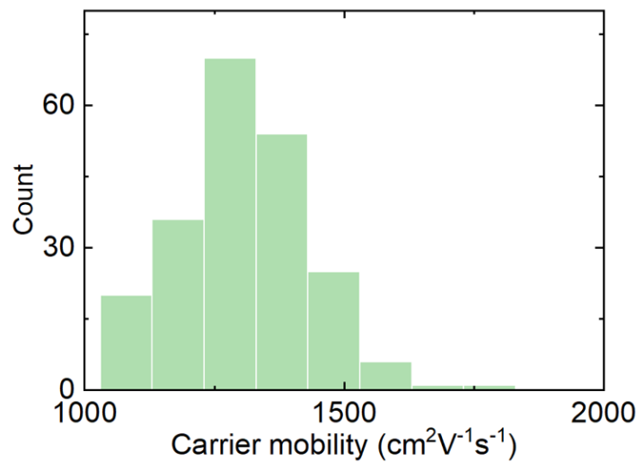
Supplementary Figure 13. Histogram statistics of RT µ of SLG grown on sapphire.
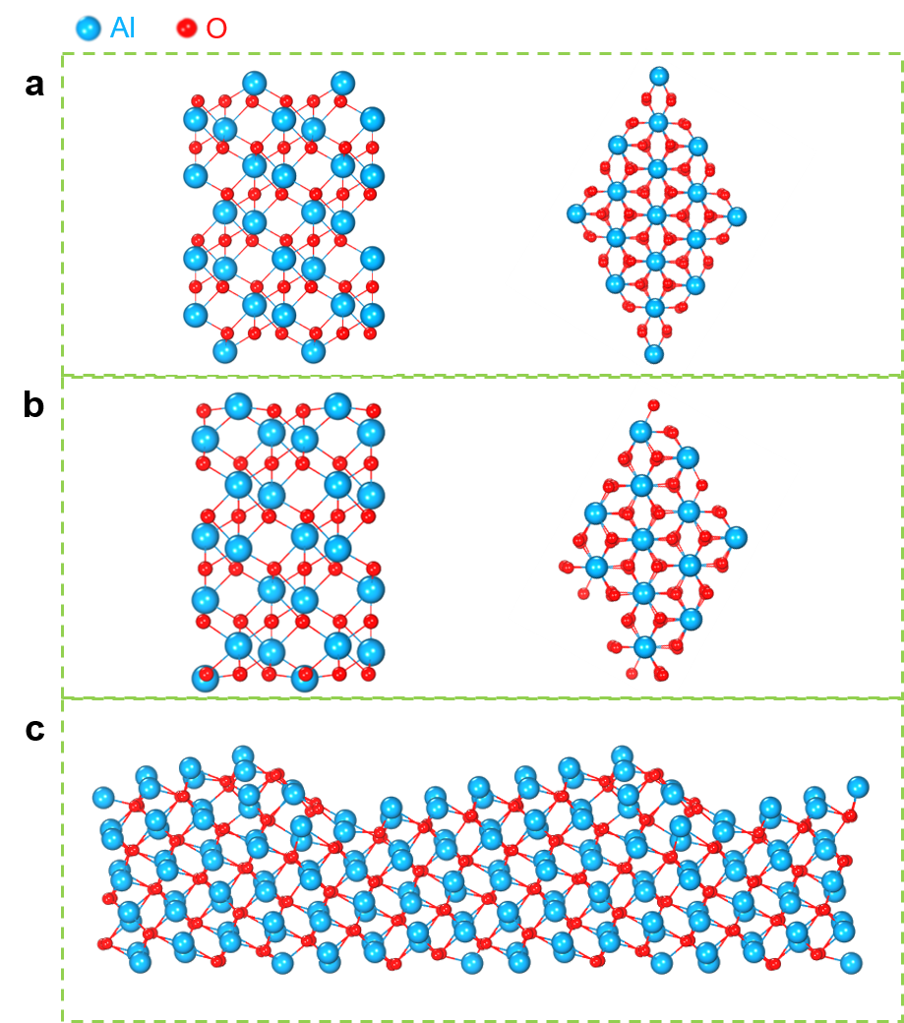
Supplementary Figure 14. a,b, Top view (right panel) and side view (left panel) of optimized (a) O-terminated and (b) Al-terminated Al₂O₃ bulk structure. c, Side-view of Al₂O₃(0001) structure with Al-step surface. The Al and O atoms are represented by blue and red balls, respectively.
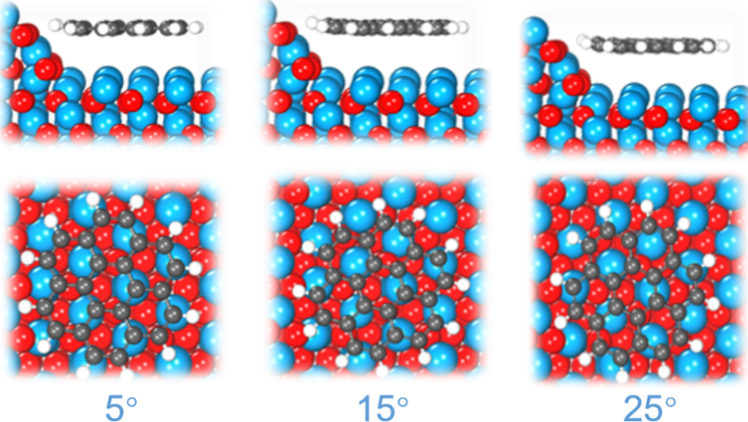
Supplementary Figure 15. Relaxation structure of C₂₄H₁₂ on surface of Al-step Al₂O₃(0001) with rotation angles of 5, 15, 25°.
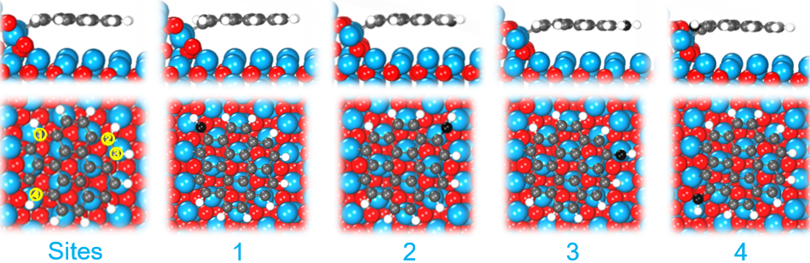
Supplementary Figure 16. Structures of C₂₄H₁₂ on Al-step with 4 adsorption sites for C atoms. The adsorption orientation of carbon atoms on an Al-step may follow specific patterns: when carbon atoms preferentially occupy sites 1 and 4 along the step structure, the growth mode tends to extend laterally along the step direction, leading to an increase in cluster width. Conversely, when carbon atoms adsorb at sites 2 and 3, this may induce longitudinal expansion perpendicular to the step direction. While sites 1 and 4 exhibit geometric symmetry according to site symmetry analysis, their adsorption energies differ significantly due to distinct chemical environments arising from different external oxygen coordination. Consequently, these sites must be considered separately in our computational models.

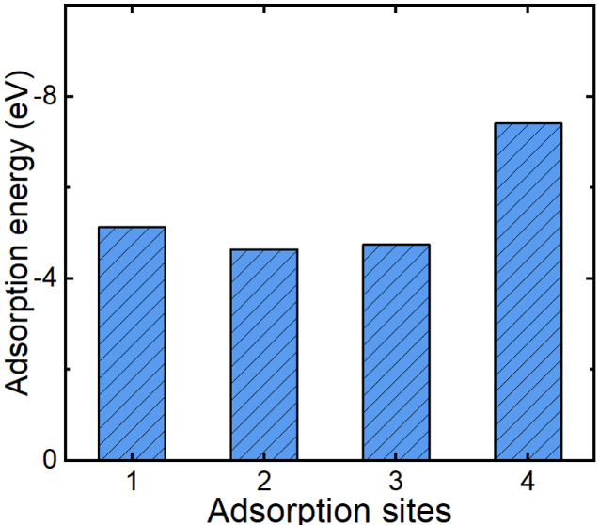
Supplementary Figure 17. Calculated adsorption energy of added C atoms at different sites.
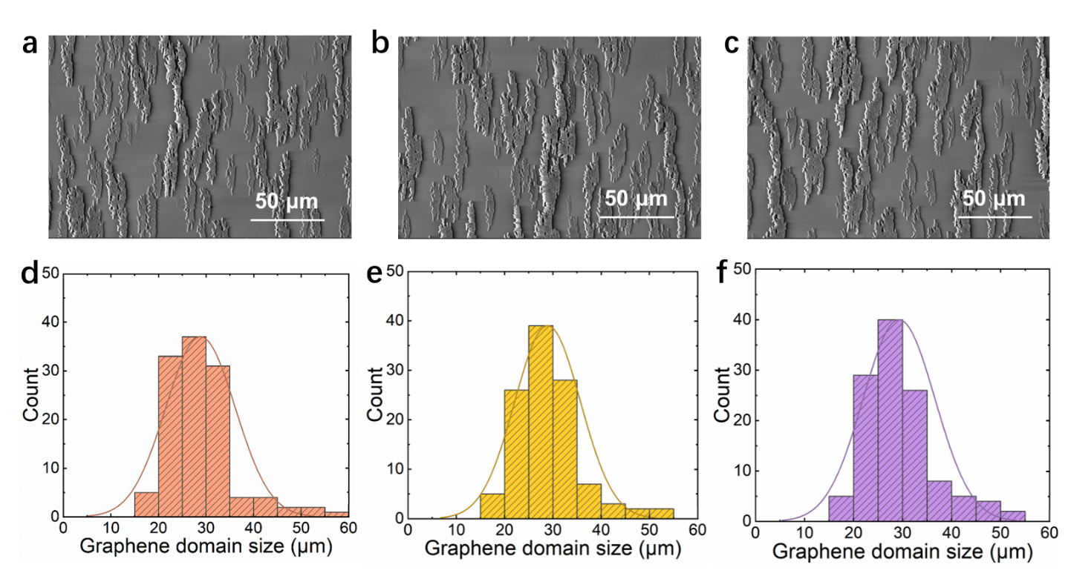
Supplementary Figure 18. a−c, SEM images of SLG domains formed over c-plane sapphire, revealing the strip-like shape features. d-f, Domain size histograms in the corresponding area, indicating the predominance of large-area domains.

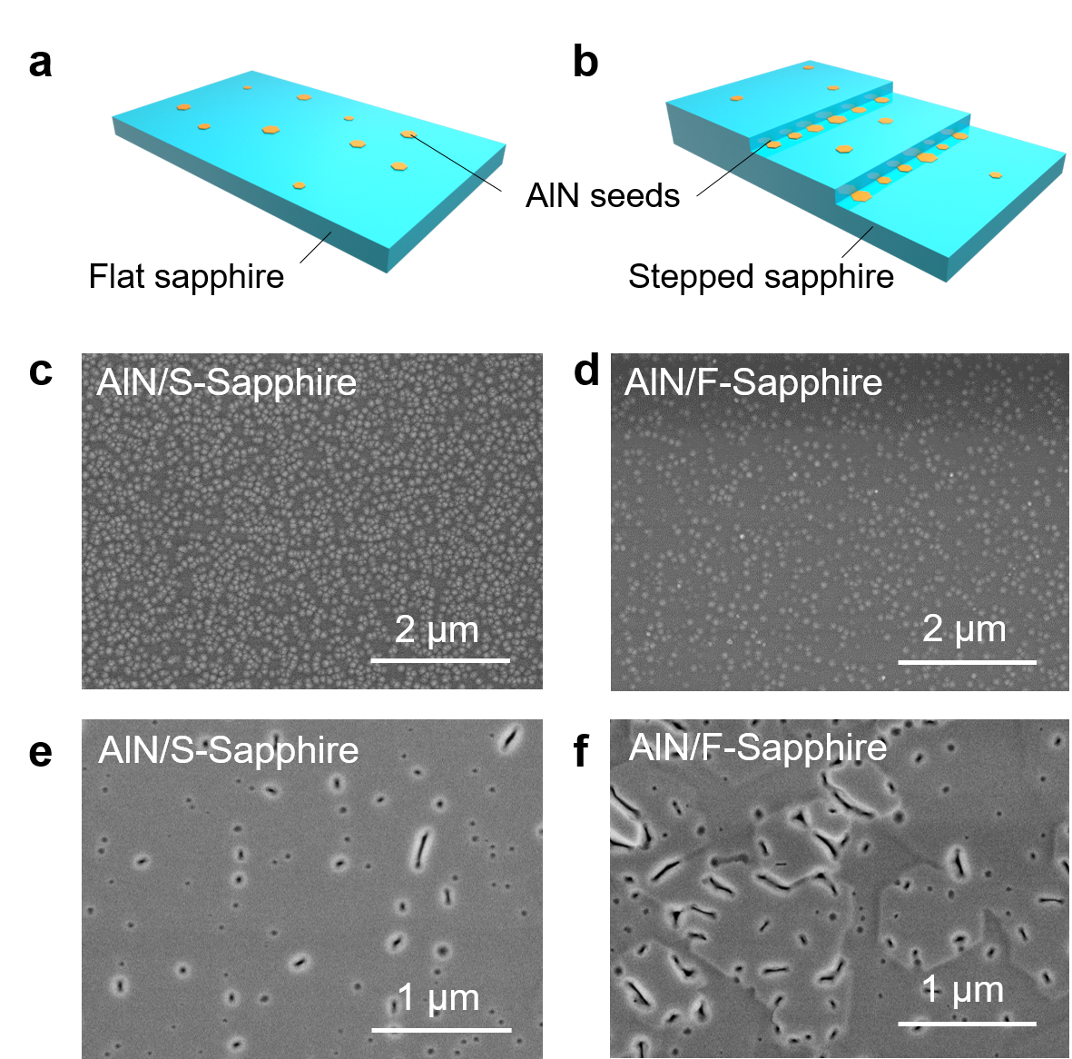
Supplementary Figure 19. a,b, Schematic illustration of epitaxial growth of AlN on (a) flat Sapphire (F-Sapphire), (b) Stepped Sapphire (S-Sapphire), c, d, SEM images of AlN grown on (c) F-Sapphire and (d) S-sapphire during the initial growth stage, demonstrating that substrates with step structure exhibits a higher nucleation density. e,f, SEM images of AlN grown on (e) F-Sapphire, (f) S-sapphire during the coalesce stage.
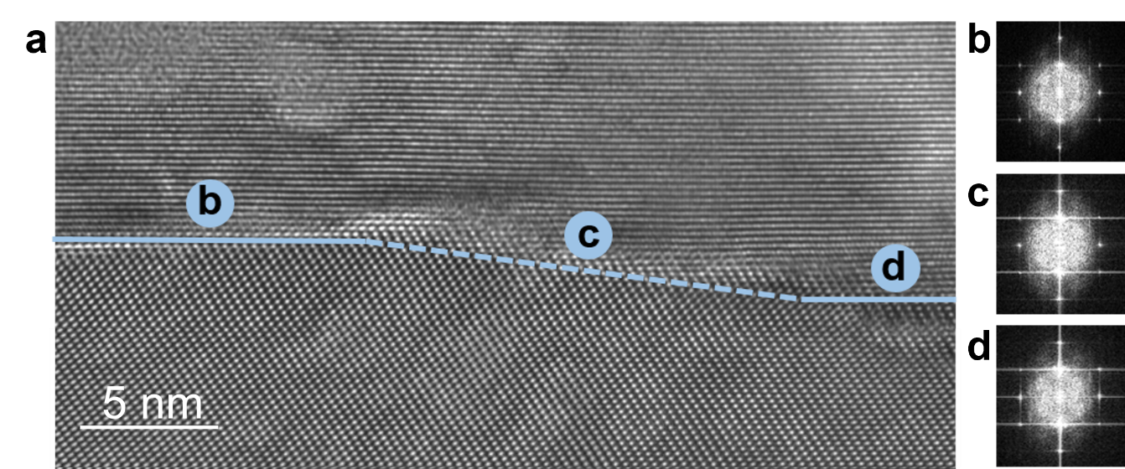
Supplementary Figure 20. a, Cross-sectional TEM image of AlN grown on SLG/S-Sapphire. b−d, Fast Fourier transform (FFT) images at the corresponding location in a show the ordered arrangement of epitaxial AlN, indicating that the steps do not adversely affect the growth of AlN.

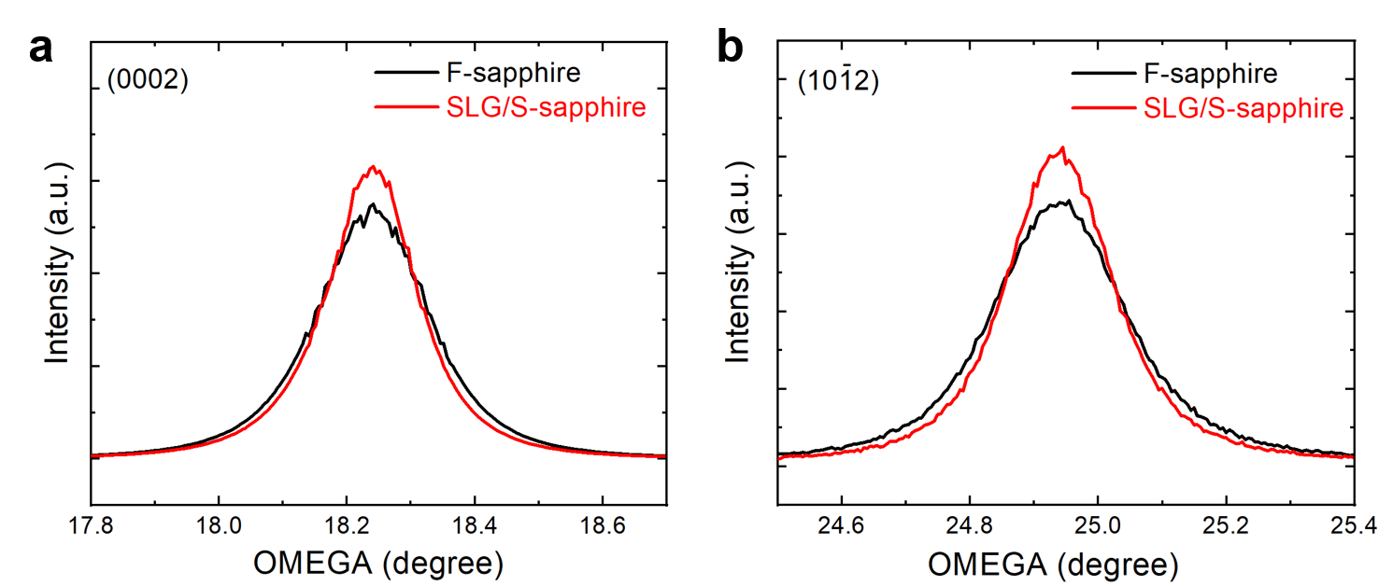
Supplementary Figure 21. High-resolution X-ray diffraction omega scans² ( a specialized X-ray diffraction technique used to characterize the crystalline quality and orientation of thin films or layered materials by scanning the incident X-ray angle (ω) while keeping the detector angle (2θ) fixed) of AlN epitaxial layers grown for 60 min. The FWHM values for the (0002) and (10-12) planes on F-Sapphire are 704.0 and 838.1 arcsec, respectively. For SLG/S-Sapphire, the values reach 598.4 and 673.3 arcsec, respectively. Notably, the FWHM value of XRD peaks quantifies the dispersion of crystalline lattice orientations and the density of lattice defects³. The decreased FWHM values indicate that the AlN films on SLG/S-sapphire exhibit higher crystalline quality as compared to those on F-Sapphire, which can be attributed to the faciliated strain relaxation on the stepped surface during the epitaxial growth⁴.
References
1. Sun, J. et al. Direct chemical vapor deposition-derived graphene glasses targeting wide ranged applications. Nano Lett. 15, 5846-5854 (2015).
2. Wie, C.R. High resolution X-ray diffraction characterization of semiconductor structures. Mat. Sci. Eng. R. 13, 1-56 (1994).
3. Wang, M. et al. High-temperature annealing induced evolution of strain in AlN epitaxial films grown on sapphire substrates. Appl. Phys. Lett. 114 (2019).
4. Bryan, I. et al. Surface kinetics in AlN growth: A universal model for the control of surface morphology in III-nitrides. J. Cryst. Growth 438, 81-89 (2016).

