Partial Freezing Enables Functional Preservation of Kidney Grafts for up to 10 Days
Supporting Information
McLean Taggart^{1,2,3}, Madeeha Hasssan^{1,2,3}, Arnaud Lyon^{1,2,3,4}, Ozge S. Ozgur^{1,2,3}, Christopher Taveras^{1,2,3}, Mohammadreza Mojoudi^{1,2,3,5}, Thomas Agius^{1,2,3,6}, Sophie Van Tulder^{1,2,3,7}, Christina Zheng⁸, Michael R. MacArthur⁸, James F. Markmann⁹, Heidi Yeh^{1,2,3}, Shannon N. Tessier^{1,2}, Mehmet Toner^{1,2}, Alban Longchamp^{1,2,3,✉}, Korkut Uygun^{1,2, ✉}.
Affiliations
¹Center for Engineering in Medicine and Surgery, Massachusetts General Hospital & Harvard Medical School, Boston, MA
²Shriners Children’s, Boston, MA, USA
³Transplant Center, Department of Surgery, Massachusetts General Hospital, Harvard Medical School, Boston, MA, USA
⁴Transplantation Center and Transplantation Immunopathology Laboratory, Lausanne University Hospital (CHUV), University of Lausanne (UNIL), Lausanne, Vaud, Switzerland
⁵Department of Molecular Biosciences, The University of Texas at Austin, Austin, TX, USA
⁶Laboratory of Sustainable Food Processing, Institute of Food, Nutrition and Health, ETH Zurich, Zürich, Switzerland
⁷Leiden University Medical Center, Leiden, the Netherlands
⁸Lewis-Sigler Institute of Integrative Genomics, Princeton University, Princeton, NJ, USA
⁹Penn Transplant Institute, University of Pennsylvania, Philadelphia, PA, USA
¹⁰Division of Cardiac Surgery, Department of Surgery, Massachusetts General Hospital and Harvard Medical School, Boston, MA, USA
✉Corresponding authors
ALONGCHAMP@mgh.harvard.edu
KUYGUN@mgh.harvard.edu
Supplementary Table 1. Human Kidney Donor Demographics
 | 3 Day Storage |  |  |  | 10 Day Storage
Age | 77 | 77 | 75 | N/A | 35 | 75 | N/A
Sex | F | F | M | N/A | F | M | N/A
BMI | 29 | 29 | 32 | N/A | 40 | 32 | N/A
Pump (Y/N) | Y | Y | Y | N | Y | Y | N
Ischemia (hh:mm) |  |  |  | N/A |  |  | N/A
Warm | 0 | 0 | 0 | N/A | 0 | 0 | N/A
Cold | 16:08 | 16:08 | 18:52 |  | 37:00 | 18:52
Sclerosis (%) | 31 | 22 | 0 | N/A | 2 | 20 | N/A
KDPI (%) | 95 | 95 | 100 | N/A | 36 | 100 | N/A

Supplementary Table 2. Pig Kidney Partial Freezing Solution Compositions
 | Loading | Storage 1 | Storage 2 | Thawing | Recovery | Simulated Transplant
Total Volume | 1L | 1.5L | 0.7L | 1L | 1L | 1L
Base Solution | WE | WE | UW | WE | WE | WE
PEG 35k | 2% | 2% | 10% | 2% | 2% | -
Dexamethasone | 61.2 μM | 61.2 μM | 61.2 μM | 61.2 μM | 61.2 μM | 61.2 μM
Bovine Serum Albumin | 1% | 1% | - | 1% | 2% | 4%
3-O-methyl-D-Glucopyranose | 100 mM | 100 mM | 100 mM | 100 mM | - | -
Hydroxyethyl starch (130/.4) | - | 3% | - | 3% | - | -
Raffinose | - | 35.3 mM |  | 35.3 mM | - | -
Trehalose | - |  | 55 mM | 110 mM | - | -
L-glutathione reduced | - | - | - | 5.0 mM | 5.0 mM | -
Furosemide | - | - | - | 0.4 mM | 0.4 mM | -
Creatinine | - | - | - | 1.0 mM | 1.0 mM | -
Snomax | - | - | 0.1% | - | - | -
Propylene Glycol |  | 6% | 12% | 6% | - | -
Penicillin Streptomycin | 4 mL | 6 mL | - | 4 mL | 4 mL | 4 mL
Heparin | 10 mL | 6 mL | - | 4 mL | 10 mL | 20 mL
Insulin | 2 mL | 3 mL | 70 uL | 200 uL | 100 uL | 100 uL
Heparinized Blood | - | - | - | - | - | 200 mL

Supplementary Table 3. Human Kidney Partial Freezing Solution Compositions
*Added after 3 hours of perfusion
 | Loading | Storage 1 | Storage 2 | Thawing | Recovery 1 | Recovery 2 | Simulated Transplant
Total Volume | 2L | 2L | 1L | 1.5L | 1L | 2L | 2L
Base Solution | WE | WE | UW | WE | WE | WE | WE
PEG 35k | 2%* | 2% | 10% | 2% | 2% | - | -
Dexamethasone | 61.2 μM | 61.2 μM | 61.2 μM | 61.2 μM | 61.2 μM | 61.2 μM | 61.2 μM
Bovine Serum Albumin | 1% | 1% | - | 1% | 1% | 2% | 4%
3-O-methyl-D-Glucopyranose* | 100 mM | 100 mM | 100 mM | 100 mM | - | - | -
Hydroxyethyl starch (130/.4) | - | 3% | - | 3% | - | - | -
Raffinose | - | 35.3 mM |  | 35.3 mM | - | - | -
Trehalose | - |  | 55 mM | 110 mM | - | - | -
L-glutathione reduced | - | - | - | 5.0 mM | 5.0 mM | 5.0 mM | -
Furosemide | - | - | - | 0.4 mM | - | 0.4 mM | -
Creatinine | - | - | - | 1.0 mM | - | 1.0 mM | -
Snomax | - | - | 0.1% | - | - | - | -
Propylene Glycol |  | 6% | 12% | 6% | - | - | -
Penicillin Streptomycin | 8 mL | 8 mL | - | 6 mL | 10 mL | 20 mL | 20 mL
Heparin | 20 mL | 8 mL | - | 4 mL |  | 10 mL | 20 mL
Insulin | 4 mL | 4 mL | 100 uL | 300 uL | 100 uL | 100 uL | 100 uL
pRBC | - | - | - | - | - | - | 1U
FFP | - | - | - | - | - | - | 1U

Supplementary Figure 1: Subnormothermic Recovery of Partially Frozen Pig Kidneys
Graphs detailing perfusion parameters during subnormothermic machine perfusion, including a, oxygen consumption, b, arterial flow, c, arterial resistance, d, venous lactate, and e, venous potassium. Graph depicting functionality parameter f, creatinine clearance rate. g, Representative histology stained with PAS at the end of subnormothermic machine perfusion and h, histological scoring. Pairwise comparison was conducted on terminal values by an unpaired t-test. * p < 0.05; ns, not significant
Supplementary Figure 2. Transmission Electron Microscopy of Pig Kidneys
a, Representative transmission electron microscopy imaging of biopsies taken at the end of simulated transplantation. All images were taken at 10,000X magnification.

Supplementary Figure 3. Extended Pig Kidney Simulated Transplantation Data
Graphs displaying the terminal perfusion parameter values of a, venous potassium and b, venous lactate. Pairwise comparison was conducted by ordinary one-way ANOVA with Tukey’s multiple comparisons test. * p < 0.05; ns, not significant
Supplemental Figure 4. Changes in Pig Kidney Histological Scoring
Graphs depicting the change in histological scoring from a, right after procurement to the end of storage and from b, the end of storage to the end of simulated transplantation. Pairwise comparison was conducted by ordinary one-way ANOVA with Tukey’s multiple comparisons test. * p < 0.05; ns, not significant

Supplemental Figure 5. 30D PF Kidneys Show Elevated Injury Compared to Kidneys Stored for 3 and 10 Days.
a, Representative, macroscopic images of kidneys at the beginning and end of simulated transplantation. b, Representative, microscopic histological images of PAS tissue at the end of storage, and following simulated transplant. graphs depicting organ health metrics c, weight gain, d, creatinine clearance rate, e, terminal AST, and f, histological scoring. Pairwise comparison was conducted by ordinary one-way ANOVA with Tukey’s multiple comparisons test. * p < 0.05; ns, not significant
Supplemental Figure 6. 30D PF Kidneys Show Dramatic Morphologic Injury on TEM.
a, Representative transmission electron microscopy imaging of biopsies taken at the end of simulated transplantation. All images were taken at 10,000X magnification.

Supplemental Figure 7. Flowchart for Human Kidney Partial Freezing
a, Schematic diagram depicting the partial freezing protocol for human kidneys.
Supplemental Figure 8. Extended Human Perfusion Parameters
Graphs depicting perfusion parameters during subnormothermic perfusion a, terminal lactate, b, terminal potassium, c, total urine production, and d, creatinine clearance rate. Graphs depicting perfusion paramerers during simulated transplantation e, terminal resistance and f, cumulative urine production. Pairwise comparison was conducted by ordinary one-way ANOVA with Tukey’s multiple comparisons test or an unpaired t-test for one-on-one comparisons. * p < 0.05; ns, not significant
Supplemental Figure 9. Change in Human Kidney Histological Scoring
Graphs depicting the a, histological scoring at different stages of the PF process as well as the b, change in scoring between those stages. Graph depicting the change in histological scoring over the course of simulated transplantation. Pairwise comparison was conducted by ordinary one-way ANOVA with Tukey’s multiple comparisons test or an unpaired t-test for one-on-one comparisons. * p < 0.05; ns, not significant
Supplemental Figure 10. Human Kidney Metabolomics
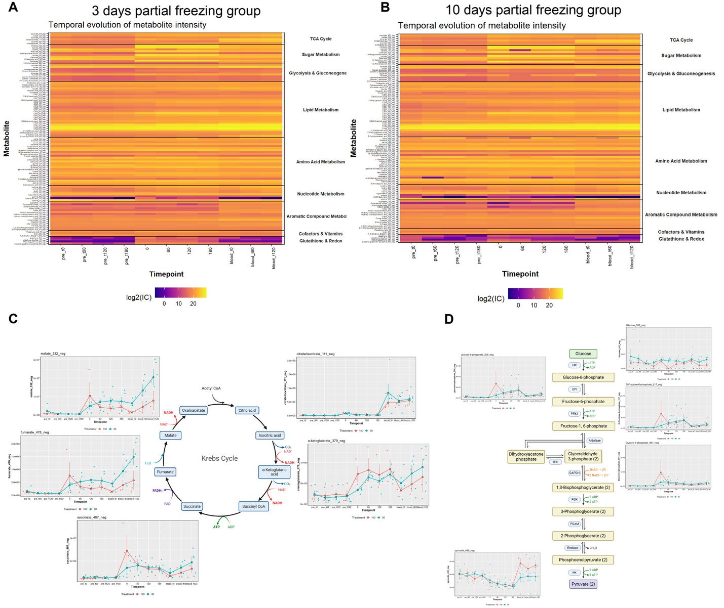
Supplemental Figure 10. Metabolomic Analysis of Partially Frozen Human Kidneys
Heatmap depicting the relative abundances of various metabolites throughout a, 3-day and b, 10-day PF. c, Graphs depicting the relative abundances of metabolites involved in the Krebs Cycle. d, Graphs depicting the relative abundances of metabolites involved in glycolysis.

