Saskemycin, a potent and selective antimycobacterial agent targeting a unique site on the ribosome

Michael A. Cook^{*,1}, Min Xu^{*,1,2}, Martino Morici^{*,3}, Dmitrii Y. Travin^{*,4,5}, Wenliang Wang¹, Dorota Klepacki^{4,5}, Nandini Chhabra⁶, Vishwas N. Rao^{1,7}, Henok Sahile⁸, Dirk Hackenberger¹, Haaris A. Safdari³, Max Berger³, Martina Corazza³, Austin N. Bond⁹, Allison K. Guitor¹, Dominique Tertigas^{1,10}, Lijun Wang^{1,11}, Adam J. Schaenzer¹, Linda Ejim¹, Venkateswarlu Yarlagadda¹², James E. Gomez⁹, Michael G. Surette^{1,10}, Yossef Av-Gay⁸, Neeraj Dhar⁶, Deborah T Hung⁹, Nora Vázquez-Laslop^{4,5}, Alexander S. Mankin^{4,5, #}, Daniel N. Wilson^{3, #}, Gerard D. Wright^{^,1, #}

* Authors contributed equally to the work
# corresponding authors’ e-mail: wrightge@mcmaster.ca, shura@uic.edu, daniel.wilson@uni-hamburg.de

Addresses:
¹ David Braley Center for Antibiotic Discovery, Michael G. DeGroote Institute for Infectious Disease Research, Department of Biochemistry and Biomedical Sciences, McMaster University, Hamilton, Ontario, Canada.
² Tianjin Institute of Industrial Biotechnology, Chinese Academy of Sciences, Tianjin 300308, China.
³ Institute for Biochemistry and Molecular Biology, University of Hamburg, Martin-Luther-King-Platz 6, 20146 Hamburg, Germany.
⁴ Center for Biomolecular Sciences, University of Illinois at Chicago, Chicago, IL, USA.
⁵ Department of Pharmaceutical Sciences, University of Illinois at Chicago, Chicago, IL, USA.
⁶ Vaccine and Infectious Disease Organization, Saskatoon, Canada. Department of Biochemistry, Microbiology and Immunology, University of Saskatchewan, Saskatoon, Canada.
⁷ Medical Scientist Training Program, School of Medicine, Duke University, Durham, North Carolina, USA.
⁸ Departments of Medicine and Microbiology and Immunology, The University of British Columbia, Vancouver, British Columbia, Canada.
⁹ Infectious Disease and Microbiome Program, Broad Institute of Harvard and MIT, Cambridge, MA, USA. Department of Genetics, Harvard Medical School, Boston, MA, USA. Department of Molecular Biology and Center for Computational and Integrative Biology, Massachusetts General Hospital, Boston, MA, USA.
¹⁰ Farncombe Family Digestive Health Research Institute, McMaster University, Hamilton, ON, Canada
¹¹ Laboratory of Microbial Resources and Biotechnology, Institute of Microbiology, Chinese Academy of Science, Beijing, China.
¹² Department of Chemistry, Indian Institute of Technology Bombay, Mumbai, India.
Determination of the SKM chemical structure
Stereochemistry of the sugars was determined from the ribosome-bound 3D-structure and confirmed by ³J proton-proton coupling constants (Table S1). Assignment of the guanidino bridge between the oligosaccharide moiety and the polyguanidino acyl chain was confirmed by the observation of distinctive heteronuclear multiple bond correlations (HMBC) between H1ꞌ (δ_{H} 4.66 ppm, d, J = 8.2 Hz)/ C2 (δ_{C} 156.1 ppm) and H4 (δ_{H} 3.18 ppm, 2H, br m)/C2 (δ_{C} 156.1 ppm) (Fig. S7, Table S1). The amide bond formed by 11-(2-methylguanidino)-undecanoic acylation on the polyagmatine moiety was assigned by the observation of HMBC correlations between H35 (δ_{H} 3.09 ppm, 2H, m, overlapped), C37 (δ_{C} 177 ppm), and H38 (δ_{H} 2.12 ppm, 2H, t, J = 7.0 Hz)/C37 (δ_{C} 177 ppm) (Fig. S7, Table S1). Matrix-assisted laser desorption/ionization (MALDI)-TOF MS/MS analysis was also performed to confirm the structure of SKM. The product ions of the polyagmatine acyl chain tail were clearly observed from the MALDI-TOF MS/MS spectrum (Fig. S9). The components of the tetra-saccharide head were confirmed through partial hydrolysis of SKM in 1.5 N HCl at 40 °C overnight (Fig. S10A), followed by the observation of the expected tri-/di-/mono- saccharide SKM product masses of 362.9972 ([M+4H]⁴⁺, calculated: 362.9963), 322.4837 ([M+4H]⁴⁺, calculated: 322.4831), 271.7135 ([M+4H]⁴⁺, calculated: 271.7132), and the polyagmatine acyl chain product mass of 293.5954 ([M+3H]³⁺, calculated: 293.5957) using HR-ESI-qTOF-MS analysis (Fig. S10B).
Given the structural complexity of SKM and the similarity between repeat units of the polyagmatine tail, the signals in the proton and carbon NMR are highly overlapped and difficult to interpret. Accordingly, SKM was partially hydrolyzed in 6 N HCl at 80 °C for 2 h followed by MS and MS/MS analyses (Fig. S11). The polyguanidino acyl product was confirmed by the observation of the signal masses of 220.4489 ([M+4H]⁴⁺, calculated: 220.4486) and 293.5956 ([M+3H]³⁺, calculated: 293.5957) (Fig. S11B). The polyagmatine acyl group product was isolated and further fragmented using MS/MS to confirm its structure (Fig. S11C). Finally, SKM was completely hydrolyzed in 6 N HCl at 102 °C for 2 days to cleave the amide bond of the guanidine-terminating acyl group (Fig. S12A). The polyagmatine chain was confirmed by observation of the mass of 639.5730 ([M+H]⁺, calculated: 639.5729) and MS/MS fragmentation pattern (Fig. S12B). The terminal 11-(2-methylguanidino)-undecanoic acid was confirmed by the observation of the mass of 258.2177 ([M+H]⁺, calculated: 258.2176) and MS/MS fragmentation pattern (Fig. S12C).

Figure S1. Natural product extract screen and validation. A. NP screen of M. tuberculosis H37Rv pUV3583c:GFP. Z scores representing relative growth rate, as inferred from GFP fluorescence, are shown in duplicate. B. Growth inhibition assays of S. aureus, M. smegmatis, E. coli and HEK293 cell viability assay with crude cell extracts of 40 candidate hits. An extract with mycobacterial-specific activity and no toxicity in HEK293 cells is indicated. The average values of duplicate assays are shown.

Figure S2. Identification of SKM and its analogues by LC-MS. A. GNPS molecular network of SKM-related molecular masses. Edge color indicates correlation score between fragmentation patterns (grey to black). Node color indicates log₂ precursor intensity (light yellow to purple). The mass of a SKM-related compound (+1 isotope) is indicated by white text. B. High resolution mass spectrometry (HR-MS) analysis of SKM. Triple- and tetra- protonated mass signals are magnified and shown in blue and red colors, respectively.
Figure S3. 2D NMR correlations and 1D NMR spectrum of SKM. A. Key COSY and TOCSY-HSQC correlations are shown in bold lines, and the key HMBC correlations are shown as curved arrows. B. Proton NMR spectrum of SKM recorded in D₂O.
Figure S4. DEPTQ NMR spectrum of SKM recorded in D₂O.
Figure S5. ¹H-¹H COSY spectrum of SKM recorded in D₂O.
Figure S6. ¹H-¹³C HSQC spectrum of SKM recorded in D₂O.
Figure S7. ¹H-¹³C HMBC spectrum of SKM recorded in D₂O.
Figure S8. ¹H-¹³C TOCSY-HSQC spectrum of SKM recorded in D₂O.
Figure S9. MALDI-TOF MS/MS spectrum of SKM.

Figure S10. Characterization of the oligosaccharide moiety of SKM through partial hydrolysis. A. Scheme of the partial hydrolysis of the oligosaccharide moiety in SKM. The hydrolyzed products are labelled as F1/2/3/4. B. HR-MS of the partial hydrolysis product of SKM. Unhydrolyzed SKM mass signals are shown in red font, the hydrolyzed products are shown in bold font.

Figure S11. Characterization of the polyguanidino moiety of SKM through partial hydrolysis. A. Scheme of the partial hydrolysis of SKM to release the polyguanidino lipid tail. B. HR-MS spectrum of the polyguanidino lipid tail. Observed triple-/tetra- protonated mass signals are indicated. C. HR-ESI-QTOF MS/MS characterization of the polyguanidino lipid tail. Predicted product ions are labelled. Predicted doubly charged product ions are shown in blue font. Observed product ions are shown in bold font and blue bold font (doubly charged product ions).

Figure S12. Characterization of the polymethylagmatine and terminal 11-(2-methylguanidino) undecanoic acid through complete hydrolysis. A. Scheme of complete hydrolysis of tail of SKM (F4 in Fig. S10A) to release the polymethylagmatine group and 11-(2-methylguanidino) undecanoic acid. B. HR-MS and MS/MS spectra of polymethylagmatine group. Predicted product ions are labelled and the corresponding observed product ions are shown in bold font. C. HR-MS and MS/MS spectra of 11-(2-methylguanidino) undecanoic acid. Predicted product ions are labelled, and the corresponding observed product ions are shown in bold font. Given the difficulty in predicting the fragmentation of the aliphatic carbon chain, the putative fragmentation patterns of the observed acyl chains are indicated with dashed lines.

Figure S13. Cloning of SKM BGC. A. Scheme for the capture of the SKM (sas) BGC through transformation associated recombination (TAR) cloning in yeast. B. pWAC40 plasmid bearing sas BGC.

Figure S14. SKM is a selective and bactericidal antimycobacterial compound, with rare indirect resistance mechanisms in M. smegmatis. A. Bactericidal activity of SKM versus M. smegmatis. Cultures were incubated with the indicated concentration of SKM for 2 days. Assay was performed in quadruplicate. The median CFU input and limit of detection (LOD) are indicated. B. Time-kill assay with control compounds in M. smegmatis. Points represent the average of two replicates, and error bars represent standard error. C. Time-kill assay with SKM singly and in combination with rifampicin in M. smegmatis. Points represent the average of 2-3 biological replicates, and error bars represent standard deviation. Concentrations of each compound in μg/mL are indicated. D. Bactericidal activity of SKM versus M. tuberculosis H37Ra. Assay was performed in triplicate. Cultures were incubated with the indicated concentration of SKM for 7 days. The median CFU input and LOD are indicated. E. Development of resistance to SKM or rifampicin in serially passaged M. smegmatis cultures. F. Point mutation in lysX confers dominant resistance to SKM. (i) Sequence alignment of lysX genes from wt M. smegmatis and a resistant mutant. (ii) Increase in SKM MIC for the lysX(L59K) mutant of M.smegmatis relative to wt. (iii) Complementation of the lysX(L59K) mutant of M. smegmatis with subcloned wt lysX does not restore sensitivity to SKM. Fold-change in MIC is shown relative to each respective strain expressing gfp. G. Viability of HEK293 cells treated with varying concentrations of SKM. Assay was performed in triplicate. Line represents a non-linear fit of a 4-parameter logistic constrained to a maximum response of 1 and minimum response of 0.
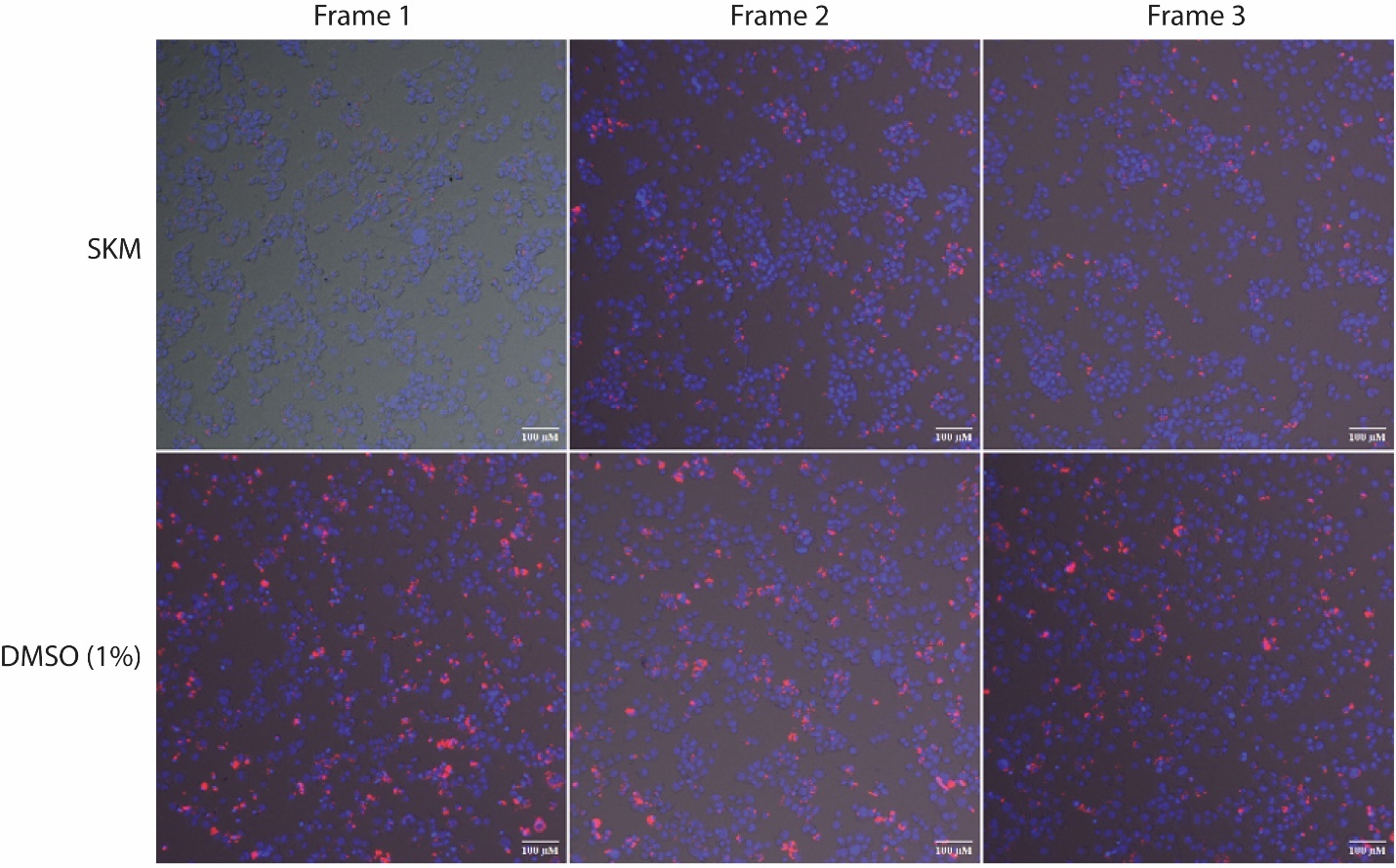
Figure S15. SKM intracellular activity in Mtb-infected THP-1 macrophages. Macrophages infected with RFP-expressing Mtb were treated with liposome-formulated SKM (16 µg/mL) and incubated for 72 hours. The cells were then fixed with 4% PFA in PBS, stained with DAPI, and intracellular Mtb load was quantified using CellInsight CX5 (ThermoFisher Scientific) High Content platform. Images were collected in the DIC, DAPI (for NucBlue fluorescence of the nuclear stain), and RFP (for bacterial dTomato fluorescence) channels. Images are representatives taken from three fields for SKM treated and the vehicle control (DMSO, 1%). Magnifications are 10×. Scale bars = 100 μm.

Figure S16. Membrane effects of SKM. A. Relative effects on membrane potential of M. smegmatis treated with SKM as determined using the voltage-sensitive dye DiSC₃(5). Bar graphs represent mean of duplicate experiments, normalized to DMSO controls. Individual data points are plotted. Valinomycin (20 μM) in the presence of 50 mM KCl was included as a positive control. B. SKM treatment of M. smegmatis does not lead to propidium iodide uptake. Normalized relative fluorescence units (RFUs), relative to DMSO controls, are shown for various SKM concentrations (μg/mL), LL-37 (256 μg/mL), and heat killed M. smegmatis cells. Error bars represent standard deviation and bar graphs indicate mean of 3 or more replicates.
Figure S17. PROSPECT profiling of SKM. SKM was screened in 8-point dose-response using PROSPECT. Adapting Gene Set Enrichment Analysis^{1,2} (GSEA) and applying it to each dose screened, the most sensitized biological gene set in response to SKM treatment was comprised of structural constituents of ribosomes [GO:0003735]. The false discovery rate (FDR) value was 2.42E-05 at the second lowest screened dose and the harmonic mean p-value combined FDR was 1.28E-04 across all doses. A. Mountain plot illustrating the sensitization of hypomorphs in GO:0003735 (structural constituent of ribosome), represented as black hashes along the x-axis. The y-axis shows the cumulative enrichment score. B. Dose-response to SKM treatment of all hypomorphic strains in PROSPECT, with 11 leading edge hypomorph strains from the data shown in A highlighted in blue (rplC, rplJ, rplD, rplP, rplE, rpsG, rpmC, rpsQ, rpmA, rplV, rplM). WT controls are highlighted in black, and all other hypomorphs are shown in grey. C. All significant pathways from GSEA. Several additional ribosomally-linked gene sets were also significantly enriched among sensitized strains (FDR < 0.0001 at any dose; Harmonic mean p-value combined FDR < 0.001 across all doses); these included cytosolic large ribosomal subunit [GO:0022625] and rRNA binding [GO:0019843].
Figure S18. Streptomyces ribosomes are sensitive to SKM in a SasO/SasN dependent manner. Transcription/translation of mScarlet-I gene in cell-free extracts derived from S. venezuelae expressing one or both of SasO and SasN methyltransferases. Assays were conducted in the presence of the indicated concentrations of SKM (A) or tetracycline (B). Translation was measured in triplicate experiments; error bars represent standard deviation. mScarlet-I fluorescence value in the absence of antibiotic was set as 100%.

Figure S19. SasO is similar to but distinct from RsmC. A. Overlay of the structure of RsmC from Thermus thermophilus (PDB ID: 2ZUL) with AlphaFold 3³ generated model of SasO from S. sp. WAC40. Relative fit was assessed using the DALI server⁴ and the overlay was generated in PyMOL⁵. B. Sequence and structure alignment between T. thermophilus RsmC and SasO, generated by the DALI server. The length of unaligned gaps in RsmC are indicated. Key features of RsmC are highlighted and key residues involved in S-adenosyl-methionine or guanosine binding are indicated by colored arrows. C. Frequency distribution of matches to SasO and RsmC in hidden Markov models (HMMs). Thresholds for defining a protein as SasO or RsmC are indicated by dashed lines. When a protein was predicted by either model, it was classified by the lowest error value. D. Phylogenetic tree of the distribution of SasO (orange) or RsmC (green) homologs as predicted in panel C.
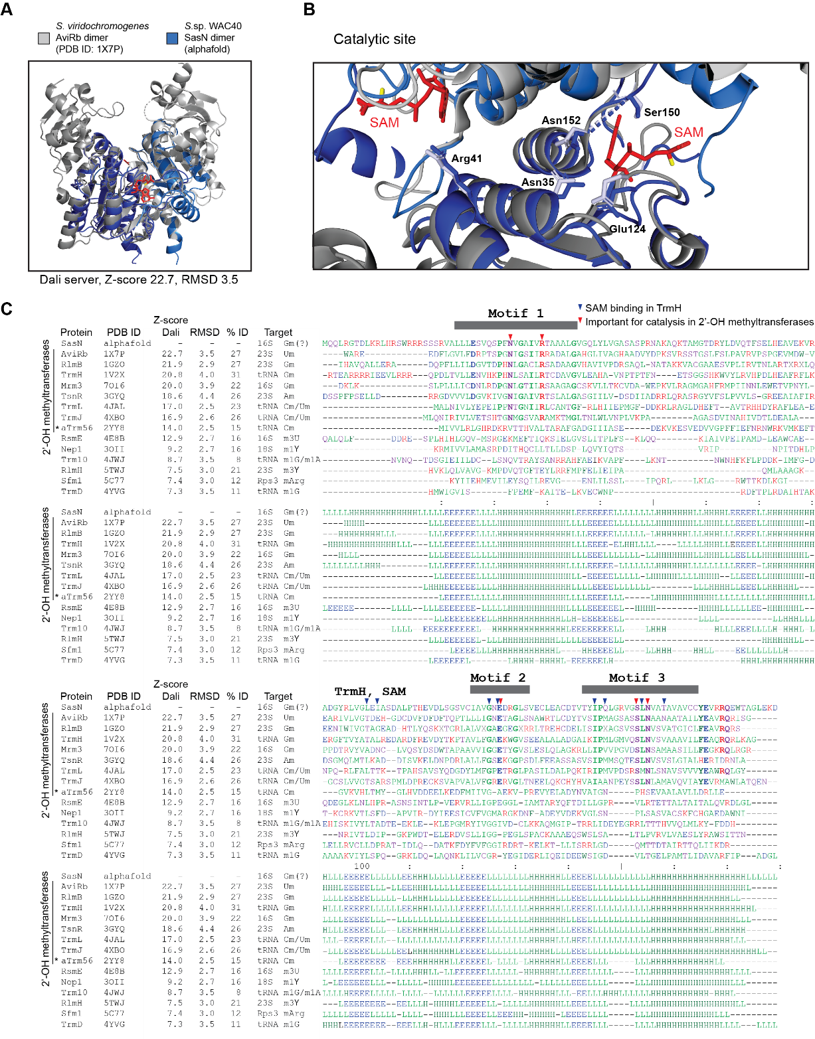
Figure S20. SasN shares structural features with SPOUT-family 2’-OH ribose methyltransferases. A. Overlay of the structure of dimeric AviRb (PDB ID: 1X7P) from S. viridochromogenes with AlphaFold 3³ generated model of dimeric SasN from S. sp. WAC40. Relative fit was assessed using the DALI server⁴ and the overlay was generated in PyMOL⁵. B. Overlay of SasN with the catalytic region of AviRb. The essential residues for catalysis are indicated. C. Structural alignment between SasN and representative SPOUT family methyltransferases, generated by the DALI server. Key motifs and residues in TrmH SPOUT 2’-OH ribose methyltransferase are indicated.
Figure S21. SasO methylates G1026 (E. coli C1051) of Streptomyces 16S rRNA. A. 16S rRNA from a SasO-expressing strain of S. coelicolor was directly sequenced using Nanopore and compared to the 16S rRNA from the wildtype strain. Nanocompore p-values determined through the GMM logit method are indicated at each position along the 16S rRNA gene rrnC from S. coelicolor A3(2) (AL645882.2) (S. coelicolor 16S rRNA numbering is used in panels A and B) ⁶⁻⁸. B. Mean intensity and dwell times (log10) for both the WT and SasO-expressing S. coelicolor strains across the region with the predicted modification. Changes in methylation status are known to affect dwell time and intensity locally within an RNA⁶. E. coli reference nucleotide positions are indicated in brackets. C. Semiquantitative analysis of integrated nucleoside ion intensities from nucleosides isolated from 16S rRNA derived from WT, SasN-, and SasO- expressing strains of S. coelicolor. Data are plotted for SasN (left) or SasO (right) on the y-axis vs WT S. coelicolor 16S rRNA nucleosides. Ion intensities with > 1.5-fold increase in relative signal intensity in rRNA methyltransferase expressing strains are indicated in red, annotated according to co-eluting standards. The retention times for the indicated ions for SasN matched those for both Gm and m1G standards, which could not be resolved.

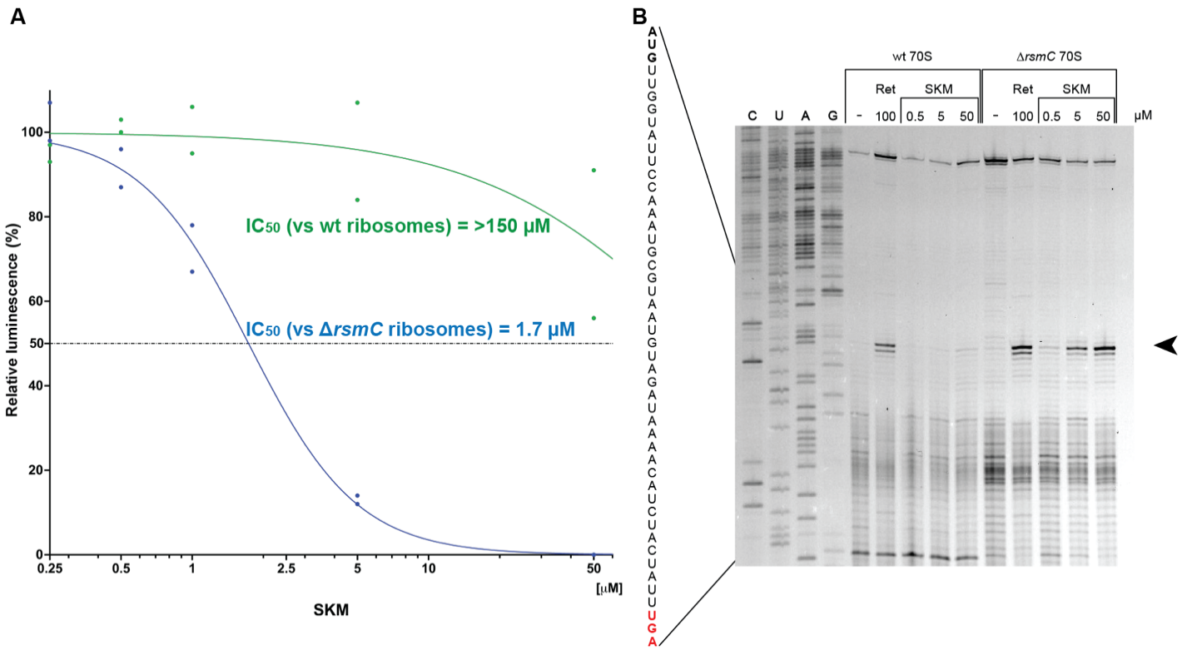
Fig. S22. Effect of SKM on cell-free translation by ribosomes from the E. coli ΔrsmC strain. A. Luminescence resulting from in vitro translation of firefly luciferase mRNA by ribosomes isolated from WT (green line) or ΔrsmC (blue line) strains in the presence of increasing concentrations of SKM. Luminescence in the absence of SKM was taken as 100%. Assays were performed in duplicate with each single measure depicted as dot. The averages were fitted to a curve utilizing least square fit function with Prism. B. Toeprinting assay monitoring the position of ribosomes, isolated from WT or ΔrsmC E. coli strains, on an ermBL-mRNA in the absence of the inhibitors (“-“) or in the presence of increasing concentrations of SKM (0.5, 5 and 50 µM). Translation initiation inhibitor retapamulin (Ret), present at 100 µM, was used as a control. The black arrow indicates ribosomes stalled at the AUG initiation codon. C, U, A and G sequencing lanes are indicated. The mRNA template sequence is shown.

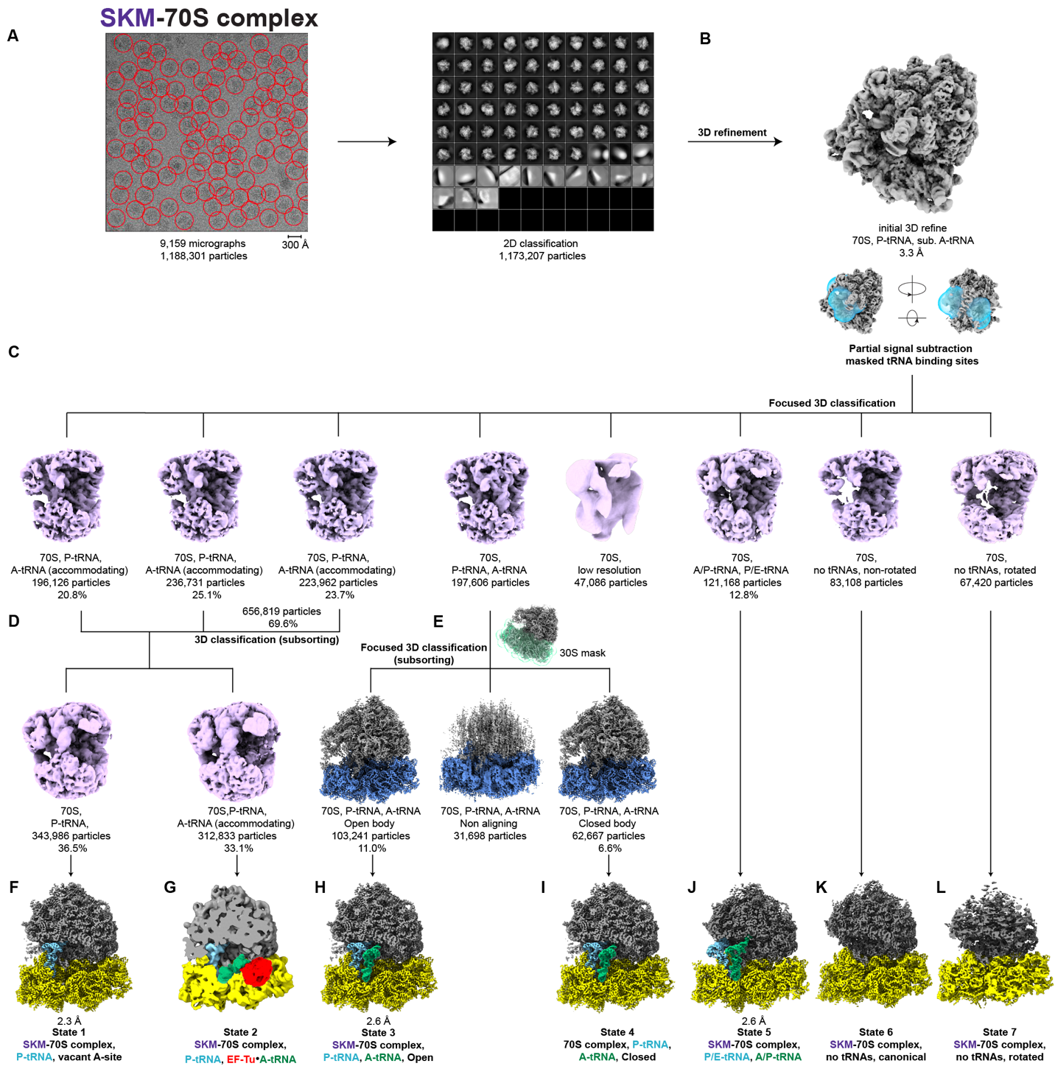

Fig. S23. In silico sorting scheme of the E. coli 70S-SKM complex. A. From 9,159 micrographs, 1,173,207 ribosome-like particles were selected after 2D classification, and B. subjected to an initial 3D refinement, and then C. partially subtracted with a mask surrounding the tRNA binding sites and 3D classified. This yielded 8 classes; three 70S classes with P-tRNA and accommodating A-tRNA (combined 69.6%, 656,819 particles), a non-rotated 70S class with A- and P-site tRNAs (197,606 particles), a class of low resolution 70S particles (47,086 particles), a rotated 70S class with hybrid A/P- and P/E-tRNA (12.8%, 121,168 particles), as well as rotated (67,420 particles) and non-rotated (83,108 particles) 70S classes with no tRNAs. D. The three 70S classes with P-tRNA and substoichiometric accommodating A-tRNA were pooled and further subsorted; 3D classification yielded two classes including a 70S class with P-tRNA and vacant A-site (36.5%, 343,986 particles) and a 70S class with P-tRNA and accommodating A-site tRNA (33.1%, 312,833 particles). E. The 70S class with P- and A-site tRNAs underwent further focus 3D classification, with a mask surrounding the 30S, yielding three classes, namely, a class of non-aligning 70S particles (31,698 particles) as well as 70S classes with P- and A-site tRNAs and either a closed (6.6%, 62,667 particles) or open (11.0%, 103,241 particles) body conformation. F-L. The subclasses were further processed to yield the final maps of States 1-7; State 1, 3 and 5 structures reached a final average resolutions (at FSC_{0.143}) of 2.3 Å, 2.6 Å, and 2.6 Å (at FSC_{0.143}), respectively. In F-I, the P-tRNA is colored cyan, H-I, the A-tRNA is green, G, the A/T-tRNA is colored green and EF-Tu in red, and in J, the P/E-tRNA and A/P-tRNA are colored cyan and green, respectively.
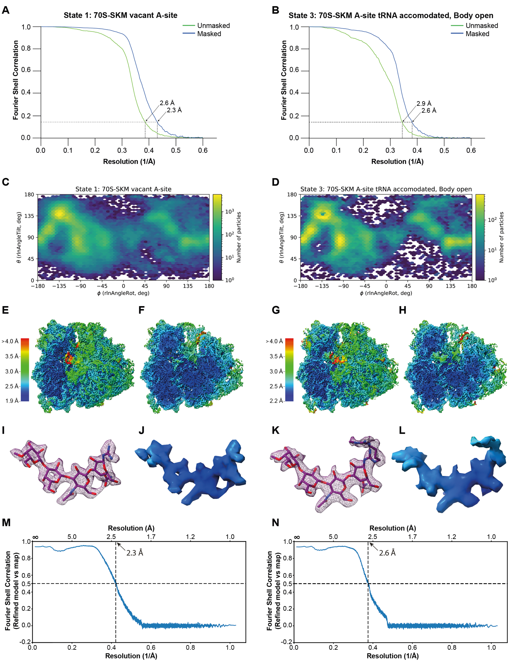
Figure S24. Angular distribution, FSC and local resolution of the SKM-70S complexes. A-B. Fourier shell correlation (FSC) curve and (C-D) Angular distribution plot of (A,C) State 1 (SKM-70S complex with vacant A-site) and (B,D) State 3 (SKM-70S complex with accommodated A-tRNA; open and unlatched), with unmasked (green) and masked (blue) FSC curves plotted against the resolution (1/Å). E-H, Overview and transverse section of the cryo-EM maps of the (E,F) State 1 and (G,H) State 3, colored according to local resolution. I-L, Molecular model of SKM and isolated cryo-EM density for SKM from (I,J) state 1 and (K,L) state 3, colored according to local resolution. M-N, FSC map versus model curves for (M) State 1 and (N) State 3.
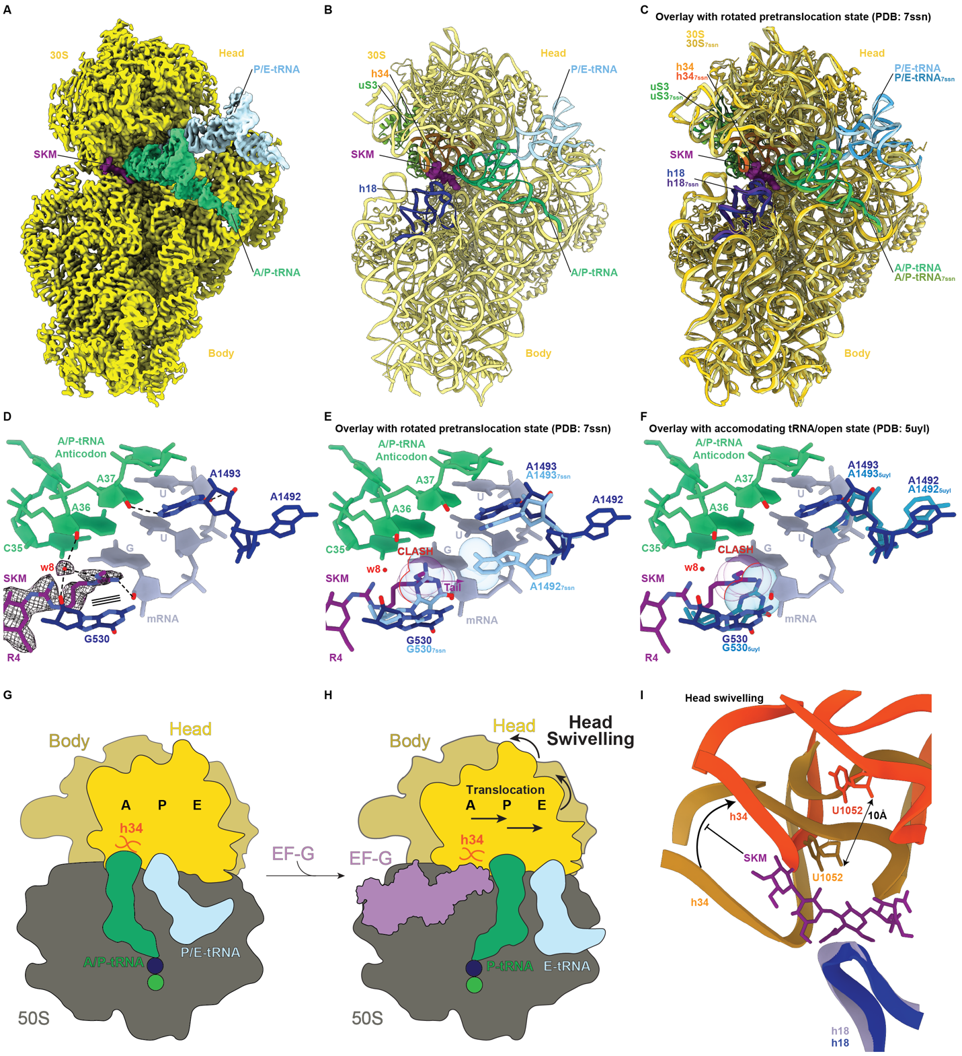
Fig. S25. Structural features of SKM-70S State 5. A. Cryo-EM map of the 30S subunit (yellow) of SKM-stalled ribosome (State 5) with hybrid P/E-tRNA (cyan), A/P-tRNA (dark green) and SKM (purple). B. Molecular model for State 5 from (a), with 30S (yellow), P/E-tRNA (cyan), A/P-tRNA (dark green), SKM (purple), h18 (blue), h34 (gold), and uS3 (green). C. Overlay of (B) with PDB ID 7SSN⁹; for the latter, the 30S (dark yellow), P/E-tRNA (light blue), A/P-tRNA (lime), h18 (violet), h34 (orange), and uS3 (forest green) are shown. D. Cryo-EM density (mesh) for tail of SKM from State 5 stacking on G530 of h18 (blue) and forming potential hydrogen bonds (black dashed line) with the 2´-OH of the third nucleotide (G) of the Leu mRNA codon (indigo) at position 2 of the template, and a structural water (w8, red sphere); w8 also forms a potential hydrogen bond with the 2´-OH of A36 of the A/P-tRNA anticodon (dark green). Bases A1492 (retracted, OFF-state) and A1493 (decoding) are also shown in blue. E. Overlay of the model of State 5 shown in (D) with decoding center bases of PDB ID 7SSN⁹ shown in light cyan. Clashes are highlighted, resulting from SKM tail occupying the space that G530 from 7SSN would invade for latching and extending (purple arrow) toward A1492 from 7SSN ON-state upon decoding. F. Overlay of the model of State 5 shown in (D) with decoding center bases of PDB ID 5UYL¹⁰ shown in dark cyan. Clashes are highlighted, resulting from SKM tail occupying the space that G530 from 5UYL would invade for latching while the incoming tRNA is accommodating in the A-site. G-H. Schematic showing (G) pre-translocation state with rotated ribosome and hybrid A/P- and P/E-tRNAs that is a substrate for EF-G (purple) binding, leading to (H) 30S head swiveling and concomitant movement of the tRNAs in the P- and E-sites. I. Movement of h34 with respect to h18 when comparing State 1 (gold) with the swiveled head observed during translocation (orange) (PDB ID 7SSD)⁹. Binding of SKM (purple) is incompatible with the head swiveled conformation.

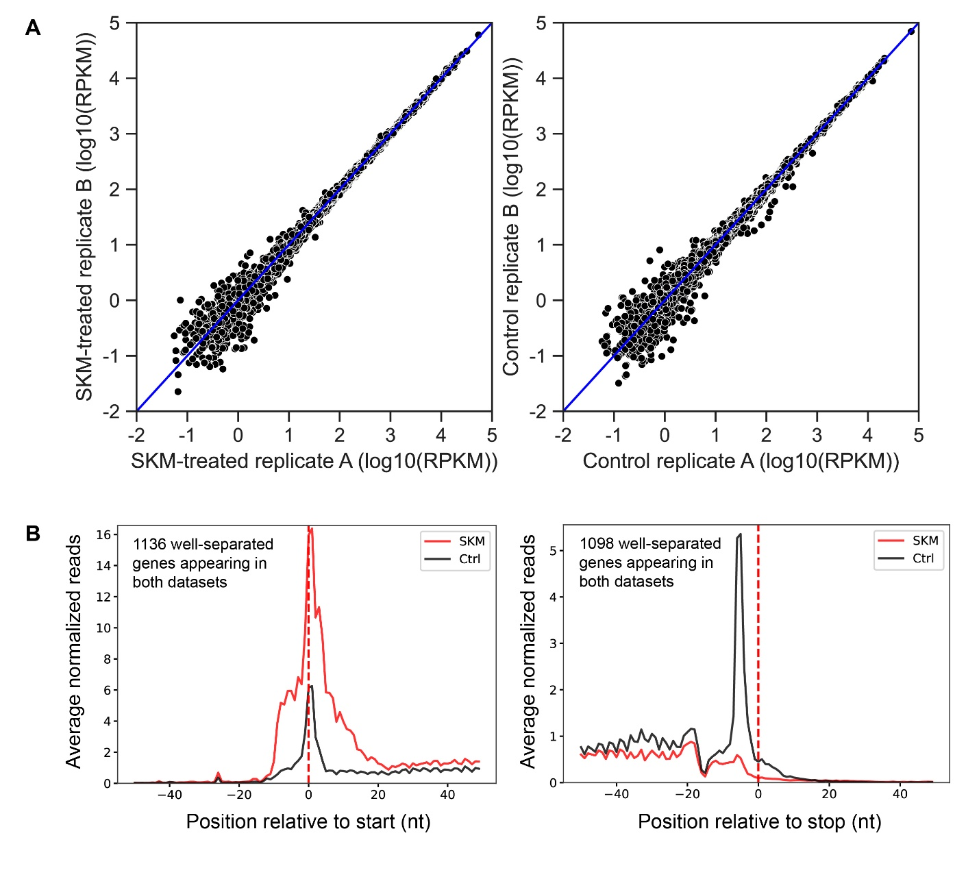
Figure S26. Consistency of ribosome profiling replicates and metagene analysis. A. Scatter plots comparing data obtained in independent Ribo-seq experiments. Plots show the number of reads [in reads per million per kilobase (RPKM)] mapped to each of E. coli protein-coding genes in the Ribo-seq libraries prepared from SKM-treated (left) and untreated control cells (right). Each black dot represents one gene. B. Metagene analysis of ribosome density around the start and stop codons of the well-separated (>50 bp apart) genes in SKM-treated (red line) or untreated (black like) cells based on the Ribo-seq results.

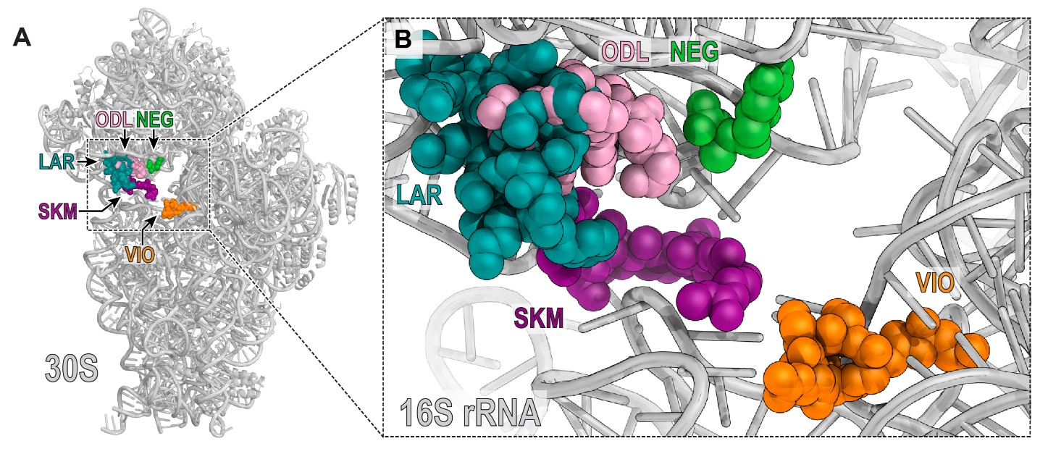

Figure S27. Superposition of select structures of antibiotics binding the small ribosomal subunit. Overview (A) and close-up views (B) of the ribosome-bound SKM (purple) of lariocidin (LAR, teal, PDB ID: 9DFC), odilorhabdin NOSO-95179 (ODL, pink, PDB ID: 6CAE), negamycin (NEG, green, PDB ID: 4W2I), and viomycin (VIO, orange, PDB ID: 4V7L).

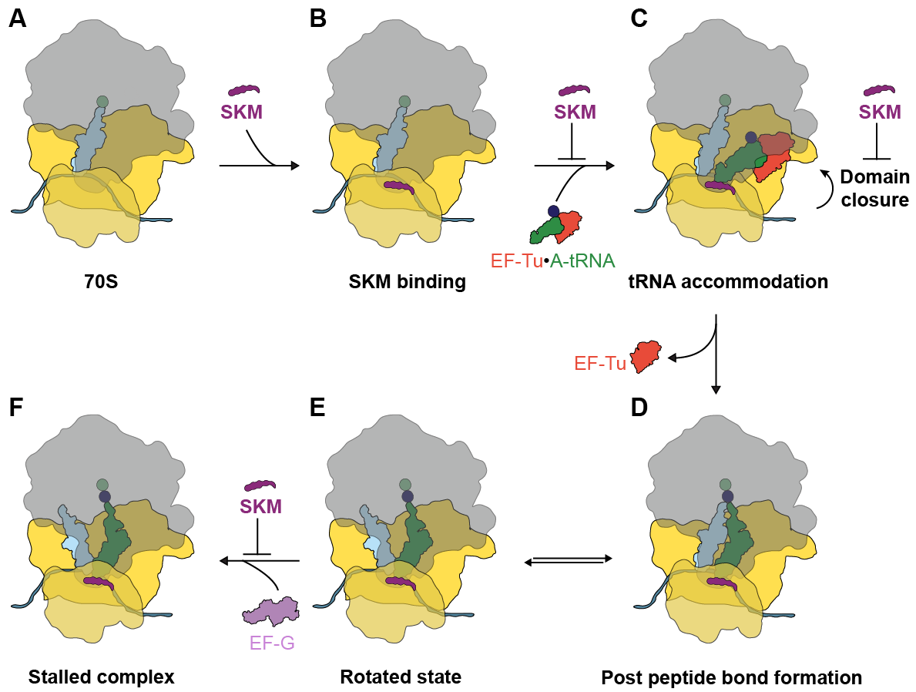

Fig. S28 Mechanism of action of inhibition of SKM during translation elongation. A, SKM binds to the initiation state with P-site tRNA, stabilizing the (B) canonical A-site vacant state (State 1, major state). C, SKM presence hampers the delivery and decoding of the aminoacyl-tRNA to the A-site by EF-Tu by inhibiting latching. D, Despite the presence of SKM, in a minor fraction of ribosomes, the A-tRNA properly accommodates, latching occurs and EF-Tu leaves the ribosomal complex. E, Following peptide bond formation, the ribosomes can continuously interconvert between the (D) canonical and (E) rotated states of the ribosome. F, The head swivelling catalyzed by EF-G required to achieve the post-translocation state is likely to be inhibited by SKM, thereby trapping the ribosome in the pretranslocational state. The color code used for the components depicted is the same used for those throughout the manuscript, with EF-Tu in light red and EF-G in faint lilac.

Table S1. H and C NMR Data of SKM.
Table S1, ¹H and ¹³C NMR Data of SKM.
No. | δ_{H} | δ_{C} | No. | δ_{H} | δ_{C}
2 |  | 156.1 | 4’ | 5.18 (d, J = 3.3 Hz) | 70.6
4 | 3.18 (2H, br m) | 40.9 | 5’ | 3.85 (dd, J = 7.7, 3.9 Hz) | 75.2
5 | 1.52 (2H, m, overlapped) | 25.2 | 6’ | 3.47 (m, overlapped)  3.57 (m, overlapped) | 60.2
6 | 1.50 (2H, m, overlapped) | 25.3 | 7’ |  | 158.3
7 | 3.09 (2H, m, overlapped) | 40.6 | 1” | 4.59 (d, J = 8.3 Hz) | 102.9
9, 16,  23, 30 | 3.09 (2H, m, overlapped) | 154.9 | 2’’ | 3.46 (m, overlapped) | 73.7
11, 14, 18,  21, 25, 28, 32,  35 | 3.09 (2H, m, overlapped) | 40.5 | 3’’ | 3.72 (m, overlapped) | 81.1
12, 13, 19,  20, 26, 27,  33, 34 | 1.50 (2H, m, overlapped) | 25.3 | 4’’ | 3.68 (m, overlapped) | 49.7
 |  |  | 5’’ | 3.43 (m, overlapped) | 74.8
37 |  | 177.0 | 6’’ | 3.59 (m, overlapped)  3.46 (m, overlapped) | 60.9
38 | 2.12 (2H, t, J = 7.0 Hz) | 35.6 | 7’’ |  | 174.7
39 | 1.45 (2H, m, overlapped) | 28.0 | 8’’ | 1.92 (3H, s) | 22.1
40 | 1.17 (2H, m, overlapped) | 25.3 | 1”’ | 4.51 (d, J = 8.2 Hz) | 103.3
41 | 1.14 (2H, m, overlapped) | 28.2 | 2’’’ | 3.55 (m, overlapped) | 70.4
42 | 1.44 (2H, m, overlapped) | 25.3 | 3”’ | 3.67 (m, overlapped) | 82.0
43 | 1.14 (2H, m, overlapped) | 28.4 | 4’’’ | 4.05 (m, overlapped) | 68.4
44 | 1.18 (2H, m, overlapped) | 25.5 | 5”’ | 3.57 (m, overlapped) | 74.6
45 | 1.13 (2H, m, overlapped) | 27.9 | 6”’ | 3.56 (m, overlapped)  3.46 (m, overlapped) | 61.1
46 | 1.44 (2H, m, overlapped) | 25.7 | 1”” | 4.46 (d, J = 7.7 Hz) | 104.1
47 | 3.05 (2H, t, J = 7.0 Hz) | 40.6 | 2”” | 3.44 (m, overlapped) | 71.3
49 |  | 155.6 | 3”” | 3.59 (m, overlapped) | 72.8
51-54 | 2.71 (3H, s) | 27.2 | 4”” | 3.51 (m, overlapped) | 78.9
55 | 2.70 (3H, s) | 27.1 | 5”” | 3.57 (m, overlapped) | 75.1
1’ | 4.66 (d, J = 8.2 Hz) | 81.8 | 6”” | 3.56 (m, overlapped)  3.66 (m, overlapped) | 60.4
2’ | 3.77 (m, overlapped) | 68.3 | 7”” | 3.41 (3H, s) | 61.3
3’ | 3.94 (dd, J = 9.8, 3.3 Hz) | 80.6

Table S2. Summary of SKM BGC.
orf | AA | Homolog (Accession, S/I %) | Proposed function
-1 | 139 | amino acid transporter (WP_030195661.1, 86/82) | Transporter
sasR | 299 | putative LuxR family transcriptional regulator (KDN85371.1, 64/45) | Regulator
sasA | 367 | protein arginine N-methyltransferase 1 (SDM24947.1, 62/46) | Arginine N-methyltransferase
sasB | 454 | glycosyltransferase family 2 protein (WP_053433326.1, 50/31) | Glycosyltransferase
sasC | 555 | Carbamoyltransferase (WP_110121283.1, 52/34) | Carbamoyltransferase
sasD | 599 | DegT/DnrJ/EryC1/StrS family aminotransferase (RKJ36437.1, 54/35) | Aminotransferase
sasE | 340 | UDP-glucose 4-epimerase (GBE20934.1, 53/38) | Epimerase
sasF | 351 | glycosyltransferase family 2 protein (WP_132430137.1, 44/30) | Glycosyltransferase
sasG | 322 | Amidinotransferase (OLB34709.1, 72/60) | Amidinotransferase
sasH | 245 | phosphatidylserine decarboxylase (PWU20886.1, 75/60) | Decarboxylase
sasI | 253 | phosphatidylserine decarboxylase (PYP52464.1, 80/62) | Decarboxylase
sasJ | 341 | mycothiol synthase (SFF95723.1, 46/33) | N-acyltransferase
sasT | 312 | Multidrug ABC transporter ATPase/permease (WP_015109135.1, 60/40) | ABC transporter ATPase
sasK | 592 | DegT/DnrJ/EryC1/StrS family aminotransferase (WP_027417272.1, 48/36) | Aminotransferase
sasL | 233 | Acetyltransferase (ABW10723.1, 62/47) | Acetyltransferase
sasM | 233 | class I SAM-dependent methyltransferase (TAE96168.1, 58/42) | Methyltransferase
sasN | 156 | tRNA/rRNA methyltransferase (EDY50587.1, 85/77) | Methyltransferase
sasO | 270 | methyltransferase family protein (RZT84174.1, 77/66) | Methyltransferase
sasP | 543 | Acyl-CoA synthetase (AMP-forming)/AMP-acid ligase II (SNS97851.1, 62/47) | Acyl-CoA ligase
sasQ | 400 | NAD-dependent aldehyde dehydrogenase (AKG44430.1, 73/57) | Aldehyde dehydrogenase
sasS | 569 | thiamine pyrophosphate enzyme (EWM11118.1, 67/55) | Deaminase
sasU | 420 | beta-ketoacyl-[acyl-carrier-protein] synthase II (OUM88315.1, 67/50) | Ketosynthase

Table S3. Minimum inhibitory concentrations
 | Isoniazid | Azithromycin | SKM
Bacterial strain | MIC  (µg/mL) | MIC  (µg/mL) | MIC  (µg/mL) | MBC  (µg/mL)
M. smegmatis mc²155 | 4 | - | 0.002 | 0.032
M. fortuitum subsp. fortuitum ATCC 6841 | 4 | - | 0.063-0.13 | -
M. abscessus ATCC 19977 | 128 | - | 0.5-1 | -
M. tuberculosis H37Ra | 0.031 | - | 0.063-0.13 | 0.5
M. tuberculosis Erdman | - | - | 0.03-0.15 | -
M. bovis BCG Pasteur ATCC 35734 | 0.13-0.25 | - | 0.013 | -
M. ulcerans ATCC 19423 | 16-32 | - | 1 | -
M. avium subsp. avium ATCC 25291 | >64 | - | 8-16 | -
E. coli BW25113 | - | - | >64 | -
E. coli BW25113 ΔtolCΔbamB | - | - | 64 | -
S. aureus ATCC 29213 | - | - | >64 | -
Neisseria gonorrhoeae ATCC 49226 | - | 0.25 | 64 | -
Helicobacter pylori ATCC 43504 | - | 0.25 | 16 | -
Tsukamurella sp. WAC06889b | - | - | 0.5-2 | -
Nocardia yamanashiensis | - | - | 2-8 | -
Corynebacterium striatum | - | - | 0.002-0.008 | -
C. aurimucosum | - | - | 0.015-0.063 | -
C. amycolatum GC43 | - | - | 0.002 | -
Rhodococcus equi | - | - | 1-4 | -

Table S4: Minimum inhibitory concentrations of modified organisms versus SKM
Heterologous expression strains
 |  | SKM MIC (µg/mL)
Bacterial strain |  | vector | SasN |  | SasO |  | SasNO
S. coelicolor M1154 + pIJ10257 |  | <0.25 | 1 |  | 16 |  | 16
S. venezuelae ATCC 10712 |  | 8 | 16 |  | >128 |  | >128
M. smegmatis mc²155 |  | 0.008 | 0.032 |  | 4 |  | 8
 |  | GFP |  | LysX |  | LysX(L59K)
M. smegmatis mc²155 |  | 0.008 |  | 0.008 |  | 0.032
M. smegmatis mc²155 (SKM^{R}) |  | 0.064 |  | 0.064 |  | ND
Deletion strains
E. coli BW25113 | 64
E. coli BW25113 ΔrsmC | < 0.25
E. coli BW25113 ΔlasT | 64
S. aureus USA300 | 64
S. aureus USA300 ΔSAUSA300_0526 | 2
S. aureus USA300 ΔSAUSA300_0517 | 64
Strains with mutations in 16S rRNA
E. coli SQ110 ΔrsmC | 1
E. coli SQ110 ΔrsmC rrsE-G1206A | 128
E. coli SQ110 ΔrsmC rrsE-G1207U | 16
E. coli SQ110 ΔrsmC rrsE-C1051U | 4
E. coli SQ110 ΔrsmC rrsE-C1054A | 16

Table S5. Cryo-EM data collection, refinement and validation statistics

 | State 1 | State 3 | State 5
Data collection and processing
Magnification | 105,000x | 105,000x | 105,000x
Acceleration voltage (kV) | 300 | 300 | 300
Electron exposure (e⁻/Å²) | 40 | 40 | 40
Defocus range (μm) | −0.3 –−1.0 | −0.3 –−1.0 | −0.3 –−1.0
Pixel size (Å) | 0.832 | 0.832 | 0.832
Symmetry imposed | C1 | C1 | C1
Initial particle images (no.) | 1,173,207 | 1,173,207 | 1,173,207
Final particle images (no.) | 343,986 | 103,241 | 121,168
Map resolution (Å)  FSC threshold | 2.3  0.143 | 2.6  0.143 | 2.6  0.143
Refinement
Initial model used (PDB code) | 7K00 | 7K00 | 7K00
Model resolution (masked, Å)  FSC threshold | 2.3  0.5 | 2.6  0.5 | 2.6  0.5
CC (mask) | 0.70 | 0.77 | 0.81
CC (volume) | 0.69 | 0.77 | 0.79
Map sharpening B factor (Å²) | -52.9 | -69.5 | -50.2
Model composition  Non-hydrogen atoms  Protein residues  RNA residues  Waters  Magnesium (MG)  Antibiotics* | 148,201  5,631  4,451  8,154  313  SKM | 149,100  5,532  4,529  8,124  313  SKM | 104,696  5,270  4,527  1,750  309  SKM
B factors (Å²)  Protein  RNA  Ligand  Water | 105.16  89.19  74.70  80.66 | 113.65  104.08  93.93  94.59 | 104.12  101.50  80.12  67.17
R.m.s. deviations  Bond lengths (Å)  Bond angles (°) | 0.008  1.141 | 0.008  1.134 | 0.009  1.209
Validation  MolProbity score  Clashscore  Poor rotamers (%) | 1.09  0.82  0.67 | 1.10  0.90  0.71 | 1.11  0.90  0.78
Ramachandran plot  Favored (%)  Allowed (%)  Disallowed (%)  Ramachandran Z-score | 95.20  4.73  0.07  −2.52 | 95.29  4.54  0.17  −2.90 | 94.69  5.23  0.08  −2.90
Table S6. Strains and plasmids used in this study.
Strains | Description | Source
E. coli Top10 | General cloning and plasmid maintenance | Invitrogen
E. coli ET12567/pR9406 | E. coli-Streptomyces tri-parental mating helper strain | ¹¹
E. coli SQ110 ΔtolC | E. coli strain harbouring a single rrn-operon (rrnE) | ^{12,13}
E. coli SQ110 ΔtolCΔrsmC | Strain used to select SKM-resistant mutants with point mutations in 16S rRNA gene (rsmC::neo) | This work
E. coli BW25113 ∆bamB∆tolC | Indicator strain | Lab stock
E. coli BW25113 ∆rsmC | BW25113 rsmC::neo | Brown lab
E. coli BW25113 ∆lasT | BW25113 lasT::neo | Brown lab
E. coli BW25113 ΔtolCΔrsmC | BW25113 ΔtolC rsmC::neo, strain used for the ribosome profiling experiment | This work
S. cerevisiae VL6-48N | MAT α, his3-D200, trp1-Δ1, ura3-Δ1, lys2, ade2−101, met14, psi+cirO, TAR host strain | ¹⁴
S. coelicolor M1152 | Δact Δred Δcpk Δcda rpoB[C1298T] | ¹⁵
S. coelicolor M1154 | Δact Δred Δcpk Δcda rpoB[C1298T] rpsL[A262G] | ¹⁵
S. sp. WAC00040 | SKM producer | Lab stock
S. coelicolor M1152/pWAC40 | SKM heterologous expression strain | This work
S. coelicolor M1154/pIJ10257 | pIJ10257 based expression control strain | This work
S. coelicolor M1154/pSasN | sasN heterologous expression strain | This work
S. coelicolor M1154/pSasO | sasO heterologous expression strain | This work
S. coelicolor M1154/pSasNO | sasNO heterologous expression strain | This work
S. venezuelae ATCC 10712 |  | Lab stock
S. venezuelae ATCC 10712/pIJ10257 | pIJ10257 based expression control strain for Streptomyces CFE TX-TL inhibition assay | This work
S. venezuelae ATCC 10712/pSasN | sasN heterologous expression strain for Streptomyces CFE TX-TL inhibition assay | This work
S. venezuelae ATCC 10712/pSasO | sasO heterologous expression strain for Streptomyces CFE TX-TL inhibition assay | This work
S. venezuelae ATCC 10712/pSasNO | sasNO heterologous expression strain for Streptomyces CFE TX-TL inhibition assay | This work
S. aureus ATCC 29213 | Indicator strain | Lab stock
S. aureus USA300 | Indicator strain | Lab stock
S. aureus USA300∆0517::Tn | S. aureus USA300 transposon mutant of SAUSA300_0517 | Brown lab
S. aureus USA300∆0526::Tn | S. aureus USA300 transposon mutant of SAUSA300_0526 | Brown lab
M. smegmatis mc²155 | Indicator strain | Lab stock
M. fortuitum subsp. fortuitum ATCC 6841 | Indicator strain | Lab stock
M. abscessus ATCC 19977 | Indicator strain | Lab stock
M. tuberculosis H37Ra | Indicator strain | Lab stock
M. bovis BCG Pasteur ATCC 35734 | Indicator strain | Lab stock
M. ulcerans ATCC 19423 | Indicator strain | Lab stock
M. avium subsp. avium ATCC 25291 | Indicator strain | Lab stock
N. yamanashiensis | Indicator strain | Lab stock
Tsukamurella sp. WAC 06889b | Indicator strain | Lab stock
R. equi | Indicator strain | Lab stock
C. striatum | Indicator strain | Lab stock
C. aurimucosum | Indicator strain | Lab stock
C. amycolatum GC43 | Indicator strain | Lab stock
C. amycolatum GC54 | Indicator strain | Lab stock
C. amycolatum GC56 | Indicator strain | Lab stock
Plasmids
pCAP03-aac(3)IV | ura3 CEN/ARS Trp1 ori tarJ-oriT attP-int_{ΦC31} neo aac(3)IV, Tar cloning capture vector | ¹⁶
pWAC40 | pCAP03 bearing sas BGC | This work
pIJ10257 | hph ermEp* traJ-oriT attp-int_{ΦBT1}, Streptomyces gene over-expression under the control of ermEp* strong promoter | ¹⁷
pSasN | sasN overexpression construct on pIJ10257 | This work
pSasO | sasO overexpression construct on pIJ10257 | This work
pSasNO | sasNO overexpression construct on pIJ10257 | This work

Table S7. gBlock and primers used in this study.
Name | Sequence (5ꞌ-3ꞌ) | Description
sas-gblock | gcctcccatggtataaatagtggCGACAAGGACAAGGAGAAGGACCGGGGCAAGCCGGACGACGGCAAGCCCGGTttaAACGGCAAGGTCCTGTCCGACCAGCACTTCGTGTTCTTCAACAACCTCAAGAGCCtaggtatgtcgaaagctacatataagga | TAR cloning targeting construct
Primers
sas-dF | gaaggtatgcggaaggtatgac | TAR diagnostic primers
sas-dR | aatgcctggaagcctgtga | TAR diagnostic primers
sasN-F | tctagaacaggaggccccatatgcagcagctcagagg | sasN cloning primers
sasN-R | gagaacctaggatccaagcttcagtccttttcgagccc | sasN cloning primers
sasO-F | tctagaacaggaggccccatatggcgcgggtcatc | sasO cloning primers
sasO-R | gagaacctaggatccaagctgacctgtgcaaacgctt | sasO cloning primers
sasNO-F | tctagaacaggaggccccatatggcgcgggtcatc | sasNO cloning primers
sasNO-R | gagaacctaggatccaagcttcagtcctttcgagccc | sasNO cloning primers
pIJ-sF | atcttgacggctggcgaga | Sequencing primers
pIJ-sR | ggcattgagcgtcagcata | Sequencing primers
lysX-UP | cgaccgagcgcaacgcgtgccgtgacagtctagcaggcatgacc | lysX cloning primers
lysX-DN | tcgtacgctagttaactacggatcgcgatccacacccacagtg | lysX cloning primers
lysX-QC-F | ggtgaggtccaattgctgtt | lysX colony PCR primers
lysX-QC-R | atccgcagatacaggtccag | lysX colony PCR primers
lysX-seq | gcatattctcccggcctatg | lysX sequencing primer
luxA-Junc-F | ttattgcttccatgaagctgttccagtctgatgtcatgc | pMV306SapI cloning primers
luxA-Junc-R | gcatgacatcagactggaacagcttcatggaagcaataatttc | pMV306SapI cloning primers
luxAstart-Junc-F | gcggccgctctagagctcttcaatgaaatttggaaactttttgcttac | pMV306SapI cloning primers
upstrPr-Junc-R | tccaaatttcattgaagagctctagagcggccgcac | pMV306SapI cloning primers
kanR-Junc-F | acagtaatacaaggggtgttatgagccatattcaacggga | pMV306SapI cloning primers
kanR-Junc-R | tcccgttgaatatggctcataacaccccttgtattactgtttat | pMV306SapI cloning primers
MV306-F | ccctgattctgtggataacc | pMV306SapI colony PCR and sequencing primers
MV306-R | cgctagttaactacgtcgacatc | pMV306SapI colony PCR and sequencing primers
luxJun-seq | cgaaatcaatcccgtgg | pMV306SapI colony PCR and sequencing primers
kanJun-seq | gcaacaaagcgacgt | pMV306SapI colony PCR and sequencing primers
A37-F | ggccgcctagagattgcgaaggttcaatccaccgacgtacactgtactc | Constitutive promoter for M. smegmatis
A37-R | catgagtacagtgtacgtcggtggattgaaccttcgcaatctctaggc | Constitutive promoter for M. smegmatis
Msm-sasO-F | cactgtactcatggcgcgggtcatctgggt | Msm sasO cloning  primers
Msm-sasO-R | ttgcaggatattatccgctaggagaggtttggtgatggtg | Msm sasO cloning  primers
A37-O-F | tagcggataatatcctgcaatcaagcttatc | Msm sasO cloning  primers
A37-O-R | cccgcgccatgagtacagtgtacgtcgg | Msm sasO cloning  primers
Msm-sasN-F | cactgtactcatgcagcagctcagaggcac | Msm sasN cloning  primers
Msm-sasN-R | ttgcaggatatcagtccttttcgagcccg | Msm sasN cloning  primers
A37-N-F | aaaggactgatatcctgcaatcaagcttatc | Msm sasN cloning  primers
A37-N-R | gctgctgcatgagtacagtgtacgtcgg | Msm sasN cloning  primers
rsmC_F | cgaatcgctcctgttgtcag | Verification of rsmC knockout in SQ110ΔtolC
KanR_rev | gcagttcattcagggcaccg | Verification of rsmC knockout in SQ110ΔtolC
rrnE_F | ttgcatggtaaatcccctg | rDNA amplification
rrnE_R | ttgcagaacaagatcttgcag | rDNA amplification
S1243 | gccattgtagcacgtgtg | Primer extension
S1116 | aagggttgcgctcgttgcg | Primer extension
MF_F1 | attaatacgactcactatagggcaacctaaaacttacacacgccccggtaaggaaataaaaat | Amplification of template encoding model mRNA
MF_F2 | gccccggtaaggaaataaaaatgttcaaagcattcaaaaacatcatacgtactcgtactc | Amplification of template encoding model mRNA
MF_R | ggttataatgaattttgcttattaaccttgcctgcgcttaaagagtacgagtacgtatgatgt | Amplification of template encoding model mRNA
NV1 | ggttataatgaattttgcttattaa | Toeprinting
M1154-BC1-A | pggcttcttcttgctcttaggtagtaggttc | Nanopore sequencing
M1154-BC1-B | gaggcgagcggtcaattttcctaagagcaagaagaagccagaaaggaggtgatccagcc | Nanopore sequencing
sasO-BC2-A | pgtacttttctctttgcgcggtagtaggttc | Nanopore sequencing
sasO-BC2-B | gaggcgagcggtcaattttccgcgcaaagagaaaagtacagaaaggaggtgatccagcc | Nanopore sequencing

References
1. Subramanian, A., Tamayo, P., Mootha, V.K., Mukherjee, S., Ebert, B.L., Gillette, M.A., Paulovich, A., Pomeroy, S.L., Golub, T.R., Lander, E.S., and Mesirov, J.P. (2005). Gene set enrichment analysis: a knowledge-based approach for interpreting genome-wide expression profiles. Proc Natl Acad Sci U S A 102, 15545-15550. 10.1073/pnas.0506580102.
2. Korotkevich, G., Sukhov, V., Budin, N., Shpak, B., Artyomov, M.N., and Sergushichev, A. (2021). Fast gene set enrichment analysis. bioRxiv, 060012. 10.1101/060012.
3. Abramson, J., Adler, J., Dunger, J., Evans, R., Green, T., Pritzel, A., Ronneberger, O., Willmore, L., Ballard, A.J., Bambrick, J., et al. (2024). Accurate structure prediction of biomolecular interactions with AlphaFold 3. Nature 630, 493-500. 10.1038/s41586-024-07487-w.
4. Holm, L., Laiho, A., Toronen, P., and Salgado, M. (2023). DALI shines a light on remote homologs: One hundred discoveries. Protein Sci 32, e4519. 10.1002/pro.4519.
5. Schrodinger, LLC (2015). The PyMOL Molecular Graphics System, Version 3.03.
6. Leger, A., Amaral, P.P., Pandolfini, L., Capitanchik, C., Capraro, F., Miano, V., Migliori, V., Toolan-Kerr, P., Sideri, T., Enright, A.J., et al. (2021). RNA modifications detection by comparative Nanopore direct RNA sequencing. Nat Commun 12, 7198. 10.1038/s41467-021-27393-3.
7. Smith, M.A., Ersavas, T., Ferguson, J.M., Liu, H., Lucas, M.C., Begik, O., Bojarski, L., Barton, K., and Novoa, E.M. (2020). Molecular barcoding of native RNAs using nanopore sequencing and deep learning. Genome Res 30, 1345-1353. 10.1101/gr.260836.120.
8. Smith, A.M., Jain, M., Mulroney, L., Garalde, D.R., and Akeson, M. (2019). Reading canonical and modified nucleobases in 16S ribosomal RNA using nanopore native RNA sequencing. PLoS One 14, e0216709. 10.1371/journal.pone.0216709.
9. Carbone, C.E., Loveland, A.B., Gamper, H.B., Jr., Hou, Y.M., Demo, G., and Korostelev, A.A. (2021). Time-resolved cryo-EM visualizes ribosomal translocation with EF-G and GTP. Nat Commun 12, 7236. 10.1038/s41467-021-27415-0.
10. Loveland, A.B., Demo, G., Grigorieff, N., and Korostelev, A.A. (2017). Ensemble cryo-EM elucidates the mechanism of translation fidelity. Nature 546, 113-117. 10.1038/nature22397.
11. Jones, A.C., Gust, B., Kulik, A., Heide, L., Buttner, M.J., and Bibb, M.J. (2013). Phage p1-derived artificial chromosomes facilitate heterologous expression of the FK506 gene cluster. PLoS One 8, e69319. 10.1371/journal.pone.0069319.
12. Orelle, C., Carlson, S., Kaushal, B., Almutairi, M.M., Liu, H., Ochabowicz, A., Quan, S., Pham, V.C., Squires, C.L., Murphy, B.T., and Mankin, A.S. (2013). Tools for characterizing bacterial protein synthesis inhibitors. Antimicrob Agents Chemother 57, 5994-6004. 10.1128/AAC.01673-13.
13. Quan, S., Skovgaard, O., McLaughlin, R.E., Buurman, E.T., and Squires, C.L. (2015). Markerless Escherichia coli rrn Deletion Strains for Genetic Determination of Ribosomal Binding Sites. G3 (Bethesda) 5, 2555-2557. 10.1534/g3.115.022301.
14. Noskov, V., Kouprina, N., Leem, S.H., Koriabine, M., Barrett, J.C., and Larionov, V. (2002). A genetic system for direct selection of gene-positive clones during recombinational cloning in yeast. Nucleic acids research 30, E8. 10.1093/nar/30.2.e8.
15. Gomez-Escribano, J.P., and Bibb, M.J. (2011). Engineering Streptomyces coelicolor for heterologous expression of secondary metabolite gene clusters. Microbial biotechnology 4, 207-215. 10.1111/j.1751-7915.2010.00219.x.
16. Tang, X., Li, J., Millan-Aguinaga, N., Zhang, J.J., O'Neill, E.C., Ugalde, J.A., Jensen, P.R., Mantovani, S.M., and Moore, B.S. (2015). Identification of thiotetronic acid antibiotic biosynthetic pathways by target-directed genome mining. ACS chemical biology 10, 2841-2849. 10.1021/acschembio.5b00658.
17. Hong, H.J., Hutchings, M.I., Hill, L.M., and Buttner, M.J. (2005). The role of the novel Fem protein VanK in vancomycin resistance in Streptomyces coelicolor. The Journal of biological chemistry 280, 13055-13061. 10.1074/jbc.M413801200.

