Supporting Information
Daphnoretin as a Potent Sortase A Inhibitor Effectively Disarms Drug-Resistant Staphylococcus aureus Infections
Yun Sun^{1#}, Tong Zhao^{1#}, Dongbin Guo¹, Peitong Jiang¹, Xinyao Liu¹, Zhangyu Du¹, Luanbiao Sun², Yuan Gao¹, Han Gao¹, Li Wang^{3*}, Bingmei Wang^{1*}, Ming Yan^{1*}
¹College of Integrated Traditional Chinese and Western Medicine, School of Clinical Medicine, College of Pharmacy, The Third Affiliated Hospital of Changchun University of Chinese Medicine, Changchun University of Chinese Medicine, Changchun, Jilin, China.
²China-Japan Union Hospital of Jilin University, Changchun, China.
³Chinese Medicine Guangdong Laboratory /State Key Laboratory of Traditional Chinese Medicine Syndrome, The Second Clinical College, Guangzhou University of Chinese Medicine (Guangdong Provincial Hospital of Chinese Medicine), Guangzhou, Guangdong, China.
#These authors contributed equally
*Correspondence: liwang1006@126.com (Li Wang), bingmeiwang1970@163.com (Bingmei Wang), mingyan.ccucm@outlook.com (Ming Yan)
The supplemental information includes the following:
Supplemental Figures 1
Supplemental Tables 1 to 2

Supplementary Figure.1 Quality test report of daphnoretin.
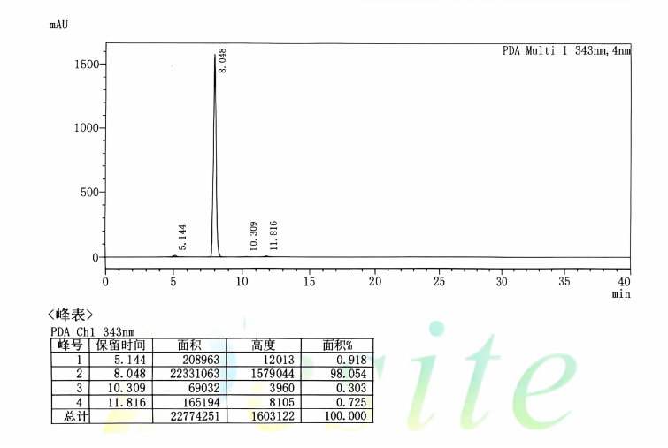
Supplementary Figure.1 Quality test report of daphnoretin. HPLC chromatogram of daphnoretin. The purity of daphnoretin was ≥98%.

Supplementary Table.1 Library of compounds screened for SrtA inhibition
Compound Name | CAS No. | PubChem  CID | Relative inhibition
 |  | 5281406  14925  10881  2724702  12756  235414  7794  1549025  9017  16592  68311  10857465  3000226  12810  8089  5367460  220374  656678  12305194  21859  5271569  10276 | +  -  -  -  -  -  -  -  -  -  -  -  -  -  -  -  -  -  -  -  -  -
  Daphnoretin
  Tricarballylic acid
  Tropone
  β-D-Glucose pentaacetate
  γ-Hexalactone
  ω-Pentadecalactone
  Citronellal
  Neryl acetate
  Citronellyl acetate
  Methyl propyl disulfide
  Diphenylamine hydrochloride
  Ambroxide
  Fusidic acid
  δ-Decalactone
  Squalane
  Ethyl linolenate
  Menthyl acetate
  Atropine sulfate monohydrate
  Arecaidine hydrochloride
  Isostearic acid
  Dibutyl maleate
  2,4,5-Trimethoxybenzoic acid
  2034-69-7
  99-14-9
  539-80-0
  604-69-3
  695-06-7
  106-02-5
  106-23-0
  141-12-8
  150-84-5
  2179-60-4
  537-67-7
  6790-58-5
  6990-06-3
  705-86-2
  111-01-3
  1191-41-9
  2623-23-6
  5908-99-6
  6018-28-6
  2724-58-5
  105-76-0
  490-64-2
#Relative inhibition of compounds at 64 μg/mL，“+” indicates an inhibition rate ≥ 70%, while “–” indicates an inhibition rate < 70%.

Primer name | Oligonucleotide
SrtA-V168A-F | 5'-TTTACCTTTTTGTTCATCTAGAGCTCCTACATCTGTAGGCTTAA  C-3'
SrtA-V168A-R | 5'-GTTAAGCCTACAGATGTAGGAGCTCTAGATGAACAAAAAGGT  AAA-3'
SrtA-N114A-F | 5'-ATGAAAGTGTGTCCTGCAATTGAAATAGCTTGATCATCTAGTG  ATTCATTTTCTTC-3'
SrtA-N114A -R | 5'-GAAGAAAATGAATCACTAGATGATCAAGCTATTTCAATTGCAG  GACACACTTTCAT-3'
SrtA-T180A-F | 5'-TTTCATTGTAATCATCACAAGTAATTAATGCTAATTGTTTATCTT TACCTTTTTGTTCATC-3'
SrtA-T180A-R | 5'-GATGAACAAAAAGGTAAAGATAAACAATTAGCATTAATTACTT  GTGATGATTACAATGAAA-3'
SrtA-K175A-F | 5'-CAAGTAATTAATGTTAATTGTTTATCTGCACCTTTTTGTTCATCT  AGAACTCCTACATCTGT-3'
SrtA-K175A-R | 5'-ACAGATGTAGGAGTTCTAGATGAACAAAAAGGTGCAGATAAAC AATTAACATTAATTACTTG-3'
Supplementary Table 2. List of primers employed in this work

